Web Development
Design Patterns

Author: Kadmin Van Vuuren
Date: 03/03/2019

Table of Contents
Introduction 3
Chapter One 4
1. Chapter One | Layered Architecture Pattern - An Introduction 4
1.1 Chapter One | Layered Architecture Pattern - Layers 4
1.1.1 Chapter One | Layered Architecture Pattern - Presentation Tier 5
1.1.2 Chapter One | Layered Architecture Pattern - Logic Tier 5
1.1.3 Chapter One | Layered Architecture Pattern - Data Tier 6
1.2 Chapter One | Layered Architecture Pattern - Mark Richards 6
1.3 Chapter One | Layered Architecture Pattern - Open & Closed Layers 7
1.3.1 Chapter One | Layered Architecture Pattern - Closed Layers | Layers of Isolation 7
1.3.2 Chapter One | Layered Architecture Pattern - Open Layers | Layers of Isolation 8
1.4 Chapter One | Layered Architecture Pattern - Pros & Cons 8
Chapter Two 9
2. Chapter Two | ORM With Repository & Unit of Work Patterns - An Introduction 9
2.1 Chapter Two | ORM With Repository & Unit of Work Patterns - Repository Pattern 9
2.2 Chapter Two | ORM With Repository & Unit of Work Patterns - UoW 11
Conclusion 12
References 13
Reading List 14

Illustration Index
Illustration 1: Presentation Tier [6] 5
Illustration 2: Multi-Tier Architecture Tiers [5] 6
Illustration 3: Mark Richards Layered Architecture Pattern [10] 6
Illustration 4: Closed Layers Image inspired by Mark Richards 7
Illustration 5: Mark Richards Open Layers 8
Illustration 6: Repository Pattern Microsoft [13] 10
Illustration 7: Sequence Diagram Illustration of Unit of Work [9] 11

Introduction

The field of programming is a large and complicated one. As such, one needs to consider how to approach such a field and thus understand what approaches are available to technical challenges that programmers face. One such approach that developers can look to utilise is that of Patterns. Patterns are recurring solutions to recurring problems [1].

Design Patterns provide developers with solutions to potentially complex issues facing programming practices, further allowing us to solve specific problems. These Patterns were, at some point, designed and implemented by experienced developers to aid others in their future projects.

This suggests that develops can further enhance their code and through the use of Design Patterns and that this further aids in making code more flexible and reusable.

This report will look to research into the above, and more specifically the Layered Architecture Pattern or N-Tier Architecture Pattern and ORM with Repository and Unit of Work Pattern. These are some of the most popular and widely used patterns in the industry and is well known to developers.

This Section Left Intentionally Blank

Chapter One

It is important to understand that when critically evaluating Design Patterns, that Patterns generally include three basic elements [2]:
- A Problem
- The Context in Which The Problem Occurs
- The Solution to The Problem

1. Chapter One | Layered Architecture Pattern - An Introduction

When looking to understand Design Patterns, this is a great place to start as it allows us to see the process involved when creating and using Design Patterns.
The Layered Architecture Pattern or N-Tier Architecture Pattern is one of the oldest and most well-known Design Patterns: Sometimes also referred to as Multi-Tier Architecture. Layered Architecture is named as such as it looks to physically and logically separate its processes. This separation sees separate processes being hosted on separate machines: The idea behind this is ensuring that services are provided without resources being shared [3]. Interestingly, we see the “N” referring to numbers 1 and above to denote its separation.

1.1 Chapter One | Layered Architecture Pattern - Layers

As suggested, Layered Architecture Pattern performs separation, but how does this separation work and how is it implemented? N-Tier Applications requires that the application be divided into three separate tiers, such as:
- Presentation Tier
- Logic Tier
- Data Tier
The above can also be described in layers as:
- Presentation Layer
- Business Layer
- Persistence Layer
- Database Layer
Breakdown of these tiers is required to provide a better understanding. Furthermore, we see Martin Fowler suggest that, the hardest part of a layered architecture is deciding what layers to have and what the responsibility of each layer should be [4].

1.1.1 Chapter One | Layered Architecture Pattern - Presentation Tier

The first layer we concern ourselves with when looking to understand a Multi-Tier Architecture, is that of the Presentation Layer. The Presentation Layers logic is primarily concerned with that of handling interactions between user and software. Furthermore, the primary responsibilities of the presentation layer are to display information to the user and to interpret commands from the user into actions upon the domain and data source [5].
So from this we can determine that the Presentation Tier acts as our Front End Layer, of which the user interacts with: implemented with languages such as HTML, JavaScript and even CSS.
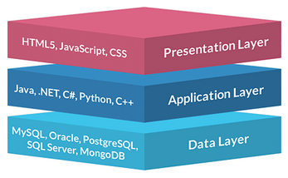Illustration 1: Presentation Tier [6]

The above illustrates and summarises what we can expect at each layer of the Multi-Tier Architecture. When concerning ourselves with web applications, we can see the front end technologies that we may use as a way of providing users a means by which they can communicate with the application software. It is important to note that this is not an exhausted list of technologies used at this tier level.

1.1.2 Chapter One | Layered Architecture Pattern - Logic Tier

Once a user has interacted with the system, instructions are then passed to the Application Layer. This tier concerns itself with the application’s logic and ultimately determines the purpose and function of the software. An example of this layer’s functions can be described as a Class written in Java that handles the creation of new user Objects, this logic further handles the parsing of data into a back-end database.
It is important to understand that this tier also defines logic of how to return information held within a back-end database. If a user wants to interact with the system through the front end interface, and retrieve information from the database, the Logic Tier will also handle this.

1.1.3 Chapter One | Layered Architecture Pattern - Data Tier

Once we have traversed the Presentation and Logic Tiers, we come to our Data Tier. This tier is primarily concerned with data storage systems such as our relational or non-relational databases. Data source logic is about communicating with other systems that carry out tasks on behalf of the application. Furthermore, for most enterprise applications the biggest piece of data source logic is a database [5].
Martin Fowler further goes on to suggest the following overview of Tiers as:
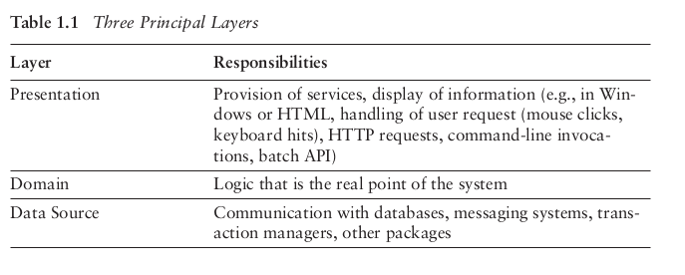
The above further illustrates Layered Architecture Tiers.

1.2 Chapter One | Layered Architecture Pattern - Mark Richards

When trying to understand the Layered Architecture Pattern we see some distinction between what has been discussed above and Mark Richards’s explanation of Layered Architecture Pattern:
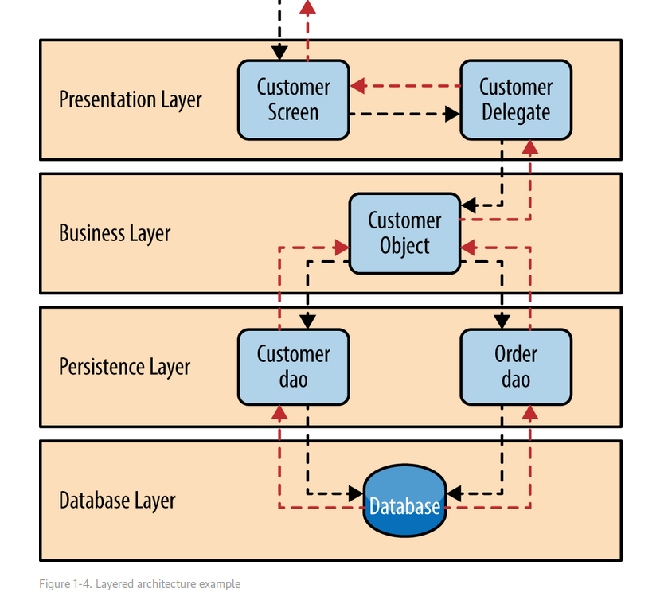Illustration 3: Mark Richards Layered Architecture Pattern [10]

The above is the same as what has been discussed throughout sections 1~1.2. However, we can see the addition of the Persistence Layer. This Layer will be discussed further throughout sections 2~, but for now we can see this as being a way in which we can present data at the application level such as Object Relational Mapping. Importantly, these differences are simply down to the implementation of the Layered Architecture Pattern.

1.3 Chapter One | Layered Architecture Pattern - Open & Closed Layers

An important concept in Layer Architecture Patterns is that of Open and Closed Layers. Looking at Illustration 3, if each one of these layers were closed it means that as a request or requests move through each one of the respective layers, it must pass to the one directly below it before proceeding to the next. As such, we can see, for example a request that originates from a layer such as the Presentation Layer, must go through both Business and Data Persistence Layers before reaching that of the Database Layer [10].
The above does suggest a possible problem as requests now have to pass through each layer in order to reach another. However, there is a good reason for this, and it is otherwise referred to as Isolation.

1.3.1 Chapter One | Layered Architecture Pattern - Closed Layers | Layers of Isolation

The layers of isolation concept means that changes made in one layer of the architecture generally don't impact or affect components in other layers [10]. We can see this is important as we already understand that separation is a key part of Layered Architectures.
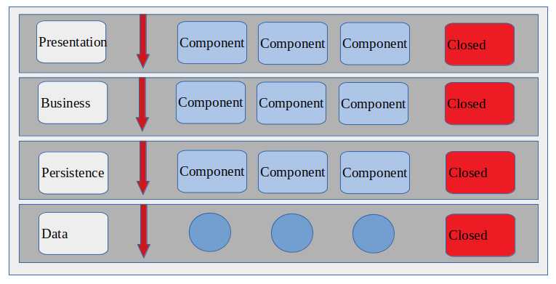Illustration 4: Closed Layers Image inspired by Mark Richards
So, what the above means, is that if we allow a layers, such as Presentation Layer to have direct access to that of the Persistence Layer, changes that are made at the Persistence Layer would affect both Business and Presentation Layers as well as the Persistence Layer itself: This would result in Tightly Coupled pieces of software. The above is important to implement when looking to provide more system security for your software components.

1.3.2 Chapter One | Layered Architecture Pattern - Open Layers | Layers of Isolation

Layers as seen in Illustration 4, can also be open if the Layered Architecture has been implemented to provide open layers. However, this presents a security risk as you don’t want to provide direct access from a layer such as the Presentation Layer to the Data Layers. Below illustrates these open layers.
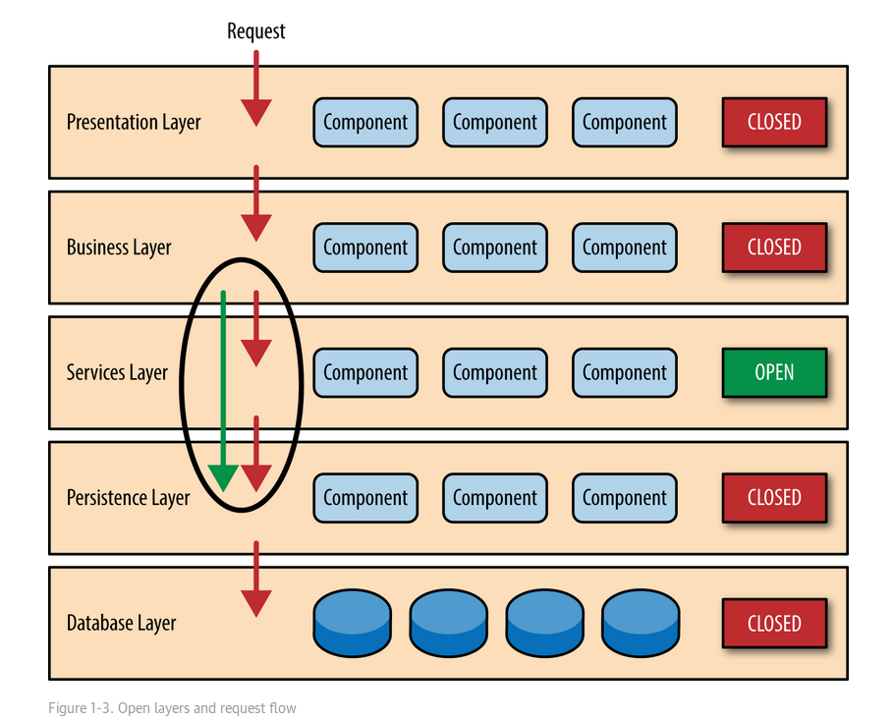Illustration 5: Mark Richards Open Layers

1.4 Chapter One | Layered Architecture Pattern - Pros & Cons

After looking into the Layered Architecture Pattern, we can denote that there are pros and cons to implementing this Pattern into your software. Firstly, we can see that by this separation of tiers, that system security would be a benefit to a Multi-Tier Architecture. We can also use this approach to provide us with increased scalability: These are the two obvious pros to N-Tier.
However, we can also denote cons to this approach. Firstly, it’s clear that complexity is an issue when looking to implement a Multi-Tier Architecture. Furthermore, this also clearly means that there is an increase to the effort that needs to be made to implement such an approach. It is also important to note that Layered Architecture-Patterns provide all of the benefits and downfalls for all respective Tiers.

Chapter Two

There are two parts to this, firstly the need to understand ORM and the second, how this is used alongside Patterns.

2. Chapter Two | ORM With Repository & Unit of Work Patterns - An Introduction

Firstly, Object relational mapping (ORM) is a technology that is used to bridge the impedance mismatch between object-oriented programs and relational databases [11]. Furthermore, ORM appears to be a mechanism by which developers can link OOP classes to that of RDBMS or Relational Database Management Systems.
Inevitably software applications will need to access and potentially modify or create data, as seen in CRUD or Create, Read, Update and Delete. This data could be held in a database of some sort or any other mechanism by which can be used to store data.

2.1 Chapter Two | ORM With Repository & Unit of Work Patterns - Repository Pattern

Today, it is much more likely that data be interacted with across multiple web-based applications and/or services, such as API’s: Furthermore, this implies that there will be multiple ORMs that need to be interacted with so to connect to multiple databases.
As such this suggests that multiple ORMs or Object Relational Mappers are used to interact with data in data stores. This direct access to data from multiple sources can result in:
- Duplicate Code
- High Potential for Programming Errors
As well as the above, this further presents challenges to developers as there is often a concern to not expose the system’s data access logic to that of their system’s UI layer, such as the Controller. It is in scenarios like this that Patterns such as the Repository Pattern come in useful [12].
When looking to design mapping for an application’s domain layer, there are a number of solutions that exist that can help architects implement this design. One such solution is that of the Repository Pattern. Microsoft suggests that using the Repository Pattern can help in achieving in the following outcomes:
- You access the data source from many locations and want to apply centrally managed, consistent access rules and logic [13].
You should use the Repository Pattern to allow for the separating of logic that retrieves data and maps it to an Entity Model, from the Business Logic that acts on the model, as suggested by Microsoft [13].

Below provides an illustration of the Repository:
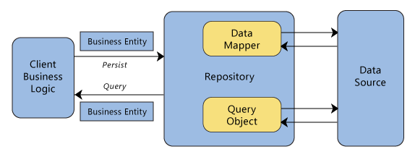Illustration 6: Repository Pattern Microsoft [13]
Using this we can see the separation of logic between mapping data to a data source such as a database and the retrieving of this data. It’s important to understand that this Repository acts like an in-memory domain object collection [14].

This Section Left Intentionally Blank

2.2 Chapter Two | ORM With Repository & Unit of Work Patterns - UoW

Before we can begin to understand the Unit of Work Pattern, we need to understand that a Unit of Work keeps track of all objects read from the database, together with all objects modified in any way. It also handles how updates are made to the database [7].
So by this we can denote that we need to have a method by which we can keep track of any changes made to data within a database, if we don’t data won’t be written back into the database [7].
Furthermore, when reading and modifying objects, we must ensure that the database state we are working in, is and stays consistent. So, if we read objects from a database, it’s important that this reading is isolated so that no other processes can change the object whilst you are working on them: This could result in inconsistencies within our data objects [7].
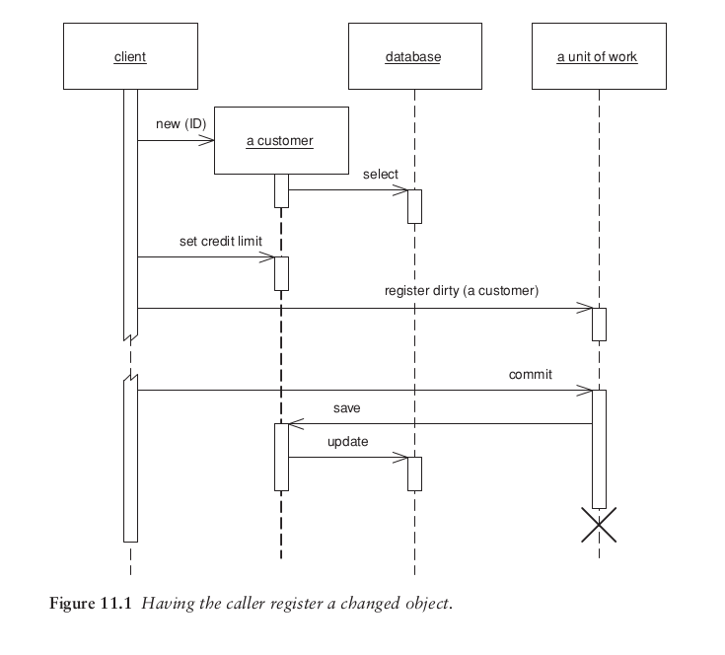Illustration 7: Sequence Diagram Illustration of Unit of Work [9]

Above illustrates an approach to Unit of Work through a sequence diagram. Using this we can see how code might be developed to satisfy this approach. Generally, Unit of Work logic will consist of methods that handle requests to update and modify objects held in a database, as seen above.

Conclusion

Each pattern describes a problem which occurs over and over again in our environment, and then describes the core of the solution to that problem, in such a way that you can use this solution a million times over, without ever doing it the same way twice [8].
This report looked try and produce a better understanding of what patterns are, and more importantly, what types of patterns are available and how they work.
We can see that by using N-Tier Architecture, that we afford ourselves the ability to manage all layers in the software interaction process, in one place. By separating software processes into separate logical areas, we improve security as well as data integrity. Even with increases effort on behalf of developers, taking a Multi-Tier Architecture approach is important.
The Repository Pattern although important, does increase the level of abstraction in your code [13]. This means that code will most likely be harder to understand, although if implement correctly, it will help to reduce code redundancy.
Finally, it seems that the Unit of Work Pattern fundamentally looks to address problems with keeping track of manipulated objects so that we know which ones we want to sync with our database, thus avoiding data inaccuracy.
Patterns afford us the ability to solve complex problems in software engineering. Although these approaches can be difficult to understand and implement, they are important when looking to develop, scalable and secure applications.

This Section Left Intentionally Blank

References

[1] J. Governor, D. Hinchcliffe and D. Nickull, Web 2.0 Architectures, Sebastopol: O’Reilly, 2009. Pg. 103.

[2] J. Governor, D. Hinchcliffe and D. Nickull, Web 2.0 Architectures, Sebastopol: O’Reilly, 2009. Pg. 8.

[3] Stackify, “N-Tier Architecture” Stackify 2019. [Online] Available: https://stackify.com/n-tier-architecture/ [Accessed: March. 10, 2019].

[4] M. Fowler, D. Rice, M. Foemmel, E. Hieatt, R. Mee and R. Staffordm, Patterns of Enterprise Application Architecture, Crawfordsville: Pearson Education, 2011. Pg. 18

[5] M. Fowler, D. Rice, M. Foemmel, E. Hieatt, R. Mee and R. Staffordm, Patterns of Enterprise Application Architecture, Crawfordsville: Pearson Education, 2011. Pg. 20

[6] Jinfonet, “3 Tier Architecture” Jinfonet 2019. [Online] Available: https://www.jinfonet.com/resources/bi-defined/3-tier-architecture-complete-overview/ [Accessed: March. 10, 2019].

[7] M. Fowler, D. Rice, M. Foemmel, E. Hieatt, R. Mee and R. Staffordm, Patterns of Enterprise Application Architecture, Crawfordsville: Pearson Education, 2011. Pg. 39

[8] M. Fowler, D. Rice, M. Foemmel, E. Hieatt, R. Mee and R. Staffordm, Patterns of Enterprise Application Architecture, Crawfordsville: Pearson Education, 2011. Pg. 10

[9] M. Fowler, D. Rice, M. Foemmel, E. Hieatt, R. Mee and R. Staffordm, Patterns of Enterprise Application Architecture, Crawfordsville: Pearson Education, 2011. Pg. 185

[10] Mark Richards, Software Architecture Patterns. O’Reilly Media, 2015.

[11] E. Erhieyovwe, A. Oghenekaro and O. Oluwole, “An Object Relational Mapping Technique for Java Framework” International Journal of Engineering Science Invention, Vol. 2, no. 6, pp.01-09, June 2013.

[12] Garywoodfine, “Repository Pattern” Garywoodfine 2019. https://garywoodfine.com/generic-repository-pattern-net-core/ [Accessed: March. 15, 2019].

[13] Microsoft, “Repository Pattern” Microsoft 2019. [Online] Available: https://docs.microsoft.com/en-us/previous-versions/msp-n-p/ff649690(v=pandp.10) [Accessed: March. 15, 2019].

[14] Martin Fowler, “Repository” Martin Fowler 2019. Available: https://martinfowler.com/eaaCatalog/repository.html [Accessed: March. 21, 2019].

Reading List
http://clientserverarch.blogspot.com/2013/03/advantages-and-disadvantages-of.html

marking criteria and Student FEEDBACK

This section details the extent to which the assessment criteria are demonstrated by you, which in turn determines your mark. The marks available for each category of skill are shown. Lecturers will use the space provided to comment on the achievement of the task(s), including those areas in which you have performed well and areas that would benefit from development/improvement.

Common Assessment Criteria Applied (Assignment 1) | Marks available | Marks  awarded
1. Engagement with Literature Skills

A basic list of reference sources has been consulted, but is not at a satisfactory level for a Masters course. Please note that if you are using multiple sections, pages, etc. from the same reference source, you do not list it multiple times. See your report for the correct way to specify such references in your write-up. Generally, expand the range of reference sources consulted to improve your work. (Grade mark: 40.00%) | 15 | 6
2. Knowledge and Understanding Skills

A very good description of the layered architecture pattern with a very good discussion of the benefits and some of the challenges/disadvantages of the pattern. The section on ORM with the repository and unit of work patterns, however, requires more depth and better explanation of the concepts as well as providing a more critical evaluation of using the repository and unit of work patterns with ORM frameworks. (Grade mark: 61.33%) | 75 | 46
3. Cognitive and Intellectual Skills

4. Practical Application Skills

5. Transferable Skills for Life and Professional Practice

The report is generally well-written and presented. See your report for some suggested improvements. (Grade mark: 70.00%) | 10 | 7

Assignment Mark (Assessment marks are subject to ratification at the Exam Board. These comments and marks are to give feedback on module work and are for guidance only until they are confirmed. ) | Late Submission Penalties (tick if appropriate) |  | 59%
 | Up to 1 week late (40% Max) |  | 59%
 | Over 1 week late (0%) |  | 59%

