Lesson Plan Phase 1

Lesson Plan – Step 1 Cynllun Gwers – Cam 1

Student-teacher | Amelia Harwood | Class: | 1B
AoLE or Subject | Iaith Cymraeg | Date: | 3/3/2020
Lesson Focus: | Farm Shop Role Play - Chwarae Rôl Siop Fferm
Meaningful links to Curriculum | Children begin to express themselves through role play. They respond to instructions, questions and other stimuli, spoken clearly by a familiar voice.  Adopt a role, making a conscious use of movement, gesture and speech, using language appropriate to a role or situation
Meaningful links to:  Cross Curricular Responsibilities | Literacy (Oracy) - They speak clearly and audibly with growing confidence and clarity with most sounds and words pronounced correctly.  (Writing) - use written language within role play and active learning.  Numeracy - They use 1p, 2p, 5p and 10p coins to ‘pay’ for items.  Children recite up to 20 and in simple sequences and count up to 10 objects reliably.
Personal Targets (Linked to QTS and identified in weekly review)

No current targets (planning during observation week).

Learning Objectives (focus on Learning- use accessible vocabulary):
The pupils will learn to:
Ask for farm shop products using Welsh Language.
Understand the experience of buying and selling through role play.
Become confident in using a range of coins and money.

Success Criteria (clearly linked to each Learning Objective and related to the process and/or product of learning) | Assessment of Pupils’ Learning  Evidence  (What have the learners to say/write/do/produce – to demonstrate learning)
I can recite numbers to twenty in Welsh.  I can name some farm shop items in Welsh.  I can use the term “Ga i...?” to ask for something.  I am beginning use money to ‘buy’ items in a role play shop. | Children can confidently recite numbers to twenty as part of a small group.  Children can use a word map to name some farm shop food items in Welsh.  Children can use the term “Ga i...?” with confidence.  Children will appear confident in handling money and the experience of buying items in a shop.

Time | Activities/Methodology/Key Concepts  (Teacher’s Role – including key teaching points, differentiation strategies and key questions) | Pupil Tasks  (Pupils’ role –including differentiation, engagement in formative assessment and homework) | Resources  (Including Health and Safety requirement)
Opening phase (with links to prior learning) | Begin by activating pupil’s prior knowledge of Welsh by reciting numbers to 20.  Numbers to 10 - LA  Discuss the role play area as a farm shop and using money.  Ask children for examples of food items that could be found in a farm shop that they already know (in English). | Engage with learning by participating in reciting numbers to 20 in Welsh. (or 10)  Play an active part within discussions about role play and real-life shopping experiences.  Give examples of familiar food items.
Teaching & Core Learning | Introduce the phrase “Ga i....?”.  Show children the word map and the food item resource.  Read over the words as a group to ensure correct pronunciation.  Allow children opportunities to be both customer and shop keep and support the use of money. | Recall the new phrase and become comfortable with the question pattern.  Read and practice pronouncing the new words.  Engage in role play opportunities as both customer and shopkeeper. (Asking for items and giving them out).  Higher level abilities can experiment with the use of money. | Word Map (Laminated).  Fruits and Vegetables pictures (Laminated).  Money (model).
Plenary | Ensure all children have had equal opportunities to be both customers and shop keepers.  Hold discussion around favourite food items and discuss opportunities for enhanced provision within the role play area.  Ask individual children to practice the sentence structure of “Ga i...?” | Engage in discussion and show interest in enhanced provision opportunities.  Be able to give examples questions using the given structure.

Lesson Plan – Phase 1
Evaluation of the Learning Experience
(include references to QTS)

Evaluation of Pupil Learning

Evidence of Learning (including attitude to learning over time)) | Learners will be evaluated as individuals, in ability set groups and as a whole class.  During the role play session, I will hold a conversation with every pupil to assess their learning and ability to use the new language pattern. I will be addressing questions to small groups (around 8 pupils) to test their knowledge of the new learning. The learners will be assessed as a whole class by replying to the register using the new language pattern on a daily basis to ask for a school dinner or a lunch box meal.  If successful, learners will be engaged in the role paly activity and excited to use their learning for enhanced provision. The pupils will seem proud to use their new welsh language skills and will be praised accordingly to encourage their engagement. Pupils should feel confident in being able to communicate effectively using the new language pattern with both adults and classmates.  Pupils who present these mannerisms and attitudes during and after the lesson will prove the reliability of these standards and show clear evidence that the teaching has been successful and effective.
Next Steps for Progress | Learning is continually being monitored and developed in this topic area during registration time which will ensure that the learning is fully understood and becomes a familiar language pattern for the children. I will ensure future lesson plans give opportunities for one on one interaction with learners to assess their knowledge and understanding. This was particularly effective for learners who lack confident and struggle to speak as part of a group.  I will aim to ensure this topic is revisited either by myself or by the class teacher after I complete my placement. I can see how this lesson can give an effective foundation for further Welsh developments in a number of different contexts and topic areas.  I know that continuing to engage with learners individually and as groups will be very effective in my continued practice and will accommodate for the range of learning styles and needs within the class. Building on the learning from this lesson will be comforting for the learners and give them confidence in their ability and passion for speaking Welsh in future lessons.

Reflective Analysis of Teaching and Strategies For Development – including justification/rationale for pedagogical choices

Evidence of my Effective Practice | Each child was engaged and excited by the role play aspect of the lesson. The pupils were very interactive and intrigued by the new language. The learners were motivated by the new resources provided (Appendix 1). The children were encouraged to try their best to use correct language patterns in order to add more aspects to the role play such as the use of money. The pupils were also excited to prove their knowledge by using the language structure for other members of staff and during enhanced provision.  Being my first planned and taught lesson, I feel reassured by the children’s levels of engagement and interest with the topic. I feel I am already improving my level of accuracy in using and teaching the Welsh language and passionate about instilling this in the learners.  I am confident in the pedagogical decisions made within the lesson that have been inspired by the experience and advice of my class teacher and the current curriculum documents.
Areas for my Development  Personal Targets for Progress | In hindsight, I am aware that I could have made improvements in the introduction to my lesson by not overwhelming the learners and allow them to learn mostly through the role paly aspects of the lesson and rely less on the children listening to my expectations.  I am currently attempting to become more adaptable to change and accommodating to learners’ ideas and needs. To do this I will allow my plans to be more flexible and attempt to give learners more choices and opportunities to ask questions. In addition, I would like to give more input on ideas for enhanced provision within my plenary to allow learners to use their new knowledge to their full learning potential.

Appendix (1)

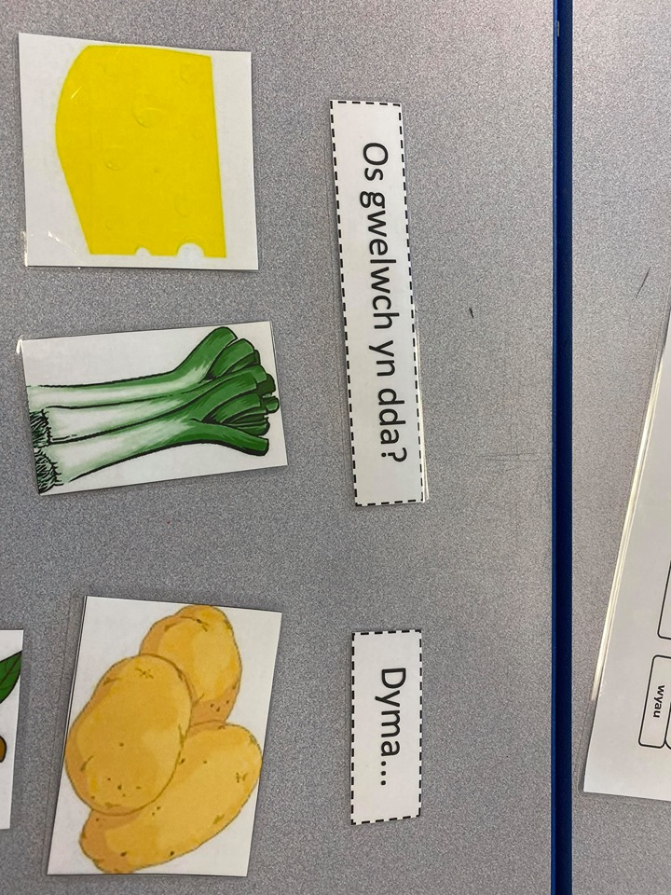
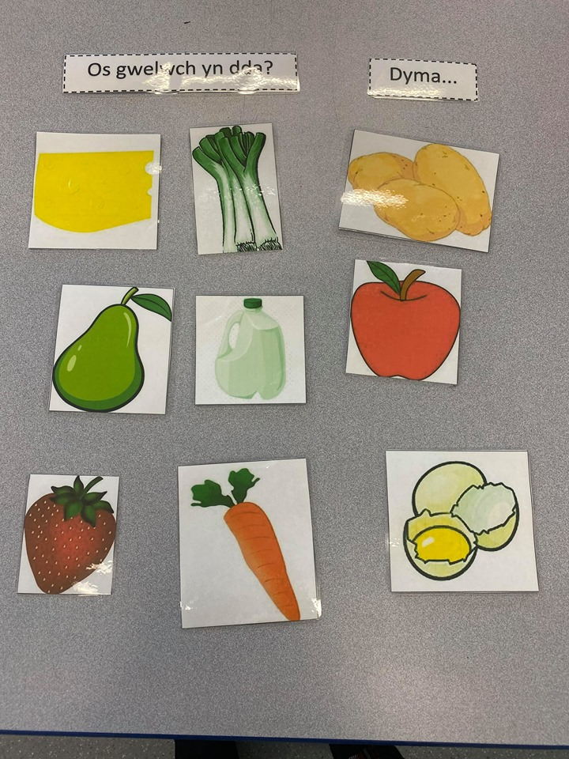

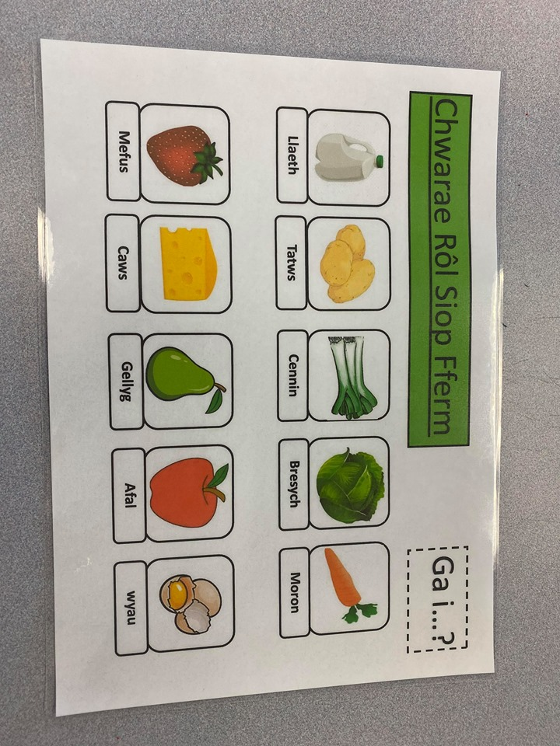

Language Mat - Resource by Amelia Harwood (2/3/20)

