Developing Welsh Language Skills
Improving both the teacher and student’s Welsh language skills is vital within the Welsh curriculum as it improves the use and understanding of the Welsh language. The new Welsh curriculum, that is to begin in 2022, encourages the use of Welsh language to be used across subjects. Therefore, as a trainee Secondary English Teacher, I have begun to implement Welsh into my lessons and the pupils learning. Below, I have attached evidence of me using and developing Welsh language skills within my lesson plans, practising and improving my own Welsh language and pupil activities that have been completed. I consider my Welsh skills to be at ‘entry level’ and therefore all the evidence shows me using simple, accessible Welsh.

Lesson Plan
Below is a lesson plan and reflection. This lesson was completed as a starter at the beginning of an English lesson to improve pupils welsh language skills. This lesson plan can be developed into a full lesson or can be adapted and changed to higher or lower attaining pupils.
Student-teacher | 1903541 | Class: | Ks3 starter
AoLE/Subject | Welsh /English | Date: | 02/ 25/2020
Lesson Focus: | Improving welsh language skills by revising expressions that can be used in everyday life and English lessons.
Relevant/meaningful links to:  Curriculum  Cross-curricular responsibilities | - Developing Welsh language skills.  - Cross-curricular teaching and learning.  - Using cross-curricular skills.
Personal Targets  (Linked to QTS and identfied in weekly review) | - To improve my Welsh literacy skills.  - To teach cross-curricular.  - There is a commitment to incremental development of personal skills in the use of the Welsh language.

Learning Objectives (Focus on Learning) | - To improve Welsh language by revising simple Welsh vocabulary. (KS3)  - To identify the vocabulary through pictures.
Success Criteria  (process/product) | - To be able to identify and confidently say the vocabulary.  - Working towards using these Welsh words casually in English lessons (where necessary).

Key Resources Health & Safety | - Pictures on powerpoint.  - Work-sheets to complete work on and stick in books.

Time | Content, Pedagogy & Assessment Opportunities (key teaching points and questions)
Links to Previous Learning | - Links to pupils previous welsh lessons and skills.  - Advancing pedegogy to teach cross-curricular subjects.  - Gives English teachers the opportuity to work with the Welsh department for assessment for learning and lesson topics.
Opening Phase | - Teacher to greet pupils as they walk in- ‘Bore da’, ‘Croeso’  - Starter- what we are doing and why.  - Identifying the focused vocabulary.  Vocabulary/ Expressions:  - Pwerus (powerful)  - Hen (old)  - Tawel (quiet)  - Araf (slow)
Teaching & Core Learning | - Revise and match the vocabulary to pictures.  - Teacher allowing pupils time to match the pictures to the correct vocabulary.  - Pupils to match the vocabulary to the correct picture.  - Teacher to go through the vocabulary, asking individual pupils to identify and answer with the correct picture.
Plenary | - Plenary to secure knowledge and revise Welsh vocabulary one more time.  - Match the Welsh and English words (2 minutes).  - Pupils to match words to the correct English words. (E.G. A-E).  - Teacher to praise pupils ‘bendigedig’, ‘Da Iawn’.

Lesson Plan – Evaluation/reflection of the Learning Experience.
Evaluation of Pupil Learning

Evidence of Learning (including attitude to learning over time) | - Pupils revising and improving simple Welsh language skills.
Next Steps for Progress | - To continue devloping pupils welsh language skills within english lessons.  - Implementing new welsh words each week to use (specific to English topic).  - Next lesson will be pupils using these words in simple sentences to describe someone/objects.

Reflective Analysis of Teaching and Strategies for Development – including justification/rationale for pedagogical choices

Evidence of my Effective Practice | - Developed my Welsh language skills and has allowed me to research and learn basic Welsh language skills effectively.
Areas for my Development  Personal Targets for Progress | - Improve my own Welsh skills by online research and online courses.  - To advance my Welsh skills in order to teach more confident, advanced Welsh skills.

Original learning resource on PowerPoint
Below are screenshots of the PowerPoint learning resource. These screenshots show the activities the pupils will be completing within time frames. This PowerPoint activity was created by me. It is simple and easy for low, middle and high attaining pupils to access. This activity correlates with the lesson plan (above).
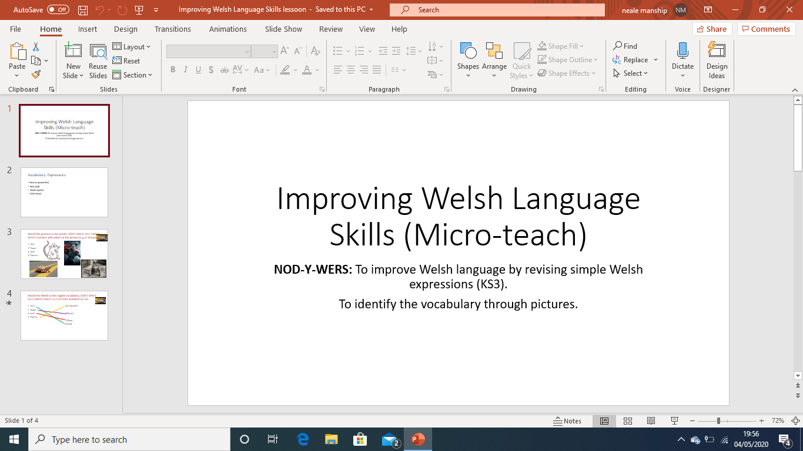
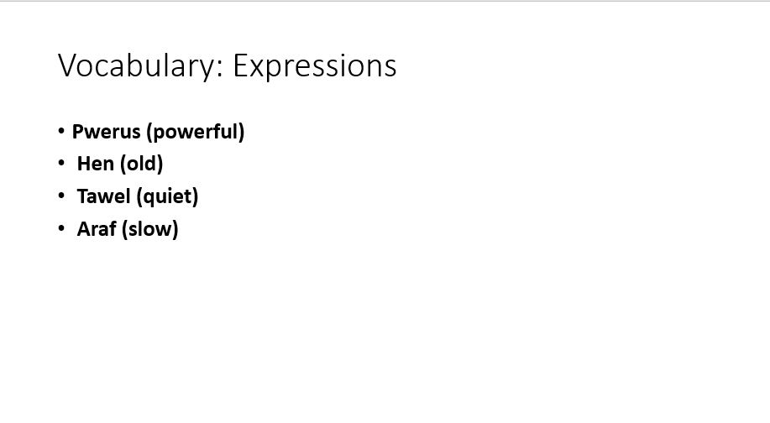

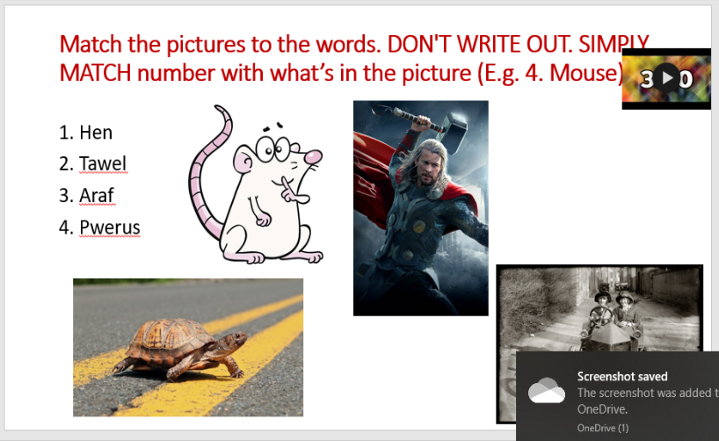
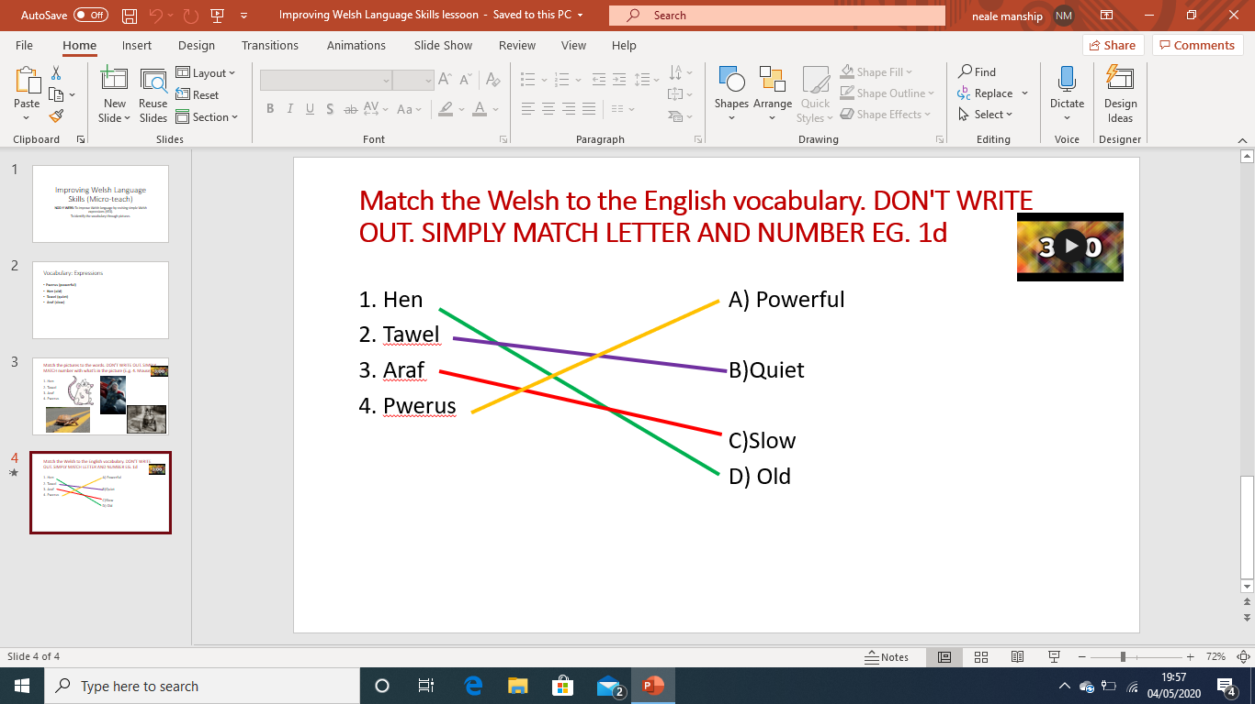

Cymraeg I Bawb lessons
Cymraeg I Bawb lessons took place in university. Eight lessons where completed in total. These sessions consisted of learning/revising the welsh alphabet, numbers, times and classroom phrases.

Below are a few activities that were used in the sessions.
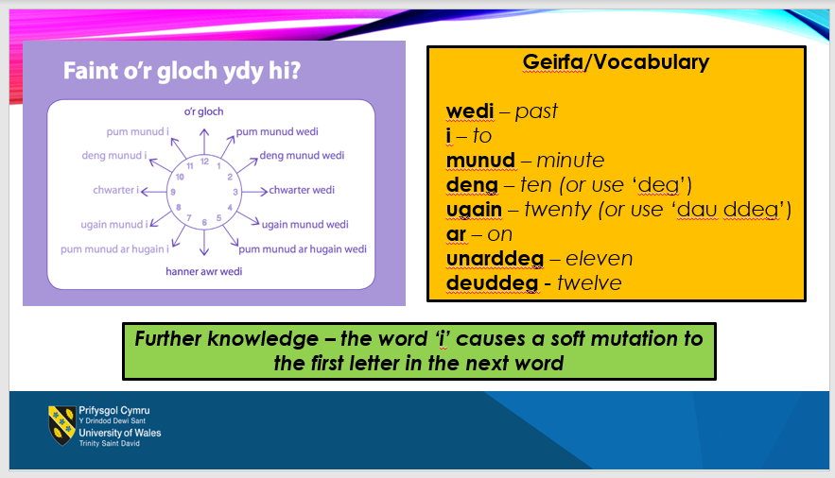
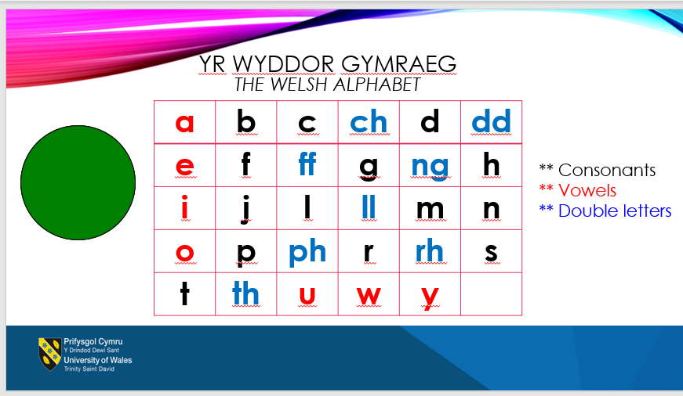

Welsh date, nod-y-wers and reading time.
I have been consistently writing the date, learning objectives in Welsh in all of my English lessons. This allows me and the pupils to effectively learn the date. Using Welsh phrases for instructions allows me to become more confident and pupils to gain a better understanding.

Below are screenshots that show me writing the date and learning objectives in Welsh.
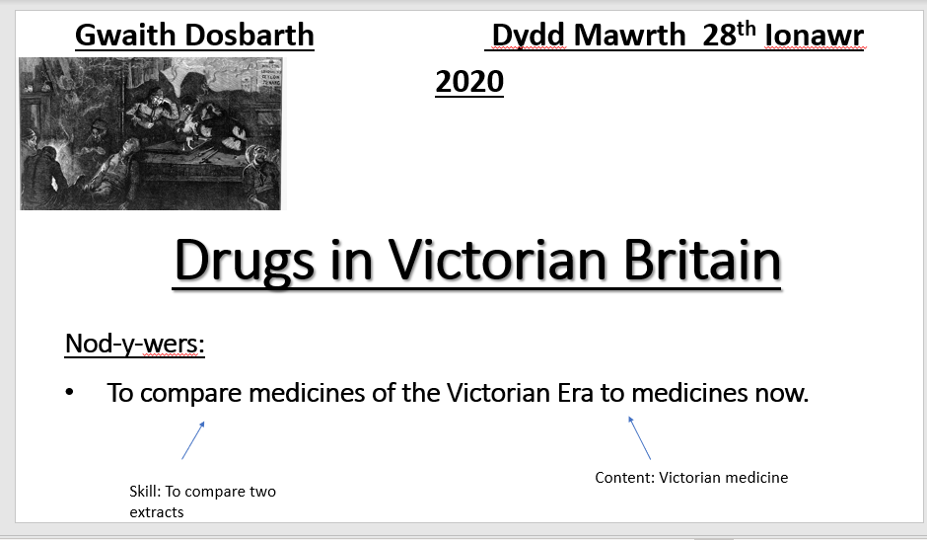

Below is a screenshot of me using the Welsh word ‘Darllen’ to instruct the pupils to read for the first ten minutes of the lesson as this was compulsory in PTE1.
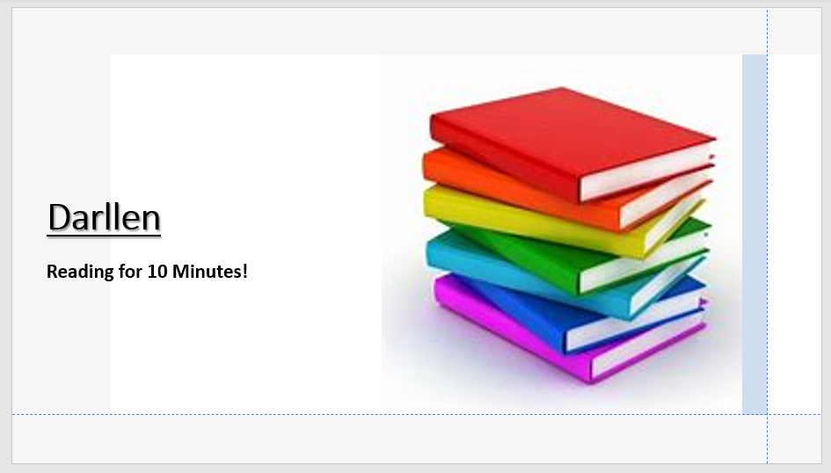

Incidental Welsh
Using incidental Welsh in my lessons has helped me improve my confidence and helped me develop my Welsh language skills.

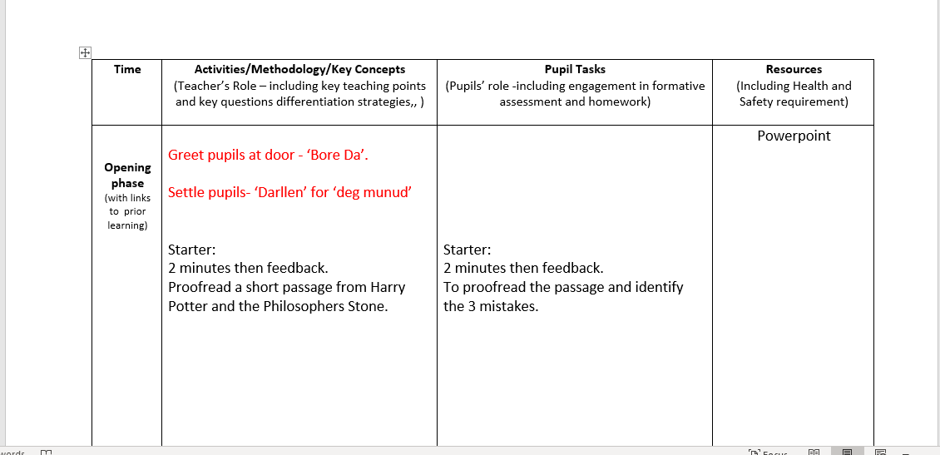
Below are screenshots of lessons where I have used incidental Welsh to greet and settle the pupils. I plan to use incidental Welsh in all of my lessons where possible (highlighted in red). These screenshots have been taken from lesson plans created by me.

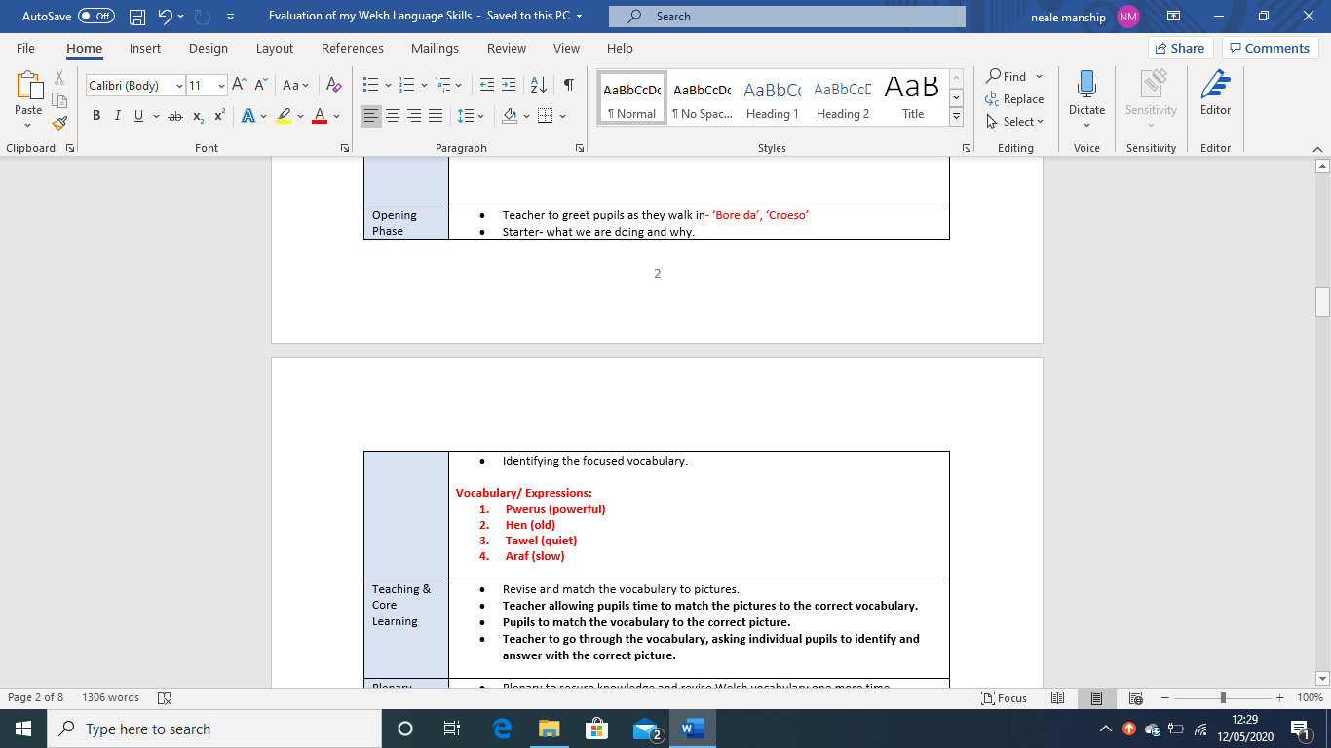

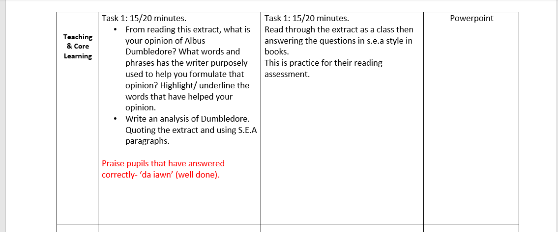
Below is a screenshot showing that I use incidental welsh to praise pupils during tasks (highlighted in red). These screenshots have been taken from lesson plans made by me.

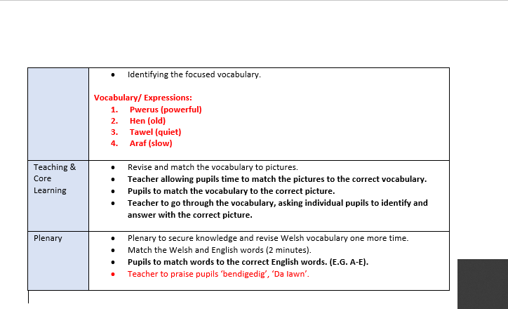

Evaluation of my Welsh language skills
Upon evaluation, I would consider all my Welsh language skills, such as listening, speaking, reading and writing, to be at entry level. With a C grade in GCSE Welsh and the ‘Cymraeg I Bawb’ welsh lessons I have received on this course, I am revising and learning more Welsh to use within my lessons. My ‘Developing Welsh Language Skills’ lesson indicates the level of Welsh that I am comfortable to teach. I implement basic ‘classroom phrases’ into my lessons such as: ‘Bore/ Prynhown da’ and ‘Darllen’. I also write the Gwaith Dosbarth, Nod-y-wers and the date on the board to remind pupils to use Welsh in their books when writing the date, title and learning objectives.
At entry level Welsh, with my reading skills, I can interact with learners, answer simple questions and offer simple feedback in the form of a simple sentence of phrase. I can also respond appropriately to learners as they develop their language skills, e.g. pronouncing simple, everyday words and phrases in Welsh. With my speaking skills, I can open and close my lessons using Welsh words and phrases with clear punctuation and I can present commands/ instructions to pupils in a simple way. With my reading skills, I can read text satisfactorily, e.g. a simple story or game instructions using simple clauses and respond to content. I can use notes that have a foundation level of Welsh on but would be very dependent on them throughout the lesson. Lastly, with my writing skills, I can write and mark simple sentences and patterns correctly and write in Welsh on a white board confidently. I can introduce a basic written information framework, e.g. display information from the content of a book with one-word answers or a multiple-choice question.
Moving forward, I hope to become more confident with my Welsh language and reach the foundation level. I will do this by practicing through online courses/websites and using Welsh as frequently as possible within my lessons. I will first depend on notes when learning and teaching more advanced Welsh. I will also seek advice and resources from the schools’ Welsh department as I believe this is the best way for me to see what the pupils are learning. I plan to develop my reading, writing, speaking and listening skills by using the foundation level Welsh framework. This will allow me to take a step-by-step approach in becoming more confident with these skills.
In conclusion, I will continue to improve and expand my Welsh language skills so I can comfortably teach a more advanced level. I will continue to implement Welsh incidentally and through starters so pupils can use and understand the Welsh language in both their Welsh lessons and in cross-curricular subjects.

