Mental health conditions and PTSD in police officers of Gwent Police Force.

Hannah Frankcombe
Student number – 1921212

BSc (Hons) Professional Policing Practice

Acknowledgments

Firstly, I would like to thank my family and friends for all their support during my three years of study. My Husband for supporting me and giving me to time to study as well as progress in my role as a Police Constable. Secondly the university for their patience in helping me through a difficult and stressful time and for being understanding regarding my additional needs. I would also like to give a huge thank you to my colleagues at Gwent Police for their guidance and advice to complete my degree as well as their ongoing support. A final special mention to Sgt Marsh my shift supervisor for supporting me and implementing time for me to complete my dissertation. It is a difficult job managing the very busy job of response officers, but he has always ensured that I and all other students on his shift have been given plenty of time to complete our work and ensured are welfare whilst doing so.

Declaration

This work has not previously been accepted in substance for any degree and is not being concurrently submitted in candidature for any degree.
Signed: H.Frankcombe Date: 04/01/2023

STATEMENT 1

This dissertation is being submitted in partial fulfilment of the requirements for the degree of BA.
Signed: H.Frankcombe Date: 04/01/2023

STATEMENT 2

This dissertation is the result of my own independent work/investigation, except where otherwise stated.
Other sources are acknowledged by footnotes giving explicit references. A bibliography is appended.
Signed: H.Frankcombe Date: 04/01/2023

STATEMENT 3

I hereby give consent for my dissertation, if accepted, to be available for photocopying and for interlibrary loan, and for the title and summary to be made available to outside organisations.
Signed: H.Frankcombe Date: 04/01/2023

STATEMENT 4

I hereby give consent for my dissertation, if accepted, to be available on the university’s IT system to those who have consent to use the system.
Signed: H.Frankcombe Date: 04/01/2023

Contents

Contents
Acknowledgments 2
Declaration 3
Contents 5
1 Introduction. 6
2 Literature review. 8
2.1 Introduction 8
2.2 Prevalence of mental health within police officers. 8
2.3 What triggers mental health in police officers? 9
2.4 Stigma. 9
2.5 Help and support in place. 10
2.6 Conclusion. 11
3 Research Methodology. 11
3.1 Research strategy. 12
3.2 Risks and limitations. 12
4 Analysis of results. 12
4.1 Introduction 12
4.2 What is Survey Monkey? 13
4.3 Officers that completed the survey. 13
4.4 Mental health identified in the participants. 13
4.5 What impacted the participant’s mental health? 14
4.6 Help and support utilized by Police officers and their ability to talk to others about their mental health. 14
5 Findings and Conclusion 15
5.1 Objectives achieved and recommendations. 15
6 Bibliography. 17
7 Appendix one. 20
7.1 Questionnaire. 20
7.2 Appendix two – Questionnaire results. 23
7.3 Ethics Form. 31
7.4 Research proposal. 55

1 Introduction.

This research aims to examine the issues of mental health within Gwent police and across the UK whilst establishing the triggers and support that’s provided to police officers experiencing mental ill health.
In recent years charities and organisations such as, MIND, Oskar Kilo and the Police Federation have conducted surveys and studies with the main objective to establish whether mental health is in fact an issue in police officers across the UK.
With Police officer’s role exposing them to situations that can be described as traumatic but also immense amount of pressure it’s easy to see why there is a philosophy that mental health is indeed a problem for Police officers. From research 4 objectives have been developed to guide and structure this piece and ensure the desired information is gathered to meet each objective.
Objectives
1. Evaluate the issue of mental health in police officers in Gwent Police and across the UK.
2. Identify the triggers that have triggered mental health within Police Officers.
3. Identify what help and support is available to police officers.
4. Explore the issue of stigma relating to Police Officers suffering from mental ill health.
The focus is to establish whether mental health is indeed and issue in Gwent Police but to also strengthen the established philosophy that mental health is an issue by exploring previous literature and surveys. The keys areas that will be explored during the survey are, how many people are suffering with mental health, the characteristics of those people, the triggers, what support they have gotten or been offered as well as the stigma surrounding those Police officers suffering from mental ill health. This research will be conducted by a survey set out in a questionnaire style format using aspects of both qualitative and quantitative data.
Police officers are often given multiple options to deal with their mental health yet there appears to be a large proportion of officers still not seeking help or if they are not finding it helpful (Mind, 2016). With this is mind an evaluation of the support in place will be conducted but also the stigma attached to Police officers as suffering from mental ill-health.

2 Literature review.

2.1 Introduction
This literature review will evidence the issues of police officers suffering mental health conditions and PTSD whether a result of the role or not. This first chapter will illustrate the issues of mental health within police forces, what has triggered those conditions, the help and support offered, whether the support given has helped in any way and the stigma attached to police officers suffering mental health conditions (Committees Parliament UK, 2022).
There are multiple studies taken place regarding mental health within police officers and staff with material ranging from written pieces to internet websites. To access material, Websites such as Oscar Kilo and Google scholar to access academic pieces will be utilised (Oscar Kilo, 2023).

2.2 Prevalence of mental health within police officers.

In recent years police forces have seen a growth in officers suffering from a range of mental health conditions some diagnosed because of their role as a police officer and some who were diagnosed before joining the force. Multiple surveys and studies have already been done in relation to the subject of mental health and evidence that there is in fact a issue across the UK and even worldwide, Two of the studies have been completed by MIND and The Police Federation.
In 2016 the police federation conducted a survey across the UK with 17,000 participants who were all serving Police officers. The main objective of this study was to evaluate the mental health and wellbeing of Police officers across the UK. Out of the 17,000 officers that participated in the survey 6,630 of them claimed to already be seeking help with their mental health with a quarter of those officers stating they had taken sick leave because of mental ill health but 65% said they had attended work even though they felt they were not fit to do so due to their poor mental health.
Another survey that has been conducted was done so by the charity MIND which they referred to as the Pay and Morale survey. A smaller number of participants completed this survey totalling 3,627 making the results of this survey more concerning. 5% of these participants admitted to making an attempt on their life and a huge 65% admitted to actively looking to leave policing due to the impact it was having on their mental health and wellbeing.
With both surveys showing that mental health within Police forces is an issue when looking for conflicting literature it became obvious that finding research going against the narrative that mental health is an issue in police forces was proved to be non-existent making it difficult to critically analysis the subject. To widen the research and strengthen the philosophy of this study I have expanded my search and discovered the survey conducted by Texas police force. Between January 2020 and February 2020, a survey was conducted in a large police force in Texas USA which included 446 sworn police officers (Jama Network, 2020).
The main objective of the study was to assess the volume of officers suffering mental illness along with the characteristics of these officers. Out of the 446 police officers 434 of them completed the survey with an average age of 37 (Jama Network, 2020).
Results from the survey showed that at least half were suffering or had suffered from mental health conditions. 12% of the officers reported suffering long term mental health conditions and diagnosis, and 26% of police officers had undergone screening for mental health all having results of current mental health illness with only 17% of those 114 seeking any support. During my research this appeared to be one of the first large scale surveys completed regarding mental health in police officers and the findings suggest that mental health is a real concern within the police force needing a lot more focus and normalization (Jama Network, 2020). With looking at this study as well as local studies provide evidence that mental health is not only an issue in local police forces but police forces across the world, you could argue that the role itself and the expectations of Police officers are increasing the risk of an individual developing mental health issues.

2.3 What triggers mental health in police officers?

When looking into mental health illness there will always appear to be a trigger or reason for people suffering from low mood. In the UK there is a charity called MIND whose aim is to provide help and support to those suffering without judgment (Mind, 2015).
Mind was provided with £4 million in funding which has allowed them to develop a program to support emergency services and provide much-needed support. Between December 2014 and January 2015 an online survey was conducted, aimed at members of the emergency services. The aim of this study was to better understand the triggers of the officer’s mental health as well as understand the support that is in place currently for officers suffering from any mental health illness (Mind, 2015).
During the survey, 1.194 police officers responded to the survey to which a staggering 91% had experienced stress, low mood, or poor mental health whilst working for the police service. Research has shown those police officers are twice as likely to develop mental health illnesses than any other industry (Mind | Blue Light Scoping Survey, 2015). Due to the nature of a police officer’s role, it is often assumed that the trigger for mental health illness would be exposure to traumatic incidents but during this research other triggers were identified such as organizational upheaval, excessive workload, and pressure from management (Mind, 2015).
57% of the police officers had said that organizational upheaval was the trigger for mental health illness, 52% said that excessive workload was the trigger, 47% reported that pressure from management was the trigger for mental health and 33% reported that exposure to one or more traumatic events had triggered their mental health illness (Mind, 2015). The figures show that organizational upheaval was one of the most common answers and part of this was the uncertainty of the job with the growing financial cuts to emergency services. Out of all three emergency services the police were more likely to report poor mental health resulting in it affecting their performance at work.

2.4 Stigma.

Stigma has proven to be a big issue within the police force with a lot of officers concerned if they seek help for mental health conditions they could be deemed not fit for duty and looked on as weak by fellow officers (Mind, 2015).
Mind asked a group of officers if their organization encourages staff to talk about their mental health 75% responded either no, not at all, or not very much. When asked how their organization supports them after reporting mental illness 67.57% replied not at all well (Mind, 2015).
The research undertaken during this study has shown that police are the most affected out of the three emergency services this includes how open about their mental health they are. Police officers were the ones to be most likely to not feel comfortable even speaking with their fellow officers finding it easier to talk about physical health rather than mental health due to the fear of being treated and seen differently (Mind, 2015).

2.5 Help and support in place.

One of the main tools used in police forces is known as TRIM (Trauma risk management). It is used in the force by any officer or police staff that may have dealt with a traumatic incident and the individual is usually referred by their shift Sargent. TRIM is designed to help anyone who has experienced trauma at work and can help teams discuss what has happened and what they have gone through, help them understand the impact it has had on them, and explore the next steps in a safe, non-judgmental environment (Blue Light Together, 2022).
TRIM is a process that is confidential with only a few exceptions, if the individual may cause harm to themselves, the individual may cause harm to others, the individual is or has been involved in criminal activity, and if the individual is or had been involved in a disciplinary matter (Kent Police, 2022).
The process of TRIM takes place over a three-month period from when the traumatic incident happens and consists of three meets with a trained TRIM advisor. The first session is recommended to take place within 72 hours of the incident happening this will be the first risk assessment for early intervention. Another meeting is to take place 28 days later and again 3 months later (Kent Police, 2022).
Most police forces utilize the TRIM process and there is little research and evidence to say whether this has helped officers and whether the process is always fully completed with staff. This is something that can be evidenced in the survey conducted with officers to establish whether TRIM is being utilized properly within Gwent police but also if officers feel they are getting a positive experience for the purpose of this project (Kent Police, 2022).

2.6 Conclusion.
It is apparent that there is a huge issue with mental health in the police force with higher rates of mental health illness than any other emergency service with a rate of 91% in one study suffering from some form of mental ill health.
Police officers find it hard to talk about their mental health with others with 75% admitting they would not be open about their mental health or traumatic incidents due to the stigma associated with police officers suffering from mental health illnesses.
With these outcomes, it is clear there is a huge problem within the police service and their response to mental health which requires more research and development.

3 Research Methodology.
Chapter two of this dissertation analysed the literature on the topic of mental health and PTSD in Police officers and by researching such literature has achieved objective one of the projects. This chapter of the dissertation is to research and identify appropriate research methods to gain the best information required to fully explore Mental health and PTSD within Gwent police. It is said that the purpose of research is to increase awareness and knowledge of a topic of interest. Whilst looking into research methods and the purpose behind research literature has suggested that there are two types of research. the first being primary and the second being secondary research. Question Pro (2022) describes primary research as a methodology used by researchers to collect data directly rather than using data that has previously been collected by somebody else some examples of primary data are, Interviews conducted either face to face or via a telephone call, Online Surveys, and focus groups. Whilst Secondary research has been described by Question Pro (2022) as, research methods that utilize already existing data, used collectively used to increase how effective the overall research is.

3.1 Research strategy.
In order to successfully collect and assess data surrounding mental health in Gwent Police a survey will be utilised to collect the data. It will be emailed to the Gwent Police force directing them to an online survey created by a platform known as Survey Monkey. Doing it this way will create an easy, accessible survey whilst ensuring all participants can complete it anonymously. To assist and guide through this method of research utilizing a framework can be crucial, Research Onion framework is an example of a framework used by many during a project such as this. The onion framework consists of 7 stages research philosophy, research approach, methodological choice, research strategy, time horizon, data collection, and analysis (Saunders et al, 2019).
Saunders et al (2019).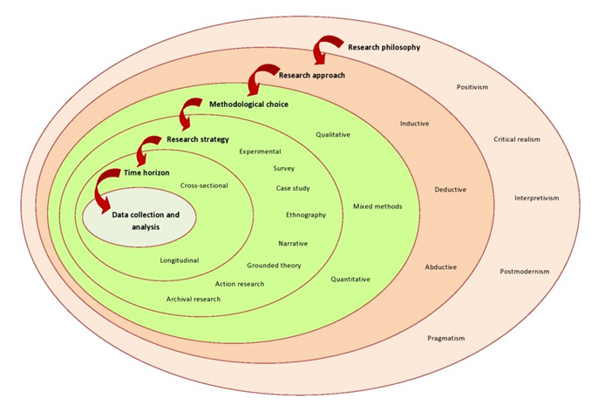
The survey will be compiled with multiple questions with an aim to successfully collect data and evidence from them. some of the questions included will be, age, sex, what their role in the force is, whether they are a student officer, whether they have suffered mental health, what mental health have they had, what help they have sought, what caused the mental health and whether they feel comfortable disclosing mental ill health. These questions will hopefully build a clearer picture into mental health within Gwent Police and what’s being done to support the staff of Gwent Police.

3.2 Risks and limitations.
With the survey being focussed on mental ill health it comes with the risk that only people suffering from mental ill health will participate in the survey risking a limited and more unreliable result. It is said that an online survey is one of the easiest methods to gain more responses it can also cause unreliable answers due to confusion or the lack of clarity of a question done via an online platform (Communications for research, 2023).

4 Analysis of results.

4.1 Introduction
Chapter three will be analysing the results of the survey explained in previous chapters, with its main purpose being to explore what mental health police officers are suffering with, how common mental health is within the force, and the help available to such Police Officers using data analysis. Data analysis is a structured process used to look through any information collected during research and establish any obvious patterns in relation to the subject being studied. To collect data a platform called survey monkey has been used to collect the data and help analyse the information captured.

4.2 What is Survey Monkey?
According to Software Advice (2023) Survey Monkey is a cloud-based tool that assists users to create, send and analyse surveys by sending them via email or other social media platforms which can result in an increased response rate. Survey monkey is a 4-star reviewed platform online (TrustRadius, 2023). This method appeared to be the most appropriate to gather evidence due to its ease of use and accessible to anybody even with time constrictions.

4.3 Officers that completed the survey.
During this survey 17 serving Police Officers have completed the survey answering 9 questions regarding their service, age, and mental health. One of the first questions asked was if they had suffered from mental ill health with 47.06% answering yes and 52.94% answering no. Out of these 17 respondents, there was a variety of ages, length of service, and student officer’s vs nonstudent officers. 100% of respondents were serving police officers, 70.59% had 0-3 years of service, 11.76% had 3-10 years of service and 17.65% had 10-plus years of service. Also asked was whether the participants were part of the PEQF program, had completed the PEQF program and whether it wasn’t required when they joined. 70.59% were currently studying the PEQF program, 5.88% had already completed it and 23.53% joined before the program was required.

4.4 Mental health identified in the participants.
During the survey, the participants were asked multiple questions regarding their mental health first being have they ever struggled with their mental health, have they ever had a clinical diagnosis of any mental health conditions, if diagnosed with mental health conditions or PTSD was the diagnosis before or after joining Gwent Police and what impacted on their mental health. 23.53% answered that they had been clinically diagnosed with a mental health condition and 79.47 had not been clinically diagnosed with mental health conditions of those that had been diagnosed half of them were diagnosed after becoming a police officer and half before becoming a police officer.

4.5 What impacted the participant’s mental health?
As mentioned in the literature review a lot of people assume the cause of mental health issues in police officers would be exposure to traumatic incidents so to gain more clarity on the causes several questions were asked to participants regarding the cause and triggers of their mental health conditions. The first question asked was what impacted their mental health with four options to choose from a traumatic incident in work, workload, other work issues, and personal issues not relating to work. A surprising 40% answering Workload. Other participants answered the following, 20% believed their mental health to be a result of a traumatic incident at work, 20% said personal issues, and the final 20% answered other issues. The findings are clear that the main cause of mental health issues in the Gwent Police force currently are the high workloads Response police officers have faced in recent years.

4.6 Help and support utilized by Police officers and their ability to talk to others about their mental health.
During the survey participants were asked about the help they obtained to support them with their mental health with four options for them to choose from. Medication, counselling, hospital treatment, and a TRIM assessment via work. 28.57% answered that they relied on medication to help with their mental health condition, 42.86% answered counselling, 28.57% had utilized a TRIM assessment in work and 0% had received hospital treatment. One of the last questions asked was whether they would feel comfortable talking about their mental health and to whom they would feel comfortable and a shocking 46.46% answered nobody (Strongmind, 2022).

5 Findings and Conclusion.
The beginning of this dissertation began with an introduction and literature review setting out the objectives that was to be achieved for what the project was about. This has been demonstrated by evidencing a good understanding of the topic and the intensive research conducted to help reach the objectives which demonstrate and evidence that I have reached the goals and objectives set out in the literature review. The research methodology evidenced the knowledge of what research is and the methods that can be used to guide and structure the research and analyse the results. This explains how the research will be conducted and why this method was used along with the negatives and positives of the use of the platform survey monkey.

5.1 Objectives achieved and recommendations.

This research project was centred around the issue of mental health in police officers of Gwent police and the help and support available to them centred around 4 objectives,
- Evaluate the issue of mental health in police officers in Gwent Police and across the UK.
This objective was to investigate the issue of mental health within Gwent police and forces across the UK. The research evidenced in three different surveys from the police federation, MIND and Texas Police force have fully evaluated the extent of officers suffering from mental health with the police federation showing their survey alone 6,630 officers out of the 17,000 that participated in this survey were suffering with mental health conditions.
- Identify the triggers that have triggered mental health within Police Officers.
This objectives aim was to identify the triggers associated with the officers suffering from mental health conditions and during the research results from a survey conducted by the charity MIND has evidenced the following, 57% stated organisational upheaval, 52% have said excessive workload, 47% said pressure from management and 33% said exposure to one or more traumatic events caused their mental health illness. Alongside this survey data was also collected via a survey created for this project. This survey evidenced the following, 40% said workload had triggered their mental health, 20% had said a traumatic event had triggered them, 20% said that personal issues triggered their mental health and 20% said other reasons were the trigger.
- Identify what help and support are available to police officers.
This objective was to explore what help was available to officers suffering from mental health, literature, and policy from the Gwent Police force shows that there is multiple options available from TRIM, access to counselling and mental health nurses at hand through occupational health but despite these methods of help and support being available mental health is still prevalent with in Police forces.
- Explore the issue of stigma relating to Police Officers suffering from mental ill health.
This objective was aimed to explore the issue of stigma around mental health in police forces and results from a survey conducted my MIND and the survey conducted for the purpose of this project evidence that stigma is an issue resulting in 46.46% stating they would not confide in anybody in the force about their mental ill health.
Throughout this research project each of the four objectives have been researched and evidenced via previous literature, surveys and a study created for this project. All research was guided by the research methodology which was created by utilising the 6 layers of the Saunders research onion model. The findings as results of the research conducted have shown that out of 17 participants, 47.06% had suffered from a mental health condition or PTSD and 52.94% said that they had not suffered from Mental health issues. Of the officers that answered yes to having suffered from some form of mental health issues. Out of the 23.53% of them, half had said that the diagnosis had come after joining the police force and the other half stated that the mental health issues began before. The reasons behind the mental health of said officers mainly came down to the high workloads and exposure to traumatic events with 40% choosing workload and 20% stating they had been exposed to a traumatic event. The most concerning objective achieved from this research was the number of officers that would not be willing to speak about their mental health which would enviably prevent them from seeking the help they may need which was 46.46% of all participants. This a number that identifiably needs to be improved on massively and a priority for the force to ensure the welfare of their officers. A massive improvement in partnership working would undeniably improve the numbers of the statistics above. Collectively understanding mental health better and hopefully minimizing the taboo around mental health. A recommendation would be improving the well-being Gwent Police offer their staff and officers and training surrounding what fellow colleagues can do to recognize a struggling co-worker and what they can do to help.

6 Bibliography.

Blue Light Together. 2022. Trauma Risk Management (TRIM) in the police. [online] Available at: https://bluelighttogether.org.uk/police/trauma-risk-management-trim-in-the-police/ (Accessed: November 2, 2022).

Communications For Research. 2023. [Online] Available at: https://www.cfrinc.net/cfrblog/online-surveys-advantages-disadvantages#:~:text=Online%20Survey%20Disadvantages,host%20of%20other%20potential%20issues.&amp;text=Repeated%20requests%20to%20complete%20the,therefore%20backfire%20against%20a%20business. (Accessed: January 01, 2023).

Committees Parliament. 2022. [online] Available at: https://committees.parliament.uk/work/6403/designing-a-public-services-workforce-fit-for-future/ (Accessed: January 02, 2023).

Jama Network. 2022. Prevalence of mental illness and mental health care use among police officer. [online] Available at: https://pubmed.ncbi.nlm.nih.gov/33026452/ (Accessed: November 1, 2022).

Kent Police. 2022. [online] Available at: https://www.kent.police.uk/foi-ai/kent-police/Policy/human-resources/trauma-risk-incident-management-trim-protocol-l11260/ (Accessed: November 2, 2022).

Mind. 2022. [online] Available at: https://www.mind.org.uk/media-a/4857/scoping-survey.pdf (Accessed: November 2, 2022).

Oscar Kilo .2022. [online] Available at: https://www.oscarkilo.org.uk/services/psychological-and-trauma-risk-management/psychological-surveillance (Accessed: November 2, 2022).

Oscar Kilo. 2023. The National Police Wellbeing Service. [online] Available at: https://www.oscarkilo.org.uk/ (Accessed: January 03, 2023).

ProProfs. 2022. Advantages & disadvantages of online surveys. [online] Available at: https://www.proprofssurvey.com/blog/advantages-disadvantages-of-online-surveys/ (Accessed November, 2022).

QuestionPro. 2023. Secondary research: Definition, methods and examples. [online] Available at: https://www.questionpro.com/blog/secondary-research/ (Accessed: January 01, 2023).

Saunders et al. 2019. [online] Available at: https://www.researchgate.net/figure/Research-onion-Saunders-et-al-2019-p-108_fig1_349083776 (Accessed: January 02, 2023).

SurveyMonkey. 2023. SurveyMonkey Software Reviews. [online] Available at: https://www.softwareadvice.com/customer-experience/surveymonkey-profile/ (Accessed: January 16, 2023).

Strongmind. 2022. TRIM. [online] Available at: https://strongmindresilience.co.uk/courses/trim/ (Accessed: January 16,

Trustradius. 2023. Software reviews, software comparisons and more. [online] Available at: https://www.trustradius.com/ (Accessed: January 02, 2023).

7 Appendix one.

7.1 Questionnaire.
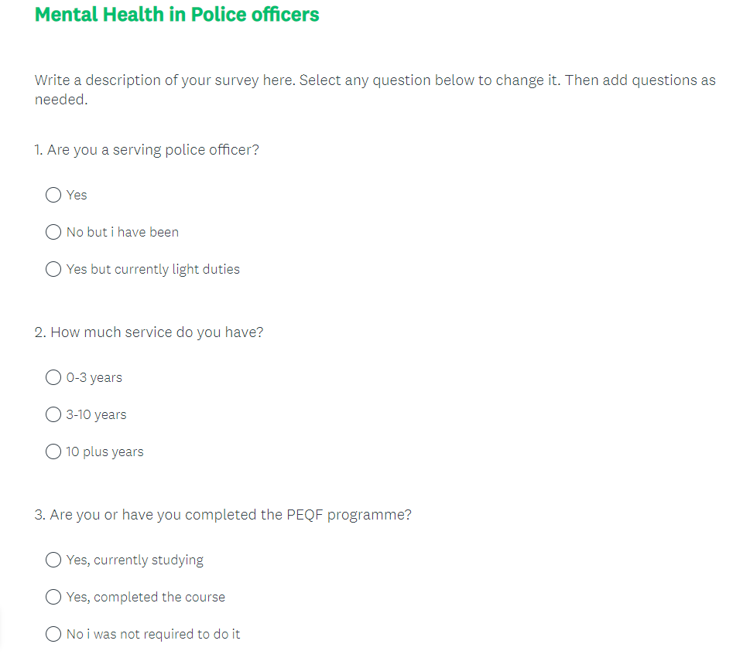

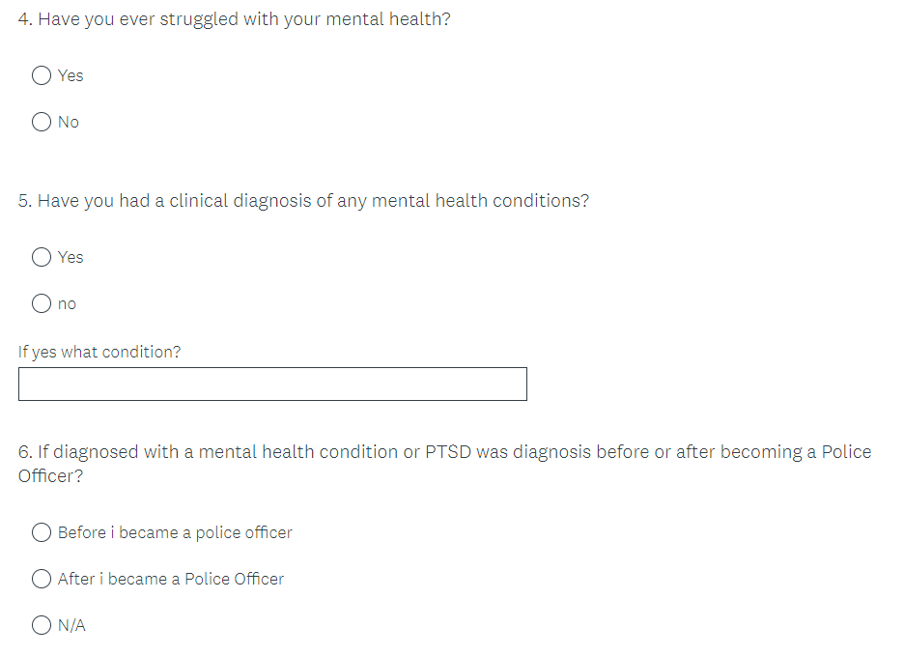
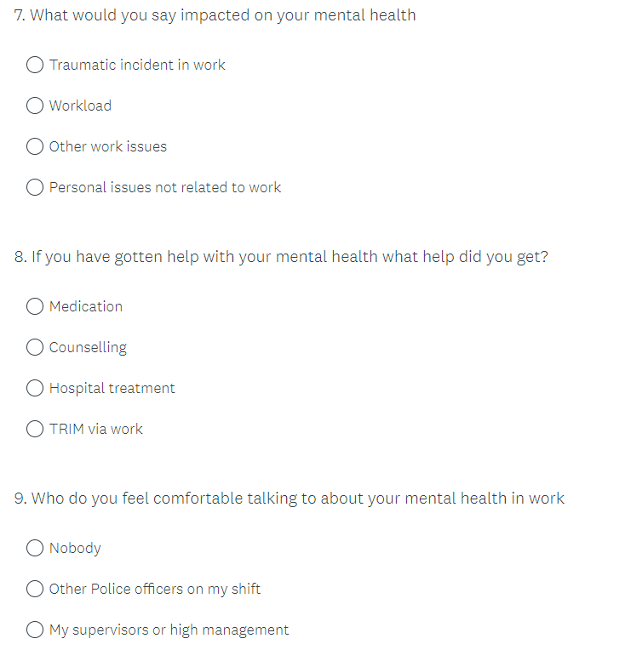

7.2 Appendix two – Questionnaire results.

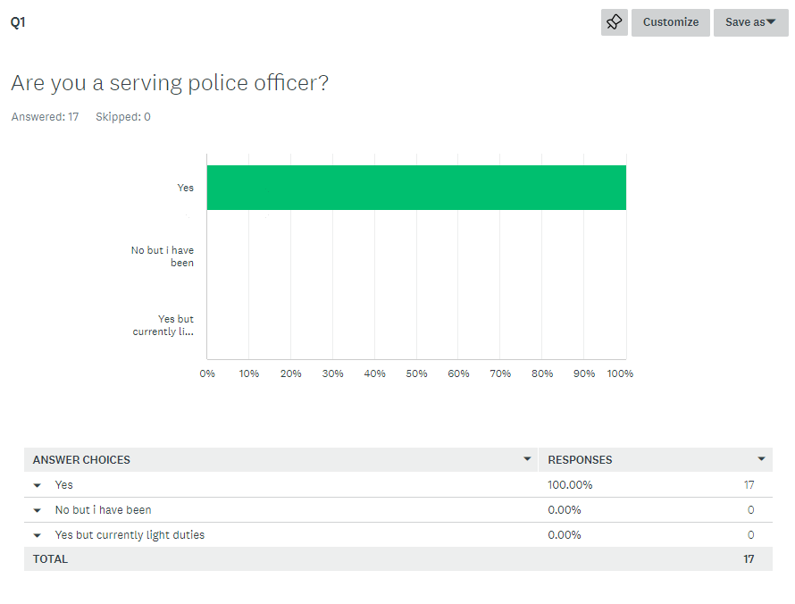

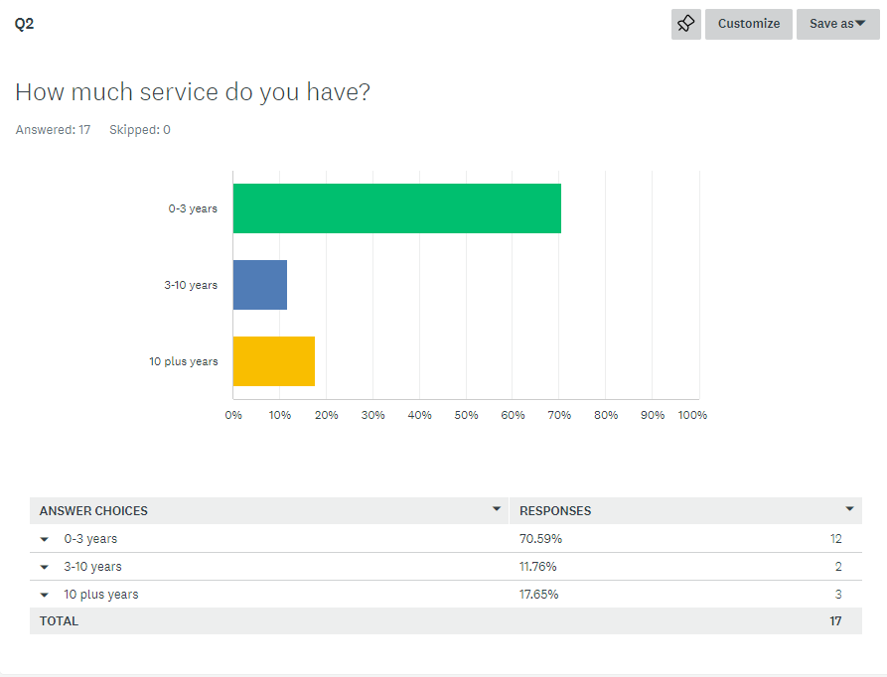

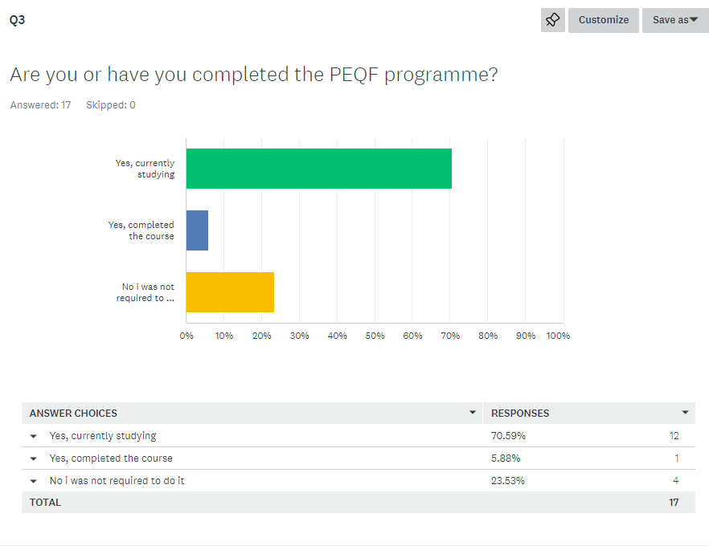

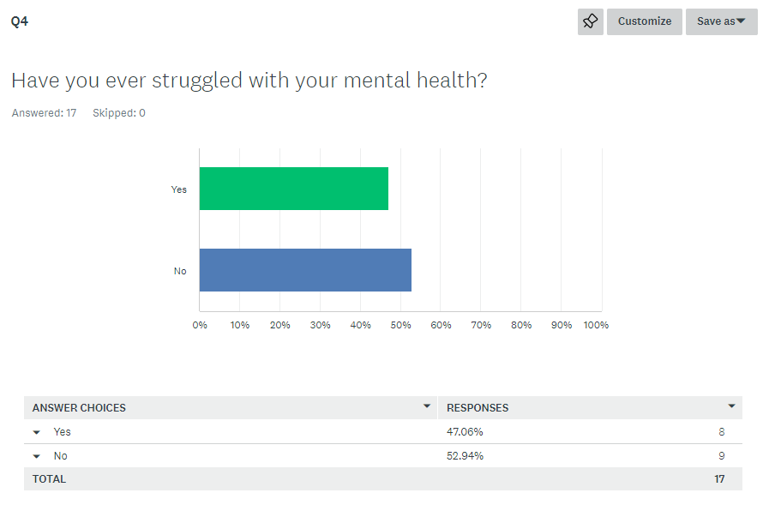

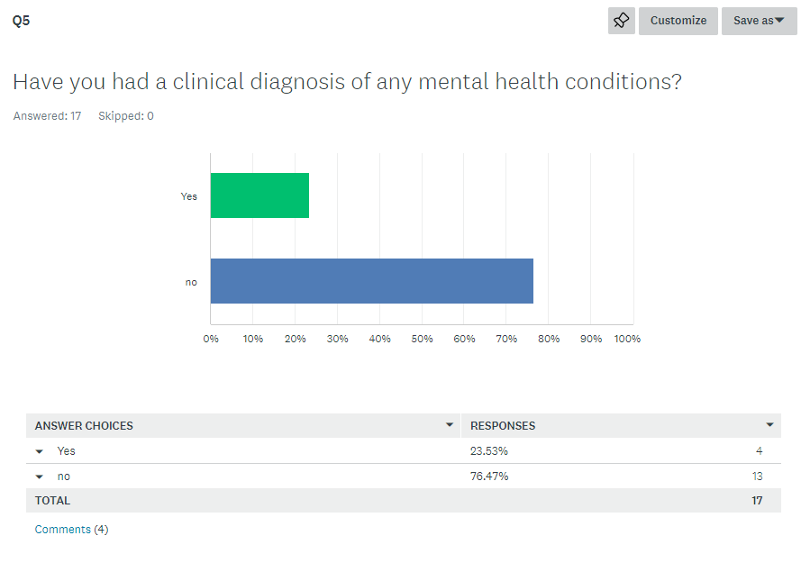

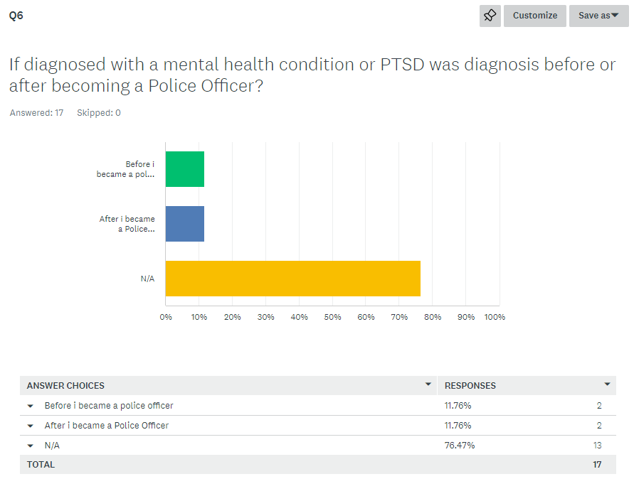

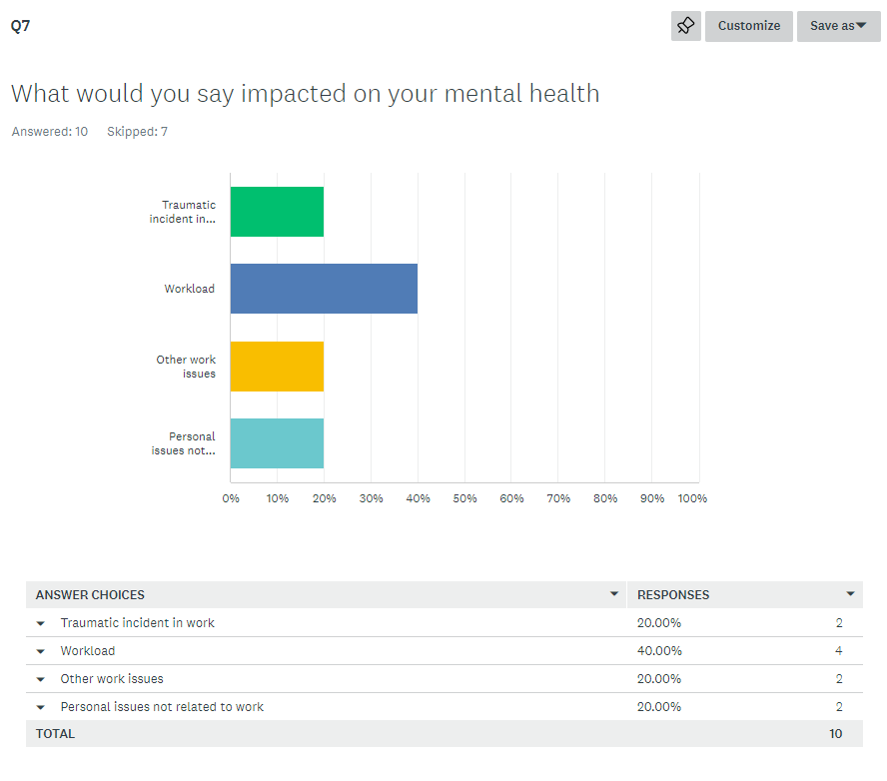
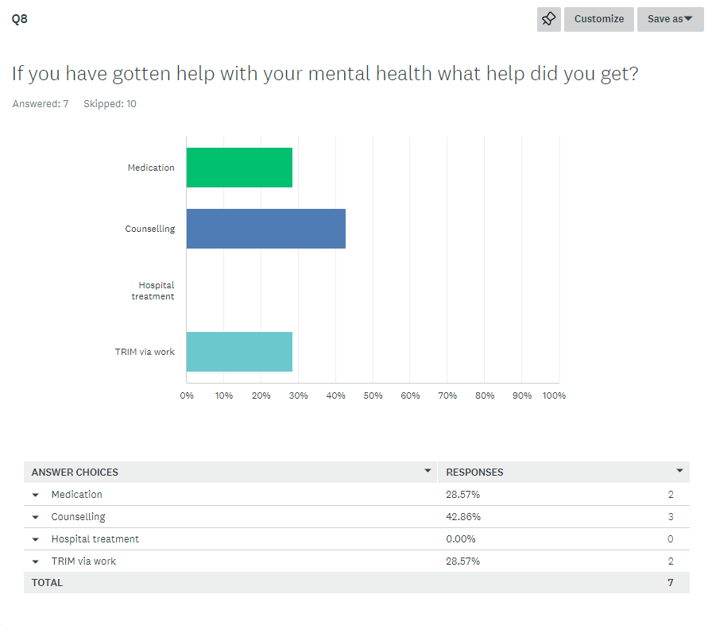

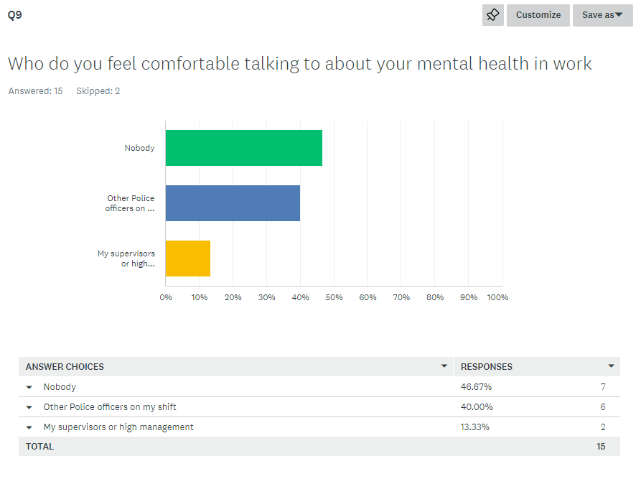

7.3 Ethics Form.

APPLICATION FOR ETHICAL APPROVAL
In order for research to result in benefit and minimise risk of harm, it must be conducted ethically. A researcher may not be covered by the University’s insurance if ethical approval has not been obtained prior to commencement.
The University follows the OECD Frascati manual definition of research activity: “creative work undertaken on a systematic basis in order to increase the stock of knowledge, including knowledge of man, culture and society, and the use of this stock of knowledge to devise new applications”. As such this covers activities undertaken by members of staff, postgraduate research students, and both taught postgraduate and undergraduate students working on dissertations/projects.
The individual undertaking the research activity is known as the “principal researcher”.
Ethical approval is not required for routine audits, performance reviews, quality assurance studies, testing within normal educational requirements, and literary or artistic criticism.
Please read the notes for guidance before completing ALL sections of the form.

This form must be completed and approved prior to undertaking any research activity. Please see Checklist for details of process for different categories of application.

Delete the Guidance Notes at the end of the form BEFORE submitting your application

SECTION A: About You (Principal Researcher)
Hannah Frankcombe
Tick all boxes which apply:

Member of staff:
☐
Honorary research fellow:
☐
Undergraduate Student
☒
Taught Postgraduate Student
☐
Postgraduate Research Student
☐

Institute/Academic Discipline/Centre:
UWTSD

Campus:
SWANSEA

E-mail address:
1921212@STUDENT.UWTSD.AC.UK

Contact Telephone Number:
07725974985

For students:
Student Number:
1921212
Programme of Study:
Professional Police Practice
Director of Studies/Supervisor:
Deepak

SECTION B: Approval for Research Activity
Has the research activity received approval in principle?
(please check the Guidance Notes as to the appropriate approval process for different levels of research by different categories of individual)
YES
☐
NO
☒
Date
If Yes, please indicate source of approval (and date where known): Approval in principle must be obtained from the relevant source prior to seeking ethical approval
Research Degrees Committee
☐
Institute Research Committee
☐

Other (write in)

SECTION C: Internal and External Ethical Guidance Materials
Please list the core ethical guidance documents that have been referred to during the completion of this form (including any discipline-specific codes of research ethics, and also any specific ethical guidance relating to the proposed methodology). Please tick to confirm that your research proposal adheres to these codes and guidelines.
UWTSD Research Ethics & Integrity Code of Practice

☒

UWTSD Research Data Management Policy
☒

☐

SECTION D: External Collaborative Research Activity
Does the research activity involve collaborators outside of the University?
YES
☐
NO
☒

If Yes, please provide the name of the external organisation and name and contact details for the main contact person and confirmation this person has consented to their personal data being shared.as part of this collaboration.
Institution

Contact person name
Contact person e-mail address
Has this individual consented to sharing their details on this form?
YES
☐
NO
☐
Are you in receipt of a KESS scholarship?
YES
☐
NO
☐
Is your research externally funded
YES
☐
NO
☐
Are you specifically employed to undertake this research in either a paid or voluntary capacity?
Voluntary
YES
☐
NO
☐
Employed
YES
☐
NO
☐
Is the research being undertaken within an existing UWTSD Athrofa Professional Learning Partnership (APLP)
If YES then the permission question below does not need to be answered.
YES
☐
NO
☐
Permission to undertake the research has been provided by the partner organisation
(If YES attach copy)
If NO the application cannot continue
YES
☐
NO
☐

Where research activity is carried out in collaboration with an external organisation
Does this organisation have its own ethics approval system?
YES
☐
NO
☐

If Yes, please attach a copy of any final approval (or interim approval) from the organisation

SECTION E: Details of Research Activity
Indicative title:
Mental health conditions and PTSD in police officers of Gwent Police Force.
Proposed start date:
23/03/2022
Proposed end date:
16/01/2023
Introduction to the Research (maximum 300 words)
Ensure that you write for a Non-Specialist Audience when outlining your response to the three points below:
Purpose of Research Activity
Proposed Research Question
Aims of Research Activity
Objectives of Research Activity
Demonstrate, briefly, how Existing Research has informed the proposed activity and explain
What the research activity will add to the body of knowledge
How it addresses an area of importance.
Purpose of Research Activity
The purpose of this research is to study and identify the problem of Mental health with in Gwent Police and what is in place to help.
(this box should expand as you type)
Research Question
Mental health and PTSD in Police officers in Gwent Police.
(this box should expand as you type)
Aims of Research Activity

To explore if front line officers of Gwent Police have suffered mental health issues as a result of their policing role.
To explore what the mental health related issue the front-line police officer within Gwent Police suffered with.
To explore the method of support the front-line police officer of Gwent Police sought for their mental health issue and identify if they use the support that Gwent Police have available.
(this box should expand as you type)
Objectives of Research Activity
To explore if front line officers of Gwent Police have suffered mental health issues.
To explore what the mental health related issue the front-line police officer within Gwent Police have experienced.
What help police officers have sought for there mental health and who provided it.
To explore the side effects of the mental health related issue the front-line police officer of Gwent Police suffered with.
To explore the method of support the front-line police officer of Gwent Police sought for their mental health issue and identify if they use the support that Gwent Police have available.

(this box should expand as you type)
Proposed methods (maximum 600 words)
Provide a brief summary of all the methods that may be used in the research activity, making it clear what specific techniques may be used. If methods other than those listed in this section are deemed appropriate later, additional ethical approval for those methods will be needed.
To gather the best and most accurate information I plan on conducting a survey across Gwent police in regards to peoples mental health. This will be anonymous.
(this box should expand as you type)

Location of research activity
Identify all locations where the research activity will take place.
Gwent
(this box should expand as you type)
Research activity outside of the UK
If research activity will take place overseas, you are responsible for ensuring that local ethical considerations are complied with and that the relevant permissions are sought. Specify any local guidelines (e.g. from local professional associations/learned societies/universities) that exist and whether these involve any ethical stipulations beyond those usual in the UK (provide details of any licenses or permissions required). Also specify whether there are any specific ethical issues raised by the local context in which the research activity is taking place, for example, particular cultural and/or legal sensitivities or vulnerabilities of participants.

N/A
(this box should expand as you type)

Use of documentation not in the public domain: Are any documents NOT publicly available?
NO
☒
YES
☐
If Yes, please provide details here of how you will gain access to specific documentation that is not in the public domain and that this is in accordance with prevailing data protection law of the country in question and England and Wales.
(this box should expand as you type)

SECTION F: Scope of Research Activity
Will the research activity include:

YES

NO
Use of a questionnaire or similar research instrument?
☒
☐
Use of interviews?
☐
☒
Use of diaries?
☐
☒
Participant observation with their knowledge?
☐
☒
Participant observation without their knowledge?
☐
☒
Use of video or audio recording?
☐
☒
Access to personal or confidential information without the participants’ specific consent?
☐
☒
Administration of any questions, test stimuli, presentation that may be experienced as physically, mentally or emotionally harmful / offensive?
☐
☒
Performance of any acts which may cause embarrassment or affect self-esteem?
☐
☒
Investigation of participants involved in illegal activities?
☐
☒
Use of procedures that involve deception?
☐
☒
Administration of any substance, agent or placebo?
☐
☒
Working with live vertebrate animals?
☐
☒
Other primary data collection methods, please explain in this box
For example, ‘focus groups’. Please indicate the type of data collection method(s) in this box and tick the accompany box.
☐
☒
Details of any other primary data collection method:

(this box should expand as you type)
If NO to every question, then the research activity is (ethically) low risk and may be exempt from some of the following sections (please refer to Guidance Notes).
If YES to any question, then no research activity should be undertaken until full ethical approval has been obtained.

SECTION G: Intended Participants
Who are the intended participants:

YES

NO
Students or staff at the University?
☐
☒
Adults (over the age of 18 and competent to give consent)?
☒
☐
Vulnerable adults?
☐
☒
Children and Young People under the age of 18? (Consent from Parent, Carer or Guardian will be required)
☐
☒
Prisoners?
☐
☒
Young offenders?
☐
☒
Those who could be considered to have a particularly dependent relationship with the investigator or a gatekeeper?
☐
☒
People engaged in illegal activities?
☐
☒
Others (please identify specifically any group who may be unable to give consent) please indicate here and tick the appropriate box.

☐
☒
Other – please indicate here:

(this box should expand as you type)

Participant numbers and source
Provide an estimate of the expected number of participants. How will you identify participants and how will they be recruited?
How many participants are expected?

30 to 40

(this box should expand as you type)
Who will the participants be?
Gwent Police officers
(this box should expand as you type)
How will you identify the participants?
Email sent via our Gwent police email address.

(this box should expand as you type)
Information for participants:

YES
NO

N/A
Will you describe the main research procedures to participants in advance, so that they are informed about what to expect?
☒
☐
☐
Will you tell participants that their participation is voluntary?
☒
☐
☐
Will you obtain written consent for participation?
☒
☐
☐
Will you explain to participants that refusal to participate in the research will not affect their treatment or education (if relevant)?
☐
☐
☒
If the research is observational, will you ask participants for their consent to being observed?
☐
☐
☒
Will you tell participants that they may withdraw from the research at any time and for any reason?
☒
☐
☐
With questionnaires, will you give participants the option of omitting questions they do not want to answer?
☒
☐
☐
Will you tell participants that their data will be treated with full confidentiality and that, if published, it will not be identifiable as theirs?
☒
☐
☐
Will you debrief participants at the end of their participation, in a way appropriate to the type of research undertaken?
☒
☐
☐
If NO to any of above questions, please give an explanation

(this box should expand as you type)

Information for participants:

YES
NO

N/A
Will participants be paid?
☐
☒
☐
Is specialist electrical or other equipment to be used with participants?
☐
☒
☐
Are there any financial or other interests to the investigator or University arising from this study?
☐
☒
☐
Will the research activity involve deliberately misleading participants in any way, or the partial or full concealment of the specific study aims?
☐
☒
☐
If YES to any question, please provide full details

(this box should expand as you type)

SECTION H: Anticipated Risks
Outline any anticipated risks that may adversely affect any of the participants, the researchers and/or the University, and the steps that will be taken to address them.

If you have completed a full risk assessment (for example as required by a laboratory, or external research collaborator) you may append that to this form.
Full risk assessment completed and appended?

Yes
☐
No
☒
Risks to participants
For example: emotional distress, financial disclosure, physical harm, transfer of personal data, sensitive organisational information
Risk to Participant:

Possible emotional distress.

(this box should expand as you type)
How will you mitigate the Risk to Participant
Whilst sending out the survey I will be clear that this is voluntary and nobody is obliged to participate and if they do not feel comfortable answering certain questions they can leave them out.
(this box should expand as you type)
If research activity may include sensitive, embarrassing or upsetting topics (e.g. sexual activity, drug use) or issues likely to disclose information requiring further action (e.g. criminal activity), give details of the procedures to deal with these issues, including any support/advice (e.g. helpline numbers) to be offered to participants. Note that where applicable, consent procedures should make it clear that if something potentially or actually illegal is discovered in the course of a project, it may need to be disclosed to the proper authorities

N/A

(this box should expand as you type)
Risks to investigator
For example: personal safety, physical harm, emotional distress, risk of accusation of harm/impropriety, conflict of interest
Risk to Investigator:
None
(this box should expand as you type)
How will you mitigate the Risk to Investigator:

(this box should expand as you type)
University/institutional risks
For example: adverse publicity, financial loss, data protection
Risk to University:

None

(this box should expand as you type)
How will you mitigate the Risk to University:

(this box should expand as you type)

Disclosure and Barring Service
If the research activity involves children or vulnerable adults, a Disclosure and Barring Service (DBS) certificate must be obtained before any contact with such participants.
YES

NO

N/A

Does your research require you to hold a current DBS Certificate?
☐
☐
☒

SECTION I: Feedback, Consent and Confidentiality
Feedback
What de-briefing and feedback will be provided to participants, how will this be done and when?

Not required.

(this box should expand as you type)
Informed consent
Describe the arrangements to inform potential participants, before providing consent, of what is involved in participating. Describe the arrangements for participants to provide full consent before data collection begins. If gaining consent in this way is inappropriate, explain how consent will be obtained and recorded in accordance with prevailing data protection legislation.

Participants are not obliged to take part in the survey if they don’t want to. They can skip any question they do not want to answer, the survey is anonymous.

(this box should expand as you type)
Confidentiality / Anonymity
Set out how anonymity of participants and confidentiality will be ensured in any outputs. If anonymity is not being offered, explain why this is the case.

No personal data will be obtained from participant. This survey is strictly anonymous.

(this box should expand as you type)

SECTION J: Data Protection and Storage
In completing this section refer to the University’s Research Data Management Policy and the extensive resources on the University’s Research Data Management web pages (http://uwtsd.ac.uk/library/research-data-management/).
Does the research activity involve personal data (as defined by the General Data Protection Regulation 2016 “GDPR” and the Data Protection Act 2018 “DPA”)?
YES
NO
“Personal data” means any information relating to an identified or identifiable natural person (‘data subject’). An identifiable natural person is one who can be identified, directly or indirectly, in particular by reference to an identifier such as a name, an identification number, location data, an online identifier or to one or more factors specific to the physical, physiological, genetic, mental, economic, cultural or social identity of that natural person.
☐
X
If YES, provide a description of the data and explain why this data needs to be collected:

(this box should expand as you type)
Does it involve special category data (as defined by the GDPR)?
YES
NO
“Special category data” means sensitive personal data consisting of information as to the data subjects’ –
(a) racial or ethnic origin,
(b) political opinions,
(c ) religious beliefs or other beliefs of a similar nature,
(d) membership of a trade union (within the meaning of the Trade Union and Labour Relations (Consolidation) Act 1992),
(e) physical or mental health or condition,
(f) sexual life,
(g) genetics,
(h) biometric data (as used for ID purposes),

☐

X
If YES, provide a description of the special category data and explain why this data needs to be collected:

(this box should expand as you type)

Will the research activity involve storing personal data and/or special category data on one of the following:
YES
NO
Manual files (i.e. in paper form)?
☐
☒
University computers?
☐
☒
Private company computers?
☐
☒
Home or other personal computers?
☐
☒
Laptop computers/ CDs/ Portable disk-drives/ memory sticks?
☐
☒
“Cloud” storage or websites?
☐
☒
Other – specify:

☐
☒
For all stored data, explain the measures in place to ensure the security of the data collected, data confidentiality, including details of password protection, encryption, anonymisation and pseudonymisation:

(this box should expand as you type)
All Data Storage
Will the research activity involve any of the following activities:
YES
NO
Electronic transfer of data in any form?
☐
☒
Sharing of data with others at the University?
☐
☒
Sharing of data with other organisations?
☐
☒
Export of data outside the European Union or importing of data from outside the UK?
☐
☒
Use of personal addresses, postcodes, faxes, emails or telephone numbers?
☐
☒
Publication of data that might allow identification of individuals?
☐
☒
Use of data management system?
☐
☒
Data archiving?
☐
☒
If YES to any question, please provide full details, explaining how this will be conducted in accordance with the GDPR and DPA (and/or any international equivalent):

N/A

(this box should expand as you type)
List all who will have access to the data generated by the research activity:
N/A

(this box should expand as you type)
List who will have control of, and act as custodian(s) for, data generated by the research activity:
Me, (H.Frankcombe).

(this box should expand as you type)
Give details of data storage arrangements, including security measures in place to protect the data, where data will be stored, how long for, and in what form. Will data be archived – if so how and if not why not.

Data obtained is anonymous and will only be viewed by myself and presented to UWTSD

(this box should expand as you type)
Please indicate if your data will be stored in the UWTSD Research Data Repository (see https://researchdata.uwtsd.ac.uk/ ). If so please explain. (Most relevant to academic staff)

(this box should expand as you type)
Confirm that you have read the UWTSD guidance on data management (see https://www.uwtsd.ac.uk/library/research-data-management/)

YES
☒
NO
☐
Confirm that you are aware that you need to keep all data until after your research has completed or the end of your funding
YES
☒
NO
☐

SECTION K: Declaration
The information which I have provided is correct and complete to the best of my knowledge. I have attempted to identify any risks and issues related to the research activity and acknowledge my obligations and the rights of the participants.

In submitting this application I hereby confirm that I undertake to ensure that the above named research activity will meet the University’s Research Ethics and Integrity Code of Practice which is published on the website: https://www.uwtsd.ac.uk/research/research-ethics/
Signature of applicant:
H.franckombe
Date:
23/05/2022

For STUDENT Submissions:
Director of Studies/Supervisor:
Deepak

Date: 23/05/2023
Signature: H.Frankcombe

For STAFF Submissions:
Academic Director/ Assistant Dean:

Date:
Signature: H.Frankcombe
Checklist: Please complete the checklist below to ensure that you have completed the form according to the guidelines and attached any required documentation:
☒
I have read the guidance notes supplied before completing the form.
☒
I have completed ALL RELEVANT sections of the form in full.
☐
I confirm that the research activity has received approval in principle
☐
I have attached a copy of final/interim approval from external organisation (where appropriate)
☐
I have attached a full risk assessment (and have NOT completed Section H of this form) (where appropriate) ONLY TICK IF YOU HAVE ATTACHED A FULL RISK ASSESSMENT
☒
I understand that it is my responsibility to ensure that the above named research activity will meet the University’s Research Ethics and Integrity Code of Practice.
☒
I understand that before commencing data collection all documents aimed at respondents (including information sheets, consent forms, questionnaires, interview schedules etc.) must be confirmed by the DoS/Supervisor, module tutor or Academic Director.
☒
I have deleted the guidance notes before submitting the PG2 for consideration

7.4 Research proposal.

Mental health conditions and PTSD in police officers of Gwent Police Force.
Introduction – Research Background.
Recent research has shown that one in five Police Officers and police staff within the UK have or have had symptoms of PTSD, also known as Post traumatic stress disorder, but over two thirds of them were unaware that they were suffering from it.
The University of Cambridge received funding by Police Care UK to allow a team of sociologists to complete a survey force wide that would concentrate on police wellbeing and giving the option for screening of mental health disorders. During the research 16,857 police officers and police staff participated in “The Job, The Life” survey which was carried out across England, Wales, Scotland and Northern Ireland (University of Cambridge, 2022).
The research showed that 90% of police workers had experienced trauma and of these one in five had said to have had either PTSD or Complex PTSD experiencing sleep disturbance, irregular heartbeats, sweats and difficulty regulating their emotions and two thirds of candidates that completed the survey confirmed that they had suffered from mental health problems that had been caused from police work (University of Cambridge, 2022).
Research states that during the study undertaken in 2014 PTSD rates in police officers and police staff were almost five times higher than the levels of the general population in the UK which was estimated to be 4.4% (University of Cambridge, 2022).
Even though above research reflects a very high number of police officer and staff suffering from mental health issues refer to accessing help as the “postcode lottery” and only 16% had been given support via their police force whilst the majority had to seek help themselves (University of Cambridge, 2022).

Research rationale.
When looking into the issue on mental health its clear from information gathered above that mental health within police officers and police staff is at an all-time high. The research conducted so far is nationwide and my research will look closer at the mental health with Gwent Police. What mental health conditions officers have or are suffering with, when they developed the symptoms and how easy it has been accessing help and support via the force, what’s working well, what could be improved and is it sustainable long term?

Research mythology.
To gain the best and most relevant information for my study I believe quantitative research best to gather and evaluate information I need.
Quantitative research is defined as “a systematic investigation of phenomena by gathering quantifiable data and performing statistical, mathematical, or computational techniques” (QuestionPro, 2022). Quantitative research collects information from people willing to engage in the study, using methods such as online surveys, online pols and questionnaires. The results can then be depicted into numerical form to create and different understanding and set up of collected information and data (QuestionPro, 2022).
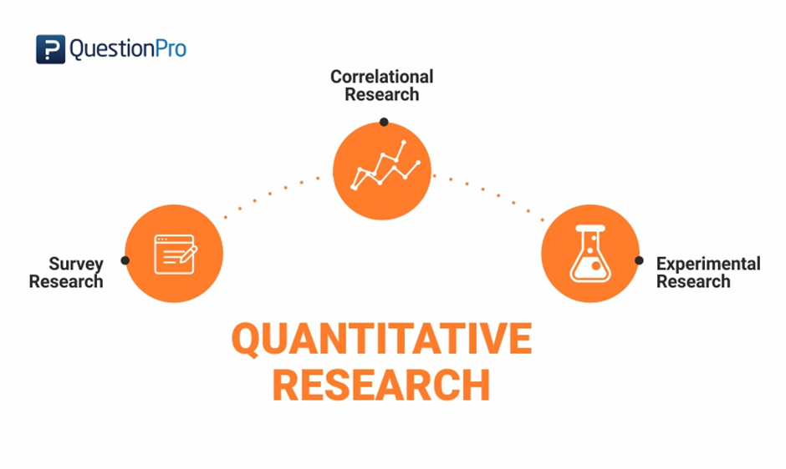
(QuestionPro, 2022).
The method best used to collect the data for this piece of work is going to be a survey sent out to officers across Gwent police force. This will allow myself to gather data in a larger quantity which can them be examined closely and combined into numerical data. Due to the volume of information, I am looking to gather quotative research is best suited to my research.

