

Changemakers BMHP5015: Wafa Nasir
Student: Davina Sawyers
Student number: 2407363
Task 1 – Personal Brand 2
Personal Branding 2
Task 2 - Network Map and Rationale 3
My Network Map 3
Rationale 4
Task 3- Blog 5
Prostate cancer and black men 5
Awareness 5
Future Screening 5
Task 4- NHS Equality, Diversity and Inclusion Quiz 6
Task 5- A Letter to Yourself 8
Task 6- GANTT Chart 9
Task 7- Making Changes- Report 9
Using Lewin’s Change Management Model to Improve 9
The plant-based food plan in a residential home. 9
Barriers 10
Conclusion 10
Reference List 10

Task 1 – Personal Brand

Personal Branding
Personal branding is how I express my unique skills, value, and capabilities. I need to show that I have the skills and edge to move into my chosen profession and how best to stand out from the crowd (Gorbatov, Khapova and Lysova, 2018).
As a foster carer, I bring soft skills to the table: things you can't teach, but an innate need to nurture and protect. I can provide a caring, safe, loving environment for children that I have never met from families I have never known. I can treat them as my own, providing a family environment. I believe becoming a CWP aligns with my need to care for and protect young children who cannot do this for themselves.
I am adaptable, organised, willing to learn, and do whatever training is necessary to fulfil my role (NHS 2020). I have been on the other side of this type of care and been a service user. I think I could add value to this job as I understand how it feels to use this service and what I think it needs to improve it. I need to gain some hands-on experience for this role to be successful at it. I also need to reframe my way of working with others daily, as fostering, for the most part, is a solo job.
In conclusion, developing my personal brand would give me more opportunities to find the career I want and be the perfect person that employers are looking for to fulfil this role.

Task 2 - Network Map and Rationale

My Network Map

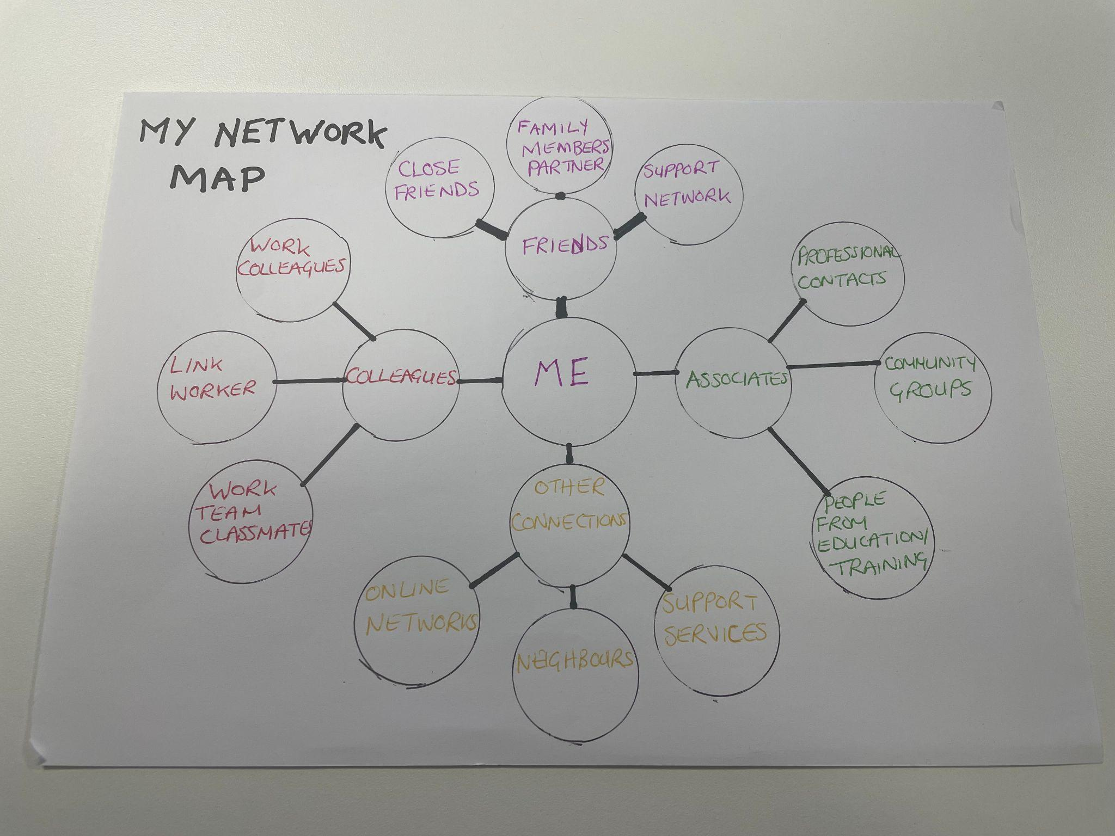

Rationale
My network map shows that I currently have a hybrid network, as I have a mixture of close friends, colleagues, and associates. My friends provide personal and emotional support, while my colleagues provide support connected to work, learning, and professional development. My associates are people I'm connected to but may not have a close relationship with. Having different types of relationships is useful because it gives me access to different types of advice, support, and opportunities.
One weakness in my current network is that I could develop more Professional connections outside of the people I already know. Although I have colleagues, my professional network could be wider and include people who have experience in areas that I would like to develop. I could also build stronger connections with people working in health and social care and other professionals who could provide knowledge, advice, and new opportunities.
To improve my network, I need to be more confident in meeting new people and maintaining professional relationships. I could attend workshops, training sessions, networking events, and community activities to meet people from different backgrounds. Building these connections could increase my knowledge and confidence, expand my opportunities for future career development, and make my network more balanced.
Having a wider network is important because professional relationships can provide access to knowledge, information, and opportunities for development (Tasselli, 2014). Networking can also increase access to useful information and resources, which can support future employability (Batistic and Tymon, 2017).

Task 3- Blog

Prostate cancer and black men
There is a real issue with prostate cancer in the male population that seems to go unnoticed more than other types of cancer in other genders. It is more prominent in white men in the UK but is twice as high in the black male population, especially those over 60. Some barriers prevent black men specifically from seeking help. One of these is that the lack of trust between the black population and Western medicine makes it difficult for black men to volunteer for the PSA tests available. The element of racism and not enough practitioners in this field who are culturally aware of the stigma and difficulties black men face is off-putting (Ettehad et al .,2025).

Awareness
Also, men can have this cancer and not be aware, as it doesn’t always present with symptoms. Black men, though, are twice as likely to have prostate cancer and are not necessarily going to be more advanced with it than other races. In a study of 730,000 men in primary care in the UK, black men and mixed-ethnicity men had higher PSA levels, especially in men over 60. Using age-specific thresholds, Black men had the highest cancer incidence at 24.7%, while asian men had the lowest at 13.4%, and white men sat in between at 19.8%. Black and white men had a similar incidence of prostate cancer in the later stages, from 70 to 79.

Future Screening
The screening tests for prostate cancer have been quite controversial, with the argument being that testing causes more harm than good and whether it lessens the mortality rates. Also, is it cost-effective to target screening by ethnicity, age, genetics, or family history. According to the NSC (UK National Screening Committee), screening of black men will show more cancer diagnoses screened than it would by screening the male population as a whole. Many screening strategies were explored, but there is a lack of actual data, making it difficult to know for sure whether screening in black men would be helpful or a hindrance and cause unnecessary pain and suffering by overdiagnosing and overtreating. A new UK-based trial is being researched right now called Transform, and it's looking at faster diagnosis and cost-effective ways to screen men for prostate cancer. More importantly, it has been tailored to eradicate inequalities in the research of prostate cancer. It aims to include at least 1 black man in every 10 men to get a better understanding of prostate cancer in this sector of men.

Task 4- NHS Equality, Diversity and Inclusion Quiz
- What is the primary goal of the NHS Equality, Diversity, and Inclusion Improvement Plan?
The primary goal is to help the 13 million NHS workers to feel included and have a sense of belonging. The plan aims to address prejudice and discrimination, directly or indirectly.

- How does the NHS EDI Improvement Plan propose to tackle the gender pay gap?
(Answer in one to two sentences.)They plan to implement the “ Mend the Gap review (2020). They will analyse the data to understand the pay gap and track and monitor it within NHS boards. Also, to implement effective flexible working policies.

- What is meant by the term ‘intersectionality’ as used in the NHS EDI Improvement Plan?
No one person is only one protected characteristic, so organisations should consider intersectionality when implementing these interventions. The nine characteristics are age, disability, race, religion, sex, pregnancy and maternity, sexual orientation, gender reassignment, and marriage and civil partnership.

- Why is it important for the NHS to create a psychologically safe work environment?
Psychologically safe work environments, where people feel like they are being treated with dignity and respect, achieve more effective and safer patient care.

- How does the NHS EDI Improvement Plan suggest improving the experience of internationally recruited staff?
Securing a welcoming support package and a warm welcome from the very inception will make them feel valued and retain this staff group.

- What role does leadership play in advancing EDI objectives according to the NHS Improvement Plan?
Effective system leadership oversees NHS delivery of the EDI Improvement Plan, ensuring progress on high-impact actions and long-term plan priorities.

- Identify one way the NHS EDI Improvement Plan aims to reduce health inequalities within the workforce.
One way for EDI to address this is to educate and train staff. Reducing bullying, harassment, and abuse would lessen common illnesses.

- Why does the NHS EDI Improvement Plan emphasise the importance of collecting and analysing data on protected characteristic
This is important to help organisations compare their performance to other regions and those providing similar services. To provide a national picture of WREs in practice to colleagues, organisations, and the public on the developments in the workforce equality agenda.

- Explain how flexible working policies can contribute to equality and inclusion in the NHS workforce.
Flexible working hours can contribute to the NHS workforce by supporting work-life balance, health and wellbeing, and continued professional development. This can be used as part of local attraction and recruitment, with a special focus on flexible retirement for staff in later stages of their career.

- What is one strategy mentioned in the NHS EDI Improvement Plan to combat bullying and harassment in the workplace?
One of the strategies is to provide comprehensive psychological support for all individuals who report that they have been a victim of bullying, harassment, discrimination, or violence.

Task 5- A Letter to Yourself

Dear Davina
You may have faced many challenges and difficult decisions at an age when you weren't emotionally intelligent enough to carry such heavy burdens. Being pregnant as a young teen in an era where this was highly frowned upon, and judgements were being made against you and your family, was very confronting and made you into the provider, protector, and the strong woman you were to become. Your story started with many obstacles you had to overcome, but this gave you the tools to be able to go through tough times and build your character and life skills, so you were then able to help and support others and never sit in judgment and criticise those who are also facing such adversities. You fought for yourself, your children, and your family's honour and were so grateful for the care, love and support that was shown then and continues to show now. This helped shape you into the woman you have become, an advocate for those who are unable to speak or stand up for themselves. A sense of injustice infuriates you and makes you passionate to defend, as you did all those years ago. Working in the health care system has definitely allowed you to show your strengths as well as your weaknesses, and they have been very lucky to have you with all the life experience you bring to the role of a Foster carer. Using your childcare experience in your job role was more than a job but more of a vocation, and you continue to show up for everybody in your orbit, providing advice, whether that is physical, mental, or emotional; even when you have nothing to give, you always find that strength and resilience to keep going. You've done a great job; be proud of yourself

Love Davina

Task 6- GANTT Chart
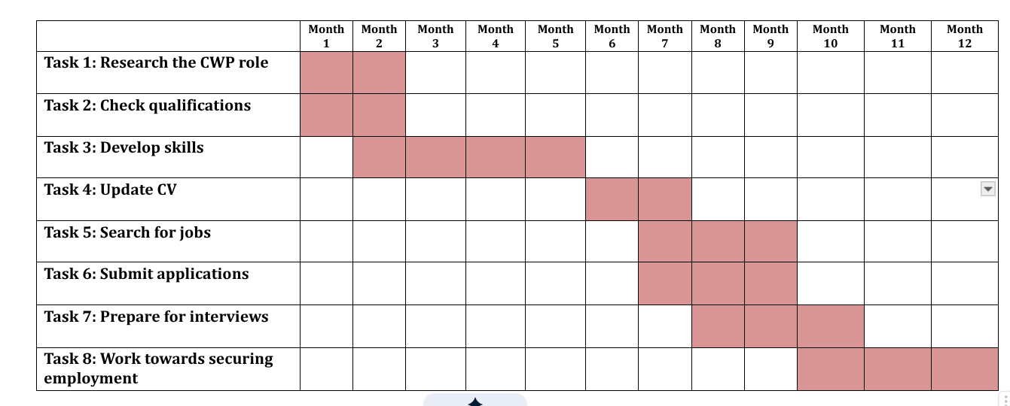

Task 7- Making Changes- Report

Using Lewin’s Change Management Model to Improve

The plant-based food plan in a residential home.
I am currently a manager in a care home, but the residents are much younger. Using Lewin’s framework Unfreeze, Change, and Refreeze I am going to address the changes needed (Prosci, 2024). Food is going to be a big part of the change. The home is more multicultural, so food choices need to be more varied. Specifically, a plant-based diet. Approximately 270,00 elderly residents are currently following a plant-based diet, so this has to be an option in our home (Whyton et al., 2026).
Providing a plant-based diet to our residents offers a more open and diverse placement for them. Firstly, educating the cook and staff on adding to the menu and the positive health effects this diet provides. It gives them their dignity by having the choice they need. Often believed to be the most important part of a resident's day, the social aspect of eating is just as important, so providing the right meals is crucial (Whyton et al., 2026).
Using effective management skills, I am going to communicate to my staff that I need them on board for the benefit of the residents (Staff, 2018). I would need a professional nutritionist to come in and educate the cook and staff and have the residents made aware that this is now an option even if they weren't having a plant-based diet prior. Also, it would be explained that it would be introduced within a time period so that everyone has time to prepare for the change.

Barriers
There could be barriers to this type of change. The biggest one is the financial cost. Plant-based ingredients are more expensive than regular processed food. Then there's the cost of the nutritionist and staff wages if they have to come in out of work hours. The residents may not want any changes to the menu, as they are stuck in their ways. The way this can be resolved is to charge slightly more for residents in order to provide this service. Offer staff this kind of meal option and include them in menu planning.

Conclusion
Although an expensive change, it is also very beneficial to the residents' wellbeing and health and allows them the dignity of choice. The healthier the resident, the fewer issues staff face.

Reference List
Batistic, S. and Tymon, A. (2017) “Networking behaviour, graduate employability: a social capital perspective,” Education + Training, 59(4), pp. 374–388. Available at: https://doi.org/10.1108/et-06-2016-0100.
Care Quality Commission (2024) Regulations for service providers and managers, Cqc.org.uk. Available at: https://www.cqc.org.uk/guidance-regulation/providers/regulations-service-providers-and-managers/health-social-care-act/regulation-9 (Accessed: October 19, 2026).

Down, L. et al. (2024) “Association between patient ethnicity and prostate cancer diagnosis following a prostate-specific antigen test: a cohort study of 730,000 men in primary care in the UK,” BMC medicine, 22(1), p. 82. Available at: https://doi.org/10.1186/s12916-024-03283-5. (Accessed October 7th, 2026)
Ettehad, D. et al. (2025) “Barriers and facilitators to prostate cancer healthcare in Black men in the UK: from diagnosis to survivorship,” Journal of Cancer Survivorship [Preprint]. Available at: https://doi.org/10.1007/s11764-025-01956-5. (Accessed October 7th,2026)
Gorbatov, S., Khapova, S.N. and Lysova, E.I. (2018) “Personal Branding: Interdisciplinary Systematic Review and Research Agenda,” Frontiers inPsychology, 9(9), pp. 1–17. Available at: https://doi.org/10.3389/fpsyg.2018.02238. (Accessed September 14th, 2026)
NHS (2020) Children’s wellbeing practitioner, Health Careers. Available at: https://www.healthcareers.nhs.uk/explore-roles/psychological-therapies/roles-psychological-therapies/childrens-wellbeing-practitioner (Accessed: September 14, 2026). (Accessed September 14^{th, 2026)}
Prosci (2024) What Is Lewin’s Change Theory? Explanation, Pros and Cons, Prosci.com. Available at: https://www.prosci.com/blog/lewins-change-theory (Accessed: October 19, 2026).
Recommendations - UK National Screening Committee (UK NSC) - GOV.UK (no date) view-health-screening-recommendations.service.gov.uk. Available at: https://view-health-screening-recommendations.service.gov.uk (Accessed: October 8, 2026)
Staff, L. (2018) The golden rules of effective management, www.lsbf.org.uk. Available at: https://www.lsbf.org.uk/blog/opinion-features/the-golden-rules-of-effective-management (Accessed: October 23, 2026).

Tasselli S. Social networks of professionals in health care organizations: a review. Med Care Res Rev. 2014 Dec;71(6):619-60. doi: 10.1177/1077558714557079. Epub 2014 Nov 6. PMID: 25380607.
Whyton, S. et al. (2026) “Plant-based diets for older adults in care homes: A realist synthesis,” BMC Geriatrics, 26(1). Available at: https://doi.org/10.1186/s12877-025-06927-0. (Accessed October 23rd, 2026)

