The differences of female deaths in the year of 2020 and 2021 by age group 85 – 89 over the week
between 1 and 5 in the year 2020 is 205 and in the year 2021 is 27. In any of the death certificate the difference of death in between 10 to 15 weeks of year 2020 is 6213. Difference of death by region in the year 2021 between the week 16 and 20 is 11196 and in the year 2020 is 7780.

In the year 2020 the total death in week 1 was 12254 whereas in week 6 the total death was 10986. Whereas in the year 2021 the total death figure of week 1 was 17751 and in the week 6 the figure was 15354. The total number of death records decreased in both the financial years. 2020 years varied the figure with 1268 and in the year 2021 the variance was 2397.

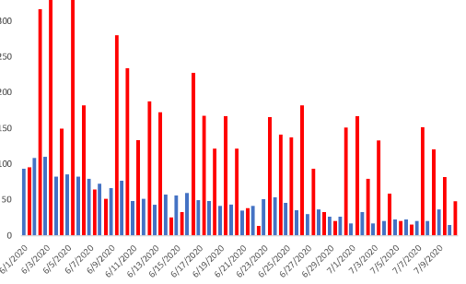
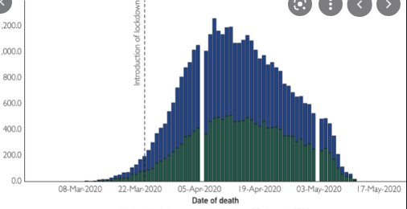
The total death of 90+ in the week 7 and 12 is 4809 (2517 + 2302) and in the year 2021 was 3247 (1894 + 1353). The difference 1562 is reported. The differences of male’s deaths in the year of 2020 and 2021 by age group 75-79 over the week between 10 and 15 is in the 2021 was 5 and in the year 2020 was 854.

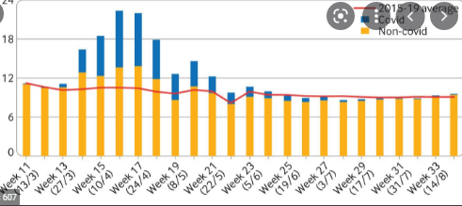
In the year 2020 the average death in week 15 was 10520. The week 20 average death figure is unavailable so this has assumed that the death figure of week 20 is 9000 so the difference is 1520. The difference between the death due to the respiratory disease in between week 11 and 16 is 286 (1794 – 1508).
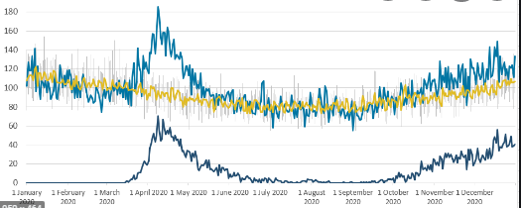
And Visualisation of Data

