University Of Wales Trinity Saint David’s
School of Engineering


Material Selection Report
Engineering Design and Materials ACHA4001

James Evans
2104143
21/03/2022

Contents
1 Introduction 2
2 Material Properties 3
2.1 Property Needs 3
2.2 Cast Iron 3
2.2.1 Cast iron properties 3
2.3 Aluminium alloys 4
2.3.1 Aluminium Alloy Properties 4
2.3.2 Aluminium alloys eutectic vs hypereutectic 4
3 Material Selection 5
3.1 Cast Iron vs Aluminium Alloys 5
4 Manufacturing processes 6
4.1 Casting process 6
4.2 Forging process 6
4.2.1 Advantages of forged 8
4.3 Piston Crown Dish design 9
5 Conclusion 10
6 Reference List 11

Figure 1. Tech Q&A: Cast vs Forged Pistons and all about Pushrod Design (McGann 2018) 8
Figure 2. Supertech Dished Pistons for Ford & Mazda 2.0L 2.3L(Derek 2020) 9

Introduction

The design requirements of a piston must be met through a mixture of good material choice and design method, a piston intended for use in regular automobiles is unlikely to prioritise performance as highly as cost and so will use cheaper more abundant materials. A piston intended for motorsport use will generally prioritise performance and will usually cost more, at the highest levels of competition restrictions and regulations play a larger part in design choices specifically material selection.

The design requirements of a piston are as follows:
The piston must provide a strong enough moveable boundary between the combustion chamber and inside of crankcase and therefore harness the maximum amount of energy/work from combustion gasses.
The movability of a piston must allow for gas transfer as well as compression.
Piston must be able to transfer force generated by combustion to a piston rod or the small end of a connecting rod
A piston must guide the movement of the small end of the connecting rod in engines where they are directly attached. (Neale Consulting Engineers 2016)

"The rings on the piston are required to: Seal the clearance space between the piston and cylinder which is needed to allow for the access of lubricant, and for any differential thermal expansion of the piston. This sealing function has two aspects:
The control of the leakage of compression and combustion gases to prevent loss of working pressure, the blowing away of the piston lubricating film and possible overheating of the piston.
In the case of pistons which are splash lubricated from the low-pressure side, the control of the loss of lubricating oil via the cylinder bores into the combustion chamber.
Provide a path for the transfer to the cooled cylinder liner, of some of the heat which enters the piston from the combustion gases."(Neale Consulting Engineers 2016)

When designing a piston and its rings its working conditions must be taken into account. These conditions in an internal combustion engine may involve: Cylinder pressures up to 140 bar (2000 psi), Mean piston speeds up to 20 m/sec (4000 ft/min), Cylinder liner temperatures up to 180⁰C, Equivalent steady heat flows into the piston up to 400 kW/m² (Neale Consulting Engineers 2016)

Material Properties

Property Needs
Pistons experience high mechanical and thermal forces due to: The extreme pressure cycles (which can peak at 200bar in the combustion chamber of a normal automobile engine) and the huge forces of inertia caused by extreme acceleration of the piston oscillating in opposing directions. (European Aluminium Association, 2011, p. 02)

Because of this the material used in piston design needs to possess certain properties; To withstand and combat inertia forces a piston must have minimum weight and enormous strength. Strength is also required to withstand peak gas pressures. The piston material should allow for good and quick dissipation of heat from the crown to the rings and bearing area then to the cylinder walls. The selected material must have good wearing qualities for the piston to maintain sufficient surface-hardness at operating temperatures. The piston should have a rigid construction to withstand thermal and or mechanical distortion. It must also have sufficient area to prevent unnecessary wear. Even expansion under thermal loads is needed and so material should contain minimum discontinuities. (Singh et al. 2014, p. 01)

The most used materials for pistons are cast iron and aluminium alloys

Cast Iron
Cast iron is made by reducing iron ore in a blast furnace and pouring it into rough ingots called pigs, the pigs are then remelted along with scraps and alloying elements in cupola furnaces. Included in the alloying ingredients are carbon and silicone with contents of 2% - 4% and 1% - 3% respectively. (Sabhadiya, n.d.)

Cast iron properties
cast iron is brittle. It has a relatively low melting point, good fluidity, castability, excellent machinability, deformation resistance, and wear resistance (Sabhadiya, n.d.)

Aluminium alloys
Both main aluminium alloys used in pistons are Siluminami. Siluminami are a group of aluminium alloys with a relatively high silicone content, used for piston design are eutectic Silumin (also referred to simply as Silumin) and wear resistant hypereutectic Silumin (aluminium-guide n.d.)

Aluminium Alloy Properties
Aluminium alloys possess extremely desirable characteristics from a performance standpoint, these include: "low density, high thermal conductivity, simple net-shape
fabrication techniques (casting and forging), easy machinability, high reliability and very good
recycling characteristics"(European Aluminium Association, 2011, p. 02)

Aluminium alloys eutectic vs hypereutectic
In industry, suppliers of aluminium pistons use a wide range of alloy compositions to tweak the alloys material properties, however they are generally based on these three basic types:
The standard eutectic Aluminium based 12% Silicone alloy which also contains approximately 1% each of Cu, Ni and Mg. Hypereutectic alloys with 18 and 24% Silicone experience lower thermal expansion and wear but do not have as much strength. (European Aluminium Association, 2011, p. 05)

Material Selection

Cast Iron vs Aluminium Alloys
Advantages of aluminium alloy
1)Aluminium uses less fuel to create more power because of its increased compression ratio and better heat dissipation.
2)It is less dense meaning a greater surface area can be achieved with the same weight.
3)The engine will heat faster
4)better cooling while the engine is running
Disadvantages of aluminium alloy
1)because of higher thermal expansion a larger clearance is required between piston and cylinder walls
2)it is more expensive
3)Aluminium is much more susceptible to corrosion and cast parts will be weaker than iron

Manufacturing processes

Casting process
The casting process begins with creating a mold of the exact reverse shape of the intended part. The mold is made from a stimuli resistant material, such as sand. (Chhabra and Singh 2012) The metal is heated in a blast furnace until it melts. The liquid Iron is poured into rough molds in which it cools into crude ingots called pigs. The pigs are then remelted and mixed with scrap and alloying elements in a cupola furnace, after this process the iron is ready to be cast in a mold into the desired shape (Sabhadiya n.d.) from here light machining follows before the piston is finished.

Forging process
Omega is a piston crafting company that makes some of the best pistons in the world with a forging process that has been honed and optimised with experience, they released a three-part video series on YouTube (MED Race Technologies 2019a, b, c). The following method was shown.

Process begins with 2618A aluminium bars, Billets of an appropriate raw mass are sheered from the bars. Imperfections are removed from each billet using a lathe. The billet is then placed in an oven until reaching a low temperature, relative to standard piston forging methods.
Once the billet has reached the correct temperature Apply heat to lower die, apply lubricant to gravity forge die. steel billet is placed in lower die and activate the forge die. Billets are Blasted to check for imperfections and excess material is machined off. The Billets then undergo heat treatment where they are heated to near melting point and then quenched. (MED Race Technologies 2019a)

CNC lathe is used to machine sides, top and then skirt of piston down to slightly larger than finished product, piston is then checked measured and Deburred. Using a lathe, panels in sides of the piston are bored. The hole height is confirmed using a vertical measuring instrument. The bore hole is then machined. The hole is made 0.02" smaller than needed so it can be honed out later in the process. Hole diameter is checked with a clock gauge. Piston is placed in CNC Milling machine and oil holes are drilled first for lubrication when cutting oil ring groves. run program which does the following: Piston crown machined flat to spec, outside diameter is machined down to tiny bit bigger than final size, Oil control ring groves are machined in, Second and top ring groves, outside diameter of crown profiled to final diameter. If piston needs offset dish an offset pad is attached to cnc lathe which makes the piston rotate concentrically.
The piston is removed, and ring groves are then inspected by hand using Go or no go slip gauges
(MED Race Technologies 2019b)

lube grooving (a small reservoir of oil to lubricate gudgeon pin) CNC milling machine is used to face bosses of the piston to give correct clearance from control rod, clearance depends on control rod size and weather it is a piston guided control rod. Circlip extraction recesses which are small engravings to allow circlip to be taken out are made on either side of bore hole. circlip groove to hold Floating piston is machined. lube grooves are then bored into the sides of the bore hole to act as a reservoir of oil that lubricates the gudgeon pin. elliptical turning removes excess material on skirts and the outer bottom edge where most expansion will occur giving them both a slightly elliptical shape this is to keep the tightness between piston and cylinder acceptable. (MED Race Technologies 2019c)

Advantages of forged
The main advantage of the forging process is the production of direction alignment, also known as grain flow. Correct grain flow eliminates almost all chance of structural defects or voids that are common in cast products. During the process of forging a metal its molecular structure is forced to directionally align giving the finished part much more uniform and therefore total strength. In the casting process, the alloy molecules are free to settle where they please, creating a random grain structure, and opening the potential for weak spots.
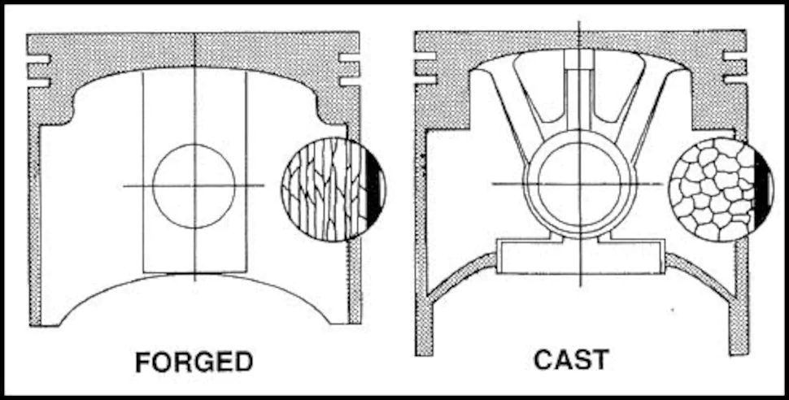
Figure 1. Tech Q&A: Cast vs Forged Pistons and all about Pushrod Design (McGann 2018)
As illustrated forging creates a superior microstructure.

Piston Crown Dish design
Most high-performance motorsport engines will have a forced induction system. This will mean a higher compression ratio which left unchecked in a forced induction engine risks tearing the engine apart. The best crown design for a piston used in forced induction systems, such as turbos and superchargers is therefore a dished crown. (Derek 2020)
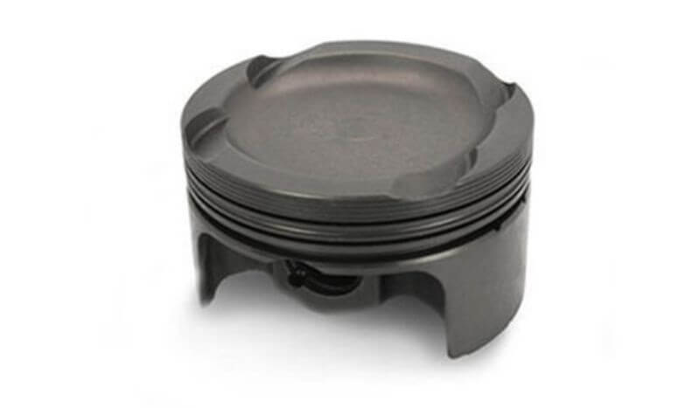
Figure 2. Supertech Dished Pistons for Ford & Mazda 2.0L 2.3L(Derek 2020)
A dished crown will prevent pre-detonation.

Conclusion
In conclusion while iron is cheaper to buy and produce and therefore better suited to a budget focused product, silumins allow for further property improvements through differing alloy compositions than iron. If paired with an optimal manufacturing process the potential level of performance far outshines that of iron. Most racing pistons are made from 2618 aluminium (Magda 2018).

Although a much larger amount of time and effort goes into the process, the clear choice of manufacturing method from a performance aspect is forging. This is due to the increased directional strength of the finished product (Cooksey 2017) Once upfront costs of machines have been covered the operating costs of a forging process can be low and many parts of the process can be streamlined by automation. Which means large scale manufacturing of metal forgings can help lower the cost per part.

Therefore, from a performance standpoint Forged Aluminium Alloy pistons designed with an elliptical top and side design and a dished crown are the best option.

Reference List
aluminium-guide n.d., Eutectic silumins: aluminum and 12 % silicon, viewed 6 March 2022, <https://aluminium-guide.com/en/evtekticheskij-silumin/>.

CHHABRA, M. and SINGH, R., 2012. 'Obtaining desired surface roughness of castings produced using ZCast direct metal casting process through Taguchi's experimental approach'. Rapid Prototyping Journal, vol 18, iss 6, pp. 458-471.

Cooksey, C 2017, Forged Versus Cast Pistons: What's the Difference?, JE Pistons, viewed 15 March 2022, <https://auto.jepistons.com/blog/forged-versus-cast-pistons-whats-the-difference#:~:text=When%20metal%20is%20forged%2C%20the,the%20potential%20for%20weak%20spots.>.

Derek, F 2020,DIFFERENT TYPES OF PISTONS EXPLAINED | TUNING 101, EManualOnline, viewed 19 March 2022, <https://www.emanualonline.com/blog/everything-you-need-to-know-about-pistons/>.

European Aluminium Association, 2011, Applications – Power train – Pistons, viewed 8 march 2022, <https://www.european-aluminium.eu/media/1570/aam-applications-power-train-1-pistons.pdf>.

Magda, M 2018, What Makes A Racing Piston?, Wiseco, viewed 6 March 2022, <http://blog.wiseco.com/-what-makes-a-racing-piston#:~:text=While%20a%20majority%20of%20racing,were%20tried%20before%20being%20banned.>.

McGann, J 2018, 'Tech Q&A: Cast vs, Forged Pistons and all about Pushrod Design',MotorTrend, viewed 15 March 2022, <https://www.motortrend.com/news/tech-qa-cast-vs-forged-pistons-pushrod-design/>.

MED Race Technologies, 2019a, How it's made - Omega forged pistons - Part 1, online video, YouTube, viewed 7 March 2022, <https://www.youtube.com/watch?v=Jr6qk5wCPEQ>.

MED Race Technologies, 2019a, How it's made - Omega forged pistons - Part 2, online video, YouTube, viewed 7 March 2022, <https://www.youtube.com/watch?v=Lsz9be_OdmM&t=0s >.

MED Race Technologies, 2019a, How it's made - Omega forged pistons - Part 3, online video, YouTube, viewed 7 March 2022, <https://www.youtube.com/watch?v=K2qQ6OL6vRU&t=0s>.

Neale Consulting Engineers 2016, Methods of Designing Piston and Ring Assemblies, viewed 6 March 2022, <https://tribology.co.uk/piston-rings/methods-of-designing-piston-and-ring-assemblies/>.

Sabhadiya, J n.d., What Is Cast Iron?- Definition, Properties, And Uses, Engineering Choice, viewed 9 March 2022, <https://www.engineeringchoice.com/cast-iron/>.

Singh, RC, Lal, R, Singari, RM, Chaudhary, R 2014, 'Failure of Piston in IC Engines: A Review', International Journal of Modern Engineering Research, vol. 04, iss. 09, p. 01, viewed 6 March 2022, <https://www.researchgate.net/publication/272575629_Failure_of_Piston_in_IC_Engines_A_Review>.

