Reflective report on SWOT Analysis

and Johari Window

professional carrier development 10/11/2023
Zaneta Zupkova (2314065) 1000 words

Executive Summary

In this report I will write about SWOT Analysis that was designed by Albert Humphrey and I will write about Johari’s Window that was produced by Harry Ingham and Joseph Luft. I will first give history of both designers I will go into more information and theories. Then I will go into details what do these models mean.

Contents

Executive Summary ____________________2
Introduction __________________________2
Main finding__________________________3
Conclusion___________________________7
Reference list__________________________8

Introduction

SWOT Analysis (strengths, weakness, opportunities, threats) has been created in 1960’s and early 1970 by Albert Humphrey it’s a business strategy tool that helps to analyse what your company does best now and what it can do better in the future. SWOT Analysis is “also known as Swot Matrix” (FN 2019) on the other hand Johari window was created in 1955 by Harry Inham and Joseph Luft. They both joined their last names together and came up with the name Johari. Johari Window is a 2 by 2 square boxes diagram that helps you to understand yourself and others relationship. “Johari Window was first devised as a tool to promote communication and strong teamwork” (Dr 2018). The Johari Window was initially planned strengthen self-knowledge and behavioural communication. It’s divided into four key parts that are open area, blind area, hidden are and unknown area this helps people to be more trusting when they work together.

Main findings
Swot Analysis:

Example below:
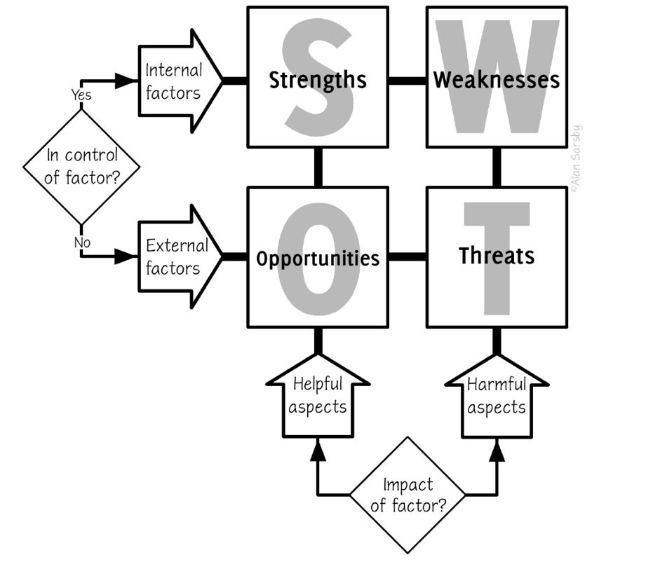
(AlanSarsby )

As you can see above in each box is strengths, weakness, opportunities and threats the top part of the boxes (strengths and weakness) these are “internal” factors (EMET) that means things that are within the control of the business. On the bottom of the boxes (opportunities and threats) these are the “external” (EMET) factors which means the that’s outside of control of the business.
This SWOT Analysis method has application components of a human performance technology method”. (Dr Dough) swot analysis has become a key tool for business (MMM)

SWOT Analysis is an easy diagram with no mathematics. In 1960s SWOT analysis was created for business purpose and for your own purpose so that you can use it however you want.

In the strengths box you can write what the business does well, what’s it good at. In the weakness part you can write things that need improvement, placing the company at a disadvantage. opportunities you can write favourable factors to improve current positioning and on the threats box you can write factors that are threats to your business that has the potential to hurt your business.
In (1965) SWOT Analysis use to be called SOFT approach but in (1967) it changed into SWOT Analysis. When using SWOT Analysis, you should avoid using long list try to keep it short.

In these boxes below you can see my SWOT:
Weakness

Strengths

- Confidence
- Timing
- Multitasking
- overthinker
- Emotional

- Quick learner
- Passion
- Flexibility
- Honesty
- Truthful

SWOT
ANALYSIS

- Education
- Business
- Friendship
- Network

- Not finishing what I started
- Mental health
- Illness-health
- Time management

Opportunities
Threats
I used myself as an example to show you what my Swot Analysis would look like if I had a business. As you can see, I used the layout 2 by 2 boxed diagram. You can do the SWOT Analysis diagram based by what works for you and what would work for your business. I used short words I have created this diagram so that you can have a better understanding in Swot Analysis.

When creating your own SWOT Analysis, it can help to position you to seize opportunities and prepare effective strategies and it can help you to make a better version of yourself.

Johari Window:

Example below:

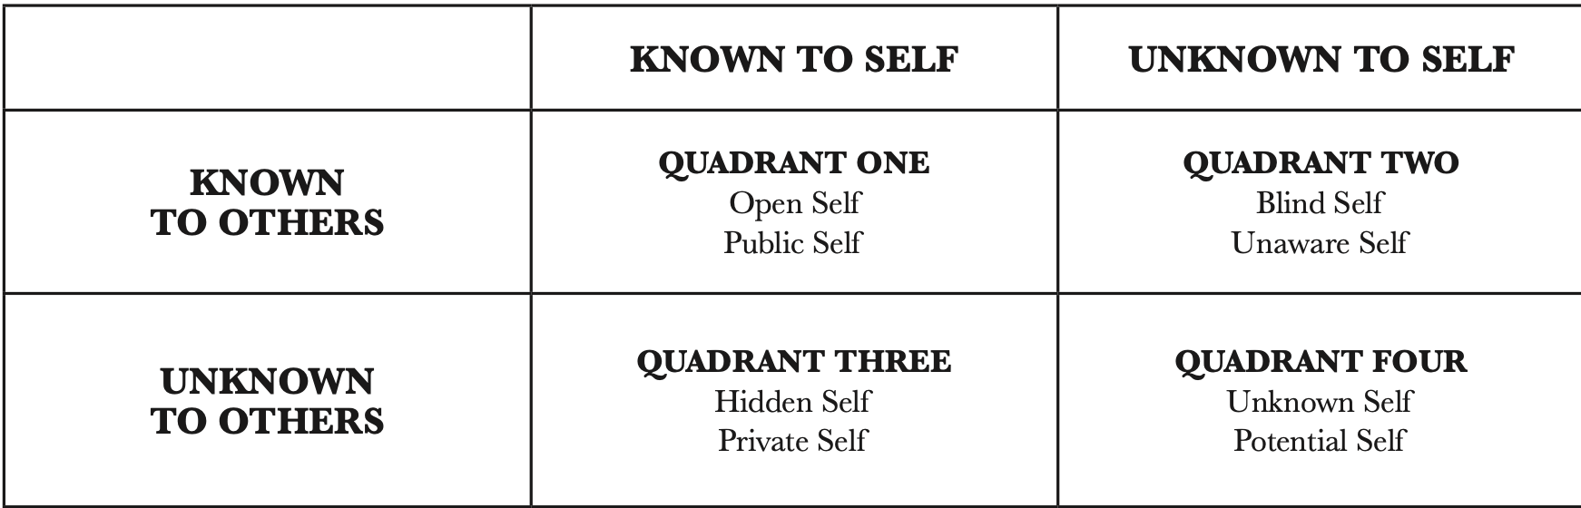

(IJCO Issue 2009)

In this example above the original author of this diagram (IJCO 2009) he has put it into four different quadrant which are:

- Quadrant one is an open area you can write anything you know about yourself and what you want to share with others.
- Quadrant two that’s a blind area what’s known about you, but you don’t know yourself.

- Quadrant three that’s a hidden area that’s what you know about yourself but keep it from others.

- Quadrant four that’s an unknown area which means things that you and others don’t know about yourself.

By building your own diagram when having a business or just wanting to try it out with your friends it can help with people knowing more about you for people to learn new things about you to teamwork with your co-workers or your friends and family this can help to improve communications with other.

Johari Window theory is a model that helps us understand our relationship and others.
The creators of Johari Window (Joseph Luft & Harry Ingham) they have created the model while conducting research regarding group dynamics at the university of California las angles (UCLA)
Johari Window is also referred to as a feedback model of self-awareness.
when the creators (Luft and Ingram) created Johari Window the following morning they presented their model and then went their own separate ways.

Johari window was created to help people better understand their relationship with them self and others. Johari window may also help to improve communications with yourself and others.
When using Johari window, you are more open to your co-worker or to people around you. This model is used by many organisations.

In this diagram below I will make an example of my own Johari window:

Known to others.
- modest
- Patient
- Trustworthy
- Clever
- caring

Unknown to yourself
Kind
- Fun
- Calm
- Organised
- Quite

Known to self

Open area
Blind area
unknow to others
- Energetic
- Proud
- Silly
- Mature

- Self confidence
- Shy
- Nerves
- Emotional

Unknown area
Hidden area

I have asked couple of my friends to describe me to that I can provide you with an example of a Johari window diagram that may help you.in this diagram I bullet pointed some key words that myself and my friends this about me. I tried to keep it short and try not me make a long list.

Conclusion

Learning about Swot Analysis and Johari window was challenging for me because when I started my course I didn’t know anything about any of these models but when I was learning about them I found it very intrusting and fun learning about the history of both of the creators of the models .I enjoyed making the diagrams for Swot Analysis because I’ve learned more about myself I found out what’s my strengths and weakness but also I found out what’s my threats which was very surprising for me because at the start of this course I didn’t know what my threats sound be I’ve learned that swot analysis helps to improve in your-self. When I was doing the Johari window diagram, I have learned more about myself and my friends I also found out that Johari window is a tool that helps people to communicate better and can help to improve your business.

Reference list

: Prasad, K. D. V.; Rao, Mruthyanjauja. (2021). Application of Johari Window to expand Open Arena with Team Building for enhancing psychological Well-being: A case stud. [Online]. ebsco host. Last Updated: 2021. Available at: https://web.s.ebscohost.com/abstract?direct=true&profile=ehost&scope=site&authtype=crawler&jrnl=1309 [Accessed 8 November 2023]

Alan sarsby. (2016). swot analysis. america: Lulu.com. p.75.
dr dough. (2009). swot anaylis. [Online]. wiley online libary. Last Updated: 2009. Available at: https://onlinelibrary.wiley.com/doi/abs/10.1002/9780470592663.ch24 [Accessed 6 November 2023].

dr. (2018). Johari Window: a Useful Communication Model and Psychological Tool for Improving Understanding Between Individuals. [Online]. jurnalint. Last Updated: 2018. Available at: https://www.neliti.com/publications/342398/johari-window-a-useful-communication-model-and-psychologi [Accessed 6 November 2023].

fn. (2019). swot análisis. [Online]. europ mpc. Last Updated: 7 feb 2019. Available at: https://europepmc.org/article/med/30725987#free-full-text [Accessed 6 November 2023].

gurl emet. (2017). swot analysis. [Online]. dspace. Last Updated: 2017. Available at: https://demo.dspacedirect.org/items/a94ef210-25e1-4399-b93e-54930f2ba37f [Accessed 8 November 2023].

mousa mohamed mousa. (2021). swot analysis. [Online]. journal of global business insights. Last Updated: 2021. Available at: https://digitalcommons.usf.edu/globe/vol6/iss1/5/ [Accessed 8 November 2023]

shreekumar. (2010). The Johari Window: a comparative study of public sector and private sector executives in India. [Online]. inder science. Last Updated: 2010. Available at: https://www.inderscienceonline.com/doi/abs/10.1504/IJICBM.2011.037423 [Accessed 8 November 2023]

