An investigation on SA1 3SS Swansea ice cream parlour

By Deri Jones

Written for Alan Nantel

Contents

- summary

- brief overview of the site

- archival information

- significant risks

- foundation type

6.0 reference list

1.0 Summary
In this assignment I will be giving a preliminary study ready for a full site investigation as a part of the feasibility stage of a project. I will be touching on archival information from surroundings, stating some of the significant and greatest risks of the site from the historic background. I will be looking at borehole samples from surrounding areas picking out defects in the ground. At the end of the assignment I will be giving my option on what I feel is the suitable foundation for the ice cream parlour given my preliminary observations.

2.0 An overview of the site
The plot of land is situated on the front of Swansea shore SA1 3SS. Close to the site is Tawe basin/south dockland. The dockland was used for typically fishing activities and to stock ships and between the years of 1919 and 1957 and was operated by ‘consolidated fisheries Ltd’(dock news site) in Tawe basin. The dockland was also used to export goods out of wales. The dockland is now used for housing and mainly boats from locals like I have shown in my photos. The dockland was also used to export copper and oil in the early 1900s.
Here is an aerial view of the site from (google maps). The proposed ice cream parlour is in the red box and I have indicated the site access point in blue circles. The plot of land is between county hall and Marriott hotel at the back of the car park. The blue circle is where the traffic lights are on Oystermouth road and then a junction off on to the road that takes you to the Marriott hotel car park.
Image from (google images)
The pictures I have taken show the proposed site and surrounding dockland close by. The green verge that you can see in pictures 1 to 3 are where the proposed site is. As you can see from the photos the ground is raised and has a lot of plants and trees grown on the plot. An investigation will need to be made to see if the trees are protected by T P O (tree preservation orders).
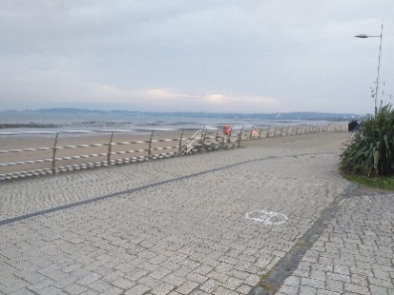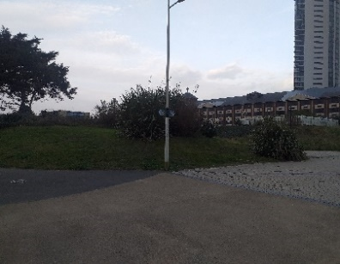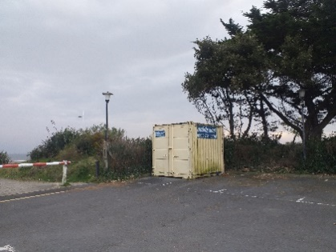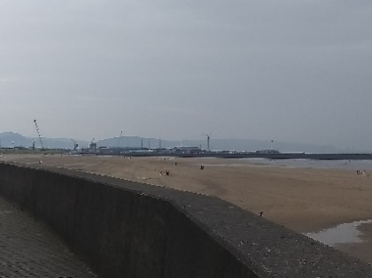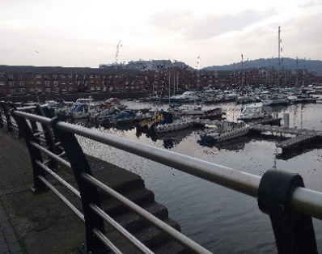

3.0 Archival information
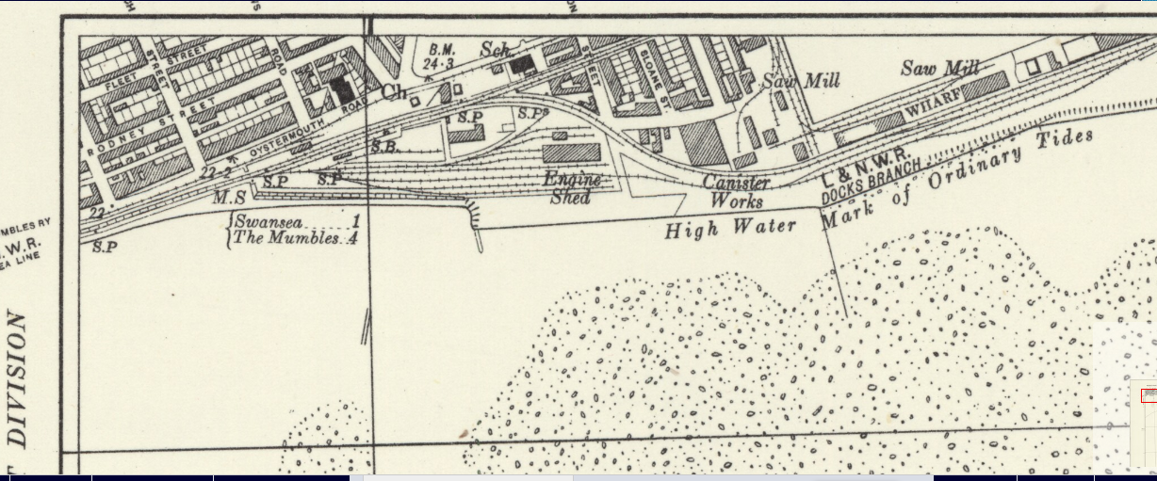
Image from (national library of Scotland)
The ordnance survey shows the land was very industrial and a lot of developed land in the 1930s. In the image dating back to 1930, it shows that the site had railway lines running from the docks as Swansea had a lot of exports. The ordnance survey shows that there was engine shed that may have led to possible contamination of the land. The engine shed might have been demolished and covered after the war which could leave voids in the soil which could lead to subsistence. The image also shows that there was a lot of industrial buildings in the area.
10 years later Swansea and the dockland area suffered as a result of the war ‘At 3.30am on June 27, 1940’(wales online 2018) from bombings as the area was targeted by the Luftwaffe. The majority of Swansea and the dockland was destroyed. There were very few buildings that could be salvaged. The bombings took place over 3 nights. As the image shows some of the buildings were destroyed. After the war some buildings were able to be rebuilt but due to the lack of funds not all.
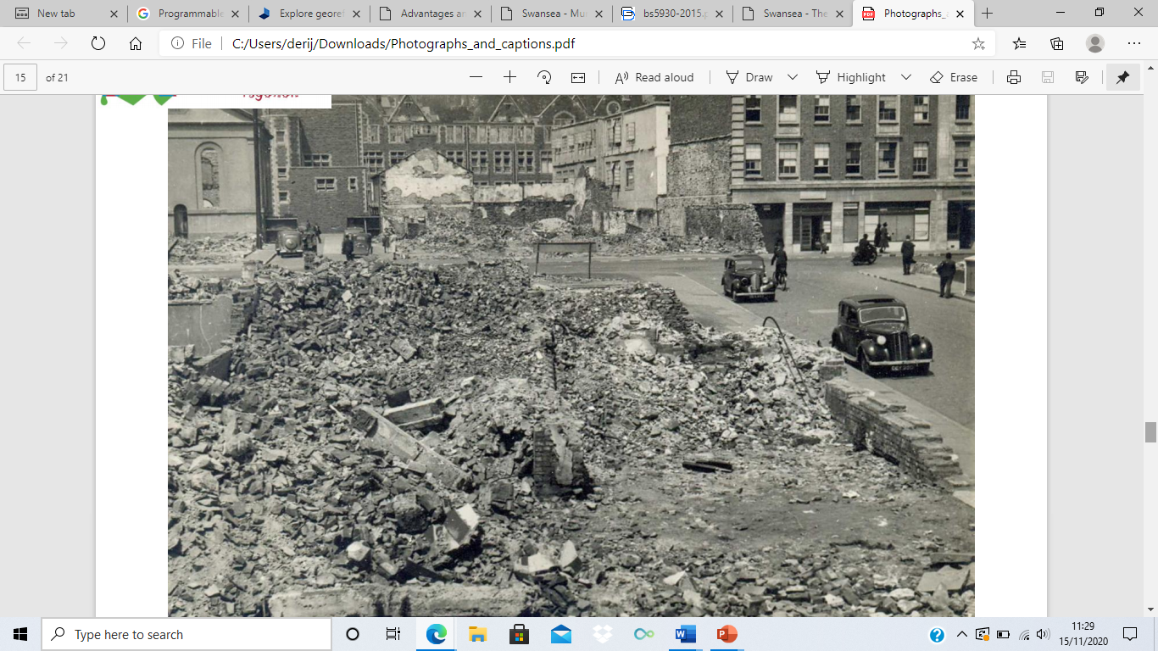
(image from Swansea council)
The next image shows the site and the surrounding area in 1960 20 years on from the last photo. The map shows that a lot more of the land surrounding the dock is now less industrial and not as many buildings were rebuilt due to the effects of the war. The areas are also more sectioned off with more roads. As you can see in the image there is a local hospital and more rail way stations close to the plot.

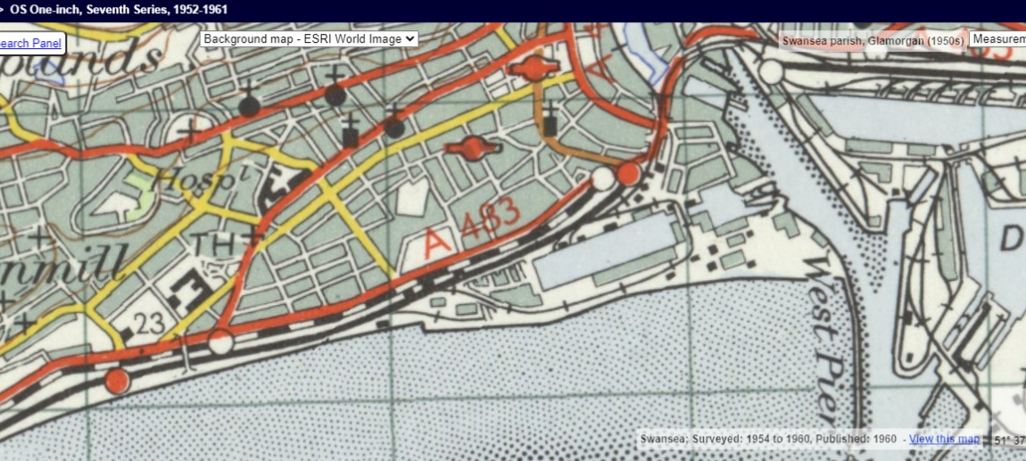
Image from (national library of Scotland)
‘Following the war, the area was redeveloped, and again in the late 1980s with a retail park, with car-parking laid out over the current site’(archaeology wales). This could have resulted in made up ground to try and backfill quickly as there wasn’t as many regulations in place like there is now. There is no evidence stating what was used to back fill around by the dockland area but looking at the bore holes most was filled with brick and other materials and not documented.

Borehole investigation
There is a few borehole logs taken from past buildings from the local area. I focussed on the bore holes that I was able to access as close to the site as I could. The borehole log was taken from the proposed new county hall in 1976. The evidence from the borehole log indicated that there was a lot of made up ground. As it is stated in the borehole logs from the engineer that some of the ground is made up with bricks and other material. There is no evidence stating what material was put in there and at what date after the war. This material would have to all be removed and carefully investigated to examine what materials lie within. The investigation Will have to follow bs5930 to do a geotechnical examination to see if the ground is contaminated.
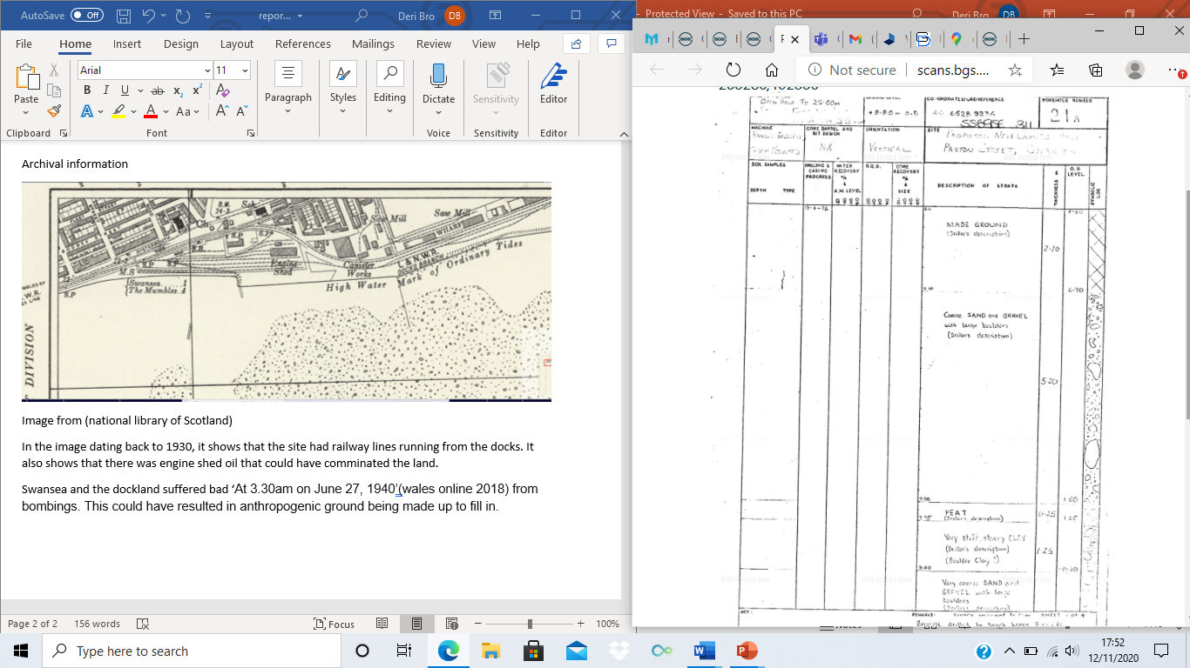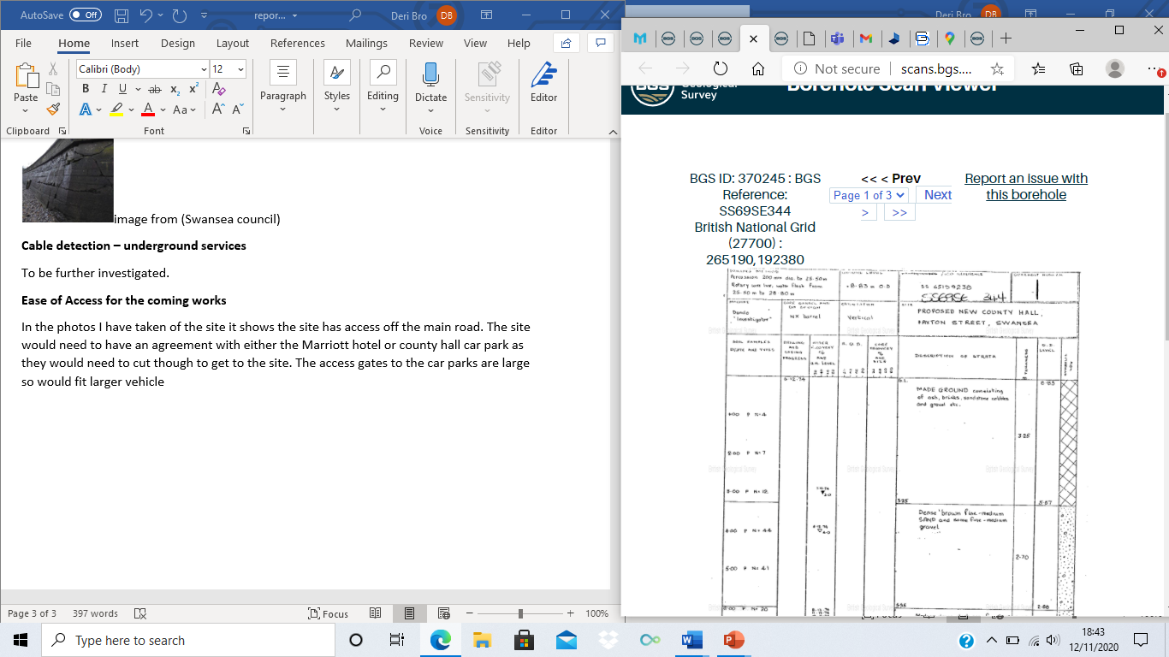

Image from BGS(1976)
Looking at other boreholes from around the dockland area they also have made up ground. The borehole is taken from the leisure centre footbridge. It also indicated as like the civic centre does that there is a lot of made up ground in the area. Looking at the borehole after the made-up ground it then goes into a lot of clay down to around 7m and then going into a grey silt. image on next page
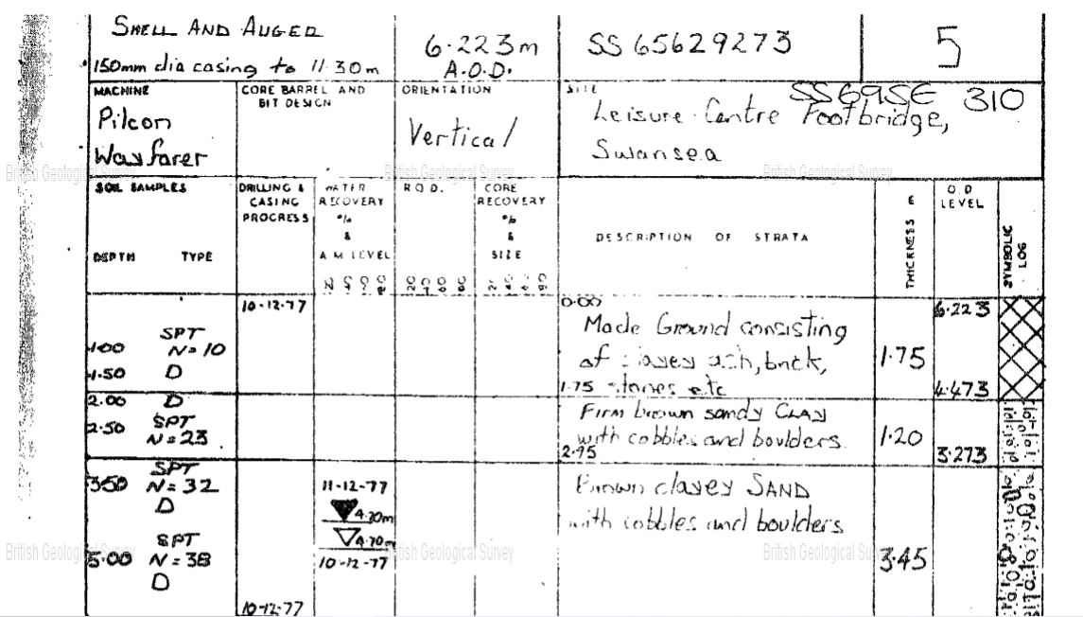
(image from BGS 1977)
Old mining workings
I could not find evidence of a coal mine around where the proposed site. The closest old mine I could find is in llanerch colliery. The mine later exploded in 1890 ’The shafts at the colliery were 253 yards deep’(The colliery guardian). The explosion was due to a naked flame used to light the mines.
Soil and rock types – conditions, strength
Looking at the borehole evidence there is made up ground at the top. It then goes into coarse sand and gravel with large bolders with clay underneath and then onto a grey silt. A foundation will need to be dug down past the clay and silt to a dense material.
Vegetation on site
Looking at the photos I have taken the land is overgrown to the rear and trees at the front. The land seems solid on a visual inspection and does not seem mushy as that would indicate that the ground is always wet or could be used to absorb the water as a drainage.
Ground water conditions
The proposed site is on the shore front of Swansea meaning that it is at high risk of flooding. The precipitation levels in Swansea are between 1.57” on the driest month and 4.94” on the wettest month. A further investigation will need to be made to see the drainage of the site.
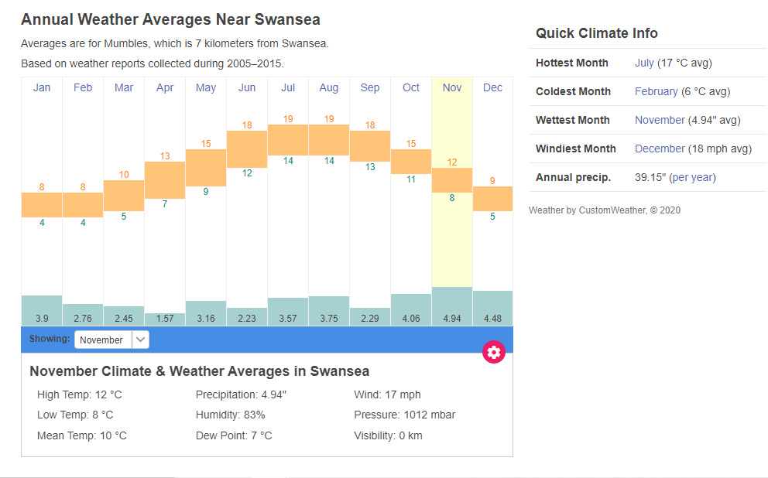
photo from (timeanddate)
Swansea does have sea defences installed to reduce the chances of flooding and the land eroding away. However, although these defences have served well over the years and continue to do so, they are showing damage and appear to be in need of updating. ‘In 2015 the Welsh Government launched the Coastal Risk Management Programme, whereby funding was made available for local authorities across Wales to undertake first stage studies or project appraisals’(Swansea council). More investigation will need to be made to see if the sea barrier problem has been rectified.
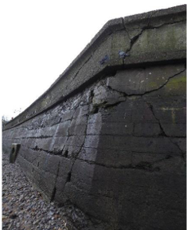image from (Swansea council)
Cable detection – underground services
More investigation will need to be undertaken to find out if there are any underlying services such as gas, water, electricity and sewerage as the information was not accessible to me. This will need to be investigated in the full site investigation.

Ease of Access for the coming works
In the photos I have taken of the site it shows the site has access off the main road. The site would need to have an agreement with either the Marriott hotel or county hall car park as they would need to cut though to gain access to the site. The access gates to the car parks are large so would fit larger vehicle such as delivery’s or the access for the ground testing. The site is just off Oystermouth road. The access via transport is to the rear of the site and has a pedestrian only access to the front on the shore. Oystermouth road is very busy road in working hours 8-5 as it is the main road to Swansea centre. Access to the site would need to be planned not to cause further disruptions to the traffic in the area possibly finding an alternative route for example.

archaeology
Close to the proposed site there has been an archaeological discovery. This meant that the works of the site had to stop until it had been examined for evidence. The discovery was in parc Tawe which is not far from the proposed site. Swansea has medieval history dating back as far at 15th century. ‘The work was undertaken as a condition of the planning permission’(arch-wales). This means that if there is anything discovered in the project then the works would have to stop and the site would need to be examined before re-starting again. There is also a possibility if there is a piece of history uncovered then the works might not be able to continue if the history needs to be preserved.

4.0 Significant risks
Given the information that I have just provided here are some of the greatest risks I feel effect the site.
Made up ground
Looking at the boreholes that were taken for the county hall the majority of samples included a lot of made up ground. The made-up ground is described in one of the photos as being bits of brick. This will affect the project as it means that further ground investigation will need to be done to determine how much of the ground will need to be removed and if the ground is contaminated. The made-up ground could also be hiding archaeological findings which would seize developments on the plot of land. There is no evidence of what material was used to back fill after the war so this would need to be examined before the work starts. When the borehole sample is done, they will need to use shell and auger to retrieve the correct information at deeper levels. Careful drilling will need to be done as there is no evidence as what is below the ground as it was Industrial ground. We will have to use BS5930 in the investigation just in case there is any contaminated ground that is lying underneath the surface. it will give us the geotechnical

Sea defences and flooding
The area is prone to flooding as it is close to the shore meaning in a storm the plot could flood. There are plans in place to try and update these defences. The sea defences in Swansea need updating like I have illustrated in my evidence. If the council do not rase enough funds to fix the defences then it will only get worse which could lead to the sea defences that are there to collapse. This could lead to the earth under the foundation being washed away causing subsidence. Being on the shore front it means the building will always be exposed to salt water so material will oxidise quicker. The plant that would need to be used would have to be serviced more often due to the salt water.

Archelogy discovery’s
Due to the land being close to the dockland it more than likely has a lot of historical history underlying the surface. Due to the blitz that happened in Swansea in the 1940s then it means that a lot of history might have been buried. The ordnance surveys show that there was a lot of industrial work before the bombings. This poses a risk as extra care will need to be taken when drilling commences on the site also if there is any large objects that have been buried then they will need to be removed not to cause any voids in the footing as that could cause subsidence and cracking within the building.

5.0 Suitable foundation for the proposed site
Following my evidence from the information I have gathard from around the site I feel the sutiable foundation needed for the site is a pile foundation. As it is a deeper foundation and has a stronger load bearing.
Here are my Resons for chosing the pile foundation:
A pile foundation can be piled into the ground down to a suitable material where it can be of load bearing. given that a lot of the site around the area are a lot of made up ground then it would have to be a deep foundation to support the load of the building at max capacity. The ground below is made up anthropogenic ground to a depth of around 5m. The ground then goes into a dense gravel with some large boulders after 7m. the pile foundation would be able to be pushed down past that point without removing to much material.
A pile foundation can be hammered into the ground through the lower density material down to the stronger ground. The proposed site is by the side of a sea meaning that the ground conditions are saturated. By using a pile foundation is means that if the water penetrates through the ground under the footing then it will not wash away the material under the footing which could lead to causing subsidence. Below I have taken a photo of a pile foundation from my site. The pile foundation on my site is for commercial flats so gives an idea on how many piles would be needed.
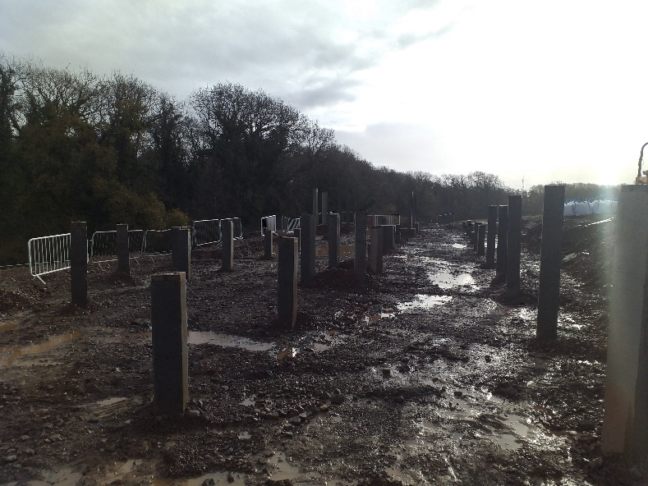
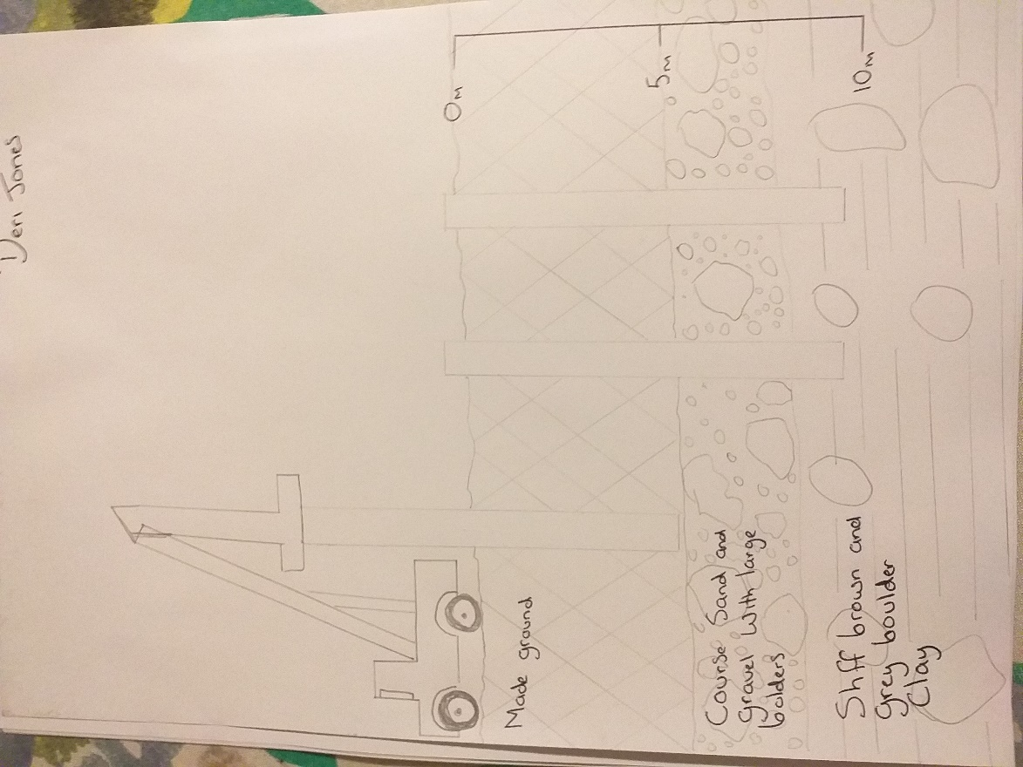
I sketched this to show how to pilling is completed and what levels they have to be taken down to. I have used the ground from a borehole that I used earlier in the assignment.

- reference list

ordnance survey web page-https://maps.nls.uk/view/102183141

Swansea and port tablet dockland hiatory webpage -http://swanseadocks.co.uk/docksnewsite/fishingandice.html

Coflein history of the dockland area webpage-https://coflein.gov.uk/en/site/580/details/swansea-docks

Newspaper article wales online webpage- https://www.walesonline.co.uk/news/wales-news/telltale-evidence-swansea-blitz-you-14422515

Mine works newspaper article The Colliery Guardian, 7th February 1890, p. 220

borehole log from BGS webpage- http://scans.bgs.ac.uk/sobi_scans/boreholes/370212/images/10677861.html

mumbels costal protection webpage- https://www.swansea.gov.uk/mumblescoastalprotection

Swansea archival webpage-https://www.arch-wales.co.uk/parc-tawe-swansea/

Time and date graphs for the precipitation website-
https://www.timeanddate.com/weather/uk/swansea/climate

codes of practice bs5930 web page- https://geotechnicaldesign.info/bs5930-2015/foreword.html#intr

