

University of Wales Trinity of St David:
Ordnance Munitions and Explosives

Academic Year 2025 - 2026

Lewis Gray (2224230)

Data Capture and Analysis
Supervisor: Mark Broadhead

December 2025

Academic Integrity Declaration
I declare that:
- the thesis submitted has been written by me alone.
- the thesis submitted has not been previously submitted to this university or any other.
- that all content, including primary and/or secondary data, is true to the best of my knowledge.
- that all quotations and references have been duly acknowledged according to the requirements of academic research.
I understand that to knowingly submit work in violation of the above statement will be considered by examiners as academic misconduct.

Abstract
A visit to Cranfield Ordnance Test and Evaluation Centre (COTEC) was arranged by the University of Wales Trinity Saint David (UWTSD) to conduct an explosive arena trial as part of a data capture and evaluation module where students were tasked with identifying an unknown explosive device using techniques and equipment studied through the module. Identifying features such as explosive mass, fragmentation pattern, fragmentation nature and forensic analysis were used to deduce the type of munition in the trial.

Contents
Academic Integrity Declaration 2
Abstract 3
Table of Figures 5
Table of Tables 5
I. Aim of Experiment 6
II. Introduction 6
I.I. Arena Trial 6
I.II. Fourier Transform Infrared Spectroscopy (FTIR) 7
III. Setup and Equipment 7
II.I. Cabling 7
II.II. Pressure Gauges 7
II.III. Strawboard 8
II.IV. Velocity foils 8
II.V. Unidentified Explosive Device (Table of other explosive options) 9
IV. Trial Results 10
IV.I. Fragmentation 10
IV.II. Pressure Gauges 11
IV.III. FTIR Analysis 12
V. Discussion and Identification of Unknown Explosive 14
VI. Conclusion 15
VII. References 15

Table of Figures
Figure 1: Cabling Protected by Steel I-Beams 6
Figure 2: Pressure Gauges Behind Munition and Strawboards 6
Figure 3: Strawbards with Numbered Velocity Foils 7
Figure 4: Fragmentation Pattern on Srawboards 8
Figure 5: Frag Pattern of Cylindrical Cased Warhead [2] 9
Figure 6: Recovered Fragments from Munition 9
Figure 7: Pressure-Time Curve from Gauges 2 and 3 10
Figure 8: Gauge 1 Frag Impact 10
Figure 9: FTIR Data 11
Figure 10: FTIR Trace Average 12
Figure 11: Computed Optical Constant of RDX [3] 12

Table of Tables
Table 1: List of Possible Munitions 8

Aim of Experiment
The aim of the research excursion to COTEC was to engage in data collection, combined with explosive forensic analysis, in an arena trial with the intent to determine the identity of an explosive charge unknown to the participants from a list of munitions provided to them. After analysing data recorded with regards to pressure waves generated after detonation of the munition, and data gathered pertaining to the fragmentation of the munition casing such the pattern of the frag and the nature of the frag; id est, whether the fragmentation was natural or preformed.

Data was also to be gathered via forensic analysis on the collected fragments of the munition. Fourier Transform Infrared Spectroscopy (FTIR) was conducted in order to determine what explosive compound was used in the unidentified munition, as knowing this could greatly aid in identifying the explosive from the provided list.

Introduction

I.I. Arena Trial
In the context of scientific and military application, an arena trial refers to a type of large-scale explosive test often used to assess the effectiveness of structural components such as glazing, doors and walls under blast loading. This involves setting up numerous targets at varying ranges around a centrally positioned explosive charge and assessing damage done to them by the blast.

Arena charges generally range from the 10 kilogramme range to the 10 kilotonne range, however, the most common yield of charge used in UK trials are in the 100 kilogramme range, measured in TNT equivalence (TNT_{e}) [1].

The purpose of the arena trial that is the subject of this paper was to identify an unknown explosive charge from a list of possible munitions ranging from a 155mm artillery round to an Improvised Explosive Device (IED) in the form of a pipe bomb by analysing the explosive characteristics of the unknown charge such as frag pattern, blast overpressure and impulse, and chemical composition.

I.II. Fourier Transform Infrared Spectroscopy (FTIR)
Fourier Transform Infrared Spectroscopy (FTIR) is a sophisticated method used to analyse and identify chemical compounds by recording the way they absorb infra-red light. Named for the Fourier Transform (FT), an integral transform which outputs a mathematical function defining the various frequencies of the original input function, FTIR is a form of absorption spectroscopy which measures how much light the chemical bonds within the chemical absorb at various wavelengths. Using the interferogram produced by FTIR, it is possible to identify the presence of chemical compounds in a solvent.

Setup and Equipment
Upon arriving to the arena site, teams were established to aid the setup of the trial and were tasked with retrieving and setting up various individual pieces of equipment.

II.I. Cabling
During the trial, cabling was set up in order to deliver a detonation trigger to the explosive charge.

Cabling was also used to facilitate the high speed acquisition of data being transmitted by a set of three pressure gauges measuring blast overpressure to the control bunker. The cables ran along the side of the trial and were covered with steel I-beams in order to protect them from blast overpressure and frag emanating from the explosive charge which could damage the cables or alter the reading given by the pressure gauges.
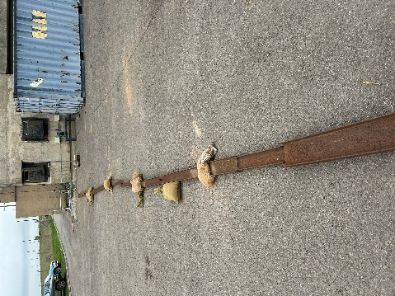
Figure 1: Cabling Protected by Steel I-Beams

II.II. Pressure Gauges
Three dynamic pressure gauges were set up in order to record the pressure generated by the unidentified explosive charge. Dynamic gauges were used as opposed to static gauges as due to the nature of the trial. The shockwaves produced during a detonation produce extremely short periods of high pressure which cannot be measured with static gauges, as they only measure steady state or pressures that vary over long periods of time, and are thus unsuitable. Static gauges are also unable to accurately measure peak overpressures as they would average out the overpressure, and it would be missing from the recordings. The pressure gauges were placed at a height of 0.5m, in line with the munition.
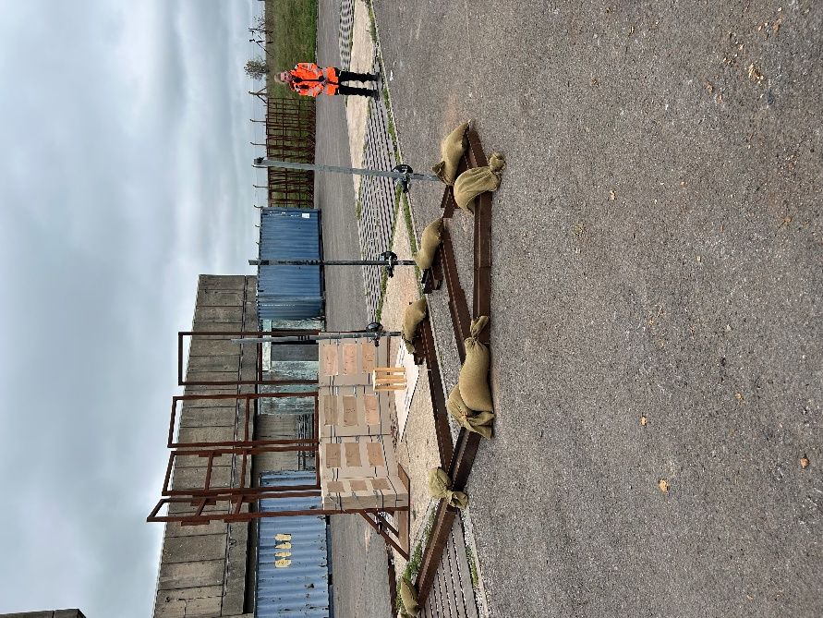
Figure 2: Pressure Gauges Behind Munition and Strawboards

II.III. Strawboard
Strawboards were used to capture fragments from the unidentified munition to allow them to be recovered after the trial so further data can be learned about the munition. Four packs of strawboards, four individual boards per pack, were placed two packs deep in a 113° arc in front of the munition. Velocity foils were then affixed to the boards facing the munition.

II.IV. Velocity foils
Twelve metal velocity foils were attached to the strawboards in order to record the strike time of the fragmentation generated by the detonation. Foils were numbered one through twelve and connected to a computer in the control bunker which would record the data to be interpreted by the participants.

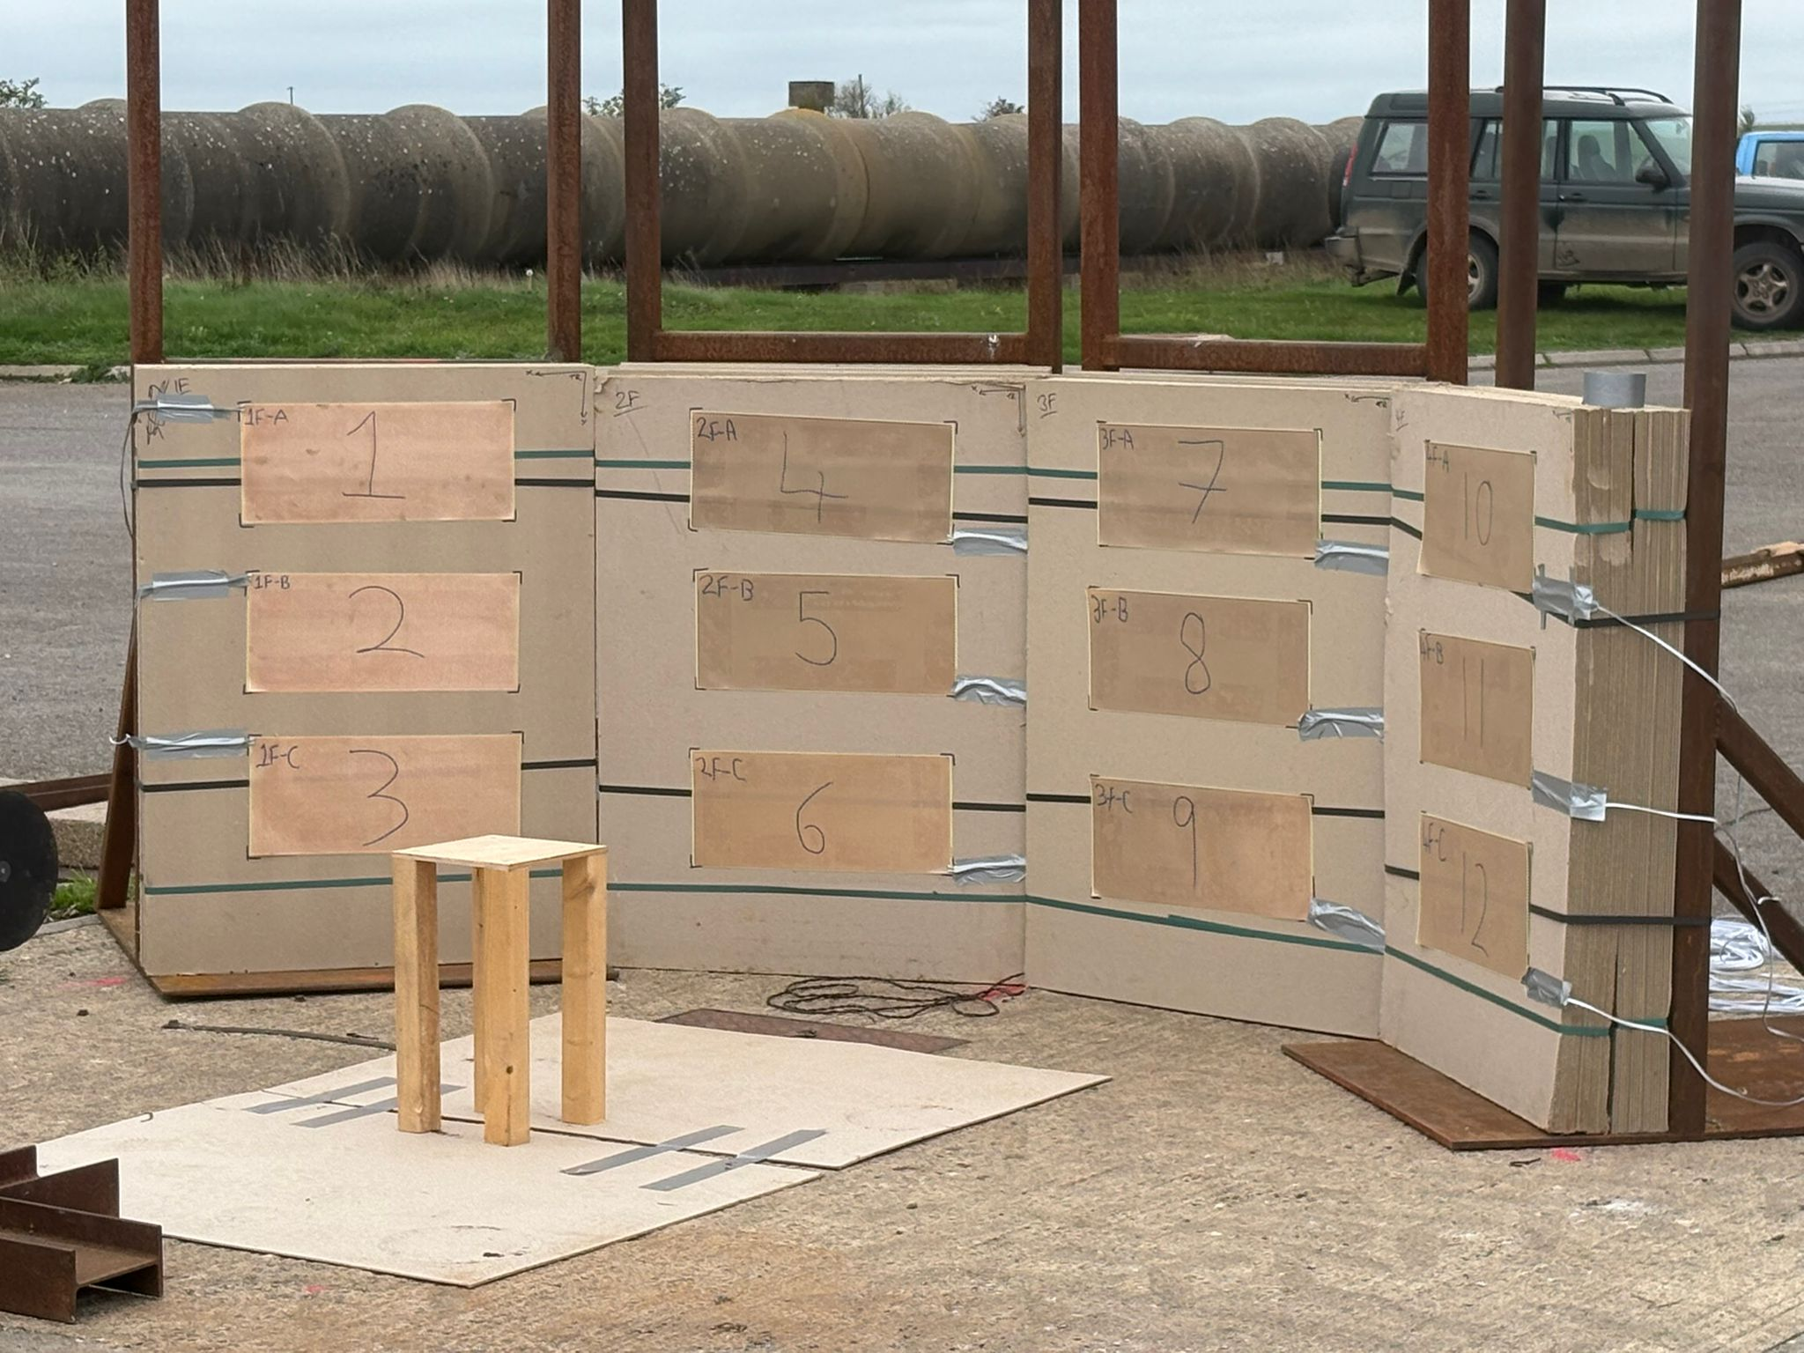
Figure 3: Strawbards with Numbered Velocity Foils

II.V. Unidentified Explosive Device (Table of other explosive options)
The unidentified munition was placed on a wooden pedestal 0.5m off the ground to be positioned approximately centred to the arced strawboards. The munition was setup by qualified, external range operators in order to maintain the safety of participants and to keep the identity of the munition unknown. A list of possible munitions that could have been detonated are listed in Table 1 with some key identifying information.

Munition | Explosive Mass (kg) | Explosive Compound
Mk. 82 | 225 | Comp B
M-67 Grenade | 0.185 | Comp B
RGD-5 | 0.11 | TNT
AR-M81 Mortar Round | 0.76 | TNT
RPG-7VL | 0.73 | RDX/TNT
155mm Shell | 1.15 | Comp B
Pipe Bomb | 264 | PE 8
Table 1: List of Possible Munitions

Trial Results

IV.I. Fragmentation
Post detonation, the spread of fragmentation was examined, and it was noted that fragments were almost exclusively found in a narrow band in the mid-section across the four strawboards, shown in figure 4. This fragment pattern is typical of a cylindrical cased charge, shown in figure 5
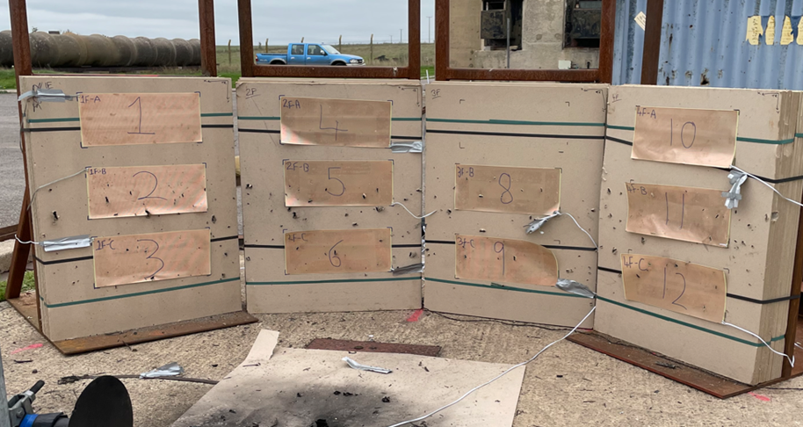
Figure 4: Fragmentation Pattern on Srawboards
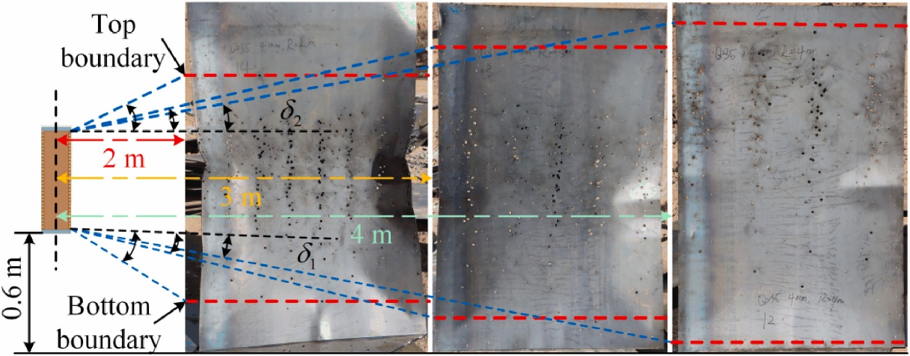
Figure 5: Frag Pattern of Cylindrical Cased Warhead [2]

Fragments were extracted from the strawboards so they could be examined further through FTIR and physical examination in order to determine the identity of the munition they originated from.

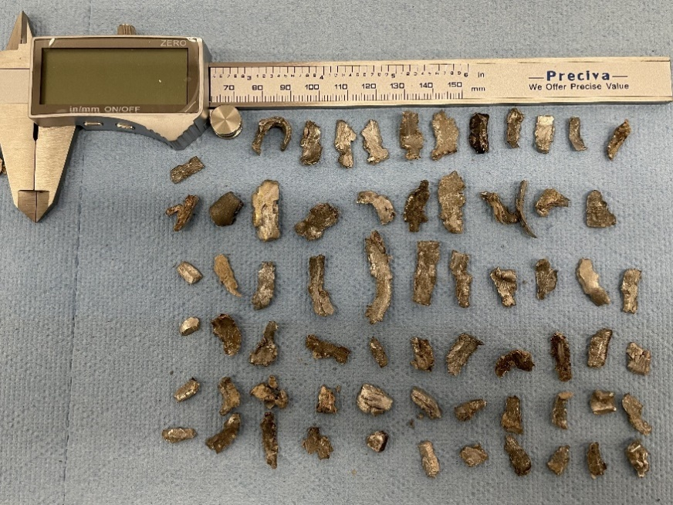
Figure 6: Recovered Fragments from Munition

IV.II. Pressure Gauges
Whilst recording the pressure data generated by the detonation, it became clear that there were abnormalities with the readings displayed by Gauge 1. Gauges 2 and 3 appeared to be operating normally, showing a blast-pressure time curve that clearly showed peak overpressure followed by a negative impulse, refer to figure 7. However, gauge 1 showed oscillations between maximums and minimums, indicating that the pressure gauge was likely struck by a frag from the munition. This was later visually confirmed post-detonation, shown in figure 8.
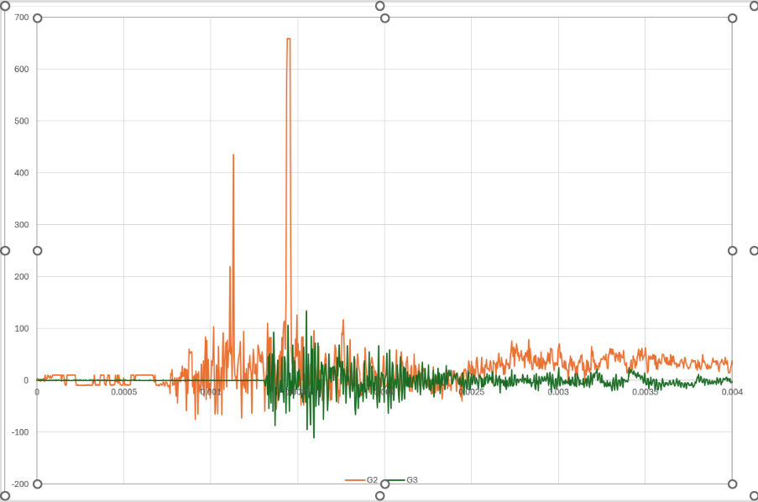
Figure 7: Pressure-Time Curve from Gauges 2 and 3

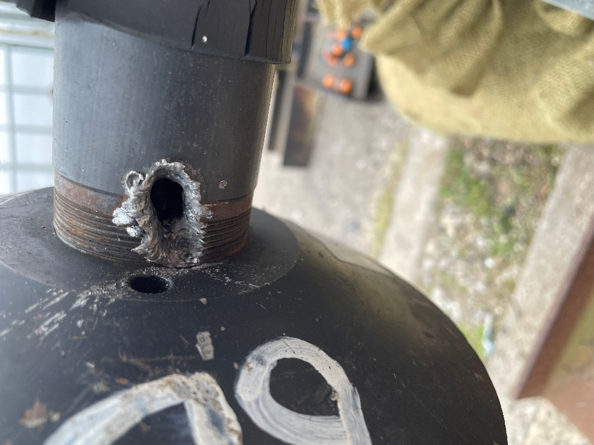
Figure 8: Gauge 1 Frag Impact

While the readings from the gauges show a clear peak pressure, they also recorded a substantial level of background mechanical noise from vibrations caused by the detonation and the reflected pressures from the strawboards and ground. Although mitigations were put in place such as insulating the gauges with rubber padding and having the munition elevated from the ground, unwanted data was still recorded by the gauges.

IV.III. FTIR Analysis
Swabs were taken post detonation of the blast area in an attempt to pick up some explosive residue from the munition in order to subject them to FTIR analysis, the results of which are shown in figures 9 and 10.
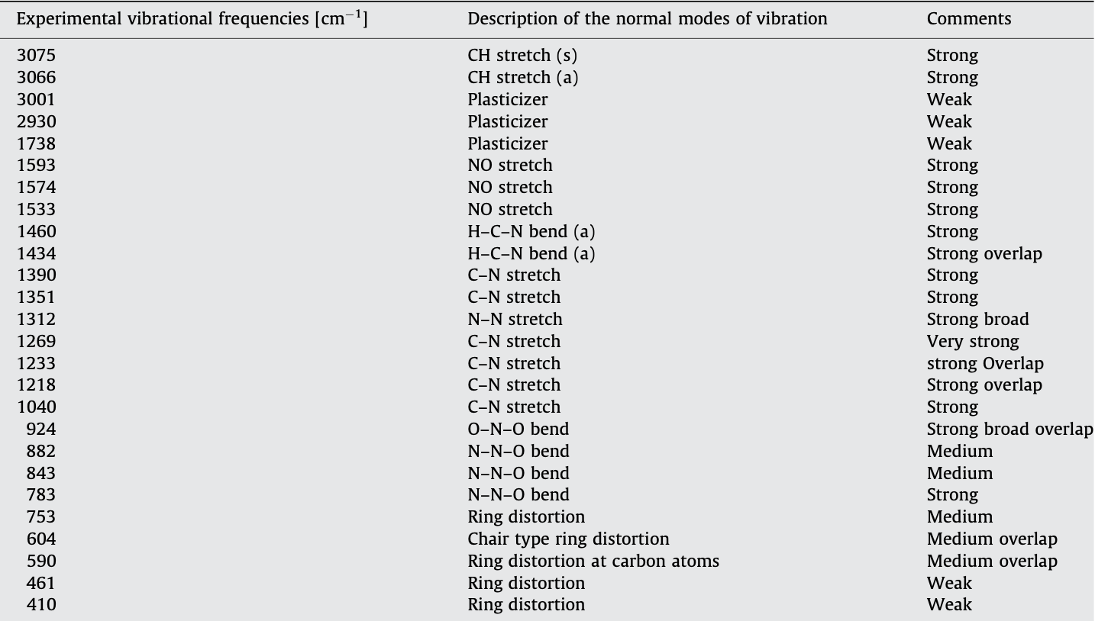
Figure 9: FTIR Data

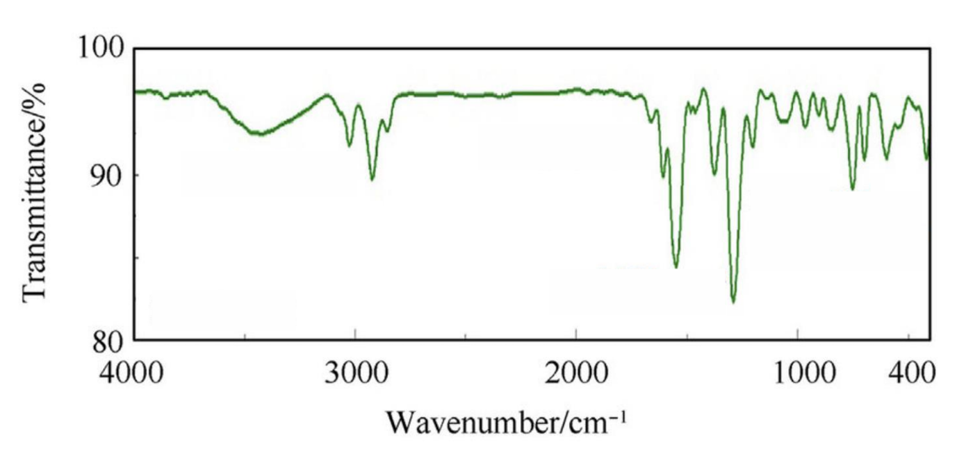
Figure 10: FTIR Trace Average
As can be seen in the trace sample and the FTIR raw data, there is a clear indication of multiple nitroalkane groups (R-ON₂) within the chemical structure of the recovered explosive, evident by the NO-stretches from 1033mm – 1095mm. This indicates that the compound is most likely either Trimethylenetrinitramine (RDX), also called Hexolite due to the presence of a cyclohexane ring; or Trinitrotoluene (TNT). Due to the absence of any carbon-carbon double bonds found in a benzene ring found in TNT, the explosive used in the munition is most likely RDX this is further confirmed when the results of the FTIR trace are compared with the computed optical constant of RDX shown in figure 11. The same peaks can be found around the 1300mm mark and the 1550 – 1600mm mark.

What the comparison also shows is an abnormal spike around the 3000mm mark which Is caused by the presence of a plasticiser. This suggests that the explosive mixture with the unidentified munition was PE 8, which is a British RDX-based plastic explosive.

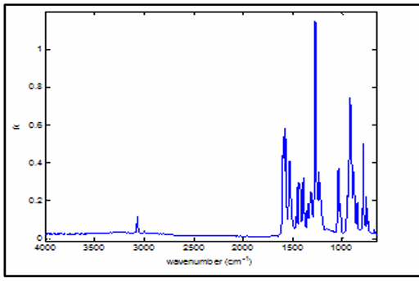
Figure 11: Computed Optical Constant of RDX [3]

Discussion and Identification of Unknown Explosive
Immediately, several munitions can be eliminated from consideration due to the size of the arena trial. The Mk.82 500lb bomb, the 155mm artillery shell and the AR-M81 mortar round contain an explosive mass too great to conduct a detonative trial at the COTEC location as a much larger arena would be required.

The RPG-7VL can also be discounted due to the nature of the munition. The RPG round is a shaped High Explosive Anti-Tank (HEAT) munition and produces a narrow jet of superplastic copper intended to neutralise armoured vehicles instead of a narrow band of frag as seen after the trial.

Upon examination of the fragments recovered from the detonation of the munition, it can be noted that the fragments are naturally formed as they are of irregular dimensions, sharp and randomly dispersed, due to the expanding gases ripping apart the munition case, creating razor sharp fragments of metal. This is in contrast to pre-formed fragmentation found in munitions such as the M67 and RDG-5 grenades. Furthermore, grenades such as the M67 and RDG-5 grenades don’t distribute fragments in a narrow horizontal band but instead fragment omnidirectionally.

FTIR analysis also shows the most explosive compound used in the munition was most likely PE-8 due to the strong presence of RDX in conjunction with a plasticiser.

Conclusion
In conclusion, the most likely munition detonated during the COTEC trial was the pipe bomb.

FTIR data suggesting the explosive composition is RDX combined with a plasticiser which would be PE 8, this combined with the fact that explosive quantity limitations means the trial had to be conducted with a smaller explosive, which ruled out larger munitions such as the 155mm artillery shell, the mk.82 500lb bomb and the 81mm mortar round.

This can be concluded from the fragmentation pattern observed on the strawboards being a thin horizontal band, and nature of the fragments being natural as opposed to pre-formed, which led to the M67 and RDG-5 grenades being discounted.

Thus, after a process of deduction, the only viable option left is the pipe bomb filled with PE 8.

References

[1] | T. Payne, A. Williams, T. Worfolk and S. Rigby, “White Rose Research Online,” 1 June 2016. [Online]. Available: https://eprints.whiterose.ac.uk/id/eprint/100849/. [Accessed December 2025].
[2] | S. Zhang, Z.-Q. Wang, S.-T. Li, Y.-Q. Chen, X.-H. Shao and L. Xu, “Coupled damage characteristics of preformed fragments and shock waves on concrete walls — Field tests,” November 2025. [Online]. Available: https://www.sciencedirect.com/science/article/pii/S2352710225028177. [Accessed December 2025].
[3] | C. S. C. Yang, “SPECTRAL CHARACTERIZATION OF RDX, ETN, PETN, TATP, HMTD, HMX, AND C-4 IN THE MID-INFRARED REGION,” DEVCOM Chemical Biological Centre, Edgewood, 2014.

