Student Name: Prisca Kiongo

Student Number : 1908199

Institution: UWTSD

Module Title: Marketing Management (LCMB7001)

Instructor : Hossein Shokri

Submission Date: 10/09/2020

Table contents

Introduction………………………………………………………………………...3
Communication…………………………………………………………………….4
Integrated Marketing Communications………………………………………….5
Current and New Promotions…………………………………………………….7
Branding and Brand Equity………………………………………………………8
IMC and Touchpoints at Virgin Atlantic………………………………………...9
Conlusion…………………………………………………………………………..11
Reference………………………………………………………………………….12

Introduction

The customer journey in the realm of marketing is the path that a business entity takes to review the purchaser from the first engagement to the end. Usually, it involves following up on the customers from the initial point of engagement to the end with the view of knowing how they react from the first point of engagement to the end. The advocacy stage comes in, whereby the customer becomes an active supporter of the brand. It helps in the marketing of the company through multiple channels that also includes positive word of mouth marketing.
In this regard, this report will use the Virgin Atlantic company as a case study. The firm is well-known for providing air transport globally and mainly operates from the United Kingdom, and appreciates the value proposition that customers expect from it (Virgin Atlantic, 2019). It includes the touching points that they go through to inform their purchase decisions (Lemon and Verhoef, 2016).
A standard end-to-end customer journey refers to the interactions that a customer has, while unaware of an entity. It includes becoming aware of or investigating it, but this should lead the person to decide to buy or inform others to purchase the same products or services. Communication awareness is an important piece especially when working on growing a huge company. It is fully considered that at the end of every business good results are met. Brand awareness generate products that become proprietary eponym. That means more of awareness of a brand, bring to building affordable network. Secondly, there is a need for evaluation and consideration, which involves a comparison of the product or service and others that are available within the market. The third stage involves the point at which a decision has to be made, whereby the potential customer is ready to choose the commodities from a wide array. At this stage, the customer has already decided on the products or services that are supposed to be taken up. Retention aims at keeping and maintaining the loyalty of the customer (Rosenbaum et al. 2017). Currently, the company has emerged as one of the companies that have used its innovative strategies to create awareness of its brand. It has critically used different mechanisms of managing the customer journey as well as communicating with them to ensure that all stakeholders are served by the company. Besides, Virgin Atlantic knows that it can achieve its business objectives through a mechanism that allows it to communicate and market its products freely (Virgin Atlantic, 2019). Under such an arrangement, it has to connect with the consumer and monitor the relationship to maintain this connection from the beginning.

Communication

Presently, it is agreed that consistent and clear communication assists in enhancing the experiences of customers in any environment (Kotler and Keller, 2019). Therefore, a provider must always aim to improve the experiences of these customers to attract and retain them. In any case, the effort is made to ensure that they have a positive experience that benefits them while at the same time ensure that the provider enjoys the fruits of offering the utility. However, it must be emphasised that communication helps this company to overcome a very competitive market (Kotler and Keller, 2019). Here, the position is to ensure that the customer's journey is attained through a viable and seamless communication trail.
Notably, personal communication has been identified as important in the evaluation of the customer's journey. In this case, it will determine the number of times that it is in contact with the customer, the importance of using these preferred channels and how to define and time the conversations (Kotler and Keller, 2019). The company has also learnt how to scale its services without increasing its operational costs. Virgin Atlantic has a marketing strategy that embraces diversities. A good example is the British Airways; in which it has broken the world record by inviting new investors to the company. Despite their budget and size, they have invited investors. Data has indicated that company like EasyJet has a rampant growing competition, in which it’s boosting the market shares.

In this case, the company only needs to offer an attachment that guarantees a touchpoint connection from the point of meeting, engagement and subsequent meetings(Maechler et al. 2016).In reality, this confirms the idea that poor communication impedes the ability of a business enterprise to track down the movements of a customer. It becomes difficult to know how a customer is doing, and how to convert these into sales of products or services. In reality, communication should be viewed as a way of transmitting and sharing information. It starts from the sender and undergoes different processes that lead to the interpretation of the actual message within it (Kotler and Keller, 2019). As is the case with many organizations, Virgin Atlantic also undergoes the same processes as shown in the model below.

Figure 1: Communication Model
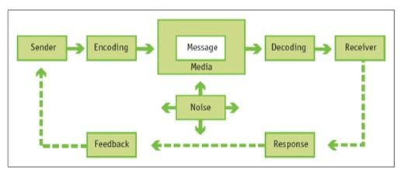
Source: (Kotler and Keller, 2019).

Integrated Marketing Communications

In this age of integrated marketing communication, the company must think creatively of what they intend to accomplish with the targeted customers through the campaigns (Andrews and Shimp, 2017). Companies need to think of creatively reaching out to targeted customers through different platforms. However, it is critical that a coordinated approach is developed to ensure a unified message is propagated through all the platforms (Luxton, Reid and Mavondo 2015). Hence, Virgin Atlantic needs to implement an integrated marketing communication strategy to achieve this goal. Implementing an integrated communication plan requires that an organisation first identifies its target audience. This can be done by analysing consumer data such as age, behavioural patterns, and social status among other segmentation factors (Andaleeb 2016). In the case of Virgin Atlantic, target customers can be segmented into different groups such as middle class or upper class. The airline will also need to identify the specific medium to use to reach out to the target audience. A specific but consistent marketing message is then created for each platform to reach out to the target customers (Luxton, Reid and Mavondo 2015). Throughout the different platforms, the airline emphasizes can focus on emphasizing its brand positioning statement “Fly in the face of ordinary” to ensure customers in different platforms are targeted with the consistent marketing message.

Essentially, integrated market communications (IMC) entails the application of the promotional tools that help in the harmonious engagement between the customer and the client. Despite this, the integration happens at all levels within the organization and may be horizontal, vertical, and in some instances internal or external(Andrews and Shimp, 2017). However, the most important factor in such arrangements is that integrated marketing communications require that the provider uses many ways through which a competitive advantage can be created. The intention of this is to drive sales and create a brand that is attractive to the customers.
Significantly, the integrated marketing communication model ensures that all the forms of communication that the company uses are carefully interconnected. At the primary level, all the promotional tools are integrated such that they work harmoniously to market the company (Keller, 2016). At Virgin Atlantic, this is carried out by a team that ensures that the company’s products and services reach the targeted market.VirginAtlantic has to package its message in a manner that can easily be taken up by the client. Under such an arrangement, the most important factor is to ensure that the products or services that the company offers are promoted (Keller, 2016. It must also be represented in a way that can translate into actual sales of the products and services. Therefore, the company has to connect or link the messages to targeted consumers. As such, Virgin Atlantic now endeavours to avoid things that can make its fail to have an integrated way of communicating. It is a web that not only involves the promotion of commodities but also the marketing of such products and services.
A model that is perceived as integrated involves all aspects of communication and marketing. In such arrangements, the provider ensures that the promotional mix is achieved. It means that the product must be offered at the correct place, price and time (Andrews and Shimp, 2017). In the case of Virgin Atlantic, the company ensures that its products and services are available to the targeted consumers whenever they need them. Essentially, it has to be reiterated that there is a need to have robust communication between the provider and the consumer. It is reported that communication helps in creating stronger engagement and relationship between the provider and the consumer. However, this has only been achieved through the ability of the company to present itself as a brand that guarantees consumer satisfaction. Therefore, Virgin Atlantic comes out as a company that seeks to offer the best products and services to potential, actual and future customers. While it is successful in communicating its brand, it still believes that the use of the correct communication channels can help it to reach out to different stakeholders. These include the customers that use its products and services.

Current and New Promotions

Virgin Atlantic employs different marketing communication media that includes both traditional and newer forms of promotions. For instance, the airline relies on television by creating TV advertising banners such as the “Depart the Everyday” (London Air Travel 2018). The ads emphasize on the company’s superior and iconic experience offered to customers and passengers of its flights. The company has also implemented a social media marketing which encompasses customer involvement as parts of its marketing strategy. For example, the airline creates the verb ‘Clubhouse’ and asked customers to take pictures of themselves ‘club housing’ and share the on Twitter and Instagram (Popick 2013). The strategy proved successful in promoting the brand and increasing the visibility of the airline among customers. The company also engages in sponsorships as part of its promotion strategy. For example, Sheppard (2014) reports that the airline has sponsored Free the Children, a network that focuses on helping children through innovative education and development programmes. Virgin Atlantic
The airline can enhance its promotional campaigns by improving its current strategies and adopting new promotional approaches. For instance, the company can improve its social media approach by adopting regular use of content marketing. This can involve creating images and videos that are relevant to target customers on social media with a specific message. The company can use hash tags and influencers on social media platforms to reach out to a wider audience and increase the visibility of the brand (Baltes 2015). Another campaign strategy may involve interacting with the customers through social media engaging in word of mouth recommendations and through vital sharing of the information through social media (Keller, 2016). The company will also be involved in an embrace, which can be conducted through sales promotions and events marketing. The company will also employ public relations and advertisements to influence and educate the public about this new product. The airline can enhance the effectiveness of its promotional campaign by also engaging in cause-related marketing. This can be achieved by engaging in social and environmental programmes to show the airlines commitment to promoting community development and environment conservation (Kuo and Rice 2015). Virgin Atlantic can also improve its promotional strategies by forming partnerships with non-profit organization to raise awareness on pollution and environmental sustainability.

Branding and Brand Equity

However, in determining the customer journey of Virgin Atlantic, there is a need to refer to the issue of brand equity. This is the value premium that the organization generates from the product, and has a recognizable name that can easily be compared to a known equivalent. Accordingly, it can be confirmed that Virgin Atlantic has created brand equity about its products and services. This is because its customers now know that the commodities that the company offers are memorable, can easily be recognized and assure of the best quality (Datta et al. 2017). In most cases, the applicable model is Keller's customer-based brand equity (CBBE) mechanism that states that the phases of brand equity move upwards. The importance of this model is that it moves upwards and it is simple to state the specific point that the brand is, and what can be done to move it to a better place.
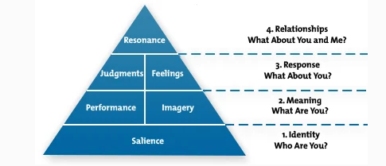
Keller’s Brand Equity Model (Keller 2016).

The brand equity creates the value in which a potential or actual customer sees in a product. Virgin Atlantic has created a robust customer base that easily recognizes its products and services whenever they are presented in the market. An individual in the United Kingdom or the world over can easily see and relate to the brand as soon as it is presented or put into direct competition with another. Apart from the visibility aspect, brand equity is achieved through the fact that the customer's experiences are positive, and they favourably report about it. Applying Keller’s brand equity model to Virgin Atlantic, specific experiences related to the airline can be developed.
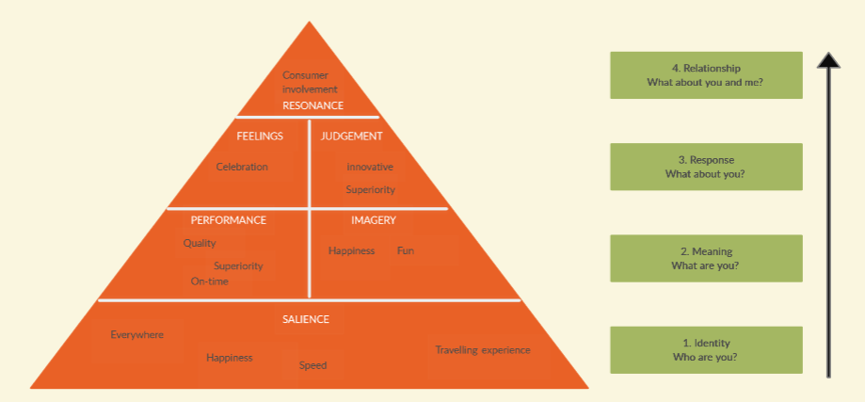
IMC and Touchpoints at Virgin Atlantic

To reach the customers, Virgin Atlantic has made an effort to ensure that it communicates well with the customers. The company knows that it has to offer information that can easily be processed by the customers. The company now appreciates that it has to apply the golden rules of integrated marketing communications. These involve engaging the senior management of the organization to ensure that the integration is achieved at all levels of the unit. Virgin Atlantic also has a clear communications strategy that adds value to the company (Maechler et al. 2016). It helps in adding value to the brand by projecting it as one of the most preferable entities to the market. There are stages or steps involved in the integrated marketing process (IMC): identifying customers’behavioural data, determining and indicating the financial value of the consumers and customers,creating a platform in which delivery of messages and incentives to bring meaningful marketing communication. The other stage is the estimation of the returns on customer investment (ROCI). The budget or financial plan should be allocated, evaluated and recycled to keep a smooth running of the company.
As part of the strategy to study the customer journey, Virgin Atlantic believes that the customer always comes first. It means that the subject of any communication is evaluated on how the customer will perceive it before, during and after the experience. It also helps in the establishment of relationships and the creation of brand values. In such an arrangement, the communications that Virgin Atlantic has with the targeted customers help it to have stronger relationships(Rawson et al. 2014). The company appreciates that it has to retain customers in as much as it attracts them to purchase its products and services. Besides, Virgin Atlantic has now proven that it uses a working marketing information system. This is premised on the fact that it knows the individuals that need the information and the time and place that this should come through. This has helped it to appear as one of the most visible brands in the United Kingdom and beyond.
Critically, Virgin Atlantic admits that it relies on the touch points to determine the extent which the customers interact with it (Virgin Atlantic, 2019). It also uses this information to know the performance of its products and services. The information is used to evaluate customers’ intentions with regards to the decision to buy or not. An understanding of the present performance helps the company to know how it can handle emerging demands by the customers. The company has worked so hard to fill in the void concerning the customer journey through steps that are aimed at meeting the needs of the consumer. To fulfill these goals, the company identifies the journeys that its customers make, and examines them from their point of view. after that, it seeks to understand how these customers navigate the touch points as they go through this journey. Despite this, Virgin Atlantic also knows that the more touchpoints it has the more complex it gets. It implies that the company should endeavour to identify the most important objectives that should be attained (Rawson et al. 2014). In many instances, it entails the efforts that can help in ensuring that the business enterprise has a continuous connection with the customer.
In the case of Virgin Atlantic, it can be stated that it assesses the customers’ experiences about their journeys (Virgin Atlantic, 2019). It then identifies the most significant, both to the customers and performance of the business. The company seeks to draw on the customer and employee evaluations at any given touchpoint to determine and review its performances as compared to that of the competitors (Rawson et al. 2014).. In the case of Virgin Atlantic, it involves looking at the ability of the company to offer the travel services within the desired parameters. Within the same vein, Virgin Atlantic now looks at its ability to know what the customers feel, their needs, expectations as well as desires within this journey (Johnson, 2012).
Already the company prides itself as one that takes good care of the client needs. Within this arrangement, it argues that it is prepared to promote its brand as one that can be relied upon by clients. This includes engaging the client in designing the type of products or services that should be offered (Ward, 2015). These are offered at the highest possible standards aimed at ensuring that the customer is retained by the company even after getting the product or service. Presently, Virgin Atlantic has reached a point whereby it relies more on offering the best commodities within the market to maintain its position in the market. It involves having a marketing model that appreciates that the customer is key, and plays a critical role in supporting the operations of the business (Ward, 2015). As such, all the products and services that it now offers are directed at fulfilling the needs and desires of the customer. Promotional strategies to raise awareness include referral programs, and impressive guest content. This allows customers to take off the mark and replace it with new logo displaying marketing strategies and data.

Conclusion

From the foregoing arrangement, it is evident that Virgin Atlantic values the concept of customer journey. It ensures that it knows what the customers want, and how it can work towards addressing these customer needs. However, this can only be possible through an evaluation of the needs that have been fulfilled as well as those that are supposed to be met. In reality, it is always a comparison of the things that they already know about the consumer such as the preferences. As a consequence, the company is now perceived as one of the most successful in using the right communication tools to attain competitive advantage. It is because it knows how to package its message as well as the presentation to the audience. Additionally, the company works hard to communicate its brand to consumers to attract them. Here, the integrated communication model applies in that it is meant to promote the brand within this particular market. Virgin Atlantic has been successful in this field in that it stands out as an innovative player that has used the correct channels of communication to engage the stakeholders, especially the customers. The company has been one of the most successful entities that easily engage the market to buy its products and services. This helps it to reach a large customer base, which has helped it to be profitable in many markets.

Reference
Andaleeb, S. S. (2016) ‘Market Segmentation, Targeting, and Positioning’, in Strategic Marketing Management in Asia: Case Studies and Lessons across Industries. Emerald Group Publishing Limited, pp. 179–207.
Andrews, J.C. and Shimp, T.A. (2017). Advertising, promotion, and other aspects of integrated marketing communications. Nelson Education.
Baltes, P. L. (2015) ‘Content marketing - the fundamental tool of digital marketing’, Bulletin of the Transilvania University of Brasov. Series V: Economic Sciences, 8(2), pp. 111–118.
Datta, H., Ailawadi, K.L. and Van Heerde, H.J. (2017). How well does consumer-based brand equity align with sales-based brand equity and marketing-mix response? Journal of Marketing, 81(3), pp.1-20.
Johnson, B. (2012). Virgin Atlantic focuses on customers with new role. [online] Marketing
Week. Available at: https://www.marketingweek.com/virgin-atlantic-focuses-on-customers-with-new-role/ [Accessed 5 Sep. 2020].
Keller, K. L. (2016) ‘Reflections on customer-based brand equity: perspectives, progress, and priorities’, AMS review. Springer, 6(1–2), pp. 1–16.
Keller, K.L. (2016). Unlocking the power of integrated marketing communications: How
integrated is your IMC program?. Journal of Advertising, 45(3), pp.286-301.

Kotler, P., and Keller, K. L. (2019). Marketing Management.Boston: Pearson,
Kuo, A. and Rice, D. H. (2015) ‘The impact of perceptual congruence on the effectiveness of cause-related marketing campaigns’, Journal of Consumer Psychology. Elsevier, 25(1), pp. 78–88.
Lemon, K.N. and Verhoef, P.C., 2016. Understanding customer experience throughout the
customer journey. Journal of marketing, 80(6), pp.69-96.
Luxton, S., Reid, M. and Mavondo, F. (2015) ‘Integrated marketing communication capability and brand performance’, Journal of Advertising. Taylor & Francis, 44(1), pp. 37–46.
Maechler, N., Neher, K. and Park, R. (2016). From touchpoints to journeys: Seeing the world as
customers do. [online] McKinsey & Company. Available at: https://www.mckinsey.com/business-functions/marketing-and-sales/our-insights/from-touchpoints-to-journeys-seeing-the-world-as-customers-do.
Popick, J. (2013) How Virgin Atlantic’s Marketing Nails It, Inc. Available at: https://www.inc.com/janine-popick/how-virgin-atlantics-marketing-nails-it.html.
Rawson, A., Duncan, E. and James, C. (2014). The Truth About Customer Experience. [online]
Harvard Business Review. Available at: https://hbr.org/2013/09/the-truth-about-customer-experience.
Rosenbaum, M.S., Otalora, M.L. and Ramírez, G.C., 2017. How to create a realistic customer
journey map. Business Horizons, 60(1), pp.143-150.
Sheppard, M. (2014) Virgin Atlantic Proudly Sponsors Free The Children and We Day UK, Virgin Atlantic. Available at: https://blog.virginatlantic.com/virgin-atlantic-proudly-sponsors-free-the-children-and-we-day-uk/ (Accessed: 7 September 2020).
Virgin Atlantic (2019). Virgin Atlantic Customer Service Plan | Virgin Atlantic. [online]
Virginatlantic.com. Available at: https://flywith.virginatlantic.com/gb/en/before-you-book/customer-service-plan.html.
Ward, C. (2015). In-flight insight: The key to customer experience at Virgin Atlantic. [online]
MyCustomer. Available at: https://www.mycustomer.com/service/channels/in-flight-insight-the-key-to-customer-experience-at-virgin-atlantic [Accessed 5 Sep. 2020].
‌

