VIKTORIA MANEVA
Student ID: 2115384

EJIRO ESOHWODE
BMSW4002_LON

Introduction:

The act and skill of providing, receiving, transmitting, and sharing information and texts in various forms through chatting, speaking, writing, reading, and other means is referred to as communication. Strong communication skills facilitate easy face-to-face or online connection between individuals, both in the real world and online. Any medium involving human connection requires the ability to communicate. (Ludon and Panlon, 1992)
Every kind of human setting requires the ability to communicate. In a professional setting, communication helps employees understand their responsibilities and contributes to the success of the organisation.

MODEL OF COMMUNICATION:
The Shannon–Weaver model of communication is broken down and explained here.

One of the first models of communication that I learned was the Shannon-Weaver model, which stated that human communication can be broken down into six essential concepts such as "sender, encoder, channel, noise, decoder, and receiver." I learned this model as one of the first models of communication that I had ever learned.
This approach can be expanded by considering "physical noise as the cause of miscommunication," as was done in the Case Study "Maria and Pedro," which was covered in the lectures that we attended.
The person who is going to transmit the message creates it and then delivers it to the person who is going to receive it using a channel such as the telegraph, phone calls, or the telephone. The person who sent the message converts it into a code that can be understood by the recipient's phone. The message will first be decoded, and then the receiver will interpret it. In this case, the machine might have generated a noise, which would lead to a disruption in the process of communication.
When it comes to face-to-face interactions, the air acts as the medium for communication; nevertheless, noise from the surrounding surroundings might make it difficult to understand one another.
In later work, Weaver implemented his thoughts on the Shannon model as well as the Shannon Weaver model.
I also learned about the Schramm's model of communication, which was developed and created on the Shannon model. Schramm has acknowledged that noise is detrimental to the text, message, and communication, and that these cannot be completed in this manner because the receiver cannot respond to the sender. In the case studies that we went through in class, in order for the communication to go smoothly, Petro should have gotten in touch with the girl and inquired as to what she meant to convey by saying "chicken and kitchen." Schramm believes that this is the one and only viable option. This model was developed in 1954, and according to the model, a message should not be transmitted until the text in question has been carefully crafted and is situated in a favourable environment in order for the recipient to be able to comprehend what is being communicated.
Because of this, according to this paradigm, encoding and decoding are always the most crucial components when it comes to good communication. Without them, it is impossible to interpret written material, and communication between different individuals can never be effective.
(Duck and Mcmahan 2020)

A discussion of the Schramm model of communication and its application

Schramm's model of communication, which was developed as a result of the Shannon model and has its origins in the Shannon model itself, is yet another model of communication that has been shown to be effective in delivering information. In 1954, the foundation for this type was laid. In this paradigm, the information and the model are not used until the message it is trying to express has been deliberately and thoroughly developed into words, at which point it can be communicated to other people. Encoding it has a significant impact on this scenario due to the fact that it is the concept that kickstarts the entire communication process by concretizing the thought in a form that can be communicated. At that precise time, when the information has been received by the recipient, his most important responsibility is to understand what the sender truly wishes to communicate. It is said that the message has a purpose and can be used in the instant when the person understands what has been sent and is able to decode the text in that moment. Without both encoding and decoding, information cannot be comprehended, and communication between various people cannot take place in an effective manner. This model posits that there are two fundamental tenets that underpin effective communication. First, it has to do with decoding and coding, and second, it has to do with the fact that the communication process is not over until the person who sent the message receives a feedback from the second party who received the message. Both of these concepts are related to cryptography.
(Duck and Mcmahan 2020)

Berlo's SMCR Model of Communication is yet another model of communication. This model was developed by David Berlo, who also goes by the name Berlo. Additionally, the Shannon Concept of Communication is where this model was derived from. David Berlo's model includes an explanation of the factors that influence the human components and ability in communication, as well as instructions for improving communication so that it is both more effective and uses less time. This model focuses on encoding and decoding, both of which take place before a message can be sent by the sender and before it can be received by the receiver. This occurs before the sender is able to transmit the message and before the receiver can get the message. As a result, this model consists of four important components that collectively represent the process of communication. These components are referred to as the sender, the channel, the message, and also the receive. Nevertheless, each one of them is susceptible to influence from other variables and causes. (Berlo 1960)
David Berlo is the one who came up with the idea for the SMCR MODEL OF COMMUNICATION back in 1961. It has been over a description and identification about the aspects that impact the people components to communication, focusing on encoding and decoding, which it is actually happening before the sender it is able to sends the message and before the receive can get the actual message. It has been over a description and identification about the aspects that impact the people components to communication. The sender, the channel, the message, and also the receiver each play a significant role in the process of communication. This model from 1961 did not discuss feedback or its use; rather, it broadened the definition of noise to include internal noise that was produced by differences between the transmitter and the receiver. These distinctions might include knowledge, communication abilities, educational background, cultural norms, or even variations in the senses. The following are examples of communication skills:
Written communication is the capacity to express messages and details via the use of written language. This skill refers to the ability to use written language.
Oral communication is defined as the process of conveying thoughts and information via the use of spoken language.
non-verbal and visual communication, which required the ability to explain oneself through gesture, expression, without words, utilising body language, facial expression, and so on and so forth.
Listening actively means being able to pay attention and comprehend what is being said without having to restate the information. It is a reference to capability "Maintain clear and effective communication by paraphrasing and restating what you hear in your own words after hearing it. This will ensure that all parties are on the same page. People are more likely to open up, avoid misunderstandings, find solutions to issues, and create trust when active listening is employed "CONTEXTUAL COMMUNICATION
Maintain good communication in a variety of settings and scenarios, including but not limited to diverse "relating to different groups of people, situations, surroundings, or patterns of behaviour over a wide range of examples. This encompasses situations such as those involving crisis communication, cross-cultural communication, academic communication, and online communication ". (Maund et.al 2017)

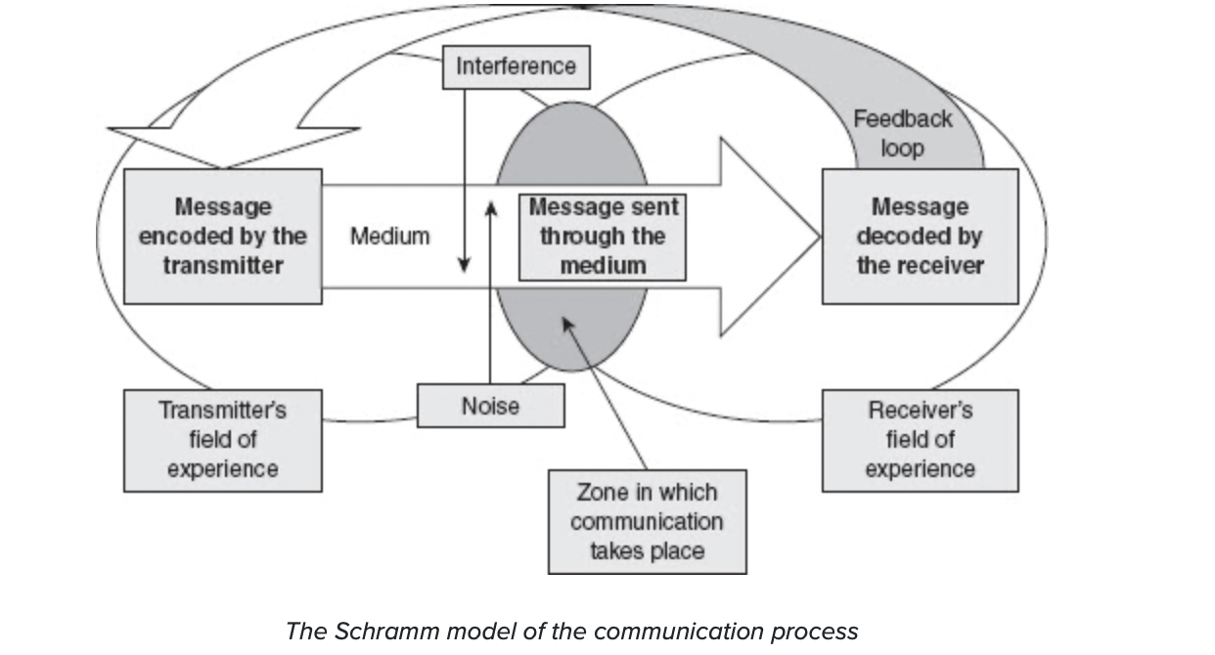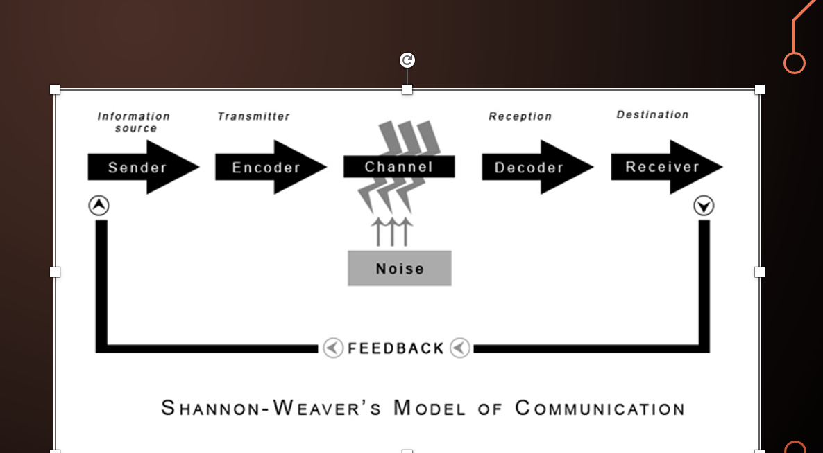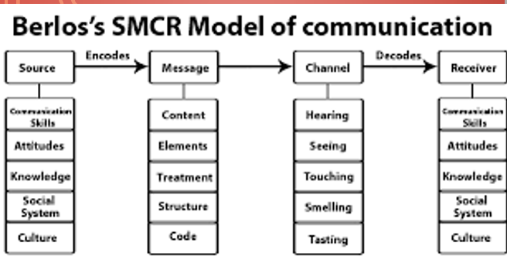

The benefits and drawbacks of contemporary communication technology.

Technology used in modern communication has both benefits and drawbacks. The advantages of communication technology are as follows. First off, it improves office productivity (Jun et 2018). The organization's production grew as a result. The second benefit is that the organization's services are of higher quality. As a result, in this instance, the clients are pleased with the services and advantages the company offers. People can communicate both within and outside of the office thanks to modern communication technology. By allowing people to share across the continent, it also strengthens the organization's network capabilities. These foster even more job flexibility.
There are a number of drawbacks to modern communication technologies in the office or in the business. First off, obtaining the equipment needed to support the communication process is more expensive when employing modern communication technology. The cost of these gadgets is typically high, and they need maintenance to stay current. Technology used for communication also diverts attention at work. People might, for instance, use their cell phones at work, further disrupting the workflow and the efficiency of the company. Staff training is also necessary for the operation of communication technology devices. Finally, there is a significant likelihood of security issues with these gadgets. This may lead to the storage of sensitive information in these devices; as a result, certain people may have access to the report, which could further affect the recorded information.
Poor Communication Examples

In the workplace, effective communication is crucial since it affects the success of the company. Efficient internal communication among staff members is a crucial component of effective communication in the workplace because it encourages employee engagement, guarantees teamwork, and supports the vision and mission of the business. When there is a gap between what is understood and what is said, there is a breakdown in the communication process at work, which is referred to as poor communication. It also develops from a lack of mutual understanding between the group's members, particularly between the leaders and the employees.
Poor communication can manifest itself in the workplace in a variety of ways, which can seriously hurt the employees. Here are some instances of improper workplace communication. First of all, there is frequently a lag between leaders and followers in an organisation. It is common for many employees to complain that the leaders of an organisation don't promptly connect with the members. This might occur. If the managers fail to address some concerns that the workers have, or if the managers lack the information to do so.
Lack of accountability in the communication process is another illustration of bad communication in the workplace. This happens particularly when nobody wants to suggest a particular circumstance. This is also determined by the type of leadership that is present in a certain company. The presence of remote workers in an organisation comes in third. These workers typically need regular communication and open communication, which might be difficult to achieve in a particular firm. The last issue is the presence of confusion in a workplace's communication system. This typically happens when members are not given the necessary information in a timely manner. For instance, leaders might not inform members of organisational change at the appropriate time or members might hear rumours about the change. This lowers staff morale and could also spread mistrust, fear, and misunderstanding among the group's participants.
Poor communication has a number of negative effects on a business, including the following: it makes employees more negative, which further reduces productivity. The second benefit is that it helps lower employee absenteeism and morale at work. When there is excellent communication, workers typically feel a sense of belonging to the company. Employee turnout may be low as a result of its absence. Thirdly, it results in poor workplace relationships. This is a result of the lack of a sense of community among employees.

How to Improve Communication Issues

Ineffective communication at a company can be reduced in the following ways: First, leaders need to be aware of their audience and their needs. This entails giving the staff greater consideration and emphasising with them (SICRE & ACCOUNTANTS, 2022). By doing this, the needs of the employees are met. Second, leaders must convey facts to members at the appropriate times and with the appropriate messages. The embers are kept updated as a result. Third, a business should employ the right channels for communication. Contact should also be established in order to find solutions to issues within the organisation.

In summary, there are three fundamental models of communication that assist individuals in communicating more effectively with one another. Listening, being straightforward, being able to communicate non-verbally, verbally, and non-verbally, and being able to keep one's emotions in check are all essential components of effective communication, which are facilitated by various communication skills. Regarding the role of technology in communication, there have been numerous advantages brought about by technological advancements, which have contributed to an enhanced communication process.

References:
Jun, Q., Chao, H., Yunhan, Y., & Jizui, Q. (2018, August). Application of modern communication technology in smart home system. In 2018 IEEE International Conference on Information and Automation (ICIA) (pp. 1577-1581). IEEE.
SICRE, M., & ACCOUNTANTS, C. (2022). THE PITFALLS OF POOR COMMUNICATION. Strategic Finance.
Lin, Y., & Guo, L. (2018). A review of the linear, interactive, and transactional models of communication. Frontiers in psychology, 9, 1213.
Wang, Y., & Shen, J. (2019). Theories and models of communication. International journal of communication, 13, 3808-3824.
Chen, G., & Yang, Y. (2020). A review of the linear, interactive, and transactional models of communication. Frontiers in psychology, 11, 547.
Deng, Y., & Sun, J. (2021). Theories and models of communication. International journal of communication, 15, 486-502.
Li, X., & Zhao, X. (2022). A review of the linear, interactive, and transactional models of communication. Frontiers in psychology, 13, 809.
Ludlow, R. and Panton. F. (1992) The Essence of Effective Communication. New York. Prentice Hall.
Maund, A.,Schriek M. and Tinkler, P. (2017) Certificate in Higher Education: Skills for the Workplace. London; Sage Publications.
Weiswasser, S.A. (1997). Role of Technology in Communication. Fordham International Law Journal. 21, (2) 14.
Rodat, S. (2019). Listening in verbal communication: Aspects regarding active listening in theoretical models of social work. Annals of the University of Craiova for Journalism, Communication and Management, 5(1), 139-158.

