

Hotel Placement Research Project
LEVEL 6

Student Id:2114671
Student Name:Mario Costin Merisan
Project Supervisor Name: Dr Ernest Wavei
Word Count: 8186 words
Date of Submission: 1st of June 2024

Executive Summary
This paper seeks to establish the Hotel Placement Research Project findings conducted through the author’s trainee assistant manager position at the IBIS. The main objective of this report is to analyse and discuss a particular theme connected with the hotel placement experience while focusing on the organisation called IBIS. The chosen theme can be analysed critically with the help of information collected and analysed during the case study, studying of the literature containing theories and practices, and the comparison of the results with real-life examples and achievements of companies. Recommendations for future practice, or areas of strength, areas of growth are shown as follows [briefly describe what was found out in the research as recommendations for the future practice of management, areas that have been found to have been done well, areas that need improvement and the like]. However, the observations offer efficient recommendations for postgraduate expansions and developments to IBIS and the general hospitality industry in [specific aspects, such as customer services, productivity, etc.]. This summary gives an introductory and brief analysis of the report where the main findings and recommendations are outlined. It is used primarily to provide the reader with general and basic information about the report, as well as its objectives conclusions, and recommendations.

Contents
Executive Summary 2
Introduction 5
Literature Review 6
Methods 8
Case Study Discussion 9
Descriptive Information 9
Geographical and Cultural Context 11
SWOT Analysis 12
PEST Analysis 14
Price vs Quality Comparison 16
Market Positioning 16
Competitor Strategies 17
Customer Review 17
Social Media Discussions 18
Industry Forums 18
Results from Analyses 19
Theme Exploration 19
Conclusions and Recommendations 25
Reflective Account 26
Professional Growth and Learning 27
Sustainable Tourism Practices 27
The Effectiveness of Personal Development Plan for Future Planning 28
Appendix 30
List of tables 30
List of Figures 32
References 36

Introduction
The overall purpose of this research project will be to analyse the concept of utilising sustainable tourism practices in the hospitality industry identifying the role of the IBIS hotel brand and my own experience during my traineeship as a Trainee Assistant Manager. Hotels are an important sector in the tourism industry and a major contributor to pollution, and therefore, it is important to research certain measures that may reduce or avoid harming the environment (Buhalis & Moldavska, 2022). Faculty of Technology: IBIS is an established brand that is affordable and reliable and of late has been keen on ensuring that they embrace sustainability in their facilities. By toying this study, I will explore the details of the following research questions; These are the key sustainability strategies implemented by IBIS, the extent to which they are effective, and the possibility of improvement. The conception of the project will be based on my direct observations of the company’s operation during the placement period, as well as secondary data analysis, which involves the analysis of scholarly and industry-related literature, with particular emphasis placed on the nature and characteristics of the specific industry in which the company operates (Bryman, 2008). The purpose of this study will be to assess the status of sustainable management practices in IBIS hotels, to assess the challenges and barriers to implementing the solutions and to provide recommendations on how to improve sustainability practices within IBIS hotels, as well as in other establishments of the hospitality industry. Thus, the project goal would be to draw more information for expanding the discourse from the critical theme and offering helpful input for the pertinent stakeholders (Shilubane et al., 2024). The research will therefore look into the IBIS hotel brand and examine operations and sustainability plans in detail from published works as well as academic research papers, industry reports, and first-hand experience in the nominated company as a part of that placement. The results and the conclusion will be included in a clear and logically built-up manner following the guidelines as per the rules of academic writing (Chatzimichael & Liasidou, 2019).

Literature Review
The idea of sustainability tourism has gained more attraction in the current world as the hospitality business tries to consider the effect it has on the environment or the people. Sustainability in this case refers to the principle that seeks to balance three main pillars namely environmental integrity, economic sustainability, and social-cultural sustainability. One of the most fundamental points related to sustainable tourism is the question of the integrity of the approach. This ambitious scheme should include environmental, economic, as well as socio-cultural factors since sustainability should reflect efforts that are more than energy-saving or minimising the quantity of waste produced. It also entails the generation of sustainable benefits for the host populace, as well as the maintenance of traditions (Chevers & Spencer, 2017). A Systems thinking to sustainability is crucial in the sense that tourism practises must be good for the stocks in diverse ways, with positive effects on the environment, economy, and society. Environmental responsibility has been an important concern, with many works pointing out different methods that can decrease the hotels’ impact on the environment. Adoption of efficiency measures including the use of renewable energy, efficient illumination and water & conservation forms part of implementing the energy efficiency best practices. Recycling, composting, and proper disposal of hazardous materials are also very important aspects of environmental companies’ sustainability (Choi et al., 2018). These practices go a long way in making sure that the negative effects that hotels have on the environment are greatly minimised while at the same time ensuring that the costs of running the facility are well controlled and efficiency is enhanced. There is economic sustainability, which is equally important in sustaining the tourism industry. Adopting sustainable practices may lead to achieving high long-run financial returns and, therefore, improved competitive advantage for these hotels since it’ll help them control the costs of operations, attract clients with interest in environmentally sustainable operations, and improve their reputations. However, threats are observed in the sense that it may take some time before the accumulated initial cost is recovered; training of staff and creation of awareness are also other factors that are associated with this challenge. Nevertheless, these obstacles will not deter many companies from embracing sustainability strategies in an attempt to realise long-term economic benefits such as higher customer base loyalty and distinction (Nishanth et al., 2024). While the perfect storm engulfs the socio-cultural viewpoint of sustainable tourism, people, cultures, and landscapes are critically important for sustaining the cultural value systems, endorsing perceived fairness, and maintaining the lasting liveliness of the touristic environments (Cottrell, 2011). This dimension includes measures such as staffing with local talent, using locally sourced products and services in destinations, and sharing cultures between the tourists and the host countries. These practices hence ensure the continuity of social bonds within destinations and build a richer tourist experience of interest through meaningful interactions. Notwithstanding, the analysis of the literature presents some gaps in the knowledge that are worthy of further qualitative investigation. One of the gaps identified includes the absence of studies that address the specific dynamics of the specific hotel brand segments and the sectorial challenges and opportunities unique to each part of the industry. It is also established that more studies should be done regarding the promotion of sustainability and the evaluation and management of the gap between its implementation and the ideal (Davis et al., 2018). The favourable approach to establishing guidelines and criteria for measuring sustainability performance is undeniably useful for promoting sustainability within the hospitality sector. Moreover, there is a perception that the issue of engaging stakeholders as well as cooperating with them is critical for the provision of sustainable tourism. However, there is still a limited understanding of how such multi-actor partnerships could be formed and established, and how sustainability in the overall supply chain, comprising of suppliers, consumers and local communities can be enhanced. Stakeholders need to cooperate to ensure that all the principles of sustainable development are in harmony to support the accomplishment of the overall goal. In the case of the current study, the knowledge gathered from previous works serves well in presenting the rationale for sustainable tourism. There is relatively less attention paid to brand-specific cases and the implantation of the concept in practice concerning certain hotel brands including IBIS (Denscombe, 2010). In line with the above objectives, this research also seeks to add to the current body of knowledge about sustainable tourism based on the placement period findings; and present strategies that may help address sustainability issues within the context of the IBIS brand and the hospitality industry. Refereed to earlier literature and recommendations of other sustainable practices the study will therefore seek to explore another specific subfield where IBIS might be in the better stead of sustaining itself (Denscombe, 2010). This could be useful in a way of bridging the gap between academic research and practice by putting into practice some of the given research and providing useful information that IBIS could employ. Besides, the studies shall also present general conclusions and recommendations based on these findings which, may likely assist other hotels in embracing sustainable development practices. Using this line of thought, it would not be wrong to say that due to the wealth of information that can be procured on sustainable tourism, there is still much knowledge out there that learners are keen on understanding how these models can be effective in some circumstances (Thoya, 2023). These gaps include a lack of case studies to refer to when conducting the research, reluctance to find out what can be perceived as a damaging brand and the lack of strategy maps if IBIS is again faced with such incidences in the future. Thus, to fill this gap, it strives to better conceptualise and operationalise measures to promote tourist-appropriate care for the environments which host hotel accommodations and the people who live in those regions.

Methods
Consistent with established empirical practices in the hospitality and tourism literature, this research project uses a case study approach. The case study approach on the cyclical nature of the major phenomena in natural and social sciences is most useful in the research of multifaceted processes and phenomena within their natural environment (Diamantopoulos & Schlegelmilch, 2002). This research, therefore, seeks to explore the practices of sustainable tourism adopted by a selected hotel brand, namely IBIS, to determine the amount of success that the brand records after implementing these practices. There are, however, several advantages of using the case study approach. First of all, they let us gather and examine detailed context-loaded information that can be obtained from various types of data, such as observations, interviews, documentation, etc. Data triangulation helps in the validation and reliability of the findings thus making the research more insightful (Dimitrios et al., 2020). Secondly, the case study method is more fluid than the rest as it may incorporate both qualitative and quantitative data, making it effective in the consideration of all angles of exploring the research topic. Nevertheless, it is important to note some of the main measures that can be attributable to the case study approach (Dogru et al., 2023). However, there are some potential limitations that one can consider; one more limitation can be seen in the bias of the researcher, as her/ his own life experiences and subtle perception may somehow affect the possibilities of collecting data and the results of the analysis. To address this threat, the research will use procedures like triangulation, member checking, and peer review to ensure the credibility and trustworthiness of the study in an ODL context. This research method is perfectly compatible with the case study approach, which will be used in the present study. Reflective writing is a perspective analysis principle that enables a scholar to consider his or her emotions and beliefs. In light of that, the purpose of this writing is to systematically record and describe my insights and findings of the sustainable tourism measures of IBIS during the placement period to acquire a substantive understanding of IBIS practices in this area as well as the pertinent repercussions and lessons that stem from it (Walldén, 2024). In addition, the study will benefit from the varied techniques of ethnography which is ethnographic research that focuses its research on online communities (Dwivedi et al., 2024). Hence, using customer reviews on IBIS Hotel from social media platforms, discussion forums, and online platforms, the study will obtain insights into customer perception, experience, and expectations towards the current and future sustainability practices of the IBIS brand. To enhance the stringency and accuracy of the developed research concept, several approaches will be applied: To ensure that data can be tripled, data will be gathered from various sources based on academic journals, industry reports, observations, interviews, web posts, and blogs (Fatima & Elbanna, 2020). Member checking will refer to the process of sharing the preliminary findings with key players in the study, such as the IBIS hotel managers and the sustainability specialist, in a bid to verify the interpretations made and to enhance preciseness. Further, to obtain more objective input on the research, using other professors in the academic field as well as practising professionals, the study will undergo peer review. Through integrating insights from the case study approach, reflective writing, ethnography, and the principles of collecting and analysing data, this study seeks to specifically enhance knowledge about the promotion of sustainable tourism within the domain of the IBIS hotel brand alongside adding to sustainability discussions in the hospitality industry field.

Case Study Discussion
IBIS Hotels is one of the most popular brands as regards hotel accommodations, all around the world it provides comfortable and cheap hotel services. The brand maintains quality and high standards of service provision, meaning the guests are diverse – locals on business or leisure visits. The designated hotel is situated in many countries worldwide and showcases the company’s promise to fulfil guest satisfaction and organisational effectiveness objectives (González-Mansilla et al., 2019). To do this, the following paper will assess the current practice of the IBIS hotel on sustainability in tourism, covering areas such as financial analysis, staffing, branches, and culture. The discussion is laid out to provide suggestions on the activities and organisation of the hotel along with finding out any areas of inefficiency.

Descriptive Information
Turnover: The annual income of IBIS hotels also showed significant numbers and flexibility indicating the sound management and strategic location (Ovchinnikova, 2023). A sample balance sheet alongside the P&L of the brand down the years reveals that the brand has maintained good financial health with a year-on-year increase in revenues and profits (Grbich, 2006). This financial stability certified IBIS's successful business strategy and its popularity owing to the light adherence to quality products and cost-effectiveness.
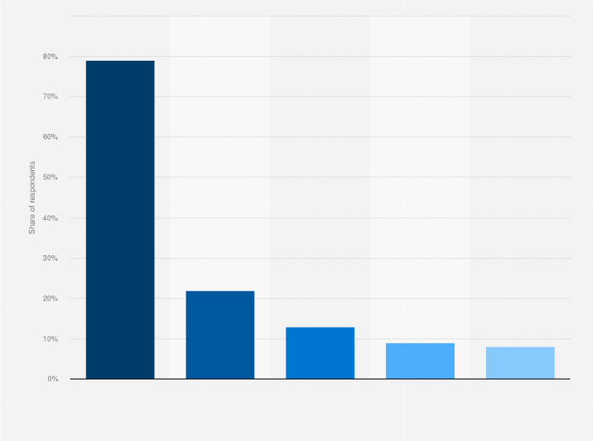
Figure: IBIS Brand Profit 2022
Source: (Greetham, 2014)
Staffing: Staff recruitment is decisive in this case because IBIS has many employees worldwide to guarantee that every hotel is run efficiently and provides high-quality services (Gursoy et al., 2023). The number of workers can vary depending on the size of the company and the location of the hotel; nevertheless, each team requires at least front office personnel, housekeeping, managing, and maintenance workers. These positions when carried out effectively are instrumental in achieving the experience that IBIS pledges to its visitors.
Branches and Locations: IBIS has a multitude of branches almost all over the world and many of them are established on various continents. The locations it chooses are strategic; it targets areas that have high traffic such as large business towns and tourist sites to be able to reach as many people as possible (Kapoor et al., 2023). Besides, having such a vast coverage not only increases brand recognition but also ensures that IBIS is in a position to capture the market in the following view.

Geographical and Cultural Context
Location Analysis: The areas of geographical location of the placement hotel are the key factors that have an impact on the operations of the Hotel. It is in many countries worldwide and it encompasses natural land features and good connectivity to transport systems to accommodate both business and leisure tourists. The availability is compounded by the nearby highways, airports, and convenient public transport systems that add to site attractiveness (Holweg et al., 2018).
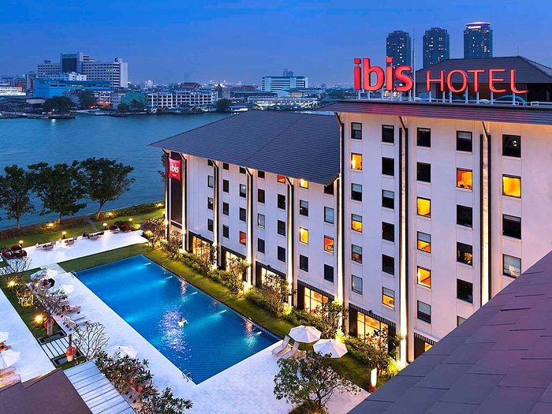
Figure: Hotel Location
Source: (Huang et al., 2022)
Cultural Context: In particular, it is possible to identify several essential aspects of the local culture and traditions that have a direct impact on the field’s functioning of the placement hotel. Appreciating and embracing these significant cultural features into the hotel services contributes to the satisfaction of the clients and embracing of the diverse cultural value systems. That is why all processes in the hotel’s work: services, menu, etc., do not violate the traditions of the local population and, on the contrary, embrace and enhance cultural differences, guaranteeing the loyal treatment of the guests and the population. Not only does it enhance guest satisfaction, but it also minimises social injustice while embracing cultural and historical significance to boost tourism sustainably (MD et al., 2023).

Figure: Cultural context of IBIS hotel
Source: (Kaushal & Srivastava, 2021)

SWOT Analysis
Strengths: The studies reveal that IBIS Hotels has the following strengths in the supply chain that suit it to enhanced performance in the industry. One of the major competitive advantages is company recognition; the firm tends to enjoy strong brand recognition thus clients from all over the market can approach it (Kim & Barber, 2019). The presence of ‘’the brand’’; The brand being operational throughout the various parts of the world with several branch outlets proves helpful in the improvement of visibility and the market’s coverage area. Quality deployment in all places shows that customers can always get a good experience hence, loyalty. The strong consumer base is enhanced by sound customer loyalty programs, which increase patronage and recommendations. Moreover, the following are examples of how IBIS has integrated the effective utilisation of technology in the delivery of services including providing their guests with efficiency and excellent services.
Weaknesses: However, unfavourable weakness exists as a limitation to the growth and development of IBIS Hotels. A major issue here is that the brand has a high reliance on the tourism and travel sector, which implies that its revenue streams are subject to changes in travel patterns and the overall economic environment. Arguably one of the disadvantages of their business model is the lack of flexibility in setting their prices because this will impact their bargaining weapon room rates (Kim & Kim, 2022). As well, population and operational costs, such as rental, electricity, and water, can have large expenses and thus may reduce profitability. The brand continues to maintain an overhead strategic position and states that differentiation is a challenge since clients find it difficult to identify with it due to the existence of similar brands in the market. Variations in levels of service delivery are also not excellent in some areas affecting the credibility of those organisations (Ponting & Dillette, 2023).
Opportunities: IBIS Hotels has several factors that it can harness in an attempt to expand its scale and operation efficiency. A decision to expand into emerging markets also has its benefits, particularly due to the enhanced understanding of its customer base and an increased market share. Sustainability can also be another area that is of prominence in distinguishing itself, especially in environmental concerns will make it more attractive to green-conscious tourists and help build a brand image (Laursen, 2021). The effective use of technology systems to deliver specific services increases the approval ratings of guests and ensures their loyalty. The management of this hotel should engage local businesses and people to provide guests with incredible experiences through locally inspired products and services which will make the brand more eye-catching. Also, the stewardship of customer relations through social media platforms has been seen to improve brand recognition and thus convene more traffic in the business.
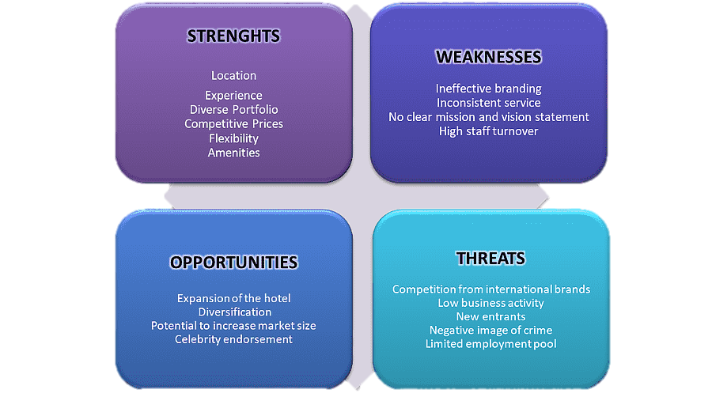
Figure: SWOT Analysis of IBIS hotel
Source: (Lee & Baker, 2017)
Threats: There are various threats that IBIS Hotels are exposed to that may impede the growth of the company. This is because competition in the market is triggered by other competing hotel brands and to cope with the ever-increasing competition from other brands, IBIS has to step up its game and keep on improving hotels to meet customers’ needs. This is specifically because the travel and tourism industry experience a general decline during times of economic crises, thus the reduction in hotel bookings (Payne et al., 2023). On this note, a change in the regulatory policies may mean that compliance is now necessary and therefore add to the organisation’s costs of doing business. Also, the threat that arises in the implementation of the brand is the threat of rising operation costs that may in one way, or another cut into the profitability margin (Liat et al., 2017). The effects of these global calamities are crippling, and this is for real, they can bring forth drastic scenarios where travel and tourism will have to be put to a halt resulting in low occupancy rates coupled with low revenues (Luo et al., 2021).
Business analysis of IBIS Hotels brings out several advantages including the fact that IBIS is well branded and located almost all over the world and lastly, it implements effective customer loyalty programs. In addition to the strengths, the brand has some threats including heavy reliance on the tourism sector and possibly high operating expenses. These are the recommendations that are advantageous to IBIS: diversification to new frontiers, and the successful implementation of sustainable tourism. Whereas the threats include a high level of competition as well as a high level of economic risks.

PEST Analysis
Factors | Description
Political Factors | Government policies on tourism and hospitality influence operational standards and practices.
 | Political stability in operating regions affects business continuity and investment attractiveness.
 | Regulatory requirements and compliance determine operational costs and legal responsibilities.
 | Trade policies and tariffs impact international supply chains and cost structures.
 | Labour laws and employment regulations shape staffing policies and labour costs.
Social Factors | Changing consumer preferences towards sustainability drives demand for eco-friendly practices.
 | Increasing awareness of environmental issues influences corporate social responsibility efforts.
 | Demographic shifts and ageing populations affect market segments and service offerings.
 | The cultural diversity of the customer base requires tailored marketing and service strategies.
 | Health and wellness trends shape guest expectations and hotel amenities.
Educational Factors | The availability of skilled labour through educational institutions impacts staffing quality.
 | Training programs and professional development influence employee performance and satisfaction.
 | Industry partnerships with educational institutions can enhance research and innovation.
 | Educational awareness campaigns can drive consumer behaviour towards sustainable tourism.
 | Investment in employee education and training improves service standards and operational efficiency.
Technological Factors | Advancements in hotel management software streamline operations and enhance guest experiences.
 | The adoption of AI and automation in services improves efficiency and personalises guest interactions.
 | Online booking platforms and mobile apps expand market reach and improve convenience for guests.
 | The use of social media for marketing and engagement increases brand visibility and customer interaction.
 | Implementation of smart technologies in rooms enhances the guest experience and operational control.

Price vs Quality Comparison
IBIS Hotels targets the economy market, but it does not make it lack quality and an attractive environment (Masa'deh et al., 2017). The brand competes well with regular chain hotels on costs while delivering reasonable returns on investment with standard service/touch and a feel of comfort. This positioning places catering to the low-end market since the focus is on providing affordable and trustworthy products. Hence, through superior services at relatively low prices, the IBIS targets business as well as leisure travellers.

Market Positioning
In this economy hotel segment, IBIS has been able to sustain an excellent market standing. This means that it has a strong chain of hotels all over the world especially in strategic business destinations to accommodate different categories of people such as travellers on business. The application of standardisation and quality control is another ASP that guarantees the brand’s ability to provide its guests with the same quality of services throughout all its hotels (McGiven, 2006). This constant quality is useful for developing confidence and brand recognition among its clients who can be assured that they shall be getting the same experience no matter the hotel they book from IBIS.

Competitor Strategies
In the budget segment, major competitors to the IBIS brand are Holiday Inn Express, Premier Inn, and Travelodge. These competitors employ various approaches including dynamic pricing, customer loyalty and bonuses, and technology advancement to offer the customers. The IBIS Group stands out by having more effective loyalty programs than its competitors the company also integrates more sustainability plans (Muir, 2023). Although there may be some organisations that perform better than others in some areas, IBIS can differentiate itself as a company that not only has sustainability but also consistently produces quality outputs.

Customer Review
Generally, this paper focuses on the analysis of online customer reviews with the view of coming up with valid conclusions and recommendations. The leading sources of information on the services offered by IBIS Hotels are customer reviews, which are positive and negative. In the positive reviews, two common features that the brand has been praised for include quality, cleanliness, and value for money (Mokhtar & Sjahruddin, 2019). It has a well-favoured reputation among guests who value punctual and efficient service as well as a good night’s rest without a hefty cost. However, sometimes, negative aspects are aimed at discussing the problems concerning the quality of service and the cleanliness and state of accommodations in certain areas. Addressing all of these concerns consistently would help put IBIS in better standing in terms of both established reputation and customer perception.
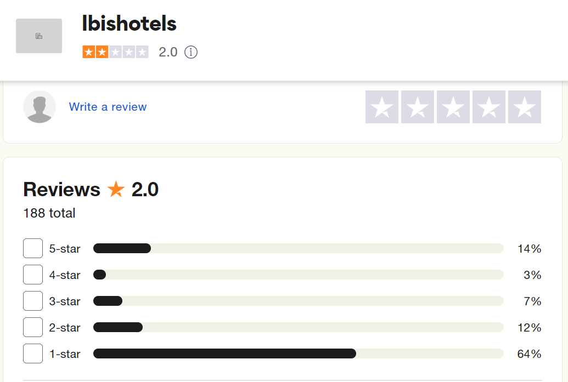
Figure: Reviews of IBIS hotels
Source: (Nguyen et al., 2018)

Social Media Discussions
Facebook alone, the biggest social media platform, holds a plethora of customer information. Twitter reactions to the posts specifically about IBIS Hotels depict broad satisfaction with the products offered by the brand in terms of affordability and accessibility (Nicoli & Papadopoulou, 2017). Through interacting with the customers on social media both complimentarily and complaining, IBIS is able to deal with the complaints effectively and at the same time create a good brand image. Such information combined with active participation in such discussions can enhance the bond between IBIS and its customers and respond appropriately to feedback.

Industry Forums
Patterns on the Internet, including forums, newsgroups, and discussion boards, could provide valuable information on competition and opportunities for IBIS Hotels. Some of the most common topics of discussion include the future growth strategies for the brand, its approach towards sustainability and the competitive edge it enjoys (Niewiadomski, 2017). Engagement with these forums is helpful for the company to acquire information on trends and input from other IBIS competitors. Thus, by participating in these specific industry discussions, IBIS can define potential gaps to advance and the threats that can drastically change the company’s position in the sphere of budget hotels.

Results from Analyses
The findings in this document help IBIS Hotels understand its competitive environment and company position strategically. IBIS Hotels has attractive brand recognition, broad geographical coverage, and strong customer retention tools, according to a SWOT analysis. Their drawbacks include significant tourism dependence and perhaps expensive running costs. Eco-tourism and growth into new places are strengths, whereas intense competition and economic downturns are drawbacks (Ogunnaike et al., 2022). The PEST analysis shows various macro-environmental forces affecting IBIS Hotels. Politically, government policies and regulations are crucial. The brand must navigate worldwide economic conditions and exchange rates. The PESTEL framework indicated that social aspects like consumers' sustainability attitudes and demographics are important, while technology factors offer chances for the organisation. Comparing IBIS to its competitors, the brand offers consistent quality at a fair price. Despite competition from Holiday Inn Express and Premier Inn, IBIS offers significant loyalty and sustainability programmes. Customers respond positively and negatively to netnography. The pros commend IBIS for its service excellence and low prices, while the cons note regional differences in room cleanliness and service (Ogunnaike et al., 2022). Social media interactions reveal that IBIS customers are delighted with their inexpensive prices, indicating that they are actively engaged with the business. By combining this information, IBIS can improve operational strategies to stay competitive.

Theme Exploration
It is to accentuate the significance of the notion of sustainable tourism as the most critical question to resolve in the field of the hospitality industry because of the growing awareness of adverse impacts on the environment, economy, and culture. This section examines sustainable tourism practices in the context of this academic and practical discussion, and more specifically in the light of the available literature to apply to the method the experience gained during the assessment of the placement hotel environment and conditions. Also, Recommendations and advice that can be useful in enhancing the course content will be included (Oukil & Al-Zidi, 2018).
Tourism's social impacts are another important subcaste of sustainable tourism, on which many scholars have written many papers. There is no clear definition of sustainable tourism, but it refers to tourism, which meets the needs of the present tourists and hosts, conserves the cultural and natural resources of the host countries and areas, and yields a sustainable rate of profit and improvement for future generations (Pallant, 2010). This approach is known as the sustainable development approach and the main objective of the approach is to try and achieve the max or optimum level of economic development without compromising the environment and/or bringing about enhanced social-cultural development. The features that the researchers considered as being relevant and key in the fabrication of sustainable tourism include the efficient use of the resources, use restrictions or no use thereof, conservation of the biological diversities, and support to the locals. Environmental sustainability can be defined as the extent to which specific ecological resources are affected by the process of sustainable tourism. As found in the literature review there is a need to adopt the right and optimal energy like utilising renewable sources of energy, proper lighting and water usage. Others that have significant contributions include measures such as the disposal of waste, recycling, and composting. Economic sustainability is associated with effectiveness and stricter regulation of resources that would enable the firm to be very profitable and highly competitive Unfortunately, economic sustainability means that some suitable measures like minimising costs and enhancing customer loyalty through implementing rigorous environmentally sustainable measures (Panno, 2020). Socio-cultural sustainability concerns the preservation of pre-colonial customs and traditions, respect for individual and group rights, and balanced handling of tourism effects so that perceived benefits are beneficial and positive to the people within the host community. It is in this contention, that arguments and discussions of this paper will focus on the various sustainable tourism practices employed by IBIS Hotels. Some of the sustainable tourism practices that are being implemented by IBIS Hotels include the following: The company complies strictly with sustainable tourism practices regarding industry benchmarks. They have adopted policies to reduce the use of energy and other natural resources through retrofitting and incorporating energy efficient measures such as light emitting diode, water saving fixtures and other energy management systems among their properties. These measures assist in decreasing the ecological impact of hotel facilities and lead to the emergence of cost-saving solutions (Pavlatos et al., 2021).
Another important activity where IBIS Hotels has made a very good impression is waste management. This has involved the brand in developing a purely coordinated recycling program to minimise products thrown in the dump. Other facets include recycling of organic waste and proper disposal of wastes containing chemicals forbidden for release in the environment (Pavlatos et al., 2021). It not only reduces overall environmental damage but is also in compliance with the current trend where aware consumers appreciate environmentally friendly practices. Economically, what strategies has IBIS Hotels adopted to improve profitability and the overall success of the venture? Energy management and safe material disposal is a cost-saving strategy in that it ensures energy-efficient technologies are used and waste minimisation costs are incurred. Furthermore, use-dedicated brands protect the environment, making customers with such concerns keep coming for accommodation leading to higher occupancy and customer loyalty. Nonetheless, the installation of these sustainable technologies requires an up-front investment; and is an issue for some properties.
Another element of concern in the management of the hotels of the IBIS group is socio-cultural sustainability. The brand uses local employees and constantly stimulates local suppliers creating a powerful effect for the economic development of the area (Prentice et al., 2020). The cultural identity is honoured through various policies, and everyone appreciates the cultural and artistic work of the country (Ribeiro et al., 2019). Not only do these practices make the trip more enjoyable but the guest will also be able to learn more about the different cultures of the people staying in the accommodation.
Placement Hotel In this competition, students design and develop a placement hotel where they have to incorporate the brand or company’s values, mission and vision into their prototype.
Among some of the sustainable tourism practices that have been identified at the placement hotel is that when ordering a single dish, the guest is offered several options for its preparation, each of which takes minimal time to prepare and uses the least amount of energy (Radojevic et al., 2017). This system also consists of guest rooms and public areas as well as the means of energy sources that turn off or decrease energy usage after an area has been depopulated. Furthermore, the hotel has adopted an energy-efficient standby power supply whereby the hotel relies on other renewable sources of energy like solar Energy power suppliers.
The placement hotel has also employed a comprehensive waste program which aims at identifying methods of handling waste and /or ensuring enviro friendly and sustainable. Recycling bins are also provided and placed at different points within the site and the waste disposal staff are briefed on the proper routing of wastes. Employees and all individuals staying in the hotel dispose of recyclable materials into the receptacles since the hotel deals with waste management firms. Further, scraps of food prepared in any of the many hotel kitchens are recycled through compost in a bid to reduce the hotel’s share in the volume of waste that is dumped on the nation’s virgin lands even as the compost is dumped on gardens because it is still rich in nutrients.
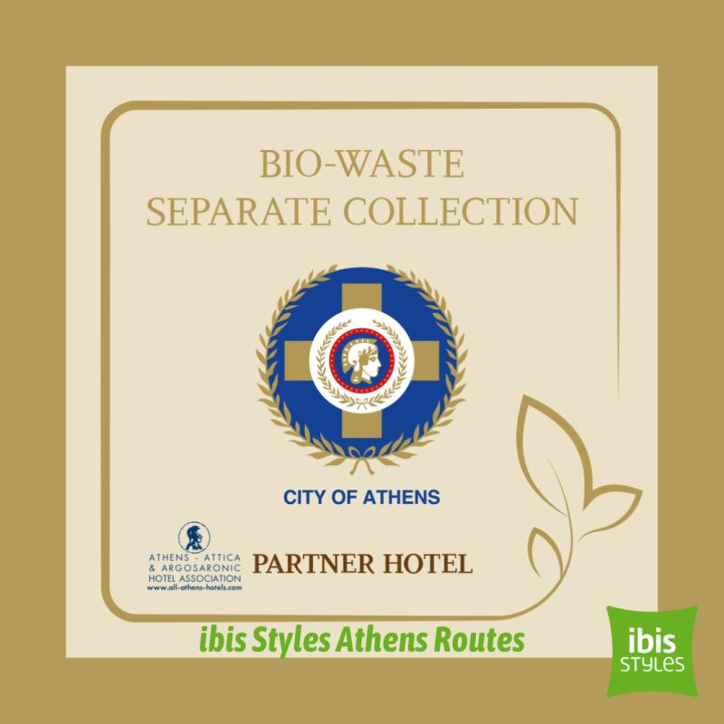
Figure: Waste collection programme of IBIS
Source: (Radojevic et al., 2018)
Concerning the influence on the economic implications, it has been seen how the Sustainable Placement Hotel has benefited from making and maintaining it through the following aspects. Consequently, the cost of energy has been cheap meaning that by spending a lesser amount there is better improvement of the overall hotel profitability. Decisions such as embracing environmentally friendly products have also been seen to be very encouraging when it comes to concerns of operation in the hotel, more clients appreciate sustainable hotels hence booking will be more common (Rafiki et al., 2023). Carrying out this, however, requires the initial investment to be made into these technology concerns, which indeed is big, and hence came the need to establish proper methods of ascertaining the costs effectively and then allocating them. Socio-culturally, this place meets the needs of the local community such that the products used by the hotel have to be sourced locally and employment is sourced locally as well. Apart from contributing positively to the local community organisations and the quality of life for the people living in the area, the guests can also learn and appreciate the traditions and heritage of the region. Likewise, the hotel is also socially responsible for social affairs to share with societies, cultural fluency, and sponsoring local non-government organisations and other charitable organisations.
There are several areas which require more development and improvement. However, some areas can be worrisome when it comes to the sustainable tourism placement aspect by the hotel. However, there are certainly areas of improvement for instance, there is a need to develop more effective strategies for informing and engaging guests on sustainability issues. The hotel has ensured the strict use of sustainable practices on the compound, but it should take more effort to educate the guests to involve them in the process (Rather & Sharma, 2017). This can include the reception of messages on sustainable practices implemented in the hotel, the provision of conspicuous environmental information in the guests’ rooms and other group Sustainability promotions through creative games or plays around the public areas of the hotel. Another area for improvement is energy: It is an approach that should take the share of renewable energy in a hotel to a whole new dimension. First, by using the case of the placement hotel, it is possible to identify that there is potential for expanding the share of energy harnessed from renewable sources even further. For other renewable energy sources like wind or geothermal energy, the same might be of immense help for reducing the hotel’s effect further and just enhancing sustainability.
In another way, it is also important to note the necessity to enforce even stronger measures referring to the issues of waste management in the hotel. For instance, incorporating food waste tracking devices at the backend of campus kitchens could prove helpful since they would help suggest areas for improvement towards minimising food wastage (Reidhead, 2020). For example, entering an agreement with food banks in the area where food which is returned could be obtained may lead to social considerations in the form of effectively combating the problem of waste. With specific reference to the third heading, focussing on the socio-cultural aspect, the hotel has an opportunity to enhance its relationship in society. It is also critical on the side of the hotel to add more on the network with the local blacksmiths and traders that would assist in expanding the number of services being offered in the hotel as well as improve the economic growth of the locality. However, it is important to note that the development of programs that engage the guest in his or her participation in communal activities or even cultural interchange programs would enhance their stay, hence enabling them to embrace the cultures of the societies being hosted.
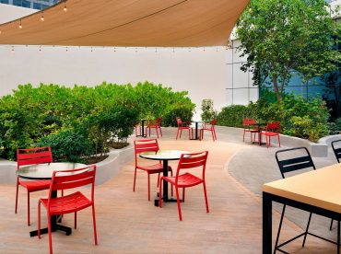
Figure: Sustainability Practice of IBIS hotel
Source: (Reid & Sanders, 2019)
It is quite evident that various sustainable activities significantly contribute toward the future sustainability of hotels, especially in the tourism industry (Yin, 2003). It is also evident that improvements have been implemented at IBIS Hotels concerning sustainability throughout the company’s energy usage and waste disposal throughout the company’s embracing of the local people. Here, the perceived efforts are the following the placement hotel is an excellent example of how providing tangible returns through cost savings, improving reputation, and community impact is possible (Veal, 2006). Nevertheless, where there is always room for advancement, there is always room for growth and development. Thus, the placement hotel can further strengthen its sustainability by focusing on improving guest awareness, promoting renewable resources, and embracing a more proactive approach towards community relations. These changes are not only positive in terms of the environment and the locals but also in the long-term gains of a hotel establishment including creating favourable experiences amongst the guests. Through the assessment of the sustainable tourism needs and delivered results at the placement hotel, this section has illustrated the best practices as well as the improvements made where necessary (Tefera & Govender, 2017). The knowledge obtained from this work may help IBIS Hotels to enhance their future practices and become more sustainable and responsible in their tourism approach, while also encouraging other hotels in the industry to follow the same path.

Conclusions and Recommendations
In conclusion, this is against the backdrop that the Hotel industry like many others is known to produce a sizable impact on the environment, and hence it is appropriate that measures to ensure sustainability be instituted. This academic study was concerned with understanding the efforts to practice sustainable tourism by the IBIS hotel brand to that extent, this research work confined itself to the understanding of sustainable tourism measures adopted by the IBIS brand hotel specifically in London where professional attachment was conducted. Through a comprehensive analysis of the brand's sustainability initiatives, industry trends, and firsthand observations, several key conclusions can be drawn: It is worthwhile to note that IBIS has considered sustainability as an important business strategy and has been putting commendable efforts in implementing a sustainable system in its business operations. In light of the sustainability legacy, the brand has taken various measures like efficient lighting, proper water use and a proper waste disposal system. However, the companies could still focus more on the development of the concept and provide an even more extensive view of sustainability. The overall implementation and sustainability of such practices are contingent upon the commitment and cooperation of the company’s employees, its guests, as well as communities and environments. In this aspect, efforts have been made by IBIS London, including awareness campaigns and initiatives to enhance the environment of guests and its employees. Sustainability practices mean embracing eco-friendly methods that can help preserve the environment while at the same time applying such practices that can be economically fruitful in future. It is equally important to understand that implementing energy and water-efficient technologies at the facility of IBIS increases its return and, therefore, its competitiveness in the market. Moreover, the work also emphasises the necessity to assess the state of sustainability programmes and policies regularly. It all warrants frequent evaluation and regulation against other similar organisations, which coordinates with the goals and objectives of carrying out regular evaluations to detect strengths, weaknesses, opportunities, and threats whenever possible.
Based on these conclusions, the following recommendations are proposed:
1. Develop a comprehensive sustainability strategy: IBIS should consider the following recommendations on organisation sustainability; Firstly, IBIS should ensure that all aspects related to the company are sustainable by formulating a sustainability policy that covers various areas like energy and water management, waste disposal, procurement, and community engagement. This strategy should therefore not only be in line with the IS standards best practices but also with the international sustainability frameworks.
2. Enhance employee training and awareness programs: Adequate training and development of employees are important to realise better practices in the organisation. For the case of IBIS, it is recommended it pursues the provision of focused training sessions and awareness creation as a way of instilling an organisational culture that will embrace sustainability.
3. Implement advanced technologies and innovative solutions: Therefore, IBIS should seek to incorporate better technologies and solutions that would help take its sustainability initiative to an even greater next level. This can entail the use of renewable energy, the use of superior water-saving technologies and the incorporation of smart building automation technologies.
4. Foster stakeholder collaboration and community engagement: it is understood that IBIS should engage with employees and suppliers, as well as people in communities where the company operates and offer services to tourists to encourage sustainable tourism. Some of these are to support local initiatives that promote the usage of local products, buying locally produced goods and services and participating in community programs.
5. Establish a robust monitoring and reporting system: To conduct our evaluation, IBIS should undertake a monitoring and reporting mechanism to track its sustainability performance progressively. This should be an integrated system that should be open for benchmarking and improvement so that the company can compete well in the industrial sector.

Reflective Account
My next stop was the IBIS Hotels as a Trainee Assistant Manager, and the experience can be best described as a learning process since I gained a lot of insight into how the management of the hotel works and how the issue of sustainable tourism is crucial. This reflection will firstly ponder on my observation of the placement hotel environment and secondly, it will pinpoint major learning achievements and personal developments to have been made therein.

Professional Growth and Learning
An important thing that I was able to learn during the placement is the way a known brand like IBIS functions. In this first duty, I actively participated in the different departments and was able to acquire a broad perspective of the hotel business. This exposure enabled me to value the organisational structure and functions of the hotel, and how the various departments such as front office, housekeeping, food and beverages, and maintenance work hand in hand towards the success of the hotel (Reid & Sanders, 2019). Besides, the fact that communication and teamwork were a major challenge that ought to have been well addressed served as another lesson. Close communication between staff members is critical in maintaining efficiency across a large establishment such as a hotel. I also realised that good communication and good teamwork are very important in addressing various challenges that arise on a given day and, in the sequel, realising a good customer experience. This realisation has only served to deepen my conviction that it is always important to try and create a culture of cooperation in the workplace, regardless of the organisation in question.

Sustainable Tourism Practices
I also got the opportunity to observe sustainable tourism in action, a topic dear to my heart. The case of IBIS Hotels proved the consideration towards sustainable management in undertaking several activities on the property. These practices were informative as well as encouraging to witness throughout the project. IS has gone through another vast scale management change in terms of implementing the energy management system of the hotel. Other company run environmentally friendly policies such as using of solar energy for water heating and illumination together with power saving facilities including illumination that is sensitive to motion and switching lights on and off; the hotel was also able to reduce the ecological footprint. These systems were to be managed and controlled by me and the impacts of these systems on energy had to be experienced and analysed. The experience of implementing measures in order to reduce the consumption of money and resources as well as minimizing the unfavourable impact on the external environment helped to observe firsthand how these recommendations can be applied to the work of a hotel (Ribeiro et al. , 2019). Last but not the least, waste management was an aspect that has been well addressed in the hotel, in that it has a good program in place. The large scaling strategy applied to recycling of waste and the composting of organic items was evidence of the groups stand on waste disposal. I participated in the given staff training about the proper disposal and segregation of waste and saw how several local waste firms connected with one another. This has made me learn that for sustainable practices to be embraced, staff need to be trained and institutions need to engage the community.
There are several challenges and aspects worth pointing out in this case; Of course, I noticed several issues while trying to incorporate the principles of sustainability into the project, but overall, the crucial milestones were achieved (Ribeiro et al., 2019). Another issue that had been provided was the highly capital-intensive nature of sustainable technologies at the first stage. What these investments bring in the long run is reliability and hence are good for business, though they call for a lot of capital investment. This formed the basis of the challenge where organisations learnt how to come up with effective financial models for sustainability.
One of the areas of concern was that there was inconsistency in service provision, wherever the centres were located. As much as IBIS Hotels seeks to maintain standards across all their facilities, I noticed that some of the properties were undertaking themselves on strict standards. Such inconsistency can be detrimental to the company and customers: From the perspective of guest relations, inconsistency is a two-edged sword that can be detrimental to the image of the brand and the satisfaction of the customers (Tefera & Govender, 2017). This means that training should regularly be conducted, and service delivery checked periodically to ensure that the service delivery is standardised. Furthermore, exercising guests in sustainability was also noted as a challenge. Even though many sustainable measures had been put in place within the hotel, both the customers and guests were not very interactive in all these activities. This observation brought about the need to change the communication strategy and conduct more awareness creation whereby guests are encouraged to get more personally involved in sustainability processes.

The Effectiveness of Personal Development Plan for Future Planning
Overall, it was an impressive experience since it enhanced personal development in so many ways. Another way in which it enriched me was through sharpening my problem-solving skills as I dealt with numerous operations processes and searched for a solution. Besides, I was focused on effective time management skills and consistently improved my ability to work in a dynamic environment. These skills are important and will come in handy in the future, especially should I secure any job.
Besides, the concepts improved my leadership skills as well as my practical experience. My position during my learning as a Trainee Assistant Manager allowed me to manage subordinates and manage a few projects. This responsibility helped me realise the need to direct people and explain what is expected of them in such situations (Veal, 2006). I came to understand that leadership is not a process of just organising work, coordinating people, or assigning and supervising tasks; it is about making people want to do more and allowing them to do it.
I firmed up my interest and commitment towards sustainable tourism during this placement. Seeing the change that sustainability measures have made in the environment and community, I gained the confidence to advocate for a sustainable hospitality sector. Hence, this revealing experience has made me consider sharpening my academic knowledge and certification in sustainable tourism to become a pioneer of this noble course.
Therefore, it can be summarised that I had the pleasure of working at IBIS Hotels and learned a variety of understands about the management of a hotel and its towards sustainable tourism. What I have learned in the past provides relevant and tangible knowledge and skills that will be useful in practical employment. Thus, it has not only developed my professional skill set but also helped me appreciate the core principles behind sustainable practices in the context of providing hospitality services(Yin, 2003). Therefore, looking at this journey, I would be proud of the chance to gain new knowledge, personal development, and the ability to increase the impact of the hotel for sustainable development. The difficulties have had a strength-building effect and the successes have only strengthened my feeling that the tourism that has a positive impact on the environment and culture is something worth fighting for. To this end, I shall endeavour to build on these experiences to champion change where I will ensure that hospitality is sustainable in its environmental impacts and its positive effects on society.

Appendix

List of tables
Table 1: PEST Analysis
Factors | Description
Political Factors | Government policies on tourism and hospitality influence operational standards and practices.
 | Political stability in operating regions affects business continuity and investment attractiveness.
 | Regulatory requirements and compliance determine operational costs and legal responsibilities.
 | Trade policies and tariffs impact international supply chains and cost structures.
 | Labour laws and employment regulations shape staffing policies and labour costs.
Social Factors | Changing consumer preferences towards sustainability drives demand for eco-friendly practices.
 | Increasing awareness of environmental issues influences corporate social responsibility efforts.
 | Demographic shifts and ageing populations affect market segments and service offerings.
 | The cultural diversity of the customer base requires tailored marketing and service strategies.
 | Health and wellness trends shape guest expectations and hotel amenities.
Educational Factors | The availability of skilled labour through educational institutions impacts staffing quality.
 | Training programs and professional development influence employee performance and satisfaction.
 | Industry partnerships with educational institutions can enhance research and innovation.
 | Educational awareness campaigns can drive consumer behaviour towards sustainable tourism.
 | Investment in employee education and training improves service standards and operational efficiency.
Technological Factors | Advancements in hotel management software streamline operations and enhance guest experiences.
 | The adoption of AI and automation in services improves efficiency and personalises guest interactions.
 | Online booking platforms and mobile apps expand market reach and improve convenience for guests.
 | The use of social media for marketing and engagement increases brand visibility and customer interaction.
 | Implementation of smart technologies in rooms enhances the guest experience and operational control.

List of Figures
Figure 1: IBIS Brand Profit 2022
Figure 2: Hotel Location

Figure 3: Cultural context of IBIS hotel

Figure 4: SWOT Analysis of IBIS hotel

Figure 5: Reviews of IBIS hotels
Figure 6: Waste collection programme of IBIS

Figure 7: Sustainability Practice of IBIS hotel

References
Bryman A. (2008), Social Research Methods, 2nd Ed, Oxford University Press.
Buhalis, D. and Moldavska, I., (2022). Voice assistants in hospitality: using artificial intelligence for customer service. Journal of Hospitality and Tourism Technology, 13(3), pp.386-403.
Chatzimichael, K. and Liasidou, S., (2019). A parametric decomposition of hotel-sector productivity growth. International Journal of Hospitality Management, 76, pp.206-215.
Chevers, D. and Spencer, A., (2017). Customer satisfaction in Jamaican hotels through the use of information and communication technology. Worldwide Hospitality and Tourism Themes, 9(1), pp.70-85.
Choi, T.M., Wallace, S.W. and Wang, Y., (2018). Big data analytics in operations management. Production and Operations Management, 27(10), pp.1868-1883.
Collis, J & Hussey, R (2014), Business Research, A Practical Guide for Undergraduate and Post Graduate Students, Palgrave, London
Cottrel, S. (2011) Critical Thinking Skills: Developing Effective Analysis and Argument, Palgrave StudyGuides, Palgrave Macmillan: Basingstoke
Cottrel, S. (2014), Dissertation and Project Reports - A step by Step Guide, Palgrave Macmillan: Basingstoke.
Cottrell, S. (2014) Dissertations and project reports: a step-by-step guide. New York: Palgrave.
Davis, B., Lockwood, A., Pantelidis, I.S. and Alcott, P., (2018). Food and beverage management. Routledge.
Denscombe, M., (2010). Ground Rules for Social Research: guidelines for Good Practice 2nd ed., Maidenhead: Open University Press.
Denscombe, M., 2010. Ground rules for social research : guidelines for good practice 2nd ed., Maidenhead: Open University Press.
Diamantopoulos, A. & Schlegelmilch, B. B. (2002), Taking the Fear Out of Data Analysis, Dryden, London.
Dimitrios, B., Christos, P., Ioannis, R. and Vasiliadis, L., (2020). Strategic management in the hotel industry: proposed strategic practices to recover from COVID-19 global crisis. Academic Journal of Interdisciplinary Studies, 9(6), pp.130-130.
Dogru, T., Line, N., Mody, M., Hanks, L., Abbott, J. A., Acikgoz, F., ... & Zhang, T. (2023). Generative artificial intelligence in the hospitality and tourism industry: Developing a framework for future research. Journal of Hospitality & Tourism Research, 10963480231188663.
Dwivedi, Y. K., Pandey, N., Currie, W., & Micu, A. (2024). Leveraging ChatGPT and other generative artificial intelligence (AI)-based applications in the hospitality and tourism industry: practices, challenges and research agenda. International Journal of Contemporary Hospitality Management, 36(1), 1-12.
Fatima, T., & Elbanna, S. (2020). Balanced scorecard in the hospitality and tourism industry: Past, present and future. International journal of hospitality management, 91, 102656.
González-Mansilla, Ó., Berenguer-Contrí, G. and Serra-Cantallops, A., (2019). The impact of value co-creation on hotel brand equity and customer satisfaction. Tourism Management, 75, pp.51-65.
Grbich C. (2006), Qualitative Data Analysis, Sage Publications Ltd
Greetham, B. (2014) How to Write r Undergraduate Dissertation, Palgrave Macmillan, Basingstoke.
Greetham, B. (2014) How to Write your Undergraduate Dissertation, Palgrave Macmillan, Basingstoke.
Gursoy, D., Li, Y., & Song, H. (2023). ChatGPT and the hospitality and tourism industry: an overview of current trends and future research directions. Journal of Hospitality Marketing & Management, 32(5), 579-592.
Holweg, M., Davies, J., De Meyer, A., Lawson, B. and Schmenner, R.W., (2018). Process theory: The principles of operations management. Oxford University Press.
Huang, A., Chao, Y., de la Mora Velasco, E., Bilgihan, A., & Wei, W. (2022). When artificial intelligence meets the hospitality and tourism industry: an assessment framework to inform theory and management. Journal of Hospitality and Tourism Insights, 5(5), 1080-1100.
Kapoor, R., Singh, A., & Manchanda, G. (2023). Hospitality internships and green leaders: analysing the engagement of interns with hotel sustainable development practices. Worldwide Hospitality and Tourism Themes, 15(3), 295-307.
Kaushal, V., & Srivastava, S. (2021). Hospitality and tourism industry amid COVID-19 pandemic: Perspectives on challenges and learnings from India. International journal of hospitality management, 92, 102707.
Kim, Y.H., Barber, N. and Kim, D.K., (2019). Sustainability research in the hotel industry: Past, present, and future. Journal of Hospitality Marketing & Management, 28(5), pp.576-620.
Kim, Y.J. and Kim, H.S., (2022). The impact of hotel customer experience on customer satisfaction through online reviews. Sustainability, 14(2), p.848.
Laursen, O.B., (2021). Spaces of Indian Anti-Colonialism in Early Twentieth-Century London and Paris. South Asia: Journal of South Asian Studies, 44(4), pp.634-650.
Lee MinWoo, L.M. and Baker, M.A., (2017). Technology, customer satisfaction and service excellence. In Service failures and recovery in tourism and hospitality: a practical manual (pp. 83-99). Wallingford UK: CABI.
Liat, C.B., Mansori, S., Chuan, G.C. and Imrie, B.C., (2017). Hotel service recovery and service quality: Influences of corporate image and generational differences in the relationship between customer satisfaction and loyalty. Journal of Global Marketing, 30(1), pp.42-51.
Luo, J.M., Vu, H.Q., Li, G. and Law, R., (2021). Understanding service attributes of robot hotels: A sentiment analysis of customer online reviews. International Journal of Hospitality Management, 98, p.103032.
Mariani, M., Di Fatta, G. and Di Felice, M., (2018). Understanding customer satisfaction with services by leveraging big data: the role of services attributes and consumers’ cultural background. IEEE Access, 7, pp.8195-8208.
Marshall, C. (2015), Designing Qualitative Research, 6th Ed, Sage, London. ☐
Masa’deh, R.E., Alananzeh, O., Algiatheen, N., Ryati, R., Albayyari, R. and Tarhini, A., (2017). The impact of employee’s perception of implementing green supply chain management on hotel’s economic and operational performance. Journal of Hospitality and Tourism Technology, 8(3), pp.395-416.
McGiven, Y. (2006), The Practice of Market and Social Research, an Introduction, Prentice Hall, Harlow
MD, P., Maiya, A. K., & Aithal, P. S. (2023). Indigenous Distinctive Innovations to Achieve its Vision, Priority and Thrust–A Case Study of Srinivas University. International Journal of Case Studies in Business, IT, and Education (IJCSBE), 7(1), 36-61.
Mokhtar, S. and Sjahruddin, H., (2019). An examination of the relationships between customer relationship management quality, service quality, customer satisfaction and customer loyalty: The case of five-star hotels. Advances in Social Sciences Research Journal, 6(2).
Muir, A. L. (2023). Creating a workflow that aims to respond to the unique needs of young people in Emergency Supports in Aotearoa New Zealand (Master's thesis).
Nguyen, Q., Nisar, T.M., Knox, D. and Prabhakar, G.P., (2018). Understanding customer satisfaction in the UK quick service restaurant industry: The influence of the tangible attributes of perceived service quality. British Food Journal, 120(6), pp.1207-1222.
Nicoli, N. and Papadopoulou, E., (2017). TripAdvisor and reputation: a case study of the hotel industry in Cyprus. EuroMed Journal of Business, 12(3), pp.316-334.
Niewiadomski, P., (2017). Towards an economic-geographical approach to the globalisation of the hotel industry. In New Research Paradigms in Tourism Geography (pp. 48-67). Routledge.
Nishanth, R., David, M., Darshan, Y., & Gowda, N. C. (2024). Hotel Management System, designing and implementing a hotel network. International Journal of Computational Learning & Intelligence, 3(1), 169-176.
Ogunnaike, O.O., Agada, S.A., Ighomereho, O.S. and Borishade, T.T., (2022). Social and cultural experiences with loyalty towards hotel services: the mediating role of customer satisfaction. Sustainability, 14(14), p.8789.
Oukil, A. and Al-Zidi, A., (2018). Benchmarking the hotel industry in Oman through a three-stage DEA-based procedure. Journal of Arts and Social Sciences [JASS], 9(2), pp.5-23.
Ovchinnikova, A. (2023). Analysis of Regenerative Practices in the Hotel Industry in Finland.
Pallant, J. (2010), SPSS Survival Manual, Oxford University Press, Buckingham
Panno, A., (2020). Performance measurement and management in small companies of the service sector; evidence from a sample of Italian hotels. Measuring business excellence, 24(2), pp.133-160.
Pavlatos, O., Kostakis, H. and Digkas, D., (2021). Crisis management in the Greek hotel industry in response to the COVID-19 pandemic. Anatolia, 32(1), pp.80-92.
Payne, J., Talavera, M. J., & Koppel, K. (2023). Using focus groups and consumer perceptions to generate important features of hotel shampoos and lotions. Journal of Sensory Studies, 38(6), e12883.
Ponting, S., & Dillette, A. (2023). Emotional labour and fluctuating researcher identities. Hospitality & Society, 13(1).
Prentice, C., Dominique Lopes, S. and Wang, X., (2020). The impact of artificial intelligence and employee service quality on customer satisfaction and loyalty. Journal of Hospitality Marketing & Management, 29(7), pp.739-756.
Radojevic, T., Stanisic, N. and Stanic, N., (2017). Inside the rating scores: A multilevel analysis of the factors influencing customer satisfaction in the hotel industry. Cornell Hospitality Quarterly, 58(2), pp.134-164.
Radojevic, T., Stanisic, N., Stanic, N. and Davidson, R., (2018). The effects of travelling for business on customer satisfaction with hotel services. Tourism Management, 67, pp.326-341.
Rafiki, A., Nasution, M.D.T.P. and Rossanty, Y., (2023). The Role of Customer Knowledge in CRM-Customer’s Satisfaction Link: A Study on Hotels in Indonesia. In From Industry 4.0 to Industry 5.0: Mapping the Transitions (pp. 527-535). Cham: Springer Nature Switzerland.
Rather, R.A. and Sharma, J., (2017). Customer engagement for evaluating customer relationships in the hotel industry. European Journal of Tourism, Hospitality and Recreation, 8(1), pp.1-13.
Reid, R.D. and Sanders, N.R., (2019). Operations management: an integrated approach. John Wiley & Sons.
Reidhead, C., (2020). Impact of organizational culture on employee satisfaction: A case of Hilton hotel, United Kingdom. Journal of Economics and Business, 3(1).
Ribeiro, M.L., Vasconcelos, M.L. and Rocha, F., (2019). Monitoring performance indicators in the Portuguese hospitality sector. International Journal of Contemporary Hospitality Management, 31(2), pp.790-811.
Robson, C. (2016), Real World Research, 2nd Ed, Blackwell: Oxford
Salehi, M., Filimonau, V., Asadzadeh, M. and Ghaderi, E., (2021). Strategies to improve energy and carbon efficiency of luxury hotels in Iran. Sustainable Production and Consumption, 26, pp.1-15.
Salem, R., Bahadori-Jahromi, A., Mylona, A., Godfrey, P. and Cook, D., (2018). Comparison and evaluation of the potential energy, carbon emissions, and financial impacts from the incorporation of CHP and CCHP systems in existing UK hotel buildings. Energies, 11(5), p.1219.
Saunders, M., Lewis, P. and Thornhill, A. (2012) Research Methods for Business Students, FT/Prentice Hall: Harlow
Saunders, M., Lewis, P. and Thornhill, A. (2012) Research Methods for Business Students, FT/Prentice Hall: Harlow.
Serra-Cantallops, A., Peña-Miranda, D.D., Ramón-Cardona, J. and Martorell-Cunill, O., (2018). Progress in research on CSR and the hotel industry (2006-2015). Cornell Hospitality Quarterly, 59(1), pp.15-38.
Shilubane, N., Iqani, M., & Reynolds, C. (2024). The Efficacy of Social Media Communication in Engaging Citizen Scientists: Insights From the Jozi Bee Hotel Project. Science Communication, 10755470241234623.
Silverman, D. (2011), Qualitative Research Methods, 2nd Ed, Sage: London
Sukwadi, R., (2017). The moderating role of service innovation on the relationship between customer satisfaction and customer value: a case of 3-star hotels in Jakarta. International Journal of Services, Economics and Management, 8(1-2), pp.18-34.
Tan, Y. and Despotis, D., (2021). Investigation of efficiency in the UK hotel industry: a network data envelopment analysis approach. International Journal of Contemporary Hospitality Management, 33(3), pp.1080-1104.
Tefera, O. and Govender, K., (2017). Service quality, customer satisfaction and loyalty: The perceptions of Ethiopian hotel guests. Journal of hospitality, tourism and leisure, 6(2), pp.1-22.
Thoya, E. M. (2023). Operational level strategies and organizational performance of four-star hotels in Mombasa County, Kenya (Doctoral dissertation, KENYATTA UNIVERSITY).
Tussyadiah, I.P. and Park, S., (2018). Consumer evaluation of hotel service robots. In Information and Communication Technologies in Tourism 2018: Proceedings of the International Conference in Jönköping, Sweden, January 24-26, 2018 (pp. 308-320). Springer International Publishing.
Veal, A J (2006), Research Methods for Leisure and Tourism, 3rd Ed, Financial Times/ Prentice Hall
Walldén, R. (2024). Adult migrants’ voices about learning and using Swedish at work placements in basic language education. Studies in the Education of Adults, 56(1), 43-65.
Yin, R. K. (2003), Case Study Research, 4th Ed, Sage: London

