Modern and Mass produced
Archaic and Individually Inscribed
Are we losing the sancity of burial through atomising modernity and capitalism??

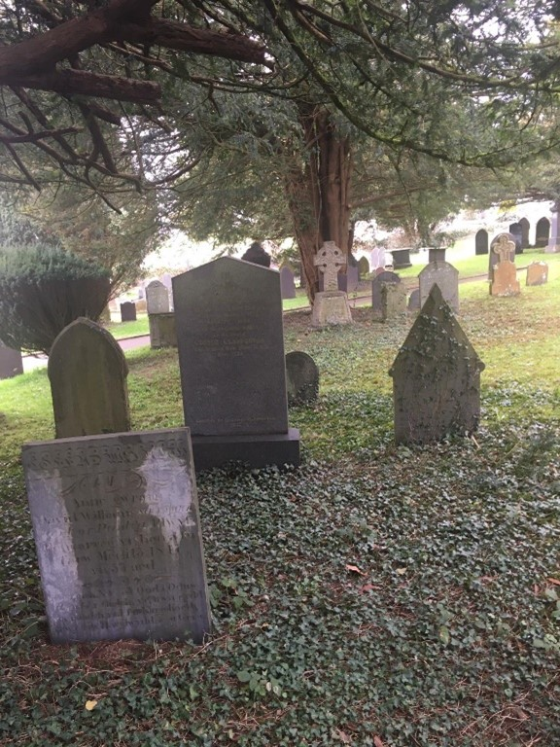
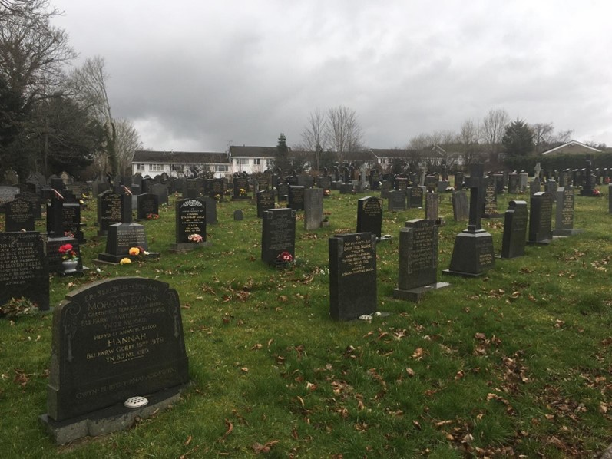
Is Induviduality The Problem?

