Recognizing What Leadership Is Needed at the Golden State Warriors

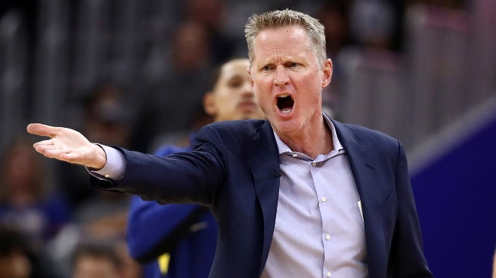
When Steve Kerr first became the coach of the Golden State Warriors basketball team, he saw the need for some changes. He wanted to steer away from the tendency for new leaders to announce that they want to change the culture, since that can be insulting. Instead, Kerr focused on key areas, such as that the team was last in their league in the number of passes. Kerr set a goal for the team to get to the top five teams in passes by striving for 300 passes per game. Kerr’s efforts seemed to pay off. During Kerr’s first season as the Golden Warriors’ coach, the team had their best record in the team’s sixty-nine-year history and one of the best seasons in NBA history.
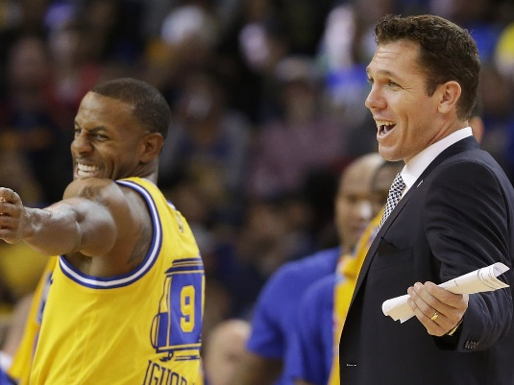
The very next season, Kerr had terrible back pain. It was so bad, in fact, that he missed the first forty-three games of the season. Kerr relied on his top assistant, Luke Walton, to coach in his absence. The team’s record with Walton at the helm was incredible: 39 wins, 4 losses. During the playoffs in a later season, another assistant (Mike Brown) oversaw 12 wins and no losses. While Walton and Brown certainly deserve credit for their efforts, Kerr had worked on developing and empowering both assistants and provided advice as a mentor.

When the Golden State Warriors struggled in early 2018, Kerr decided that what was needed was for the players to coach themselves. On the morning of a game against the Phoenix Suns in February 2018, Andre Iguodala was put in charge of a practice and JaVale McGee oversaw the computer while other players analyzed film during a team meeting. Then, in the game that evening, Iguodala, David West, and Draymond Green took turns coaching during timeouts while Green (who was injured) was in charge of overseeing the team during much of a game. Kerr explained these coaching moves in these words: “I have not reached them for the last month. They’re tired of my voice. I’m tired of my voice. ... We just figured it was probably a good night to pull a trick out of the hat and do something different. ... As coaches, our job is to nudge them in the right direction, guide them, but we don’t control them. They determine their own fate.” That trick seemed to work. That night, the Warriors beat the Suns by more than 40 points. 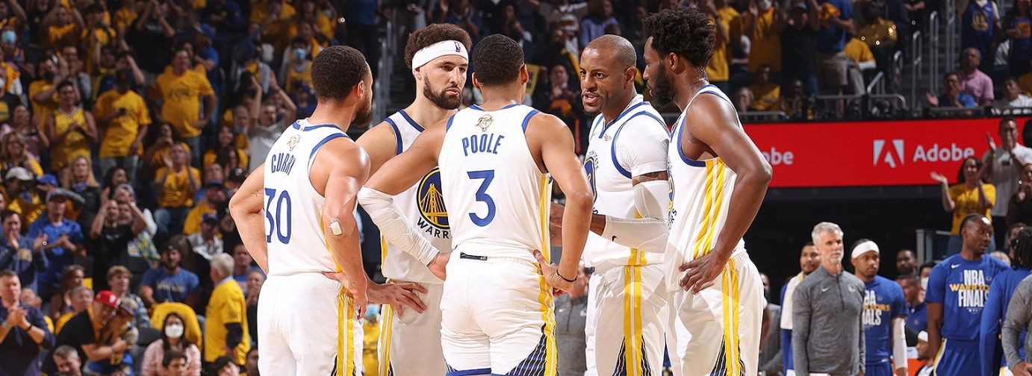
Another aspect of Kerr’s leadership is that he stands up for what he believes in. Reporters have asked him questions about how current events are affecting his team. He easily could have dismissed the questions, especially when they were asked of him shortly before a game. Most coaches are silent when asked controversial questions out of concern about what team owners or sponsors will think. Instead, Kerr took the time to explain his position and what he thinks is right. As Bob Myers, the Warriors’ general manager, puts it, “There is no hidden agenda to Steve, it’s ‘I will say what I feel and speak my mind and I’m going to try to live in that manner and try to back it up’.”

Discussion questions:
- What leadership models, theories, or concepts do you see in this case? List and describe.
- What situational conditions or leadership actions do you think are necessary for it to be effective to let players coach themselves?
- What does this case suggest about followership (and about how leaders might relate to followers)?
- What are the advantages and disadvantages involved in speaking up on current events? In what ways does this approach help and/or hurt Kerr’s strength as a leader?

Source: Robbins, S., and Coulter, M. (2021) Management, Global Edition. 15th edn. Pearson. Pp. 505-506

