

BMHP5015: Building Your Personal Brand for Sustainable Employment
Component 1 – Portfolio

Student Name: Maminata Dembele
Student Id: 2409810

Word count: 2099
Task 1 – Personal Brand
Personal branding is how an individual markets themselves‚ their skills‚ values and behaviour to the workplace․ In health and social care‚ brand building is important because employers will look for staff who are caring‚ honest‚ respectful and committed to providing high-quality care․ An established personal brand can communicate professionalism‚ ease career opportunities‚ and create and maintain relationships with employees/workers and service users (CIPD‚ 2024; World Economic Forum‚ 2023).
I think my personal brand is kindness; I'm very patient and I respect everyone․ I'm also someone who enjoys helping people achieve their goals and working within a team․ I am a good listener and I try to understand the different needs of people before making a decision․ I also think that honesty and a sense of responsibility are very important to health and social care professionals․ I know I still need to work on my confidence delivering group sessions‚ my public speaking and my knowledge of digital health care technologies‚ which are becoming more important as the health and social care sector continues to develop and change with the introduction of new digital technologies (Skills for Care‚ 2024).
I will also focus on professional development courses‚ volunteering in community care‚ going to careers fairs and improving my LinkedIn profile․ My goals also include reflecting on my experiences so that I can improve on skills such as communication‚ leadership and decision making․ These actions will help me build a professional identity that is committed to safe‚ compassionate and person-centred care․

Task 2 – Network Map and Rationale
Network Map
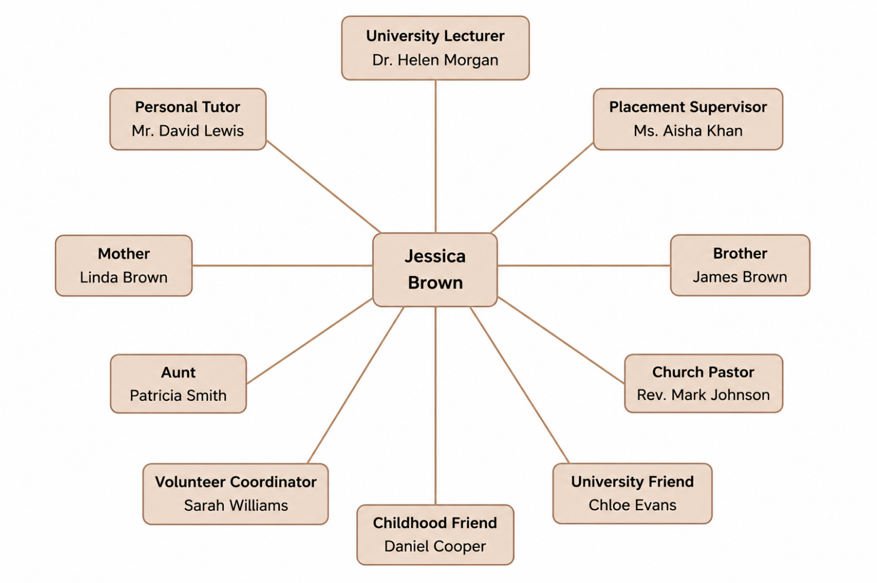

Rationale
I have called my network a selective network because I have selected the people in my network based on whether their involvement is helping me achieve my personal‚ academic and career goals․ Everyone in my network is contributing something different towards enabling me to achieve my career goal of becoming a Senior Support Worker (SSW) in healthcare․ My family‚ like my mother‚ brother‚ and aunt‚ inspires‚ advises‚ and supports me in my hardship and encourages me to stay motivated and focused on my academic pursuits․
My university lecturer‚ personal tutor and placement supervisor help me gain professional knowledge‚ develop practical and theoretical skills‚ and prepare for employment in the health and social care sector․ They have given me confidence and realistic expectations of what it means to care for a patient․ My church pastor‚ volunteer coordinator‚ and friends help me grow as a person‚ in resilience‚ and in community service․
I have a strong network of professional contacts‚ although I do need to develop my professional links further‚ especially with health care managers‚ NHS staff‚ and other professional bodies․ I will build relationships and increase my understanding of potential jobs and employability by attending NHS careers fairs‚ volunteering‚ joining professional groups on LinkedIn and discussing career options with healthcare professionals on my placements․ Expanding my network will give me better professional identity and enable me to gain confidence and career development opportunities in the UK health and social care sector (CIPD‚ 2024; World Economic Forum‚ 2023).

Task 3 – Blog
Supporting University Students' Mental Health: Why It Matters
Target Audience: University Students
Although life on campus can be exciting‚ it can also be stressful․ Stress‚ anxiety‚ homesickness and academic pressure are common feelings while students adjust and acclimatise to university life․ It is important to maintain mental health as well as physical health‚ as this can have an important impact on learning‚ relationships and wellbeing․ According to the Office for National Statistics (2024)‚ mental wellbeing remains an important area of focus for young adults who are experiencing educational and financial pressures․
Factors such as managing homework‚ part-time employment‚ debt‚ and family responsibilities and obligations can affect students' mental health․ Some students can feel lonely when moving away from home‚ or can struggle to form new friendships when beginning their studies․ If not initially addressed‚ issues like these can lead to problems with academic performance. Universities and the NHS offer a range of services for students with mental health difficulties‚ including counselling services and wellbeing teams‚ peer support and NHS Talking Therapies․ You should never feel embarrassed to ask for help․ Providing early support can stop things getting worse․ You could also try moving more‚ eating healthily‚ and getting enough sleep․ Talking to friends or family members you can trust is also good for mental health (NHS England‚ 2024).
As a part of the university community‚ you can help by looking out for your friends‚ discussing mental illness and breaking down the stigma associated with mental health․ Universities should continue to provide accessible mental health services that are appropriately suited to students' needs. Taking care of your mental health is an important part to sustaining a healthy and successful time at university․ Seeking help at any stage can help you through a difficult time and achieve your goals both academically and personally․ It is not a sign of weakness․

Task 4 – NHS Equality, Diversity and Inclusion Quiz
1. What is the primary goal of the NHS Equality, Diversity and Inclusion Improvement Plan?
The vision is for the NHS to be a place where every NHS staff member feels respected‚ valued and included‚ and has equal opportunities to succeed‚ regardless of their background (NHS England‚ 2023).
2. How does the NHS EDI Improvement Plan propose to tackle the gender pay gap?
The NHS committed to monitoring pay data‚ improving access to career advancement‚ promoting flexible working‚ taking steps to narrow the gender pay gap․
3. What is meant by the term 'intersectionality'?
Intersectionality recognises that discrimination can occur on multiple grounds simultaneously‚ for example‚ the intersection of race with gender‚ disability‚ age or sexual orientation․
4. Why is it important for the NHS to create a psychologically safe work environment?
A psychologically safe workplace is one in which employees feel free to share ideas‚ voice concerns‚ report mistakes‚ and collaborate without fear․
5. How does the NHS EDI Improvement Plan suggest improving the experience of internationally recruited staff?
The plan recommends improved induction programs‚ mentoring and training‚ and support to help international staff feel welcome and valued․
6. What role does leadership play in advancing EDI objectives?
Leaders can create inclusive workplaces‚ set and measure equality goals‚ and foster climate in which everyone is treated with respect․
7. Identify one way the NHS EDI Improvement Plan aims to reduce health inequalities within the workforce.
The NHS seeks to improve staff access to health and wellbeing services and to promote equality of access to career development․
8. Why does the NHS EDI Improvement Plan emphasise collecting and analysing data on protected characteristics?
By collecting workforce data‚ inequities can be identified‚ monitored‚ and evidence-based interventions can be developed to increase equity․
9. Explain how flexible working policies can contribute to equality and inclusion in the NHS workforce.
Flexible working allows employees to balance work with family responsibilities‚ health conditions or personal commitments while remaining productive․
10. What is one strategy mentioned in the NHS EDI Improvement Plan to combat bullying and harassment in the workplace?
The NHS encourages inclusive leadership‚ clear lines of reporting‚ education and a zero-tolerance policy for bullying‚ harassment and discrimination․

Task 5 – A Letter to Yourself
Dear Younger Me,
Starting university was great fun and an amazing experience․ I know that a lot of the time you think that you're not good enough for university or doubt your own abilities‚ but you've been through the stress of deadlines‚ coursework‚ exams and balancing your studies with the social side of university life․ However‚ looking back‚ it probably only helped make you stronger and more determined․
On a different note, I wish you had understood emotional intelligence․ Understanding your own emotional state will help you handle stress when you feel like you are losing control of a situation. It would have enabled you to understand other people's feelings‚ and help you to communicate and resolve problems․ These are important skills for everyone who works in the health and social care sector where patience‚ compassion and respect are so important when caring for patients․
This is something I wish had been cultivated in you․ Life is full of trials․ They shouldn't prevent you from reaching your goals․ Everything is an opportunity to learn․ Whatever happens‚ see life as a learning experience‚ rather than worrying about how you messed something up‚ instead treat it as something you will learn․ So always believe that you can do it‚ and don't be afraid to ask for help when you need it․ Build a strong support network: your lecturers‚ your classmates‚ your friends‚ your family‚ because they will support you when times are tough․ My advice is to keep learning‚ stay positive‚ and always remember why you went into this profession (to help others), and you will achieve your goals․
Your faithfully‚
Your Future Self

Task 6 – Career Development Gantt Chart
Career Goal: Become a Senior Support Worker within the UK Health and Social Care Sector
Activity / Task | Description | Jan–Mar | Apr–Jun | Jul–Sep | Oct–Dec | Jan–Mar | Apr–Jun | Expected Outcome
Complete Degree | Successfully complete all university modules and assessments. |  |  |  |  |  |  | Degree achieved
Create Professional CV | Develop a tailored CV highlighting qualifications and transferable skills. |  |  |  |  |  |  | Professional CV completed
Develop LinkedIn Profile | Create and regularly update a professional LinkedIn profile. |  |  |  |  |  |  | Strong online presence
Volunteer in Community Care | Gain practical experience supporting vulnerable people. |  |  |  |  |  |  | Practical experience gained
Complete CPD Courses | Undertake safeguarding, dementia awareness and first aid training. |  |  |  |  |  |  | Professional certificates obtained
Attend Careers Events | Participate in NHS recruitment fairs and networking events. |  |  |  |  |  |  | Expanded professional network
Apply for Support Worker Roles | Submit applications for suitable vacancies. |  |  |  |  |  |  | Employment opportunities secured
Prepare for Interviews | Practise interview techniques and improve confidence. |  |  |  |  |  |  | Increased interview confidence
Secure Employment | Begin employment and continue professional development. |  |  |  |  |  |  | Career successfully started

The action plan will allow me to work towards my career goal of becoming a Senior Support Worker by completing the rest of my degree and gaining experience through volunteering and work based training over the next two years․ Building my employability skills is also a priority‚ which will involve structuring my CV‚ updating my LinkedIn page‚ networking with healthcare professionals and attending careers events to find relevant job opportunities․ Once I have found a suitable position‚ I will apply for the role and prepare for and carry out interviews as well as develop my skills further․ Completing this plan will help me to stay focused‚ organised and committed to my long-term career goals․
Task 7 – Making Changes Report
Introducing a Staff Wellbeing Programme in a Residential Care Home
Introduction
As a manager of a residential care home‚ I would aim to implement a staff wellbeing program‚ with the overall aim being to improve the health and job satisfaction of the workforce and ultimately to improve the quality of care being provided to residents․ This is due to health and social care staff experiencing stress levels due to high workloads‚ emotional demands and staffing shortages. This may improve staff morale‚ reduce sickness absence and increase retention (Skills for Care‚ 2024).
Implementing the Change
In order to implement the plan I would follow Kotter's Eight-Step Change Model․ The first step is to Create Awareness by explaining the importance of staff wellbeing to staff members and residents․ Next‚ I would get staff representatives involved in running the programme and ask for input from everyone in the organization․ Possible actions might include wellbeing workshops or support‚ flexible working where possible and team meetings around different issues․ Celebration of small wins throughout the implementation process may help keep up motivation and a desire to stay in the program process (Kotter‚ 2012).
Possible Barriers
Some staff may not participate in wellbeing‚ or may not have the time to do so‚ and may also feel that a wellbeing program is not relevant to them․ Budget restrictions may also impact what wellbeing is offered․
Recommendations
Barriers can be attacked with communication‚ visible management commitment‚ staff involvement and program assessment․ The positive changes in workplace culture are expected to increase staff wellbeing‚ increase cooperation among colleagues‚ and improve care given to residents․

Task 8 – Self-Reflection
Reflection Using Kolb's Experiential Learning Cycle
Completing this module made me realise that to be employable is not only about the knowledge you gain but also about communication skills‚ networking‚ resilience‚ leadership and personal branding․ These skills are important in order to succeed in a career in health and social care. Using Kolb's Experiential Learning Cycle I will reflect on what I learnt during this module․ In producing this portfolio I was able to identify my strengths and what I need to improve on․ This helped me to learn how professional skills can be developed and improved through experience‚ observation‚ and refinement (Kolb‚ 1984).
Perhaps the most important thing I have learnt is that specific activities like creating a personal brand‚ networking‚ and engaging in continuous professional development improve employability‚ but should be considered early in one's career․ I have also grown in confidence regarding the importance of emotional intelligence and effective communication in dealing with different people.
For the future I wish to continue to volunteer‚ enrol in professional training courses‚ network within my profession‚ and reflect on my experience to continue to improve in my practice and develop into a confident healthcare professional․ Essentially, this module has improved my confidence and my employability developing my understanding of the roles within Health & social care and developing my skills and confidence to become a reflective‚ compassionate and lifelong learner․

References
Burnes, B. (2020) 'The origins of Lewin's three-step model of change', Journal of Applied Behavioral Science, 56(1), pp. 32–59.
Chartered Institute of Personnel and Development (CIPD) (2024) Profession Map. London: CIPD.
Good Things Foundation (2024) The Digital Inclusion Blueprint. Sheffield: Good Things Foundation.
Kolb, D.A. (1984) Experiential Learning: Experience as the Source of Learning and Development. Englewood Cliffs, NJ: Prentice Hall.
Kotter, J.P. (2012) Leading Change. Boston: Harvard Business Review Press.
LinkedIn Learning (2024) Workplace Learning Report 2024. Available at: https://learning.linkedin.com (Accessed: 5 July 2026).
NHS England (2023) NHS Equality, Diversity and Inclusion Improvement Plan. London: NHS England.
NHS England (2024) Inclusive Digital Healthcare: A Framework for NHS Action on Digital Inclusion. London: NHS England.
Office for National Statistics (2024) Personal Well-being in the UK. Newport: ONS.
Office for National Statistics (2025) Labour Market Overview, UK. Newport: ONS.
Ofcom (2025) Online Nation 2025 Report. London: Ofcom.
Putnam, R.D. (2000) Bowling Alone: The Collapse and Revival of American Community. New York: Simon & Schuster.
Skills for Care (2024) The State of the Adult Social Care Sector and Workforce in England 2024. Leeds: Skills for Care.
World Economic Forum (2023) The Future of Jobs Report 2023. Geneva: World Economic Forum.
World Health Organization (2021) Global Strategy on Digital Health 2020–2025. Geneva: WHO.

