Assignment brief

You are required to choose an age group such as teenagers, young children, adults or older people and discuss the Dietary Reference Values (DRV) for this group. Outline the development of the Dietary Reference Values in the United Kingdom and the role of the Scientific Advisory Committee on Nutrition (SACN). You should also discuss the role of the Eatwell Guide for this group of people and how guidelines are turned into practical advice.

Report

This report considers the Dietary Reference Values (DRV) for teenagers in the UK and how it has evolved. In addition to this, we will also discuss the role of the Scientific Advisory Committee on Nutrition (SACN) and the Eatwell guide for this age group (11-18) as well as how guidelines are converted to practical advice.

Figure 1 - Dietary Reference Values
Age/gender | 11-14 (male) | 11-14 (female) | 15-18 (male) | 15-18 (female)
Energy (MJ/day) | 10.5 | 8.4 | 10.5 | 8.4
Energy (kcal/day) | 2500 | 2000 | 2500 | 2000
Macronutrients
Protein (g/day) | 42.1 | 41.2 | 55.2 | 45.0
Fat (g/day)[less than] | 97 | 78 | 97 | 78
Saturated fat (g/day)[less than] | 31 | 24 | 31 | 24
Polyunsaturated fat (g/day) | 18 | 14 | 18 | 14
Monounsaturated fat (g/day) | 36 | 29 | 36 | 29
Carbohydrate (g/day)[at least] | 333 | 267 | 333 | 267
Free sugars (g/day) [less than] | 33 | 27 | 33 | 27
Salt (g/day)[less than] | 6.0 | 6.0 | 6.0 | 6.0
Fibre (g/day) | 25 | 25 | 30 | 30
Source: (Public Health England, 2016)

It is recommended by Public Health England (2016) that the figures shown in Figure 1 above should be used in conjunction with the figures suggested by SACN (Scientific Advisory Committee on Nutrition, 2011) which states in their report that “the requirements for energy for all population groups, with the exception of pregnant women, have been set at the level of energy intake required to maintain a healthy body weight in otherwise healthy people at existing levels of physical activity.” The role of the SACN, as stated in an article by the Digicomply editorial team (2023), is to:
- systematically review scientific evidence to evaluate the relationship between diet and health outcomes
- develop evidence-based dietary guidelines that inform both the public and healthcare professionals on optimal nutrition
- provide recommendations to guide government policies such as food labelling, nutrition education and public health initiatives, and
- engage with various stakeholders such as industry representatives, regarding nutritional issues.
Figure 1 also suggests that as males and females get closer to adulthood the protein requirements increase, more so for males, while overall caloric intake stays the same. Fibre requirements also increase equally for both males and females, which implies that the extra calories reserved for protein and fibre should be deducted from nutrients such as salt, free sugars and fats, labelled [less than] in Figure 1.

According to Public Health England (2011), “it is important to note that Dietary Reference Values (DRVs) should be used to assess the energy requirements for large groups of people and populations but should not be applied to individuals due to the large variation in physical activity and energy expenditure observed between people.” This suggests that every individual may have unique dietary requirements and that these guidelines should be used only as a means of covering the requirements of larger groups or communities rather than being used to suggest the requirements of an individual, so for example a competitive pro athlete would have a far higher energy expenditure than the average office worker who spends the majority of the day in sedentary behaviour such as being seated in a classroom environment; consequently their energy requirements and caloric intake should also be increased relative to their energy expenditure.
The UK's DRVs have evolved during the last century from nutrient recommendations aimed at preventing deficiencies in individuals to broader population-level guidelines. This reflects the average intake levels necessary for optimal health across a diverse population. DRVs are designed to provide evidence-based reference points for nutrient intake to maintain health and prevent the risk of nutritional imbalances in the general population.
The foundations of the dietary guidelines in the UK started to develop and form during the Second World War, primarily due to the growing concern over constant food shortages caused by the war and the knock-on effect they could have concerning malnutrition, affecting both military personnel and the general population. This put pressure on the Medical Research Council (MRC) to issue the first official dietary recommendations in 1941, which inevitably served as the precursor to our modern-day DRVs. These guidelines focussed on preventing the effects of wartime austerity and at this stage in the development of the DRVs, the primary objective of the nutrition recommendations was to avoid war-related deficiency diseases including scurvy and rickets (MRC, 1941).
In the 1960s and 1970s as the understanding of nutrition grew, the UK began to look beyond the realms of deficiency disease prevention and started to incorporate recommendations for chronic disease prevention. During this time the Department of Health and Social Security (DHSS) published more detailed dietary guidelines which emphasised the importance of the balance of nutrients and energy required to promote overall health. The publication was commissioned to address a much broader range of nutrients and to ensure the general population was meeting their dietary requirements. (Department of Health and Social Security, 1979).
In the 1980s, the UK adopted the concept of Recommended Dietary Allowances (RDAs) in accordance with international standards, which were designed to meet the nutritional requirements of most of the population. These RDAs, based on research conducted in the USA, provided more specific guidelines for such key nutrients as vitamins, minerals and macronutrients (HM Stationery Office, 1989).
In the 1990s, the UK converted from RDAs to Reference Nutrient Intakes (RNIs). The Food Standards Agency (FSA), established in 2000, adopted the responsibility of reviewing and updating dietary recommendations. The shift from RDAs to RNIs focused on average nutrient intake requirements that would meet the needs of a suggested 97.5% of the population. This change also reflected a more nuanced understanding of how nutrients are utilised across diverse populations. (Food Standards Agency, 2001)
Since the early 2000s, DRVs have evolved to include not just vitamins and minerals, but also broader health considerations, including macronutrient intakes such as energy, fat, protein, and carbohydrate balance. The DRVs have now adapted to aim to prevent malnutrition for not only a lack of nutrition but also an excess. This shows a pattern which is consistent with the growing concerns for public health regarding obesity, diabetes, and cardiovascular disease, also known as non-communicable diseases (NCDs) in the UK. The Scientific Advisory Committee on Nutrition (SACN) reports regularly review the latest available scientific evidence to ensure the guidelines are based on the most up-to-date information and continue to play a key role in updating these values through data obtained from this research. (Department of Health, 2011)

Figure 2 - The Balance of Good Health (1994)
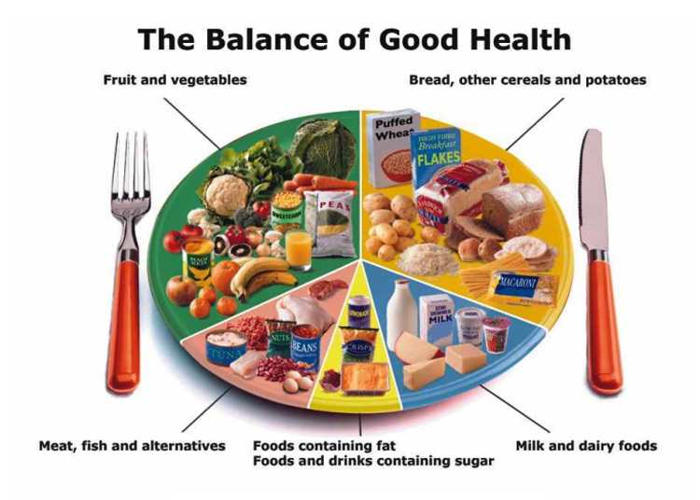
Source: (Henderson, 2023)

Figure 3 - the Eat Well Plate (2007)
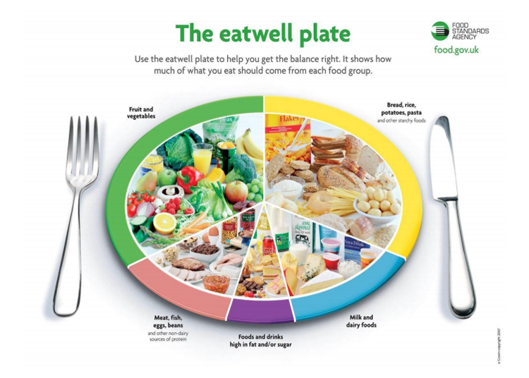
Source: (Henderson, 2023)

Figure 4 - The Eat Well Guide (2016)
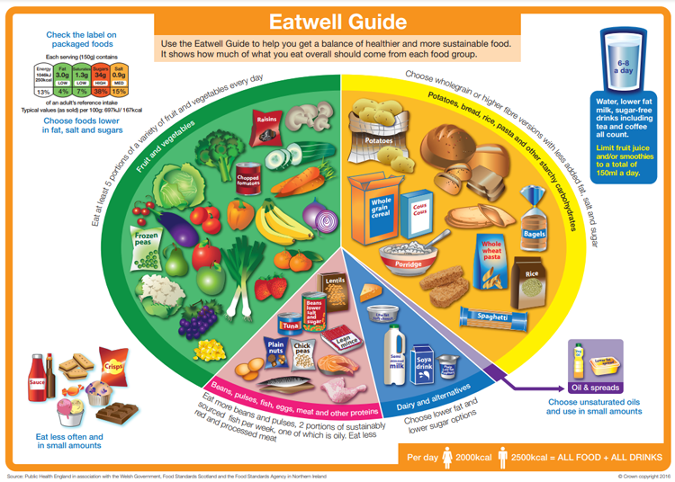
Source: (Henderson, 2023)
The main purpose of the Eat Well Guide shown in Figure 4 is to promote healthy eating habits within the general population in the UK. It was designed and developed to replace the earlier Eatwell Plate shown in Figure 3 and represents a balanced diet through five main food groups including fruits and vegetables, starchy foods, proteins, dairy alternatives, and oils and spreads.
This evolution of the Eat Well Guide not only reflects changes in dietary recommendations but also demonstrates a growing awareness of health issues related to nutrition. The guidance aims to foster healthy eating patterns among diverse populations while addressing public health challenges such as obesity and malnutrition (Medici, 2023). The guide underscores the importance of portion control and variety in diet to ensure individuals receive essential nutrients and serves as an educational tool.
Over time, the Eat Well Guide has undergone significant modifications based on emerging nutritional science and public health needs. Initially introduced in 1994 as the Balance of Good Health (shown in Figure 2) and then in 2007 as the Eatwell Plate, its gradual transformation into the current guide illustrates a shift towards integrating sustainability with health considerations (Leslie et al., 2013). The updated guide not only puts emphasis on what constitutes a balanced diet but also demonstrates how food choices impact environmental sustainability. This dual focus is increasingly relevant in today’s context where climate change poses critical challenges to the integration of sustainable food practices into dietary recommendations.
An article by Henderson (2023) available at my-bmi.co.uk states that “over the last few decades, dietary recommendations have changed and revisions to the original design of a segmented plate have been made twice in recent times” and refers to the changes made throughout the evolutions of the Eat Well Guide. These changes include but are not limited to; the use of a knife and fork in the illustrations for both the initial Balance of Good Health (1994) and the following Eat Well Plate (2007), which was later removed in the Eat Well Guide (2016) as it was intended to represent overall diet and not individual meals. The graphics changed with each evolution in an attempt to make it more appealing to the general population and be more tempting for them to follow the recommendations.
In terms of its specific role with adolescents aged 13-18 years old, the Eat Well Guide plays a crucial part in addressing their unique nutritional needs during this critical developmental phase. Adolescence is characterised by rapid growth and increased energy demands due to physical development; thus, proper nutrition is essential for overall well-being (nidirect, 2023). At this stage in development, teenagers require a balanced intake of macronutrients which include proteins, carbohydrates and fats, as well as essential vitamins and minerals to support bone density, muscle growth, and cognitive function. The guide also emphasises the importance of instilling healthy eating habits such as lifelong nutrition literacy, combating lifestyle-related issues, such as obesity, and promoting mental health, ensuring adolescents thrive during this developmental stage.
Word count:1451 (not including assignment brief and text within table shown in Figure 1)

References
- ‌ Department of Health, 1989. Report on the Nutritional Aspects of Cardiovascular Disease. Her Majesty’s Stationery Office. [Accessed 19 Nov. 2024]
- Department of Health and Social Security, 1979. Dietary and Nutritional Aspects of Cardiovascular Disease. Department of Health and Social Security. [Accessed 22 Nov. 2024]
- Food Standards Agency (FSA), 2001. The Role of Nutritional Guidelines in Preventing Diet-Related Diseases. Available at: https://www.food.gov.uk [Accessed 14 Nov. 2024].
- Henderson, L., 2023. The History of the Eatwell Guide | Diet & Weight Loss Advice. Available at: https://my-bmi.co.uk/education/the-history-of-the-eatwell-guide/ [Accessed 14 Nov. 2024].
- Leslie, A., Thompson, R., and Edwards, J., 2013. 'Evolution of the Eatwell Plate to the Eat Well Guide: addressing nutrition and sustainability', Journal of Public Health Nutrition, 16(7), pp. 1234-1240. [Accessed 19 Nov. 2024]
- Medici, A., 2023. 'The purpose of the Eat Well Guide: promoting healthy eating habits in the UK', Nutritional Science Review, 12(4), pp. 45-58. [Accessed 24 Nov. 2024]
- Medical Research Council, 1941. The Nutritional Status of the Population: A Report on the Deficiency Diseases During Wartime. MRC. [Accessed 19 Nov. 2024]
- nidirect, 2023. 'Nutrition for adolescents: the Eat Well Guide and dietary recommendations'. Available at: https://www.nidirect.gov.uk/articles/nutrition-adolescents [Accessed 14 Nov. 2024].
- Public Health England, 2011. SACN Dietary Reference Values for Energy. Available at: https://www.gov.uk/government/publications/sacn-dietary-reference-values-for-energy [Accessed 14 Nov. 2024].
- Public Health England, 2016. Government Dietary Recommendations Government Recommendations for Energy and Nutrients for Males and Females Aged 1 - 18 Years and 19+ Years. [online] GOV.UK. Available at: https://assets.publishing.service.gov.uk/government/uploads/system/uploads/attachment_data/file/618167/government_dietary_recommendations.pdf [Accessed 14 Nov. 2024].
- Scientific Advisory Committee on Nutrition (SACN), 2011. Dietary Reference Values for Energy and Nutrients for the United Kingdom. Department of Health. [Accessed 22 Nov. 2024]
- Scientific Advisory Committee on Nutrition, 2011. Dietary Reference Values for Energy 2011. Available at: https://assets.publishing.service.gov.uk/media/5a7edb37ed915d74e33f2d8f/SACN_Dietary_Reference_Values_for_Energy.pdf [Accessed 14 Nov. 2024].
- team, D. editiorial (2023). Scientific Advisory Committee on Nutrition (SACN). [online] Digicomply.com. Available at: https://www.digicomply.com/food-regulatory-bodies-standards-and-authorities/scientific-advisory-committee-on-nutrition-sacn [Accessed 28 Nov. 2024].

