Installing a copy of SPSS Statistical Software in readiness for the BMDS7010 Data Analysis Module
(this is part of self-study BMDS7010-01)

Hello everyone, here is a little guide that will enable you to get a licensed copy of SPSS software for BMDS7010. Complete this within the week in self-study time and you should be fine. Note we may encounter problems of it not working behind the NHS firewall etc. in that case, raise that issue with your IT helpdesk on an individual basis. In the past all such problems have been fixed if you ask for such help.

You need to apply for the software individually too - it is assigned via a personally-signed licence. You may also need permissions to download the software via your work accounts.

Step 1 - Go to UWTSD IT helpdesk which now uses ServiceNow – this link should get you a blank form:

https://uwtsd.service-now.com/

Step 2 – Make a new request for SPSS – do a simple search for SPSS and it should appear as below (as it is a UWTSD catalog item).
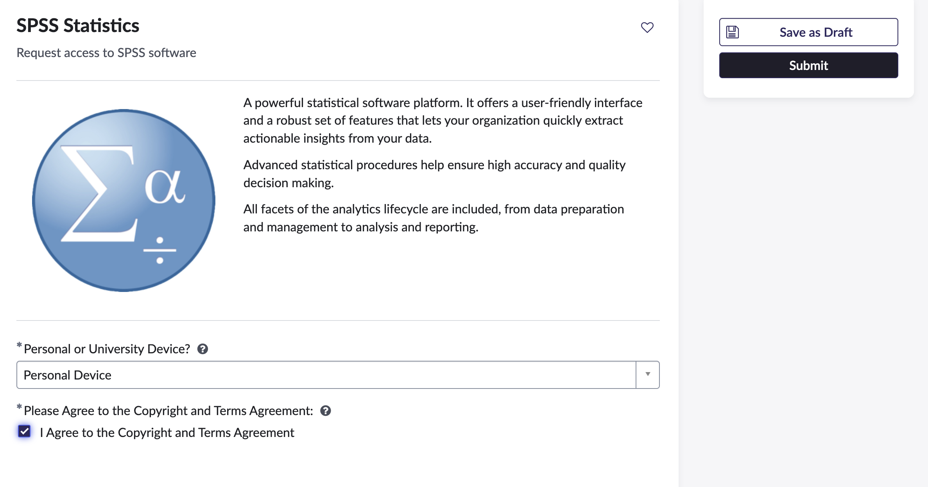
Step 3 – you should get an email and an agreement - it should be straightforward, however we have recurring problems with NHS machines that don’t have permissions to install SPSS. As mentioned, the past that has been resolved by students contacting their own IT helpdesks, explaining the need and gaining the permission. For all other problems, there is UWTSD helpdesk online or 0300 500 5055

Step 4 – once you get a download link, please test it out and see its working fine.

In readiness for Week 2 self-learning, please go through this procedure and test it out. If you can’t get it installed and working within the week, please let us know by email.

