

PRELIMINARY DESK STUDY FOR
THE ‘INNOVATION MATRIX’
Presented For:
ALLAN NANTEL
Due Date:
15/12/22

TABLE OF CONTENTS
FIRGURE LIST 3
EXECUTIVE SUMMARY 4
1. INTRODUCTION 9
1.1 Pupose 9
1.2 Background 9
2. HISTORICAL BACKGROUND 12
3. GEOLOGICAL BACKGROUND 17
4. ENVRIONMENT BACKGROUND 23
5. ARCHAEOLOGICAL BACKGROUND 24
6. RECOMMENDATIONS 25
7. PROPOSED FOUNDATION 26
8. BIBLIOGRAPHY 29

FIGURE LIST
Figure Number | Page Number
Figure 1 Shows a topside view of the Innovation Matrix | 5
Figure 2 Shows a left topside view of the Innovation Matrix | 6
Figure 3 Shows a front view of the Innovation Matrix | 7
Figure 4 Shows a rear view of the Innovation Matrix | 8
Figure 5 Shows the proposed site | 10
Figure 6 Shows access to the proposed site | 11
Figure 7 Shows the Fabion Bay in the 1870s | 14
Figure 8 Shows the Prince of Wales Dock in the 1890s | 15
Figure 9 Shows the aftermath of the Swansea Blitz | 16
Figure 10 Shows Page 1 of a documented borehole log | 19
Figure 11 Shows Page 2 of a documented borehole log | 20
Figure 12 Shows Page 3 of a documented borehole log | 21
Figure 13 Showing Geological makeup of site | 22
Figure 14 Shows legend for geological makeup | 22
Figure 15 Shows the recommended pile driven foundation | 27
Figure 16 Shows the pile cap section of foudnation | 28

EXECUTIVE SUMMARY
The University of Wales Trinity St. David plans to enter a new stage of campus development by introducing a steel framed, two story building, the ‘Innovation Matrix’ between the campus IQ Building and it’s library Y Fforwm. The proposed site will be located at SA1, which is Swansea’s waterfront, therefore being a coastline project.
A preliminary desk study was conducted to aid a full site investigation study, which will be carried out by professional ground contractors, as part of the feasibility stage of the project. A detailed historical background of the site is to be provided along with recommendations to be given to the ground contractors on contents to be included in the full site investigation.
Primarily the docklands were used as trading ports for various materials such as coal, iron, copper and tinplate. Other than housing various ships, the docklands and surrounding areas provided smelting factories, railways, production and storage sheds. Swansea was also riddled with bombs during the second world war, therefore one may assume bomb remnants to be found in the area. This information can aid the full site investigation revealing the potential hazards and contaminants. The discharge of oil and other chemicals into the water at docks and other locations where ships are loaded and unloaded can be causes of pollution. In addition, the operation of ships can cause air pollution by releasing emissions including nitrogen oxides and sulfur dioxide. Both the natural environment and human health are at risk from these pollutants.
Construction near a shoreline carries several concerns. The possibility of coastal erosion, which might jeopardize the foundations of buildings and other structures, is one significant danger. The structure may suffer damage or perhaps collapse because of this. The natural flow of water can be hampered by construction along a coastline, which can result in floods or other issues.

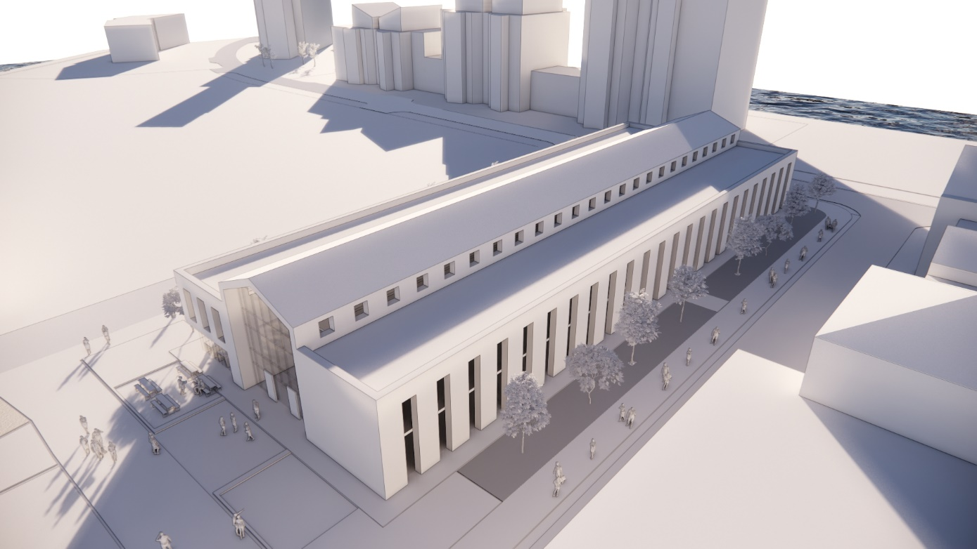
Figure 1 Shows a topside view of the Innovation Matrix

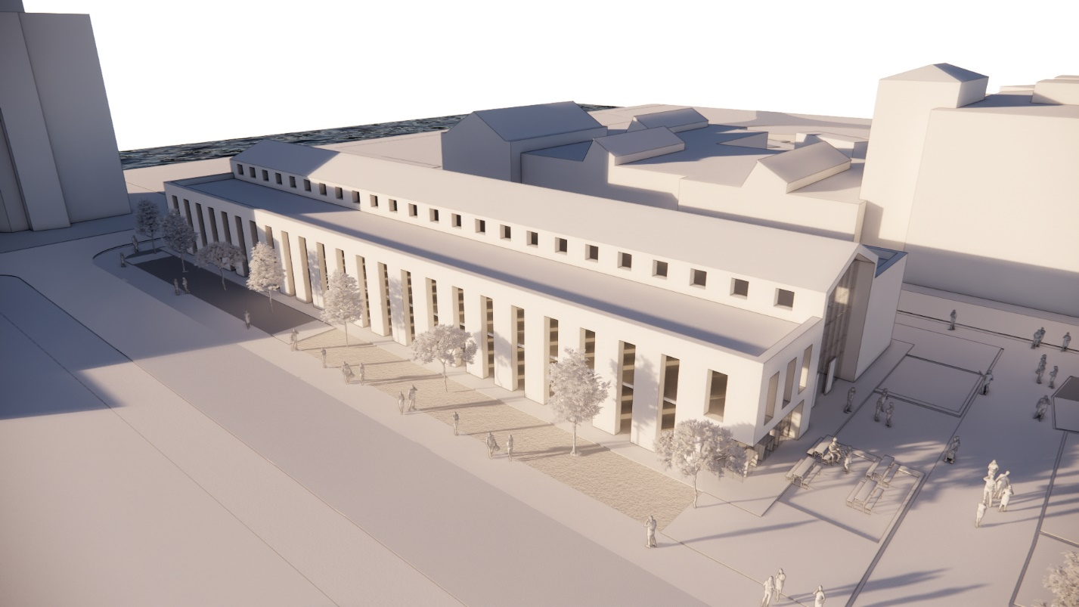
Figure 2 Shows a left topside view of the Innovation Matrix

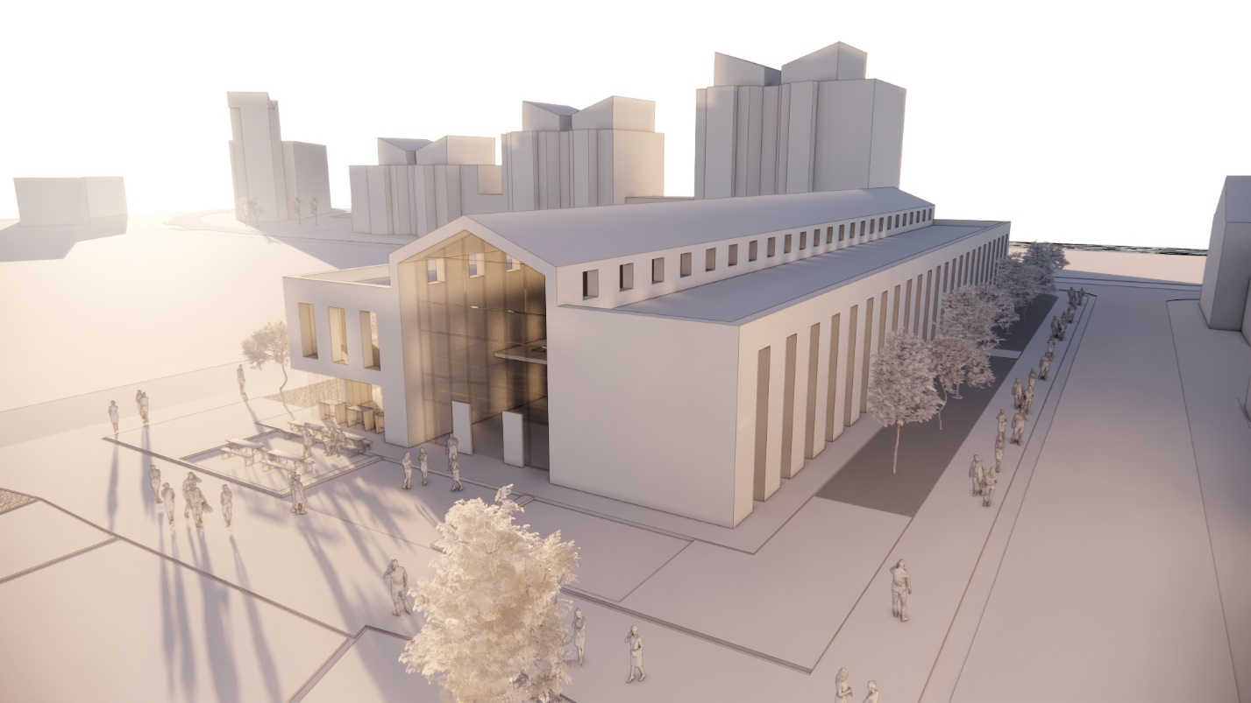
Figure 3 Shows a front view of the Innovation Matrix

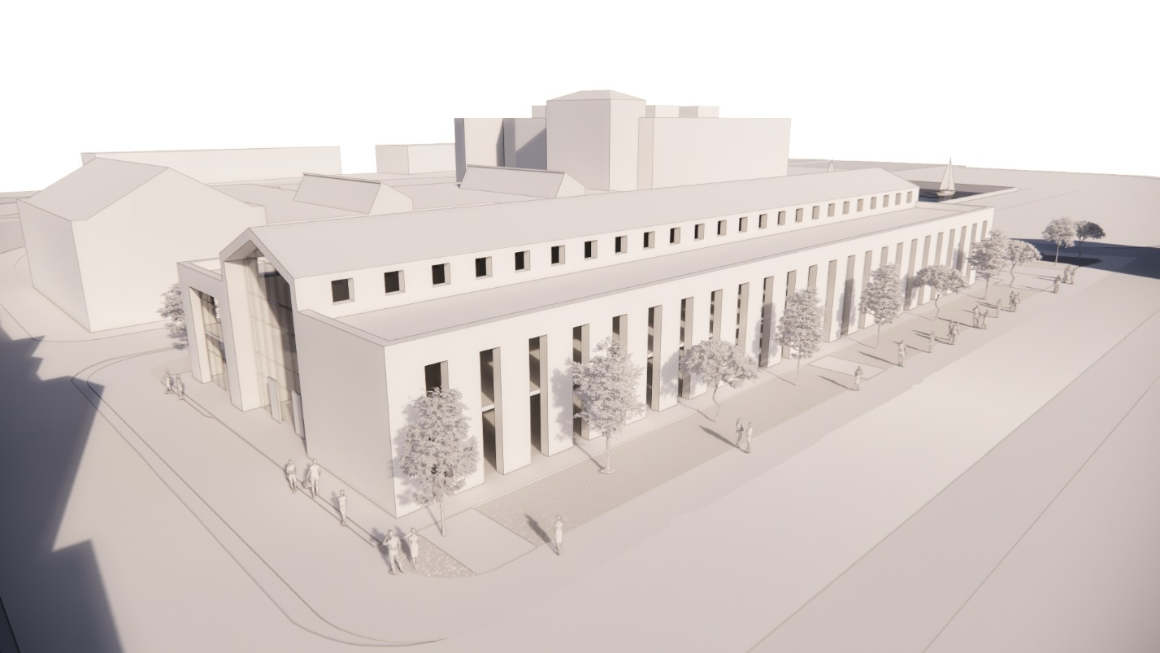
Figure 4 Shows a rear view of the Innovation Matrix

1. INTRODUCTION
1.1 Purpose
- To conduct a preliminary desktop study for a full site investigation of a proposed projected located at SA1 Waterfront adjacent to the UWTSD IQ Building.

1.2 Background
- Location: The site is located below the Prince of Wales Dock at SSW Wales. It is situated between the UWTSD Campus IQ building and Y Fforwm. The coordinates are 51°37'02.4" N 3°55'36.7" W
- Current site use: The site is currently used as a parking lot and cycle hub. There is also a footpath which borders the site’s boundary edges and connects both the IQ building and Y Fforwm.
- Proposed site use: UWTSD plans to build a steel framed two story building adjacent to their IQ building. The proposed building will have an approximate 3,200 square meters of floorspace.
- Site Access: The site can easily be accessed from the main A483 along Fabian Way, into Kings Rd which will lead directly to the SA1 Waterfront campus visitors parking lot.

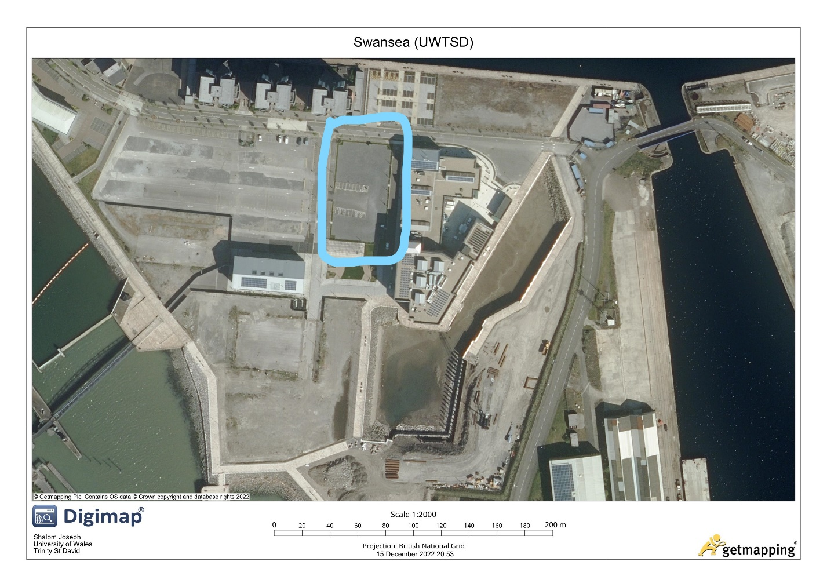
Figure 5 Shows the proposed site

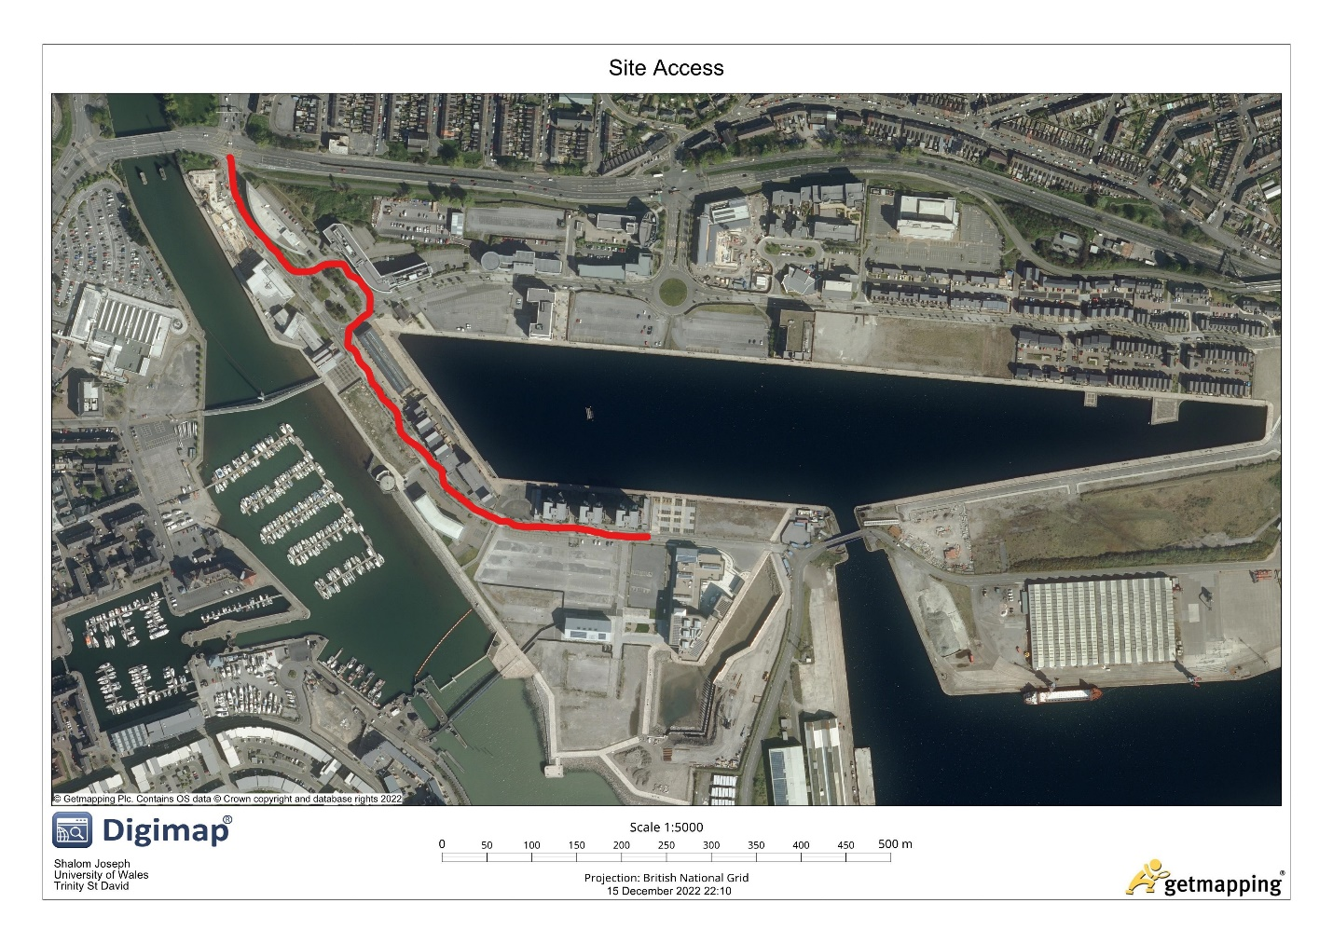
Figure 6 Shows access to the proposed site

2. HISTORICAL BACKGROUND
Archival data in form of 18th and 19th century maps indicate that the site lays within the mudflat region of what was once Fabian Bay. Swansea's growth as a significant port began in the early 18th century, when the advent of copper smelting and tinplate production, together with a sharp increase in local coal mining and iron production, led to the construction of numerous new wharves along the banks of the River Tawe. Four tonnes of copper ore required an average of eighteen tonnes of coal to process into one tonne of copper (Williams 1990, 24). On the west bank of the River Tawe, brand-new quays and docks were constructed to support Swansea's quickly expanding businesses. With the building of New Cut in 1845, the River Tawe's flow was changed, continuing the port's growth into the 19th century. According to Barrie (1980), the North and South Docks were built in 1852 and 1859, respectively. The need for mooring space had increased significantly by the end of the 19th century, therefore the main dock area was moved to the east side of the River Tawe and away from the old port area. The Prince of Wales Dock, which opened in 1881 and was expanded in 1898, was the first significant dock on this side.
As a result, of increased industrial activity throughout the region, greatly enhanced was the area's rail access. The development area is depicted on Ordnance Survey maps from the late 19th century to the middle of the 20th century as being covered in several railway lines and embankments that connect the Dock and Swansea beyond. The docks could still be accessed by these railway lines up into the 1960s and 1970s. Some of these routes started to be cleared in the early to mid-1970s, and by the late 1970s, sheds and warehouses had been set up along the north side, spanning the construction site. In the last ten years, the property has been levelled and the contemporary warehouses and sheds removed.
Up until the industry started to deteriorate after the First World War, the town's vast copper production fueled growth in both the people and the local economy. Swansea experienced a recession, and the "Three Nights' Blitz" in 1941 very nearly completely destroyed the town centre. During the Second World War, the German Luftwaffe bombed Swansea heavily and continuously for three nights. The bombing occurred on February 19, 20, and 21st, 1941. There were 230 fatalities and 397 injuries overall.
Although some construction remnants from the area's prior land use were found during archaeological investigations in a nearby plot, deeper excavations to the north also turned up peat deposits of paleoenvironmental relevance. Therefore, it is believed that there may be some archaeological relics on the development site.

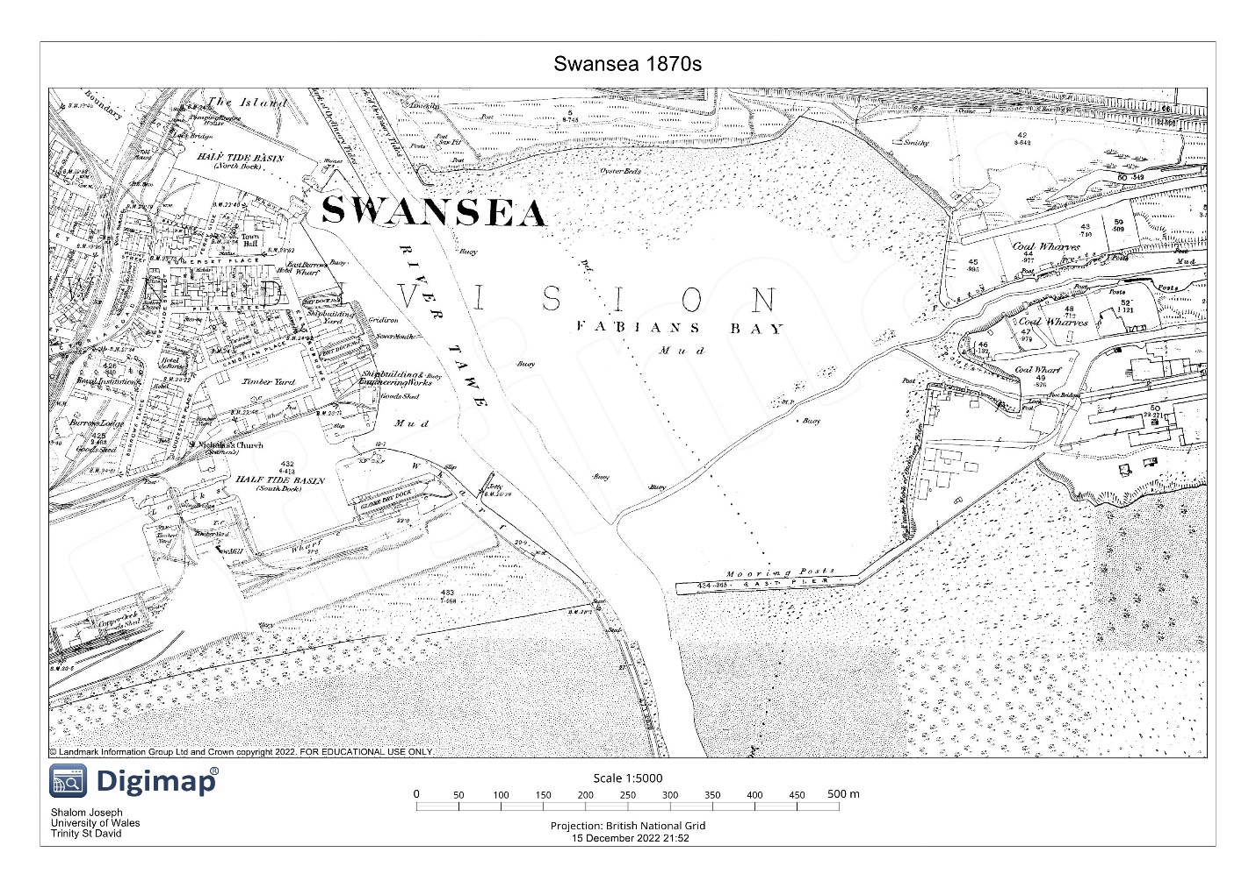
Figure 7 Shows the Fabion Bay in the 1870s

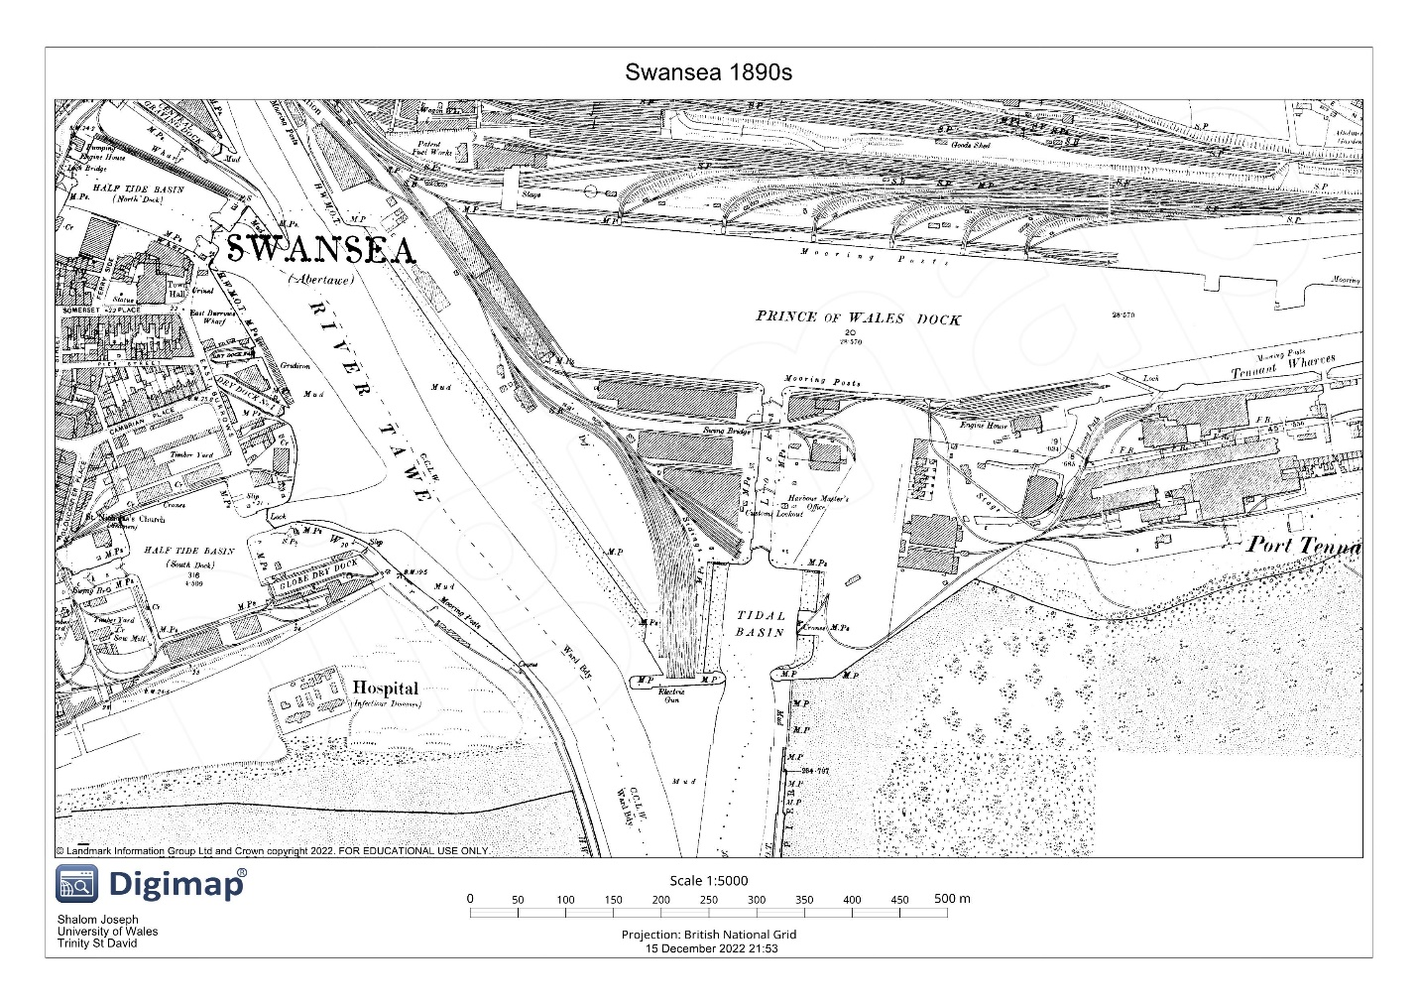
Figure 8 Shows the Prince of Wales Dock in the 1890s

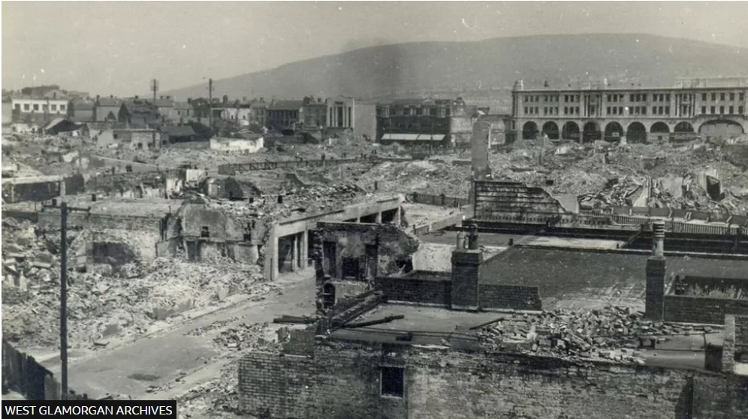
Figure 9 Shows the aftermath of the Swansea Blitz

3. GEOLOGICAL BACKGROUND
Swansea was built on top of Carboniferous Coal Measures, and the region's growth and prosperity have been substantially impacted by the mining industry. Soils in the site region have not been thoroughly mapped, but they probably contain alluvium from the nearby River Tawe as well as sizable peat deposits. The South Wales Middle Coal Measures Formation, which underlies the region, is made up of a mixture of mudstone, siltstone, and sandstone. Raised sand and gravel deposits from a storm beach are on top of it (BGS 2017).
Several dangers and difficulties might arise when constructing on mudflat ground. The likelihood that the ground will move or settle over time is one of the key dangers. Mudflats are often made up of loose, moist silt, which makes them unstable in some situations. Buildings built on mudflats may settle or shift, resulting in structural damage and perhaps making the structure dangerous.
The drill log found there has been analysed, and it was concluded that the till beneath it is artificial. Ash, loose fine grey medium-sized sand, a touch of soft sandy clay, red-brown clay with brick shale, and solid bricks make up the upper 3.50 metres. Up to a depth of 18 metres below the artificial layer, the underlying soil consists of a stratification of layers of stiff grey, brown gravelly boulder clay, sandy clay, thick sand with gravel, and dense sand with gravel. The bedrock is a grey mudstone that lies 18.50 m (the borehole log went down to 22 m) below these layers.
Rocky coastal environments are characterized by the presence of rocky shores, which are areas where waves have eroded the coastline and created steep slopes or cliffs. Rocky shores typically have a narrow strip of land between the shoreline and the ocean, and they are often exposed to strong waves and currents. If the rock, such as granite or sandstone, is resistant to erosion, it will not be as quickly eroded away by the waves and will remain rocky. Additionally, the frequency and strength of the waves can influence how the coastline develops and how rocky shorelines are formed. The shoreline will erode more quickly and become rocky if the waves are powerful and frequent. And last, the formation of rocky coastlines can also be influenced by the contour of the shoreline. A steeply sloping coastline will be more vulnerable to wave erosion and the development of rocky shorelines.
The process of ground subsidence causes the ground level to recede or sink. This may occur for a few reasons, but it frequently results from the withdrawal of subterranean water or minerals, from the compaction of soil brought on by large loads or excessive use, or both. Ground subsidence can result in several issues, such as infrastructure and property damage, flooding, and other environmental effects. Subsidence occasionally even renders a place uninhabitable. To stop these harmful impacts, it is crucial to recognise and address the causes of ground sinking.

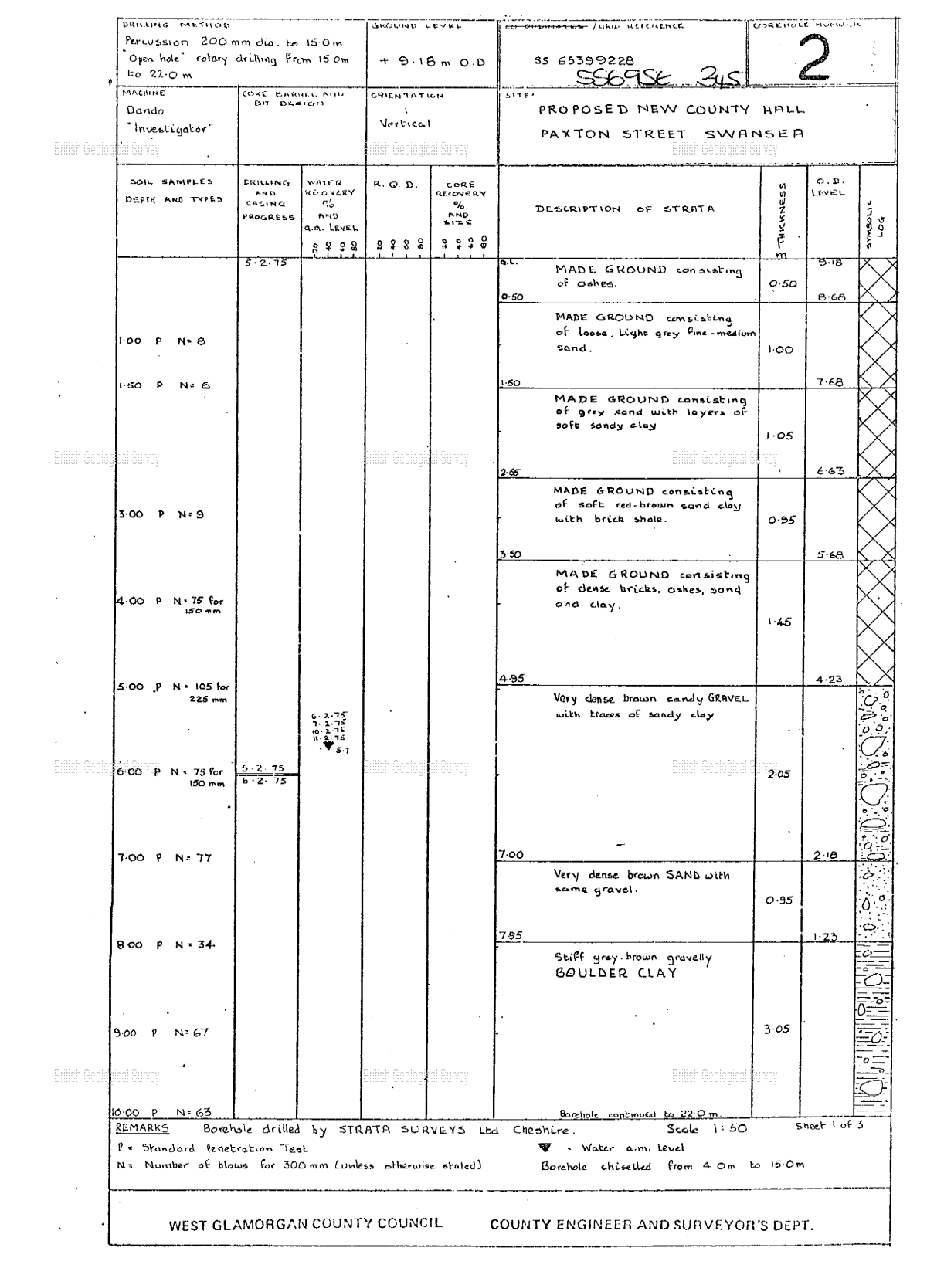
Figure 10 Shows Page 1 of a documented borehole log

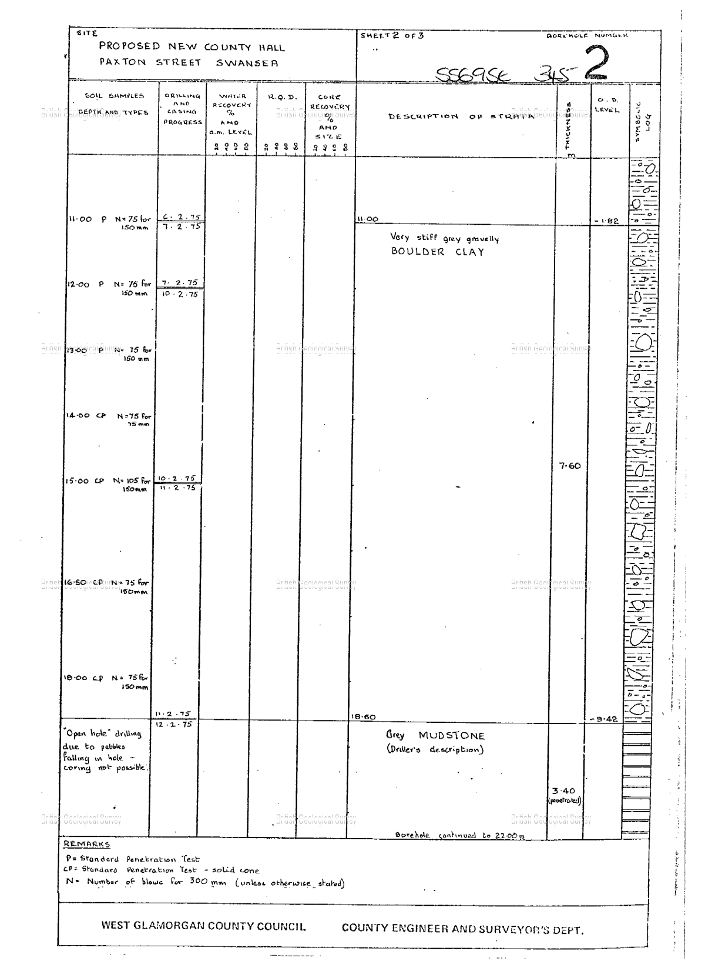
Figure 11 Shows Page 2 of a documented borehole log
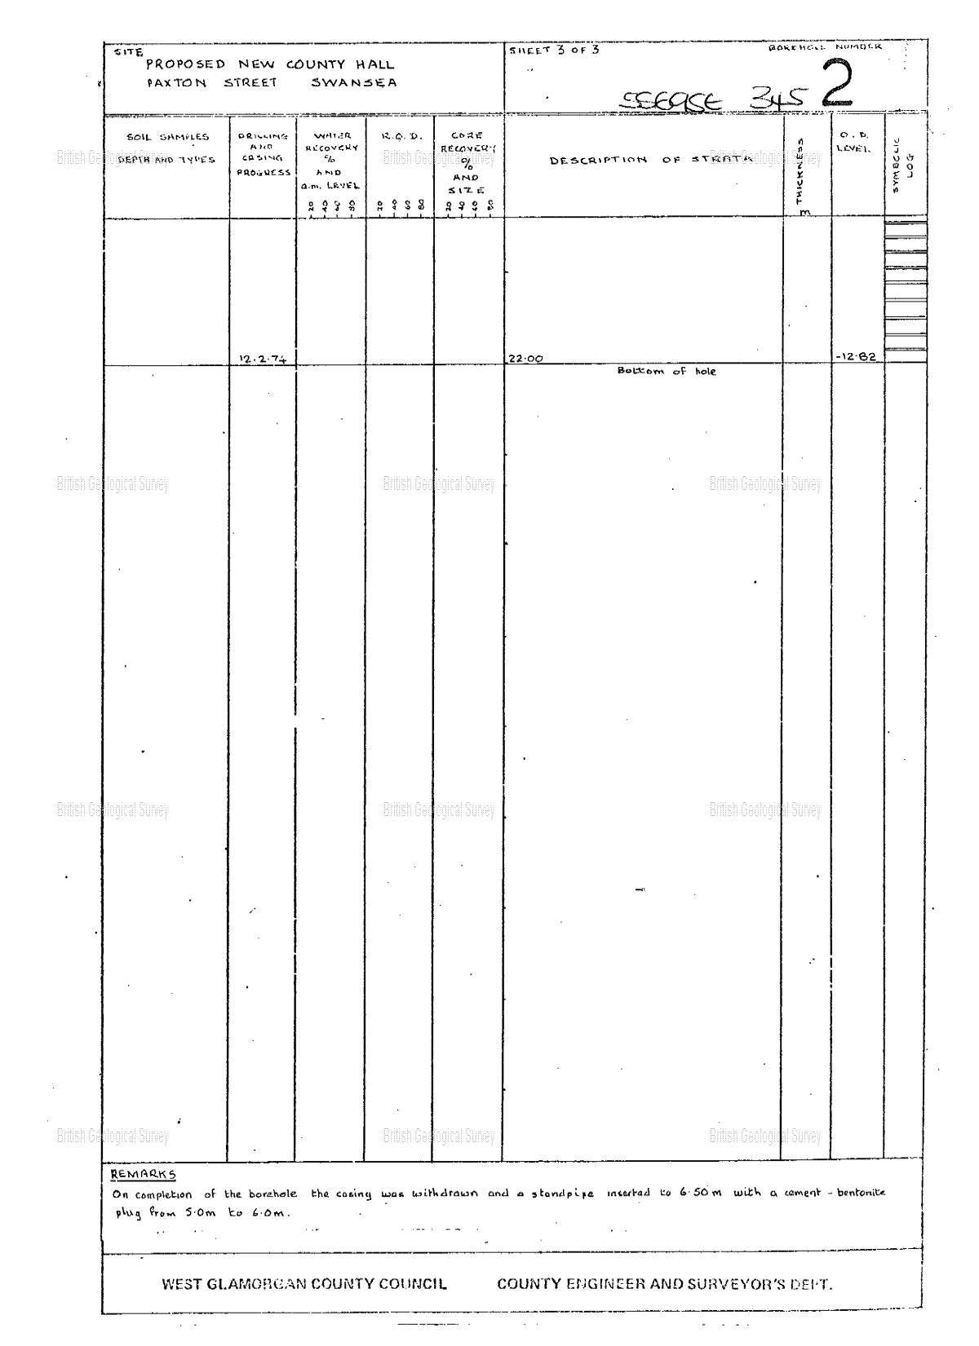
Figure 12 Shows Page 3 of a documented borehole log

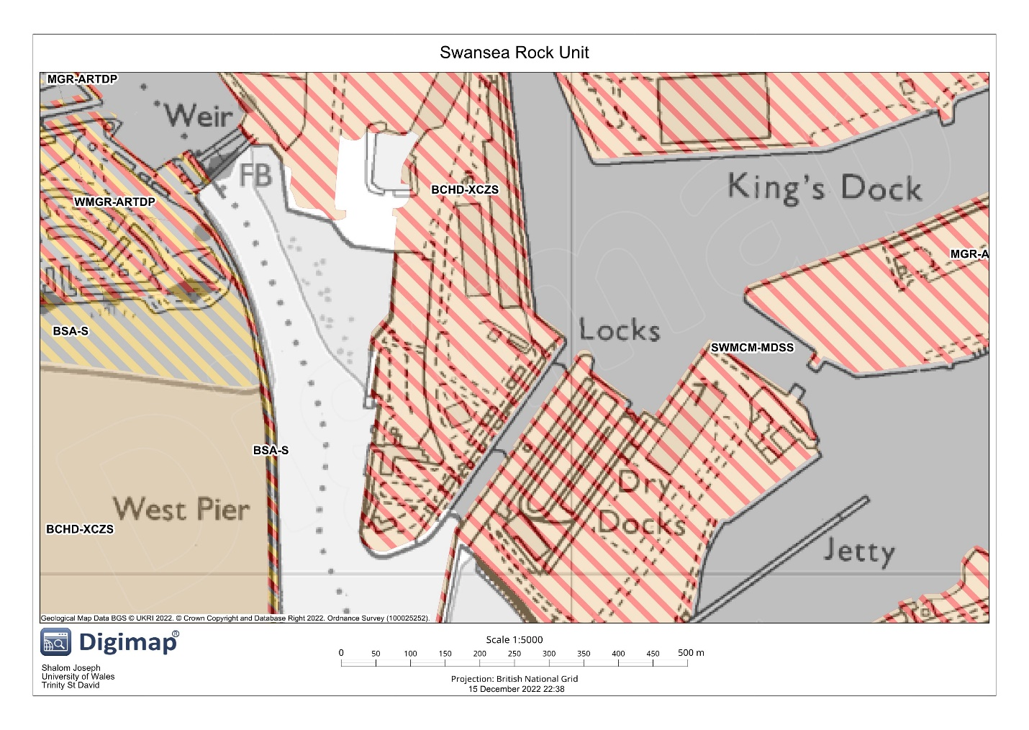
Figure 13 Showing Geological makeup of site
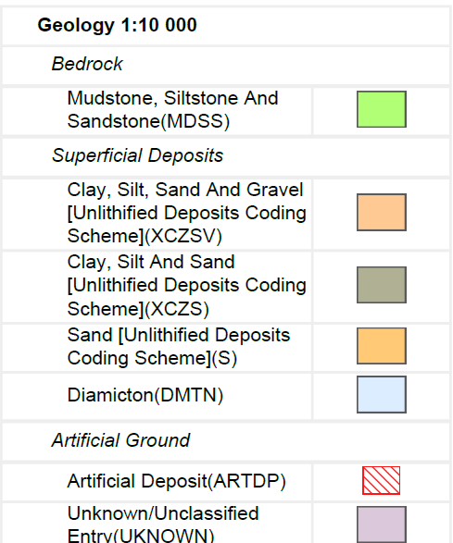
Figure 14 Shows legend for geological makeup

4. ENVIRONMENTAL BACKGROUND
Industrial docksites, which are locations where ships are loaded and unloaded, can produce pollution in several ways. Chemical and other contamination releases into the sea are a typical industrial docksite pollution type. This may occur if ships leak gasoline or other potentially dangerous materials, or if chemicals are released from the ships during the loading and unloading procedure. Additionally, the burning of fossil fuels, the release of emissions from ships, and other industrial activity can all contribute to air pollution near industrial dock locations. This pollution may have detrimental effects on the local ecosystem, including the quality of the air and water, as well as harm to plants, animals, and people.
Furthermore, Hazardous materials are frequently handled at railroad sites, and incidents involving chemical spills can have negative effects on both people and the environment. according to Rails-to-Trails Conservancy, railway sites are known to release a variety of contaminants that are harmful to the environment (2019). Traces of lead and arsenic have been found in coal, sider, and ash, to name a few. They continued by saying that metals and traces of asbestos could be found in specific places, in addition to the possibility of occasional oil, gasoline, and pesticide spills. Due to their creation from coal ash and cinder, where they can be found in high amounts, other serious problems like lead and arsenic may be discovered during soil surveys, according to (Rails-to-Trails Conservancy, 2019).
The threats posed by old bomb remains in the ground can be numerous. The possibility that the devices will detonate poses one of the biggest risks because it could result in major injuries or perhaps fatalities for nearby residents. Old bomb remains could potentially be contaminated with dangerous ingredients that, if touched or detonated, could unleash poisons or radioactive materials. This is a threat to human health and can harm the environment.

5. ARCHAEOLOGICAL BACKGROUND
The flow of the River Tawe has also been dramatically changed, but less so through natural processes than by the New Cut's opening on March 14, 1845. Previously, the River Tawe closely followed the edge of the road that is today called The Strand. The river ran directly east of the castle; therefore it was evident that the main mediaeval port area was close below it. Archaeological evidence of this was found when work was being done on the castle's back. Potential mooring stakes were also found, as well as evidence that the riverbed had been revetted with oak planks and wooden piles. On the west bank of the River Tawe, which formed the eastern border of the mediaeval town, there may have been further waterfront.
The Prince of Wales Docks development area used to be part of the Fabian's Bay mud flats, which served as a key region for intertidal activities including oyster reproduction, as indicated by the Oyster Beds.

6. RECOMMENDATIONS
- There are a few important factors to keep in mind when it comes to the foundations for two-story steel-framed structures. Making sure that the earth is properly ready to support the weight of the construction comes first. To make the ground solid and stable, this may require removing any loose or unstable soil and compacting the ground. The type of foundation chosen will also be influenced by the building's size and design, as well as the site's specific location and soil characteristics. Concrete slab foundations, reinforced concrete strip foundations, and pile foundations are a few popular choices for two-story steel-framed buildings. It's also important to keep in mind that in order to make sure the ground is acceptable for the construction of a two-story steel-framed building, it may be essential to do additional testing and analysis for buildings built on artificial ground. A structural engineer or other trained specialist should always be consulted to identify the optimum foundation for your specific project.

- The site should be surveyed to determine the radiation levels present and pinpoint any regions with elevated radiation levels. This can entail measuring radiation levels using specialist tools like geiger counters. Sampling soil, water, and other materials at the site is another method of figuring out the extent of radioactive contamination. Additional testing methods include keeping an eye on the air quality or analysing plant and animal tissue.

7. RECOMMENDED FOUNDATION
A pile driven foundation is a type of foundation that is used to support structures in areas where the soil is not suitable for other types of foundations. Pile driven foundations are typically used in areas where the soil is too soft or too unstable to support a structure, such as in areas with high water tables or areas with expansive soils. Pile driven foundations are also used in areas where the soil is too weak to support a structure, such as in areas with high seismic activity.
The primary benefit of a pile driven foundation is that it is a cost-effective solution for supporting structures in areas where the soil is not suitable for other types of foundations. Pile driven foundations are typically less expensive than other types of foundations, such as concrete or steel foundations, and they can be installed quickly and easily. Additionally, pile driven foundations are less likely to be affected by soil movement, which can be a problem with other types of foundations.
Another benefit of pile driven foundations is that they are highly durable and can last for many years. Pile driven foundations are typically made from steel or concrete, which are both highly durable materials. Additionally, pile driven foundations are designed to be resistant to corrosion, which can be a problem with other types of foundations.
Finally, pile driven foundations are also beneficial because they can be used in areas where other types of foundations are not suitable. For example, pile driven foundations can be used in areas with high water tables or areas with expansive soils, which are not suitable for other types of foundations. Additionally, pile driven foundations can be used in areas with high seismic activity, which can be a problem with other types of foundations.
Overall, pile driven foundations are a cost-effective, durable, and versatile solution for supporting structures in areas where the soil is not suitable for other types of foundations. They are less expensive than other types of foundations, they are highly durable, and they can be used in areas where other types of foundations are not suitable.
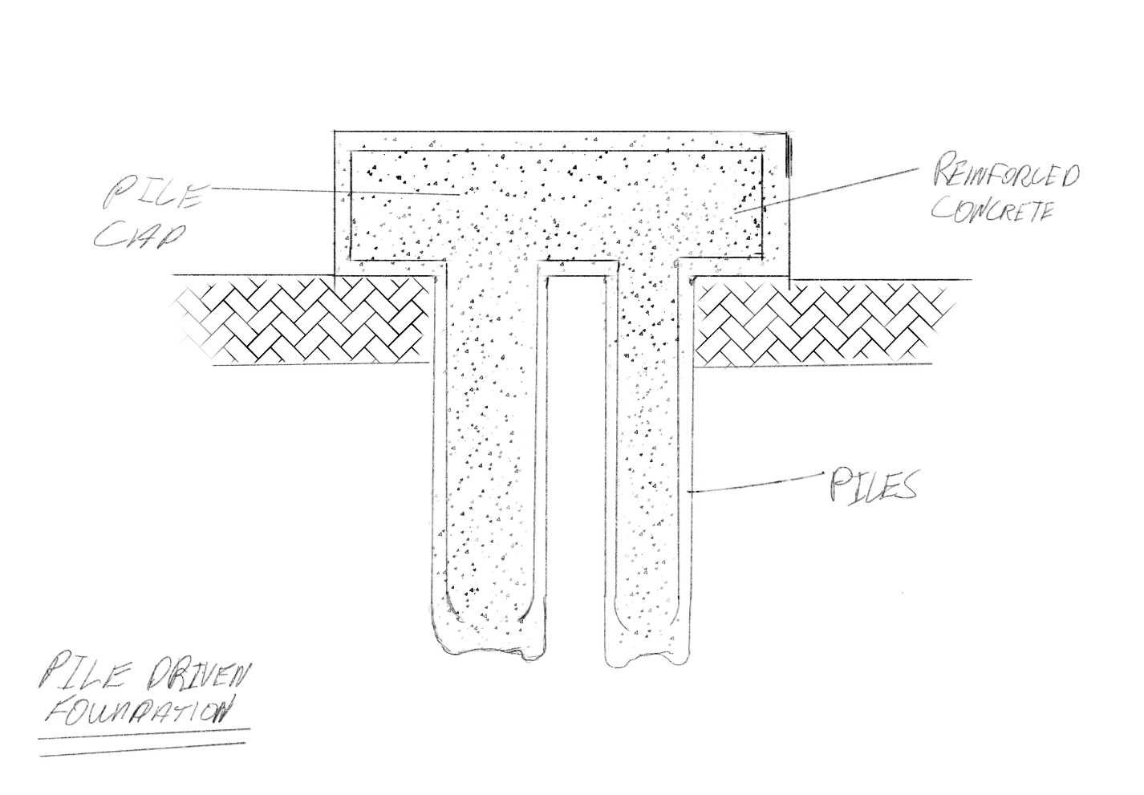
Figure 15 Shows the recommended pile driven foundation

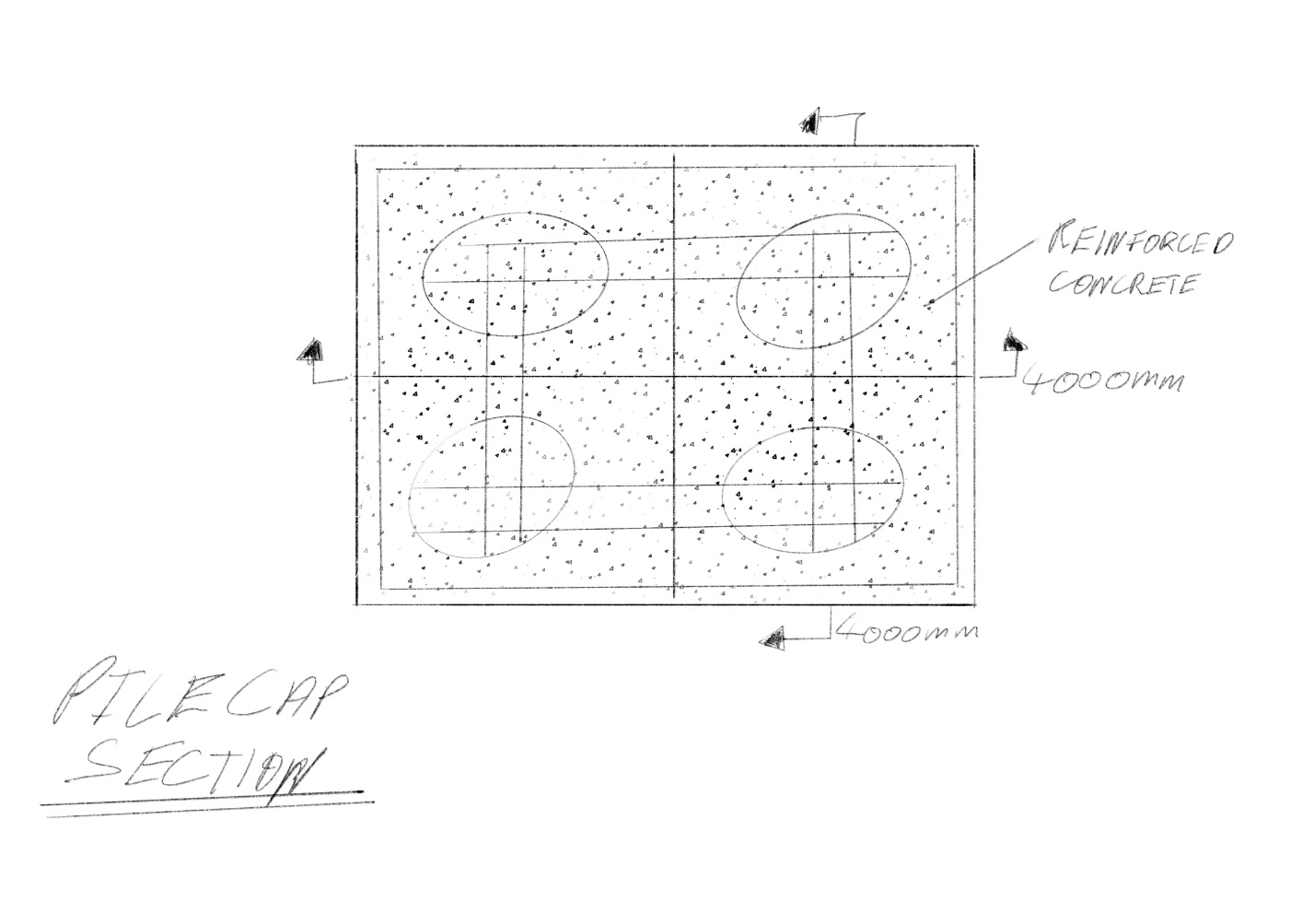
Figure 16 Shows the pile cap section of foudnation

8. BIBILIOGRAPHY
- Digimap (1870). Swansea. Historic Roam. Available at: https://digimap.edina.ac.uk/roam/map/historic
- Digimap (1890). Swansea. Historic Roam. Available at: https://digimap.edina.ac.uk/roam/map/historic
- Digimap (2022). Swansea. Aerial Roam. Available at: https://digimap.edina.ac.uk/roam/map/aerial
- Digimap (2022). Swansea. Geology Roam. Available at: https://digimap.edina.ac.uk/roam/map/geology
- Rails-to-Trails Conservancy (2019). Environmental Contaminants | Rails-to-Trails Conservancy. Rails-to-Trails Conservancy. Available at: https://www.railstotrails.org/build-trails/trail-building-toolbox/acquisition/environmental-contaminants/
- Bowen, F. (2011). Canolfan Glandwr, Prince of Wales Dock, Swansea.
- Swansea. (n.d.). Air quality. [online] Available at: https://www.swansea.gov.uk/article/6412/Air-quality.
- Swansea. (n.d.). The Three Nights’ Blitz. [online] Available at: https://www.swansea.gov.uk/article/5720/The-Three-Nights-Blitz.
- www.swanseadocks.co.uk. (n.d.). Swansea and Port Talbot Docks Website. [online] Available at: http://www.swanseadocks.co.uk/docksnewsite/aerial3.html

