Tutorial Week one session two
Crystal Ltd
Crystal Ltd was established in 1999 to sell a range of computer software to small businesses. Since its incorporation, the business has grown rapidly and demand for its products continues to rise. The most recent financial accounts for the company are set out below:
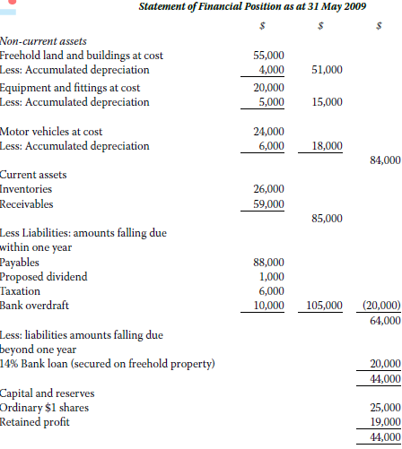
Note. The statement of financial position is another name for the balance sheet. It is one of the main financial statements and it reports an entity's assets, liabilities, and the difference in their totals. Detailing the balance of income and expenditure over the preceding period
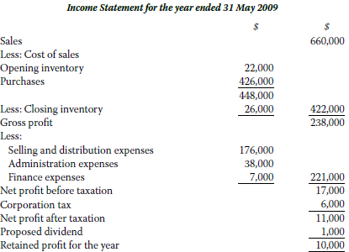
Note. An income statement or profit and loss account (also referred to as a profit and loss statement (P&L), statement of profit or loss, revenue statement, statement of financial performance, earnings statement, operating statement, or statement of operations) is one of the financial statements of a company and shows the company’s revenues and expenses during a particular period. It indicates how the revenues (money received from the sale of products and services before expenses are taken out, also known as the “top line”) are transformed into the net income (the result after all revenues and expenses have been accounted for, also known as “net profit” or the “bottom line”). It displays the revenues recognized for a specific period, and the cost and expenses charged against these revenues, including write-offs (e.g., depreciation and amortization of various assets) and taxes. The purpose of the income statement is to show managers and investors whether the company made or lost money during the period being reported.

The company is family owned and controlled and, since incorporation, has operated without qualified finance staff. However, the managing director recently became concerned with the financial position of the company and therefore decided to appoint a qualified finance director to help manage the financial affairs of the business. Soon after joining the company, the finance director called a meeting of his fellow directors and at this meeting stated that, in his opinion, the company was overtrading.

Requirements
- What do you understand by the term ‘overtrading’ and what are the possible consequences of this type of activity?
- What are the main causes of overtrading and how might the management of a business overcome the problem of overtrading?
- Calculate the liquidity ratios for Crystal Ltd. Explain the significance of each ratio you calculate. Also work out the average payable and receivable periods for Crystal ltd and commented on their significance.

