

Module: Strategic Management
Module Code: LCMB 7003
Assignment Title: Assessment 1 (Strategic Management)

Student Name: Miraj Ahmmed
Student ID: 2123801

Executive Summary
The report intends to analyse the strategic management of Tesla in the point view of given case study. The strategic move of the company to the auto industry of US is mainly discussed so that the different kinds of business strategy for the company can be appraised for sustainable value addition. For instance, the industry analysis has been conducted at the inception point. After that the internal analysis on Tesla has been conducted as per analysing financial data, SWOT analysis and organisational value chain analysis. After that the external analysis on Tesla has been conducted in the point view of PESTLE, Porter’s five forces model and so on. By conducting internal and external analysis, different types of environmental factors are mainly discussed that have impact on the organisation. Then, the strategic approaches relevant to Tesla are discussed so that the company can grab more competitive advantage than that of its competitors. Finally, the recommendations are given to the organisation for capturing sustainable values from the market.

Contents
Executive Summary 2
Introduction 4
Industry Analysis 5
Conducting internal analysis 7
Resource based view and competency 7
Financial highlights 8
Value chain analysis 10
SWOT analysis 12
Conducting external analysis 14
Application of Porter’s five forces model 14
PESTLE analysis on Tesla 16
McKinsey 7-S Framework on Tesla 19
Strategies for Tesla to grab competitive advantages 21
After sales services 21
Growth share matrix 21
The Ansoff Matrix 23
Conclusions 25
Recommendations 26
References 27

Introduction
Tesla Inc. is an American based automotive multinational organisation that was established in 2003. The electronic cars, solar panels, solar roof tiles, battery energy storage and various kinds of products are basically produced by the management of Tesla Inc. around the world. The case study named “Tesla’s entry into the US auto industry” has been analysed in the effective form and the strategic moves of the company to the market of the United States are mainly evaluated as per using different kinds of theories and models. For instance, the internal and external analysis on Tesla Inc. tend to be conducted to this report so that the diving factors in both internal and external environments can be identified in the proper ways. After that, the strategic approaches relevant for Tesla Inc. to grab the competitive advantages from the market are also outlined for the completion of the report. According to analyse the case, the recommendations tend to be provided to the management of Tesla so that the strategic turn can be ensured for superior value addition.

Industry Analysis
After the great recession in 2008, the automobile industry of the United States has been grown so fast as the economic activities in this region have been boosted in the significant manner. In 2016, the values of automobile sector at the United States was about $270 billion. The demand for the electric car has been increased in the recent age and the purchasing trends of the new electronic car has also been enhanced over times (Alan Baum, 2016). For instance, there had $28.24 billion market value of the US electric car industry. It has been projected that the market size of the electric car will be $137.43 billion for the fiscal year 2028. United States has been considered as the third most electric vehicle manufacturer in the world. Hence, China and European United are considered most electric vehicle manufacturer in the world. As the demand of the customers for the electric vehicle has been boosted in the recent age, the electric car production campaign of Tesla can add values by serving the good quality of electric vehicles to the consumers.
The automobile industry of the United States has been analysed in this context so that the overview of the market can be assessed and it can be analysed whether Tesla can add values by entering into the US auto industry (Elliott, 2015). For supporting the discussions, some charts and figures are used in the effective manner. They are discussed a follows:
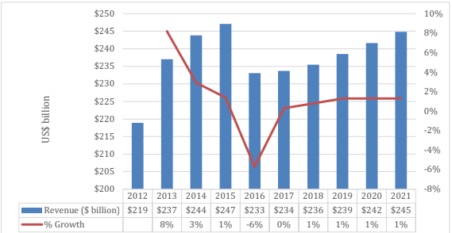
Figure: US new cars market value
Source: marketline.com
From the bar chart, it is overt that the value of the US car sector is $245 billion in 2021 and it ensured the growth of 1% than that of the previous year. In compared to the last the 10 years, the most value was found in 2015. During this year, about $247 billion was met the value of the car sector of the United States. The most reduction of value in the US car market was faced at 2016 and about 6% growth was reduced in that fiscal year. After the great recession in the US, the resurrections were seen to the US car market as the income level of the people being increased over the years.
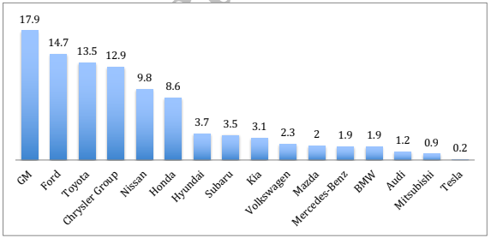
Figure: US car manufacturer by market share by 2018
Source: WSJ.com
The analysis of market share among the companies is regarded as significant indicator to analyse the overall industry. It has been found that the GM, Ford, Toyota are the market giants in the car manufacturing sector of the United States grabbing the market share 17.9%, 14.7% and 13.5% respectively. In 2018, Tesla grabbed only 0.2% market share in the car manufacturing sector of the United States. It denotes the inferior position of Tesla in the car sector of the United States. For this reason, the new project of launching the electric car to the market amid the increased demand of the customers can be regarded as strategic choice by the top management of Tesla. Moreover, there have very tough competition in the car industry of the United States and the values of the organisations are very congested.
In such high competitive sector, the quality control and innovation in the products play the most vital roles to become the market leader. As GM, Form, Toyota, Nissan, Honda, Kia, BMW, Audi, Mitsubishi and various kinds of famous companies are in the market of the United States, the management of companies need to make step carefully and undertake the effective strategies for superior value addition (Birkinshaw, 2014).

Conducting internal analysis
The internal business environment of Tesla has been analysed in the effective manner to conduct the internal analysis on the company. For instance, the organisational resources, its financial performance over the years, the value chain management and the SWOT analysis has been conducted on the company. The strategic entry to the car industry of the US of Tesla has also justified on the basis of the internal analysis.

Resource based view and competency
The huge resources of Tesla have been considered is competency in the automotive market as the economies of scale facility has been grabbed by the company having it huge resources. For example, the main resources of Tesla are electric powertrain, intellectual property, financial capability, human resources, patent pledge, supplier code conduct, full self-driving capability and so on. Hence, about 110000 employees are working to different factories of Tesla around the world which denotes to the strong resource of the company to the international market (Hill et al., 2019). In US, the company has also huge human resource to ensure the optimum production of electric cars. Current market value of Tesla is $735 which implies its financial capability in the market. The intellectual property of Tesla like electric powertrain is highly effective to increase the value of the organisation in the global arena. Moreover, there have the promotional comparative advantage position of Tesla in different social media and satellite TV channels. The strong promotional competency of Tesla is also considered is one of the key resource to uphold the organisational offering towards customers in the market. Above all, the organisational resources of Tesla are value added to become one of the biggest electric vehicle producer in the market.

Financial highlights
Particulars | 2021 (million) | 2020 (million) | 2019 (million)
Revenue | $53823 | $31536 | $24578
Operating income | $6523 | $1994 | -$69
Net income | $5519 | $721 | -$862
EBIT | $6523 | $1994 | -$69

The financial performance of Tesla has been depicted in the above table of last three fiscal years. Hence, the organisational revenue, operating income, net income, and EBIT are basically discussed. For instance, the revenue of Tesla has been increased to $53823 million in 2021 from $31536 million in 2020. The values and quality of the electric car of Tesla has been increased to the market and it has reflected its overall revenue to the market. The operating income and net income of the organisation are also increased in the large extent for the year ended 2021. Though the overall profit of Tesla was reduced in the significant extent in 2019, the company has been enabled to recoup its loss as per proper supervision of customer demand and quality control strategy. The impact of COVID-19 has been reflected to the financial performance of the organisation in 2019 and 2020.
Current ratio: (Current asset/ Current liabilities) = 1.43
The current ration of Tesla Inc. has been determined as 1.43 which denotes that the company has more current asset than that of its current liabilities. In fact, the organisation has proper ability meet its different kinds of short term obligations.
Profit margin: (EBIT/ Sales) *100 = 12.06%
It has been calculated that Tesla Inc. has 12.06% profit margin against sales. It denotes that the company generates about 12.06% earnings before interest and tax on its sales. It percentage of profit margin indicates the organisational advantage position in the industry (Birkinshaw, 2014). As the product of Tesla has huge demand in the market, it has enabled to gather about 12.06% profit margin.
Gearing ratio: (Long term borrowings/ Capital and reserves) = 2.56
The gearing ratio denotes how much an organisation collects its fund from borrowings. The debt equity ratio of Tesla Inc. has been calculated as 2.56 that denotes the organisation has moderate debt equity ratio.
Net profit margin: (Net profit/ Sales) *100 = 10.25%
The net profit margin denotes to the net profit on the sales volume of the organisation. Hence, the net profit margin of Tesla Inc. is 10.25% which is quite good for the organisation. By this way, it can be concluded that the company is operating well to generate the net profit by selling of its products to the market.
EPS (Earning per share): (Net profit margin/ Number of shares) = $4.90
Earnings per share refers to the earning from per common stock outstanding to the organisation. The corporate profitability can be measured in the effective manner as per calculating the earning per share. Hence, the earning per share of Tesla Inc. has been calculated as $4.90.

Value chain analysis
The value chain analysis is regarded as effective measure to evaluate the organisational activities and capture the values from different kinds of activities within the organisation. the managers can add or subtract values from different activities as per the organisational needs. The value chain analysis of Tesla Inc. has been conducted in the point view of primary and supportive activities. They are described as follows:
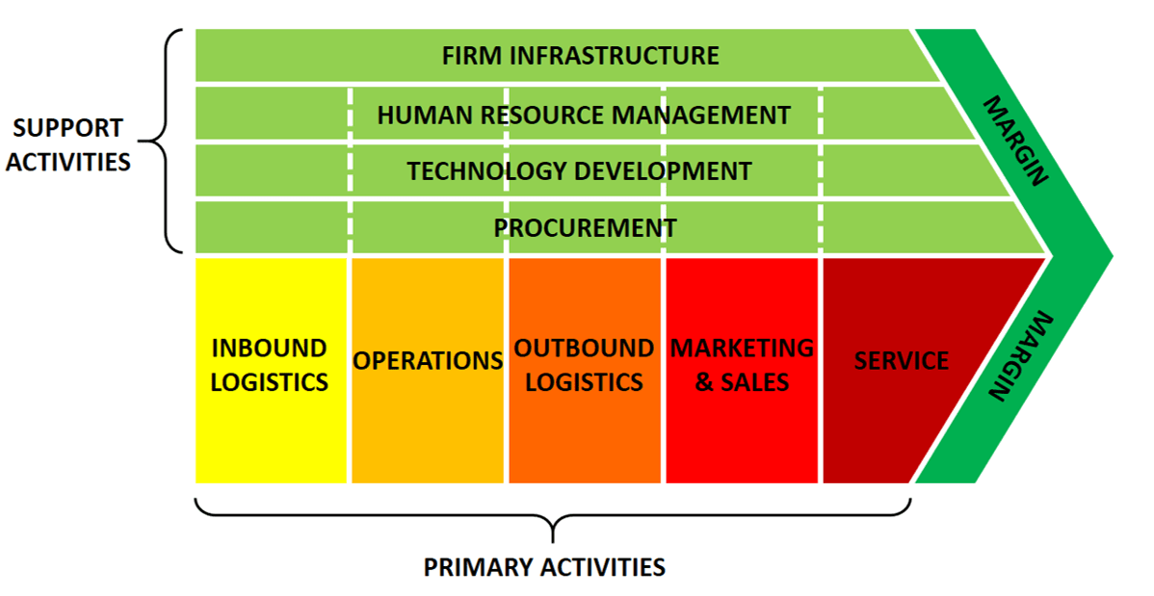
Source: (Hill et al., 2019)
Primary activities:
Inbound logistics: The inbound logistics of Tesla Inc. includes the receipt and storage of the raw materials to manufacture of the electric vehicles (Jeyarathmm, 2018). For example, the company uses aluminium, steel, lithium, nickel, copper and various scare materials and they are stored effectively in inbound logistics.
Operations: The manufacturing and assembling operations are mainly operated by the employees of Tesla Inc. in different factors around the world. In reality, the operations of Tesla Inc. are divided into automotive and energy generations (Birkinshaw, 2014). In automotive operations, different electric cars are manufactured by the company and the solar panels and energy production activities are operated by the company in optimum manner.
Outbound logistics: The outbound logistics of Tesla involved the warehousing and distribution of the electric cards and energy storage system. Tesla Inc. ships the electric cards to its own stores and gallery around 35 countries in the world. It denotes to the huge capacity of the company in outbound logistics.
Marketing and sales: According to Elon Musk (CEO of Tesla Inc.) the word of mouth marketing strategy is mainly focused by the company to the market to promote the organisational products (Jeyarathmm, 2018). Moreover, different unconventional marketing and selling strategies are followed by the management of Tesla Inc.
Services: Tesla Inc. provides the customer services of the electric cars so that the customer satisfaction can be ensured (Hill et al., 2019). Hence, the post purchase services and services warranty are provided to the customers so that they can be assured from the top management of Tesla about buying their products.
Supportive activities:
The primary activities in the value chain of Tesla Inc. are operated on the basis of some supportive activities. The supportive activities of Tesla Inc. include the infrastructure of the organisation, its human resource, the technology and procurement. About 110000 employees are associated in different factories of Tesla Inc. to the market (Jeyarathmm, 2018). Moreover, the new technologies the launched by the company as the research and development team of the organisation are associated with developing of technology and add the superior values.

SWOT analysis
Various internal environmental factors are assessed as per conducting the SWOT analysis. They are described as follows:

Source: (Lethbridge and Chan, 2020)
Strengths: Tesla Inc. is known as most valuable automotive company in the electric vehicle sector of the world. The most value of the organisation and being the top employer in the market are regarded strength of the organisation. Moreover, Tesla is best in class electric cars. Its electric cars can travel up to 600km in a single battery charge. After the COVID 19 pandemic, the overall sales of the electric cars of Tesla has been boosted by 87% and it also consolidated the strength of the organisation (Birkinshaw, 2014). In a nutshell, the innovation by the management of the organisation, its cross ell and diversification, huge loyal customers, rapid promotion and high capacity are regarded as organisational strengths to the market.
Weakness: There has mechanical complication of manufacturing the electric cars of Tesla. For example, the company faced huge challenges when it designed the Model X. Sometimes, the company failed to meet the demand of customers as per providing them products. Thus, the brand value of Tesla can be affected negatively (Jeyarathmm, 2018). Moreover, the company has limitation to produce high volume of electric vehicle due to the lack of capacity in different countries and it has identified as the weakness of Tesla. In either case, Elon Musk is the sole representative of Tesla and it may be regarded a weakness of the company in some aspect.
Opportunity: As the market of Tesla Inc. is expanding day by day, the range of opportunity of the company is also increasing as well. The sales expansion of the company to the untapped market can expand the organisation opportunity. Tesla Inc. may also product the less expensive cars which can arise the competitive advantage of the company and the sales volume can be boosted in the large extent (Lethbridge and Chan, 2020). The company has also opportunity to bring the battery production technology in house along with current product line so that the products of the company can be diversified and more values can be grabbed from the market. The demand in air-taxi service cab be fulfilled by the company and range of opportunity from the market can be grabbed by the organisation.
Threats: Along with some strength and opportunity, Tesla Inc. has some threats in carrying out the business activities in the market. The high extent of competition to the market of the United State is regarded as ultimate threat for Tesla Inc. to carry out the business. For example, the Nissan, Honda, Kia, Volkswagen and different kinds of companies are increasing their offering of electric vehicles and the direct competition has been created for Tesla Inc. to survive in the market (Lethbridge and Chan, 2020). The self-driving cars of Tesla are still a matter of concern to some of the customers in the market and it can arise the threat of the organisation in massive sales of the products.

Conducting external analysis

Application of Porter’s five forces model
The competitive environment of Tesla Inc. has been analysed in this context so that the nature of competition in the electric vehicle sector can be assessed and strategic position of Tesla Inc. can be identified in the significant manner. The porter’s five forces model is explained as follows:
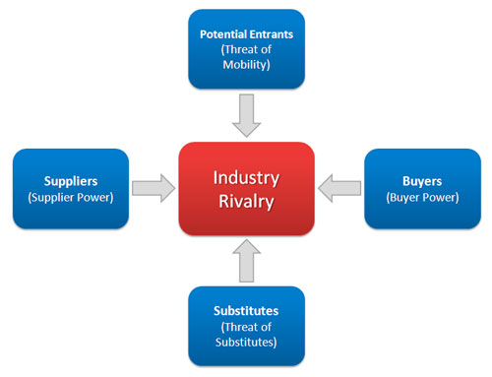
Source: (Worthington et al., 2018)
Potential entrants: The threat of new entrant to the market is high for Tesla Inc. as the barrier of entry is low. There are some Chinese companies who enter into the market easily in the electric vehicle sector. The easy supply chain and government support for the new electric vehicle start-ups by chain can be regarded as high threat for Tesla Inc. As the Chinese companies are dominating the market, the new start-ups from China can arise huge threat for the organisation (Joann Muller, 2016). Though, Tesla Inc. has some economies of scale and some fixed costs in the elect vehicle sector, they are not enough to diminish the threat of new entry in this sector.
Bargaining power of buyers: The bargaining power of buyer depend on the availability of products in the market and number of companies offering the same products. As some companies along with Tesla Inc. provides electric vehicles to the market of United States, the bargaining powers of buyers is moderate. Tesla segments its different kinds of products at the high end market with premium pricing and it has made the bargaining power of the buyers’ is moderate (Joann Muller, 2016). Due to the intense competition in the low end market, Tesla Inc. competes in the luxury market so that the luxury pricing of the company can meet the values of target customers and organisational superior value addition can be managed in the effective ways.
Threat of substitutes: The treat of substitute product is high for Tesla Inc. in the market. As Tesla grabs about 14.55% market share in the international electric vehicle sector, the range of competitors of the company is very high. Hence, GM, Ford, BMW and many kinds of companies offer substitute products and the overall threat for Tesla Inc. has been increased in the large extent by the impact of these types of substitute products (Lethbridge and Chan, 2020). Tesla Inc. has relatively low advertising cost while other companies spending million dollars for advertising costs. The high advertising campaign of many kind of competitors of Tesla Inc. has increased the threat of substitute products.
Bargaining power of suppliers: The bargaining power of suppliers depend on the availability of the suppliers for the company. Hence, the bargaining power of suppliers of Tesla Inc. is very high as the number of suppliers are limited in market. For example, the raw materials of the electric cars of Tesla Inc. come from Germany (SCHAFFER, 2022). By the impact of COVID 19, the supply of the raw materials has been disrupted. Moreover, the limitation of good quality of suppliers of the company in the global market has made the bargaining power of the suppliers very high.
Industry rivalry: The industry rivalry is intense at the electric vehicle sector of the United States. The existence of various kinds of market giants at the market of United States has made the intense rivalry among the organisation. Hence, GM, Ford, Nissan, Toyota and many kind of market giants are existed to the market (Lethbridge and Chan, 2020). Moreover, the start-ups, traditional automakers are also existed to the market and it has made the situation very complex. The perfect competition has been seen due to the existence of various types of companies at the electric car sector.

PESTLE analysis on Tesla
The macro environmental analysis of Tesla has been conducted by conducting the PESTLE model. The impact of various kinds of environmental factors on the strategic move of Tesla Inc. are mainly assessed through conducting this model. Various types of factors are discussed as follows:
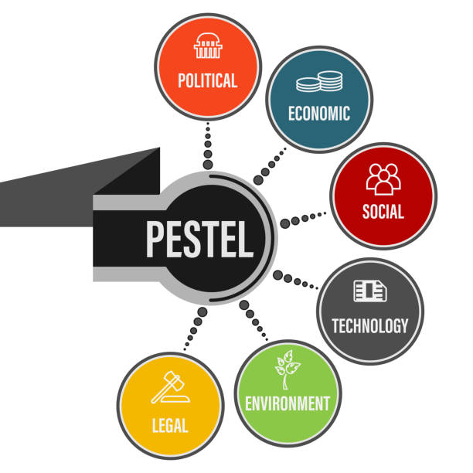
Source: (SCHAFFER, 2022)
Political: The political rules and regulations have the direct impact on the business activities of Tesla Inc. As per entering the US auto industry, the trade license need to be taken at the inception point. Moreover, the management of Tesla is bound to obey the rules provided by the government of US to carry out the business in this region. The political situation of US is quite well and Tesla Inc. can grab opportunity from the stable business environment within the market of United States (Lethbridge and Chan, 2020). The government of US provides incentives for the electric vehicles companies and it can be considered a key opportunity for the business growth of Tesla Inc. To check the environment issues and reducing the carbon emission, the government incentivise huge fund to the electric vehicle manufacturer.
Economic: The GDP, GNP, NNP, Interest rate, unemployment rate, inflation and various economic indicators reflect the overall economic environment of the market. The GDP of US is the highest in the world and the purchasing power of the customers is very high as well as their income level. Recently, the level of inflation had been increased to the market of United States and it can be regarded as threat for Tesla Inc. In either case, the costs of the battery have been reduced in significant rate and the costs of the renewable energy has also been reduced and they can arise the opportunity for Tesla Inc. (SCHAFFER, 2022). The reduction of costs of these products can provide the cost leadership advantage to Tesla to become the market leader. The economic stability issue in the market of US has been identified as threat to the economic environment for the company to fulfil the organisational goals.
Social: The social values, belief, behaviours and attitudes affect the business organisation in the large extent. For this reason, the organisation needs to comply with the customer demand and provide the products for value proposition. The customers at the market of United States have popularity in low carbon lifestyle. Meanwhile, the choice the electric car can be good choice for the customers and fulfil their demand in optimum manner (Lethbridge and Chan, 2020). The demand of customers in the renewable energy has also been enhanced to the market and it can broaden the level of opportunity for Tesla Inc. to deal with the customers. By fulfilling the customer preference in the electric vehicle sector of United States, Tesla Inc. has opportunity to create the strategic position in the market.
Technological: The application of modern technology to the activities of the business can increase the competitive edge and ensure the value addition of the company from highly competitive market. For instance, the main focus of Tesla Inc. is to launch the innovative products by using the modern technology. The automation system has been ensured to the management of Tesla Inc. and different kinds of activities of production are implemented by the direct help of technological tools (SCHAFFER, 2022). For this reason, the accuracy and reliability of products of Tesla Inc. has been increased to the market. The management of Tesla intends to maintain the high rate of technological change in its different kinds of products. The proper response of the organisation associated with technology has expanded the organisational opportunity to grow fast in the market.
Legal: To carry out the business activities properly, the management of Tesla Inc. needs to comply with some legal provisions of government so that different kinds of business activities of the company can be legal at the point view of law. Hence, the equality act, employment act, health and safety act and various legal promotion must be complied by the management of Tesla Inc. Different kinds of legal factors have direct impact on the policy making and business activities of Tesla Inc. to the market (Worthington et al., 2018). The energy consumption relations and international patent protection activities of Tesla Inc. are also regulated as per legal promotion. For this reason, these legal factors have wide range of impact on the business activities of Tesla Inc.
Environmental: The management of Tesla Inc. needs to control the emission of the organisation towards environment. As there have the government compulsion on controlling carbon footprint, the top management is determined to control the organisational carbon emission undertaking the green management policy (Worthington et al., 2018). For instance, the organisations in the automobile sector of US tend to expand the environmental programs and raising the standards of waste disposal. To check the environmental concern, the tendency to become green organisations have been seen to the company so that the impact of climate change can be responded in the optimum manner.

McKinsey 7-S Framework on Tesla
McKinsey 7s model is known as strategic vision of the organisation at the market so that the assessment on different elements of the organisation can be examined in the proper manner. This model has been divided into two phases. They are hard elements and soft elements. Different kinds of elements are explained as follows:
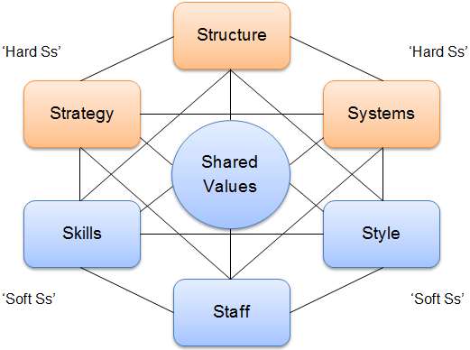
Source: (Worthington et al., 2018)
Strategy: The main business strategy of Tesla is revolved on electric cards and accelerate the transition of the world to sustainable energy. The electric cars and energy products of tesla are differentiated as per the performance, design, stainability and various kinds of aspects (SALONER, 2018). Moreover, Tesla Inc. trades with some luxury products with luxury pricing strategy which is very essential to capture the customer value.
Structure: The organisational structure of Tesla is very close to the divisional structure compared to other known structure. Hence, the top management of the company is divided into energy, engineering and production, human resource management, legal wing, finance, sales and customer service management.
Systems: Most of the activities of Tesla Inc. are implemented as per the automation system. Hence, the rapid use of technological tools is seen ensure optimum production. Moreover, the system of the organisation is based with customer management (SALONER, 2018). The company values the customer demand to associate with them in more extent.
Style: The style of the company is known as soft element. The participative leadership style is followed to the management of Tesla Inc. to ensure the inclusion of all level of employees to organisational function (Sadler, 2014). For instance, different small teams are existed to the management of the company so that they can provide the shared and team based performance.
Stuff: Tesla has about 110000 employees associated with different countries. The huge number of employees are very effective to fulfil the common goal of the business. Tough there have gaps in required capabilities and capacities of stuffs, the company uses its stuffs in optimal standard (Sadler, 2014).
Skills: Tesla Inc. has high extent of workforce with diverse skill set of the employees. From the context of the employability skills, the company is in the ultimate comparative position at the market than that of others (Worthington et al., 2018). The unique skill of its employees ensures the proper task management at the organisation.
Shared values: The core values of the organisation are creativity, honesty, transparency, trust among the stuffs, quality and accountability (Worthington et al., 2018). The corporate culture of Tesla Inc. belongs these kinds of values so that the standard of the company can be increased among the competitors. The values of the company have made the inclusive corporate culture this is very effective to ensure the participation of the employees at the organisational activities in large extent.

Strategies for Tesla to grab competitive advantages

After sales services
Tesla Inc. has different modes of electric cars and solar energy panels. The company has opportunity to grab competitive advantage by assuring the customers about the after sales services of the products. The electric cars of Tesla are very unique and its repairing is scarce at the market. For this reason, the after sales services can be provided to the wide range of customers at the market to fulfil the customer satisfaction and increase the association between the customers and the organisation (Sadler, 2014). The after sales service offering to the customers can capture the attraction of the customers and the overall loyalty of the customers can be increased by getting the after sales services. From this perspective, Tesla Inc. can grab the competitive advantage by satisfying its customers than that of the competitors.

Growth share matrix
The growth share matrix is a strategic approach to assess the priority in the business unit of the products of the organisation. Frequently, the top management needs to take the strategic decision to the organisation and this kind of matrix can be applied in such kind of business situation so that the right choice can be made by the company. The application of BCG matrix in the point view of Tesla is explained as follows:
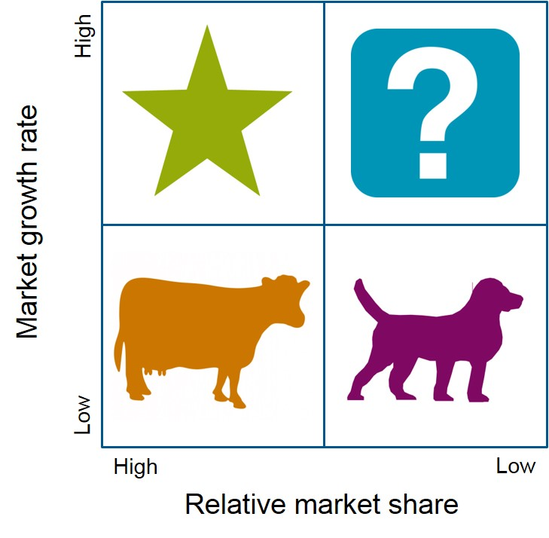
Source: (Richard Vierecki et al., 2016)
Star: The start products of Tesla have sustainable growth opportunity as these products have high market demand. The start products can arise high relative market share and high growth in compared to the competition and grabbing the competitive advantage from the market. Hence, the vehicles and energy products are star products of Tesla (McGee et al., 2016). Indeed, Tesla is the market leader at the international sustainability industry, the company has focus on the healthier environment. The 3 series is the latest electric vehicle of Tesla and it is considered as the start product of the company to achieve the high growth and increase the organisational market share in large extent.
Cash cow: The cash cow are the products of the organisation that have low growth but still profitable for the company. All kinds of other vehicles are falls in this category and cash cow products need small extent of investment. The Powerwall product of Tesla is another example of cash cow and this kind of battery of the company can be used by the customers in domestic setting. Through, the cash cow products have low growth, it is considered one of the key source of strategic advantage for the company.
Question mark: The organisations can face dilemmas in the case of question mark products. These types of products have low market share as the range of the competition in the market is so high. The company can’t differentiate the products for long time due to the high competition (Richard Vierecki et al., 2016). To manage the high growth of these products, the organisation needs huge investment. For example, the miscellaneous accessories, energy storages and solar panels of the company are regarded a question mark products which have low market share for the organisation.
Dog: The products have low market share and low growth are marked with dog products. The deadweight loss can be faced by the companies from these kinds of products. The products which compromise the customer orders and have below offering to the market can be marked with dog products (McGee et al., 2016). These products can’t fulfil the demand of customers and the value proposition by the organisation can be hampered. Tesla sometimes comprise the orders of the customers and the dog products can be arisen to the product line of the organisation.

The Ansoff Matrix
The electric vehicle market is highly competitive and the management of Tesla needs to take some strategic decisions to create the strong base of the company in highly competitive market. The Ansoff growth matrix is an effective tool to take strategic decision by the company so that large extent of competitive advantage can be grabbed by the organisation from the market. The components of this matrix are explained as follows:
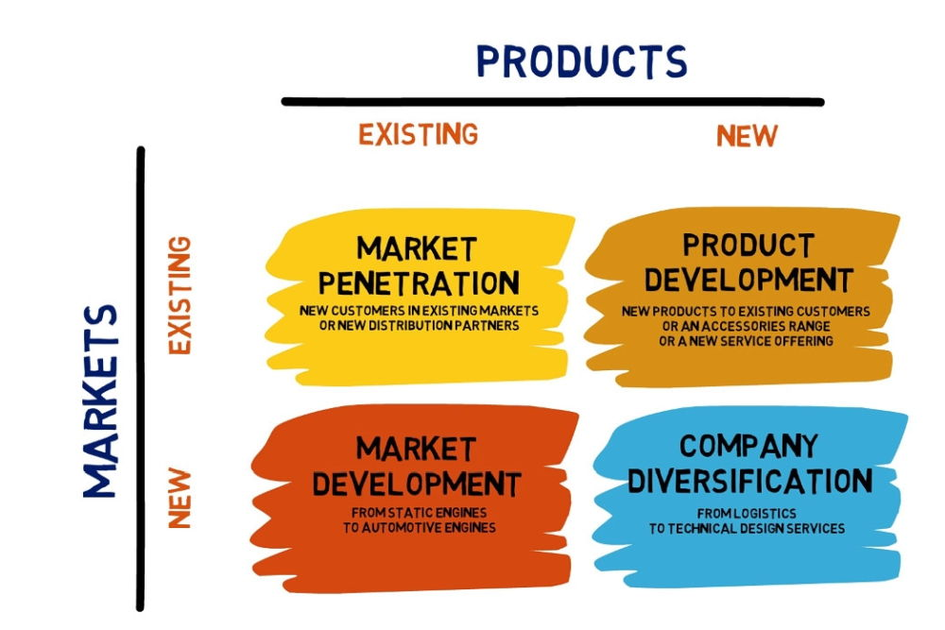
Source: (Ansoff, H., 2017)
Market penetration: To respond the demand of the customers properly, Tesla can enter into the niche market of the United States. The market penetration strategy is to offer the existing customers in the existing market and range of the services can be increased (Birkinshaw, J., 2014). The focus at the niche market can provide the ultimate control to the organisation to manage the demand of the customers and supply the desired products to them so that the value addition can be ensured. Different models of electric cars can be offered to the existing customers to improve the condition of the company at the current market.
Market development: The market development strategy is about to deal with the current products of the company to the new market. Hence, Tesla can expand the market of the company in different countries to increase the competitive advantage. On the basis of the demand of clean energy and electric vehicle, the top management of Tesla can expand the market beyond the border (Ansoff, H., 2017). The market development strategy of Tesla can increase the number of customers of the organisation as well in different countries. By developing market, the opportunity of Tesla can be enhanced to grow fast at the international arena.
Product development: The product development is another growth strategy that can be adopted by the management of Tesla. In this case, the current products of the organisation can be developed by conducting proper research. The product development should be based on the customer demand so that the sales of the products can be enhanced at the market. As the managers of Tesla are determined to ensure intense use of technology, the product development can be effective choice for the company to grab more advantages than that of the competitors in automobile sector (Birkinshaw, J., 2014). The research and development are also needed at the product development functions to supply the most value added products to the consumers.
Diversification: The launch the new product at the new market is known as the diversification strategy. For ensuring the rapid growth of the business and capture more market share, the diversification strategy can be relent for the company. In the context of Tesla, the diversification strategy can be adopted by the organisation (Ansoff, H., 2017). For instance, the company needs to expand its activities in different emerging market to capture the demand of the customers and supply them effective products to take the values of the customers in return. Different kinds of new models of Tesla cars can be launched to the new market of the organisation at the global market to capture more values than that of the customers in the automobile sector.

Conclusions
At this point of the report, it can be concluded that the strategic decision of Tesla is determinant behind the organisational success at the global market. The case study of Tesla’s entry to the auto industry of US has been analysed as per conducting the internal and eternal analysis. The macro and micro environmental factors are critically evaluated to assess their impact on the value addition of the company. The social, political and economic environmental factors have most impact on the strategic decision of Tesla and the organisational success at the market. Different strategic approaches to grab more values than that of competitors are also critically analysed to this report so that the organisation can easily take the value added decision. Having strong values of Tesla at the market, huge number of loyal customers and organisational technological expertise have made Tesla one of the giant company at the market of United States and the global market as well. The gap analysis of the company is also analysed to this report the possible threat on the company are estimated. Finally, value added strategies are designed to create close terms with the customers and capture the sustainable competitive advantage.

Recommendations
The market entry of Tesla to the auto market of the United States has been analysed in the effective manner to this report. The organisational internal and external analysis are conducted in the optimal standard so that the strategic move of the company can be assessed and its business strategy can be appraised by the managers. Hence, the recommendations are given so that Tesla can add more competitive advantage from market and secure the organisational base than that of competitors. The recommendations are given as follows:
- The quality control strategy should be followed by the management of Tesla strictly so that the company can provide the good quality of products ahead of competitors and capture the superior values.
- Tesla should apply the value based marketing approach so that the company can uphold the values of products and prefer to the advertising campaign according to the values of different kinds of products.
- The management of Tesla should focus on low cost supply of raw materials to become the costs leader at the electric vehicle industry and capture the most portion of market share.
- The channels of promotion of products should be increased by Tesla to get more connected with the customers at the global market and increase the organisational sales. The multi-channel promotion can also enable the company to capture most portion of values from the market.

References
Alan Baum, “What’s Driving the U.S. Auto Industry’s Financial Performance,” Ceres, August 7, 2017; “Automotive Revolution –Perspective Towards 2030,” McKinsey & Company, January 2016.
Ansoff, H., 2017. Strategic management. Basingstoke: Palgrave Macmillan.
Birkinshaw, J., 2014. Strategic management. Northampton, MA: Edward Elgar Pub.
Elliott, R.H., Rosenbaum-Elliott, R., Percy, L. and Pervan, S. (2015). Strategic brand management. Oxford University Press, USA.
Emerald Group Publishing., 2015. Strategic Management. Emerald Group Publishing.
Hill, C., Schilling, M. and Jones, G., 2019. Strategic management.
Jeyarathmm, M., 2018. Strategic Management. New Delhi: Himalaya Pub. House.
Joann Muller, “Tesla’s Future Hinges on Reinventing Auto Manufacturing,” Forbes, August 4, 2016.
Keller, K.L., Parameswaran, M.G. and Jacob, I. (2011). Strategic brand management: Building, measuring, and managing brand equity. Pearson Education India.
Kelly, P. and Ashwin, A., 2013. The business environment. Andover: Cengage Learning.
Lethbridge, D., Ng, S. and Chan, M., 2020. The business environment in Hong Kong. New York: Oxford University Press.
Maitland, I., 2014. The business environment. Oxford: Made Simple Books.
McGee, J., Thomas, H. and Wilson, D., 2016. Strategic management. [Limerick]: McGraw-Hill.
Richard Vierecki et al., “Connected Car Report 2016: Opportunities, Risk, and Turmoil on the Road to Autonomous Vehicles,” Strategy& (PwC), September 28, 2016.
Sadler, P., 2014. Strategic management. New-Delhi: Koganpage India Prt. Ltd.
SALONER, G., 2018. STRATEGIC MANAGEMENT. [Place of publication not identified]: JOHN WILEY.
SCHAFFER, R., 2022. INTERNATIONAL BUSINESS LAW AND ITS ENVIRONMENT. [S.l.]: CENGAGE LEARNING.
Worthington, I., Britton, C. and Thompson, E., 2018. The Business Environment. Harlow, United Kingdom: Pearson Education Canada.

