Saleh Ahmed 2010208

Effective Teamwork and Communication
BMSW4009 Deadline: 14 March 2025

Contents

Introduction 3
Findings 3
Conclusion 6
References 7

Introduction

Teams share common characteristics, with members working toward shared objectives and requiring collaboration to achieve these goals. Each team member has distinct and defined roles, some of which may vary from one another (McIntyre, Halthill, and Richard, 2000). Bedeian (1989) defines teamwork as a group of two or more individuals whose primary aim is to collaborate and accomplish a common goal through interaction.
Teams are formed to tackle tasks, objectives, and goals that are too complex or large for one individual to handle alone. The impact of teamwork on organizational effectiveness has been demonstrated in numerous studies (Weldon and Weingart, 1993).
Personally, I see myself as a natural leader in team settings. My life experiences have enhanced my ability to manage large groups. I am actively involved in several welfare and charity organizations, where I resolve issues, listen to the needs of the community, and organize fundraising projects. I consider myself a natural leader because I prioritize ensuring everyone’s perspective is heard, fostering respect, and facilitating teamwork.
In my view, effective teamwork involves clear communication that caters to different levels of understanding, creating an environment where people feel safe and comfortable sharing their opinions and feel valued.

Findings

During the Effective Teamwork and Communication module, I learned how to maximize the potential of teamwork. I learned that the key to a team's success is through forming friendships, actively listening and sharing ideas, respecting and valuing each other, minimizing conflict, and maintaining open communication. When team members understand their roles, and a leader takes responsibility while being considerate, the team functions well, helping to complete the task successfully. This understanding has helped in my social clubs. For example, in my cricket club, five members left the club due to a disagreement, the conflict escalated mainly because of misunderstanding. To resolve the issue, I organised individual meetings, listened to the concerns of the members, and then organised a team meeting so that the misunderstanding could be resolved.

While it is easy to select members for a group, blending them into a successful team is more challenging. Without effective communication, a team cannot perform well, as I observed during our Problem-Solving (BMSW4014) presentation, Issues like poor communication, limited knowledge sharing, unclear role assignments, lack of practice, and insufficient support for individual performance can undermine team success. Cooperation and leadership are important, but without effort and collaboration from every member, completing a team task becomes impossible (Badke and Hopinger, 2018).
Belbin's theory suggests that each team member takes on at least two roles, which can be assessed through the Belbin website. The effectiveness of a team depends on how well individual members contribute and engage with their strengths, working toward the shared goal. When the team is well-structured, with members fulfilling their designated roles and interacting without conflicts, tasks become much easier to complete. For example, a cricket team would struggle if all players had the same skill set. However, with a diverse range of specific skills, the team can succeed and win the match.
Bruce Tuckman's model of small group dynamics, Forming, Storming, Norming, Performing, states that all teams go through these stages of development. It is commonly believed that these stages are necessary for a team to grow and reach the point where it can work effectively together and deliver high-quality results. Tuckman, along with Mar Ann Jensen, later introduced a fifth stage: Adjourning, which occurs when a team completes its project and moves on to other endeavour’s. For high-performing teams, the end of a project often brings feelings of sadness, as the members have become closely bonded, only to go their separate ways (G. Abudi, 2010).

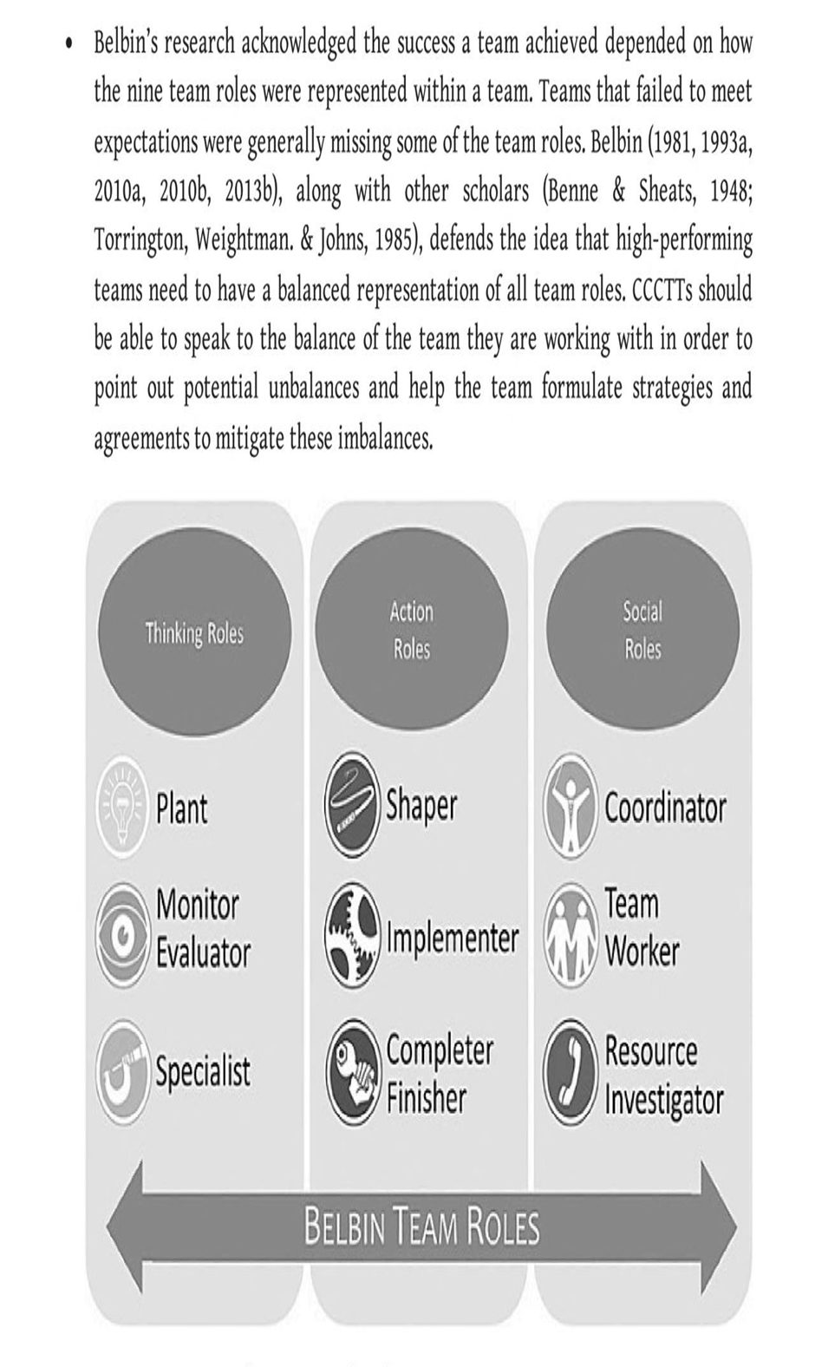

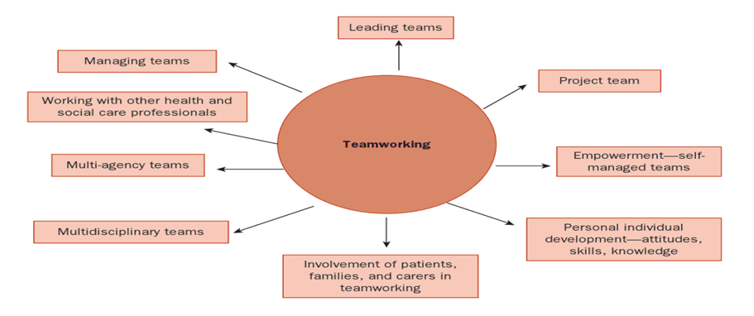

A case study of qualified nurse working with other people within teams, review definition of the team and consider the fundamentals skills of an effective team. By collaborating it will not be difficult to identify potential problem and will be addressed to, help you reflecting on the role within team, in turn easily be part of the existing team. Explore and develop the teamworking skills that mainly focuses on every task effectively. Its pivotal in all sector and organisations create a culture of teambuilding in influencing individual to work effectively and share their views talents and resources which is very essential to the outcome (Martin and Henderson,2001,93).
According to (Mcbride and Hyde,2006, Smith et al 2009) good teamwork improve performance such as enhance patient safety and satisfaction, reduced lengthy stay in acute environments, lowered mortality rates high staff morale and recruitment and retention.
Positive teamworking makes heathy working place (Fleissig et al 2006), underperforming team members can reduce teams’ performance and effect team morale and individual motivation (Chapman 2009). To make sure all the team works well it is individuals’ responsibility to have positive attitude personally motivated towards you work and your team.

Government policy has promoted multidisciplinary teamworking with some evidence suggesting that interprofessional educational opportunity are imported for embedding positive attitudes early in the professional’s career. This however problematic according to (Thurgood 1992 a,1992 b, Henderson 2009, Mahon et al 2009, Miller at al 2009, Pollard 2009) explored improvements in interprofessional collaboration opportunities for prequalifying health and social care students. It’s very important to share and gather within the sector, collaboration for recruiting as their practical knowledge and understanding be balance for the team (Cook et al 2001). Vital for all sector to consider sharing disciplinary option between, it makes everyone pre notified the preferred process so there is less waiting, better care, less consultation (Fleissig at al 2006).
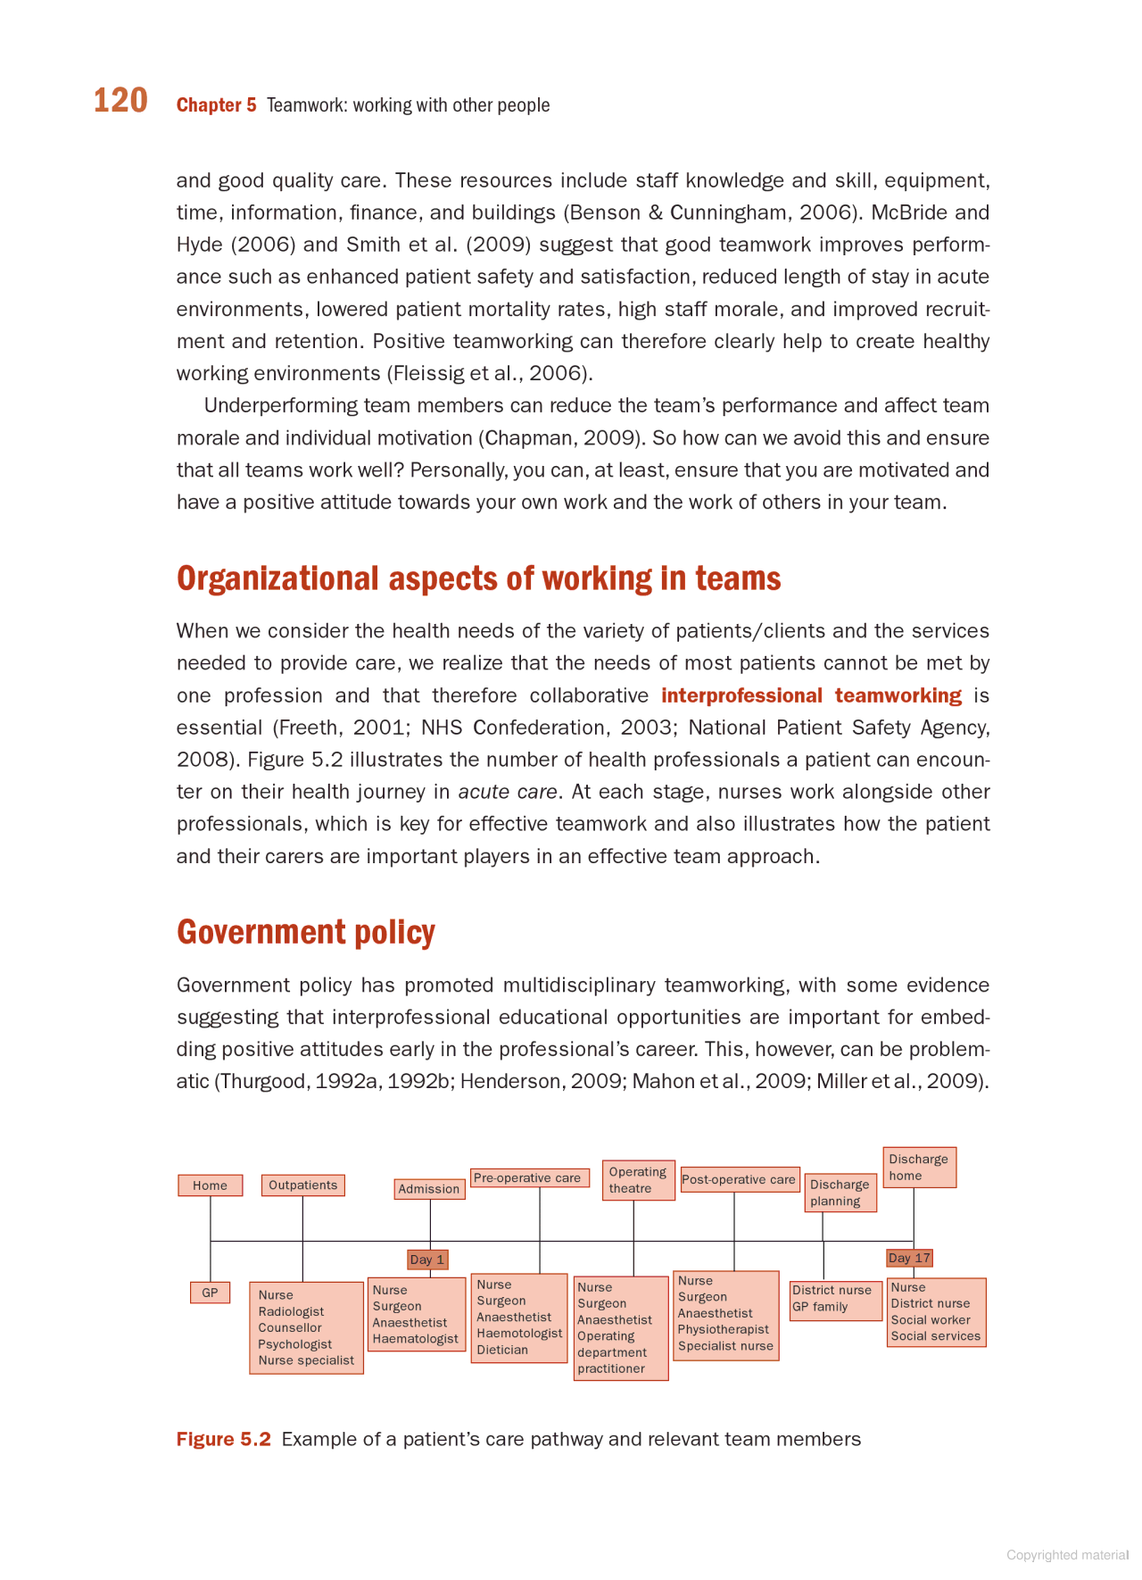

Conclusion
Teams have become the building blocks of organisations (Lowter, Mohrman and Ledford,1992). As organisations grow and become structurally more complex, groups of people needed who work together coordinated ways to achieve objectives that contribute to the overall aims, effectiveness and competitiveness of the organisation. Team working provides the flexibility needed to respond effectively and appropriately and more quickly than competitors working on their own. Ever changing demands of deadlines on organisational environment provides the path for innovative mechanism for bringing together the range of expertise, skills and knowledge required to complete complex work tasks.
So to rectify that sort of problem do not happen again in the cricket club we have created a policy of following the effective communication between all players and if and when any differences of opinions comes consult the coach and management with or no conflict. Resulting that we have managed to resolve the issues so common goal was achieved.

References

Abudi, G. (2010) The five stages of team development: a case study. Available at: https://www.projectsmart.co.uk/team-building/the-five-stages-of-team-development-a-case-study.php (Accessed: 7 March 2025)
Badke-Schaub and Hofinger (2018) ‘Failure in Teams: Why Successful Teams Do Not Fail (So Often)’, Strategies in Failure Management. Available at: https://link.springer.com/chapter/10.1007/978-3-319-72757-8_5 (Accessed: 12 March 2025)
Cook, R.C., Cook, J.G., Murray, D.L., Zager, P., Johnson, B.K. and Gratson, M.W., 2001. Development of predictive models of nutritional condition for Rocky Mountain elk. The Journal of wildlife management, pp.973-987.

Borrill, C.S. and West, M.A., 2005. The psychology of effective teamworking. In Teamwork: Multi-disciplinary perspectives (pp. 136-160). London: Palgrave Macmillan UK.Available at: https://link.springer.com/chapter/10.1057/9780230523203_7

Lance, C.E., Hedge, J.W. and Alley, W.E., 1989. Joint relationships of task proficiency with aptitude, experience, and task difficulty: A cross-level, interactional study. Human performance, 2(4), pp.249-272.

Lawler III, E.E., Mohrman, S. and Ledford Jr, G.E., 1992. The fortune 1000 and total quality. The Journal for Quality and Participation, 15(5), p.6.
Lynch, D.S., Lynch, M.J. and Clemens, C.M., 2019. Belbin team roles. In The handbook of communication training: a best practices framework for assessing and developing competence. Routledge.

Mahon, B.Z., Anzellotti, S., Schwarzbach, J., Zampini, M. and Caramazza, A., 2009. Category-specific organization in the human brain does not require visual experience. Neuron, 63(3), pp.397-405.

McBride, A. and Hyde, P., 2006. Human resource management 14 in healthcare. Healthcare Management, p.237.

O'Connor, S.D., 1992. Thurgood Marshall: The Influence of a Raconteur. Journal of Supreme Court History, 17(1), pp.9-13.

Weldon, E. and Weingart, L.R., (1993) ‘Group goals and group performance.’ British Journal of Social Psychology, 32(4), pp.307-334.

