

UNIVERSITY OF WALES TRINITY SAINT DAVID

BA Business Management

International Financial Management
LCBB6002

Assessment 1

Report: Critically analyse and evaluate the importance of international financial management

Name: Anastasia Ursu
Student ID: 2024744

Lecturer: Dr Konstantina Mari
Date: 05.05.2023
Word count: 1500

2023
Contents

Executive summary 3
1. The importance of international financial management 3
2. Apple, Inc.'s difficulties in the global financial markets. 4
3. Apple's Dividend Policy Implementation and Evaluation 4
4. Evaluate the efficient market hypothesis theory in relation to Apple Inc. 6
5. Methods of appraising projects at Apple Inc. 7
Conclusion 7
References 8

Executive summary

Apple Inc. is a prominent multinational corporation that ranks highly in terms of revenue, profits, assets, and brand equity. The progression of this event has been swift, yet not consistently steady, as it has encountered obstacles throughout its development. The present study aims to conduct an analysis of Apple Inc (Report, 2022).
This article aims to analyse the implementation and assessment of dividend policy by a typical company, Apple. Establishing a consistent dividend is crucial for Apple. The company has established a policy aimed at addressing the needs and interests of its shareholders as well as potential new investors. To align with its trajectory, Apple must anticipate forthcoming patterns of dividend expansion.
The objective of this report is to analyse the Efficient Market Hypothesis and its applicability to the corporation, Apple. Upon conducting an analysis, a trading strategy that can be recommended to investors will be determined.

1. The importance of international financial management
International finance is crucial to international trade and the flow of goods and services between economies. It is significant for several reasons, the most prominent of which are described below (Bekaert, 2013).
- Finding the exchange rates, comparing the rates of inflation, getting an idea about investing in international debt instruments, determining the economic position of other nations, and evaluating the state of overseas markets are all essential uses of international finance, which is an important tool (Macmillan, 2022).
- The determination of relative values of currencies is a crucial aspect of international finance, and exchange rates play a significant role in this regard. The field of international finance facilitates the computation of said rates.
- Several economic factors play a crucial role in determining international investment decisions. The assessment of the safety of foreign debt securities for investors is influenced by the economic factors of the respective economies.
- The prominence of international finance has increased as a result of the process of globalisation. Comprehending the fundamental principles of global institutions facilitates the maintenance of equilibrium among them.
- The maintenance of peace among nations is facilitated by an international finance system. In the absence of a robust financial metric, it can be argued that all nations would prioritise their own interests. International finance plays a crucial role in mitigating the issue.
- International financial institutions, such as the International Monetary Fund (IMF) and the World Bank, serve as intermediaries in the resolution of international financial disputes (Madura, 2021).

2. Apple, Inc.'s difficulties in the global financial markets.
Apple, the world's largest information technology corporation, has seen both success and failure. Over the course of its existence, Apple has introduced a new type of personal computer, ushered in the smartphone era, and created its own demand for devices that the world had never imagined or dreamed of, outside of your typical Star Trek episode (Report, 2022).
Apple, on the other hand, now has a new challenge: adapt to an ever-changing global customer and shifting demand, or risk losing its dominance in the information technology sector. Apple has pioneered the path for new advances in cell phones and portable gadgets such as the iPod and iPad during the last decade. (Madura, 2021) However, Apple has recently given up and its innovations have become a thing of the past. Apple delivers just little changes to its products year after year, failing to give the shock and awe impact that Steve Jobs gave nearly 7 years ago. It is this lack of surprise and imaginative innovation that has turned away devoted customers (Marrero, 2017).
Apple must adjust to withstand this slide and regain lost position. It must consider the new aspects that influence customer purchasing across the world. These factors include sustainability, environmental effect, VR, AR, and AI. Customers across the world are seeking for ecologically "green" technologies and items that give them the impression that they are contributing to climate change. Adapting new technologies such as VR, AR, and AI to their products will also set Apple apart from its competitors. Long gone are the days of a simple software update every year; in the coming years, Apple must provide significant updates to their devices and/or completely new devices to provide a rally for the brand and its stock, truly carrying out Jobs' vision and legacy (Report, 2022).

3. Apple's Dividend Policy Implementation and Evaluation
A dividend policy is a method through which a firm distributes its free cash to its shareholders. It is critical to assess how much free cash will be maintained for business expansion and how much will be retained for shareholders (Arnold, 2013).
First, evaluate Apple's dividend growth. Apple has raised its quarterly cash dividend yearly since 2012. Apple increased quarterly dividend increases by roughly 10% by following the trend. Since share buybacks reduced the number of outstanding shares, Apple could pay higher cash dividends per share. Even if Apple purchased back its shares, boosting the quarterly dividend will benefit shareholders, giving Apple more leverage. Due to share buybacks, Apple's dividend expenditures only grew 5%, despite a 10% dividend rise. Apple's dividend distributions will range from 2% to 10% in the coming years, leaning towards a sustainable growth rate (Report, 2022).
In this study, we will analyse the evaluation conducted by Apple with regards to its dividend policy. analyse the trend of Apple's dividend trajectory over time.
Provide more context and information about the specific time frame and factors that may affect the future condition of dividend expenses in Apple. Additionally, it is important to note that predicting future financial outcomes is subject to uncertainty and risk.
It is assumed that Apple's dividend pay-out growth rate is 5% due to the company's consistent dividend policy (Lin, 2020).
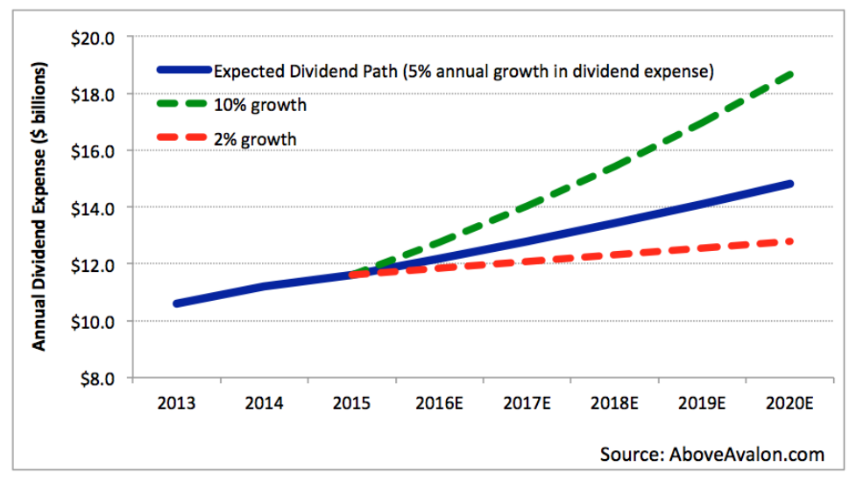
Figure nr:1
Source: AboveAvalon.com
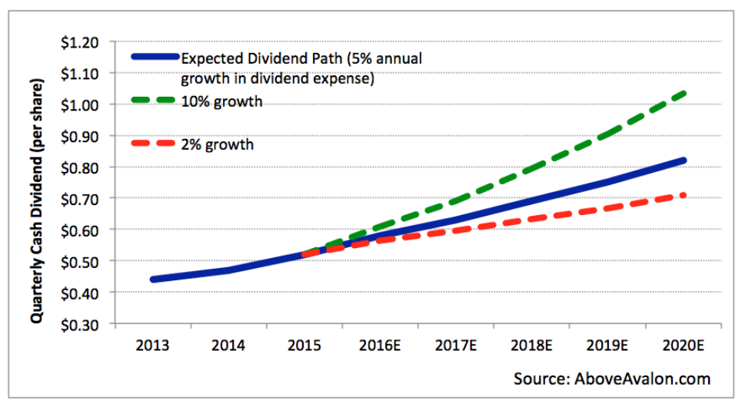
Figure nr:2
Source: AboveAvalon.com
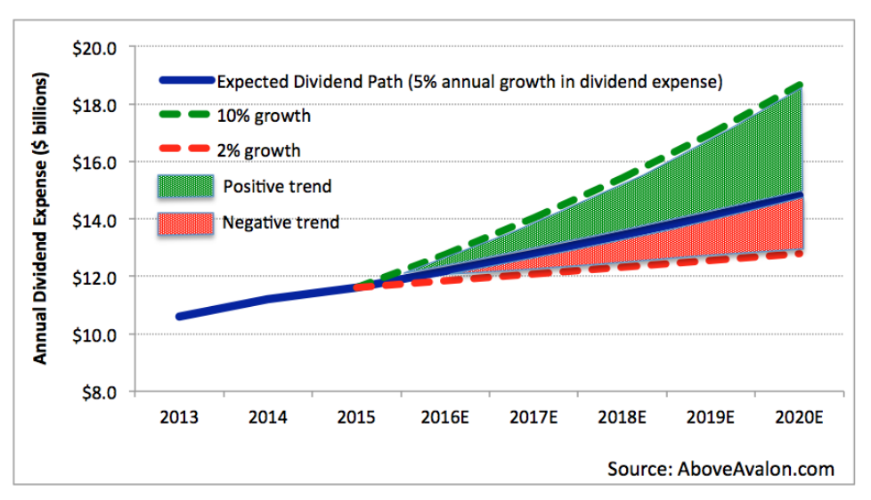
Figure nr:3
Source: AboveAvalon.com

4. Evaluate the efficient market hypothesis theory in relation to Apple Inc.
According to the efficient market theory, it is almost difficult to consistently outperform the market since share prices represent all available information.
Efficient Market Theory:
- The predictability of new information is limited, as any prediction of it would already be encompassed within the existing body of knowledge.
- The unpredictability of stock prices is attributed to their responsiveness to new and unforeseeable information.
- The fluctuations in stock prices exhibit a stochastic process known as a Random Walk. The theory of Random Walk asserts that variations in stock prices follow a uniform distribution and are uncorrelated with one another (Madura, 2021).
Several empirical studies have been carried out to evaluate the validity of EMT. The behaviour of stock prices appears to exhibit a stochastic pattern. Fama himself conducted one of the earliest and most influential studies. The researcher discovered that the behaviour of stock prices in the United States adhered to a random walk model, rendering them unpredictable. The unpredictability of market prices is a notable characteristic. Previous research has yielded comparable findings, indicating that market prices exhibit unpredictability and adhere to a random walk model. Empirical evidence suggests that actively managed funds exhibit inferior performance compared to passively managed funds. Furthermore, certain research has indicated that funds managed through active management strategies, which aim to exceed market performance, frequently exhibit lower performance than the market once fees and transaction costs are taken into consideration (True, 2023).
The trend of multinational business has exhibited a general increase over a period of time. Three prevalent theories that elucidate the rationale behind the international expansion of multinational corporations (MNCs) are: 1) the theory of comparative advantage, 2) the imperfect markets theory, and 3) the product cycle theory. These theories exhibit a degree of overlap and may serve to complement each other in the construction of a coherent framework for the advancement of international business (Bekaert, 2013).

5. Methods of appraising projects at Apple Inc.
Apple is a continuous process that involves providing feedback to both the appraiser and appraised individuals. It serves as a formal opportunity for personal counselling, motivation, salary reviews, and allocation of merit payments (Arnold, 2013).
Personnel are evaluated according to predetermined objectives, duties, and accomplishments based on goals that have been jointly planned and agreed upon by individuals and their supervisors. The performance evaluation process facilitates the human resources department in identifying any deficiencies in a specific skill set, thereby enabling them to initiate recruitment efforts to address such inefficiencies. Incentives are provided as a result of exemplary performance (Bekaert, 2013).
Apple utilises a pair of assessment instruments to evaluate the performance of its workforce. Evaluation is a performance appraisal technique that involves gathering feedback from colleagues and team members to gain a distinct perspective on an individual's performance. Although managers possess the ability to evaluate an individual's outcomes and achievements, 360 Degree feedback (Madura, 2021).

Conclusion
To summarise, despite possessing a remarkable market value and advanced technologies, Apple is confronted with significant risk factors that have the potential to negatively impact its sales and overall profitability. Overall, it is not advisable for investors with an interest in Apple's stock to make a purchase.
The escalation of Apple product prices and the heightened competition within the market are generating significant strain on the company. Moreover, the influence of unforeseeable occurrences such as the COVID-19 pandemic must be acknowledged. These factors are exogenous and beyond the purview of the company's control or predictability. Therefore, it cannot be guaranteed that Apple will be able to capitalise on all potential opportunities and mitigate all potential threats in order to increase its revenue. Moreover, an alternative option exists that is superior. Samsung, a formidable rival of Apple across various sectors and the company that has surpassed iPhone in the worldwide smartphone industry, exhibits a lower P/E ratio and PEG ratio in contrast to Apple. This would render Samsung's stock a more prudent investment.

References

Arnold, G.( 2013). Essentials of corporate financial management. 2 ed. Harlow, England: Pearson Education.
Bekaert, G. J.(2013). International financial management. Pearson new international edition. ed. s.l.:Pearson.
Lin, L.( 2020). Analysis on Apple’s Implement and Assessment of Dividend. Web of Conferences, Volume 2018, pp. 1-4.
Macmillan, G.(2022). International Finance Scope, Importance, Advantages and Disadvantages. International Journal of Accounting Research, 10(1), p. 10:225.
Madura, J.(2021). International Financial Management. 14 ed. UK: Copyright.
Marrero, A. G.(2017). The Rise of Apple Inc: Opportunities and Challenges. Journal for global business and community, Volume 157, pp. 1-10.
Report, A.( 2022). Apple Inc Annual Report, California: s.n.
True, T.( 2023). Efficient Market Theory. Finance Strategists, pp. 1-4.

