Assignment 2
Learning in the Digital Era
UNIVERSITY OF WALES TRINITY SAINT DAVID
LONDON CAMPUS
Video Link: https://www.youtube.com/watch?v=a5yNLOI6QN8

Module Name: Learning in the Digital Era
Module Code: ACCA 4025
Student Name: Farhana Akhtar
Student ID: 2541761
Group: 1

Lecturer’s Name: Koushik Modak

Table of Contents
Introduction 2
Main Body 2
Conclusion 17
References 18

Introduction

This presentation covers three main tasks. First, I will discuss my self-evaluation, including my strengths, weaknesses, and the traits I gained through self-reflection. Next, I will present my Professional Development Plan (PDP), including my SMART goals and progress towards one goal. I will then explain the key concepts of resilience from Unit 4. Finally, I will conclude by reflecting on how these activities have supported my personal and professional development for a future career as a Data Analyst.

Main Body
This report focuses on the importance of self-evaluation and how it helps improving our future. Again, self-evaluation comes from the self-reflection. So, Gibb’s reflective cycle has been integrated and applied to identify and understand our own self-evaluation. The SMART goal theory has been applied to understand how we can achieve our goals with an appropriate professional planning. Finally, a summary of Unit 4 has been discussed in this report.

Video Link: https://www.youtube.com/watch?v=a5yNLOI6QN8
Slide 1 COVER PAGE
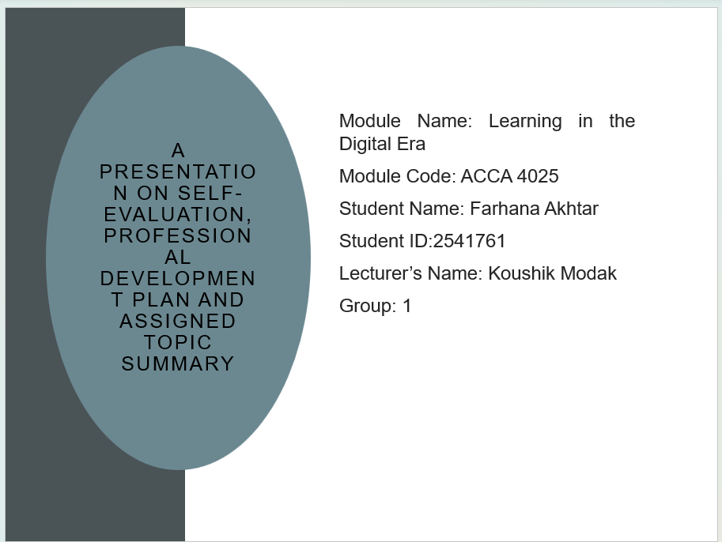

Slide 2 CONTENTS 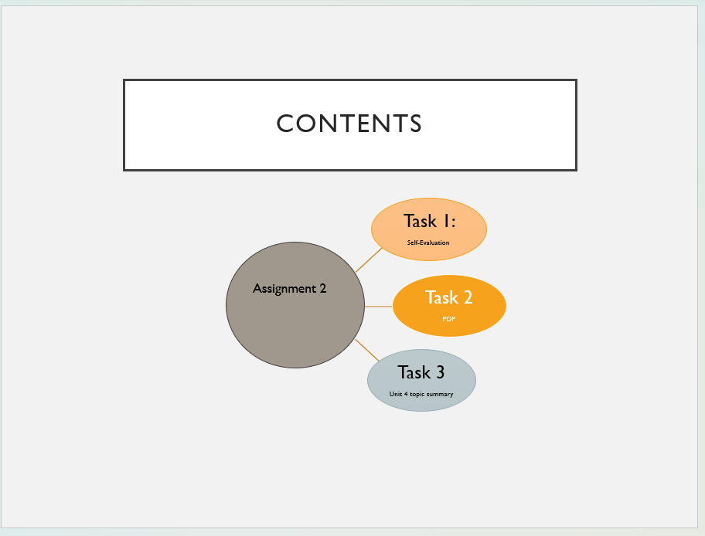

Slide 3 INTRODUCTION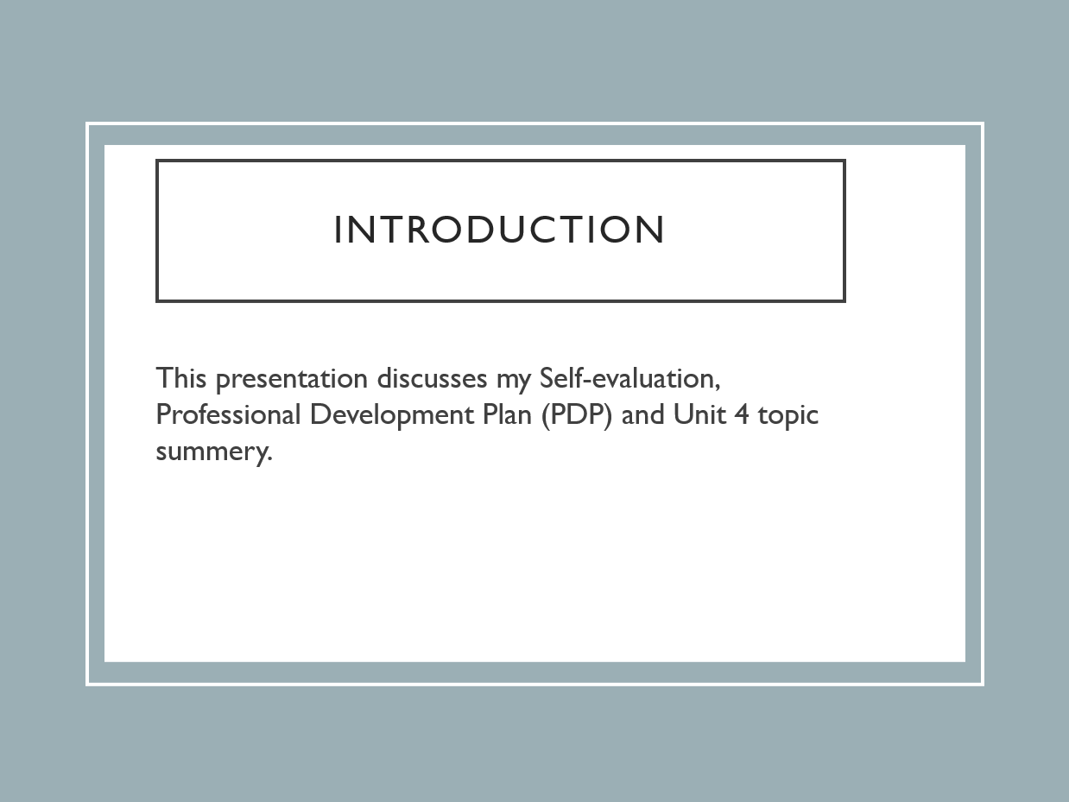

Slide 4 GIBB’s REFLECTIVE MODEL
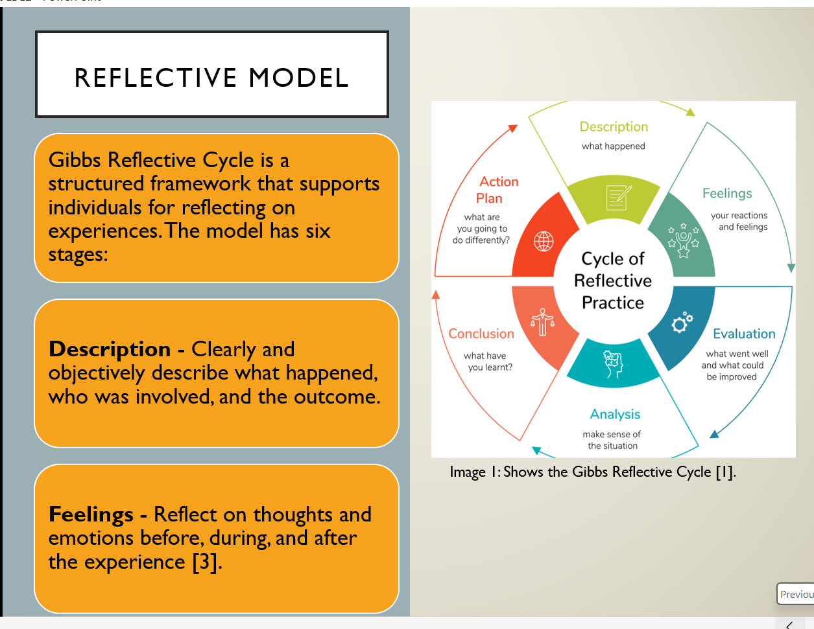
Slide 5 GIBB’s REFLECTIVE MODEL
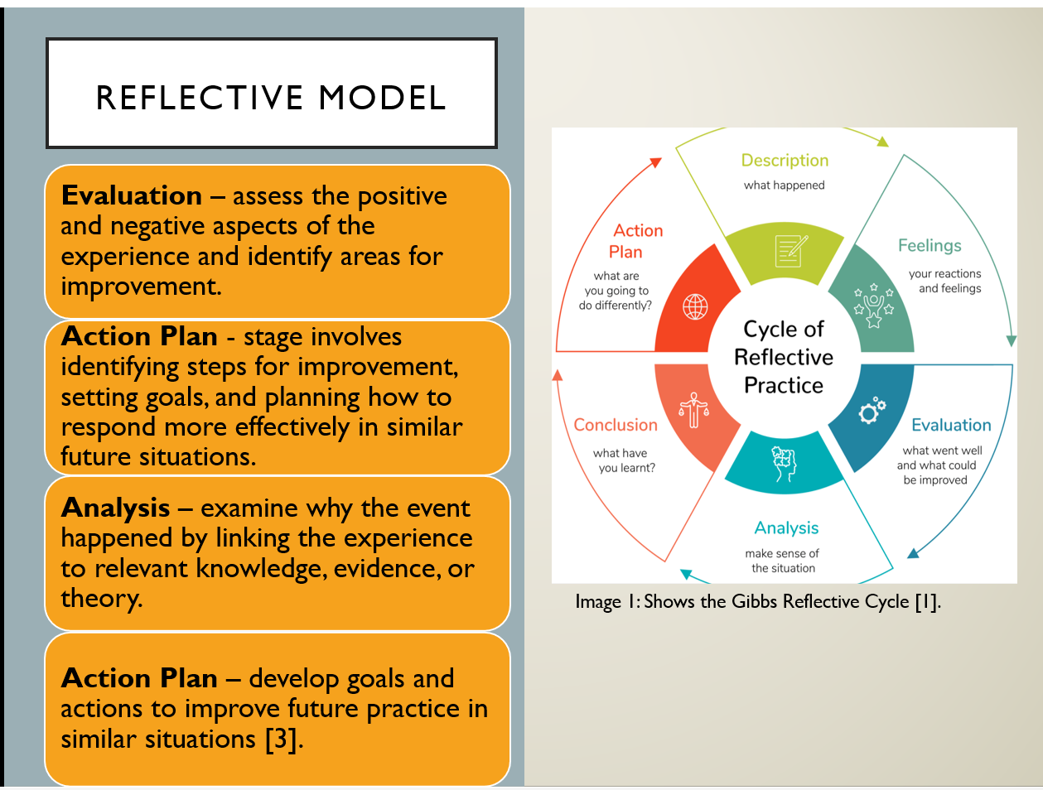

Graham Gibbs introduced the Gibbs Reflective Cycle in 1988 as a structured model for reflection. The model is widely used in educational and professional settings to support critical thinking, evaluate experiences, promote continuous learning and apply these perspectives for future practice. The cycle has six stages:
- Description – require individuals to give a clear and an objective account of the event by explain what happened, who was involved, the actions that took place and the outcome without including any personal judgements.
- Feelings – At this stage, individuals reflect on their emotions, thoughts, and reactions before, during, and after the event. Understanding these feelings helps a person to gain deep insight into how the experience affected them and how their action affected by their emotions.
- Evaluation – involves critically assessing the experience by the positive and negative aspects. It encourages a person to reflect on what was successful, identify areas that could have been improved and the factors that influenced overall outcome of the event.
- Analysis – focuses on exploring the factors that influenced the situation and relating the experience to relevant knowledge, evidence or theory. This deeper level of reflection enables individuals to achieve a better conception of why events occurred in a particular way and how different factors contributed to the outcome.
- Conclusion – this stage is about reflecting on the experience to identify key lessons. It requires individuals to consider what they have learned, what could have been approached differently and how the situation could have been improved. It helps summarise the main outcomes and lessons learned for future development.
- Action plan –this stage concentrates on creating an action plan for future improvement based on the reflections. It includes setting goals, identify specific actions to take if a similar event repeat [1].
In Assignment 2, I will use Gibbs' Model to reflect on my self-evaluation, identify my strengths and weaknesses, and develop SMART goals within my Professional Development Plan. This reflective process will help me recognise areas for improvement, monitor my progress, and support my personal and professional development towards a future career as a Data Analyst.

Slide 6 TASK 1: SELF EVALUATION
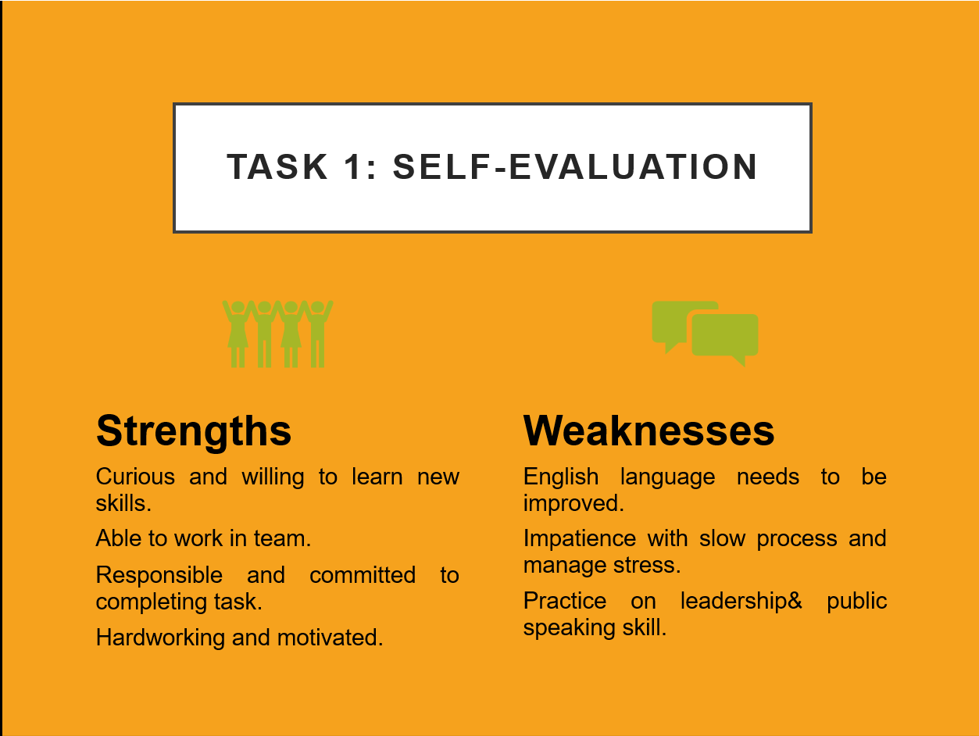
My individual SWOT analysis helped me identify my strengths and weaknesses and understand how they may affect my future professional development as a Data Analyst. My main strengths include willingness to learn, hardworking, responsible and able to work effectively as part of a team. These qualities enable me to complete tasks efficiently, adapt to new challenges and collaborate successfully with others. I am also committed to improve my knowledge and develop new technical skills.
However, the SWOT analysis also highlighted areas that require further improvement. I need to improve my English communication and public speaking skills to communicate ideas more confidently in academic and professional environments. I also wish to strengthen my leadership skills, become more patient, improve my ability to manage stress and avoid taking too many responsibilities. Identifying these weaknesses has allowed me to create a SMART professional development plan with clear goals, appropriate courses and measurable outcomes. By building on my strengthen and working on my weaknesses, I will be better prepared for a successful career as Data Analyst.

Slide 7 TRAITS GAINED FROM THE SELF EVALUATION
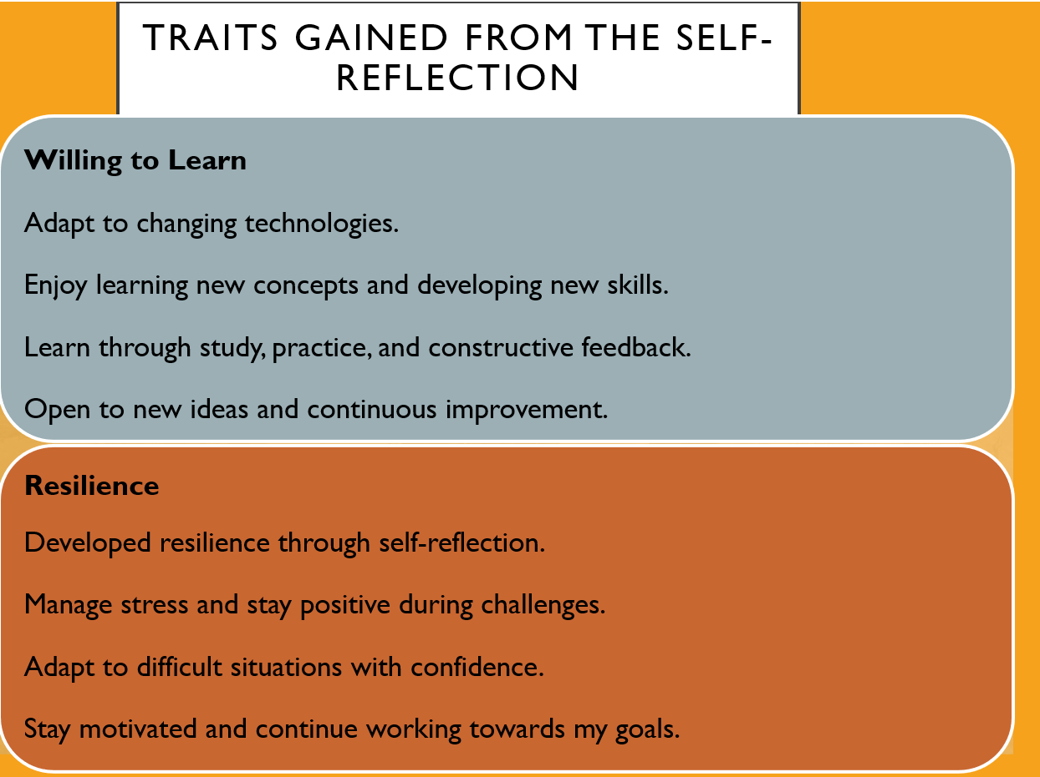
Trait gained from self-reflection
Through my self-evaluation, I gained a better understanding of my strengths and the areas I need to improve. It increased my self-awareness by helping me reflect on my abilities and identify opportunities for further development. I have realised that I enjoy expanding my knowledge and developing new skills. I actively learn from studying, practical experience, and feedback, while remaining open to new ideas. This mindset helps me adapt to changing technologies and supports my goal of becoming a successful Data Analyst. I also strengthened my resilience by learning to manage stress, overcome challenges and stay focus on my goals.
Overall, the self-evaluation has contributed significantly to my personal and professional development. It has increased my confidence, strengthened my ability to adapt to new situations, and encouraged me to set realistic goals for continuous improvement. These traits will help me become a more effective learner, a better team member, and a competent professional in the future.
Slide 8 PROFESSIONAL DEVELOPMENT PLAN 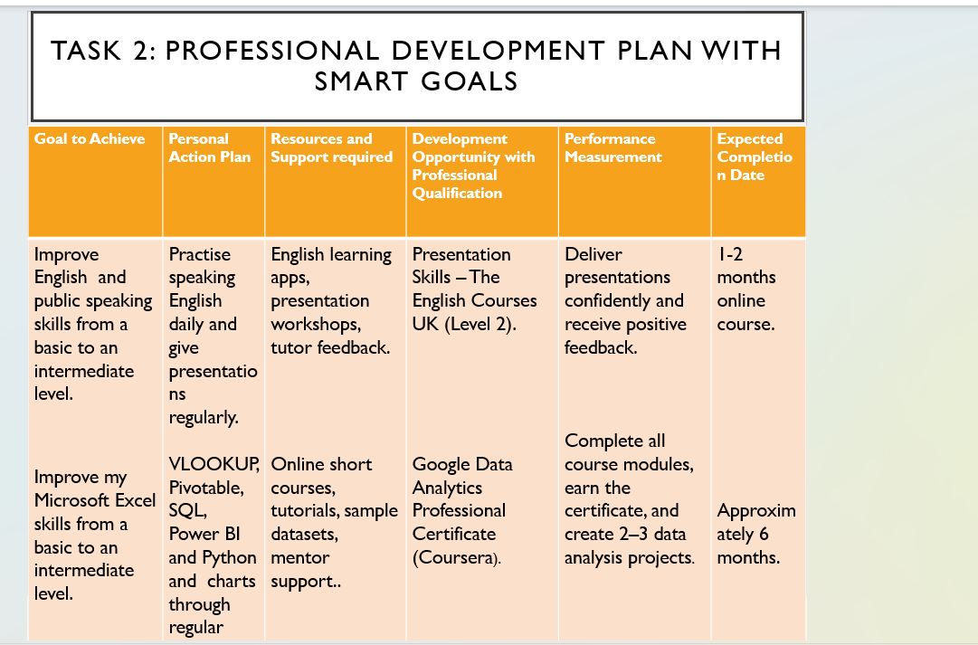

Slide 9
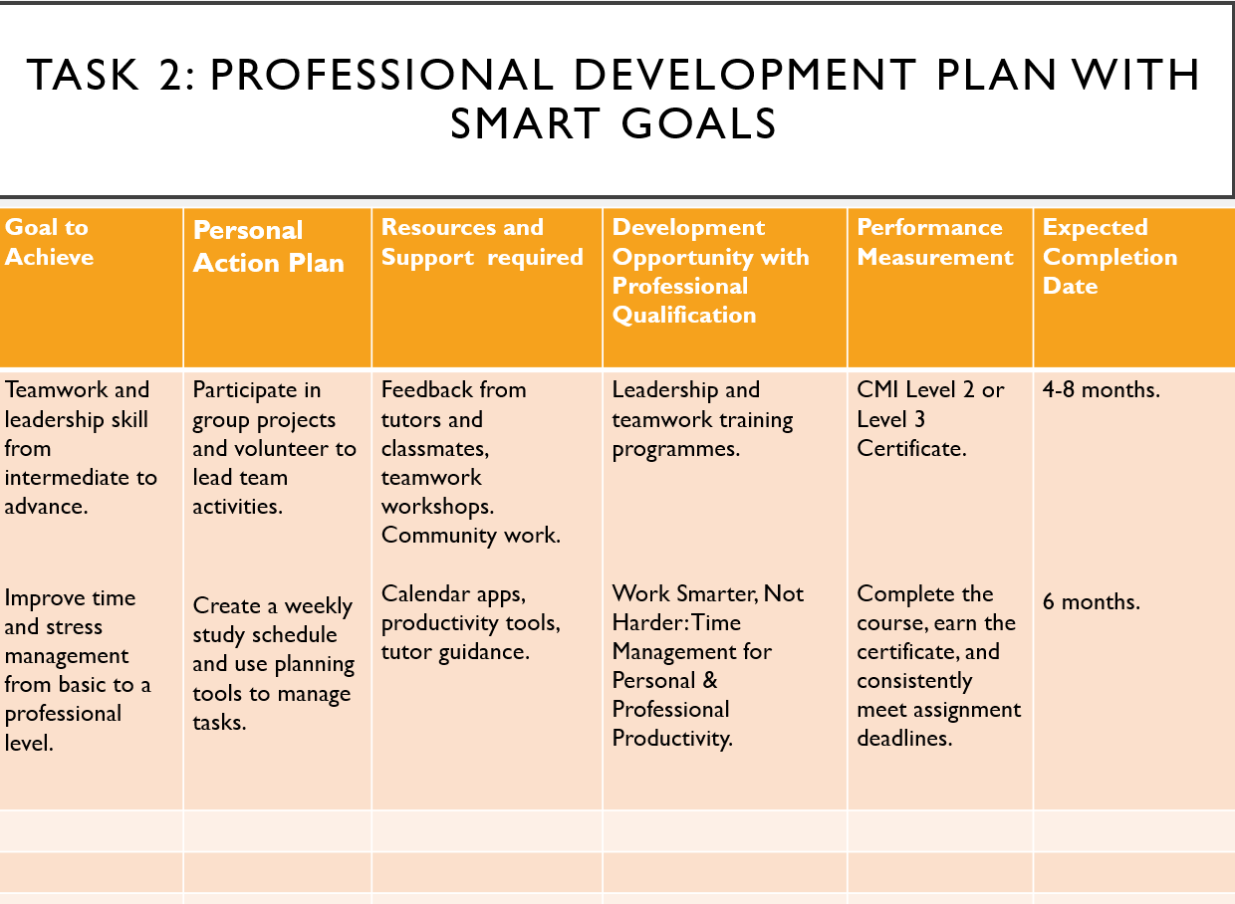

Slide 10
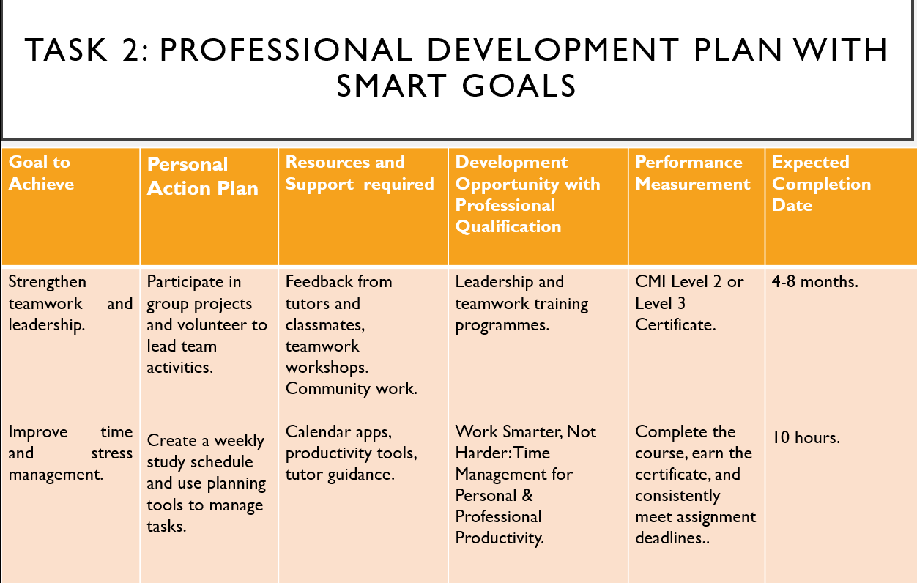

Evidence of SMART goal of developing skills.
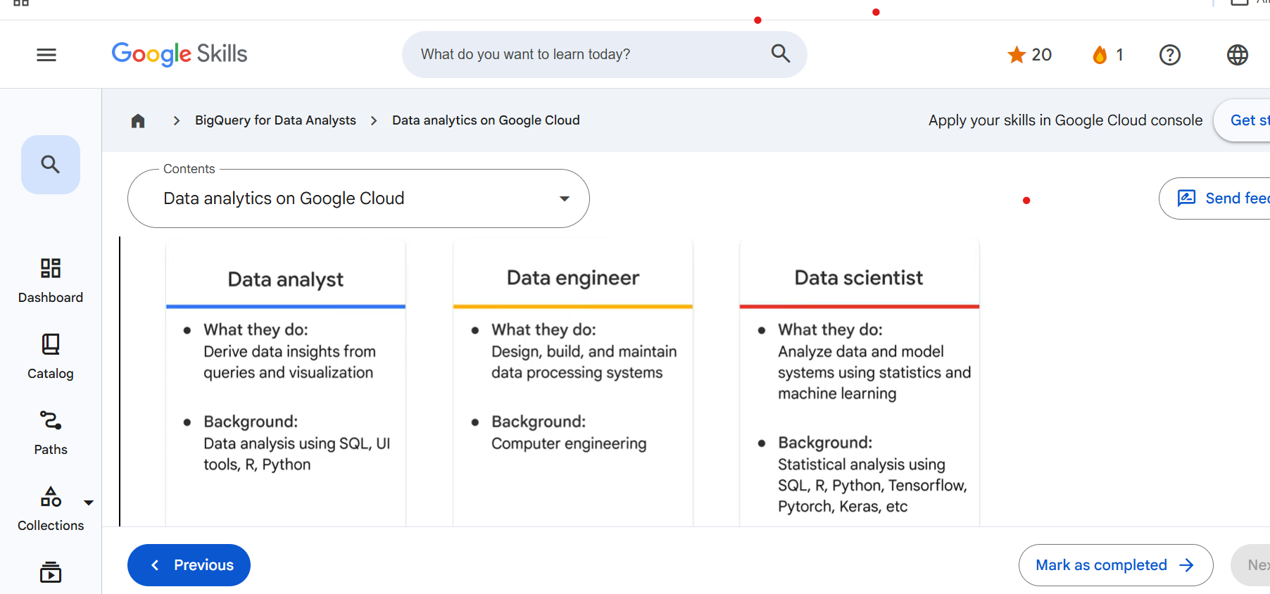
Screenshot 1. This image shows enrolment in the Google Skills Big Query for Data Analysts course [2].
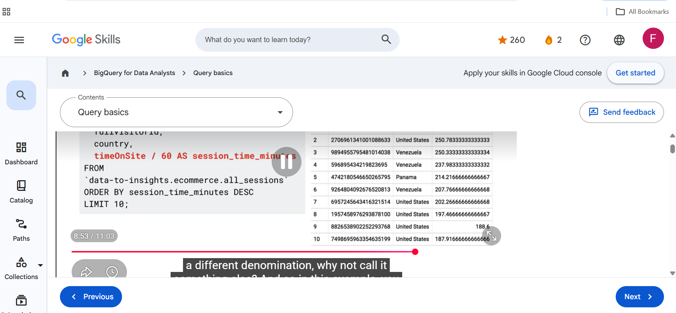
Screenshot 2. Here I am learning SQL query basics to develop practical.

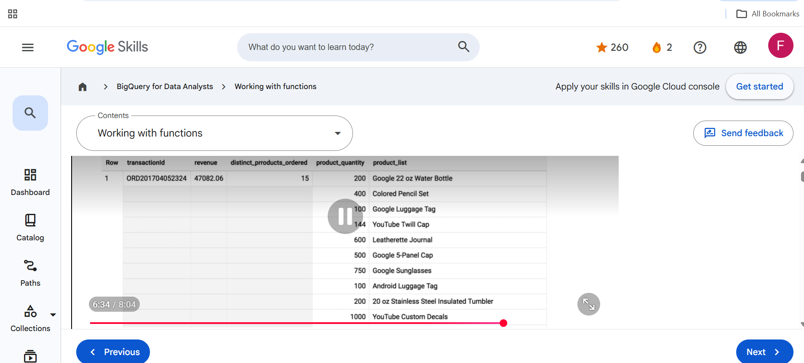
Screenshot 3. This image shows my progress in the Google Skills course, demonstrating the development of SQL and data analysis skills [2].

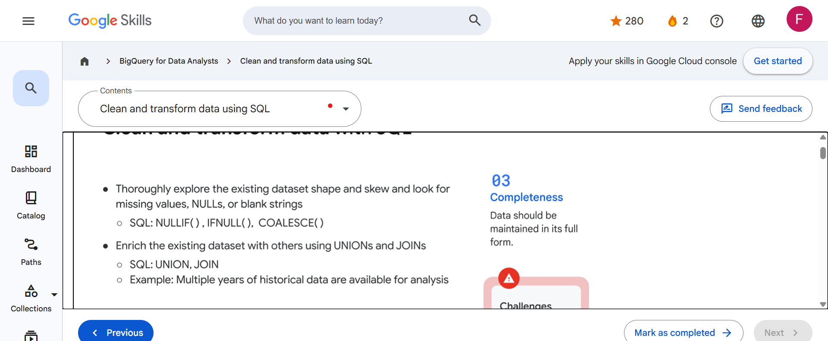
Screenshot 4. Learning how to clean and transform data using SQL [2].

Slide 11
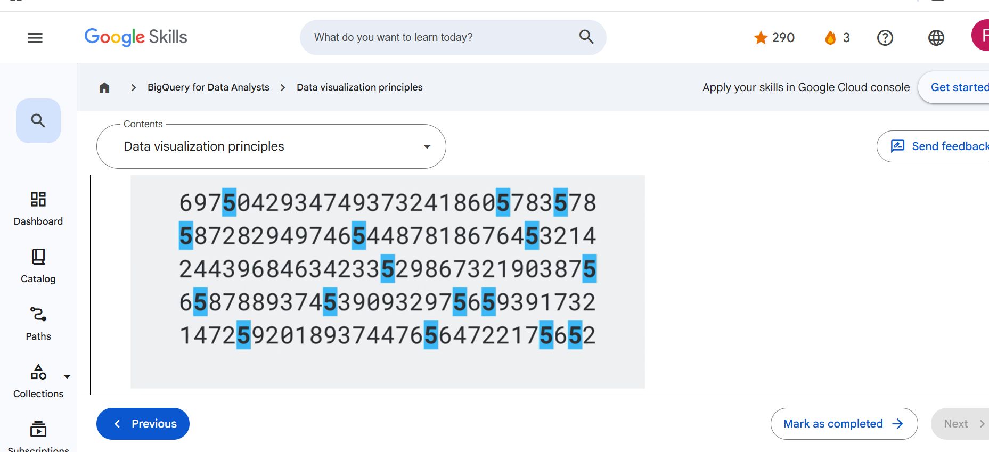
Screenshot 5. Here I am learning data visualization principles in the Google skills Big Query for Data Analysts course.
Brief explanation:
To make progress toward my SMART goal of developing my data analysis skills, I enrolled in the Google Data Analytics Professional Certificate on Coursera. The screenshots provide evidence of my course enrolment, learning activities and completed modules. Through this course, I can develop practical skills in Excel, Big Query, data visualisation and data analysis which are essential for a future career as a Data Analyst.
Completing this course has strengthened my technical knowledge and improved my confidence in analysing and interpreting data. It has also enhanced my problem-solving skills and encouraged me to continue learning through practical projects and additional training. This progress demonstrates that I am actively working towards achieving my SMART goal and preparing for future employment as a Data Analyst.

Slide 12 UNIT 4 TOPIC SUMMARY
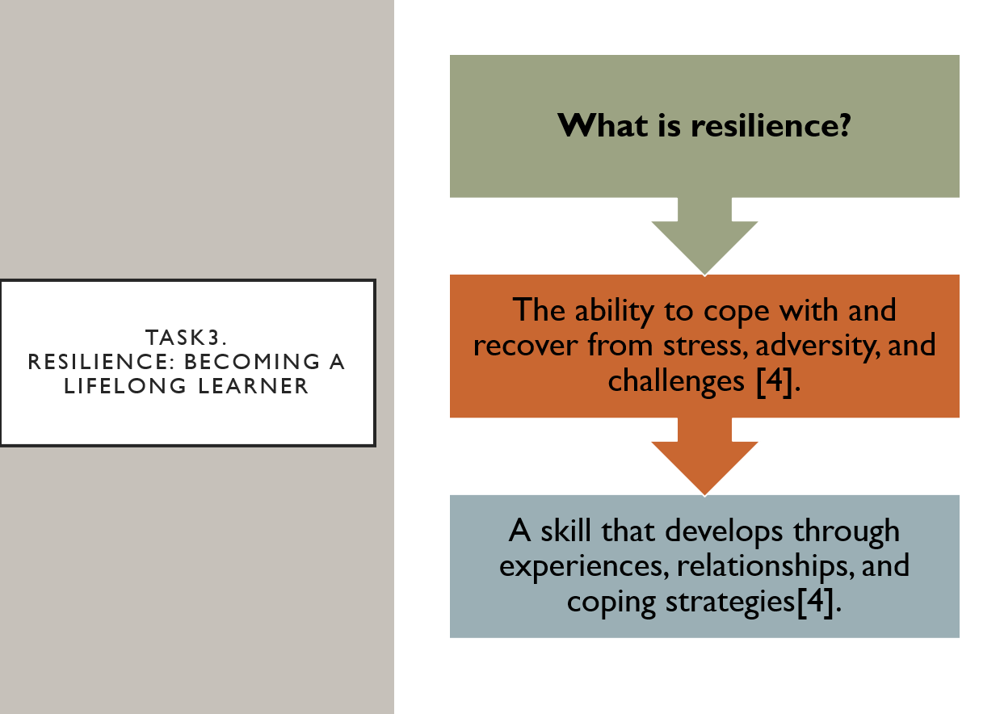
Slide 13
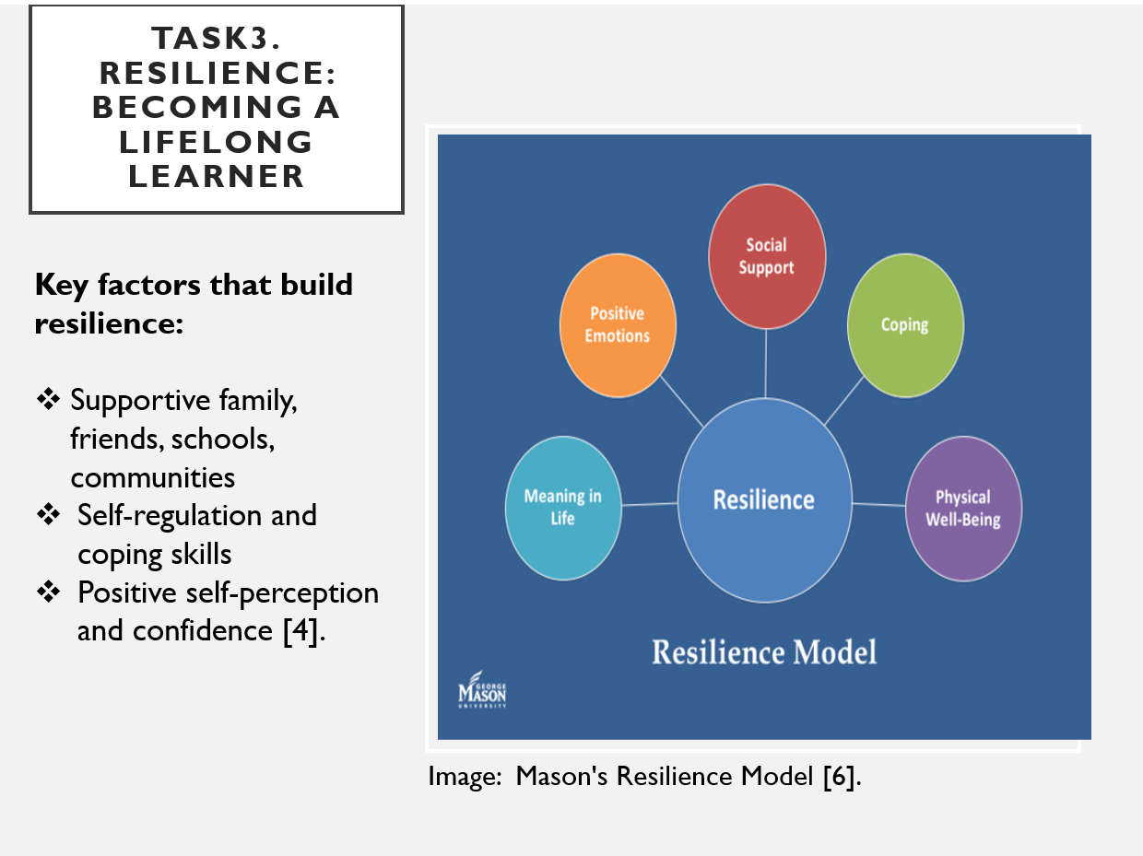

Slide 14
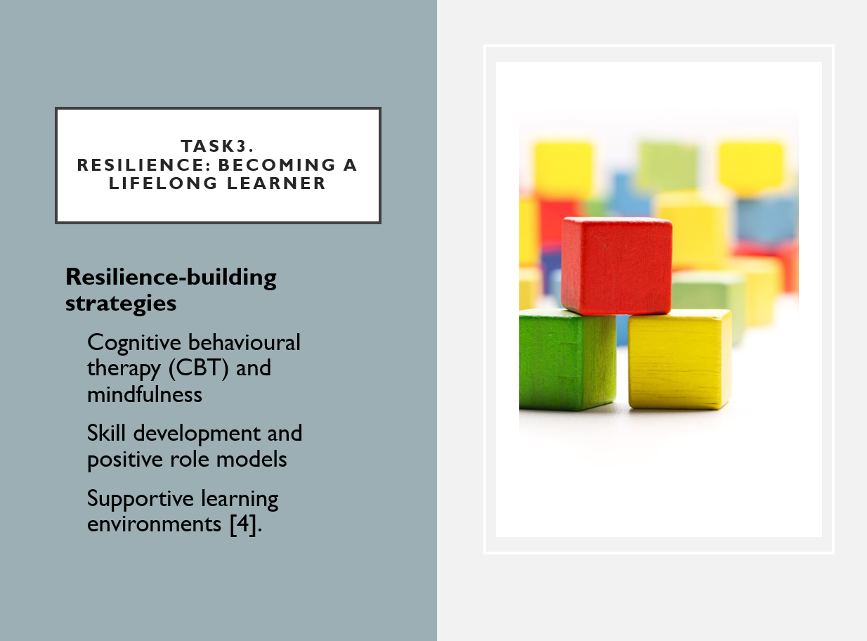
Resilience
Resilience refers to a person’s ability to cope with stressful situations, overcome challenges, and recover from difficult experiences. It develops through life experiences, relationships, and coping skills.
Protective factors
Research shows that resilience is influenced by factors such as hardship, supportive relationships, and previous experiences. Protective factors can include social support, cognitive abilities, strong community connections, and a positive view of oneself, religious connection, and self-regulation, help individuals adapt to adversity and recover from stressful events.
Resilience-promoting interventions
Resilience can be strengthened through cognitive behavioural therapy (CBT), skills training, mentoring, positive role models, and supportive environments such as trauma-informed schools. These approaches enhance confidence, emotional well-being, and coping skills, enabling individuals to respond more effectively to future challenges. As a lifelong learning, as the ability to adapt to challenges and persist through setbacks can support ongoing personal and skill development [4],[5].

Slide 15
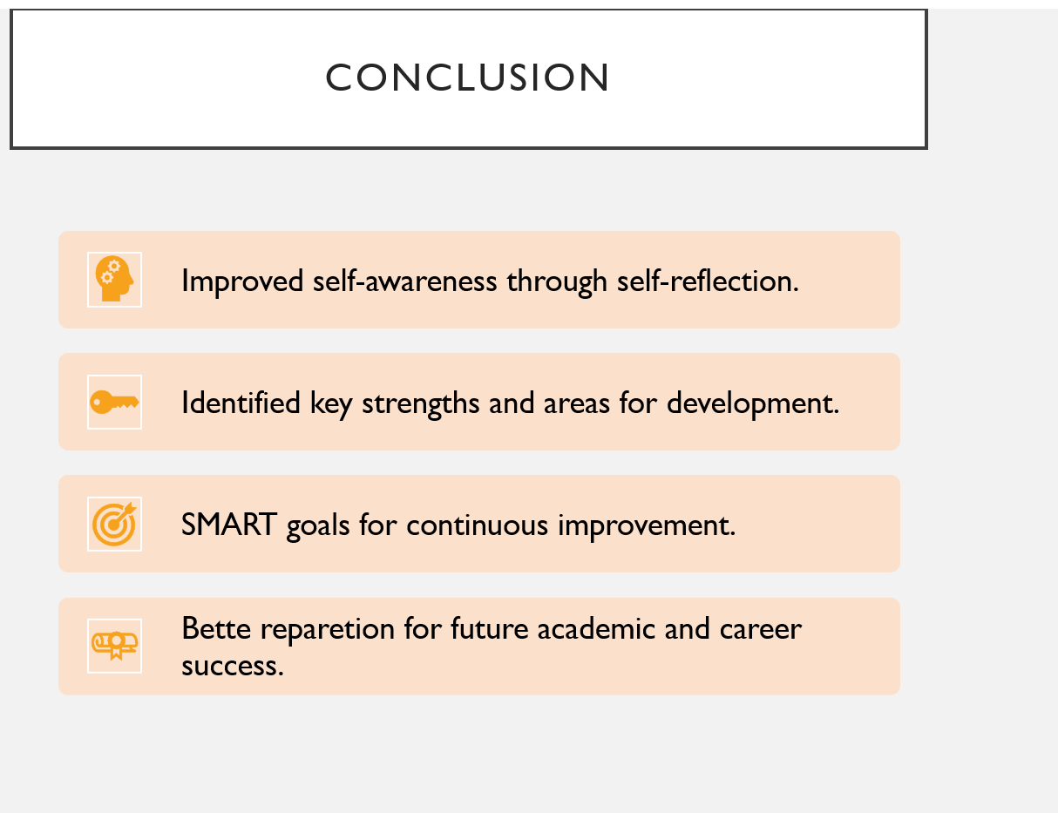
Conclusion
This presentation has helped me evaluate my strengths, weaknesses and personal development needs while creating a clear plan for future improvement. Through self-reflection, I recognised the importance of developing communication, leadership, teamwork, time management and resilience, which are essential skills for both academic success and a future career as a data analyst. Creating SMART goals showed me how setting specific and achievable objectives can support continuous personal and professional growth. Overall, this assignment has increased my self-awareness, confidence and motivation to keep improving my skills and prepare for future study and employment.

Slide 16 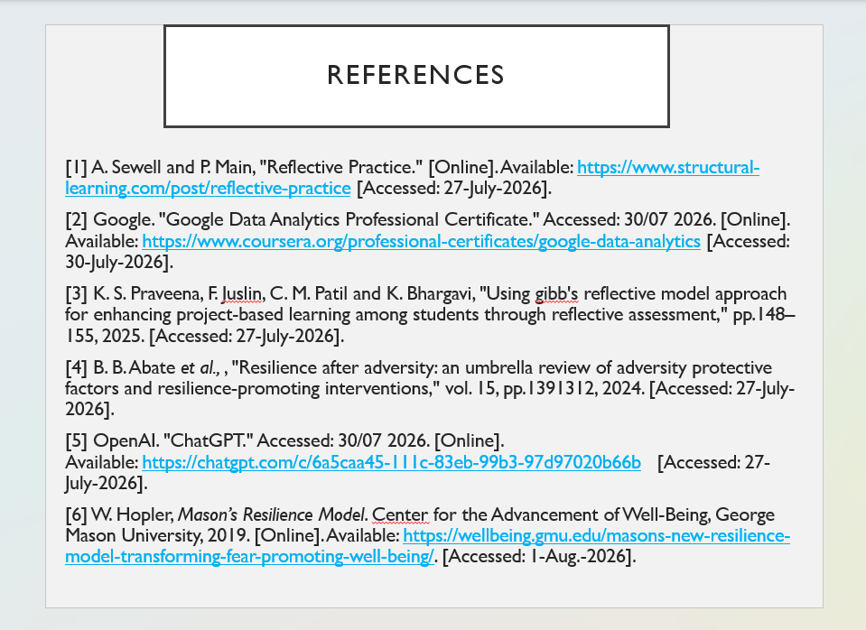

References
[1] A. Sewell and P. Main, "Reflective Practice." [Online]. Accessed: 27/07/2026. Available: https://www.structural-learning.com/post/reflective-practice
[2] Google. "Google Data Analytics Professional Certificate." Accessed: 30/07/2026. [Online]. Available: https://www.coursera.org/professional-certificates/google-data-analytics
[3] K. S. Praveena, F. Juslin, C. M. Patil and K. Bhargavi, "Using gibb's reflective model approach for enhancing project-based learning among students through reflective assessment," pp.148–155, 2025, Accessed: 27/07/2026.
[4] B. B. Abate et al.,, "Resilience after adversity: an umbrella review of adversity protective factors and resilience-promoting interventions," vol. 15, pp.1391312, 2024, Accessed: 27/07/2026.
[5] OpenAI. "ChatGPT." [Online]. Accessed: 27/07/2026. Available: https://chatgpt.com/c/6a5caa45-111c-83eb-99b3-97d97020b66b
[6] W. Hopler, Mason’s Resilience Model. Center for the Advancement of Well-Being, George Mason University, 2019. [Online]. Available: https://wellbeing.gmu.edu/masons-new-resilience-model-transforming-fear-promoting-well-being/. Accessed: 1/08/2026.

