Design a Hotel Breakfast Bord

Name: Larisa Luciana Tomozei
Student ID: 2127769
Module Code: BMIH5003
Lecturer: Luciana Suardi

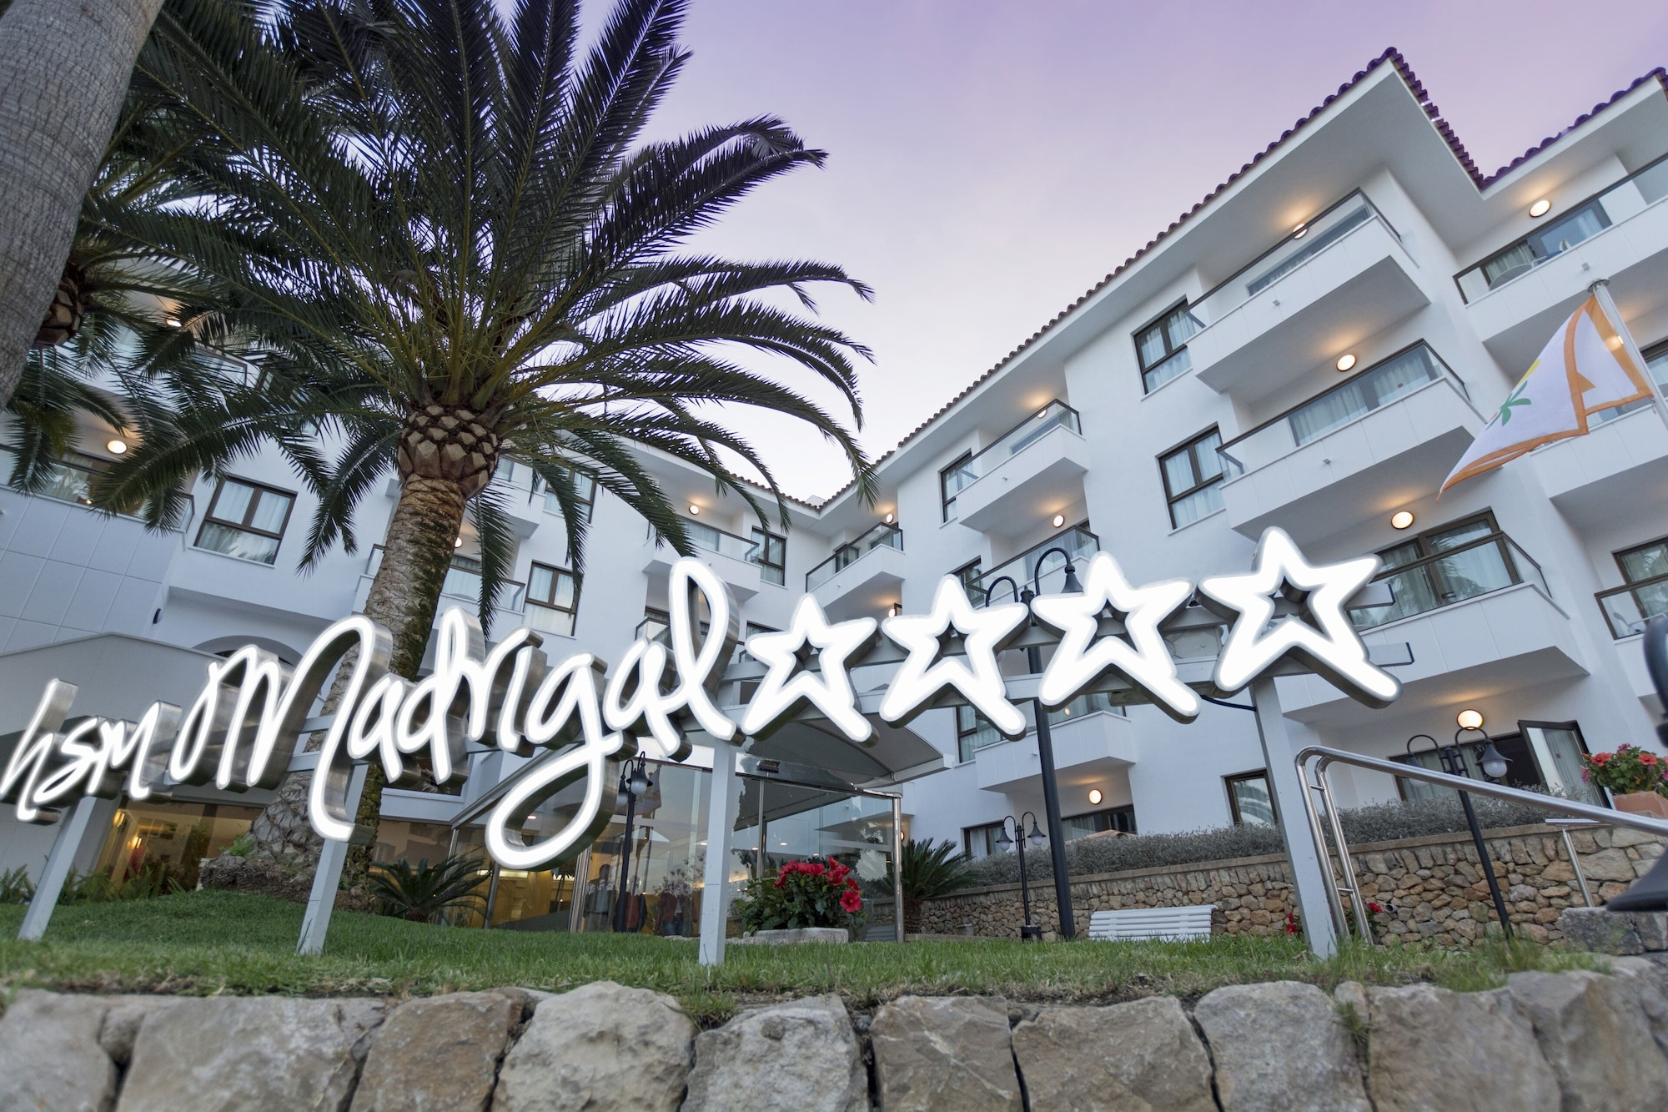
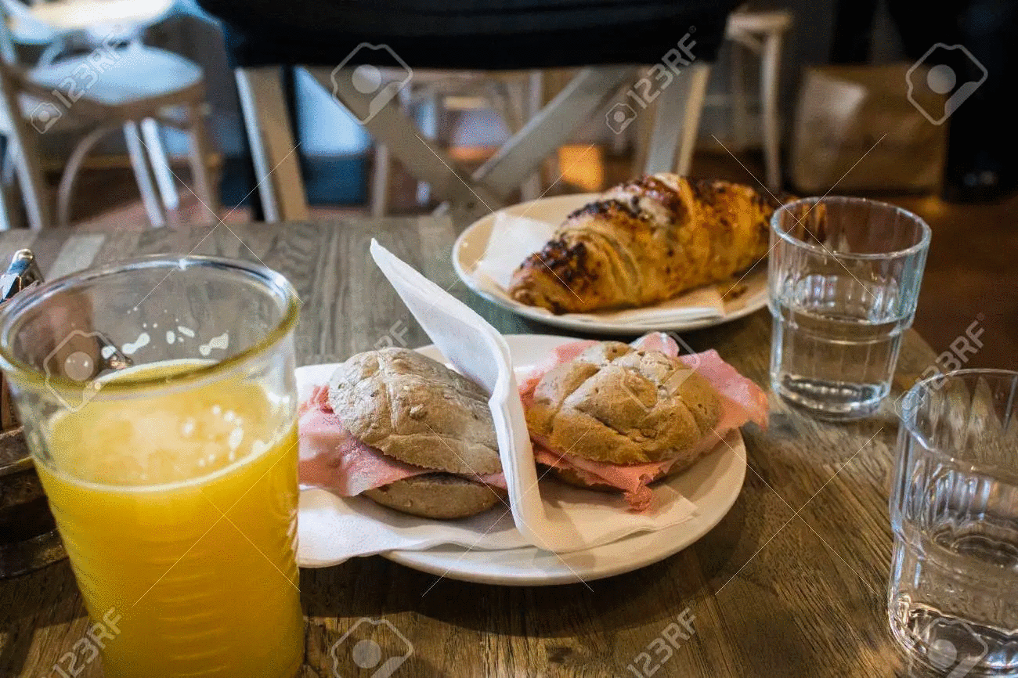

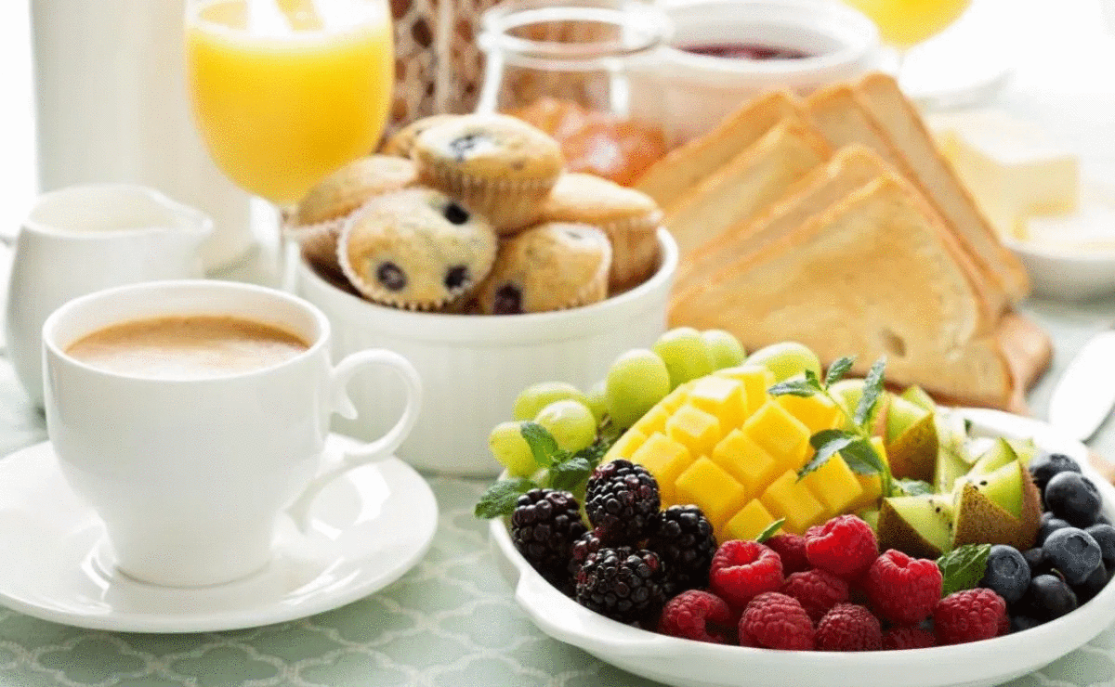

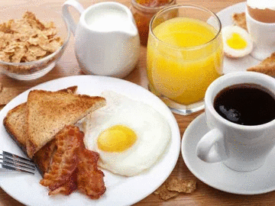
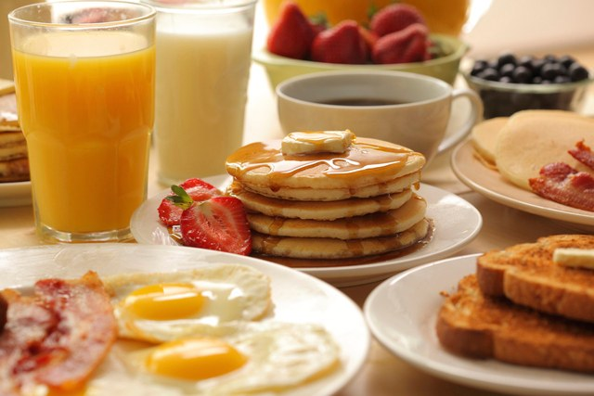
La Desayunos è dalle 8:00/11:00
Breakfast starts from 8:00/11:00

succo d'arancia + orange juice with
panino con prosciutto fritto sandwich with fried ham
o Cornetti or croissants
3.00 €
Café + Coffee
Muffin o Muffins or
Tagliere di frutta fresca Fresh fruit platter
4.50 €
Caffè Coffee
Uovo (fritto o bollito) Egg (fried or boiled)
Prosciutto fritto Fried ham
Pane abbrustolito Toast bread
succo d'arancia orange juice
5.00 €
Caffè Americano American coffee
Pancake americani American pancakes
con miele e fragole with honey and strawberries
Succo d'arancia o latte orange juice or milk
Pane abbrustolito Toast bread
Frutta fresca Fresh fruit
6.50€

DESAYUNOS

BREAKFAST

