Student Name | Julian Milligan
Student ID Number | 1904804
Date | 13/10/2020
Module | Information Engineering
Module Code | ACCB4013
Lecture | Bev Holland

Celtic Caterers have requested a new system to help maintain orders, invoice information, events, suppliers’ details and customer information. Below are 4 diagrams aimed at describing the new system.

Context Diagram
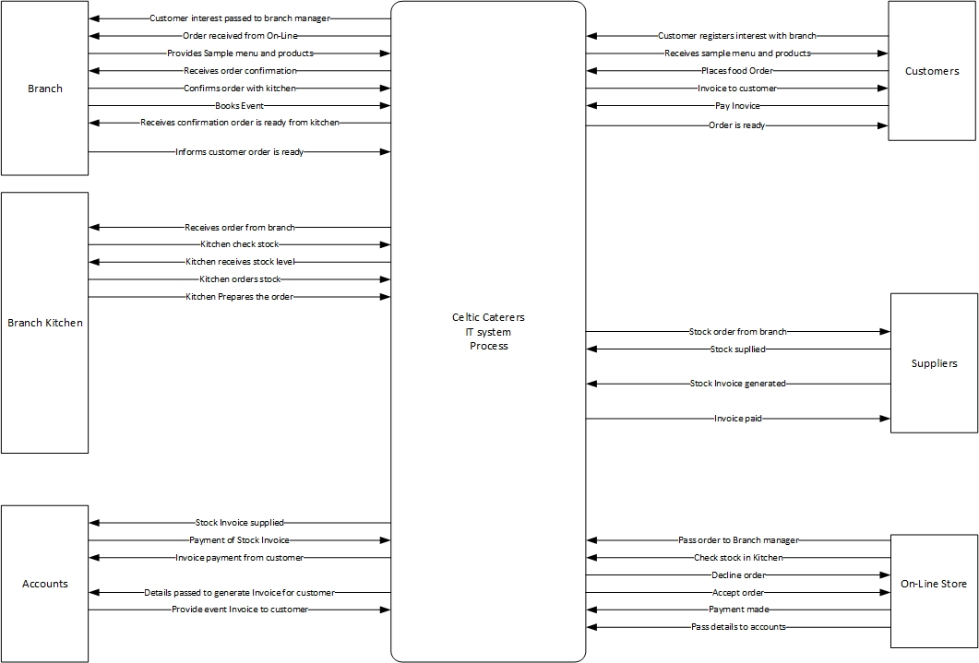
Above shows my Context Diagram for the new system.

Level 0 DFD
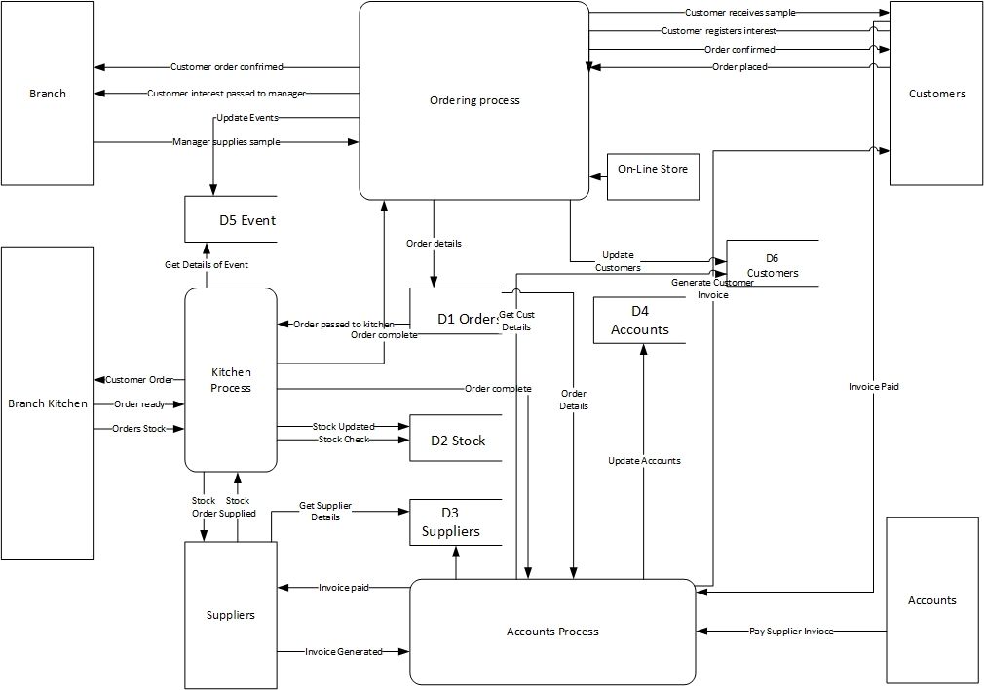
Above is my Level 0 DFD which shows the individual process and data stores.

Level 1 DFD – Accounts Process
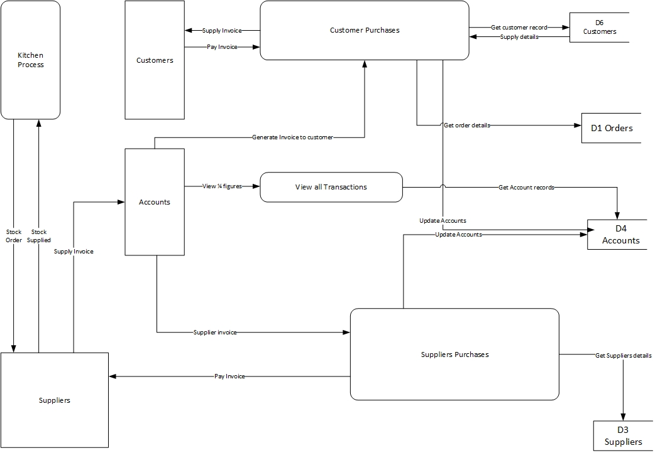
Above is my Level 1 DFD which focuses on the Account Process.

ERD Diagram


