WORKSHEET 3 – QUESTION

A chef is running a cake business, and they require organic ingredients. For this purpose, they keep a single free-range chicken in their garden to supply their eggs.

The chicken will lay one egg a day and two eggs are required per cake, which is of a standard size.
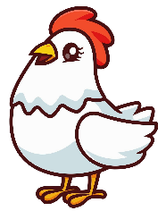


a) Write a program allow the chef to calculate how many cakes they can make after n days.

Your program output might look something like these examples:

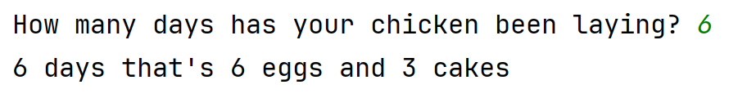

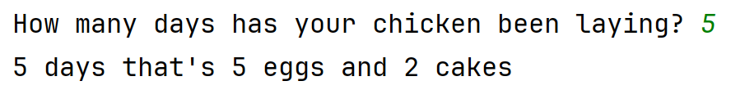

(Hint: remember that the cakes are a standard size and that you cannot bake half a cake)

Use validation in your code where appropriate to prevent the user from entering inappropriate values.

(continues….)

b) Extend your program as follows

If the chicken is fed on superfood (avocado on toast), she will lay 3 eggs over two days.

Revise your program to allow for this by introducing a short menu interface to allow the user to choose the type of food.

Your program might look something like this:

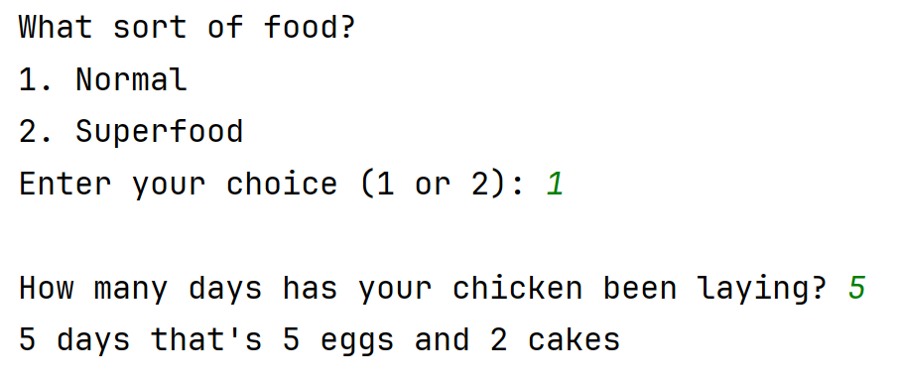
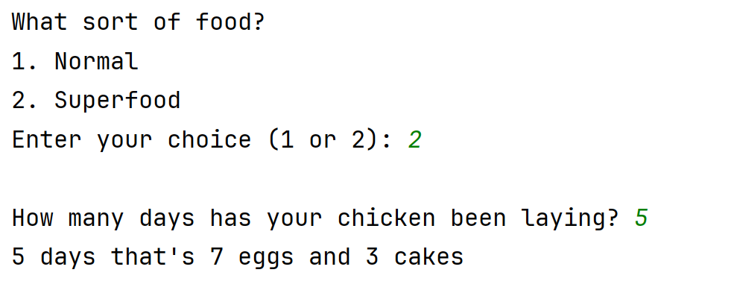

Note: in my Superfood example above, 5 days = 7 eggs.

(2 days = 3 eggs) + (2 days = 3 eggs) + (1 day = 1 egg)

NB The chicken cannot lay fractions of an egg.

