

University of Wales Trinity Saint David’s
School of Engineering
Modelling Logistics operations (M5X01280)
Chris Ashmead
1902167
BSc (Hons) Logistics and Supply Chain Management

Abstract

To cope with the increased pressure to perform and react swiftly to sudden changes of consumer demand, maintain a comparative advantage over their nearest competitors, elevate disruptions within their logistic systems and supply chains. A number of counteractive measures have been introduced by companies in the form of simulation models.

Table of Contents
Introduction 4
Advantages of simulation modelling 4
Disadvantages of simulation modelling 5
Types of modelling approaches 5
SCOR model 5
System Dynamics 6
7
Heuristic method 7
Simulation Software systems 7
Anylogic 8
Locating a distribution centre 8
Last mile route optimisation 8
Arena 9
Panama Canal expansion 9
Managing warehouse inventory 10
11
Conclusion 11
References 12

Introduction

Due to the ever-increasing strain to perform against stiffening competition, the need to facilitate the intensified expectations of customer demand and the need to continually seek to deduce problems and make improvements within their logistics systems. Companies have begun to invest in and focus heavily upon simulation modelling as a tool to design, redesign, analyse and create models to manage problems that may occur more proficiently.

- Simulation modelling is defined as the practice of creating a digitalised model and analysing it to gain an insight into a system's performance derived from a set of data inputs (Mangan et al, 2016).
- A model can be defined as a system used as a surrogate for another approach that can be utilised to gain a greater understanding and insight into certain aspects of the real world (Sanchez, 2007).

Advantages of simulation modelling

A simulation model for an organisation can be incredibly alluring due to its ability to imitate real-life processes and address what could happen if several perimeters were applied. (Banks, 1999) provides an extensive list of the many advantages of simulation modelling.

- Simulation modelling can allow a company to effectively experiment with the possibility of implementing changes and resolving issues without having to fully commit a number of resources fully.
- Simulation modelling can provide a company with the option of carrying out a particular process in a matter of minutes which would have normally taken a several hours to conduct within a real system environment.
- Once a simulation model has been created, it can be used to trial different operational practices and new policies without impacting a company's real working system.
- A simulation model often costs as little as 1% of the total amount spent on the execution of a design or redesign. This is because the cost of changing or adapting a system after it has been put in motion is usually significantly higher. For this reason, simulation modelling could be considered a reliable investment for many companies.

Disadvantages of simulation modelling

(Banks et al., 2010) describes several associated disadvantages of simulation modelling :

- The creation of simulation modelling can only be conducted by applying specialist training, which is very much built over time. Moreover, it can be said that even if two models were created by two qualified people that might have a distinctive likeness, it is highly doubtful that the models produced will be identical.
- Because most simulation outputs are inherently irregularvariables that are typically dependant on randomly generated inputs, it can sometimes be hard to ascertain if a particular observation is the consequence of a model interplay or complete randomness.

Types of modelling approaches

SCOR model
The supply chain operations reference model (SCOR) is a handy tool that can measure, improve, and assess a company's supply chain's operational performance from its supplier's supplier to its customer's customer (Persson, 2011). The model incorporates a series of business principles of process restructuring, benchmarking and calculation into its framework. The model's framework focuses on five main processes within the supply chain: plan, source, make, deliver and return.

- Plan - this initial step focuses on developing business regulations that bridge across inventory, resources and transportation whilst still maintaining that the supply chain plan remains in line with the company’s financial plan.
- Source - this area explains how to regulate inventory, supplier systems and supplier efficiency. Additionally, it considers how supplier payments are managed and when to acquire, validate and transport goods.
- Make - this step focuses on manufacturing and production including all associated processes. It also involves the overseeing of the supply chain as well as associated equipment and transportation.
- Deliver - this step centres on order fulfilment, warehousing and transportation. It also entails receiving customer orders and charging them when goods have been received.
- Return - Organisations must be proficient and ready to deal with the return of packaging and defective products. This step incorporates the handling of business rules, returned stock and transportation
Figure 1 – Overview of the SCOR Model
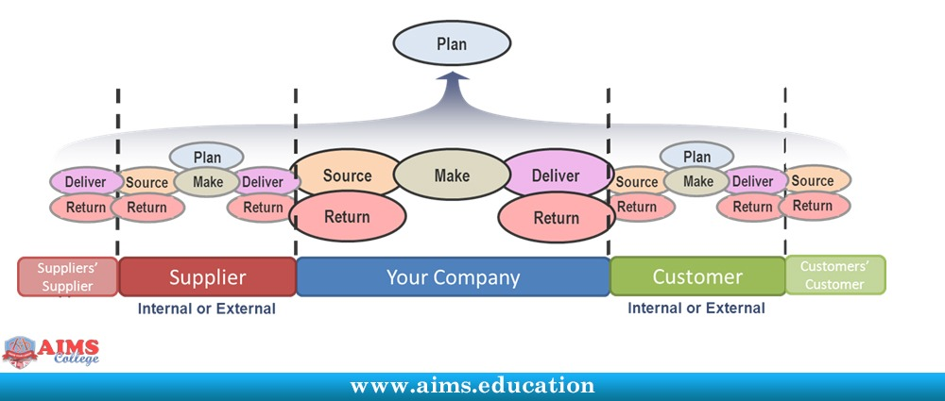

System Dynamics

System dynamics (SD) is a very complicated simulation method. It is used to produce a general interpretation of a large problem within a complicated system while overlooking a system's essential features such as people, products, or events. (Ge et al., 2004) describes how system dynamic modelling has been effectively used to analyse the bullwhip effect within a UK supermarkets supply chain. To create the SD model, the supermarket considered the following factors as the most important: information delays, physical delays, and primary sources for a bullwhip effect. Fig 2 depicts an overview of the company's supply chain's complete SD model constructed using MATLAB simulation. Once the MATLAB simulation was run with the factors as mentioned earlier inputted several times. The simulation model revealed that reducing the amount of physical delay applied can dramatically enhance the supply's chain performance, while a shorter delay can produce a shorter total lead time. Consequently, this resulted in lower costs, a smaller amount of inventory needed, fewer goods in transit which amounted to a greater level of responsiveness. Nevertheless, the findings also showed that when the processing of orders and transportation time was unable to be further reduced, the performance capability of the company's supply chain was reliant mainly on the flow of information.
Figure 2 -MATLAB Supply chain model (Ge et al,2004)
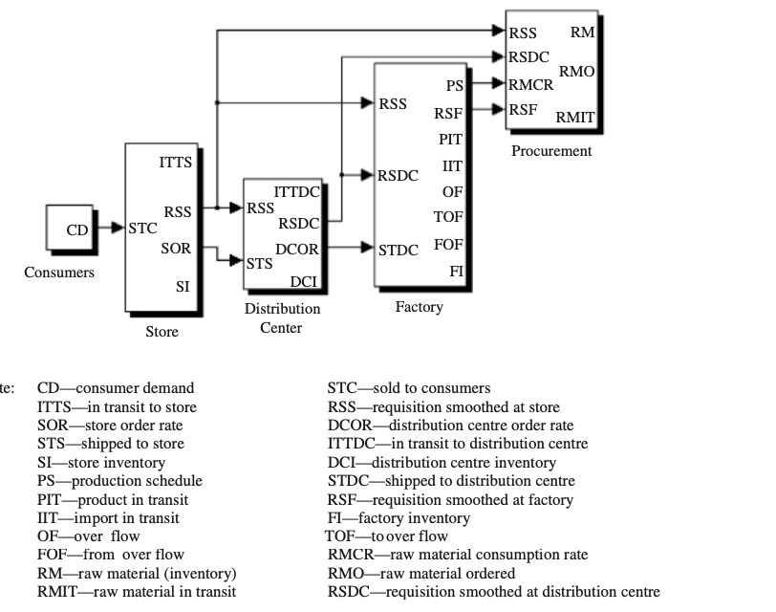

Heuristic method

Companies can use the heuristic method to figure out the most appropriate way to configure both supply and demand across the entirety of a supply chain to provide the highest customer service quality level. Additionally, a heuristic approach can provide an instant fix to a particular planning issue.(Yavari and Geraeli, 2019) explain how a heuristic approach was applied for addressing issues associated to the design of a green closed-loop supply chain with a dairy company. The heuristic method was used to provide assistance to help with the environmental associations of transporting products between each process of the supply chain as means to reduce the company’s environmental impact and as a way to reduce their amount of expenditure.

Simulation Software systems

Anylogic and Arena are a series of comprehensive simulation modelling software's that can provide logistic companies with agent-based, discrete event and system dynamic capabilities to produce a simulated real-life representation of a particular business operation. It combines the associated problems and the high complexity of business processes to create a model (Banks et al., 2010). Both of these simulation software's are used within logistics and supply chain management in several ways. The following case studies highlight how Arena and Anylogic have been effectively used to find a solution to companies' ongoing logistical-based issues.

Anylogic

Locating a distribution centre

The US apparel company Fruit of the Loom sought to expand its business capabilities and wanted to know whether the construction of an additional distribution centre (DC) would be deemed worthwhile and financially viable based upon shipping costs or would redistributing products back to pre-existing DC's be the better alternative. To test their proposed theory, the company decided to create a supply chain model produced using Anylogic's agent-based simulation. The simulated model comprised of several different interconnecting agents:

- Distribution centres
- Clients
- Vehicles
- Cotton manufacturers
- Centralised yarn mill

Having these agents in place provides the company with a real-time digitalised representation of its entire supply chain, its current distribution centres (DC), and the supply networks that run between them. The Anylogic simulation software was also highly advantageous for the company to test a diverse range of scenarios and several variations that enabled the company to decide whether creating a new distribution centre was a possibility (Anylogic, 2021a).

Last mile route optimisation

The Electricite de France (EDF) company were looking to optimize their current transportation routes to guarantee that all of their consignments were shipped to schedule. Consequently, as a result further action was needed the company organised a team decided that the best course of action for deducing any potential issue to be avoided was through the implementation of Anylogic’s agent-based simulation software to produce a delivery model. During the early stages of creating the model, and as a means of reflecting the company's current real-time delivery system more accurately, several limitations concerning the electric vehicle were addressed as follows:

- The vehicle must never lose its power during deliveries
- The only available charging points were located at the company’s charging station
- The energy consumption of the vehicle is based upon whether the vehicle is empty or laden
- The upper limit of the vehicle route is one hundred kilometres

After addressing the limitations, the team inputted a full description of all the company's vehicles information (vehicles dimensions, vehicle speed and loaded weight capacity and battery) and whether the vehicle was loaded, unloaded, on route or currently waiting were inputted into the simulation as interconnecting agents. During the simulation, the EDF team made subtle changes to the interconnecting agents, such as reducing traffic density or shutting off electric charging points and watching the simulation to see if it impacted the complete logistics system. The EDF company concluded that creating the simulated model enabled them work out the maximum number and correct proportion of electric trucks with various forms of batteries within their collection of vehicles. Furthermore, the company also established from the model was the precise amount of chargers that they would require and the amount of power that they would need to ensure that all deliveries of goods remain unhindered and arrived in good time (Anylogic, 2021b).

Arena

Panama Canal expansion

The Panama Canal Authority (PCA) were seeking to establish an in-depth master plan that could be utilised to provide a level of guidance for the continuing development of the Panama Canal. A vital part of the preparation stage involved the evaluation of several sales, capital and functional scenarios to identify what effect it was likely to have on the overall canals capacity (Arena, 2021). To address any potential issues an Arena simulation model was created for the purpose of analysing canal movements that were based of the predicted demand of the following differing parameters – vessel type, size and restrictions such inclement weather patterns.

Once the simulation was up and running, it correctly estimated the canal's northern and southern parts' traffic flow. It could accurately predict how vessel traffic would be affected due to bad weather systems. By the detailed analysis that the model provided, the PCA concluded that the Panama Canal would be subjected to considerable capacity restrictions for the next 5 to 10 years, which will have adverse implications on the canal's service standards. Furthermore, the PCA stated that the model had been extremely beneficial for assessing a series of different approaches regarding the canal's current infrastructure's expansion capacity and subsequently helped them decide to begin constructing the third set of locks (Rabelo et al, 2012).

Managing warehouse inventory

A building materials trading company wanted to significantly improve how their warehouse was being managed due to several persistent problems that were occurring from stock out situations due to incorrect inventory control, high batch sizes and inaccurately defined target stock. The company proposed that the most appropriate course of action to address the issues was to develop a model using Arena simulation. To enhance their current average inventory levels, average sales losses and deducing the considerably high proportion of consumers dissatisfied with its main product cement. Once the company had collected data for the inventory levels, sales losses and the total number of unhappy customers.

Upon entering the data into Arena, it produced two separate models, focusing on inventory (fig 3) and selling (fig 4). The model was run for thirty days and was continuously assessed with parameters (enter parameters) being constantly adjusted to see the impact it was likely to have from one day to the next. After simulating for the thirty days, the researchers concluded that the model had been an extremely effective tool for the company and provided them with clear recommendations of how they could implement subsequent changes to keep hold of customers and eliminate potential stockouts(Chaabane, 2016).

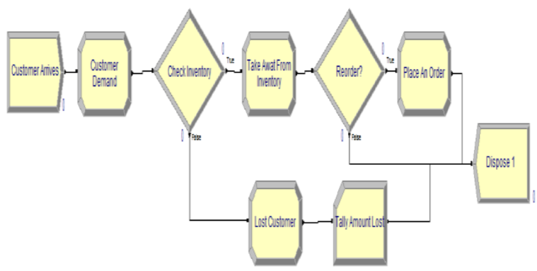
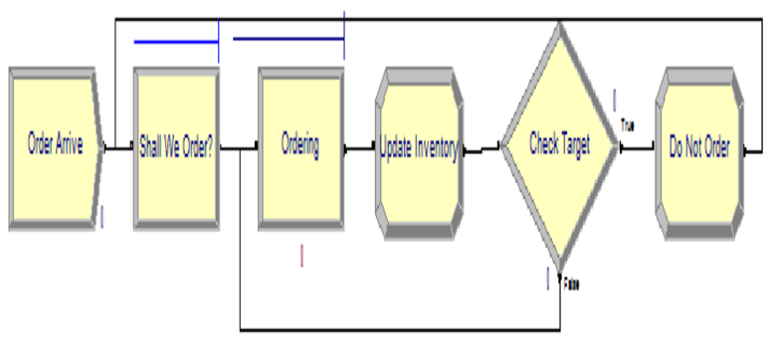
Figure 4 - Arena model for selling (Chaabane)
Figure 3 - Arena model for inventory (Chaabane,2016)

Conclusion

To summarize, this report has provided a critical evaluation of the important role that models, and simulation can and continue to play as a means to benefit the logistics and supply chain industry as exemplified by the extensive array of working examples that have been discussed throughout. The inclusion of models should be considered as a vital component of all organisations to strive to obtain a competitive edge against their competitors, as well providing them a digitalised bird’s eye view of all logistic and supply chain procedures.

References

Anylogic, 2021a. Apparel Company Chose Location for New Distribution Center Using Simulation Modeling. [online] Available at: <https://www.anylogic.com/simulation-modeling-helped-apparel-company-choose-location-for-new-distribution-center/> [Accessed 1 Mar. 2021].
Anylogic, 2021b. Electric Vehicle Route Optimization: Plan Delivery with Simulation Software. [online] Available at: <https://www.anylogic.com/electric-vehicle-route-optimization-delivery-with-simulation-software/> [Accessed 25 Feb. 2021].
Arena, 2021. Panama Canal Utilizes Port Simulation Software for Major Expansion. p.2.
Banks, J., 1999. Handbook of simulation: Principles, methodology, advances, applications, and practice. [online] Available at: <https://linkinghub.elsevier.com/retrieve/pii/S0278612599901115> [Accessed 27 Feb. 2021].
Banks, J., Carson II, J.S., Nelson, B.L. and Nicol,David M., 2010. Discrete Event System Simulation. 5th ed. Pearson.
Chaabane, A., 2016. Managing Warehouse Inventory: A simulation case study.
Ge, Y., Yang, J.-B., Proudlove, N. and Spring, M., 2004. System dynamics modelling for supply-chain management: A case study on a supermarket chain in the UK. International Transactions in Operational Research, 11(5), pp.495–509.
Mangan, J. and Lalwani, C., 2016. Global Logistics and Supply Chain Management. 3rd ed. Wiley.
Persson, F., 2011. SCOR template—A simulation based dynamic supply chain analysis tool. International Journal of Production Economics, 131(1), pp.288–294.
Rabelo, L., Xanthopoulos, petros and Marin, M., 2012. Expansion of the panama Canal:Simulation Modeling and Artificial Intelligence.
Sanchez, P.J., 2007. FUNDAMENTALS OF SIMULATION MODELING. p.10.
Yavari, M. and Geraeli, M., 2019. Heuristic method for robust optimization model for green closed-loop supply chain network design of perishable goods. Journal of Cleaner Production, 226, pp.282–305.

