Module Code: BMSK4003
Module Name - Digital Skills and Research Methods
Module Lecturer – Renuga Jayakumar
Student Id – 1705780
Student Name – Mohbub Bakth

Contents
Introduction 3
Evaluating the effectiveness of the use of modern technologies within the workplace 4
Exploring social media for marketing, information gathering and communication within the workplace 8
Creation of own personal accounts in several social media 12
Conclusion 13
References 14

Introduction
The use of modern technology in the workplace simplifies the task of the operational and functional area of the organization. This modern technology such as social media tools increase customer exposure to the organization as the company can reach a large number of consumers through the social media tools. The use of modern technology also reduces cost structure of the business organization by increasing productivity of the employees as well as the production process. In this report, the effectiveness of the modern technology and the use of social media as the marketing tool and communication process have been explained.

Evaluating the effectiveness of the use of modern technologies within the workplace
The meaning of technology is broad that can be explained as something like products, processes or applications that help people or organization to accomplish tasks and find out solution of problems such as problem with effective communication system in the workplace. From time to time the technology is improved and developed that can be called as modern technology. The use of modern technology in the workplace simplifies the task and improves the efficiency of the operation. To apply and use the modern technologies, the digital skill is required to the organization and its human resources. Digital skill can be defined as the practical knowledge and competency needed to use digital technologies such as mobile phone and laptop (Ramzan et al., 2013). Business organization adopts various modern technologies such as web-based communication tool email to run internal and external communication. Modern technology helps organization to attain competitive advantage such as by using ERP software the organization can better run supply chain management and can get efficiency on this field compared to other organizations. Moreover, the technology is also used in the workplace to ensure higher productivity and efficiency in the operations and other functional area.

Figure 1: Modern Technologies
Source: (Yin and Cui, 2016)
The smart phone is one of the most useful modern technologies in the workplace that brings about high efficiency in the communication system (Belloc, 2010). The evaluation of the effectiveness of the use of modern technologies is as follows:
Efficient communication
Modern technology brings about a tremendous change in the communication system. At present, people can communicate with each other without requiring physical presence such as using cellular phone. The business organization gets the blessing of modern technology in field of running effective communication system (Chan, 2012). The modern technology such as web-based email, smart phone, laptop, video conferencing and social networking tools helps the business organization to maintain an efficient and effective communication with the customers, suppliers and employees. These technological tools reduce time and cost of the business organization to communicate with the internal and external business stakeholders. By using web-based email such as Gmail or Outlook, the manager of the business organization can communicate with the employees to delegate them sudden task or duty. Moreover, the employees can get supportive ideas about the task from the managers or colleagues through sending and receiving email. For example, Microsoft and Google creates Dashboard system for running their logistics and manufacturing activities more efficiently as in this system the managers and employees can get information more easily and in an organized way (Loon, 2014). By using social networking tools such as Facebook, Twitter and Blogs, the business organization can run market research and can communicate with the customers. The organization can provide updates about the products and services in these tools as well as the customers can provide their feedback through these social networking tools. Thus, it helps to conduct an interactive communication system that increases organizational knowledge about the market condition. But the use of these modern informational technological tools require lower cost which in turn increases organizational cost efficiency. The business organization can also communicate more quickly and efficiently with the suppliers of the raw materials. It makes easy to run order processing system.
Workplace productivity
The workplace productivity is increased because of the use modern technology in the business organization. This productivity comes from both operational and human resource sector such as the use of modern technology in the operational section such as ERP software makes the operational function more efficient and cost effective (Venegas, 2010). The computer technology reduces both cost and time of data processing as it processes data fast and it records unlimited data that reduce the cost of documentation. The use of smart phone and laptop increases productivity of employees as it allows the employees to get support from the supervisor any time. The automation of working also allows the employees to keep focus on other task and get more knowledge and ideas about the task.
Cost reduction and higher profitability
The use of modern technology reduces cost structure of the company by increasing productivity of the working. Modern technology reduces transportation cost of the company such as the manager can arrange meeting through online that reduces overall transportation cost. Moreover, it reduces the cost of storage of data such as the company can avoid data storage cost by using computer hard disk or cloud computing system (Belloc, 2010). The use of technologically improved equipment helps the company to attain economies of scale in the production section that reduces overall fixed cost the company. Moreover, the advertising cost is decreased due to the use of online technology such as using search engine optimization for increasing customer exposure of the products. The reduction of cost contributes positively in the profitability of the company.
Improved employability
The use of modern technology in the workplace such as in the training session increases employability of the employees. The employees can be trained through using video conferencing. The business organization can get benefit of hiring employees through online such as outsourcing the customer relationship management task where the employees in another lower labour cost country can offer service to the customers on behalf of the business organization.
Instant feedback and customer service
The business organization can manage customers’ complaints using online technology such as blogs or using social networking tools such as Facebook and Twitter. Moreover, the organization can offer different services such as providing necessary information to the customers by using email or SMS system.
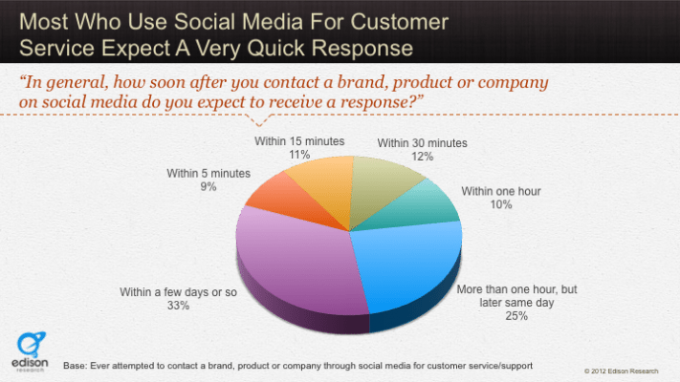
Figure 2: Effectiveness of modern technology
Source: (Loon, 2014)
But there are some negative impacts of the use technology observed such as cybercrime or computer virus (Loon, 2014). Through cybercrime the hackers can steal valuable information of the organization. Moreover, the computer virus or malware may cause a loss of valuable data from the computer or data storage that hamper operations of the organization. In the intra-office management, the invasion of privacy can be taken place by using others computer or smart phone.
The use of technology causes the organization to bear some maintenance cost that can be higher in some cases. The company needs to arrange anti-virus or protection to avoid hacking or computer virus attack. Moreover, the software needs to be upgraded that is also costly for the company.

Exploring social media for marketing, information gathering and communication within the workplace
At present more than 2.5 billion people are attached with the use of social media. Thus, the business organization takes this social media as a big scope for marketing, gathering information and communicating with the consumer. Social media marketing can be defined as the exploring customer exposure with the help of social media tools such as Facebook, Twitter, LinkedIn, Instagram etc.

Figure 3: Social Media
Source: (Bock, 2012)
In the social media marketing technique, the business organization tries to increase the traffic of customer through online. The organization posts products’ features and attributes in these social media tools where the followers are customers (Luo, 2012). It helps the company to advertise the products to the customers. Moreover, the customers can review the products’ quality and other attributes in these social media tools after using the products. It works as a positive marketing for the company when the customers provide good comments and reviews.
The organization can influence buying pattern of customers more effectively by using social media as a marketing tool. For example, the organization can post upcoming offers or trends about the products in the Facebook wall that helps to reach a large number customer within a short time in the online.
To run a social media marketing, the business organization can create marketing plan that involves following steps:
The marketer at first needs to identify which social media the company will use. This identification is based on the current trends of the use of social media for example, the company can use Facebook as a social media marketing tool and thus the company has to make a Facebook page using the name of the company (Kong and Lee, 2017). After that, the company needs to identify the target customers group and take idea about their expectation and views from the company. For this, the marketer can make a Facebook Poll where the customers can provide their point of views about the products and the company. Moreover, the company can get ideas about the market trends from the comment section of the Facebook post. The company can also run communication regarding the customers’ feedback in the messenger section of the Facebook. The company can then measure the suitability of the tool by following the conversion rate. Finally, the company can track the data and make analysis of the suitability of that social media tool.
Social media for information collection
Information is needed to make any kind of decision in the organization. Moreover, customer information and market data is required for the company to make strategies and operational decision. The business organization collects information using two modes such as using Face to face communication or using online system such as social media tool. In case of social media, the company can run online survey to collect data from the potential customers. The company collects information about customers’ demand, interest, preferences and choices by following the customers’ posts (Zhang, Shabbir and Mujeeb-ur-Rehman, 2015). Moreover, in the Blogs, the customers share their opinion about the products and their preferences and this information can be used by the organization. The organization can also open a chat group with its employees where the employees share their opinion about the current trends and their views regarding the pay and working environment. By using LinkedIn, the managers of the organization can gather important information about the market and trends by following the post of the experienced employees or managers of other company as in the LinkedIn, the experts share their experience and views about the market trends.
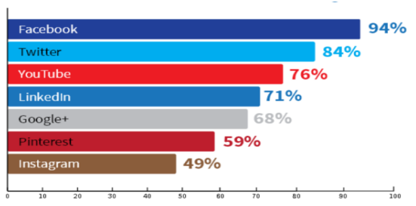
Figure 4: Use of Social Media to gather information
Source: (Bregman, 2012)
The business organization also creates ‘Share & Help’ platform in the Facebook where the employees share their ideas, interest, complaints and opinion that can be used by the organization as an important tool to make decision (Alhabash and Ma, 2017).
The main benefit of collecting information through social media is that it requires less cost for the company to collect information. Moreover, the company can collect information from huge number of customers or employees with fewer time. But the problem with this process is that the collected information may be false as authenticity cannot be verified easily by the company.
Social media for commutation
In the workplace, the social media tools bring about a new effective option to run communication. The manager can communicate with the employees through the social media tools such as in the Messenger option of Facebook (Barutcu and Tomas, 2013). It is effective in the sense that the employees may sometimes do not pick the phone or the email may be remained unchecked. And in this case, the social media tools help a lot to the organization to communicate with the employees as the activity in the social media is huge.
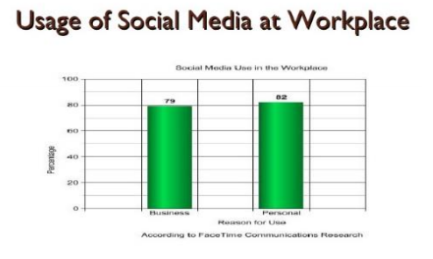
Figure 5: Usage of social media at workplace
Source: (Gruzd et al., 2016)
In the social media communication system, the employees can freely communicate with the managers or supervisors as it seems more informal. It helps the company to gather more information and ideas from the employees (Yin and Cui, 2016). Moreover, the communication in the social media tools such as Messenger and WhatsApp is conducted in real time and it eliminates the risk of missing any information. Using social media for communication is more cost effective for the company as they require few cost. The organization can also communicate with the employees staying in the long distance through the social media tools and it requires few time.
The disadvantage of the use of this social media for communication purpose is that the employees may not take seriously the information due to the informal communication system (Chan, 2012). The employees may put less importance on the information provided through the social media tools such as WhatsApp or Viber.

Creation of own personal accounts in several social media
I have created personal account in the Facebook and Twitter and the links have been given below:
Facebook Account:
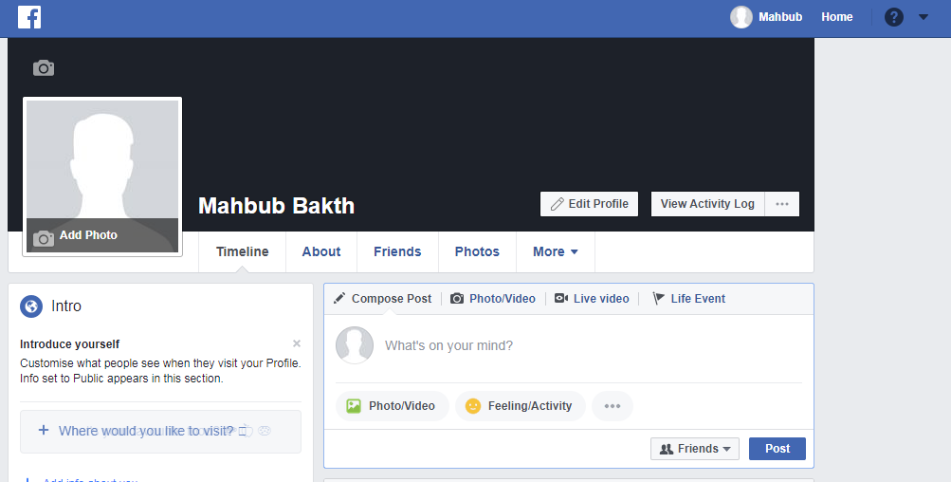
Link: https://www.facebook.com/mahbub.bakth.31
Twitter Account:
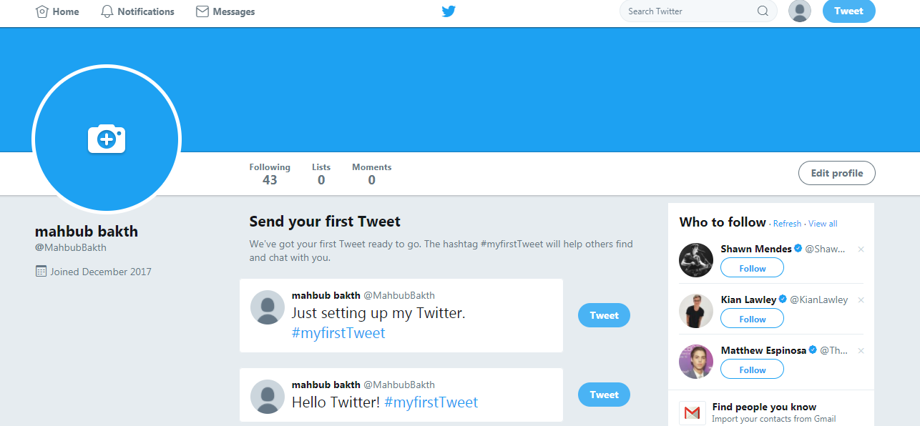
Twitter ID Link: https://twitter.com/MahbubBakth

Conclusion
The use of modern technological tools increases the efficiency of the origination. It brings efficiency in the communication, production and customer service section. Moreover, the business organization can manage its logistics function more effectively by using the modern technological tools such as ERP software. The social media tools are used as the tool of marketing by the organization. These communication tools are more cost effective and require less time.

References
Alhabash, S. and Ma, M. (2017). A Tale of Four Platforms: Motivations and Uses of Facebook, Twitter, Instagram, and Snapchat Among College Students?. Social Media + Society, 3(1), p.205630511769154.
Barutcu, S. and Tomas, M. (2013). Sustainable Social Media Marketing and Measuring Effectiveness of Social Media Marketing. Journal of Internet Applications and Management, 4(1), pp.5-24.
Belloc, H. (2010). On. [Place of publication not identified]: Nabu Press.
Bock, J. (2012). The technology of nonviolence. Cambridge, Mass.: MIT Press.
Bregman, S. (2012). Uses of social media in public transportation. Washington, D.C.: Transportation Research Board.
Chan, L. (2012). Social media marketing for digital photographers. Indianapolis, IN: John Wiley & Sons.
Gruzd, A., Haythornthwaite, C., Paulin, D., Gilbert, S. and del Valle, M. (2016). Uses and Gratifications factors for social media use in teaching: Instructors’ perspectives. New Media & Society, p.146144481666293.
Kong, J. and Lee, G. (2017). Elderly's Uses and Gratifications of Social Media. International Journal of Cyber Behavior, Psychology and Learning, 7(3), pp.23-36.
Kutubkhanah Alsaied, H. (2017). Perceived Effectiveness of Social Media as an English Language Learning Tool. SSRN Electronic Journal.
Loon, J. (2014). Media technology. Maidenhead: McGraw-Hill/Open University Press.
Luo, J. (2012). Soft computing in information communication technology. Berlin: Springer.
Ramzan, N., Zwol, R., Lee, J., Clüver, K. and Hua, X. (2013). Social Media Retrieval. London: Springer.
Venegas, C. (2010). Digital dilemmas. New Brunswick, N.J.: Rutgers University Press.
Yin, H. and Cui, B. (2016). Spatio-Temporal Recommendation in Social Media. Singapore: Springer Singapore.
Zhang, J., Shabbir, R. and Mujeeb-ur-Rehman, A. (2015). Role of Social Media in Pre-purchase Consumer Information Search: A Uses and Gratifications Perspective. Mediterranean Journal of Social Sciences.

