University of Wales Trinity Saint David

Academic and Employability Skills

Valentin Vasile
ID: 1712926

Executive summary
Student gets different skills while studying but are not efficient for the corporate life. They need to develop their skill for future job studying journal, books and getting training from the different institute. This report shows the importance and way of developing employability skill using different theory. Using, Katz’s three skill approach the key skill of the HR manager has been pointed out. The needed academic skill and weakness area of skill also identified. Kolb’s reflective theory used to identify competence of mine and analyse the feedback from others in the academic task. Finally, a short articulate plan has been developed for skill development that is needed in future job life.

Table of Contents
Introduction 1
The application of skill for HR professional 2
Conceptual skill 3
Human skill 3
Technological skill 4
Reflection on my personal competence 5
Skill gap analysis 8
Plan to develop the skill gap 9
Conclusion 10
Reference 11

Table of figure:
Figure 1 Katz's Three Skill Approach 2
Figure 2 Kolb's Reflecting Model 6

Introduction
The HR manager has to perform multitask with more responsibilities than other employees. There are need different skill for the HR manager in different organisation.The graduated students of different university need these skills so that they can perform future job role. I want to be an HR manager in a multinational company and I am preparing myself for the job role. HR manager should have some skill as leadership, delegation, communication, motivation etc. the skill gap analysis helps to find out the weakness area of the skill. Here, the needed HR manager skill, application of skill for the HR professional, Kolb’s reflective model to reflect my competence and experience, skill gap analysis, and development plan has been discussed.

The application of skill for HR professional
The most critical job in an organisation is managing human resources and motivating them for a given task. This profession needs some skills to perform well and managing employee within the organisation. According to Jasper (2013), the HR Manager needs leadership and delegation skill to lead the subordinates. The HR Manager should have an attractive personality and ability to know employee psychology to become a leader and delegate them. He also needs management skill for planning, controlling and coordinating employees. The employee needs the motivation to do the task and taking the risk to achieve something.
The manager has to motivate them so that employee can have guidance and encourage achieving objectives, discussed by Rouse (2010). The HR manager has to make a plan for staffing and give training to the employee. The resources for the employee have to coordinate and the performances of the employee also have to control. The communication skill is vital to be an HR manager and teamwork. The manager also needs problem-solving skill so that he can solve any problem without increasing it.

The skills that HR professionals need to perform their job role effectively is discussing below-
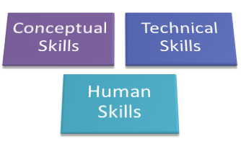
Figure 1Katz's Three Skill Approach
Source: (Morgan,2016).

Conceptual skill
Delegation: HR manager delegates the subordinates for certain task with decision making power. By delegation, the manager can enhance the skills of subordinates and make them more productive. For instance, the worker of Nestle can participate in decision making when the manager makes a decision.

Problem-solving skill: While operating a business and guiding employee, many problems can arise. If the manager has no problem-solving ability, he cannot overcome the problem, elaborated by Dhami et al. (2012). This skill is in the core of managing the business operation, also the employee.

Leadership skill: Nowadays, the organisation seeks leadership skill for HR professional so that they can lead an employee to their goal. The effective and worthy HR professional can guide and control employee smoothly using a different leadership style.
Management skill: According to Thill and Bovée(2016), the manager should have the management skill as planning for employee training, recruiting and budgeting; coordinating the assets and human resources, controlling the employee performance and evaluate them; collaborate employee for the task.

Human skill
Communication skill: HR manager have to make a connection with several parties within and outside of the organisation. For instance, the manager of Tesco can communicate and make deal properly because of communication skill. This skill assists to motivate and make good relation with the employee.

Multitasking: The HR manager is responsible for multitasking as planning, staffing, controlling, coordinating, motivating etc. According to Scheppandf Schepp (2009), Multitasking is essential for the HR professional. So, he should have this skill to perform the role responsibilities.

Motivation skill: Employee need the motivation to complete any given task and this is the responsibilities of the HR manager. He can motivate employee through many ways as financial and non-financial. This will increase the productivity through improving performance.

Negotiation skill: HR professional can make deal with employee and third parties of the organisation effectively because of this skill. For example, the HR manager of Unilever can settle differences and make an agreement avoiding an argument. It is beneficial for the negotiator to avoid dispute.

Ethics: The HR manager should have a sense of ethics in case of maintaining organisational policies, discussed by Maund et al. (2017). He has to gain employee trust and organisational trust to perform his role. Integrity and values are the key characteristics of HR manager. He has to maintain the employee act, competitors act and human right act for the people around the organisation.

Technological skill
Management related technology skill: Sutterby (2011) discussed that the manager has to communicate with people in social media and record employee performance. He can also measure performance through talent management software. For instance, through technological skill, the HR manager of Amazon can record employee information and communicate with social media.

Reflection on my personal competence
A graduate student may not have the skill that is required by the HR manager job. In this case, the University student can get training from the different institute and practice them in regular life before joining to the job. The skill that is needed in every day in my academic life is discussing below-

Communication skill: This is the most important skill that is needed for a student. The university student has to communicate with their classmates and teacher for regular classwork, discussed by Cottrell(2010). I can communicate and make good relation with other easily because of this skill. I communicate with the teacher for the given task and with classmates for completing the group task.

Adaptive skill: This skill is needed for a University student because they have to face the different situation as examination, poster and PowerPoint presentation. my classmates also come from a different society and country. So, any situation can come in every day and I have to manage the situation.

Time management skill: In student life, time management skill is necessary for well study and test. According to Morgan(2016), every student cannot manage the time efficiently because of negligence in the study. In the result, it becomes the reason for failure. But I try to manage time efficiently so that I can get this skill for the future job.

Collaboration skill: As many of classwork have to do in a group, students have to cooperate with each other. The collaborating skill helped me to work with my classmates while completing group task. We co-operated with each other for the assignment and presentation.

Problem-solving skill: In student life, many problems come to the success stage. This skill helped me to solve the academic problem as study problem, oral presentation and group assignment. In professional life, this skill also needed for performing the job role.

Research and writing skill: A university student has to research on several topics for the academic purpose (Maund et al. 2017). The writing skill also needed for research. I am capable of writing well in English while researching. This skill helped me to complete to individual task and getting the mark.

Using Kolb’s reflective model, the personal competence and skill gap can be identified, discussed by Scheppand Schepp (2009).This model helped to find my own experience and skills while working with classmates as a team. The reflective of my personal competence using this model is given below-

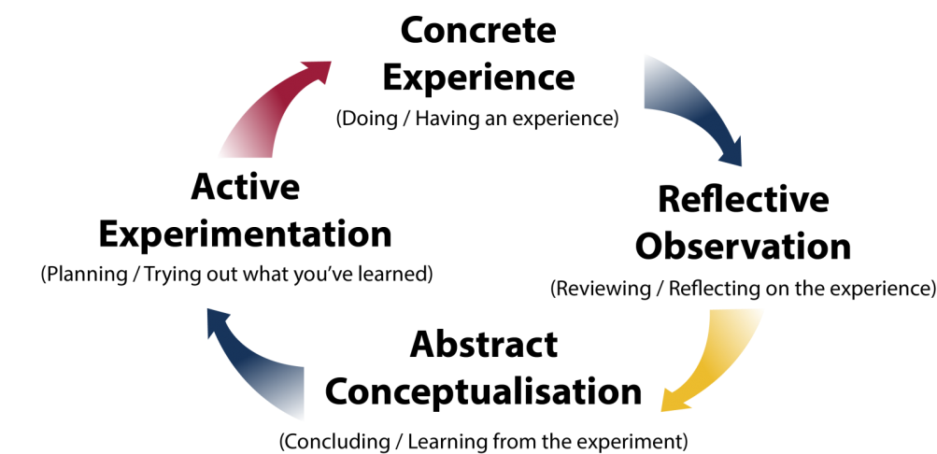
Figure 2 Kolb's Reflecting Model
Source: (Simplypsychology.org. 2018)
Concrete experience: According to Dhami et al. (2012), the group leader has more responsibilities than other group members. Before starting work I thought that the role of a leader is difficult and I cannot perform the role significantly. There was another thought in my mind after being a team leader. For instance, I may not able to motivate them and guide for best output. These though lead me to improve my communication and collaborating skill. The group members were quite soft for me and they accepted me as a leader because of my competence.

Reflective observation: I completed many assignments, report and presentation with my team members. While working with team members, they fully cooperate with me. Although everyone work is a team with cooperation, there rise to conflict and misunderstanding, elaborated by Jasper (2013). This was the reason for some low marking on our task. Because of negligence and time management, I was late to identify the communication gap. After all, I solved the problem and this was possible for my conceptual skill. I solved the problem because of my problem-solving skill and time management skill.

Abstract conceptualisation: I motivated group members, identified the performance gap and communicated with members to solve the problem. But it was late and we were low marked because of the low performance of our group. But I was lazy about it and the result was not beneficial for us. Because of my negligence, it happened.
After analysing out weaknesses, I practice some reflective theory, read the journal to improve my skill. This helped to identify individual strength, possible problem of failure, weaknesses and contribution in teamwork. I ensured that these kinds of negative situations may not arise in future and I am practising this in regular life.

Active experimentation: I got any experience of being a leader which will be beneficial in my professional life. Rouse (2010) discussed that the group work in academy gives the experience and knowledge about the manager role. I made an action plan considering my improvement need. Some skills were identified as time management skill, change management skill, research and writing skill etc. need to develop by me. Some of these were recovered and some are in consideration. I need training and engagement in practical work so that I can improve my skills. I researched, read journal and books to know about improving skill for the different job role. It is a big challenge now become qualified for an HR manager position.

Skill gap analysis
There was some strength of mine as delegating members and solving the problem. When I reflective model used, I founded that I have to improve my skill area for future carer development. The key weakness of my skill is given below-

Skill | Weakness
Time management skill | I have to complete task considering the time efficiently. But while researching and group working I found that cannot manage the time efficiently. So I need to improve this skill for future job.
Leadership skill | As a leader, I motivated and lead my group member. Then I found that I have to improve this skill for future job. Because leading subordinates is important part for HR manager and I need to improve and practise this skill.
Communication skill | I am capable to communicate with people in my academy. But I think, I was not able to communicate properly with my team members. So,this kill need continuous improvement for future job.
Technological skill | I can operate academic software as MS word, PowerPoint, excel etc. but an HR manager has to operate management software, social sites, recording software. I have little knowledge about operating these software. S, I need to get a train and improvement.

Planto develop the skill gap
The action plan should be SMART which is necessary to develop the skills and evaluating the performance.

Skills | Resource needed | Criteria for the completion | Time bound
Time management skill | Training for institution or job training | Training from institution and application from daily work | 3 month
Leadership skill | Joining workshop, training and practicing different theory. | Get training from institution and recording the achievement | 1 year
Communication skill | Engagement with social media, tries to know people psychology. | Journal, theory for knowledge and get training | Continuous process
Technological skill | Get training and practising | Get training, Recording and evaluating. | 6 month

Conclusion
The HR manager has to handle all the operation related to the human in the organisation. The labour supply and performance measurement of the employee is the responsibility of him. To perform the job obligation, the manager should have different skill, knowledge and talent. Using Kolb’s model, the weakness, gained knowledge and experience can be identified and evaluated. In this report, the necessity of skill and its application to HR professional job role, Kolb’s reflective model, weakness area of skill and skill development plan has been made to improve the skill.

Reference
Cottrell,S.(2010)SkillsforSuccess:PersonalDevelopmentandEmployability(PalqraveStudySkills)Hampshire:PalqraveMacMillan.
Dhami, M., Schlottmann, A. and Waldmann, M. (2012). Judgment and decision making as a skill. Cambridge: Cambridge University Press.
Jasper, M. (2013). Professional Development. Wiley.
Maund, A., Schreik, M. and Tinkler, P. (2017). Certificate in Higher Education: Skills for the Workplace Student Yearbook. Sage Publications.
Morgan,P.(2016). TheBusinessStudent'sGuidetoStudyandEmployability. SagePublications
Rouse, K. (2010). Personal development. South Melbourne, Vic.: Oxford University Press.
Schepp, B. and Schepp, D. (2009). Amazon top seller secrets. New York: AMACOM.
Simplypsychology.org. (2018). Kolb's Learning Styles and Experiential Learning Cycle | Simply Psychology. [online] Available at: https://simplypsychology.org/learning-kolb.html [Accessed 6 Aug. 2018].
Sutterby, J. (2011). The early childhood educator professional development grant. Bingley, U.K.: Emerald.
Thill, J.V. and Bovée, C.L., 2016. Excellence in business communication. Prentice-Hall, Inc..

