

Name: Keval Hansraj Mange
Student ID: 2240155
Module: Marketing Management
Submitted to: Tushara Balendran

Assessment- 2 (25%)

TABLE OF CONTENTS
 | Introduction | 4
1 | Macro Analysis | 5
2 | Porter’s 5 Forces | 8
3 | Micro Analysis | 10
4 | STP Analysis | 12
5 | Marketing Mix | 14
6 | Recommendation- Ansoff Matrix | 16
 | References | 18

INTRODUCTION
This report addresses the macro and microenvironment of the HP organization. It includes an analysis of external factors that affect the operations posing opportunities and threats, and internal factors that determine the strengths and weaknesses of the company. Theories like PESTLE, STP, and Marketing mix analysis are used in this report to assess the company's performance.

ABOUT THE ORGANISATION.
Hewlett Packard Enterprise Company, commonly known as HPE, is a technology firm specializing in a range of products and services, including computers, laptops, storage, data center networking, and enterprise solutions. They provide both wired and wireless network hardware, along with various software products such as cloud-based management, analytics, and location services. Additionally, HPE offers investment solutions like leasing, financing, and asset management services. Their customer base spans commercial and large enterprise sectors, serving industries such as manufacturing, telecommunications, public sector, financial services, health and life sciences, media and entertainment, and small to mid-sized businesses. HPE operates globally with a presence in the Americas, Europe, Middle East, Africa, and Asia Pacific, with its headquarters located in San Jose, California, USA.
For the fiscal year ending in October 2023, HPE reported revenues of $29,135 million, indicating a 2.2% increase from the previous fiscal year (FY2022). The company's operating margin for FY2023 was 7.4%, a significant improvement from 2.5% in FY2022. Likewise, the net margin for FY2023 stood at 7%, up from 3% in FY2022.

PESTLE ANALYSIS
The PESTLE Analysis stands as a valuable tool employed to recognize and examine the primary influencers of change within the organizational landscape. PESTLE is an acronym encompassing political, economic, social, technological, legal, and environmental factors. This analytical approach involves conducting an organizational audit to ascertain the diverse elements and pressures in the external environment that impact the company’s success. (Buye, 2021)
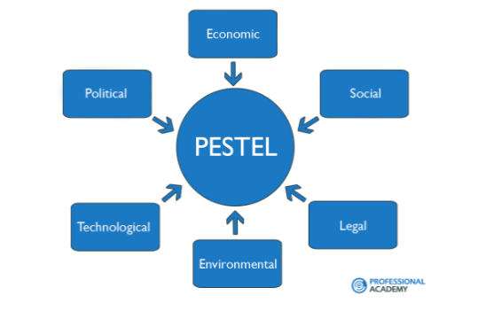
Source: Holly Fosher (University of New Hampshire)

HP’s PESTLE analysis:
- Political:
The political environment refers to many aspects like the stability of the country, support of the government to the industry in which the company lies, and government actions. For HP, political factors are favourable as the government is stable, and also supports technology-oriented companies like HP and there are no major steps against HP or the industry at the moment. On top of that government is investing in AI. (Perera, 2017)
- Economic:
Economic forces consist of the economic stability of the country, poverty rate, inflation rate, disposable income, interest rates, and GDP of the country. As per the current situation, the UK’s economy has recently been hit with a recession and disposable income also has been reduced. In the UK, the aftermath of the pandemic has brought about a significant challenge with the rising cost of living. Rent prices have seen a substantial increase, surging by approximately 6.2% since 2016. Additionally, the average cost of purchasing a house in the UK stood at GBP 291,000 in the last quarter of 2023, as reported by the Office of National Statistics (www.ons.gov.uk, 2023). This surge in housing costs has had a notable impact on the disposable income of residents in the UK. This indicates unfavourable economic environment for HP. (Perera, 2017)
- Social:
Social factors mean the current trend, customer behaviour, population, and other cultural factors. If HP is considered, social forces are unfavourable as customers are inclined towards smartphones nowadays. (Perera, 2017)
- Technological:
When technological factors are discussed, it means the firm’s involvement in researching to develop new technology and investing in it. HP is constantly keen to develop new technologies or innovations in new technology means technological factors are favourable for HP. Furthermore, social media marketing and SEO are also performed by HP.
- Legal
Legal forces include consumer laws and laws about using recyclable material for HP. The company is already using renewable and recyclable raw materials making legal forces favourable for itself.
- Environmental:
Environmental forces are critical as they determine firms’ efforts to make the environment sustainable. With the surge in global warming, the greenhouse effect, and other environmental concerns it becomes important for businesses to contribute to environmental sustainability. HP and other companies in the industry face challenges in reducing emissions and plastic usage by the government. (unfavourable)

Advantages and Disadvantages of PESTLE Analysis
Advantages
- The tool is user-friendly and straightforward, making it easy to grasp and apply.
- It enhances comprehension of the business environment.
- It creates the cultivation of strategic thinking skills.
- It aids in mitigating the impact of potential future business threats. It assists organizations in foreseeing and proactively addressing upcoming challenges.
- It empowers projects to identify and capitalize on new opportunities more effectively. (Aziri, B. and Ismaili, R., 2020)

Disadvantages
- The tool tends to oversimplify the data it handles, making it easy to overlook crucial information.
- Regular updates are essential for the tool to maintain its effectiveness.
- Collaboration from diverse perspectives and departments enhances the tool's efficacy.
- Access to data sources, which can be both time-consuming and costly, is a prerequisite for using the tool.
- Many assumptions underlie the data used by the tool.
- Given the dynamic shifts in the business environment, projects find it more challenging to predict developments. (Aziri, B. and Ismaili, R., 2020)

PORTER’S 5 FORCES ANALYSIS

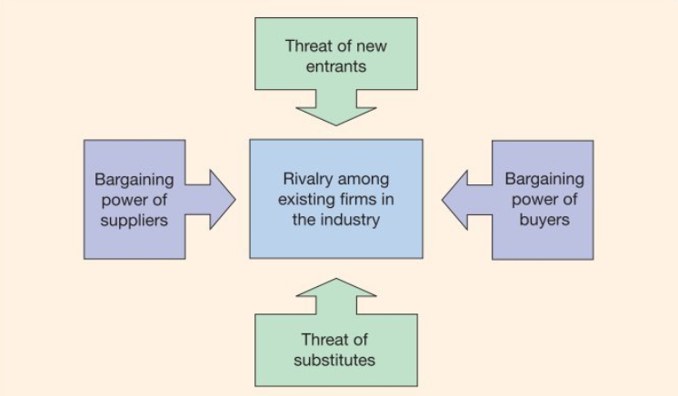
Source: Pearson Education

- Industry Rivalry
Industry Rivalry in HP’s case is high. Many companies are competing for a higher market share by offering similar products at competitive prices. Even if competition is high, it is difficult to leave the industry when the company has made high initial investments. When differentiation is low in the market companies like HP have to make extra efforts in the quality of service and products.
- Threat of New Entrants
The threat of new entrants is moderate for HP. The cost of entry is higher as companies in the computer technology industry have to make investments in R&D and production houses. However; the internet market has made entry less costly recently.
- Threat of Substitutes
Substitutes are considered a major problem (High) for HP. The technological industry is commonly known for constant innovation; therefore, the company has to spend a high amount on research and innovation as substitutes use the leapfrog strategy to capture the market.
- Bargaining Power of Suppliers
The bargaining power of suppliers is moderate for HP. HP relies on more than one supplier which reduces the bargaining power of suppliers. Nevertheless, it is costly for HP to constantly change its supplier.
- Bargaining Power of Buyers
Buyers have high bargaining power over the company. HP has prominent brand loyalty due to quality products and competitive prices. But customers nowadays have a lot of options to choose from, the industry is so competitive that every brand offers different benefits to retain customers.

MICRO ENVIRONMENT ANALYSIS
SWOT Analysis

Source: Self Developed

Strengths:
Brand Name:
HP’s brand name is associated with quality and reliability. Because of the brand name, customers prefer HP’s products over competition.
Large Size:
HP is the 15th largest organization overall and the largest company in the industry. A large size allows the company to have more resources and economies of scale.
Innovation and R&D
HP is known for its innovation and it has more than 36000 patents under its name.
Weaknesses
Slow Response Speed:
A large size limits the efficiency of communication within the organization, when it comes to decision making large companies like HP lack response speed.

Dependency on Supply Chain
HP and most computer-selling companies rely on Intel for the chips required for the products. If any dispute happens with Intel, it may threaten HP’s position in the market.
Opportunities
Increasing Market
The computer and laptop market is increasing and therefore, the opportunity for growth is also increasing for HP.
Technology Innovation
There is a rise in the number of new and futuristic technologies coming into the market. Companies including HP have an opportunity to merge new technology with its products to attract customers.
Threats
Intense Price Competition
As the industry is packed with strong competitors, HP has to participate in intense price wars with rival companies, which leads to reduced profits.
Cost Management Challenges
Due to reasons like price wars, sole suppliers, increasing investment in R&D, and new technology, it becomes difficult to manage costs to survive in the market.

STP ANALYSIS
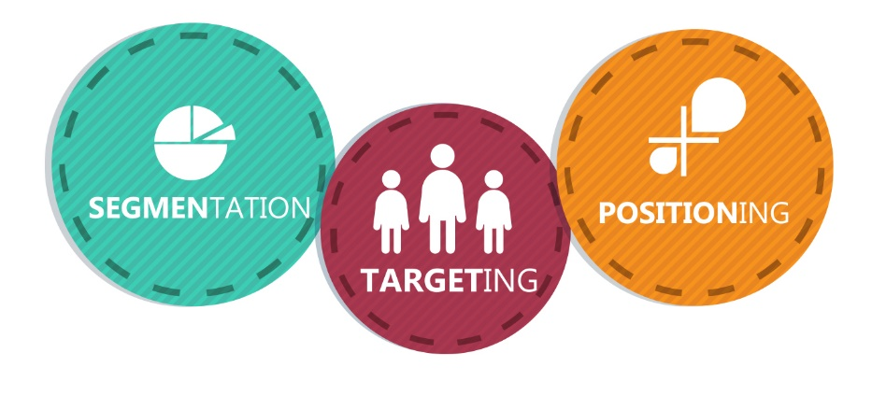
Source: martechlive

Segmentation Strategy
Segmentation is sorting out a diverse group of potential customers based on their unique traits and characteristics. HP does this by looking at where people live and their details, creating categories of customers with similar needs. The goal is to understand these customers better and tailor products to what they specifically want. By doing this, HP can figure out which areas are most promising to focus on, ensuring they target the right people in the right places. Essentially, it's about being smart in choosing which markets to go after, so the company can be more successful and capture a bigger share in those areas. (Ritika, 2020)
Targeting Strategy
Once a company breaks down a large group of people into smaller segments, the next step is to focus on the customers who genuinely need and want their products. This way, the company avoids wasting resources on people who may not be interested. HP adopts strategies that allow them to offer personalized products, catering to the diverse needs of different groups in society. Essentially, it's about being smart in how they approach the market, making sure they invest where there's genuine demand, making the market more profitable for them. (Ritika, 2020)
- Differentiated Targeting
HP uses a differentiated targeting strategy. With its diversified product range like professional, gaming, efficient, and balanced PCs, HP changes the techniques of how products will be marketed.
Positioning Strategy
After a company divides a big group of people into smaller segments, the next move is to pay attention to the customers who truly want and need their products. This helps the company avoid spending resources on people who are not interested. HP uses clever strategies to provide customized products, meeting the varied needs of different groups in society. In essence, it's about being savvy in how they navigate the market, ensuring they focus on areas where there's a real demand, making the market more profitable for them. (Ritika, 2020)
- HP’s Perceptual Map
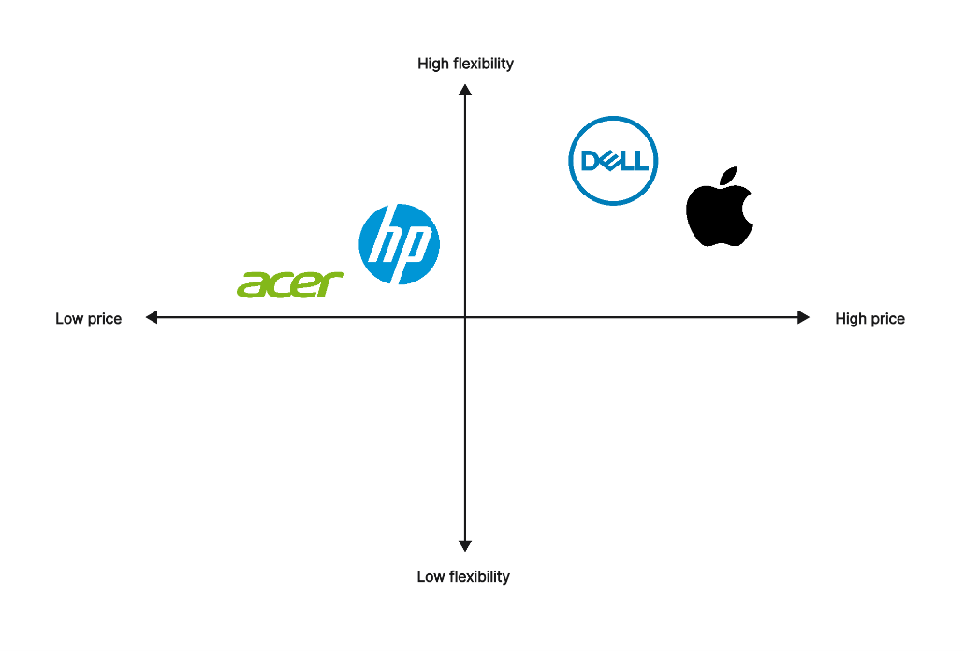
Source: BoardMix

MARKETING MIX- 4Ps of MARKETING
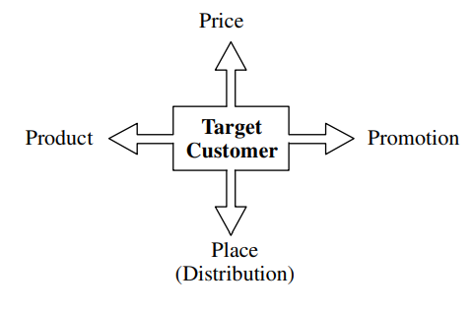
Source: University of Peshawar
Definition: “Marketing Mix is the set of controllable variables that the firm can use to influence the buyer’s response” by Philip Kotler
Product:
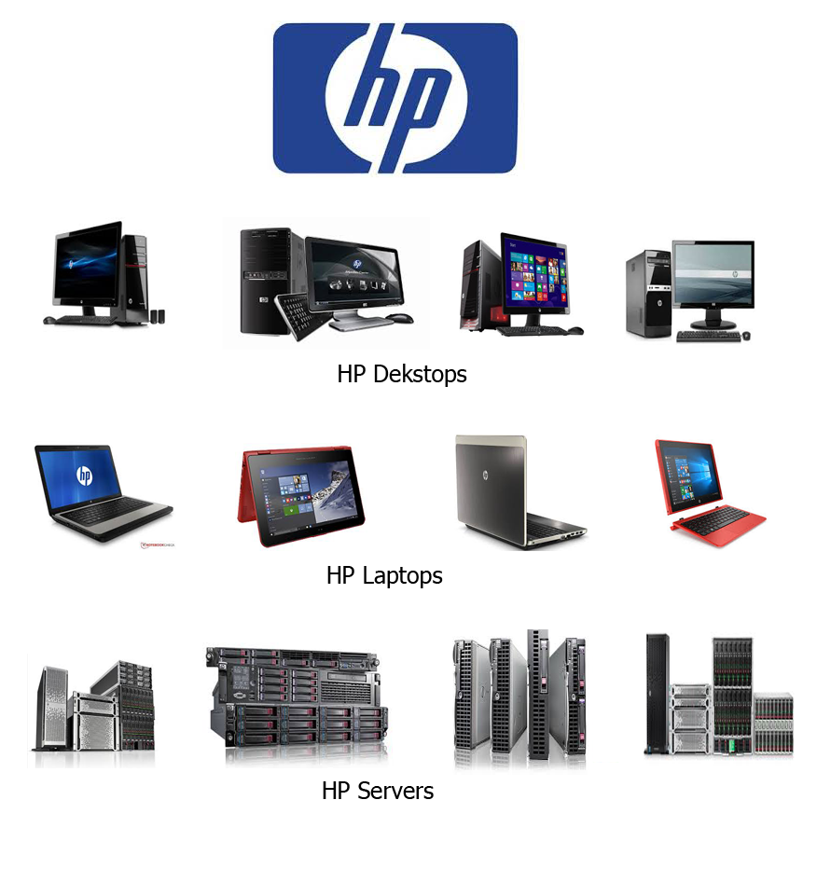
Source: Agile Techfrontier Corporation
HP has a different range of products like desktops, laptops, and servers as shown in the picture above. Apart from those products HP has intangible products like cloud storage and servers.

Price:
Hewlett-Packard follows a fair and competitive pricing approach. They carefully consider various factors like production costs, distribution, promotion, and the prices set by competitors before determining a reasonable selling price for their products. It is about making sure the price is just right, taking everything into account. (Shastri, 2021)
Place:
HP has a smart distribution strategy in place. They sell their products to both individual customers and businesses, both directly and indirectly. To make this happen, HP has teamed up with retailers and tech vendors to get their products out there. They have set up their stores where they offer a range of products and services, making sure customers are dealt with by well-trained and courteous staff.
HP has branches in various places like Geneva, Ontario, Singapore, Miami, Tokyo, Victoria, Houston, and Rivonia. They run a global program called the "Developer and Solution Partner Program" (DSPP) for system integrators, developers, and software vendors. HP maintains a direct connection with its partners, including suppliers, logistics providers, and manufacturers, to ensure everything runs smoothly in the network. (Shastri, 2021)
Promotion:
Hewlett Packard has kicked off an initiative called "One Voice" to boost not just its brand but also to showcase a range of consumer electronics and hardware products. They're using vehicles to highlight their diverse products and services, including a website organized by business application.
Employees are encouraged to participate in discussions about servers, networking, and storage. There's a "Trade Program" where consumers can exchange their old products for new ones instead of receiving discounts.
The company regularly announces discounts on various products as part of its overall strategy. Hewlett Packard has established partnerships and sponsorships with several companies, including sponsoring the shirts of a "Premier League Club" and supporting the "BMW Williams Formula 1" team, later transitioning to "RenaultF1." Additionally, they've secured naming rights for the HP Pavilion in San Jose. (Shastri, 2021)

RECOMMENDATION AND CONCLUSION
Ansoff Matrix
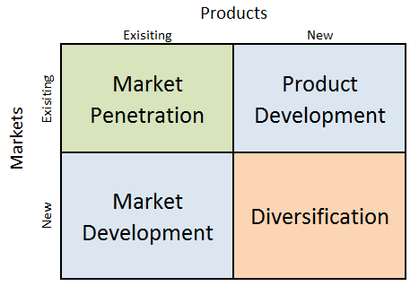
Source: research-methodology.net

After analyzing various factors of HP in this report, the Ansoff matrix will be used to recommend strategies that can lead to further improvements for HP. Recommended Strategies:
Product Development:
HP is already a renowned name in the computer industry. HP already has a strong brand image in the industry; however, it is evident that HP is missing a lot of potential benefits by not entering the smartphone market. Laptops and smartphones are somewhat similar. HP already has suppliers of laptops and computers raw materials or spare parts, it can use some of them in smartphone production. On top of that, it will be cheaper for HP than any new brand as HP has consumer data from its other product line. Many companies like Apple, Samsung, LG, Sony, and Xiaomi are following this practice and are successful.
Diversification:
Product diversification is when a company enters a new market with a new product. It is recommended that HP enters in entertainment market with its own streaming platform or form a strategic alliance with an existing company that is in the entertainment business. OTT platforms are on the surge and many production houses are in contracts with OTT platforms by offering them the rights of their content. A prominent example is Apple TV+ and Warner Brothers Studios with rights.

References:
Aziri, B. and Ismaili, R., (2020). Business environment analysis is a key stage in the process of strategic management. ECONOMIC VISION-International Scientific Journal in Economics, Finance, Business, Marketing, Management and Tourism, 7(13-14), pp.99-110.
Perera, R. (2017). The PESTLE Analysis. 2nd ed. Sri Lanka: Nerdynaut.
MarketLine (2023) Country Analysis Report: United Kingdom, In-depth PESTLE Insights. ML00002-031. Available at: MarketLine Advantage database (Accessed: 26 Dec. 23)
www.ons.gov.uk. (2023). Cost of living insights - Office for National Statistics. [online] Available at: https://www.ons.gov.uk/economy/inflationandpriceindices/articles/costoflivinginsights/housing.
MarketLine (2023). Company Summary HP Inc. [online] MarketLine Advantage. Available at: https://advantage-marketline-com.ezproxy.uwtsd.ac.uk/Company/Summary/hewlett_packard_company [Accessed 4 Jan. 2024].
Ritika (2020). STP of HP | PDF | Hewlett Packard. [online] Scribd. Available at: https://www.scribd.com/document/444221666/STP-of-HP [Accessed 1 Jan. 2024].
Shastri, A. (2021). The Successful Marketing Mix of HP with 4Ps Explained | IIDE. [online] IIDE The Digital School. Available at: https://iide.co/case-studies/marketing-mix-of-hp/ [Accessed 1 Jan. 2024].
Maity, S. (2015). Estimation of market share of HP. [online] www.slideshare.net. Available at: https://www.slideshare.net/SAMRATMAITY1/final-project-of-hp [Accessed 1 Jan. 2024].
Buye, R. (2021). Critical examination of the PESTLE Analysis Model. ResearchGate.

