Sam Da Rosa - 1707339

Drill Press
main sliding unit
Engineering Design Project

Abstract

A methodical design process will be used to redesign a drill-press main sliding unit to suit both the manufacture and the customer. The product must be designed for batch production for a quantity of 1000 units per week. The material to replace the steel component will be a polymer and must with stand the required forces that a drill press will undertake. Therefore, Finite Element Analysis will be used to provide a real-life simulation of the drilling forces that will act on the components.
Likewise, Mould flow analysis will be used to improve the design of a product to be suitable for injection moulding, allowing the designer to identify weld lines, draft angles, air pockets, fill and cooling times as well as injection pressures.
From research and analysis of the designs, a polymer component has been created that meets both the requires PDS (in terms of functions, aesthetics, ergonomics and health and safety) as well as meeting the design brief.

Table of Contents

Abstract 1
Introduction 3
Design Process Structure 4
Design Brief Analysis 5
Product Design Specification 6
Manufacturing Processes 9
Material Selection 11
Six R’s of Sustainability 14
Considering Costs: Research 15
Existing Products 16
Target Market 18
Initial Designs 20
Initial Design 1 21
Initial Design 2 22
Initial Design 3 25
Analysing the Initial Designs 26
QFD 27
Final Design 28
Conclusion 31
References 32

Introduction

The aim of the report is to show the design process used to create a product that will meet the required specifications. A consideration for materials, manufacturing methods and CAD to communicate the design will been used. Matrix analysis tables will conclude the design choices and an investigation into the products performance will be made.
‘Designed for manufacture’ will be considered which implies the product will be designed to optimise the manufacturing processes to reduce cost, cycle times as well as increase injection moulding efficiencies and effectiveness. All conclusions will be justified where additional improvements will be identified (Anderson, 2019).

Design Process Structure

An overview of the design process will be used to provide a structure for this report. This will ensure the designed product will suit the needs of the target market by investigating if the product is fit for purpose, meets the recognised British standards and provides an ergonomic solution.
The design process will minimise time to market, potentially reduce the manufacturing and product costs, improve the products reliability and enable poorly designed aspects to be identified early in the design journey. The design journey should be traced along a time line to keep on schedule.

Design Process
- Design Brief Analysis: Identify the problem and investigate the needs and wants from both the manufacture and target market.

- Product Design Specification: Identify the constrains of a product and investigate what is required of the solution for it to be successful.

- Research: Research and identify the existing products on the market through reverse engineering and product analysis as well as investigating material properties and manufacturing techniques.

- Initial Designs: Think of possible products that would provide a solution to the design brief. This can include sketches and CAD drawings to form solutions.

- Initial Design Selection: Methodically select the most appropriate solution where justification should be made to account for the decision.

- Design Development and Prototyping: With the aid of the PDS, the designs should be developed into a refined product that improves the suitability to the design brief. Virtual prototyping should be used to aid the process.

- Testing and Evaluating: The final product should be tested against the PDS and Brief.

(Garrett, 1996)

Design Brief Analysis

The design brief stating the requirements of the task and what is involved will be investigated. The designer must link back to the design brief and refer to the design specification.

Objectives
To show the design process in detail, linking to the relevant standards to consider ‘design, material and manufacturing process’ for the creation of a solution for a drill press component.
The brief askes for 2D and 3D model tools, such as FEA and mould flow analysis. Therefore, Autodesk Inventor or SolidWorks will be used to form an analysis.
Matrix tables, traffic light systems and brainstorming will be used to decipher between manufacturing processes, material and designs to understand the positives and negatives of each aspect.
A product design specification will be created to understand the requirements of both the customer and manufacture, where there will need to be some compromise on some aspects so this will aid in the design decisions.
(UWTSD, 2019)

Understanding the Design Brief

‘…take to market’
The manufacture requires a finished product that will be refined for customer use, requiring limited design faults and efficient design to market processing.

‘… 1000 units per week’
The product should be suitable for low volume production but be able to meet the minimum manufacturing quantities. Different manufacturing methods positives and negatives will be considered

‘… polymetric material…’
To reduce the cost to the manufacture the material must be from plastic.

Ergonomics
The design brief requires for easy ‘assembly’; hence ergonomics and anthropometric data will be considered for both the end customer and the assembly process.

Product Design Specification

A product design specification (PDS), presented in Figure: 1.0, will be used to determine the constraints of the redesigned part by analysing different aspects of a potential product in detail; increasing the likelihood of success. This PDS will meet the BS 7373 standard (Institution, 2005).

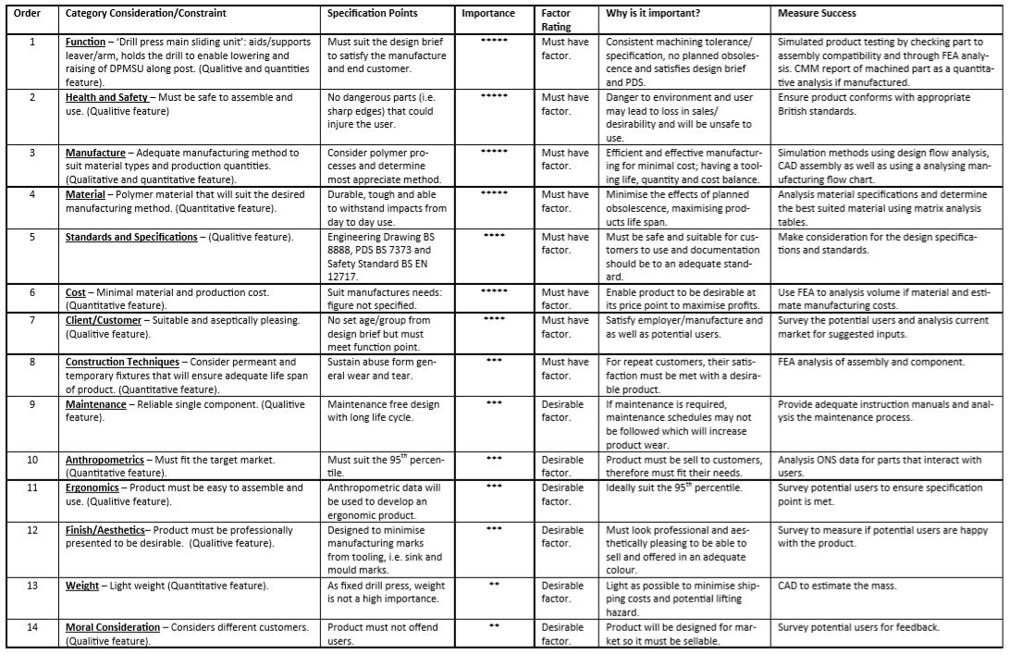
Figure 1: PDS (Institution, 2005)

Manufacturing Processes

This section will determine the most suitable polymer manufacturing method to use with consideration for the PDS where 1000 units per week will be manufactured, specific strength requirements and the ability to form complex geometry will be needed.
Manufacturing Process | Advantages | Disadvantages | Consideration | Reference
Injection Moulding | - Thermoplastics and Thermosets.  - Complex geometry capability.  - Efficient process once setup.  - High volume production.  - Material consistency.  - Minimal net shaping/post processing.  - Dimensional accuracy. | - Initial tooling cost.  - Expensive for low volumes.  - Moisture on polymer pellets requires drying before use. | With the ability to be used for a variety of materials, this flexible offering enables complex parts to be created. Shrinkage should be considered with critical dimensions and costly mould tools required. | (Clarke, 2016)
3D Printing | - Minimal waste material created.  - Minimal tooling cost.  - Enables easy future design changes.  - Complex geometry capability. | - Long printing times compared to other processes.  - Size limitations, depends on machine.  - High energy consumption.  - High initial outlay/cost.  - Limited materials.  - Some materials produce toxic emissions. | Useful to reduce the time for design to market, but the cycle time itself would be too long for the requirement of 1000 units per week; therefore, not the most cost-effective method. However, the application would suit the design geometry of the DPMSU. | (Pearson, 2018)  (The Pros and Cons of 3D Printing, 2017)
Extrusion | - Low production costs.  - High volume capability.  - Easy to perform net shaping.  - Good mechanical properties using cold extrusion. | - Unable to create varying geometries in part.  - High initial investment. | The process would be able to manufacture the required volumes but will be unable to form the complex shape. | (Rosato, 1998)

Considering the advantages and disadvantages of each process, the use of injection moulding will be most applicable to the PDS and design brief requirements. According to (Bayer, 2000) intuitive designing of part geometry can be used to reduce cycle times and cost to form an efficient and effective manufacturing process. For example, using a two-piece moulds instead of multiple sliders to increase the reliability of the process.
Likewise, depending on the type of polymer used in the injection process will depend on the abrasiveness of the material and rate of wear on the tooling. As low volumes will be used, soft tools from aluminium or non-hardened steel that have a life cycle of 50,000 shots will be more than adequate, lasting the manufacture 42 months before a replacement is required if the production volume of 1000 units per week is maintained. On the other hand, hard tool manufacturing would last up to 500,000 cycles but would require a higher initial investment and will not be needed.
During the injection moulding process, sprues are wasted in the manufacturing process. Proper recycling can be used to reform them back into pellets which will reduce the impact on the environment (Clarke, 2016).
Alternatively, 3D printing can be used to manufacture the parts but would be unable to meet the requires demands of the market. Furthermore, there are other processes to create polymer products. Such as by using Computer Aided Design (CAD) and Computer Aided Manufacture (CAM) on a laser cutter, using a 3D printer, line bending, vacuum forming, blow moulding, compression moulding, extrusion, and rotational moulding (Webs, 2012).

Material Selection

There are two main types of polymers, thermosoftening (thermoplastic) and thermosetting plastics. Thermosoftening polymers have weak intermolecular forces, these let the chains slide past each other meaning that these types of plastic can be reused and recycled by being able to be form new shapes. Plastics made of these polymers are stretchy and have a low melting point. Examples of this are Polyethylene and Rubber. On the other hand, there are thermosetting plastics. These polymer chains cannot slide past each other as they have strong intermolecular forces, these chain links hold the polymer firmly place hence this cannot be formed into other shapes or reused. Examples of these are Bakelite and Melamine. (Product Design, 2015)
An investigation into which material would be most suitable for an injection moulding of a DPMSU. Software simulation, data and material properties have been compared as well as the pros and cons.
Material | Advantages | Disadvantages | Specification | Consideration | Reference
ABS | - Impact and heat resistance (depending on moulding conditions)  - Tough  - Light weight  - Low melting temp’  - Recyclable | - Low chemical resistance  - High friction  - High wear | - Tensile Strength: 46 MPa  - Melt Temp:  190°C to 270°C  - Inject’ Mould Temp:  40°C to 80°C  - Shrinkage: 0.5% to 0.7% | The moulding temperature will reduce the production cost and has a low raw material cost. However, its high friction properties will make the application less suitable for the DPMSU. | (Mold, 2017)  (Roger, 2015)
Polyethylene  (HDPE) | - Ductile  - Impact resistant  - Moist absorbent resistant  - Widley recycled  - High density | - Relatively expensive | - Tensile Strength: 20 MPa  - Melt Temp:  130°C  - Inject’ Mould Temp:  20°C to 65°C  - Shrinkage: 1.7% to 2.9% | HDPE has a low moulding temperature that would minimise the cost of production but has a high initial raw cost. | (Mold, 2017)  (Rogers, T., 2015)
Polycarbonate | - Transparent  - Impact resistant  - Withstand deformation  - Recyclable | - Easily scratched  - Some forms are toxic | - Tensile Strength: 59 MPa  - Melt Temp:  280°C to 320°C  - Inject’ Mould Temp:  85°C to 120°C  - Shrinkage: 0.6% to 0.9% | This plastic has a low shrinkage rate requiring less injection holding pressure and time needed to keep the dimensional tolerances. As PC is easily marked, the DPMSU will suffer from frequent contact with swarf which will decrease its aesthetic appeal. | (Mold, 2017)  (Rogers, 2015)
Polyamide | - Wear resistant  - Low friction  - Chemical resistant  - High melting temperature  - Recyclable | - Low impact strength  - Brittle with high GF percentages | - Tensile Strength: 76 MPa  - Melt Temp:  230°C to 290°C  - Inject’ Mould Temp:  40°C to 90°C  - Shrinkage: 1.3% to 1.7% | Nylon would make a suitable material with its ability to be filled with glass fibre to increase the tensile strength. Being a low friction material, this would suit the touching parts making it easier for the DPMSU to slide up and down. | (Mold, 2017)  (Creative Mechanisms Staff, 2016)
HIPS | - Tough  - Impact resistant  - Low cost  - Dimensional consistency  - Non-toxic | - Some forms are flammable | - Tensile Strength: 25 MPa  - Melt Temp:  250°C to 290°C  - Inject’ Mould Temp:  40°C to 80°C  - Shrinkage: 0.2% to 0.8% | This would provide a low cost, recyclable and impact resistant material but having a relatively low tensile strength would make other materials more suitable. | (Mold, 2017)  (Omnexus, n.d.)
Polypropylene | - High melting point  - Crack/fatigue resistant  - Impact resistant  - Chemical resistant  - Light weight  - Low mould temp  - Inexpensive | - Thermal expansion  - Poor surface bonding adhesion  - High friction  - Non-load bearing | - Tensile Strength: 32 MPa  - Melt Temp:  200°C to 280°C  - Inject’ Mould Temp:  40°C to 80°C  - Shrinkage: 1.5% to 2.0% | This plastic would make a cost-effective solution but due to its high coefficient of friction and being most suitable for non-load bearing applications, this material is not as applicable as other plastics for a DPMSU. | (Mold, 2017)  (Creative Mechanisms Staff, 2016)

Different material properties have been considered, HIPS have the least shrinkage rate which means it will have the least dimensional tolerance change upon cooling. Shrinkage if affected by holding pressure and time, melt temperature, wall thickness and types of additives used in the material. Shrinkage should be considered when designing draft angles but is less important with the parts dimension itself, as shrinkage should be considered by mould designers to account for its affect (Bayer, 2000).
After considering the advantages and disadvantages, polyamide would be most suitable due to its high tensile strength at 76MPa and having a low coefficient of friction which will make the material most suitable for the mating surfaces with the guide shaft. A consideration for glass filled polyamide could be used. FEA will be used to determine if the additional gained strength benefits are worth the decreased tooling life. (Creative Mechanisms Staff, 2016). Also, polyamide pellets will collect moisture so it will be required to be dried before injection moulding.

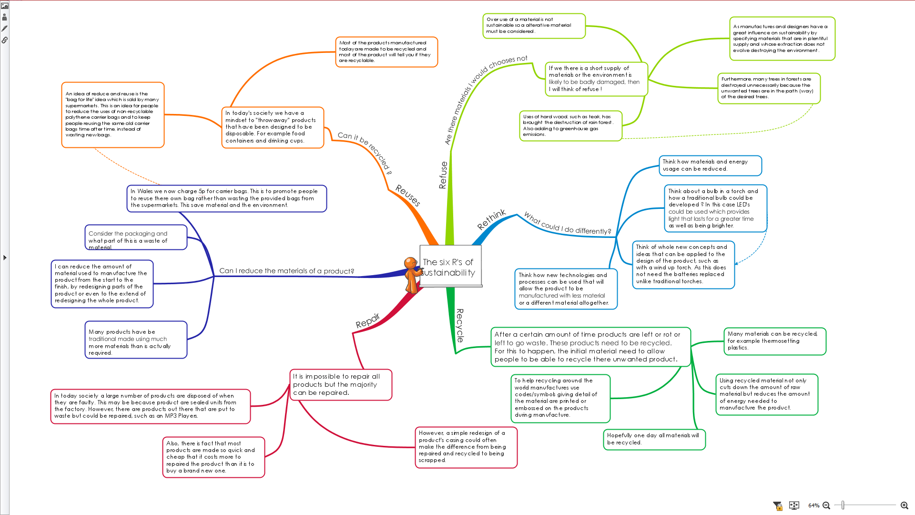
Six R’s of Sustainability
A consideration for the 6’R of sustainability will be made to ensure the product is environmentally friendly, uses the least amount of material and is able to be recyclable. Therefore, thermoplastics will be used instead of thermosets. Please see full size mind map in appendix 1.
(Product Design, 2015)

Considering Costs: Research

In this section, an investigate into the cost of possible materials that could be used to create this product, considering different grades and types from which the best material can be selected to use. A research table will show different prices from a supplier; allowing the materials to be source at the lowest price. Furthermore, a consideration for other types of costs will be made such as: labour and expenses.

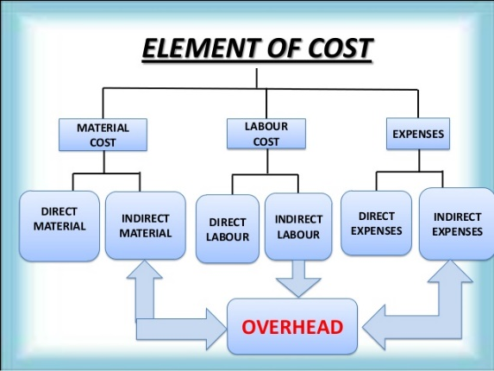
Project Cost
(Leao, 2016)
Overheads
This includes indirect labour and materials that are used to create the project, such as: time spent conducting quality control processes, machine maintenance, electricity to run the machines as well as tooling and cleaning chemicals as this does not ‘add value’ to the product but effects the overall product cost. (Leao, 2016).
Labour
The direct labour cost will include all persons used to manufacture the raw materials into the finished product, i.e. adds value to the product. The final labour cost will depend on if this product is brought to market, meaning commercial manufacturing processes will need to be considered for full scale production. For example: indirect costs such as corrective and planned maintenance tasks.
Materials
The cost includes all raw materials used to manufacture the product. An investigation into the different types of materials will be made.

Material | Approx. Quantity (Kg) | Source/Availability | Cost (£)
ABS | 1 | https://plasticker.de/ | 0.65
Polyamide | 1 | https://plasticker.de/ | 0.88
Polypropylene | 1 | https://plasticker.de/ | 0.49

In conclusion, the best material for the DPMSU is polyamide due to its tensile strength, however, it is the most expensive material of the three meaning a higher cost per unit.

Existing Products

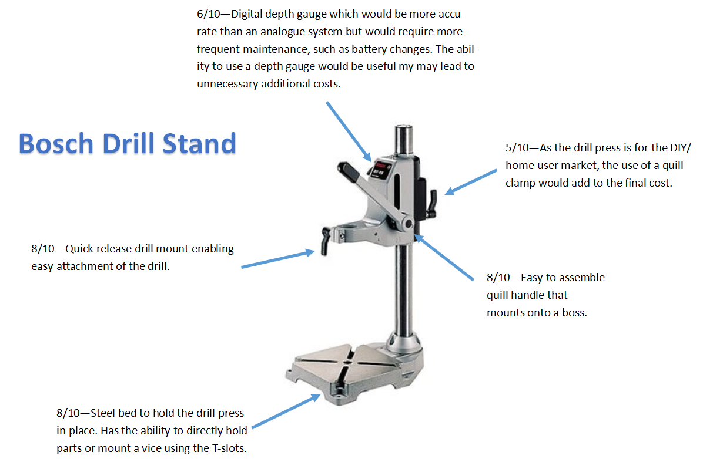
(Gandhi Appliances, 2019)
This section will analysis the existing products that are both available on the market as well as the product provided by the assignment brief.
The analysis of the existing product (drill press shown on the right) has highlighted the features and rated them out of 10.
Current Design
An FEA into the current product will be made to estimate a base line stress analysis that the revised design must withstand.
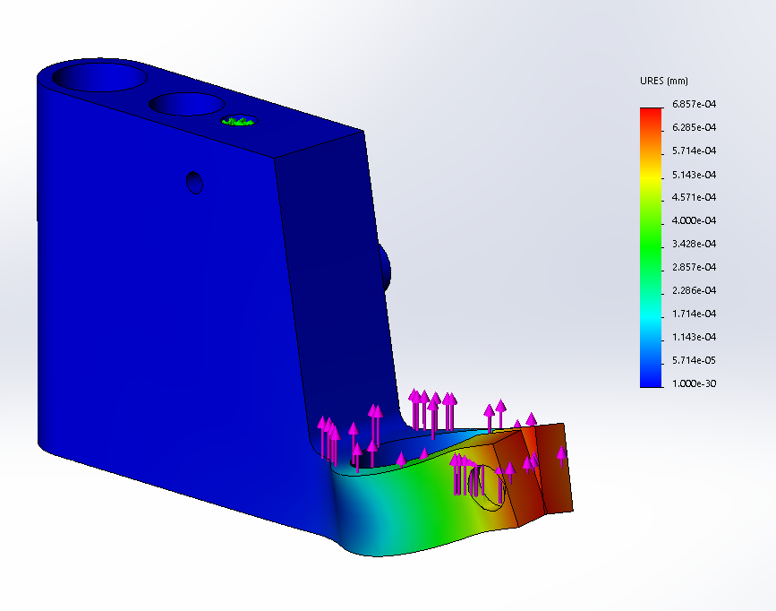
Using F=ma, 10N force equates to 1Kg of applied mass.
Under 10N conditions, the maximum displacement is 0.00069mm.
Wall thickness
According to (Bayer, 2000), the non-uniform and thick walls would lead to long cooling periods as well as sinks and voids. Therefore, making this not suitable for injection moulding.
Likewise, this design has unnecessary holes, weight and no draft angles.

Target Market

In this section, an analysis of the target market will be conducted to find out who would want to use this type of product; through primary and secondary research (survey and use of the internet), where a consideration will be made for potential customers’ thoughts and feelings.

Survey/Questionnaire
The survey investigates 30 people’s thoughts about the type of drill press a user would want to use. A consideration was made for its use, colour and form.

Questions asked

- What do you think of when you consider a DIY drill press?
- Makes drilling easier.
- Unsuitable for my use.
- Rather drill by hand.

- What type of environment would this product be used in?
- Home user.
- Semi-professional/Hobbyist
- Place of work.
Work
Hobbyist
Home User

Conclusion
In conclusion, after surveying 30 different potential users I discovered that most of my target market would be a ‘home user’ that will utilise it to make the drilling process easier. The survey suggests that this product will be less suitable for the professional market as most of them have access to industrial equipment unless if they require a portable drill press for offsite applications. Likewise, some hobbyist would use this product, but others would prefer either a pillar drill or vertical milling machine. As I will consider injection moulding, the product can be offered in a verity of colour to suit the customers’ needs.
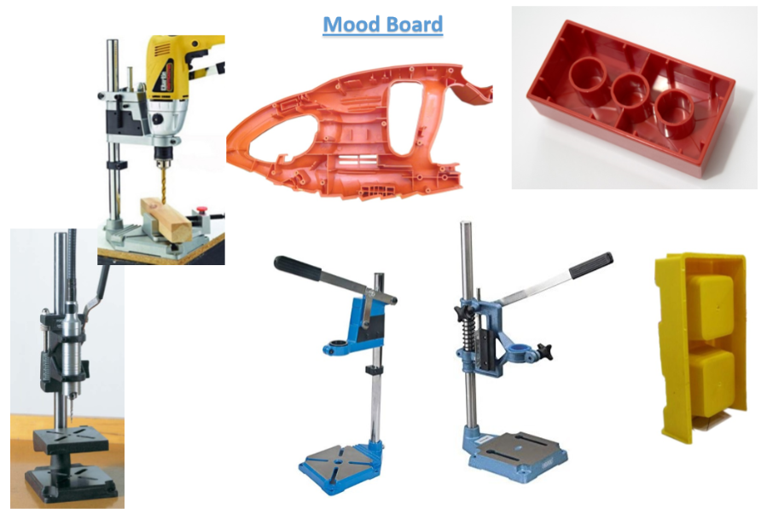
(Drill Press Design, 2019)

Initial Designs

Three initial designs have been created using CAD, the base material used is Polyamide 66. FEA has been used to analysis the potential stresses that will be seen when using a drill press and where these results will be compares to the existing product. Likewise, Mould flow analysis will be used to identify weld lines, draft angles, moulding time, cooling time and potential short shots (Bayer, 2000).
A matrix analysis table will be used to determine the most suited design for a DPMSU, identifying the products function, aesthetics and manufacturing potential. This table will include simulation data for to aid the analysis.

Initial Design 1

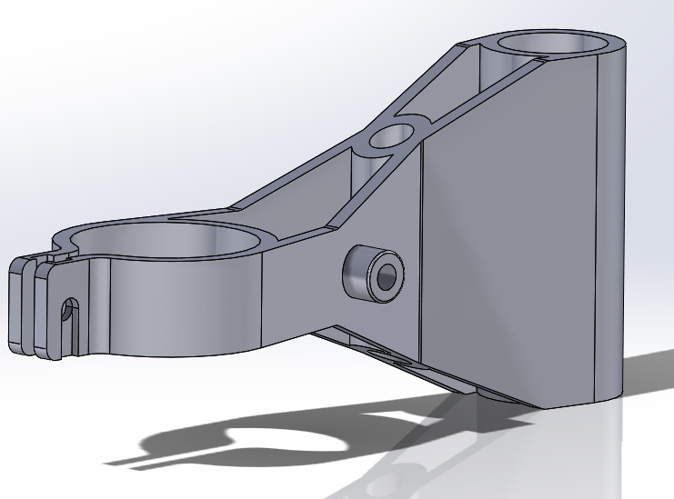
Initial design 1 utilises a uniform wall thickness even around the fillets.
Additional ‘corrugations, curves and ribs’ have been considered to increase strength without the use of thicker walls. A design consideration for ‘critical thickness’ of 4mm has been made.

Draft Analysis
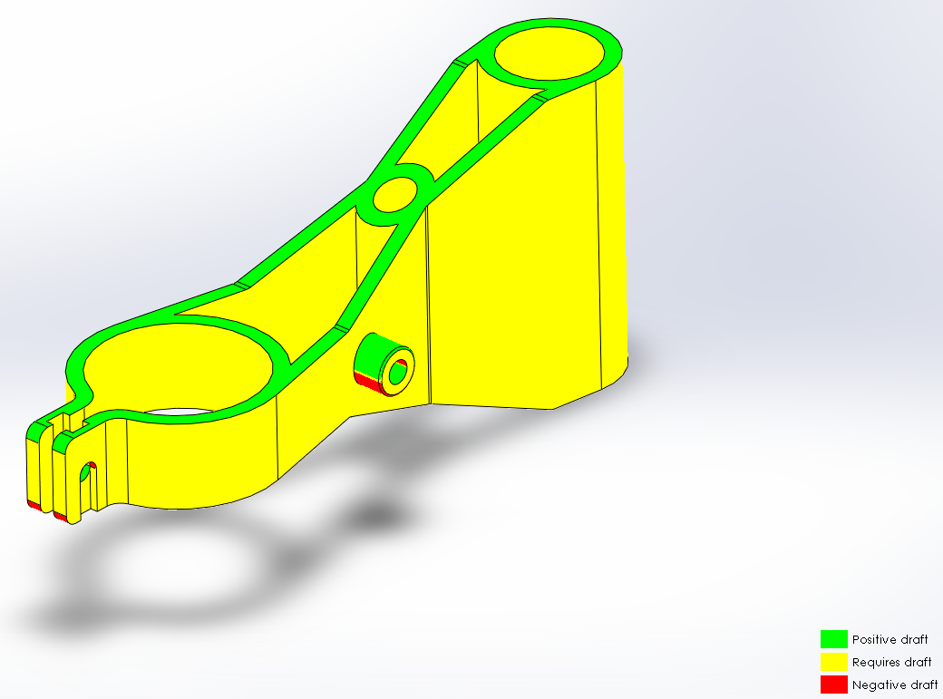
Using the draft analysis tool, this initial design would require additional draft angles indicated by the yellow key.

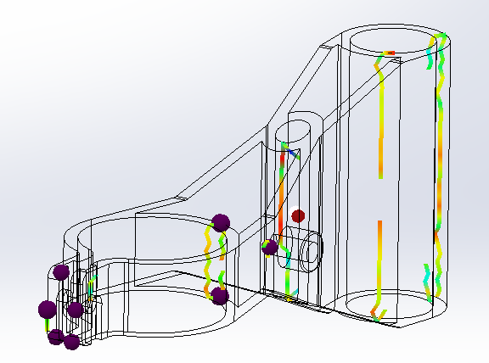
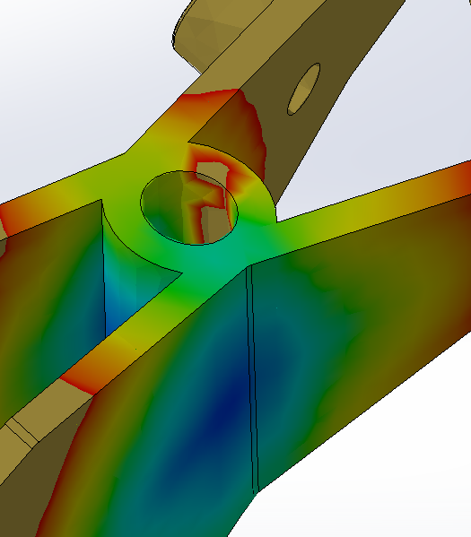
Mould Flow Analysis
Mould flow analysis shows that racetracking occurs which may lead to gas entrapment problem (Bayer, 2000). The analysis shows that there are air traps present but all are in a position that can be vented. There are minimal and non-random weld lines present.

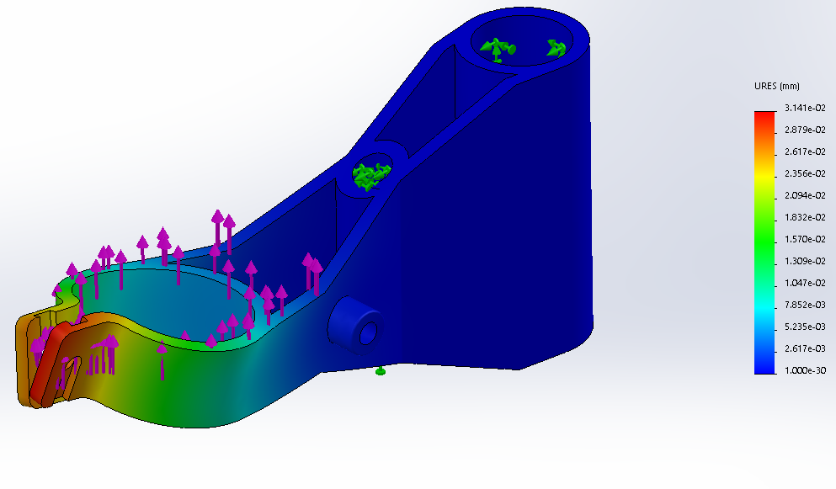
Initial Design 2
Both the displacement of 0.031mm and von Mises of 0.77MPa seen in the FEA are within a reasonable amount when compared to the original product.
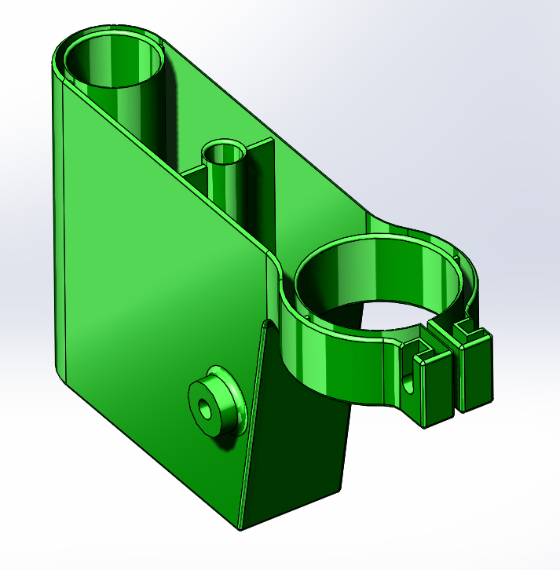
Initial design 2 utilises the original geometry that has been shelled with a uniform wall thickness to become injection mould friendly.
Internal ribs are used to support the bosses to minimise the deflection.

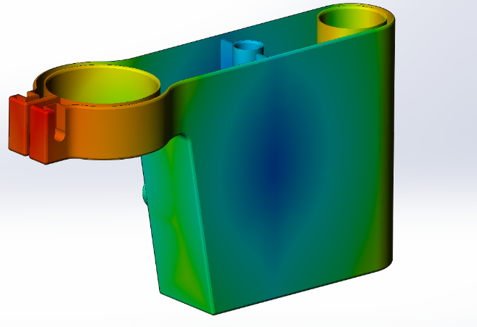
The Mould Flow analysis suggests this design would have the shortest cycle times, having a large surface area for cooling. Likewise, this uses the least amount of material but requires almost eight times the injection pressure of the first design.

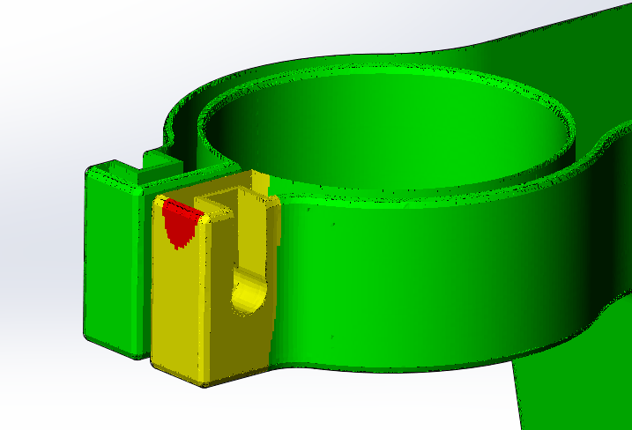
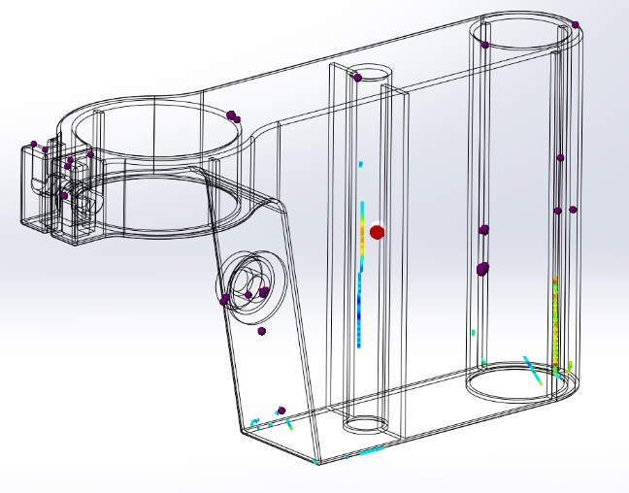
Supporting the argument against the high injection pressure, a warning has been given with the design regards to the ease of fill which suggests that this will need revising if taken further
A benefit for this design is that there are minimal weld lines present, however, there are many potential air traps through the design. The Mould flow should be investigated further to see if further alterations are required, such as the use of flow leaders and wall thickness changes.
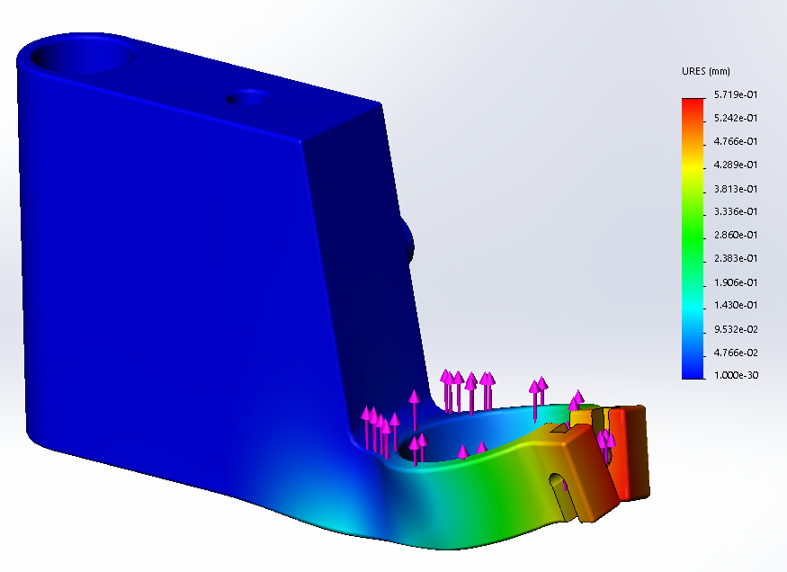
The displacement of 0.57mm and von Mises of 8.78MPa is the highest of the three designs but does not exceed the yield strength of 139MPa.

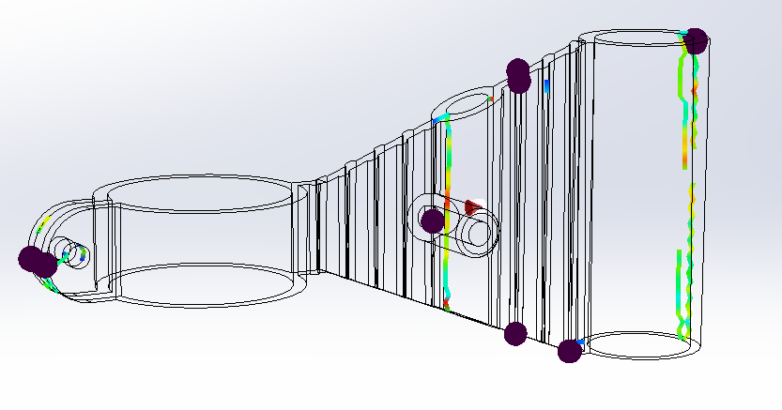
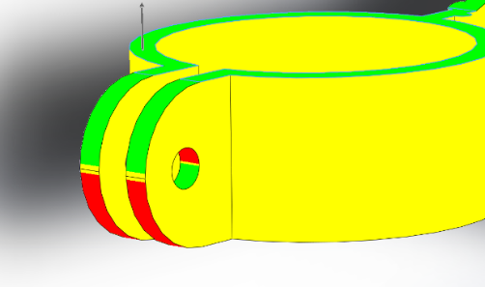
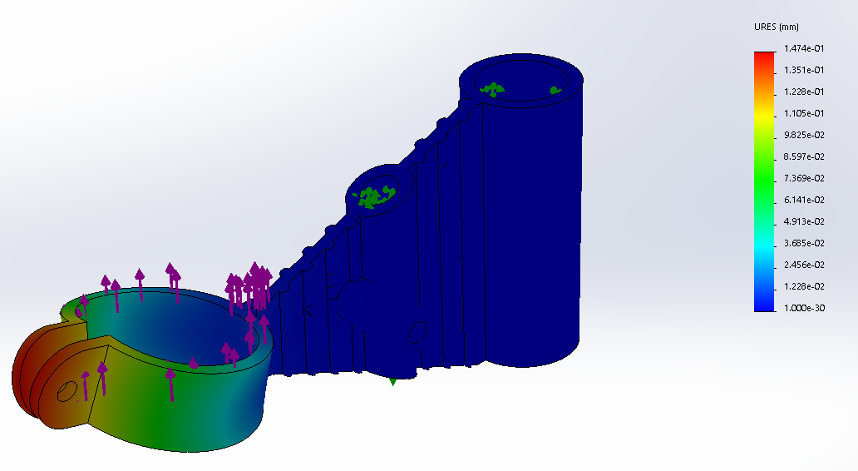
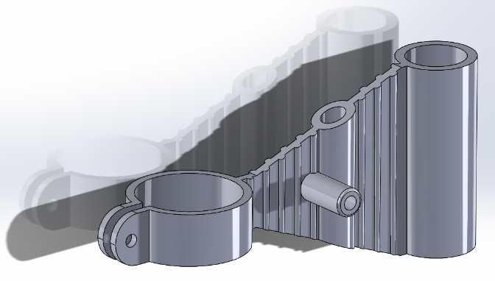
Initial Design 3
A mould flow analysis was used to simulate the process of injection moulding. The results are displayed in the table below.
This design has minimal weld lines and air traps which are shown in the wire diagram.
To hold the drill in place, a standard M6 bolt would be used to provide the clamping pressure required. This design requires sliders to be integrated into the mould for both the boss and drill clamp; unlike design 1 and 2 which has been altered to avoid sliders at the drill clamp.
The FEA report suggests that this design will not exceed the yield strength of Nylon.
Design three utilises a 4mm wall thickness with ribs to provide a product that can withstand the required stress. Radiuses are used to minimise concentrated stress points. (Bayer, 2000)

Analysing the Initial Designs

Matrix Analysis Table
Constraint | Initial Design 1 | Initial Design 2 | Initial Design 3
Function | 9 | 4 | 6
Health and Safety | 8 | 5 | 7
Manufacturing | 5 | 7 | 6
Ergonomics | 7 | 5 | 5
Cost | 6 | 8 | 7
Aesthetics | 8 | 4 | 6
Environment | 6 | 4 | 7
Wow Factor | 9 | 3 | 6
Total | 58 | 40 | 50
Rank Order | 1 | 3 | 2

Each design constraints have been scored 0 – 10 to determine which design is most suited to the PDS.

Key
7 - 10 | Positive
4 - 6 | Neutral
0- 3 | Negative

The results show that the first initial design is the top scorer with a total of 58 points.

FEA and Mould Flow Analysis

The data will be analysed where the positive, neutral and negative aspect has been given a 1, 0 and -1 respectively.
Constraint | Initial Design 1 | Initial Design 2 | Initial Design 3
Fill Time (Sec) | 5.73 | 0.77 | 3.76
Cooling Time (Sec) | 102.73 | 5.77 | 54.76
Injection Pressure (MPa) | 10.61 | 87.02 | 4.25
Sink Marks (mm) | 0.10 | 0.26 | 0.21
Ease of Fill (Easy/Difficult/Warning) | Easy | Warning | Easy
Maximum Deflection (mm) | 0.031 | 0.57 | 0.15
Max Stress (MPa) from FEA | 0.77 | 8.78 | 2.24
Weight (Kg) | 0.088 | 0.052 | 0.059
Totals | 1 | -2 | 2
Rank Order | 2 | 3 | 1
Key
1 | Positive
0 | Neutral
-1 | Negative

Using the matric analysis tables from the FMA and Mould analysis, the third design achieves the best score. However, design 1 only missed out from being the best by a single mark and was close the third designs figures on each aspect it lost out in. The second design performed poorly across the board; having the weakest structure and saw the most deflection even though it contained the least material to produce the lowest weight and cycle times. Overall, the first design has the most greens suggesting that it contains the most positive aspects and when investigating the actual data, the first design will be taken forward for further development.

QFD

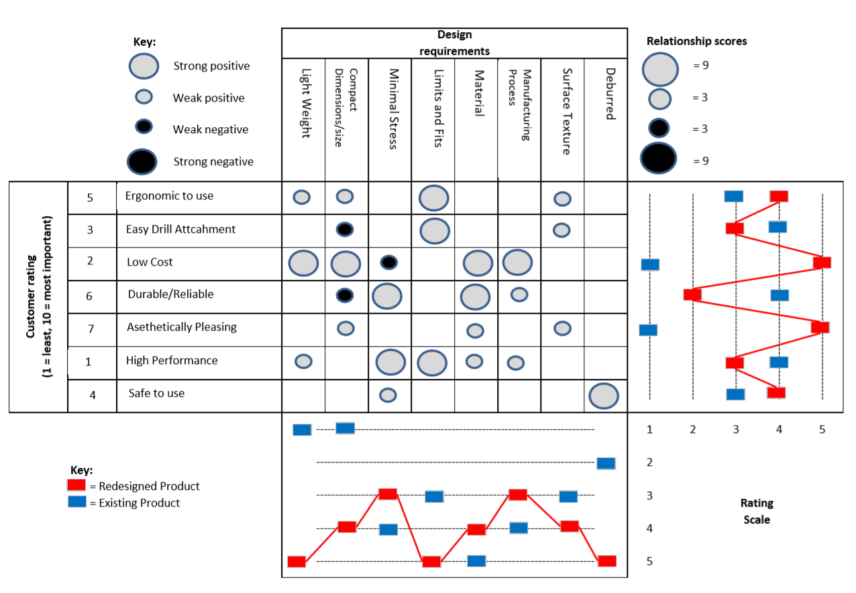
The QFD (see appendix: 2 for zoomed version) will be used to consider the customers’ needs and wants and how they will relate to the design requirements; ensuring the product will be suitable (Day, 1990).
An analysis of the first initial design has been used to identify the relationship; where the most influential aspect to the customers would be the function of the product which depends on size, limits and fits of the bored holes as well as the material. There were a few negative aspects that would need to be considered.
A comparison between the existing product (shown in blue) and design product (shown in red) proves that potentially the revised design could be an improvement over the original product.
Overall, this QFD will be used to aid the design process to ensure the product suits the users’ needs.

Final Design
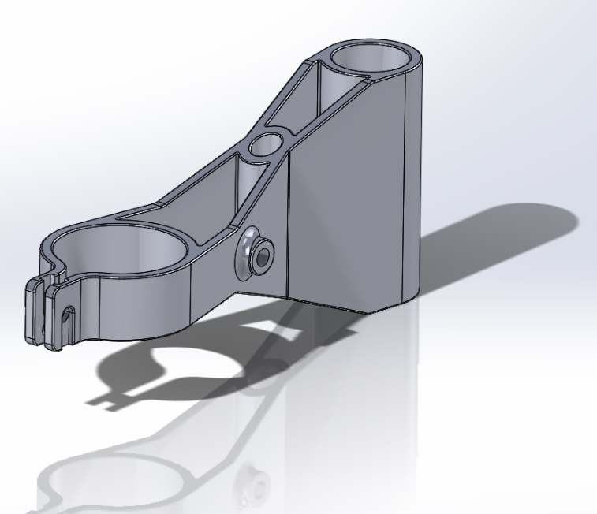
The final design has been refined with the use of additional fillets and geometry modifications to reduce the defelction when the product is under an applied force.
Similar to the intial design, FEA and Mould flow analysis has been used to test the product against the PDS and identify potential improvments.
Limit and fit claculations have be used to find the bore size dimenstions for a clearance hole for the two shafts.

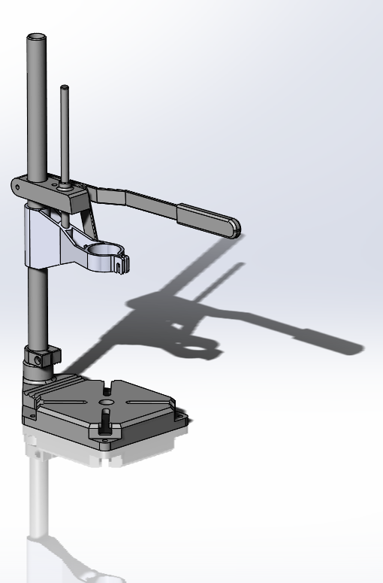
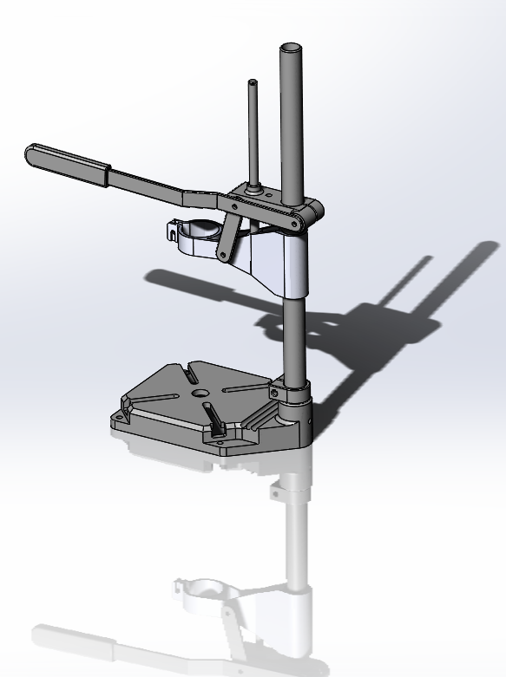

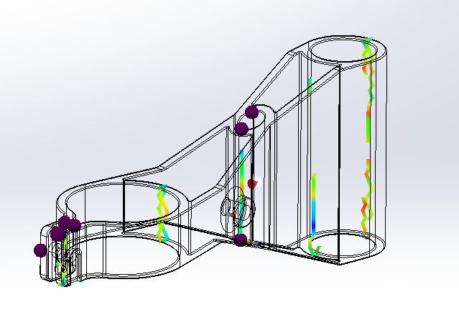
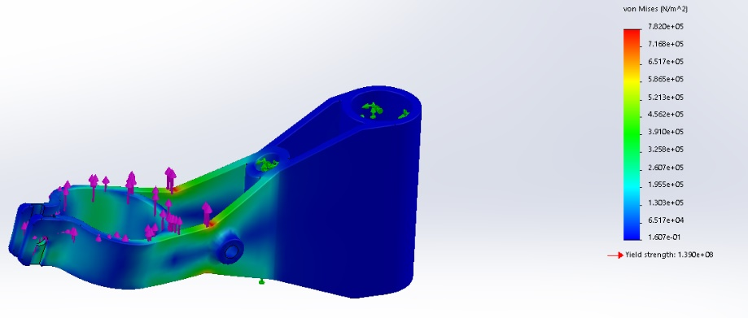
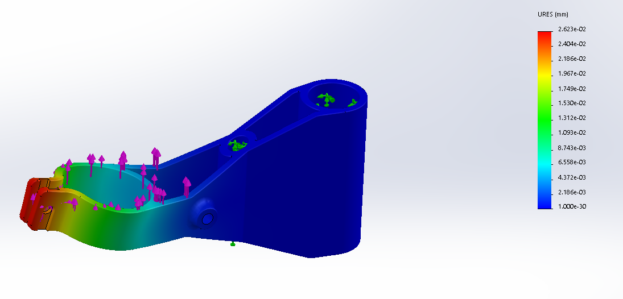
Similar to the initial design, there are minimal weld lines and air traps which are present in reasonable locations.
The von Mises stress is shown which is almost identical to the initial design. The stress does not exceed the materials yield strength but shows that the most stress is seen at the centre of the design near the boss (circles in red).

This analysis shows the deflection which has been reduced when compared to the original designs (see table below).
Constrain | Initial Design | Final Design
Fill Time (Sec) | 5.73 | 10.10
Cooling Time (Sec) | 102.73 | 143.16
Injection Pressure (MPa) | 10.61 | 1.10
Sink Marks (mm) | 0.10 | 0.14
Ease of Fill (Easy/Difficult/Warning) | Easy | Easy
Maximum Deflection (mm) | 0.031 | 0.026
Max Stress (MPa) from FEA | 0.77 | 0.78
Weight (Kg) | 0.088 | 0.088

Matrix analysis table above compares the initial design 1 to the revised final design.

The max stress seen when a 10N force is applied to the DSMPU has not changed when comparing the initial and final designs. However, there is 16% less deflection at 0.026mm which is due to the addition of large radius. The less deflection that is seen, the less fatigue will take place. Likewise, to support the boss that attaches to link arm, a 3mm radius has been used. The negative effect is that there is an increase in injection cycle time even though the amount of material used has almost stayed the same. However, the decreased injection pressure to 1.1MPa will reduce the manufacturing cost even though there is a 5 second increase in fill time. This design now utilises a draft angle on the part to make the ejection from the mould easier.

Conclusion

Firstly, research into existing products enabled an insight into current issues with competitor’s products and lead to design improvements. Secondly, a mood board to collaborate products allowed for back to back comparison of products with the use of pictures. Also, a matrix analysis table was used through the design journey to determine which design idea would be best.
With the design developed and the prototype realised, the product has been successfully designed to meet the customer and manufacture requirements. The cost of production would be reduced with the use of a polymer replacement material, such as polyamide which will withstand the required forces. Likewise, polyamide is a thermoplastic that can be recycles through primary, secondary and tertiary methods which will make the product more environmentally friendly. This component/DPMSU will be functional and a cost-effective solution to the manufactures design problems.
The injection moulding process with the use of soft tooling would be best suited to the production of the DPMSU and would be an alternative to 3D printing.
As a future improvement, the design could be developed to reduce the cycle time with improved geometry as well as minimising the injection time and yield stress. If the wall thickness is increased by ‘10%’ then the part stiffness will increase by ‘33%’ (Bayer, 2000) and the use of further ribs will aid the products durability. As an alternative material to Nylon 66, a glass filled Nylon could be used to increase the strength of the component even though the wear rate on the mould itself would increase. However, as there is only 1000 parts a week required, a soft mould with polyamide will be more than adequate.

Appendix

(See Below)
Appendix 1: 6 R’s of sustainability
(Product Design, 2015)

Appendix 2: QFD

References

Bayer. (2000). Part and Mold Design. U.S.A.: Bayer Design Engineering Services Group.
Clarke, C. (2016, 12 18). Avantages and Disadvantages of Injection Moulding. Retrieved from Martin's Rubber Company: https://www.martins-rubber.co.uk
Creative Mechanisms Staff. (2016, May 4). Everythin You Need To Know Abould Polypropylene Plastic. Retrieved from Creative Mechanisms: https://www.creativemechanisms.com
Creative Mechanisms Staff. (2016, March 10). Everything You Need To Know About Nylon (PA). Retrieved from Creative Mechanisms: https://www.creativemechanisms.com
Day, G. (1990). Quality Fuction Deployment. Productivity Press.
Drill Press Design. (2019, February 15). Retrieved from Google Images: http://google.co.uk
Gandhi Appliances. (2019, February 19). Bosch BS45 Drill Stand 220/240 Volts. Retrieved from Gandhi Appliances: http://gandhiappliances.com/
Garrett, J. (1996, June). Design and Technology: Stages in the Design Process. Retrieved from SEDL: www.sedl.org/
Institution, B. S. (2005, December). BS 7373-3:2005. British Standards.
Leao, L. (2016, June 16). How to Calculate your employee's Cost with Overhead costs . Retrieved from Electrical Engineering 80/20: https://www.e3seriescenter.com/
Mold, M. (2017, January 23). Most Common Thermoplastics Used In Injection Molding. Retrieved from MME: https://www.midstatemold.com
Omnexus. (n.d.). Shrinkage. Retrieved from Omnexus by SpecialChem: https://omnexus.specialchem.com
Pearson, A. (2018, January 24). 10 Disadvantages of 3D Printing Technology. Retrieved from 3D Insider: https://3dinsider.com/
Product Design. (2015). ALevel Design and Technology: Product Design. Newport: Bassaleg School.
Roger, T. (2015, July 13). Everything You Need To Know About ABS Plastic. Retrieved from Creative Mechanisms : https://www.creativemechanisms.com
Rogers, T. (2015, August 21). Everything You Need To Know About Polycarbonate (PC). Retrieved from Creative Mechanisms: https://www.creativemechanisms.com
Rogers, T. (2015, September 14). Everything You Need To Know About Polyethylene (PE). Retrieved from Creative Mechanisms: https://www.creativemechanisms.com
Rosato, D. (1998). Extruding Plastics. Chatham: Kluwer Academic Publishers.
The Pros and Cons of 3D Printing. (2017, June 19). Retrieved from Mode Solutions: https://www.modeprintsolutions.co.uk
UWTSD. (2019, 02 22). Engineering Design Assesment Specification. Swansea: UWTSD.
Webs, P. (2012). What is ABS Material? Retrieved from ABS Material: http://www.absmaterial.com/

