UNIVERSITY OF WALES TRINITY SAINT DAVID
INTRODUCTION TO PHYSIOLOGY(BMHN5023)
Case Study Report Asthma
Lecture: Robert Nartowski
Student name: Svetlana Spinu
Student number: 2419396

Table of Contents
Introduction 2
Structure of the respiratory system and process of mechanical respiration 3
Process of gas exchange in the lungs 4
Reaction of irritants in the respiratory system 4
Recording and tracking respiratory functions 5
Evidence-based recommendations for lifestyle changes 7
Conclusion 8
Reference 9

Introduction
Asthma is considered to be a chronic lung disorder that is characterized by severe inflammatory reactions. Eventually, the airways of the suffering individual tighten due to swelling, thereby causing the secretion of excessive mucus, which hinders appropriate breathing. According to the discussion conducted by Reddel et al. (2022), asthma is inferred to be a heterogeneous health complication, which majorly affects the respiratory system, and airflow limitation can persist for a longer time depending on the severity. Some of the common symptoms for asthma include wheezing, coughing, shortness, and chest tightness. As a result of triggering reactions associated with allergies, poor lifestyle habits, and viral infections, these exacerbations can elevate while causing discomfort among the suffering individuals. In addition to that, risk factors for the condition of asthma can account for genetic, environmental, hormonal, and personal factors. This can be supported by the article of Li et al (2025), mentioning medical history, allergic reactions, “Mycoplasma pneumoniae” (MP) infection, and increased concentration of neutrophil in the body as risk factors for severe asthma. This report shall highlight the appropriate structure along with the process of the “respiratory system” for a better understanding of the impact on the individual. Also, lifestyle changes and evaluation of the vital signs associated with asthma shall be indicated, which can help the suffering individuals to engage and manage their complicated health condition.
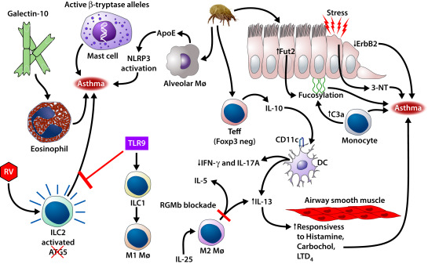
Figure 1: Contributing factors of asthma highlighting different mechanism for development of asthma
(Source: Miller et al. 2021)

Structure of the respiratory system and process of mechanical respiration
The respiratory system of humans is divided mainly into the lower and the upper tract, which facilitates the exchange of carbon dioxide and oxygen. In support of that, one of the reports presented by Wang et al. (2021) indicated that the respiratory system is in the form of a large structure of a tree where the alveolar surface, along with the airway, is covered by epithelial cells. The lower tract of the respiratory system includes bronchi, trachea, and bronchioles. On the other hand, the upper tract of the respiratory system includes the pharynx, the nasal cavity, the nose, and the larynx. In addition to that, the study of Kia’i and Bajaj (2023) outlined that the lungs in the respiratory system involve alveoli that are linked by the squamous epithelium, which gradually allows for appropriate and easy diffusion of oxygen along with carbon dioxide.
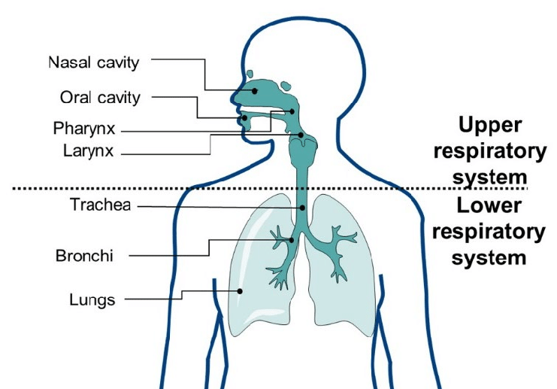
Figure 2: Demonstration of respiratory system structure
(Source: Cruz-Jiménez et al. 2022)
The process of mechanical respiration is inferred to be the rhythmic and physical process incorporating the aspects of inspiration, expiration, pressure dynamics, and mechanical ventilation. As it can be determined that during the stage of inspiration, the respiratory muscles eventually contract, causing an increase in volume within the rib cage that in turn results in a decrease in pulmonary pressure. The discussion of Tran et al. (2021) supports the statement by highlighting that the lungs gradually dilate, thereby decreasing the pressure within the alveoli, which results in the air entering the airways as an appropriate pressure gradient is generated. However, opposite pressure is exerted in the case of expiration. This can be supported by the article of Sundaram and Karthika (2021), mentioning about the pressure gradient in such conditions, the need for air movement in the thorax, which is associated with the determination of resistance, inertia, and compliance in the lung. Oxygen eventually enters the blood of the individual, while carbon dioxide is released due to the factors driven by the pressure differences.

Process of gas exchange in the lungs
Gas exchange is facilitated by the process of diffusion in association to the functioning of the alveoli surrounded by the capillaries. According to the report of Patel and Patel (2023), it can be determined that after oxygen enters the respiratory system, it diffuses in the blood capillaries by alveolus, thereby increasing the concentration of oxygen in the arterial blood. In addition to that, the oxygen gets diffused in the hemoglobin by the “pulmonary capillary tube”. As it can be inferred that the respiratory gases are effectively transported by the process of inflation or inspiration to the alveoli, and using passive diffusion, the gases are transported to the alveolar membrane. The process of gas exchange is divided into two sequential stages, which include oxygen being diffused by tissue barriers to enter the “red blood cells”, followed by the binding with hemoglobin. One of the appropriate studies presented by Magor-Elliott et al. (2021) indicated that gas exchange is associated with the appropriate functioning of the pulmonary ventilation. The aspects of pressure gradient majorly depend on the Potential efficacy for gas diffusion, along with the rate of blood flow.
The carbon dioxide in the body is known to diffuse out from the “red blood cells” in the subsequent alveolar spaces during the process of exhalation by the capillary walls. However, the discussion of Dassios et al. (2023), the mentioned that the elimination of carbon dioxide is associated with the aspects of tidal volume thereby creates an appropriate interface for gas exchange. In support to that, another report by Schmid et al. (2022), have significantly presented that quantification for carbon dioxide diffusion can be determined by the evaluation of ratio integrating respiratory exchange in relation to uptake of oxygen by the blood. The concentration of carbon dioxide is higher in the blood when compared with that of the alveoli, therefore the diffusion of carbon dioxide takes place by the capillaries during exhalation.

Reaction of irritants in the respiratory system
Inhaled irritants like smoke and fume particles eventually trigger critical immune responses that can cause the release of certain chemicals by the cells present in the airway that are responsible for developing inflammation. Also, the alveoli are swollen and are followed by fluid leakage. In support of that, the discussion presented by Bhat et al. (2024) mentioned that different types of irritants, like allergens, toxicants, and pathogens, have the ability to translocate easily within the associated tissue due to disruption of the epithelial barrier, thereby exacerbating inflammatory response and tissue damage. As it can be determined that exposure to a low dose of formaldehyde can increase the reaction against “Dermatophagoides pteronyssinus”. One of the studies by Bezerra et al. (2023) has indicated that the exposure to irritants or allergens can gradually promote the activation of the leukocytes, particularly neutrophils and eosinophils, along with NADPH oxidase, thereby inducing the production of oxygen. This can also cause dismutation for H2O2, where the “reactive oxygen species” (ROS) is associated with causing hyperresponsiveness.
The inflammatory receptors effectively identify the conserved pattern of the molecular structure presented by the pathogen, thereby activating the inflammatory cells, such as natural killer cells, dendritic cells, T cells, and macrophages. These cells are responsible for releasing inflammatory mediators, proinflammatory cytokines, and chemokines against the pathogen. This can be supported by the report of Chavda et al. (2025), mentioning that proinflammatory cytokines contribute to the pathogenesis of respiratory diseases against any situation of injury or infection. The cytokines react by triggering a series of events that result in inflammation of the region while damaging the airways along with the tissues of the lungs. In addition to that, the inflammatory reactions result in a reduction of the lung compliance as the lung eventually is stiffened, which makes it difficult to breathe for the individual. As highlighted by the discussion of Wallbanks et al. (2024), that the air pollutants as irritants in the body account for deterioration of the respiratory system by presenting the complications of increased reactivity and permeability of the airways along with bronchoconstriction. These conditions gradually result in a reduction in the rate of “peak expiratory flow” (PEF) that will require acute exposure. Also, the irritants result in increased coughing, irritation, and wheezing, which elevates discomfort in the suffering individual and can also be responsible for developing a condition of comorbidity.

Recording and tracking respiratory functions
“Peak expiratory flow” (PEF) is determined to be the essential indicator for lung functioning and presents with better understanding of airflow limitation in the body. One of the studies conducted by DeVrieze and Giwa (2024) has indicated that routine and regular monitoring of the PEF can help to evaluate the efficacy of associated therapeutic interventions, which can allow for identification of potential exacerbations. Flare-ups can be detected by analyzing the associated clinical recording of the respiratory system, thereby facilitating the suffering individual to be facilitated with early preventive measures and treatment for the mitigation of comorbid conditions. In addition to that, the discussion conducted by Rhee and Katchamat (2025) outlined the use of PEF for management of asthma, which can diminish the perception of the symptoms, enhance aspects of self-management, and gradually improve the attribute of medical adherence. Also, the patient can be addressed with a reduction in the utilization of acute healthcare facilities. Another report presented by Taylor et al. (202) has mentioned that the extraction of breathing rate from the results of an electrocardiogram (ECG) can facilitate the associated individuals in a care setting with realistic opportunities aimed at acquiring continuous monitoring. These strategies can eventually enhance the quality of life for the patients and increase their ability to self-manage. As the respiratory functions are effectively monitored in case of asthma, safety for the aspect of poor perceivers can be improved, and can also be proven efficient against asymptomatic conditions of the disease.
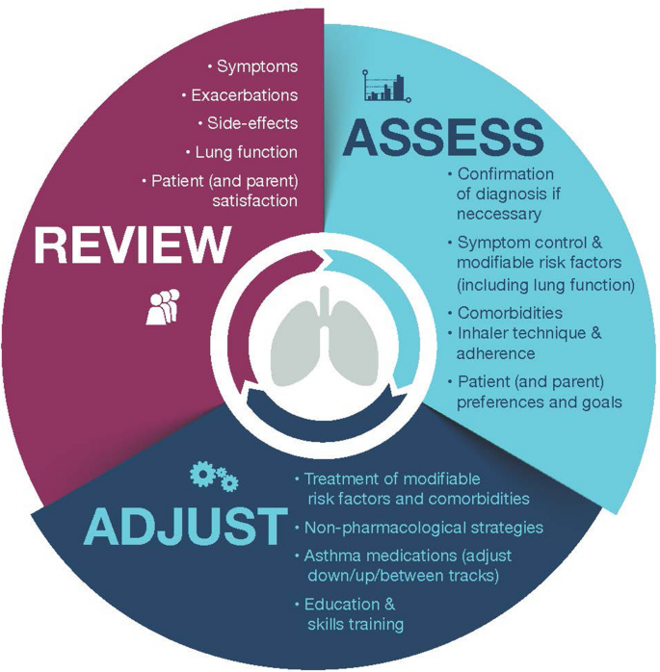
Figure 3: Depiction of asthma management cycle for mitigation of risk factors and other adverse outcomes that can help patients to acquire appropriate goals
(Source: Menzies-Gow et al. 2022)

Evidence-based recommendations for lifestyle changes
The asthmatic patients should include the lifestyle changes of weight management, improved dietary plans, physical exercise, and management of stress, along with cessation of tobacco. In support of that, one of the discussions conducted by Price and Simpson (2023) indicated that physical exercise on a regular basis can improve clinical outcomes of the patient against asthma, as the functioning of the lungs is improved along with better sleep cycles. Also, physical exercise, precisely the approach of “aerobic physical training,” significantly promotes anti-inflammatory response against asthmatic symptoms, thereby improving “bronchial hyperreactivity” (BHR), sleep quality, and “exercise-induced bronchoconstriction” (EIB).
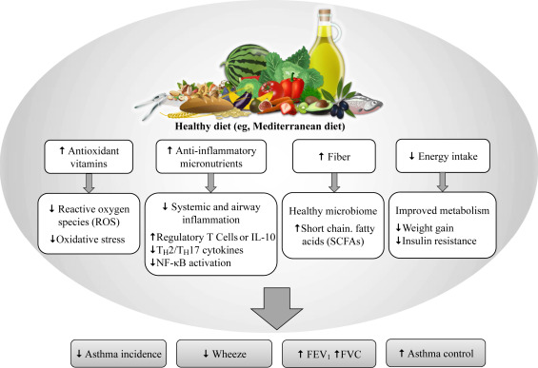
Figure 4: Beneficial dietary modification, integrating Mediterranean diet, that can enhance overall health outcomes of the patient against asthma
(Source: Reyes-Angel et al. 2021)
In addition to that, dietary interventions integrating adherence to a higher-quality and healthy diet pattern can reduce complications associated with the inflammatory response in the body against asthma. As highlighted by the article of Rodrigues et al. (2023), adherence to an evidence-based “Mediterranean diet” can modulate multiple inflammatory mediators that contribute to pathogenic properties in asthmatic conditions. Consumption of healthy fats, vegetables, fruits, and fiber can enhance the quality of nutrients, minerals, dietary fiber, and antioxidants, which are responsible for the prevention of inflammatory responses developing as complications of asthma. Combining nutrient intake and phytochemical content from appropriate food products can enhance anti-inflammatory and antioxidant activities in the body by multiple pathways, which eventually suppresses the expression of the metabolic genes, while inhibiting production of “pro-inflammatory cytokines”. On the other hand, the approach of smoking cessation can enhance the functioning of the lungs, thereby reducing the severity of the associated health complications. In support, the report of Bellou et al. (2022) highlights that smoking cessation is responsible for altering inflammatory phenotype among the suffering individuals, which in turn is linked with a reduction in sputum neutrophils, thereby reducing the symptoms. As it can be inferred that facilitating education with proper support to the suffering individual can help them to ensure improvement in adherence with the plan of care and develop a better understanding of such behavioral changes.

Conclusion
The report presents the complications of asthma and the strategies to enhance understanding among the suffering individuals. This can thereby enhance lifestyle modifications and “quality of life” for the patient, thereby reducing the potential condition of comorbidity. Initially, the structure of the respiratory system, along with the mechanical process of respiration, has been addressed to determine the pathways that are involved in the development of asthma. Also, the discussion on the process of gas exchange can highlight the attributes for understanding the mechanism of the body to absorb oxygen and release carbon dioxide, effectively supported by a relevant literature search. As it can be inferred that management is also possible and addressed by monitoring, tracking, and recording the aspects of respiratory functions, thereby allowing safe management and integration of critically evaluated treatment strategies. Improved behavioral activities, healthy eating habits, and active participation in physical exercises can result in enhanced health outcomes. These actions can evidently improve bodily functions by reducing complications, integrating inflammatory reactions, and expression of mutated genes. Understanding such aspects of management, monitoring, tracking, and physiology of the disease can enhance the ability of the suffering patients to cope with the disease along with self-management practices, which are responsible for improving behavior.

Reference
Bellou, V., Gogali, A. and Kostikas, K., 2022. Asthma and tobacco smoking. Journal of Personalized Medicine, 12(8), p.1231.
Bezerra, F.S., Lanzetti, M., Nesi, R.T., Nagato, A.C., Silva, C.P.E., Kennedy-Feitosa, E., Melo, A.C., Cattani-Cavalieri, I., Porto, L.C. and Valenca, S.S., 2023. Oxidative stress and inflammation in acute and chronic lung injuries. Antioxidants, 12(3), p.548.
Bhat, A.A., Afzal, M., Goyal, A., Gupta, G., Thapa, R., Kazmi, I., Alzarea, S.I., Shahwan, M., Paudel, K.R., Ali, H. and Sahu, D., 2024. The impact of formaldehyde exposure on lung inflammatory disorders: Insights into asthma, bronchitis, and pulmonary fibrosis. Chemico-biological interactions, 394, p.111002.
Chavda, V.P., Bezbaruah, R., Ahmed, N., Alom, S., Bhattacharjee, B., Nalla, L.V., Rynjah, D., Gadanec, L.K. and Apostolopoulos, V., 2025. Proinflammatory cytokines in chronic respiratory diseases and their management. Cells, 14(6), p.400.
Cruz-Jiménez, A.E., Quintanar, J. and Luján-Montelongo, A., 2022. An Overview of Antivirals for Treating Lower Respiratory Tract Infections. Journal of the Mexican Chemical Society, 66(1), pp.130-153.
Dassios, T., Williams, E.E., Jones, J.G. and Greenough, A., 2023. Pathophysiology of gas exchange impairment in extreme prematurity: Insights from combining volumetric capnography and measurements of ventilation/perfusion ratio. Frontiers in Pediatrics, 11, p.1094855.
DeVrieze, B.W. and Giwa, A.O. 2024. Peak Flow Rate Measurement. [online] PubMed. Available at: https://www.ncbi.nlm.nih.gov/books/NBK459325/ [Accessed 12 Feb. 2026].
Kia’i, N. and Bajaj, T. (2023). Histology, Respiratory Epithelium. [online] National Library of Medicine. Available at: https://www.ncbi.nlm.nih.gov/books/NBK541061/ [Accessed 10 Feb. 2026].
Li, Q., Fan, Y., Luo, R., Hu, J., Wang, L. and Ai, T., 2025. Related risk factors that predict moderate to severe asthma attack in children: analysis based on logistic regression and decision tree. International Journal of General Medicine, pp.3919-3931.
Magor-Elliott, S.R., Fullerton, C.J., Richmond, G., Ritchie, G.A. and Robbins, P.A., 2021. A dynamic model of the body gas stores for carbon dioxide, oxygen, and inert gases that incorporates circulatory transport delays to and from the lung. Journal of Applied Physiology, 130(5), pp.1383-1397.
Menzies-Gow, A., Jackson, D.J., Al-Ahmad, M., Bleecker, E.R., Cosio Piqueras, F.D.B.G., Brunton, S., Canonica, G.W., Chan, C.K., Haughney, J., Holmes, S. and Kocks, J., 2022. A renewed charter: key principles to improve patient care in severe asthma. Advances in therapy, 39(12), pp.5307-5326.
Miller, R.L., Grayson, M.H. and Strothman, K., 2021. Advances in asthma: new understandings of asthma’s natural history, risk factors, underlying mechanisms, and clinical management. Journal of Allergy and Clinical Immunology, 148(6), pp.1430-1441.
Patel, N. and Patel, K., 2023. Estimation of Pulmonary Gas Exchange in the Human Respiratory System Under Normal and Abnormal Conditions. Biosciences Biotechnology Research Asia, 20(1), pp.255-262.
Price, O.J. and Simpson, A.J., 2023. Exercise and asthma–trigger or treatment?. Respiratory medicine, 213, p.107247.
Reddel, H.K., Bacharier, L.B., Bateman, E.D., Brightling, C.E., Brusselle, G.G., Buhl, R., Cruz, A.A., Duijts, L., Drazen, J.M., FitzGerald, J.M. and Fleming, L.J., 2022. Global Initiative for Asthma Strategy 2021: executive summary and rationale for key changes. American journal of respiratory and critical care medicine, 205(1), pp.17-35.
Reyes-Angel, J., Han, Y.Y., Litonjua, A.A. and Celedón, J.C., 2021. Diet and asthma: is the sum more important than the parts?. The Journal of allergy and clinical immunology, 148(3), p.706.
Rhee, H. and Katchamat, N., 2025. Asthma Symptom Self-Monitoring Methods for Children and Adolescents: Present and Future. Children, 12(8), p.997.
Rodrigues, M., de Castro Mendes, F., Delgado, L., Padrão, P., Paciência, I., Barros, R., Rufo, J.C., Silva, D., Moreira, A. and Moreira, P., 2023. Diet and asthma: a narrative review. Applied Sciences, 13(11), p.6398.
Schmid, K., Knote, A., Mück, A., Pfeiffer, K., von Mammen, S. and Fischer, S.C., 2022. Interactive, visual simulation of a spatio-temporal model of gas exchange in the human alveolus. Frontiers in Bioinformatics, 1, p.774300.
Sundaram, M. and Karthika, M., 2021. Respiratory Mechanics: To Balance the Mechanical Breaths!!. Indian Journal of Critical Care Medicine: Peer-reviewed, Official Publication of Indian Society of Critical Care Medicine, 25(1), p.10.
Taylor, L., Ding, X., Clifton, D. and Lu, H., 2022. Wearable vital signs monitoring for patients with asthma: a review. IEEE s8ensors journal, 23(3), pp.1734-1751.
Tran, A.S., Thinh Ngo, H.Q., Dong, V.K. and Vo, A.H., 2021. Design, control, modeling, and simulation of mechanical ventilator for respiratory support. Mathematical Problems in Engineering, 2021(1), p.2499804.
Wallbanks, S., Griffiths, B., Thomas, M., Price, O.J. and Sylvester, K.P., 2024. Impact of environmental air pollution on respiratory health and function. Physiological Reports, 12(16), p.e70006.
Wang, D., Cong, Y., Deng, Q., Han, X., Zhang, S., Zhao, L., Luo, Y. and Zhang, X., 2021. Physiological and disease models of respiratory system based on organ-on-a-chip technology. Micromachines, 12(9), p.1106.

