Analysis.

Introduction.

Cohen et al. (2019) states that a questionnaire is the most beneficial research method for the convenience of the public and is the most effective method for collecting data from a large amount of participants. Therefore, as a part of the primary research a questionnaire was conducted where 82 participants took part in answering the questions that were provided. The evidence surrounding the topic of ‘Are men often overlooked as victims of domestic abuse by society and how effective are the strategies to prevent domestic violence’ have not been thoroughly looked upon providing minimum evidence. This evidence provides further clarification and evidence to suggest the findings associated with whether or not there is stigma regarding if females are more commonly known for being victims of domestic abuse. This chapter will explore the findings and results that were carried out from the primary research conducted surrounding the reasoning to why men are often overlooked as victims and how effective they believe the strategies available are. Collins (2019 highlights that the questionnaire will ensure an accurate representation of how society observes their thoughts regarding men being overlooked as victims of domestic abuse. Lambert (2019) reinforces that the research method of a questionnaire is systematic method on how research will be collected that ensures the results collected have more relevance that ensures reliable infromation to be used.
This chapter is set out to cover the themes and objectives by describing, analysing, comparing and contrasting the results that have been found. The qualitative data collected will be anyalysed by the method of content analysis. According to Shaheen et al. (2019) is the method of evaluating patterns by meassuring the difference betwwen different variables. Wheras the quantititative data will be analysed through a thematic and content analysis. Cernasey & Axon (2023) describe a thematic analyis for quantitative data as a method that idenifies the patterns and themes surrounding the data collected.The context of empirical research will be inluded which will cover the relevant theories and data observed will ensure a conclusion and the rationale behind the answers. This ensures that the questionannire will compare and contrast the data aginst the theoretical predicitons. A crucial part is ensuring that the indivuals targetted are from a wide audience to ensure the findings are a fair representation from community. This was ensured by reaching different genders and age groups for the most accurate results possible.

Main body.

The first question asked within the questionnaire was ‘What is your gender?’ By including this it ensures that the data collected enables sufficient trends to be recognised and provides a full understanding towards any bias that may occur during analysing data. Devlin et al. (2020) reinforces that using one gender as a target audience causes issues such as impacting the results. This could be by issues such as not adressing the populations viewpoints as a whole that can impact the result from differences between genders. The results found that 62% of participants were female, 1% chose to disclose as other and 37% of participants were male. From this, there will be a representation from both genders that will allow the data to reflect an accurate representation of communitties views as a whole.
Also inlcuded were the two question asked was ‘Are you a victim or have previously been a victim of domestic abuse?’ and ‘Are you aware of any males that have been a victim of domestic abuse?’ 87.8% said that they had not previously been a victim of domestic while 12.2% said they had previously been a victim of domestic abuse. The findings of 66.7% of participnats not being aware of a male that has previously bee a victim while 33.3% stated they were awayre of a male that had experienced it.
The next question asked was ‘Do you think domestic abuse victims are more likely to be males or females?’ The results below show that 81.7% of participants belived that women were more likely, 9.8% belived men were more likely and 8.5% chose the option of ‘other’ of being more liekly to be a victim of domestic abuse.

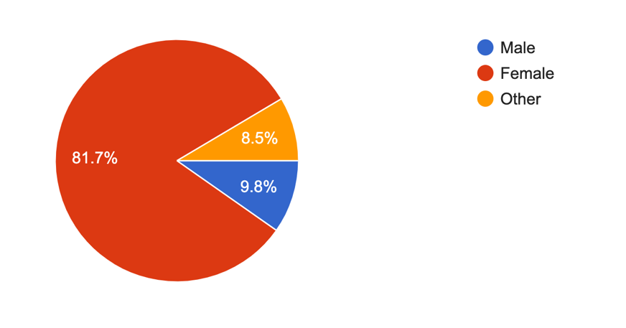
The above results show that participants as a whole believe women are more likely to be victims of domestic abuse that reinforces that the stigma of men being overlooked as victims of domestic abuse with a low percentage choosing the option of men being more likely to be a victim of domestic abuse. This portrays that domestic abuse is portrayed as a crime where perpetrators are quite often known as males. This is reinforced by Perryman & Appleton (2016) stating that men are often silenced as victims when seeking the support that suggest that their often victims that individual’s arent aware of. Therefore, the results suggest that as male victims are overlooked regarding are less likely to be percieved due to gender stereotying due to their more aggressive nature and women being victims are far more advertised in societies.
The next question that was followed on from the previous question asked was ‘Why do you think this?’ This question enabled the participnats to explain why they choose their answer to the previous question. This provided a range of answers that included many patterns that were able to be highlighted from the results. The most common answer was that statistics show that domestic abuse is more commonly reported among women. This is reinforced by several other answers received such as inlcuding societal norms, power dynamics and historical context. Therefore this shows that women are often percieved as more vulnerable individuals in many cultures and societies which may be the reason to what can lead to a higher prevalance of abuse against them. Other answers portray this which can lead to a higher prevalence of abuse against them. Additionally, men may be less likely to report abuse due to fear of relation, stigma, or lack of support highlighting that a higher percentage of women report it that results with a higher coverage seen on social media and in the press online. The patterns observed from the results are reinforced by (Moore, 2021) that it’s the stigma we have been raised with to belive that women are more liekly to be victims and that the statistics we are aware of as communities are indisputable. On the other hand, an observation has been made to results such as male are stereotypes as erpatraotors but in relaity they are ashamed to speak out that hides their identity as victims and males fear being listened and belived as victims.
The next question asked was ‘What would you define domestic abuse as?’ This question ensures that the participants are able to explain their knowledge regarding the defintion of domestic abuse and is able to explain their answers further regarding why they chose women as the higher percentage of victims being females. The results show that majority of participants stated that domestic abuse is physical abuse, emotionall abuse and controlling and cohersive behaviour. The other participants described domestic abuse as patterns of behaviour in an intimate relationship where an individual seeks to gain or maintain power through controlling by using psychological manipulation. This rienforces that society are aware and have been educated about the key concepts of domestic abuse. Prycroft & Gough (2019) explains domestic abuse as incidents or reoccuring incidents where controlling and coerive behvaiour, degrading and threatening behaviours take place. Comparing this to the results given this is similar in the way that the same use of language and actions are carried out. The results included the term isolating, sexual violcence, harrassment, stalking, digital abuse and use of threatening language that highlighted that the public are aware of what domestic absue entails that ensures that the results are not misinterpreted because of indivuals missunderstanding the definition.
The question ‘What type of domestic abuse do you believe is more common in males?’ provided results such as emotional, physical, verbal, controlling and coercive behaviour being the most common domestic abuse towards men. These results show that society belive that men are far more open to being controlled and emotionally abused to compared to abusive methods that werent stated such as sexual abuse, financial abuse and being maipulated. Westmarland & Burrell (2023) highlights that many aspects of domestic abuse are’nt made aware of and theres a specific attention towards physical abuse and that this is the only type of abuse that needs serious attention. Therefore, this suggest that the reasoning towards the pattern of majoirty choosing physical abuse suggest this is why women are looked as as more likely to be victims because the emtional and mental abuse wasn’t considered.
The findings of the question ‘Do you believe that men are often overlooked as victims of domestic abuse?’ are shown on the chart below.
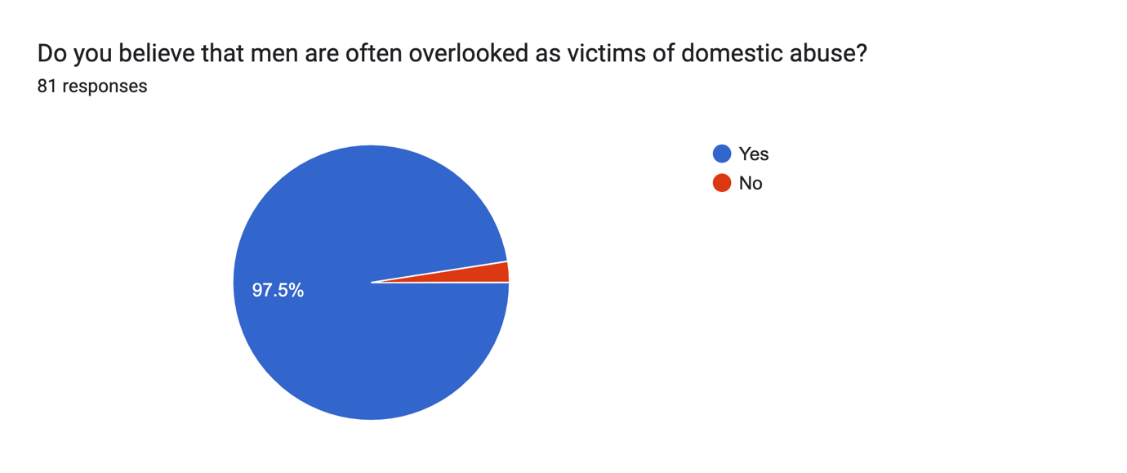
The results provide us with the results of majority of participants believing men are often overlooked as victims of domestic abuse. The next question following on from this ‘Why do you think this?’ This enables us to have an explanation regarding why majoirty of participants believe this. The results include various of reasons for example men keeping quiet, feel as though they won’t be believed, sign of weakness, usure of where to seek support, bad experience when previously seeking help or afraid the woman will be believed over the man. Gadd et al. (2014) reinforces the observations made regarding being similar to the findings of why men often don’t seek support such as stigma, failure to be heard, don’t want to sperate families and a cultural reasoning. This highlights the concerns the indiviuals have that act as barriers from feeling as though they can report the abuse that keeps men experiencing domestic abuse hidden.
The question ‘What strategies are you aware of for supporting male victims of domestic abuse?’ provides us with the results of the police, NHS, family members and friends, helplines and online support systems. These reuslts show that communities are aware of the key support systmes that are implemented into our communities as a means of establishing a stronger suport system for individuals struggling. The most popular method of support was the police service but saying this all these methods suggetsed there are issues when providing support for men to go overlooked as victims of support. This is highlighted by Hine et al. (2022) stating that male get refused from women domestic abuse shetleters and call handlers give negative feedback and advice to the vcitims such as recent issues of stating that they ar at fault.
The following question ‘Do you believe there are enough domestic abuse strategies available’ show the following results.
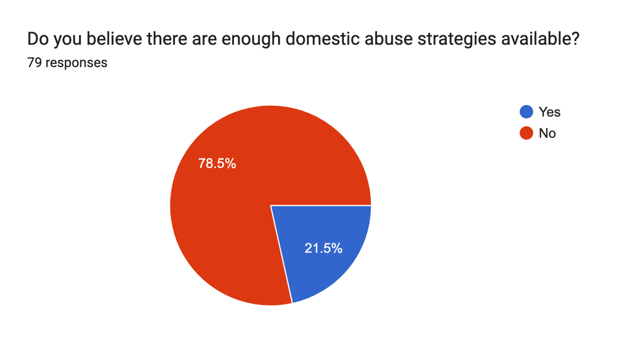

The results show that majoirty of participants believed there are not enough domestic abuse strategies available. This may be reasons that they are not educated on all the relevant support systems available or don’t believe they are effective enough. This is reinforced by Hammond & Fido (2024) by stating that society believe there are more support available for women in comparison to men. This is highlighted by the ManKind initiative stating that a third of domestic abuse victims are men and when seeking support from refuges only 0.8% of these victims were offered beds. This shows that men don’t belive there is the sufficent support available such as the exaple of only 20 beds avaialble for male victims in England as opposed to 3,600 for female victims.
The next question asked ‘Do you believe there are enough opportunities for men to seek domestic abuse support?’ follows on from this with results showing below that overall participants belive that there are not enough opportunities available for men to seek domestic abuse support. This highlights the issue of men feeling as though they are stuck in the ongoing abuse with the barrier of not feeling as though there is sufficent support avialble. Huntley et al. (2020) highlights this ongoing issue by stating that there is a failure to ensure that male domestic abuse victims have the basic level of suport they are required and are being failed in this department. This suggest that victims do not feel heard and feel as though this is their nromailty and they have no other choice but to stay in these situations.
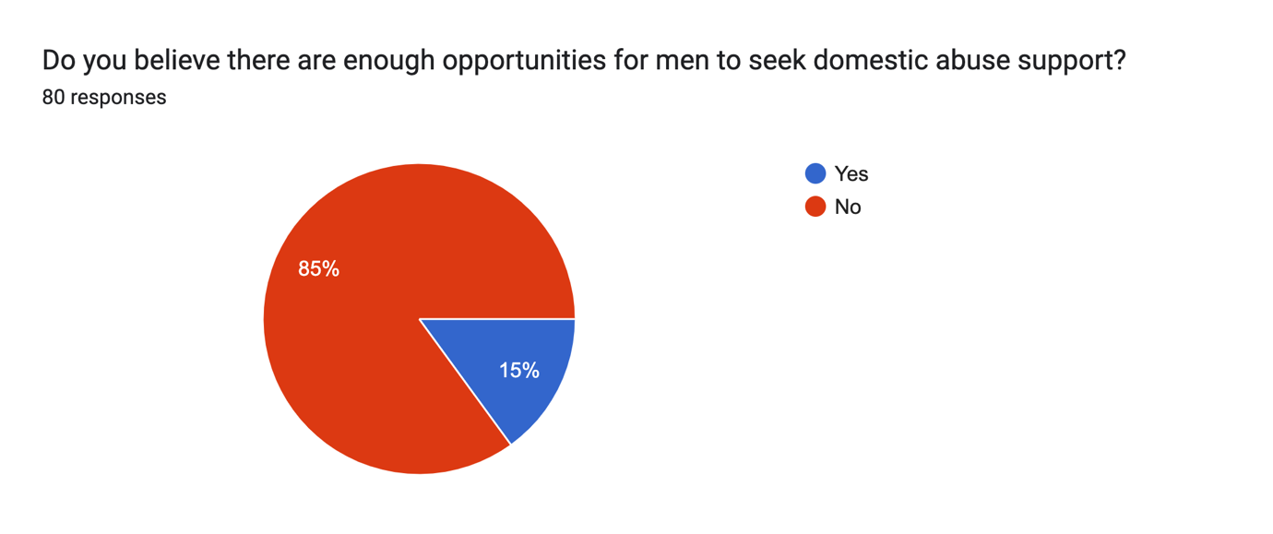
The last question asked was ’What further strategies should be put in place for male domestic abuse support?’ The results provided from participants varied from raising more awareness such as more advertisemnt to reducing the stigma towards females being victims. For example the same principle being put in place for both genders such as claire’s law being implemented for eveyone that is in need. Another point raised that their should be more stratagies to seek the initial sings such as the police should be visiting schools to educate children and identify whether they are experiencing domestic abuse. This is highlighted by Gabrielle (2022) by stating that partnership agencies should be more aware of the shortfalls in society such as more questioning from health services such as local surgeries. This entails partnership agancies taking caution as vtcims oftenly are not open about their trauma or experiences therefore, should be informed on how to pick up on warnings and traits that they show as being victims.

Conclusion.

To conclude, by observing the results from participants the data collected show patterns from observations such as a large amount of individuals beliving that men are often overlooked as victims of domestc absue. The findings suggest that society as a whole have a stigma towards women oftenly being the victims of domestic abuse and at the forefront society are unsuccesful in providing support that male victims are aware of. Entilli & Cipolletta (2017) reinforce the data analysed that society belive that stratagies are seen as support for women and men feel uncomfortable seeking support because of the barriers they face such as feeling ashamed, don’t want to break famillies up and financial issues. Therefore, ensuring that support is provided where these barriers can be supported and spoken about is crucial for the future of male domestic abuse vcitims.

Word count=

Reference list.

Cernasey, A. & Axon, D., (2023) Research and scholarly methods: Thematic analysis. Journal of the American College of Clinical Pharmacy, 6(7), pp. 751-755.

Cohen, L., Manion, L. & Morrison, K., (2019) Research methods in education. 8th Edition ed. London: Routledge.

Collins, H., (2019) Creative research : the theory and practice of research for the creative industries. 2nd Edition ed. London: Bloomsbury Publishing Plc.

Devlin, N., Parkin, D. & Janssen, B., (2020) Methods for Analysing and Reporting EQ-5D Data. 1st Edition ed. London: Springer Nature.

Entilli, L. & Cipolletta, S., (2017) When the woman gets violent: the construction of domestic abuse experience from heterosexual men's perspective. Journal of clinical nursing, 26(15), pp. 2328-2341.

Gabrielle, N., (2022) Children - the hidden or direct victims of domestic abuse?. The Journal of social welfare & family law, 44(4), pp. 512-528 .

Gadd, D., Corr, M.-L. & Fox, C., (2014) This is Abuse… Or is it? Domestic abuse perpetrators’ responses to anti-domestic violence publicity. culture, 10(1), pp. 3-22.

Hammond, C. & Fido, D., (2024) Ending the stigma of male domestic violence and abuse victims: A mixed-methods study. Journal of criminal justice, Volume 93, pp. 102-102.

Hine, B., Bates, E. & Wallace, S., (2022) “I Have Guys Call Me and Say ‘I Can’t Be the Victim of Domestic Abuse’”: Exploring the Experiences of Telephone Support Providers for Male Victims of Domestic Violence and Abuse. Journal of interpersonal violence, 4(37), pp. 5594-5625.

Huntley , A., Szilassy, E. & Potter, L., (2020) Help seeking by male victims of domestic violence and abuse: an example of an integrated mixed methods synthesis of systematic review evidence defining methodological terms. BMC health services research, 20(1), pp. 1085-1085.
Lambert, M., (2019) Practical research methods in education : an early researcher's critical guide. 1st Edition ed. London: Routledge.

Moore, T., (2021) Suggestions to improve outcomes for male victims of domestic abuse: a review of the literature. SN Social Sciences, 1(10), p. 252.

Perryman, S. & Appleton , J., (2016) Male victims of domestic abuse: implications for health visiting practice. Journal of research in nursing, 21(6), pp. 386-414.

Prycroft, A. & Gough, D., (2019) Multi-Agency Working in Criminal Justice 2e Theory, Policy and Practice. 2st Edition ed. London: Princeton University Press.

Shaheen, M., Gupta, M. & Prathap, R., (2019) Qualitative techniques for workplace data analysis. 1st Edition ed. London: Business Science Reference.

Westmarland, N. & Burrell, S., (2023) ‘I’m a red-blooded male’: Understanding men’s experiences of domestic abuse through a feminist lens. Criminology & criminal justice, 3(6), pp. 12-19.

