Effective team-working and communication.
Code: BMSW4002
Student name: Zainab Sesay
Student ID: 2119599
Lecturer name: Obinna Nkwocha

Contents
Introduction 3
How management at Green Fields Care Home can develop an effective team. 3
The impact of effective team-working in the health care settings 5
The types of roles that are needed to create a cohesive and effective team 7
Conclusion 8
Reference 9

Introduction
The term teamwork refers to working together towards achieving any targeted goal or organizational success (Cohen and Levesque 2017). Team working is key to organizational success which is why every organization has teamwork. Basically, it is an idea that unity is strength, and division can bring decline. Besides, each and every organization has different departments such as the HR department, finance department, sales department, marketing department, and so on. These stated departments work as teams or organs of a company. There are many parts or individual duties in a workplace where workers work as a team. Every team consists of various employees and staff. This case study is going to solve green fields care home’s communication and other misunderstandings. The study will show how green fields care home can solve communication and misunderstanding issues in the workplace. The study also demonstrates how it can make effective team working group and role differentiation.

How management at Green Fields Care Home can develop an effective team.
Green fields care home needs to develop an effective team by which it can continue to run its operation effectively toward achieving organizational goals. In this section, we are going to demonstrate how it makes an effective team. First of all, some primary works need to be done before creating an effective team.
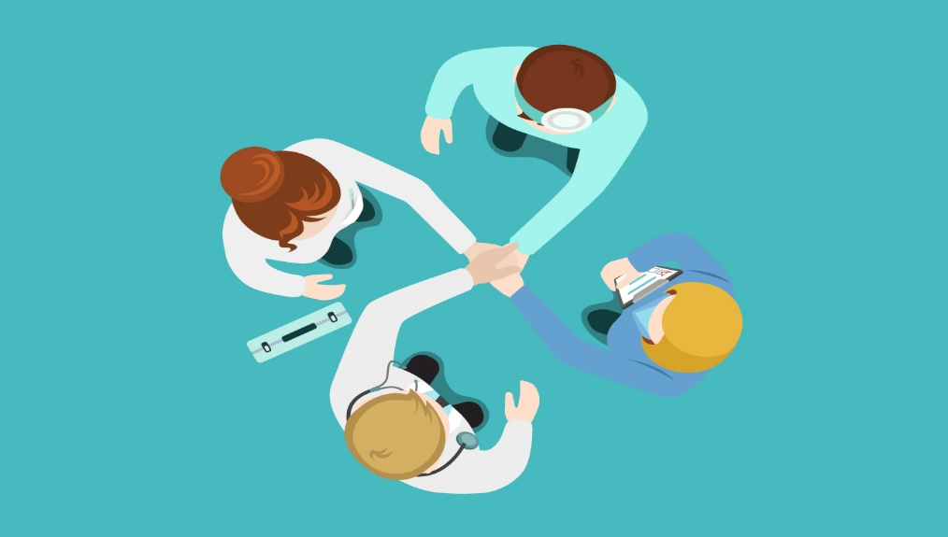

Context
Context is a very primary stage of team building where the management should look for some elements such as adequate resources, leadership and structures, performance evaluation, reward policy, and trust (Bryant and Albring 2016).
Adequate resources can boost the ability of team working and lack of resources can recede its impact. So, green fields care home should support its employees with adequate resources. Leadership and structure are another part of the context because employees are essential for any organization and leadership is known as the backbone of the organization, effective leadership can create a better ambiance in the workplace. Leaders differentiate the duties of employees in order to have the best outcomes for them. Performance evaluation and reward policy are one of the most effective strategies for having better feedback from the employees (Arvey and Murphy 2015). When a company offers a reward for doing a particular job, then the employees put all their efforts behind achieving it. Finally, the employees should show trust in the leaders, because leaders are someone who will try to build a positive working atmosphere in the workplace.
Composition
Now it is time to see how an effective team can be built. There are some ways for building a new effective team such as the ability of team members, roles, personality, diversity, size, etc (Fapohunda 2019). When composing a team, a manager should look for these stated elements.

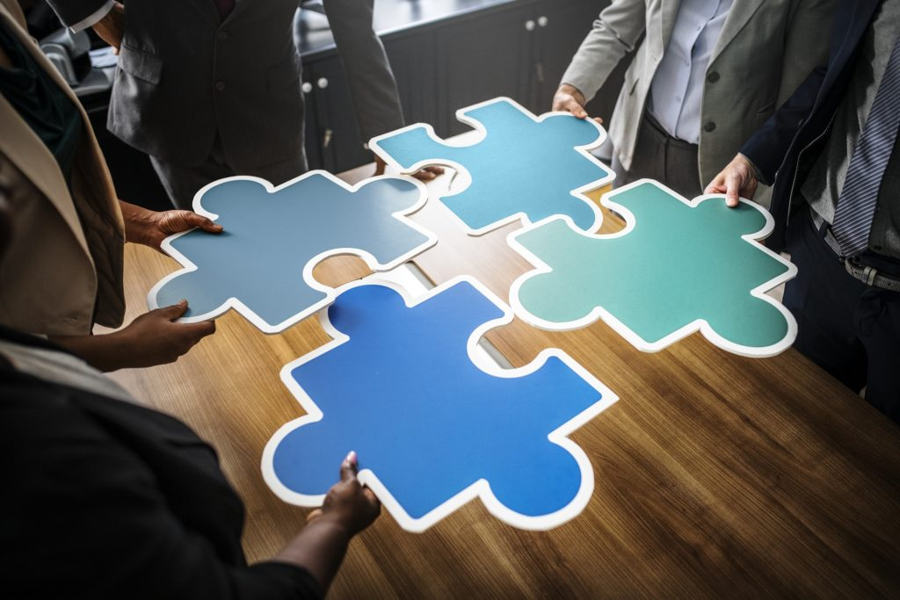
Team ability: An assessment is necessary before building a team on the basis of team members’ abilities. The assessment will provide information on whether the members are good enough or not. After having the result, the manager would take proper steps in order to execute the plan by the members.
Roles: Team roles should be selected by each of the employees and duties can be allocated according to the role. Without differentiating roles for each employee, teamwork would not be suitable and effective. Disbursement of roles can make employees more attentive toward given duties.
Team diversity: Team diversity is an essential part of building an effective team. Having proper skillful and diverse employees for each position is important. If a team consists of diverse people along with multiple skills would make an effective team that can achieve organizational goals.
Team size: Team size is also an important element of effective team building. It takes two to build a team, but how many members can build an effective team. Several types of research show the amount of effective team building members and it is exactly ten members (Aubé and Tremblay 2018). However, the organization and its leader should determine how many people they need to fulfill their requirements.

The impact of effective team-working in the health care settings
Health caregivers who are working as a team can be effective in their respective sections. Nurses who are working collaboratively rather than individually can work precisely without making any mistakes (Clements and Priest 2016). Doctors sometimes make a board which is basically a team consisting of several doctors to take action in order to complete a critical surgery. A critical surgery cannot be done by an individual doctor. Decision-making is not always easy to do and for this reason, doctors make a board which is consists of experts. Health care professionals always work as a team because patients can file a case against them if they do any mistakes when taking care of patients. The term medical error is now widely spread the word is everywhere and people are more conscious of medical error. If nurses do any mistakes that would be harmful to the owner of the hospital. For this reason, heath care providers are more dependent on team working and effective team working can make patients feel better and quick recovery.
There is some common impact of effective team-working in the health care field such as receding medical errors, soaring patient safety, lessening patient mortality rate, increasing job satisfaction, and many more (Mickan 2019). As I already mentioned medical error and patient safety above, it is not important to do it again. However, there are two important elements that need to discuss. Effective team working can ensure patient safety by providing proper care and guidance to the patient. Patients are not aware of taking medicine properly as a result they may get infected. Providing medicine and making an outline for taking medicine would help ensure patient safety. Above all, caregivers can get satisfaction through the service they provide, because it considers a charity.

Barriers of effective teamwork
Barrier of effective teamwork refers to the issues which are causing problems and hampering teamwork (Bennisb 2020). There are some issues that are hampering teamwork and lessening the efficiency. In this section, we are going to figure out what are the issues that hampering teamwork.
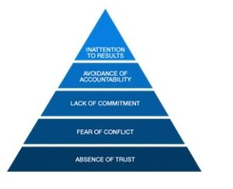
Teamwork is important for every sector of life, especially in the decision-making process. Green field health care home would face some issues when working as a team. Those issues are given below;
Lack of trust: The first issue is a lack of trust in the motive of the group. Team members who are participating in the teamwork must have trust among them. If any of them feels uncomfortable and heavy workload may create a lack of trust. Team members who are not willing to disclose weaknesses may create a lack of trust among them.
Fear of conflict: Lack of trust issue may create conflict among members because no one wants to disclose weakness. If a leader cannot figure out the lack of trust, then there will be a chance of conflict. However, support of less-skilled members can overcome conflict issues and it has to be discussed properly.
Lack of accountability: As a member of the group, every individual should be accountable to the leader of the team. Negligence in providing information to the leader may cause a lack of accountability. The role of each employee must be fulfilled and they have to provide daily basis reports and progress to the leader.
Lack of communication skills: communication is a serious issue that can lead to failure and success in terms of goal achievement. Teamwork is totally dependent on communication and each individual should have the ability to present his own views in the team meeting (Tongue and Forese 2017). If team members are not capable of understanding the discussion then teamwork would not be suitable. So, green field health care home should recruit skilled professionals to build an effective team.

The types of roles that are needed to create a cohesive and effective team
Every organization needs to work through a team which is basically known as teamwork. It is important to build a cohesive and effective team for having better outcomes for the employees. There are many roles that can build a cohesive and effective team and those are presented below;
Create a mission: Creating a mission is the most important thing before selecting members. The mission is something that can be set before establishing a team. Basically, there is a purpose for making a team, but the mission is not as like as purpose. Mission means to have a proper goal to achieve.
Search for diversity: Effective team making must need diversity which means having various skills and experienced people in the team. A diverse group of people can solve any problem easily. Team success is not possible without having diverse people in the team.
Exercising teamwork: It is important to exercise before going to final teamwork. Exercise is necessary and it gives the leader an opportunity to check the work before going to take the final decision. The leader can be checked the efficiency of the work and the possibility of failure at a time. Team exercise will make the leader enable to evaluate the work of each member.
Giving feedback: After completing the given task the leader should give feedback on each individual's submitted work. It makes an employee understand what actually needs to change and develop further. On the other hand, employees also can check their work and give feedback. It will give them the opportunity to figure out their mistakes.
Celebrating success: When the team achieves success and submitted the work successfully then it is time to celebrate. The celebration will bring a positive atmosphere to the workplace and employees get motivation for other projects later. A celebration party should be arranged and appreciation for each employee’s work should be added.

Conclusion
Effective team making is a key to the success of any organization and it is important to have an effective team (Opie 2019). Otherwise, targeted goals cannot be achieved and organizations may face a decline in the market. In this case study, we demonstrated the ways of building an effective team as well as how it can be cohesive. The study also shows many aspects that are related to effective teamwork. The study has been provided in the context of Green field care home company. We also demonstrated how teamwork can be effective in the context of caregiver professionals such as doctors and nurses.

Reference
Cohen, P.R. and Levesque, H.J., 2017. Teamwork. Nous, 25(4), pp.487-512.
Bryant, S.M. and Albring, S.M., 2016. Effective team building: Guidance for accounting educators. Issues in Accounting Education, 21(3), pp.241-265.
Arvey, R.D. and Murphy, K.R., 2015. Performance evaluation in work settings. Annual review of psychology, 49(1), pp.141-168.
Fapohunda, T.M., 2019. Towards effective team building in the workplace. International journal of education and research, 1(4), pp.1-12.
Aubé, C., Rousseau, V. and Tremblay, S., 2018. Team size and quality of group experience: The more the merrier?. Group Dynamics: Theory, Research, and Practice, 15(4), p.357.
Clements, D., Dault, M. and Priest, A., 2016. Effective teamwork in healthcare: research and reality. HealthcarePapers, 7, pp.26-34.
Mickan, S.M., 2019. Evaluating the effectiveness of health care teams. Australian Health Review, 29(2), pp.211-217.
Bennis, W.G., 2020. Some barriers to teamwork in social research. Social Problems, 3(4), pp.223-235.
Tongue, J.R., Epps, H.R. and Forese, L.L., 2017. Communication skills. Instructional course lectures, 54, pp.3-9.
Opie, A., 2019. Effective team work in health care: a review of issues discussed in recent research literature. Health Care Analysis, 5(1), pp.62-70.

