Introduction to Web & Database Concepts
Declan Shipley
2303938
Introduction to Web & Database Concepts
Developing an MS Access Database for Coastal Tourism Management


Contents
Who Would Use the DBMS? 2
Coastal Getaways Departments Who Require Access to the CTMS 2
Entity Relationship Diagram 3
Relational Database Schema 4
Application of Database Management System 5
Design & Creation of the Reports 6
Revenue Report 6
Feedback Report 7
Design & Creation of the Forms, User Interface & Menus 8
Reservation Form 8
User Menu for the Database 8
The Importance of Databases in Coastal Tourism 10
Challenges & Benefits of a Digital Data Management System 10
References 11
Table of Figures 13

Who Would Use the DBMS?
There are several different people who will use the DBMS, and all for differing reasons and uses. People who would use the DBMS are:
- Tourists
- Local Businesses
- Database Administrators
- Coastal Getaways Employees
Therefore, it’s imperative that the DBMS is suited for all of these people to use accordingly and efficiently, whilst remaining professional-looking and user friendly. The tourist’s and local businesses must be able to browse for coastal-holidays and holiday-packages, whilst being able to filter through depending on their choices, as well as included forms for reviews and feedback, and as discussed on this website [1], is extremely important when searching for important or relevant data. The database must have an administrator, as they “make systems more responsive for the end user, and thus increase productivity [2]. These administrators must be able to moderate and control the DBMS seamlessly and efficiently, editing data, forms, tables and more, without damaging the integrity and functionality of the database as a whole.

Coastal Getaways Departments Who Require Access to the CTMS
The CTMS is the system which will again be used by people mentioned prior but will serve a different purpose, which is to allow users to register, explore packages, view detailed itineraries, view prices and much more. As discussed, there are multiple people who will use this CTMS, so its important that all of them can comfortably use the CTMS for their own purpose, meaning it must be user friendly, the importance of which is discussed in this article [3]. Within Coastal Getaways, there are multiple departments that would use this system, such as the sales team, to discuss with potential customers and guide them through the booking process. The accounting department will also use the system, as they will need to take payments and reservations, and then create more in depth reports from the reports and data contained within the database, which is a big benefit of databases [4] and finally the database administrator will also use this system, in order to check functionality and integrity according to the information on the DBMS.

Entity Relationship Diagram

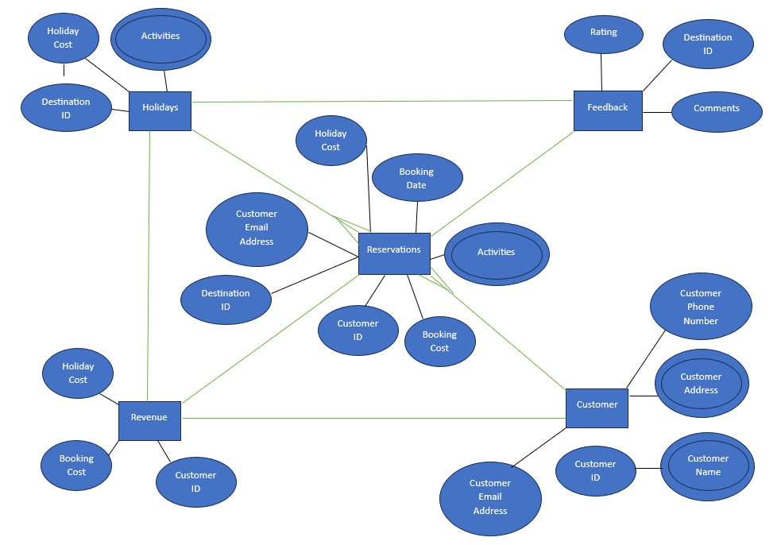
Figure 1: Entity Relationship Diagram
This is an Entity Relationship Diagram, which diagrams the relationships between the entities that will be contained within the DBMS and is a necessity when conceptually modelling the database [5]. Here we can see that every other entity connects to the “Reservation” entity, and the “Holidays” & “Customer” entities have a “One-to-Many” relationship with it, meaning that multiple attributes within these entities are also contained within the “Reservations” table, this is known as the cardinality, which “helps in query optimization” [6]. Also, attributes shown such as “Customer Address” are known as a “Multi-Valued Attribute”, so they can have more than one value input. These entities will eventually become tables within the DBMS, and their attributes become fields within the tables.

Relational Database Schema
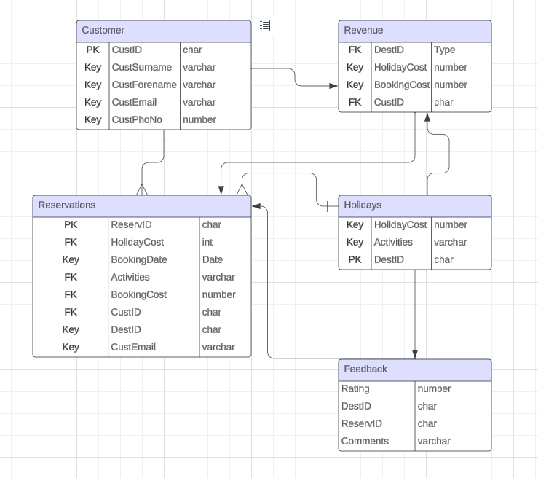
Figure 2: Relation Database Schema
This is the Relational Database Schema, and it’s essentially an advanced view of the ERD, and has many advantages over an ERD, as discussed here [7]. It shows the entities and their respective attributes in a more detailed manner. This schematic is a far superior and accessible representation of the tables and their fields, and it also details the data type of the fields, and which fields are primary/foreign keys. Again, this is an important stage in creating a database, as it allows you to plan the tables and fields ahead of time, potentially adding in missed fields, or allowing you to expect hurdles and plan accordingly, which the importance of is discussed here [8].

Application of Database Management System
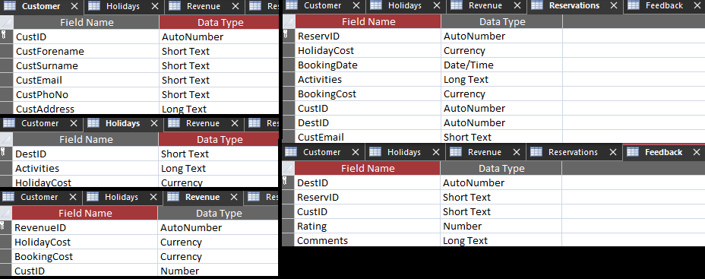
Figure 3: Design View of Tables within the Database
The image above shows all of the tables and fields that were incorporated into the DBMS, and as shown, they have not changed since the database schematic diagram, and as detailed here [9], is critical in creating a consistent and familiar DBMS. Also shown here are all of the data types for all fields, and each has been chosen in order to provide functionality, accessibility, and validation within the DBMS, and it important to structure both the data types and data correctly, as discussed in this book [10], ensuring it runs as smoothly as possible. Finally, this image shows which fields are primary keys, represented by symbols shown in the column to the left of the field names, which allows the tables to be interlinked and perform complex functions within the forms, allowing for easier querying [11] and macros to be made, making the DBSM more user friendly and accessible.

Design & Creation of the Reports

Revenue Report

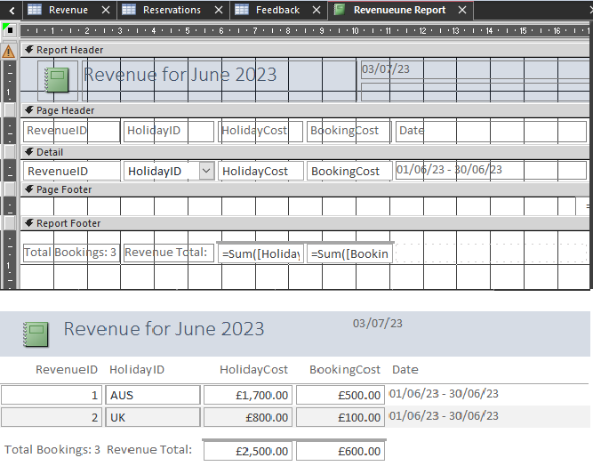
Figure 4: Design and Report View of Revenue Report
The above images show two different views of the “Revenue” report, these being the report view and the design view. The design view allows a user to edit the layout, add features such as buttons or labels, and format the existing ones, making it more eye-catching. The report view is also shown, which is what most users of the DBMS will see, as general users should not be able to edit the layout or design of the database, only add, edit, browse, or delete records. The record shows the total revenue made by the company for the month of June, as shown in the image above, this was done by using a calculation within the program, to make a sum from “HolidayCost” and “BookingCost”, and then displayed both of these values below. It’s important that the report gives detailed information, as discussed on this website [12], as there could be important business or financial decisions based off the report created.

Feedback Report
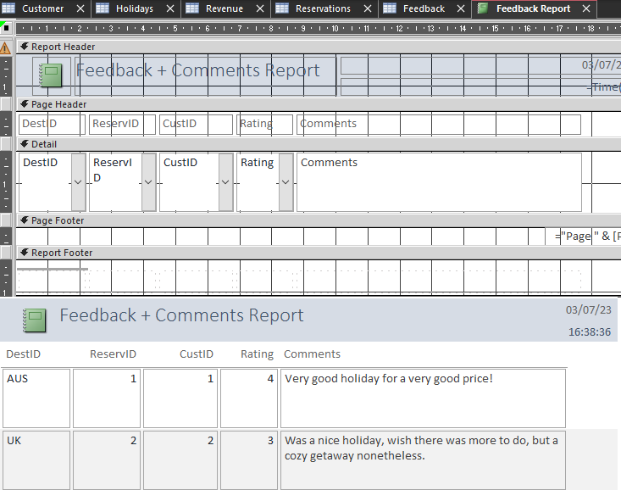
Figure 5: Design and Report View of Feedback Report
Again, the above image shows both views of the report, but this time relates to feedback left by customers, detailing their holiday experiences. As shown, there were 2 reviews and rating left by customers, which will allow the team at Coastal Getaways to learn and improve their holiday experiences and packages, hopefully leading to more revenue in the future. Again, the design layout is shown, and each box has the correct format, validating what the user inputs whilst they’re filling out the form, meaning for valid data which can be trusted. The importance of formatting correctly is discussed in this article [13].

Design & Creation of the Forms, User Interface & Menus

Reservation Form
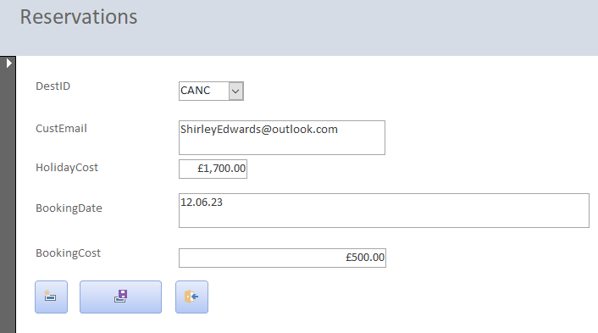
Figure 6: Reservation Form
Here, a completed reservation form is shown, detailing where the customer wants to go, how much it will cost and when they are going. This is a very simple form, and as such, doesn’t need to be very extravagant. The buttons at the bottom all have a purpose also, which are:
- The first button is a “New Entry” button, which allows a user to open a blank version of this form, which they can then fill out.
- The second button is a save button for the form, which will then add the input data into the appropriate table within the DBMS, which in this specific scenario is the “Reservations” table.
- The last is simply a button to close the form, it doesn’t save the form before closing, so both buttons have to be used in conjunction in order to effectively save and exit the form.
It should be noted that the form is incredibly simple, and as discussed in this book [14], provides more functionality within the database and forms, as its easier for a user to understand and use.

User Menu for the Database

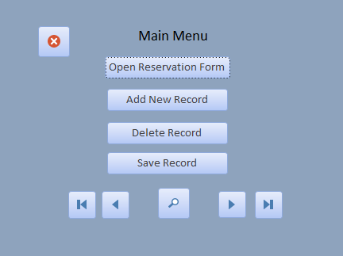
Figure 7: Database Main Menu
Finally, this is the main menu for the CTMS in order give users an idea of what they want to do, represented in a simple manner. These buttons each perform a function, relative to what a normal user should be able to do within the CTMS. These are very simple functions, such as:
- Open Reservation Form.
- Add New Record.
- Delete Record.
- Save Record.
- Browse Records.
- Search for Records.
The user will be greeted with this menu as soon as they open the database file, which will speed up record-browsing and make it, so they are less confused on where to go, and allow them to navigate the database more easily and comfortably, as discussed in this article [15].

The Importance of Databases in Coastal Tourism
The creation of a database is of an utmost importance to any person(s) or business, as discussed in this article [16]. This remains true if they’re interested in browsing or marketing holiday packages related to a coastal environment, for many reasons. The major advantage to this is that all holiday packages will be in a central location, allowing for easy access to a plethora of packages. A database makes sorting through and filtering massive amounts of data extremely efficient, as a user can just input keywords, or check boxes to filter the information, making the customer experience smooth and efficient.

Challenges & Benefits of a Digital Data Management System
When it comes to transitioning from a manual to digital data management system, there are many obstacles and challenges that can present themselves during the process, as discussed in this article [17], challenges detailed here include:
- Training staff to use the database safely.
- Data Integrity being maintained.
- Creating the database.
- Making the user database user-friendly.
These challenges can be easily overcome in a number of ways, the first is by getting a trained professional to create the database, and proficient training being provided to staff, and this ensures that the database is a good standard, and all data within is maintained in valid. The benefits of creating and maintaining a digital data management system are that data entry, editing, removal and queries are sped up dramatically, meaning for quicker sales or browsing by the customer, which means more revenue for Coastal Tourism.

References

[1] | QuestionPro, “Data Filtering: What It Is, Uses, Benefits and Example,” QuestionPro, 27 November 2023. [Online]. Available: https://www.questionpro.com/blog/data-filtering/. [Accessed 6 January 2024].
[2] | LinkedIn, “The Importance of Database Administration,” LinkedIn, [Online]. Available: https://www.linkedin.com/pulse/importance-database-administration-greg-woodard#:~:text=A%20database%20administrator%20can%20analyze,user%20and%20thus%20increase%20productivity.. [Accessed 6 Jan 2024].
[3] | P. Darbyshire, “User-friendliness of computerized information systems,” Computers in nursing, vol. 18, no. 2, pp. 93-99, 200.
[4] | T. R. Weirich, C. Natalie Tatiana and T. C. Pearson, “AssuranceAuditing Researcg,” in Accounting and Auditing Research and Databases: Practitioner's Desk Reference, Hoboken, John Wiley & Sons, 2012, pp. 215-241.
[5] | B. Sikha and E. Richard, Database Design Using Entity-Relationship Diagrams, CRC Press, 2003.
[6] | K. Gurusharan, Elements and Digitization of Computer, New Delhi: Educreation Publishing, 2019.
[7] | T. Halpin, “Relational Mapping,” in Information Modeling and Relational Databases: From Conceptual Analysis to Logical Design, Morgan Kaufmann, 2001, pp. 405-457.
[8] | R. Rossouw, “King III Integrated Report - Why It's Crucial to Plan Ahead,” Keeping Good Companies, vol. 62, no. 9, pp. 537-538, 2010.
[9] | H. Oakasha, S. Conrad and G. Saake, “Consistency management in object-oriented databases,” Concurrency and Computation: Practice and Experience, vol. 13, no. 11, pp. 955-985, 2001.
[10] | M. J. Johannes, Data Types and Data Structures, Prentice hall International (UK) Ltd., 1986.
[11] | C. Marco, C. Marco and P. Andreas, “Counting Database Repairs under Primary Keys Revisited,” Proceedings of the 38th ACM SIGMOD-SIGACT-SIGAI Symposium on Principles of Database Systems, vol. 19, no. Counting Database Repairs under Primary Keys Revisited, pp. 104-118, 2019.
[12] | H. M. Dess, “Database Reviews and Reports,” 2006. [Online]. Available: http://www.istl.org/06-winter/databases4.html?ref=SexŞhop.Com. [Accessed 2024 Jan 6].
[13] | K. Tin Htet, Formatting and searching a massive, multi-parameter clinical information database, Massachusetts Institute of Technology, 2005.
[14] | P. Mollerup, Simplicity: a matter of design, BIS Publishers, 2015.
[15] | J. Macgregor, E. Lee and N. Lam, “Optimizing the Structure of Database Menu Indexes: A Decision Model of Menu Search,” Human Factors: The Journal of the Human Factors and Ergonomics Society, vol. 28, no. 4, pp. 387-399, 2019.
[16] | D. Barbar, “Mobile Computing and Databases-A Survey,” IEEE Transactions on Knowledge and Data Engineering, vol. 11, no. 1, pp. 108-117, 2007.
[17] | “Cooper, Joshua; James, Anne,” Challenges for Database Management in the Internet of Things, vol. 26, no. 5, pp. 320-329, 2009.

Table of Figures
Figure 1: Entity Relationship Diagram 3
Figure 2: Relation Database Schema 4
Figure 3: Design View of Tables within the Database 5
Figure 4: Design and Report View of Revenue Report 6
Figure 5: Design and Report View of Feedback Report 7
Figure 6: Reservation Form 8
Figure 7: Database Main Menu 9

