ONLINE PORTFOLIO OF SET EXERCISES

NAME: Nabila Noreen
STUDENT ID: 2425430
PROGRAMME: BSc Health and Social Care
MODULE: Changemakers: Building your Personal Brand for Sustainable Employment
MODULE CODE: BMHP5015

TASK 1
Personal Brand
Healthcare Management Professional (Aspirant Health Service Amanager)
Introduction
A personal brand is the intentional professional image and/or message a person can share with employers. Creating a brand in the health and wellness industry is important as it sends a message of key competencies, clinical commitment, and leadership to potential healthcare organizations in a competitive environment.
​Body
​My current self is someone who is professional, reliable, and caring for people who work in the healthcare administration. In fact, many people consider me efficient, I am always looking for solutions and are always cool during emergencies. Effective Communication and Inter professional working to ensure optimum patient pathways. But at the same time I realize that my brand needs polishing with regard to strategic health informatics and cutting edge digital leadership. To help fill this void, I will pursue certified healthcare data analytics training and look to work with more experienced hospital administrators for mentorship. I will be able to make a difference in my dream job as a clinical operations manager by making a patient-centric innovation in the healthcare industry through this.
Conclusion
​After all, its all about building my personal brand to help bridge the gap between what I am good at, and what I want to be in the future. Continued professional development will help me to reach a high level of excellence as a visionary leader in healthcare ready to transform the delivery of healthcare services.
​References
​Pawar, A. and Gandhi, R. (2016) ‘The Power of Personal Branding’, International Journal of Engineering and Management Research, 6(1), pp. 840–847. Available at: https://www.researchgate.net/publication/339956223_The_Power_of_Personal_Branding (Accessed: 1 October 2026).
​Temporal, P. (2019) Advanced Brand Management. London: Herman House Limited. Available at: https://www.perlego.com/book/1384725/advanced-brand-management-3rd-edition-building-and-activating-a-powerful-brand-strategy-pdf (Accessed: 2 October 2026).

TASK 2
Network Maps
Early-Career Business Graduate
Network Map
Career Network
Hospital Administrators, Senior Clinical Coordinators, Healthcare Data Analytics Mentor

Social Network
- University Peers
- Close Friends
My Professional Self
(Healthcare Management Student)

Support Network
- Immediate Family
- Close roommates

Community Network
- Local Wellness Centre Volunteers
- Neighbourhood Charity Groups

Rationale
In my professional and personal relationships, I have a hybrid network. This structure provides close, reliable personal and selective professional relationships that are engaged to actively inform my career trajectory in healthcare management.
I wield my social capital in the form of bonding capital because during some high stress periods of my academic career my family and close friends were very supportive of me (Putnam, 2000). However, there is one significant issue – lack of linking funds. There aren’t strong direct links with people in structural power, such as hospital directors, senior health care executives, etc., in my network, as my network is primarily peers and very few my family. Furthermore, the bridging capital needs to be expanded intentionally and strategically, to bring me closer to professionals from the other disciplines of health that are relevant to digital health, such as digital health innovators and clinical informatics specialists.
I will seek out and attend healthcare leadership conferences in my area, join healthcare leaders in LinkedIn groups, and attend hospital administrative committees. This vertical and horizontal connection will get firmed up and increase my professional visibility, give me strategic inputs and institutional decision makers. In conclusion, building professional relationships outside of my comfort zone is key to propelling me forward in my career as a hospital operations manager.
References
Burt, R.S. (2005) Brokerage and Closure: An Introduction to Social Capital. Oxford: Oxford University Press. Available at: https://share.google/y5vPnMYx4krXojTzg (Accessed: 4 October 2026)
Putnam, R.D. (2000) Bowling alone: the collapse and revival of American community. New York: Simon & Schuster. Available at: https://www.researchgate.net/publication/397472219_Functions_of_social_capital-bonding_bridging_linking (Accessed: 3 October 2026).

Task 3
Healthcare Management Professional Blog
Target Audience: Hospital Administrators and Clinical Operations Teams
Title: Streamlining Patient Flow: Why operational efficiency matters in modern hospitals.
Introduction
Being a healthcare management training, I’ve seen the effect of hospital clogs on patient outcomes and Staff morale. With the increasing demand for healthcare services that often exceeds the resources of the medical institutions, optimizing patient flow has become an essential need for modern healthcare institutions.
Main Body
Patient Flow is the whole phenomenon of patients’ flow of care from hospital entrance – through admission – to safe discharge planning. Consequently, emergency departments are overcrowded, elective surgeries delayed and clinical staff face extreme burnouts when there are blockages. Studies in the healthcare sector conducted in recent years have revealed that the use of intelligent bed management and real time data forecasting can lead to as much as a 25% decrease in waiting times of patients in addition to reducing pressure on frontline staff (The King’s Fund, 2026).
To attain this sort of efficiency, hospital administration must shed its reactionary attitude to worry handling and begin to view the management of the concern in a facts-based way. Rather than, however, encouraging cross-disciplinary training programs, encouraging administrative coordinators, and introducing real time tracking software to the day-to-day workflows. If clinical and administrative teams can operate seamlessly and in synergy the usage of beds in a hospital can be optimized, and the overall provision of services can be improved.
Conclusion
In the final outcome, effective patient flow makes hospitals a safer and more responsive environment for all. My vision as future healthcare managers is to lead the way with structural changes to keep our employees safe and ensure the safety and care of our patients. Let’s work together to create better and more resilient health systems now.

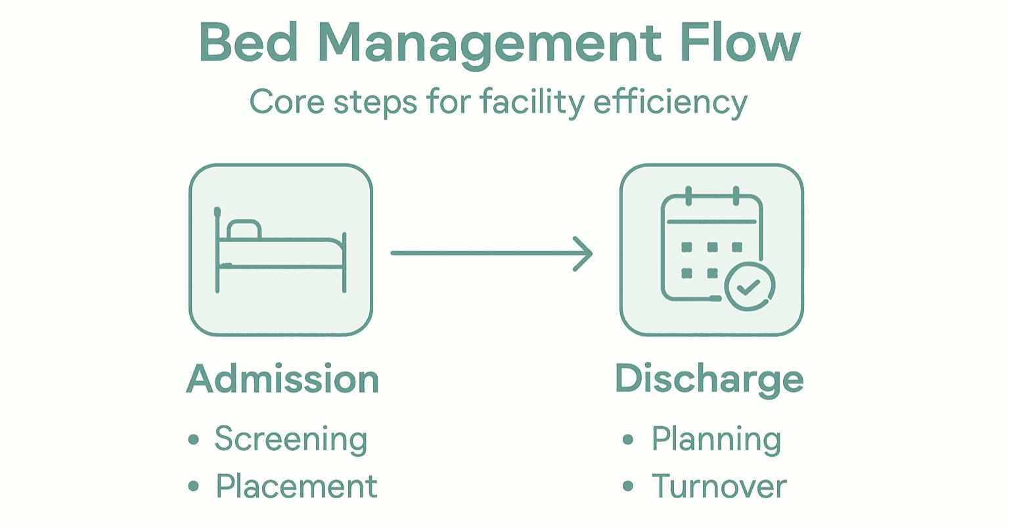
References
The King’s Fund (2026) Digital Health and AI Conference 2026: What’s real, what’s next and what’s at stake. Available at: https://www.kingsfund.org.uk/events/digital-health-ai-conference-2026 (Accessed: 5 October 2026).
​The King’s Fund (2026) Health And Care Explained 2026: Online Event. Available at: https://www.kingsfund.org.uk/events/health-care-explained-2026-conference (Accessed: 8 October 2026).

Task 4
NHS Equality, Diversity and Inclusion Plan Document
- What is the primary goal of the NHS Equality, Diversity, and Inclusion Improvement Plan?
The plan is designed to tackle discrimination, boost leadership accountability and improve the overall sense of belonging for NHS staff.
- How does the NHS EDI Improvement Plan propose to tackle the gender pay gap?
It proposes monitoring intersectionality in future pay gap reports and embedding inclusive practices and transparency into workforce policies.
- What is meant by the term ‘intersectionality’ as used in the NHS EDI Improvement Plan?
It means understanding that different protected characteristics interact and exacerbate the barriers and inequalities faced by people.
- Why is it important for the NHS to create a psychologically safe work environment?
It makes employees feel safe to raise concerns, speak up without worry of reprisal, and innovate, or learn from mistake.
- How does the NHS EDI Improvement Plan suggest improving the experience of internationally recruited staff?
By proactively supporting international staff to access training, career progression, and personal development plans through line manager.
- What role does leadership play in advancing EDI objectives according to the NHS Improvement Plan?
Leaders are responsible for inclusive practice, audit of organisation information, and modelling compassionate behaviour.
- Identify one way the NHS EDI Improvement Plan aims to reduce health inequalities within the workforce.
By tackling shared factors that affect the health, attendance and turnover of employees with certain protected characteristics.
- Why does the NHS EDI Improvement Plan emphasise the importance of collecting and analysing data on protected characteristics?
Identify areas for concern, prioritise actions and monitor staff experience on an annual basis.
- Explain how flexible working policies can contribute to equality and inclusion in the NHS workforce.
They support staff with caring responsibilities or returning from parental leave, to retain diverse talent and promote work-life balance.
- What is one strategy mentioned in the NHS EDI Improvement Plan to combat bullying and harassment in the workplace?
To have clear reduction targets, disciplinary data by protected characteristics looked at and full psychological support given to victims.

Task 5
Letter to Self

Dear Younger Me,
I know that you are sitting at your desk right now, feeling overwhelmed with the pressure of studying at university, and at the same time, you are taking delivery shifts. I do recall all the weight on your chest when you had a significant drop in your GPA and wondered at your abilities. You were feeling all alone and doubting whether you are fit to become a healthcare leader.
If you could look back, you would realize that you lacked in emotional intelligence and resiliency which did not stem from your lack of intelligence or work ethic. These were tough months and you took every failure as your own fault, rather than seeing them as learning moments. But if you were emotionally aware, you would have realized that physical and mental exhaustion isn’t necessarily a measure of productivity.
You would have learned how to deal with and overcome academic failure while still maintaining your composure and concentration – instead of falling into a downward spiral of failing to remember they were for accountability. Your boundaries will be pushed as a healthcare manager every day with the pressure from coordinating operations and making crucial decisions. Developing resilience can help you manage your stress levels, understand those of others, cooperate with multiple disciplines and manage the delays in a hospital setting like any other.
Please don’t be so hard on yourself. Know that during rough times, one’s future goals can come and go. You will develop emotional agility and the ability to adapt when it comes pressure, which will enable you to run hospital operations with confidence. “Trust the process”, don’t underestimate yourself, reach out for help during difficult times.
Through connection and trust forever,
​Your Future Self

Task 6
Gantt Chart
PAST 18 MONTHS (JAN 2025 – AUG 2026) — LEVEL 4/5 COURSEWORK & EARLY
CAREER
Emphasizing basic academic units, statutory compliance and Health Care Skills development.
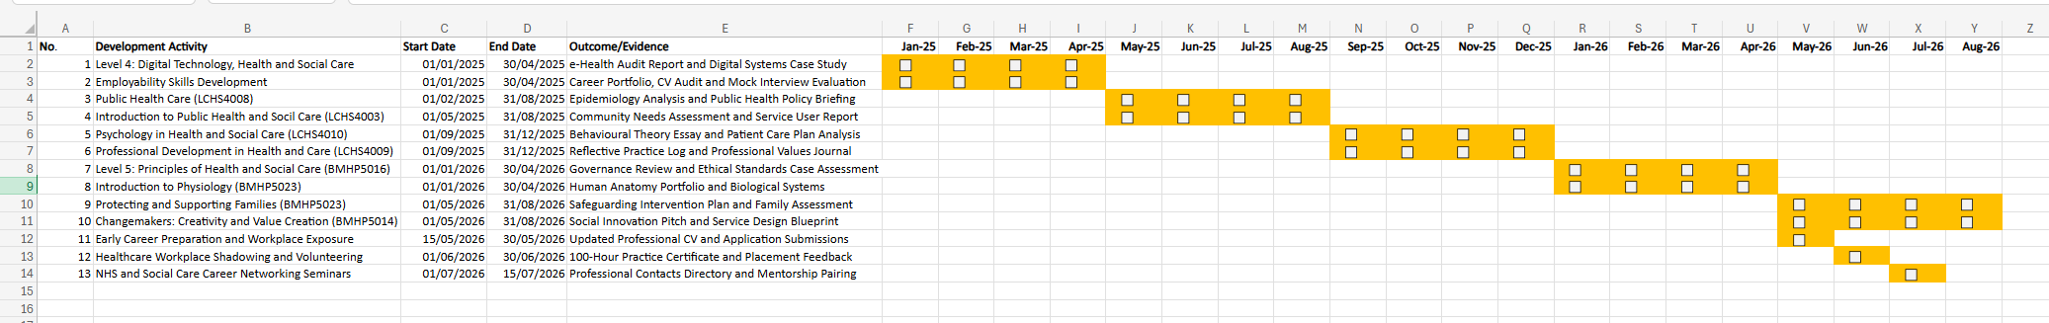

Task 7
Healthcare Management Professional Report
Focus: Implementing Digital Care Planning Software in a Residential Care Home
Introduction
As the manager of a residential care home in Birmingham, West Midlands, I am looking to move from paper care records to a digital care planning software system. This modernization is necessary to raise the level of our care and to comply with regulation.
Planning the Change
Guided by Lewin’s Change Theory, our implementation plan moves through unfreezing, moving, and refreezing stages. We will unfreeze existing practices by showing how paper files form dangerous information silos. We will rollout user-friendly digital care tablets during the moving phase involving senior nurses, care assistants and admin staff for our care home in West Midlands. Lastly, we will refreeze, by embedding digital record-keeping into day-to-day routines. This change helps us tackle important compliance issues, keep our documentation current as we go down to the patient level and furthers our goal of becoming a high performing, CQC rated Outstanding facility.
Skills required
To do this, I need to ensure that I am a good transformational leader to build confidence, communicate well to understand technological advantages, and have good time management. Also, it will be essential to have active conflict management skills to handle staff fears and technical issues during the initial rollout phase within the care home team.
Barriers and Solutions
Staff resistance (digital anxiety) and technical disruptions are potential barriers. To overcome staff resistance, we will actively involve care workers in selecting the software and provide comprehensive, hands-on training sessions (Log My Care, 2025). We will plan supernumerary shifts and match staff who are tech-savvy with reluctant learners as a peer mentor to help deal with time constraints while implementing. Additionally, communication pathways will sustain all team members during the transition process and reduce frustration and provide for continuous resident care delivery at high standards.
Conclusion
Digital care planning will transform our working practices and improve the safety of our residents. This will help ensure long-term clinical excellence in our West Midlands care home through collaborative engagement and strong leadership.

References
Log My Care (2025) What is digital care planning? Benefits, tools, and best practices. Available at: https://www.logmycare.co.uk/blog/what-is-digital-care-planning-benefits-tools-and-best-practices/ (Accessed: 15 October 2026).
​Unique Senior Care (2026) The state of care in the West Midlands. Available at: https://www.uniquecare.co.uk/live-in-care/west-midlands/state-of-care/ (Accessed: 19 October 2026).

