
Assignment 1
Marketing fundamentals

Lina Abu Tair
ID: 1904528

YMCA Support young people

YMCA is one of the best – established youth charities in the word and is there to help and assist youths in all aspects of their lives. The main aim of the charity is to give young people a sense of empowerment that will help them develop and grow in whichever situation they may find themselves in. The charity provides its services to almost 72,000 young people on a yearly basis and provides support and advice, food banks, sexual health advice as well as drug and alcohol
advice and counselling.

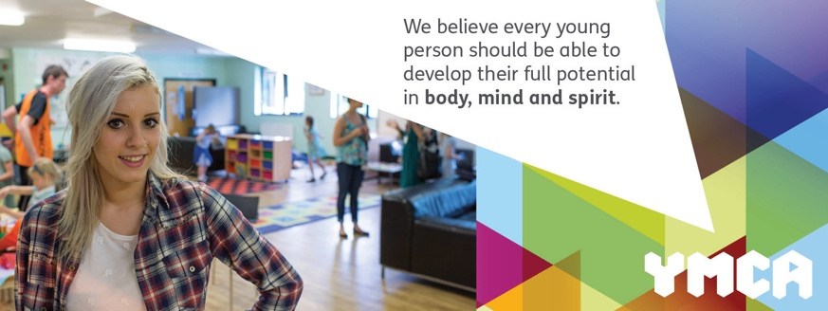
Furthermore, the YMCA offers professional counselling session online (via zoom) or in- person at various locations which can be organized via phone or email. Counselling sessions are also available via telephone.

Many find these sessions helpful to explore their feelings in an environment that is safe and confidential. The YMCA provides counselling for a variety of issues such as anxiety, depression, bereavement and abuse etc. Counselling is available to all ages, regardless of gender, physical ability, sexual orientation or religion. The support provided by the YMCA can open doors to many opportunities such as training, work placements or volunteer opportunities.
For more information, visit www.ymca.org.uk. You can find your nearest YMCA here.
Get involved by supporting the charity via this link.
Contact us by email enquiries@ymca.org.uk.
Telephone: 02071869500.
You can follow us on social medias on Instagram @YMCAEngland_Wales/linktree.
Facebook: YMCAEnglandWales. Twitter: YMCA England & Wales. YouTube channel: YMCA England & Wales.

The Government Support Young People with YMCA

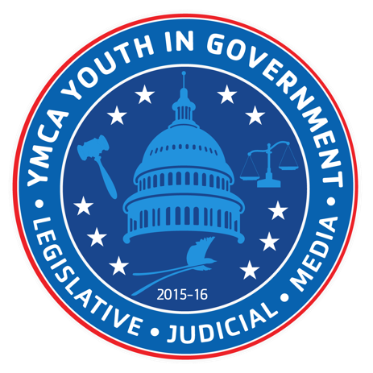
At the YMCA, one of their fundamental goals is to help young people achieve their potential and give them the confidence to make their own life decisions. The charity focuses on sport and physical activities to encourage socializing with like – minded people so it can lead to attaining strong and healthy relationships. Through government funding, there is an even bigger focus on educating young people and enhancing their practical skills to qualify and integrate them into the workforce. The government recognizes that 40% of children’s attainment outcomes becomes evident by the age of five and so it takes responsibility for providing early years provisions, ensuring the future employment of young individuals in the field of work.
This is especially important in our current society where young people are struggling and are in constant battle with increasing private rent, particularly in Wes and South London, despite their status of employment. This often makes it difficult for young people to move on from YMCA hostel accommodations which are offered to individuals aged between 16 – 25 that are already in employment or educations.

The YMCA welcomes and encourages government funding to help young people from all walks of life, ensuring that working families, those on low incomes, and young people experiencing homelessness rebuild their lives, live independently, and build their skills so they can make a career for themselves. Overall, the YMCA’s objective is to encourage positivity in young people’s lives and help them to stand ready and support them in order for them to achieve brighter and better futures.

Seek out, speak out and inspire. Securing the futures of the youths of today.

Contact us:





