Andrew Davies (2213112)
2213112@student.uwtsd.ac.uk
Computer Architecture & Operating Systems

Table of Contents
Introduction 2
Use of Windows OS CLI commands 4
Linux CLI Commands 10
Window OS Scripts 11
Use of Linux Scripts 15
Conclusion 18
Appendix 18
Tutorial 1 Activity 18
Certified Course Engagement 19
Bibliography 20

Introduction
This report focuses on the fundamental roles of an operating system. It begins by explaining what an operating system is and some of its key functionalities. We then proceed to demonstrate the practical use of Windows and Linux CLI commands, as well as how to execute scripts, that showcases the interaction between the end user and the computer hardware, in both Windows and Linux environments. We’ll begin by discussing the fundamental roles of an Operating System.
A general-purpose Operating System is the foundation of how any computer functions. It manages the interaction between software and hardware which allows applications to run, which in turn allows the end-user to facilitate tasks, perform a wide range of operations and process data [1]. There are a few different operating systems, with the most popular being Windows, MacOS and Linux. Stallings describes the Operating System as having two main objectives: the first being, as a means of convenience for the user [2]. Computers are highly complex machines, and the Operating System is used to minimise this complexity for the end user by providing them with a user-friendly interface via various applications, which allows them to successfully operate the computer [2]. The second main objective Stalling described Operating Systems as having is efficiency [2]. A computer is built from a set of resources that is used to store, move, and process data [2]. To manage these resources, an Operating System uses several different functions. Below, we will provide a brief overview of these functions and how they contribute to a computer’s efficiency and functionality.
From an end-user perspective, one of the most important aspects of an operating system is to provide the user with the means of easily executing commands [1]. The Operating System provides an interface to do this, either by means of a Graphical User Interface (GUI) or a command line tool, which then interacts with the system’s kernel, to perform tasks [1]. The screenshot below shows the PowerShell command line interpreter, which allows the users to run custom scripts that interacts with the Operating System’s underlying components [3]
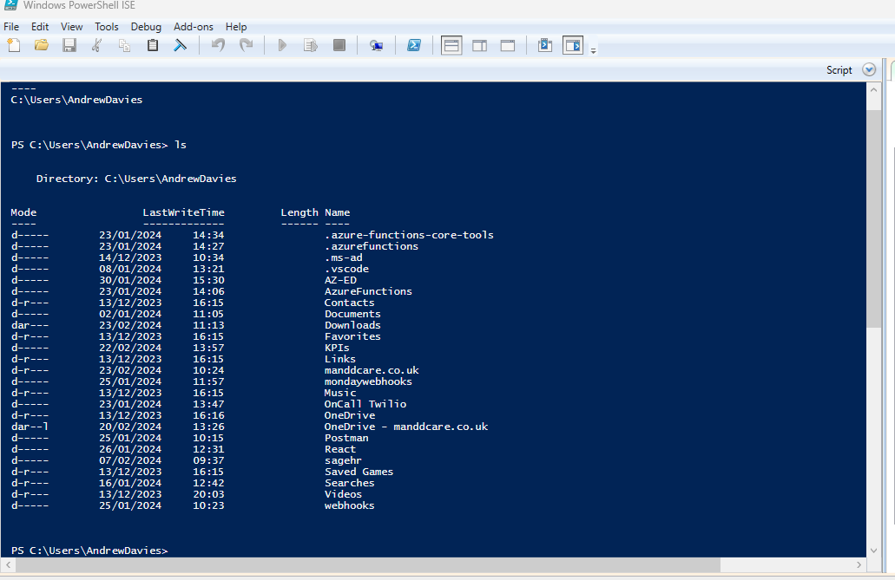

A computer’s central processing unit (CPU) is designed to receive and execute instructions from a computer program. An Operating System ensures that the CPU processes and distributes these instructions as efficiently as possible [1]. It does this through several different functions, for example, CPU scheduling is a scheduling algorithm designed to distribute the CPU’s resources [2]. This involves allocating CPU time to different processes in a way that doesn’t over-strain the CPU [2]. The below screenshot shows the CPU usage. This tool helps users identify which processes are consuming significant amounts of CPU time. The user can then close any unnecessary programs, which should in theory improve the CPU’s performance.

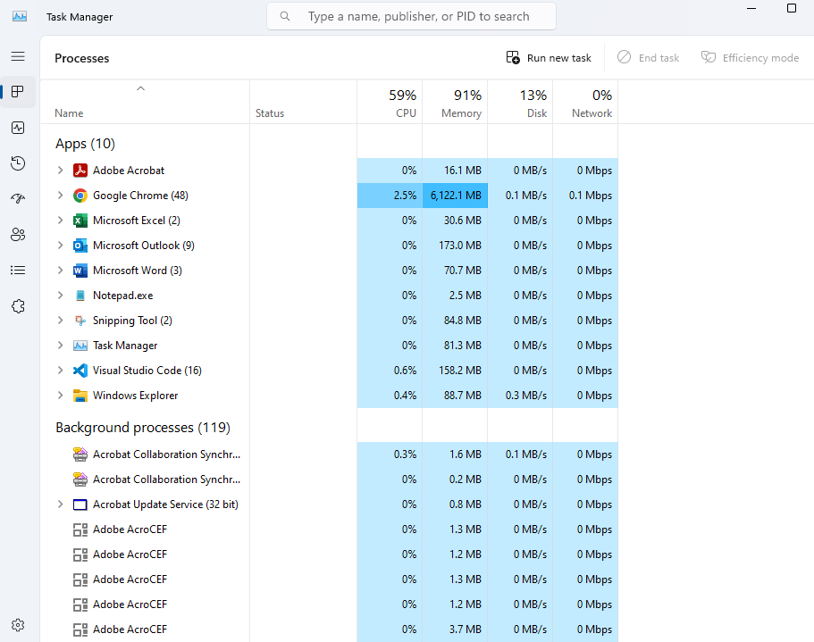
In addition to managing the CPU and providing a nice user interface, an Operating System also oversees storage management [4]. This involves providing a directory structure for each file on the system and a means of managing and moving these files [1]. It also provides a security layer for managing read and write access for these files. The screenshot below shows the security layer for a folder. It gives details of which groups and users can access the file and the level of control granted:

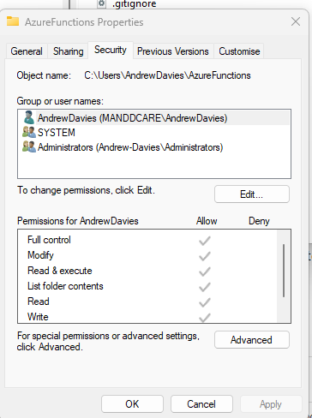
Above, we discussed some of the key functionalities of an Operating System. Collectively, they ensure that the software and the hardware can work together effectively. The key functions aren’t limited to what was discussed above, the Operating System also manages the memory of a device ensuring that applications have sufficient resources to run, handles input and output devices by providing drivers and interfaces for user interaction and co-ordinates network connections [1].

Use of Windows OS CLI commands
As briefly mentioned in the overview above, file system management is a key function and one of the most visible aspects of the Operating System [1]. An Operating System uses a file system method to structure and organise its data into files and directories [1]. In terms of retrieving and managing data, with regards to the end user, they can use a graphical user interface, which provides a visual representation of the directory structure, or a command line tool where the end-user can type in commands to traverse the directory tree. Below, we will look at some of the most common Windows OS CLI commands.
Dir
The command ‘dir’ prints a list of all subdirectories and files within the current directory [5]. In the example below, ‘dir’ is called inside the user directory, which in turn, prints out all the files and subdirectories located within user:
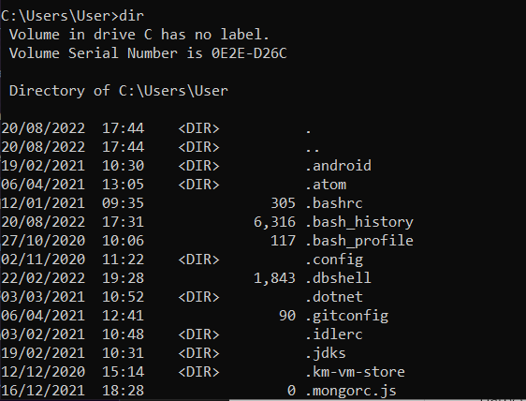

Dir /od
The above command is a switch variation of the directory command. The forward slash, followed by the letters ‘od’ (order & date), sorts the directory, in ascending order, by the date they were last modified [6], as seen in the example below:
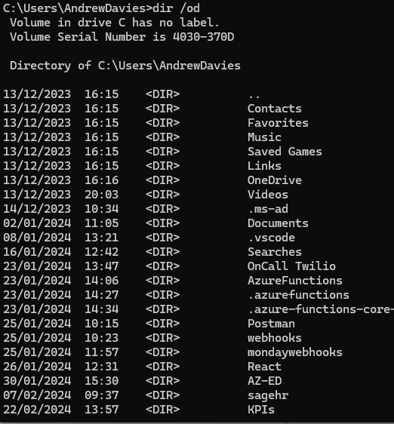

Dir/oe
Again, Dir/oe is a switch variation of the Dir command. It sorts the directories in alphabetical order based on their extension [7]. Any files that don’t have an extension will come first (in alphabetical order), followed by files that do have extensions. See example below:
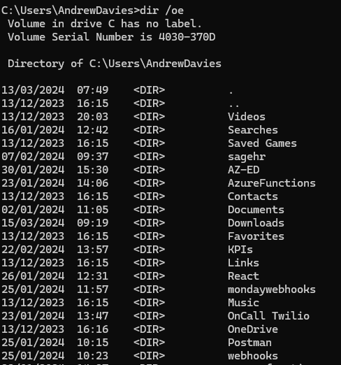
CD
The command cd followed by a directory name, changes the directory to the one specified in the command. The name provided in the command can be a relative path or an absolute path. A relative path allows the user to move to a directory relative to the current directory (i.e to a subdirectory or to move up a directory). An absolute path (i.e. the full path to the directory) allows the user to move to a directory that isn’t on the same level as the current directory [7].
In the example below, we use a relative path to change directory into the ‘test’ directory.
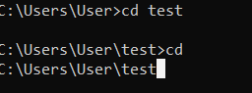
Mkdir
The mkdir command followed by a name, allows the user to create a new directory.
In the example below, we create a directory called ‘project’. When a ‘mkdir’ command is called, the new directory gets created as a subdirectory of the current path [8]. If we want to create it in a different location, we’d have to specify the absolute path.
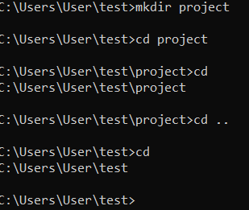

Tasklist
Tasklist command shows a list of all tasks that are currently running on the computer [9]:
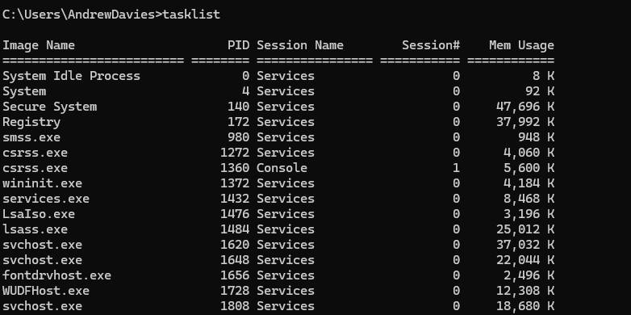

findstr /n /i "string" *.js
The above command uses multiple switches and the findstr command to search for a string pattern within all files within the current directory that has the .’js’ extension. This method – which can be used with other string patterns – is particularly useful for software development. It can help developers quickly identify where certain code snippets are used inside their scripts [10]. The example below shows how we can search for debugging snippets, such as ‘console.log’, prior to deployment.
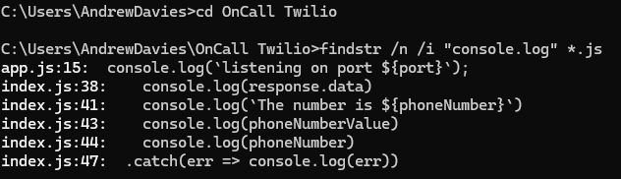

Ipconfig /all
Ipconfig with the /all switch provides detailed information relating to the network configuration of a computer. This can be used to diagnose network issues and configure settings.

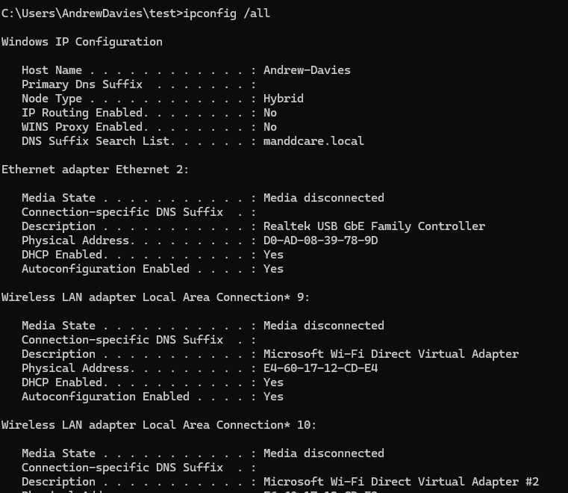

Del
The del command followed by a file or directory name will delete that file/folder. In the example below we use the del command to delete a text file called test1.txt
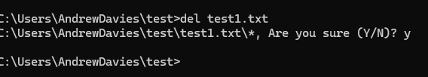

Linux CLI Commands
Having explored Window OS CLI commands, we’ll now look at the Linux OS. Linux uses Bash as its command line interpreter. Like the Windows OS CLI, Bash allows users to interact with the Operating System. Unlike the Windows OS, Linux provides the user with greater freedom to control their environment due to it’s open source code [11]. This is evident in the bash terminal, where users can execute a wide array of commands. We’ll look at some of these commands below.
Cd and ls
The above commands are used to change directory into the root folder (cd /), and then to list all of the files within that folder (ls) [12]:
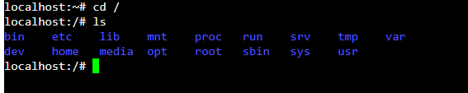
Pwd
Similar to the lone ‘cd’ batch command, ‘pwd’ prints the current working directory:
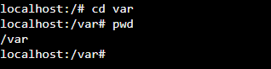
Creating new groups & checking if new group was created
The command ‘sudo groupadd’ followed by a group name creates a new user group. Users can be added to this group and permissions can be applied to different files and directories [12]. This is particularly useful when different teams require different access to files and folders.
After the group is created, we use the command ‘grep supportstaff /etc/group’ to check whether the group has been created.
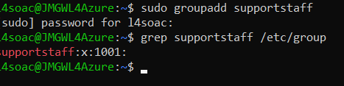
Creating a user
The following command creates a user called ‘testser’. Once the user has been created, we check to see the user’s id and what groups they have been assigned to [13].
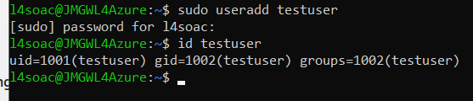

Checking a user's group
The following command checks to see which groups a user has been assigned to:
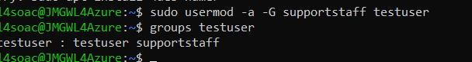

Change ownership of a directory and set permissions on that directory
The command chown followed by :supportstaff and a directory name changes the group ownership of the specified directory without altering its user ownership [14]. The command chmod g+rx followed by a directory name grants the group associated with that directory read (r) and execute (x) permissions. This allows group members to view the directory contents and enter the directory. A real-world case for a command like this would be to provide access to certain groups to collaborate on a project.
To then change the permissions of that group to be able to write, you would use the command ‘chmod g+w media’. This command adds (+) the write permissions to the directory.
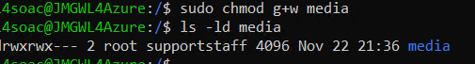

Window OS Scripts
Having looked at basic commands for both Windows OS and Linux OS, we’ll now proceed to discuss and demonstrate the use of Windows OS Scripts, using PowerShell.
Below, is an image of the script that mimics the roll out of a html, CSS and JavaScript file to a production setting. The entirety of the script is depicted in the image. Further down, we'll break down the functionality and logic behind the code.
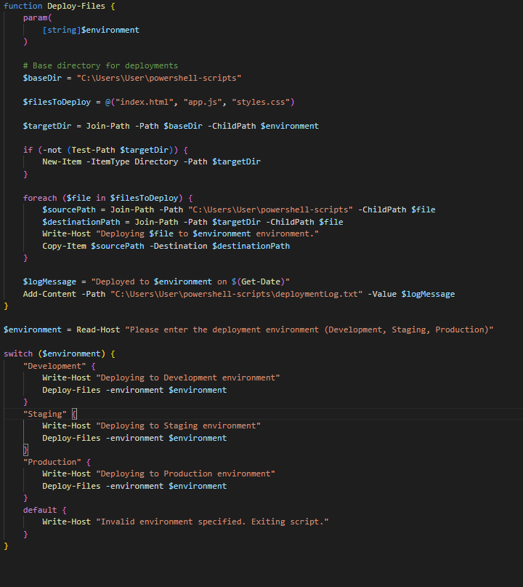

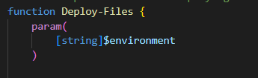
First we begin by defining a function called ‘Deploy-Files’, which accepts an argument called ‘environment’ as a parameter. The argument represents the setting to which the scripts will be deployed to [15].

Inside the function, we define the following variables:-
$baseDir: This is the path to which the root path to which the files will be deployed to. In a real world production, this could be replaced by a string that represents a deployment server.
$filesToDeploy: These represent the html, css and JavaScript files.
$targetDir: This is the full file path of where the files will be deployed. We append the environment variable here (the user will be accessed to enter an environment: development, staging or deployment).
We then check if the directory exists, if it doesn’t, we create that directory:
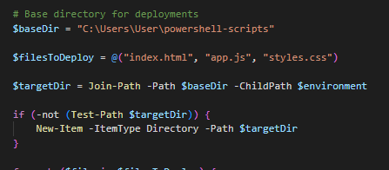
We then use a foreach loop to iterate through the filesToDelpoy array, and then copy those files to the environment specified by the user. We also create a text file which logs the deployment process, before exiting the function [16].
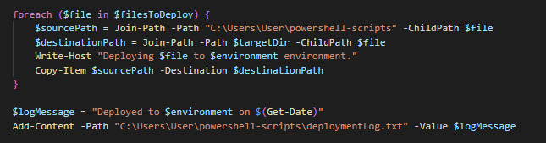
The environment variable is used to store the user-input, after being asked which environment they want to deploy to. We use a switch statement to determine the environment based on the user input.
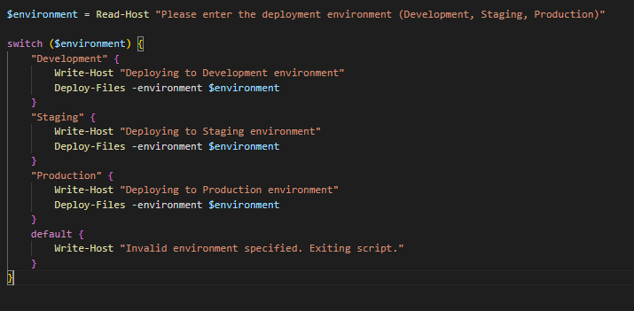
The images below show the result of running the script:
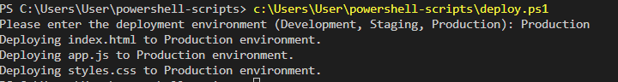
We specify the Production environment, which then deploys the files to the Production directory:
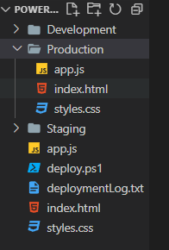

Use of Linux Scripts
Finally, we will now look at the key features of a Linux OS scripting language. This will be demonstrated by using a bash script to create a user interacted to-do list.
The image below shows the full script. We will discuss the logic and functionality further below.
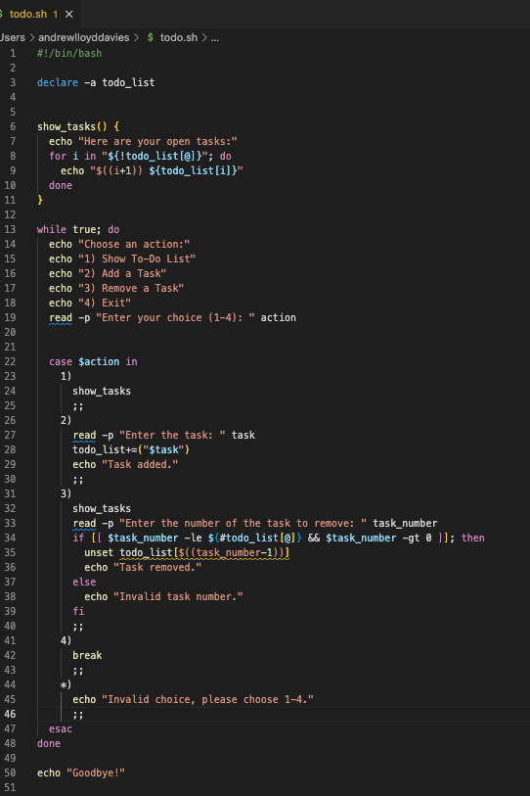
We begin by declaring a variable that will hold an array of to-do items [13]:
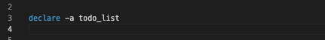
We then define a function called show_tasks. This uses a loop to iterate over the array and prints the to-do item to the terminal. Each to-do item is preceded by a number. We iterate over the indices of the array, rather than the element itself, as we will be be expecting the user to input a number corresponding to a task when they want to remove an item from the list. When printing out the index of the array, we add +1 to the number as arrays are zero indexed [13] (i.e. they start from zero, rather than 1), this creates a better UI for the end-user.
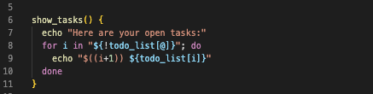
We then create a menu for the user to interact with. This is done by using a while loop. The condition of the while loop is always true; therefore, it will always be displayed to the user (unless the user breaks out of the loop). The user is prompted to enter a number between 1-4, which is then stored in a variable called ‘action’.
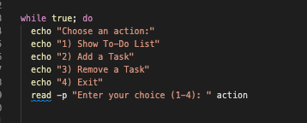
After the user enters the action, we use a case statement to determine how the script should proceed:
If the user enters ‘1’, the show_tasks function is called, and all tasks are displayed:
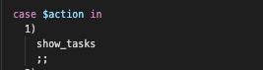
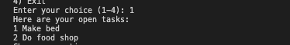
If the user enters ‘2’, the user is prompted to enter a task, which will then be added to the todo_list array.
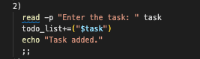
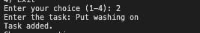
If the user enters ‘3’, a task is removed from the array. This is done by using the following commands:
- The show_tasks function is called. As mentioned earlier, each item is associated with an index.
- The user is prompted to enter a number, which is then stored in a variable called task_number
- We then use an if statement to check whether this number is within the correct range. ‘-le’ checks the length of the todo_list array and ensures the number entered is less than or equal to the length of the array, and ‘-gt 0’ checks whether the number is greater than zero. If both conditions are met, the ‘unset’ command is used to remove the corresponding item from the array [13]. Else, a invalid statement is printed to the terminal.
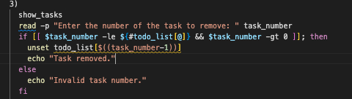
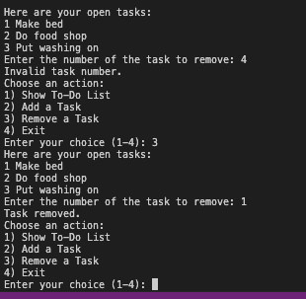
If the user enters ‘4’ this will break out of the loop. If any other number is entered, a invalid message is printed to the terminal.
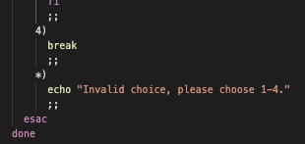

Conclusion
This report has looked at the essential role the Operating System plays in facilitating interaction between the end user and the computer’s hardware. This has been demonstrated using practical examples and detailed demonstrations of CLI commands and scripting within Windows and Linux environments. With the Windows and Linux scripting examples, we have attempted to show two scenarios that could translate to real world use cases. Both examples demonstrate the usefulness of using the OS to streamline tasks.

Appendix

Tutorial 1 Activity

An Operating System is responsible for managing a computer’s hardware and software resources [17]. In the world of computers, it can be argued that the three best known Operating Systems are Windows OS, Linux, and Mac OS.
Developed by Microsoft, Windows OS has been around since the mid 80s [15]. It provides a simple, graphical user interface for the end user, which allows them to navigate the computers functions and programs with ease. When it was first developed, unlike other operating systems, it provided visual based commands which meant that people who were less IT proficient could easily execute operational commands [18].
Unlike Windows, Linux is an open-source Operating System, which means that anyone can access and modify its source code [19] . It’s predominantly used for managing servers due to its stability and flexibility. System administrators can easily manage users and groups, due to its robust permission system [14]. Although it’s possible to have a graphical user interface, the majority of users operate the system through a Linux based command line such as Bash.
The MacOS was developed for Apple computers. It possesses many of the same features as a Windows OS, however, it’s been solely designed for Apple products. It provides a GUI for the end-user, which is easily navigated. Unlike Windows, which uses PowerShell, the command shell for the MacOS is Unix based [20].
These three manage the majority of personal computers. However, when we think of mobile phone devices, the market is dominated by Android and iOS. With Android developed by Google and iOS by Apple, they cater to most of all smartphone users. Android is a Linux based system whilst iOS is based on Unix [21].
Whilst the above is predominantly associated with personal computers and mobile devices, it’s important to consider networking operating systems. The role of an OS within a network is to coordinate devices across a network [22]. The two main types of network OS are peer to peer and client-server [22]. Peer to peer caters to small area networks. It allows users to share resources across a network and costs significantly less than client-server [22]. Client-server is controlled centrally, which means it’s more suited to larger networks where resources can be more easily managed [22].

Certified Course Engagement

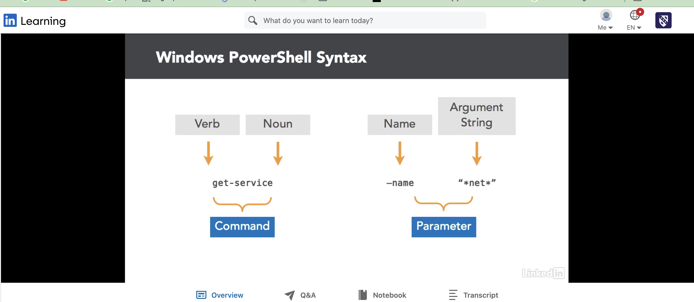
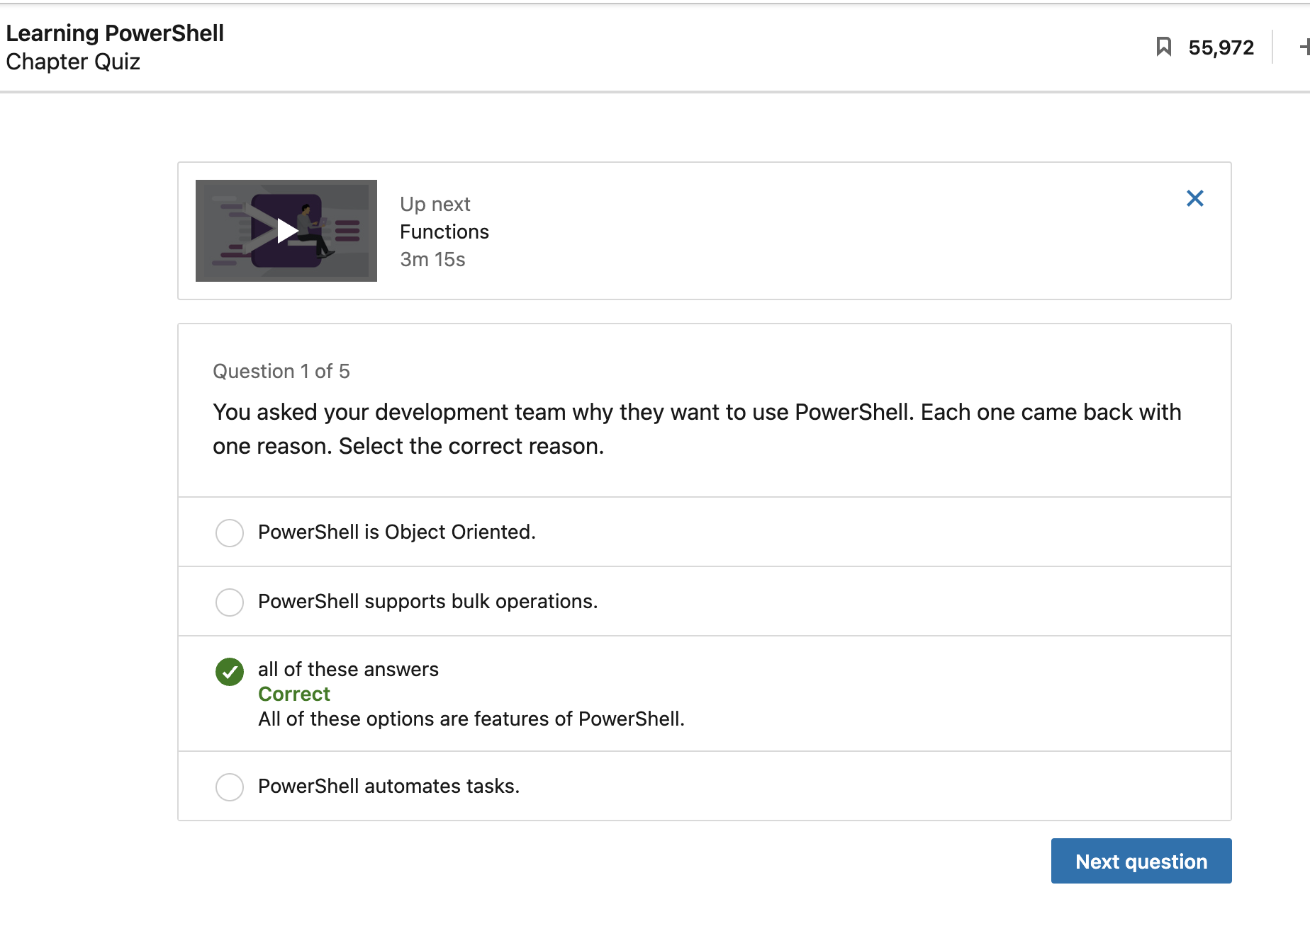

Bibliography

[1] | I. Englander, The architecture of Computer Hardware, Systems Software & Networking – An Information Technology Approach, John Wiley & Sons, 2014.
[2] | W. Stallings, Computer Organization and Architecture (10th Ed), Pearson, 2016.
[3] | "Learn Microsoft - What is PowerShell," Microsoft, [Online]. Available: https://learn.microsoft.com/en-us/powershell/scripting/overview?view=powershell-7.4. [Accessed 22 03 2024].
[4] | S. Jernigan, "LinkedIn Learning," LinkedIn, 16 01 2020. [Online]. Available: https://www.linkedin.com/learning/comptia-it-fundamentals-fc0-u61-cert-prep-1-computer-basics-hardware-and-operating-systems/operating-system-functions?resume=false&u=77966930. [Accessed 22 03 2024].
[5] | "windows commands," Microsoft , [Online]. Available: https://learn.microsoft.com/en-us/windows-server/administration/windows-commands/dir. [Accessed 08 03 2023].
[6] | "Windows Batch Scripting," WikiBooks, [Online]. Available: https://en.wikibooks.org/wiki/Windows_Batch_Scripting#Switches. [Accessed 22 03 2024].
[7] | J. Moeller, The Windows Command Line Beginner's Guide, Azure Flame Media, 2013.
[8] | L. Holmes, Windows PowerShell Cookbook, Cambridge: O'Reilly, 2013.
[9] | "Learn Microsoft - Tasklist," Microsoft, [Online]. Available: https://learn.microsoft.com/en-us/windows-server/administration/windows-commands/tasklist. [Accessed 22 03 2024].
[10] | "Learn Microsoft," Microsoft, [Online]. Available: https://learn.microsoft.com/en-us/windows-server/administration/windows-commands/findstr. [Accessed 22 03 2024].
[11] | F. Copes, "The Linux Command Handbook – Learn Linux Commands for Beginners," freeCodeCamp, 03 11 2020. [Online]. Available: https://www.freecodecamp.org/news/the-linux-commands-handbook/. [Accessed 22 03 2024].
[12] | E. Siever, Linux In A Nutshell, O'Reilly, 2009.
[13] | S. Simpson, "LinkedIn Learning," LinkedIn, 22 02 2023. [Online]. Available: https://www.linkedin.com/learning/learning-linux-command-line-14447912/learning-linux-command-line?u=77966930. [Accessed 22 03 2024].
[14] | C. Negus, Linux Bible, Wiley, 2020.
[15] | A. Rathbone, Windows 11 for dummies, Wiley, 2021.
[16] | S. M. Burrell, "PowerShell: Scripting for Advanced Automation," LinkedIn Learning , 2018.
[17] | T. Anderson, Operating Systems: Principles and Practice, Recursive Books, 2014.
[18] | S. Gibbs, "This article is more than 9 years old From Windows 1 to Windows 10: 29 years of Windows evolution," 02 10 2014.
[19] | Computer Systems and Software Engineering: Concepts, Methodologies, Tools, and Applications, Management Association, Information Resources, 2018.
[20] | D. Smith, Apple macOS and iOS System Administration, 2020.
[21] | A. O. A. A. O. A. Akinlolu Adekotujo, "A Comparative Study of Operating Systems: Case of Windows, UNIX, Linux, Mac, Android and iOS," International Journal of Computer Applications, vol. 176, no. 39, 2020.
[22] | K. Yasar, "network operating system (NOS)," Tech Target, 2023. [Online]. Available: https://www.techtarget.com/searchnetworking/definition/network-operating-system. [Accessed 11 04 2024].
[23]

