  Component One:  What are the key skills required when working in the housekeeping team? 750 words (+/- 10%)  Contribution to Overall Module Assessment: 25% | Student No: | 2128049
 | Module Title: | Student Journal (Learning Log)
 | Module Code: | BMIH4006
 | Lecturer: | Laurence Blake Ffion Cumberpatch Tristan Hawkins Kathryn Roberts Lisa Bassler

Key skills required when working in the housekeeping team
Housekeeping is the division of a hotel that is in charge of the upkeep of the hotel's common spaces and guest rooms. Members of the housekeeping team are accountable for a variety of responsibilities, such as - This entails tasks such as making the bed, changing the sheets, vacuuming the carpets, dusting the furniture, and cleaning the bathroom. It is the responsibility of the housekeeping team to replenish the supplies in each guest room as needed. The hotel's lobby, corridors, and elevators are just some of the public spaces that the housekeeping team is tasked with maintaining. Housekeeping personnel may also be responsible for guest laundry and dry cleaning, depending on the hotel's policies. Whenever a housekeeper notices a problem with a guest room or a common space, they should notify maintenance right away. To sum up, cleaning is vital to the cleanliness and comfort of a hotel's visitors (Kappa and Nitschke, 2020). Even in the busiest environments, housekeepers are expected to maintain a high standard of quality and efficiency. Housekeeping staff members are crucial to the smooth operation of any hotel or other hospitality business (Williams and Smith, 2018). They're vital in making sure guests have a good time and feel at home in the environment they're in.
Focus on Specifics. Housekeeping staff have an exceptionally high standard to uphold while cleaning guest rooms, common areas, and community spaces (Karner and Oliphant, 2022). They require a keen eye for detail to spot even the smallest issues and implement prompt solutions.
Managing one's time. If they care about how their homes look, housekeepers need to be efficient with their time. They should be able to set priorities for the tasks on the list.
Conditioning the body. Cleaning might be deemed physically demanding if it requires a lot of moving about, stooping, reaching, and lifting. Housekeepers should be in peak physical condition and able to do their jobs without difficulty.
Knowledge of how to communicate. Excellent housekeeping requires a communicator who can work well not just with visitors but also with upper management and other employees (May, 2019). In order to provide first-rate customer service and troubleshoot any issues that may arise, it is crucial to have excellent communication skills (Wood, 2018).
Organisation. Professional cleaning services have high standards for efficiency and thoroughness. They need to be able to clean according to established policies and procedures and manage supplies and tools for the cleaning staff.
Problem-solving. Good housekeepers utilise their analytical and creative skills to address any problems that arise. They ought to be able to come up with creative solutions when they encounter a scrubbing issue.
Participant in the team. The ability to work with people and find common ground is essential for a housekeeper (Mitchell, 2018). They must also be compliant with policies and respectful to superiors.
Helping Customers. Housekeepers require excellent communication skills to address visitors' questions and complaints. Keep up an image of professionalism while remaining approachable and friendly at all times (Morris, 2017).
Flexibility. Housekeepers need to be flexible, quick learners, and able to keep their cool in a high-stress environment with a lot of other people depending on them. They must be flexible with their schedules and able to perform shifts of diverse durations and times.
Dependability. Housekeepers are expected to be trustworthy employees who regularly up for shifts on time and are prepared to accomplish their responsibilities (Reynier, 2018). (Robinson, 2020). They also need to be trustworthy and competent in carrying out their duties and responsibilities.
Sincerity and uprightness. Housekeepers need to be trustworthy individuals who will respect their visitors' personal space. They need to maintain a level of professionalism and consistency in their demeanour.
Fundamentals of housekeeping. A good housekeeper will be well-versed in standard cleaning procedures and have extensive experience with a wide array of cleaning products and tools. They also need to be able to follow all health and safety rules and guidelines (Sinha and Chopra, 2014).
In conclusion, cleanliness is crucial in the hospitality sector since it contributes to an inviting and relaxing setting for guests. The people in the cleaning team need to have a wide variety of abilities, from technical know-how to strength and stamina (Sosulski 2020). The ability to pay close attention to detail, effectively manage one's time, and provide exceptional service are just a few examples.

Word Count | 729 words

Component Two:
Contribution to Overall Module Assessment: 25%
In this scenario – You have just been promoted to the team leader for a floor within the hotel. A guest complains that on their arrival, their room had not been properly cleaned. Create an action plan and answer the following questions.

Problem | Why did it happen? | What are you going to do? | How will you prevent this from happening in the future? | What measures would you introduce to improve team effectiveness?
One passenger complained to the others that the room they had originally reserved had not been cleaned properly. | -To find the cause, current cleaning methods must be examined. This will help us notice any issues fast.  -Cleaning personnel may lack management or training. Both are plausible.  -As they're short-staffed, the cleaning team may have to rush. If so, we're in trouble. If time is short, cleaners must work more quickly. | Apologize to the guest and provide a solution, such as an upgrade or a free meal.  A comprehensive investigation of the troubled room can validate the guest's complaint and address any neglected issues. | -To guarantee that cleaning staff is providing the service visitors demand, there must be checks and balances.  -The cleaning staff must be routinely coached and educated to instil the value of comprehensive cleaning and keep them up to date on cleaning techniques and standards. | -To maximise their potential, cleaning workers should get periodic coaching and feedback.  -Open communication and mutual respect are essential for teamwork.
Many distinct types of wear and tear are seen on the carpet. | -Analyzing the floor's foot traffic patterns and identifying high-traffic areas may assist visitors to find the problem and find a solution (Rai, 2020).  -This is due to extensive foot traffic, inadequate upkeep, and poor cleaning. | -Investigate the affected area.  -If damaged sufficiently, the carpet can be repaired or replaced.  -Travellers from a maintenance contract to solve the problem and ensure the carpet's future upkeep. | - Maintain the carpet with a regular cleaning and care regimen.  -To relieve high-traffic areas, plan traffic regulations.  -Cleaning employees should learn how to preserve carpets without damaging them. | -Regular feedback and coaching may enhance cleaning crew productivity.  -Open communication and respect are essential to achieve teamwork.
Disparate Stains on the Upholstery | -Figure out what's wrong by watching how the parts are used and noting any places that seem to have deteriorated faster.  -Accidents, sloppiness, and carelessness may cause them. | -The damage must be assessed in detail.  -Clean or repair damaged or torn upholstery.  -Maintaining your upholstered furniture might help you identify and fix the issue. | -Clean and maintain the furnishings regularly.  -Guests must utilise a cleaning service that doesn't damage furniture.  -Several high-traffic regions might benefit from resource-optimized congestion reduction. | -Regular coaching and review may help the cleaning team reach its potential.  -Team members that meet frequently are more inclined to cooperate and work hard

Component Three:
Contribution to Overall Module Assessment: 50%
Your task is to create and prepare a presentation following the detailed scenario provided below.

As the floor housekeeping manager and given the recent guest complaints you need to put together a basic training presentation for your colleagues within the housekeeping team to get the best out of them, ensure that brand standard is being achieved and that Health and Safety procedures are also being followed.
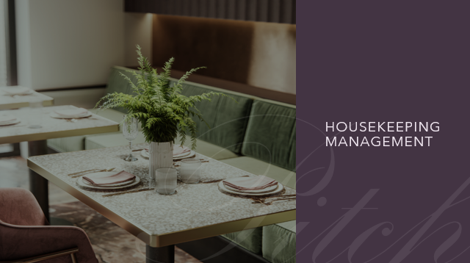
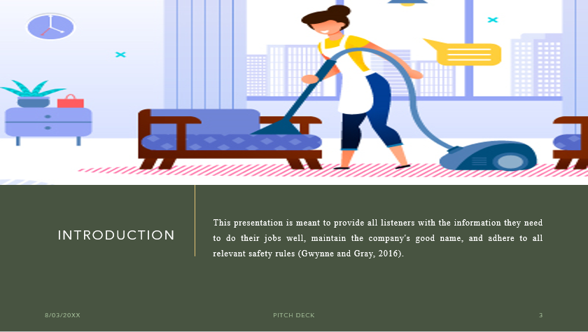

Training Notes:
Introduction
The presentation represents the ways in which Hotel Trinity may improve their skills. This presentation is meant to provide all listeners with the information they need to do their jobs well, maintain the company's good name, and adhere to all relevant safety rules (Gwynne and Gray, 2016).
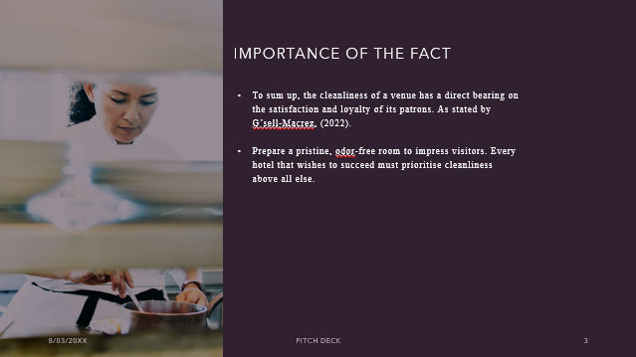

Training Notes:
Training in Housekeeping
To sum up, the cleanliness of a venue has a direct bearing on the satisfaction and loyalty of its patrons. As stated by G’sell-Macrez, (2022), a hotel's ability to fulfil its customers' needs is contingent on the quality of its infrastructure. Prepare a pristine, odour-free room to impress visitors. Every hotel that wishes to succeed must prioritise cleanliness above all else.

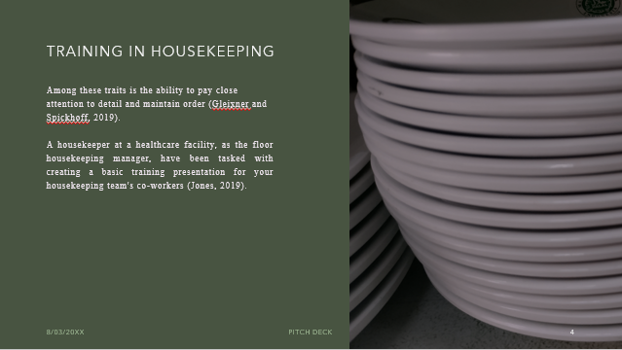

Training Notes: Training in Housekeeping
It doesn't matter what type of building it is, housekeepers are essential to the success of any cleanliness programme (public or private). Among these traits is the ability to pay close attention to detail and maintain order (Gleixner and Spickhoff, 2019). A housekeeper at a healthcare facility, as the floor housekeeping manager, has been tasked with creating a basic training presentation for your housekeeping team's coworkers (Jones, 2019).

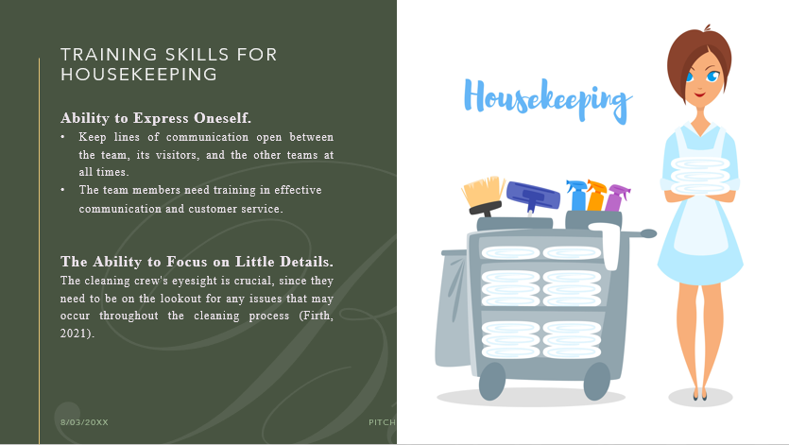

Training Notes:
Ability to Express Oneself. If the cleaning staff can coordinate their efforts well, they will save time and do a better job. Keep lines of communication open between the team, its visitors, and the other teams at all times. The team members need training in effective communication and customer service.
The Ability to Focus on Little Details. The cleaning crew's eyesight is crucial since they need to be on the lookout for any issues that may occur throughout the cleaning process (Firth, 2021).

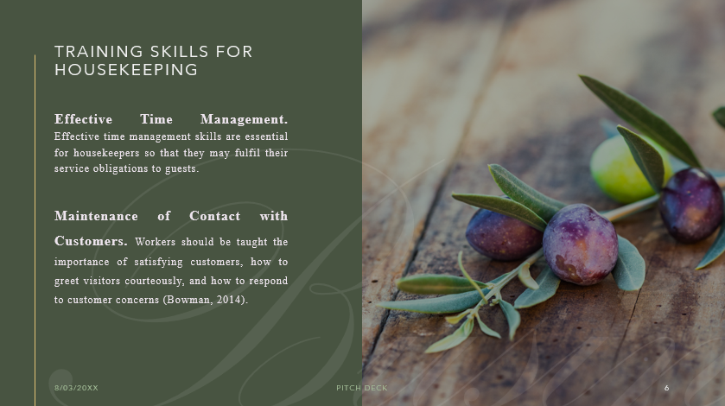
Training Notes:
Effective Time Management. Effective time management skills are essential for housekeepers so that they may fulfil their service obligations to guests. Team members need to be shown how to get the most out of their time together.
Maintenance of Contact with Customers. The success of a hotel depends on the efforts of the cleaning crew as much as on those of any other department. Workers should be taught the importance of satisfying customers, how to greet visitors courteously, and how to respond to customer concerns (Bowman, 2014).

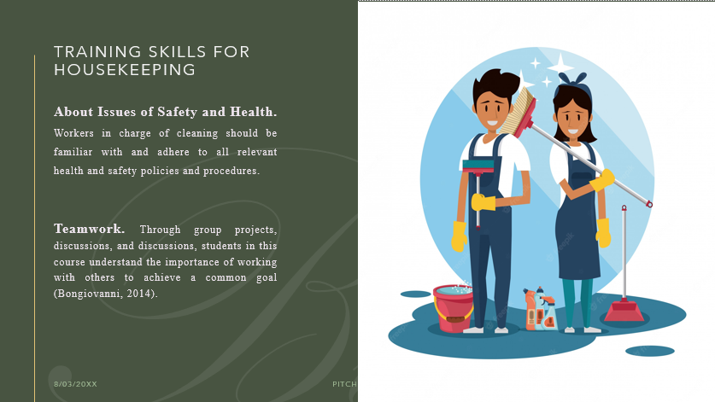
Training Notes:
About Issues of Safety and Health. Workers in charge of cleaning should be familiar with and adhere to all relevant health and safety policies and procedures. Individuals in charge of keeping the building clean should know how important it is to follow all safety protocols.
Teamwork. All members of the housekeeping staff need to be able to work together effectively because of the nature of the job. Through group projects, discussions, and discussions, students in this course understand the importance of working with others to achieve a common goal (Bongiovanni, 2014).
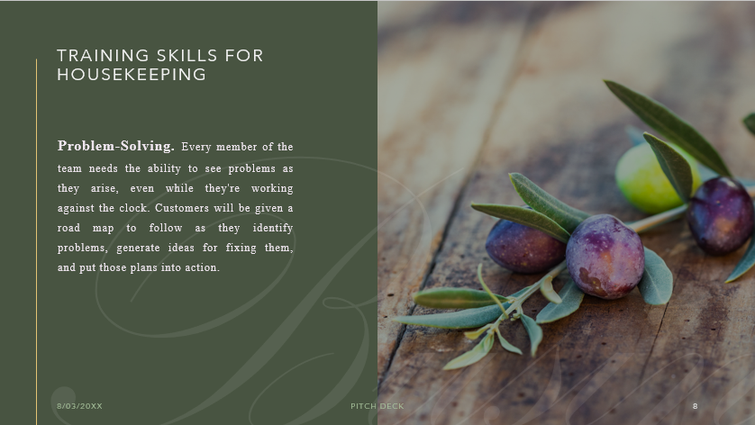
Training Notes:
Problem-Solving. Every member of the team needs the ability to see problems as they arise, even while they're working against the clock. Customers will be given a road map to follow as they identify problems, generate ideas for fixing them, and put those plans into action.

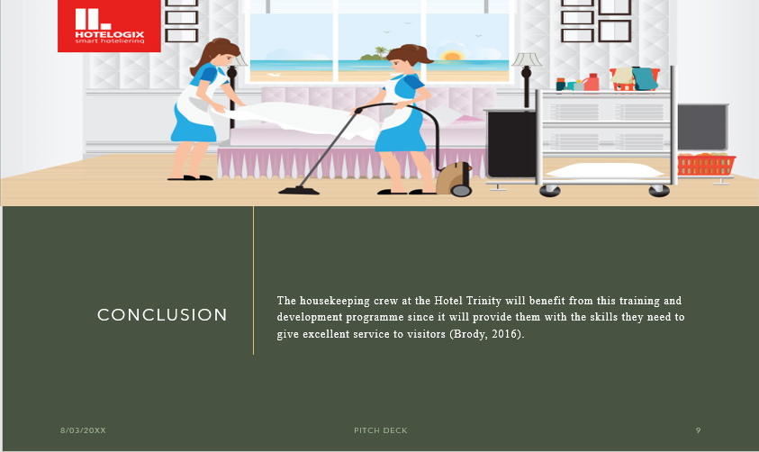
Training Notes:
Conclusion
The housekeeping crew at Hotel Trinity will benefit from this training and development programme since it will provide them with the skills they need to give excellent service to visitors (Brody, 2016). To maintain Hotel Trinity's high standards of tidiness, comfort, and service, all must work together and commit to the principles described in this presentation.


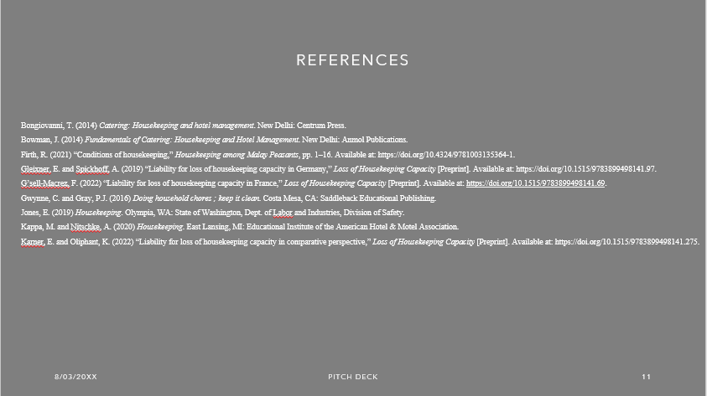

References
Bongiovanni, T. (2014) Catering: Housekeeping and hotel management. New Delhi: Centrum Press.
Bowman, J. (2014) Fundamentals of Catering: Housekeeping and Hotel Management. New Delhi: Anmol Publications.
Firth, R. (2021) “Conditions of housekeeping,” Housekeeping among Malay Peasants, pp. 1–16.
G’sell-Macrez, F. (2022) “Liability for loss of housekeeping capacity in France,” Loss of Housekeeping Capacity [Preprint].
Gleixner, E. and Spickhoff, A. (2019) “Liability for loss of housekeeping capacity in Germany,” Loss of Housekeeping Capacity [Preprint].
Gwynne, C. and Gray, P.J. (2016) Doing household chores ; keep it clean. Costa Mesa, CA: Saddleback Educational Publishing.
Jones, E. (2019) Housekeeping. Olympia, WA: State of Washington, Dept. of Labor and Industries, Division of Safety.
Kappa, M. and Nitschke, A. (2020) Housekeeping. East Lansing, MI: Educational Institute of the American Hotel & Motel Association.
Karner, E. and Oliphant, K. (2022) “Liability for loss of housekeeping capacity in comparative perspective,” Loss of Housekeeping Capacity [Preprint].
May, C.P. (2019) Housekeeping. Regency Park, S. Aust.?: International College of Hotel Management.
Mitchell, J.I. (2018) “Table 1: Comparison of housekeeping and non-housekeeping genes between pigs and humans.”
Morris, A. (2017) “Liability for loss of housekeeping capacity in England and Wales,” Loss of Housekeeping Capacity [Preprint].
Reynier, C. (2018) “The Art of Photography in the good housekeeping essays,” Virginia Woolf’s Good Housekeeping Essays, pp. 45–56.
Robinson, M. (2020) Housekeeping. New York: Picador Farrar, Straus and Giroux.
Sinha, P. and Chopra, B. (2014) Housekeeping. New Delhi: Crescent Publishing.
Sosulski, K. (2020) The visiting homemaker, a suggested training program.
Williams, S. and Smith, A. (2018) Darn it!: Traditional female skills that everyone should know. New York, NY: Skyhorse Publishing.
Wood, A. (2018) “Housekeeping, citizenship, and nationhood in good housekeeping and modern home,” Women's Periodicals and Print Culture in Britain, 1918-1939 [Preprint].

