Professional Career Development
Module Number BMSW4005
TM Sidhu 1920725
Lecturer Hassan Alharahsheh

Table of contents
Introduction………………………..…………………….…1
Role play as interviewer and as interviewee…….……1
Reflecting the Role play ………………………….………3
Gibbs cycle………………………………………………….3
Swot analysis ……………………………………………….5
Smart objectives…………………………………………….6
Johari Window………………………………………………7
Conclusion………………………………………………..…7
References…………………………………………………..8
Appendices………………………………………………….9-20

Introduction
My Name is TM Sidhu and currently I am currently studying certificate of higher education skills for the workplace. I have completed my level 3 qualification in Business administration from Association of business executives in 2000. This is when I decided to stop studying and plan to start work. Coming back to the university for completing my degree was the most difficult decision in my life. But after a year I am so confident and enhance my skills, knowledge, and awareness of the professional world. I always want to work in an office environment, and it took me three years to get the job I always wanted. During those three years I was selling computer parts in computer fairs. I was submitting applications for marketing, management and administration jobs and getting refusal from everywhere due to lack of experience, knowledge, and employability skills. By the passive of time, I developed my communication, sales, and marketing skills by selling computer parts. This led me to get my first job in 2004 when I joined the bright future law associates as a marketing executive. From the first day I work hard and try to find the ways to develop myself to progress. I done many trainings and attend number of workshops and seminars in the relevant fields, which help me to work fourteen years in the same organisation.
This report will discuss and analyse the role play as main topic, there will be a reflection on the role play also after Swot analysis, personal development plan delivered. SMART objectives and JOHARI WINDOW will be examined.
This report also determines the skills and knowledge area that are considered as significant for working adequately. Additionally, it incorporates readiness for employability and personal advancement through with the assistance of ascertainment of individual strengths and areas for further development.
Role Play
Due to covid 19 pandemic situation university organised the role play using Microsoft teams, the role play was executed in week 10 of the term. There were two members in each group and 10 minutes allowed to each member to answer the questions. there were two parts of the role play which was divided between me and my partner, first part was as interviewer and second part was as interviewee for each. I had a chance to interview my partner first for the role of clinical manager and then my partner had to interview me for the role of international officer at Lancaster university.
I had to act in two different positions as an interviewer and interviewee, here I will discuss only about the scenario whereby my partner acted as interviewer and I was acted as interviewee.
Interview started with polite greetings and the first question was asked by my colleague as interviewer to tell her the reasons to work at Lancaster university as international officer; I answer this questions by giving two reasons first this is a great opportunity to work with one of the best university in the country, I worked with international office during my previous job where our organisation helped them to recruit international students and I am quite familiar with the working style of international department at Lancaster university.
Second, this role perfectly matches my student recruitment and advisory background.
Second question was about my suitability for this role, and I replied that I always wanted to work as an international officer with UK universities My current qualification helping to improve organisational and management skills which required for this roll. My experience from previous employment is the perfect preparation for the international officer role. I am confident that my skills match with all the required skills for this job.
The next question she asked to briefly outline the relevant skills and experience and I replied that Although I have not Had a chance to gain work experience at a university yet, I have already proved myself at bright future law associates. I was the senior counsellor and advise many students. I am a trained ICEF counsellor I also completed OISC immigration advisor course. I helped overseas students for their visa applications, helped them with their refusals by submitting administrative review and appeals at Asylum and immigration tribunals.
Then she asked about my greatest achievements, I said at the end of 2018 when I lost my job due to business closer and at that time international student applications were down because of strict immigration rules and there were no job opportunities in a particular field I was really depressed and stressed, it was the lowest point of my life. I have two options one just gives up and do nothing second is to find something I am interested. to come out from the depression, I was watching BBC gardener’s world programme which inspired me to start gardening and that was when I started to learn about gardening and design my garden from scratch. This helps me to come out from depression and think positively. I was keep looking for the opportunities and Then in January 2020 I saw advertisement regarding university of wales trinity saint David’s management degree course it attracts me. but I had no courage to join the university, it took me months to push myself to come back to study. As I was out of work for few years, I knew it will be difficult to go back into the industry without learning new skills and techniques. This was the greatest challenge ever in my life to join the University to complete my degree.
Next question is to provide further information in support of my application which I replied with mentioning my fighting back skill which I recently discovered when I was diagnosed with corona positive, attack was swear and my condition was worse, my body gave up but mentally I was strong, it was always in my mind to fight back. This fighting back skill bring me back to this world.
Lately. she gave me the opportunity to ask any question and question was bout training and learning opportunities available along with this role.

Reflection on the role play
Reflective practice is learning through experience, it is continuous improvement, by means of consciously analysing the results of your recent actions and making the necessary adaptive changes, in order to improve the next set of results (Farmer, 2017).
Gibbs and Kolb described the reflective practices by saying same things with different terminology to communicate similar thoughts. I am using Gibbs reflective cycle for analysing my reflections on the role play.
Gibbs Reflective Cycle
‘it is not sufficient simply to have an experience in order to learn. Without reflecting upon this experience, it may quickly be forgotten, or its learning potential lost. It is from the feelings and thoughts emerging rom this reflection that generalisations or concepts can be generated, and it is generalisations that allow new situations to be tackled effectively.’ (Gibbs. 1988)

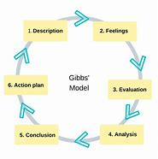
Gibbs model is composed on 6 steps.
Description
During the role play when it was my turn to interview my colleague for the role of clinical manager at London clinic, I asked all my questions with confidence and my behaviour was composed. My colleague also acted in a same manner. Interview finished smoothly in 10 minutes.
Feelings
it was me who interviewed my colleague first and realised that how effectively she answered all the questions, her body language was excellent. My own performance as interviewer was excellent, I think the reason behind was not acting as interviewee, the whole pressure was on my colleague. When it was my turn to answer the questions, I remember I was nervous as I want to perform exactly as my colleague performed.
Evaluation
Even I was little nervous being interviewee, I found number of positive points in the role play, my partner’s calmness and comforting encourages me. the whole role play went smooth however, there was interruption due to my partner’s device which was quite upsetting for me.
Analysis
My overall experience of the role play could have been batter if my partner used the home broadband Wi-Fi. But lecturer Hassan Alharahsheh was very cooperative and understand that the external factors are beyond any body’s control. His comments were very positive and encouraging. Even the technological interruption occurred we till manage to finish our role play within the given time frame. The situation made me to realize that it is not only to rehearse your questions and answers, but you must consider other external factors involved as well.
Conclusion
I conclude this by stating that me and my colleague still need to improve our interview skills, and all this can achieve by learning and practice.
Action Plan
We identify our weaknesses during the reflection of the role play, to overcome these weaknesses more rehearsals and practises required.

Personal Development Plan
SWOT Analysis

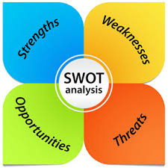
I will use swot analysis for the position of international officer at Lancaster university.
Strengths
I have certain skills which I always consider to be my strengths. My communication skills are strongest strength which can help when effective communication required dealing with international students.
I do consider my self as a good negotiator, when dealing with overseas recruiting agencies I will use my negation skills so that they work on our terms.
Through my planning and strategy skills I will achieve the targets set by the university. My qualification and training as immigration advisor and student counsellor are additional skills.
I am very confident, reliable, and dependable individual who is very meticulous about his work.
Weaknesses
My weaknesses are limited but I do believe that I must overcome these by focusing and giving priorities. Such weaknesses are completing tasks at last moments, always believe I know everything.
Opportunities
Once I conclude my degree there will be more opportunities to progress and work in higher management. internal and external trainings will also enhance the opportunities to work effectively.
Threats
Due to covid 19 situation more people lost their jobs, there will be more competition for one job.

SMART OBJECTIVES
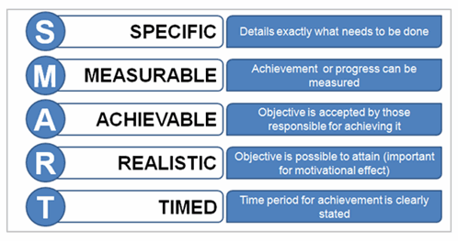
Following a thorough analysis and assessment of my abilities and skills, smart objectives need to be presented as a framework to enhance my career.
Specific
Working as international officer at university is my goal and main objective of my degree.
Measurable
I am progressing in my degree and I can measure my goals.
Achievable
My previous experiences, trainings, and detailed action plan all these indicate that it is achievable.
Realistic
I am very clear with my future career, joining the university after years of study gap was the first step to achieve my goal.
Timely
Time frame of 2 years required to reach my goals.

JOHARI WINDOWS
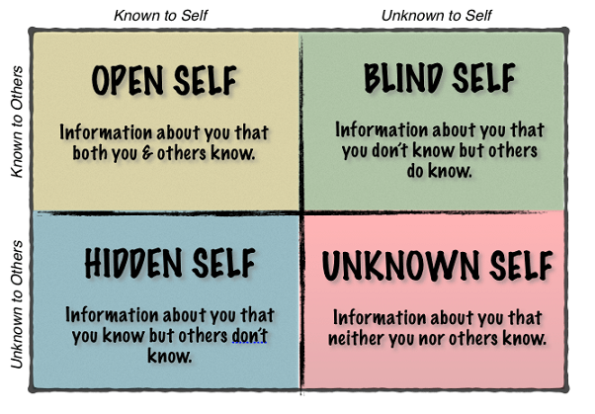
Open
Everyone is aware of my extrovert personality but very meticulous about my work. I am considered as reliable and dependable person.
Blind
I am helping people out of way I never noticed about this but most of the people mentioned this.
Hidden
I am a very sensitive person, but others do not know about this.
Unknown
I do not know and others also unknown to this that I never get angry and show anger to anyone.
Conclusion
This report has been concluded that it has been imperative to know myself to accomplish my goals. New skills and qualifications required to compete for the target job. A careful consideration also required to overcome my weaknesses so I can perform efficiently. Role play exercise help me to identify my positive and negative points also teachers feedback allows me to analyse and then implement to achieve my goals.

References
Farmer, C. (2017). Personal development: reflective practice. corporate coach group. [online]. Available from:
Personal Development: Reflective Practice | Corporate Coach Group
Gibbs, G. (1988). Learning by doing: A guide to teaching and learning methods. Further education unit. Oxford polytechnic oxford. [online]. Available from:
https://thoughtsmostlyaboutlearning.files.wordpress.com/2015/12/learning-by-doing-graham-gibbs.pdf

Appendices


