University of Wales Trinity Saint David

17/12/2025
Module Name Analysing and Solving Problems
Module Code: ACCA4019

Student Name: Vasile-Eduard Cornila
Student ID: 2423608
Group Number: 1

Lecturer’s Name: Dr. Redhwan Al-amri

Analysing and Solving Problems
Table of Contents
Introduction 3
Task 1 4
Deconstructing the problem: 4
Proposed solution, flowchart and explanation 5

Introduction

This report analyses a real-world problem faced by an online grocery delivery service, GrocerQuick, which is experiencing difficulties in managing its delivery routes efficiently. The organisation aims to optimise delivery routes to reduce fuel consumption, improve delivery times, and ensure that no delivery exceeds a 30-minute delay.
The purpose of this report is to apply structured problem-solving and abstract thinking techniques to develop a logical and generic solution to this challenge. The problem is first deconstructed into key components, requirements, constraints, and variables using the MoSCoW technique. A proposed solution is then presented, supported by a flowchart and pseudocode that outline the logical steps involved in optimising route allocation and scheduling.
The report further provides detailed explanation of how the proposed solution addresses fuel efficiency, time constraints, and order allocation. A reflective and critical evaluation of the problem-solving approach is included justifying the chosen techniques and acknowledging any assumptions or limitations. Relevant academic and professional literature is integrated throughout to support the analysis, design decisions, and reflection, with sources referenced using the IEEE referencing style.

Task 1

Scenario Summary

GrocerQuick is an online grocery delivery service that needs a structured approach to plan delivery routes more efficiently. The solution must (1) allocate orders to routes efficiently. (2) reduce fuel consumption, by minimising total travel distance, and (3) ensure timely delivery so that no order is more than 30 minutes late.

Deconstructing the problem:
The first stage of problem-solving involves breaking the scenario into manageable components. GrocerQuick’s main problem is inefficient route management, which affects operational cost and customer satisfaction. Using abstract thinking, the problem can be separated into orders, delivery vehicles, routes, constraints and performance measures. These constraints include vehicle capacity limits, driver shift times, customer delivery time windows, and a maximum allowable delivery lateness of 30 minutes. The presence of multiple, sometimes competing, constraints increase the complexity of the problem and prevents the use of simple shortest-path approaches.
The problem also involves trade-offs that must be carefully balanced. For example, assigning an order to the geographically closest driver may reduce distance but could result in lateness if the driver’s route is already near its time limit. Conversely, prioritising time feasibility may increase distance travelled. These trade-offs justify the need for decision points within the solution, where feasibility is explicitly checked before commitments are made.
Key variables include the number of orders, delivery locations, distance between locations, delivery time windows, vehicle capacity, and fuel consumption rates. Constraints include a maximum delivery delay of 30 minutes, limited vehicle capacity, and fixed operating hours.
To define the scope of the proposed solution, the MoSCoW technique was applied, as shown in Table 1 [1].
Must-have | Should-have | Could-have | Won’t-have
Efficient allocation of customer orders to delivery routes | Balanced workload across delivery vehicles | Include real-time traffic integration | Machine learning-based optimisation
Minimisation of total travel distance to reduce fuel consumption | Ability to recalculate routes if a vehicle becomes unavailable | Manual route adjustments by a dispatcher | Live GPS vehicle tracking
Compliance with the maximum 30-minute delivery delay | Improved utilisation of available vehicles | Basic reporting on route efficiency
Table 1
This analysis helps distinguish essential requirements from desirable features while clearly defining limitations.

Relevant Variables
The following variables describe the problem so the solution can work for any number of orders, drivers, and locations.
orderId – Unique identifier for the order.
customerLocation – Customer address/ latitude and longitude.
deliveryWindowStart / deliveryWindowEnd – Promised delivery time window.
orderSize – Volume/weight/number of products.
specialConstraints – Chilled/frozen/fragile/age-restricted items.
driverId – Unique identifier assigned to each driver
vehicleCapacity – Maximum load the vehicle can carry.
shiftStart / shiftEnd – When driver can work.
startLocation – Where the driver begins his route.
currentLoad – Running total of assigned orderSize.
distanceXY – distance between two points X and Y (depot and customer location(s)).
travelTime – Estimated travel time between X and Y.
routeDistance – Sum of distance across a route.
routeSchedule – Arrival and departure times for each stop.
maxLateness – 30 minutes
maxStops – Optional operational limit to keep routes manageable.

Proposed solution, flowchart and explanation

Flowchart
The proposed solution follows a structured guide route optimisation process inspired by the vehicle routing problem [2]. Orders are grouped geographically, assigned to delivery vehicles based on capacity, and sequenced to minimise travel distance while respecting time constraints.
The process begins by collecting all orders and storing their locations, delivery deadlines, and order sizes. Orders are then clustered using distance-based grouping to reduce unnecessary travel [3]. Each cluster is assigned to a delivery vehicle with sufficient capacity.
Figure 1, below, represents the generic steps for optimising the delivery process.
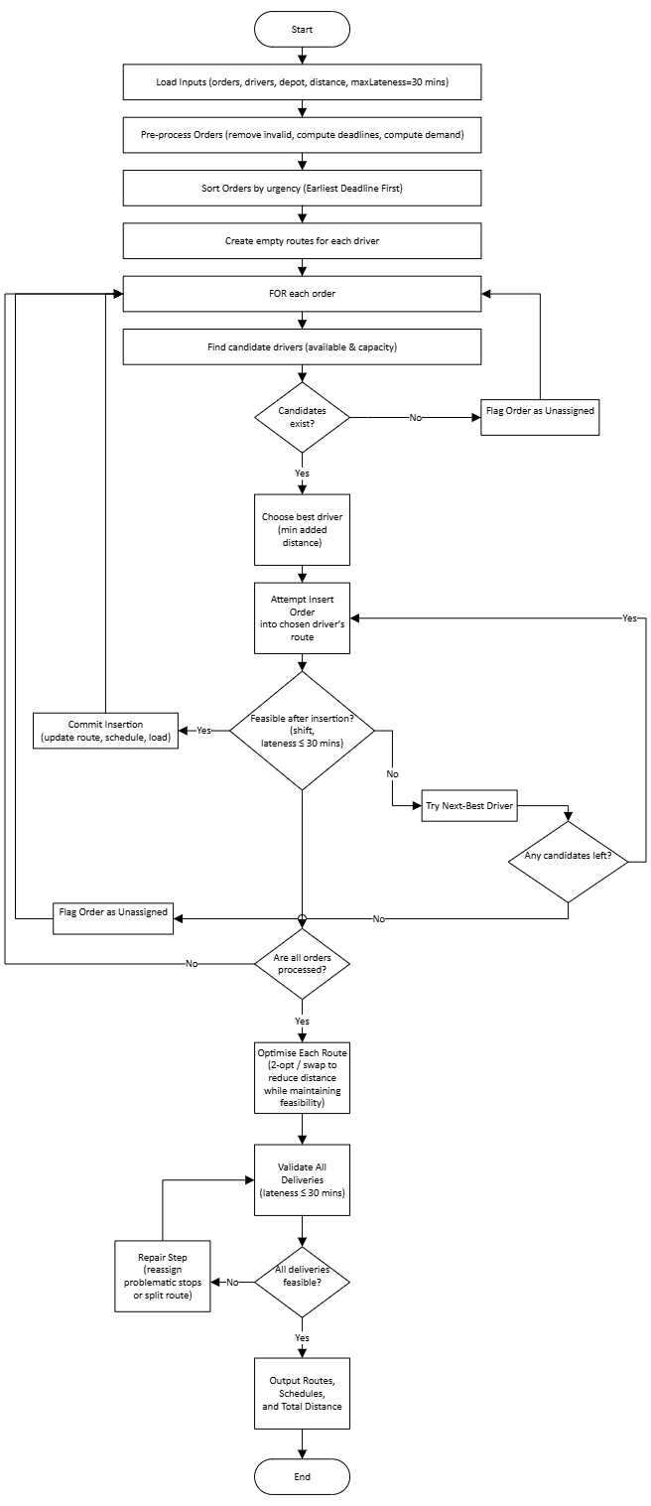 Figure 1

Pseudocode
Below is the pseudocode which outlines the logical steps used to allocate orders, optimise delivery routes, and validate time constraints in a generic and independent manner.

START
Input orderId
Input driverId
Input distanceXY
Input maxLateness
Output Optimised delivery routes
Output Delivery Schedules
Output total travel distance
// Pre-processing
FOR each order IN orders DO
IF order is invalid THEN
remove order
ELSE
orderDeadline = deliveryWindowEnd + maxLateness
orderDemand = orderSize
END IF
END FOR

Sort order by earliest deadline first

// Initialise routes
FOR each driver IN drivers DO
Route(driver) = empty
Schedule(driver)= empty
currentLoad(driver)= 0
END FOR

orderIndex = 0

//Main allocation loop
WHILE orderIndex < number of orders DO
currentOrder = orders(orderIndex)

candidateDrivers = empty list

FOR each driver IN drivers DO
IF driver is available AND
currentLoad(driver) + currentOrderDemand ≤ vehicleCapacity THEN
add driver to candidateDrivers
END IF
END FOR
Sort candidateDrivers by is empty THEN
Flag currentOrder as unassigned
orderIndex = orderIndex + 1
CONTINUE
END IF

Sort candidateDrivers by minimum added route distance
Assigned = false

FOR each driver IN candidateDrivers DO
Attempt to insert currentOrder into route(driver)
Build trial schedule

IF schedule is feasible AND
Lateness ≤ maxLateness AND
Shift constrains satisfied THN
Commit insertion
Update route, schedule, and currentLoad
Assigned = true
BREAK
END IF
END FOR
IF assigned = FALSE THEN
flag currentOrder as unassigned
END IF

orderIndex = orderIndex + 1
END WHILE
// Post-allocation optimisation
FOR each driver IN Drivers DO
optimise route(driver)
// e.g. 2-opt or swap, maintaining feasibility
END FOR

// Validation and repair
validate all deliveries

WHILE any delivery is infeasible DO
attempt to repair routes
IF no repair possible THEN
EXIT loop
END IF
revalidate deliveries
END WHILE

output routes, schedules, and total distance

END

How this addresses the objectives

The proposed solution uses a two-phase heuristic approach that reflects common practice in delivery route optimisation. In the first phase, a feasible initial solution is constructed by allocating orders to delivery routes using a greedy insertion strategy. In the second phase, each route is refined through local optimisation to further reduce travel distance while preserving feasibility.
The process begins with data loading and pre-processing. Invalid orders are removed to prevent infeasible routing decisions, and delivery deadlines are calculated by extending the customer delivery window by the maximum allowable lateness of 30 minutes. Orders are then sorted by urgency using an earliest-deadline-first rule. This prioritisation reduces the risk that time-critical orders become infeasible later in the allocation process. [4] Time limits (≤ 30 minutes late) are enforced by feasibility simulation on every tentative insertion. This ensures constraints are not “fixed later” but are respected throughout construction, aligning with VRPTW practice.
For each order, a list of candidate drivers is generated based on availability and remaining vehicle capacity. This filtering step reduces computational complexity and ensures that only feasible options are considered. Candidate drivers are evaluated based on the additional distance incurred by inserting the order into their existing route. This aligns route construction with the objective of minimising fuel consumption.
Fuel reduction is approximated by minimising total distance (or travel time), and then further reduced by local search improvements such as 2-opt, which is widely used for route refinement.

Reflection and Justification

A range of structured problem-solving techniques were applied in the development of the proposed solution. Abstract thinking was used to transform a real-world challenge into a recognised optimisation model, namely the Vehicle Routing Problem with Time Windows (VRPTW). By abstracting the problem, established optimisation concepts and heuristics could be applied without reliance on company-specific implementation details.
The problem was further addressed using decomposition, whereby the overall task was divided into small, manageable stages. These stages included problem validation, requirement prioritisation using the MoSCoW technique, route construction, route optimisation, and final validation. This subdivision improved clarity and ensured that each constraint was handled systematically. It also enabled the solution to be audited easily against the assessment criteria, particularly in relation to requirements, constraints, variables, and decision points.
The MoSCoW technique was effective in defining scope and managing complexity. By clearly distinguishing between must-have, should-have, could-have, and won’t-have requirements, the solution was kept realistic and achievable within operational constraints. This prioritisation ensured that essential business rules, such as delivery time limits and vehicle capacity, were always enforced, while more advanced features were deliberately excluded to avoid unnecessary complexity.
A hands-on approach was selected rather than an exact optimisation method. This decision was justified by the computational complexity associated with large-scale routing problems. Heuristic methods provide high-quality solutions within reasonable timeframes and are commonly used in real-world logistics systems. The use of greedy insertion followed by local optimisation (e.g. 2-opt) represents a practical balance between solution quality and computational efficiency.
Several assumptions were made in the design of the solution. Travel times and distances were assumed to be known and static, which may not fully reflect real-world traffic variability. Service times were assumed to be predictable, and dynamic order arrivals were not considered. These assumptions limit the realism of the model but are appropriate given the academic scope of the task. Future enhancements could include real-time traffic integration and dynamic re-optimisation.
In addition, the solution demonstrates the application of systems thinking, as the delivery process was treated as an interconnected system rather than a set of isolated decisions. Changes made during order allocation directly affect route feasibility, delivery times, and overall fuel consumption. By validating constraints at each stage of the process, the solution ensures that local decisions do not negatively impact the overall system performance.
The use of structured pseudocode and flowchart representation also supports professional communication and transferability of skills. These artefacts clearly document the logic of the solution, making it understandable to both technical and non-technical stakeholders, such as operations managers or system developers. This clarity is essential in real-world environments where solutions must be reviewed, implemented, and maintained collaboratively.
Although the heuristic approach does not guarantee a globally optimal solution, it provides a robust and practical method for route optimisation within realistic operational limits. This trade-off between optimality and computational efficiency reflects common practice in logistics and demonstrates an appropriate level of judgement for real-world problem-solving. Consequently, the chosen approach effectively balances theoretical foundations with practical applicability.
Overall, the proposed approach is appropriate as it provides a logical, scalable, and constraint-aware solution that directly addresses GrocerQuick’s operational objectives while remaining aligned with recognised problem-solving and optimisation principles.

References

[1] | K. Wiegers and J. Beatty, Software Requirements, Redmond, WA, USA: Microsoft Press, 2013.
[2] | G. Laporte, “What you should know about the vehicle routing problem,” Naval Research Logistics, vol. 54, no. 8, pp. 811-819, 2007.
[3] | J. Bramel and D. Simchi-Levi, The Logic of Logistics:, Berlin: Springer-Verlag New York Inc, 1998.
[4] | H. C. Lau, M. Sim and K. M. Teo, “Vehicle routing problem with time windows and a limited number of vehicles,” European Journal of Operational Research, vol. 148, no. 3, pp. 559-569, 2003.

