Project Proposal

Can the variations in weather affect the real time Noise results against Modelled predictions?

Introduction
The aim of this project is to compare recorded results from sensors placed at various points around the range boundary with the predictions from the Met office at Larkhill. The current predictions are calculated at 2 metres above ground level, however a large proportion of the firings carried out on the range during trials are at a height of up to 1 metre above ground, ground level or buried.
The current Monet formula is unable to process predictions for buried charges so there will be no Modelled data to run a comparison against for the data obtained from the sensors placed around the Range.
Met office weather forecast will be obtained for the firing days this will enable a comparison of data to be carried out to see if there is any variables due to the weather conditions.

Background Research/literature review.

Representations from local Parish Councils and occasional complaints from members of the public have highlighted concerns over noise. For this reason it has been decided that explosive firings on Porton Down Range will be restricted if there is a possibility that annoyance or structural damage could be caused.

Experience at The Royal School of Artillery (RSA) Larkhill has indicated that in practice blast noise complaints were unlikely if the impulsive noise level was below 120 dB. The Meteorological Office at Larkhill has developed a computer model to predict the probable blast noise levels at various distances from a standard explosive source.

Based on this experience and modified by local operating conditions the Dstl noise prediction policy has been formulated. By using data supplied by the Meteorological Office at Larkhill no local built-up area will be subjected to an impulsive noise level of more than 129 dB from a single explosion on Porton Range. This is further restricted in that where the predicted blast noise level is of the order of 125 dB or more repeated firings will be curtailed to one every 20 minutes.

The current blast noise prediction model used by the Larkhill Meteorological Office is based on radio-sonde ascents made at Larkhill at various times through the day. The sonde data is processed by computer and used to plot a series of isopleths of noise levels related to a standard source of 2.4 kg of PE4 explosive at a scale of 1:10 000. Copies of this diagram are sent to Porton Down Range and are available at 0800, 1000, 1200 and 1400 hours each day with each prediction being valid for the two hour period following the given times.

No noise limits have been set for buildings within the Establishment. If the forecasts suggest that excessive noise levels might be experienced (between 120 and 129 dB) at points within the HQ Building, the Enclosed Area or the Farm, Range Control will ensure the electronic notice board at the main entrance to the Porton site displays Range activity. [1]

The temperature and humidity can affect sound measurements. With a fixed temperature a decrease of in humidity could reduce the sound to a listener. Temperature and humidity affect although humidity changes slowly, this is a factor that affects measurement repeatability. [2]

Project design
This project could be carried out alongside booked in trials for data retrieval, this enables more data to be collected and enables more data comparison due to mitigation that would be used in the trial.
- Decibel Meters (Make and model TBC)
- Tripods to mount Decibel readers
- Met office weather data
- Met office Noise model forecast
The data that is collected will be compared with the predicted Met office modelling to see if there are any differences between Modelling and real time data, the Met office weather data will then be analysed and compared with the real time data obtained.
The variables that need to be considered during the project duration, has the potential to have both positive and negative effects. These variable may have effects on the data that is recorded this could be as simple as “the wind blowing in a different direction”.
- Temperature
- Humidity
- Wind
- Surroundings (mitigation if there is a blast structure built around ground zero)
- Overall weather
- Measurement methods (Different brands of decibel readers)
- Charge size
- Locations (open area trials sites/enclosed trials sites)
- Type of Explosive (PE vs C4)

Resources/Planning

The costing for the project is reduced to only the author’s time to carry out data retrieval. This is due to the author being able to run the project alongside scheduled work that is currently planned on the Range.
Gantt chart
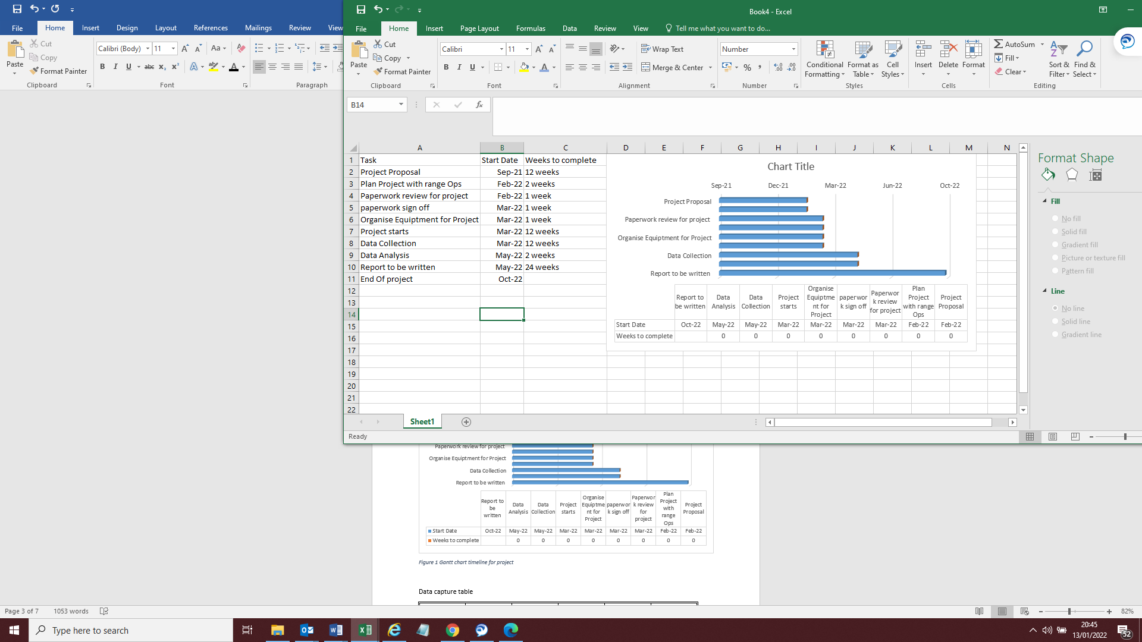
Figure 1 Gantt chart timeline for project

Data capture table
Date | Trial Site  Locations | Time | Explosive Weight (kg) | Peak Lin (dB) | Larkhill Prediction
Example  15/03/2022 | OP15 | 0900 | 1 | 115 | 120
Figure 2 Example of Table for data collection
Acoustic plot Model example
The acoustic model will show (Red outline) the noise level of the charge that is being modelled for inside the Porton down Range boundary, the location of the Acoustic sensors will be placed in locations on this boundary line.
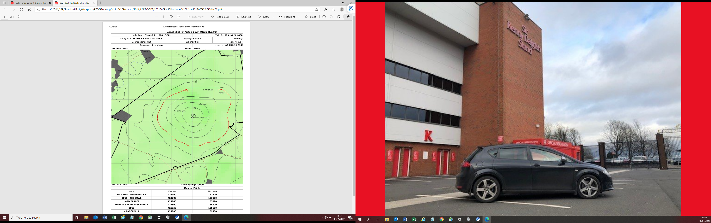
Figure 3 Example of Acoustic Model

Met Office weather forecasts
A Forecast similar to the one below will be collected on the days of the data retrieval this will offer more data analysis to be carried out. Having this information helps to see if there is a trend in the weather but a deviation on the noise readings.
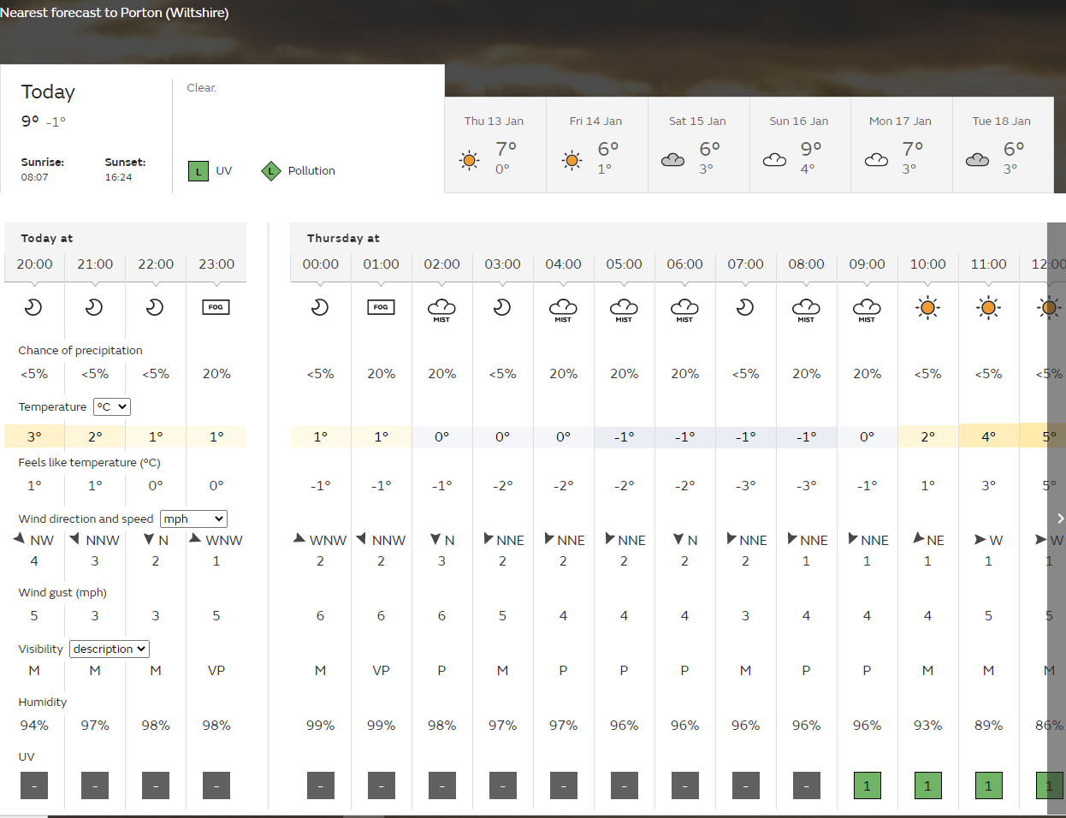
Figure 4 Example of a Met office forecast

Ethics form
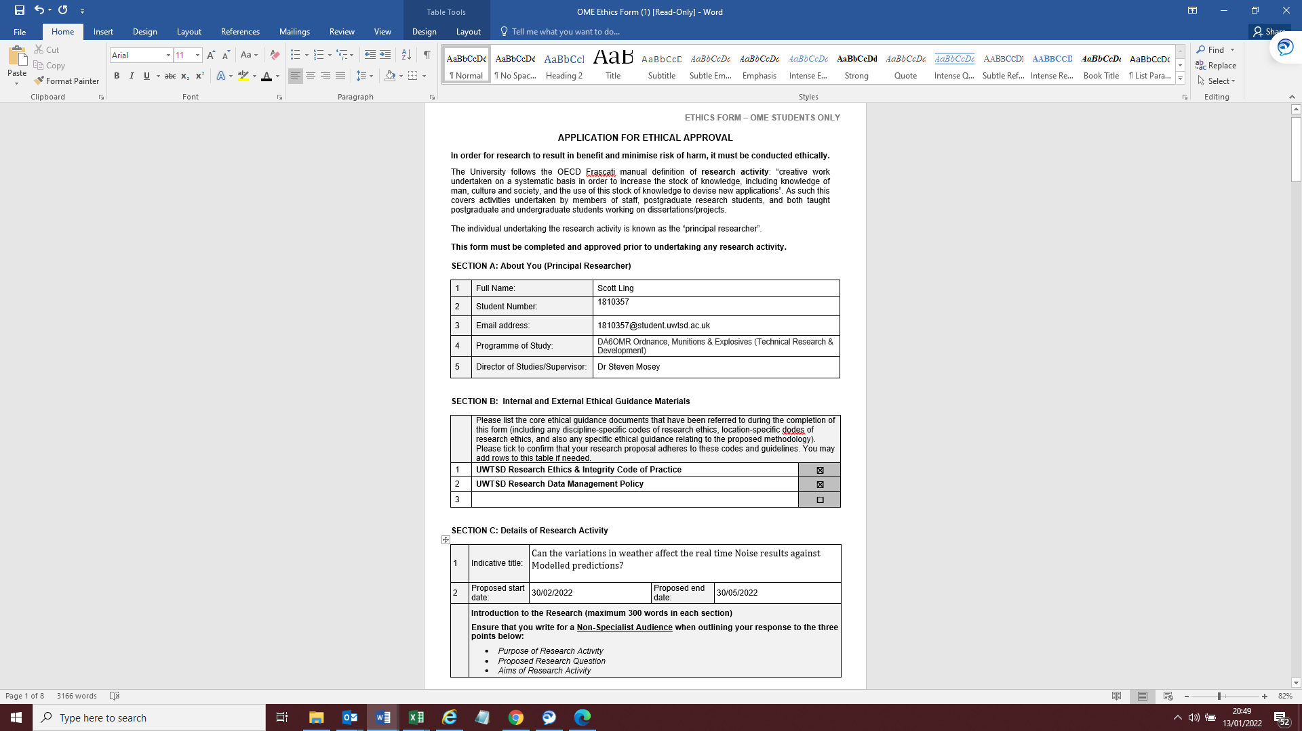
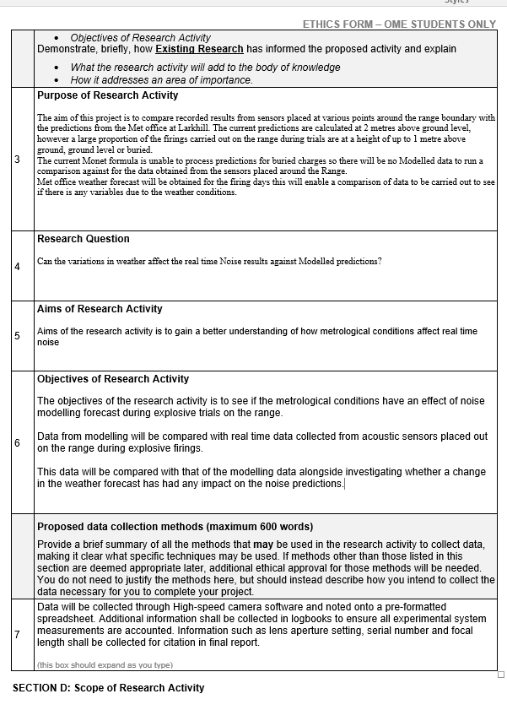
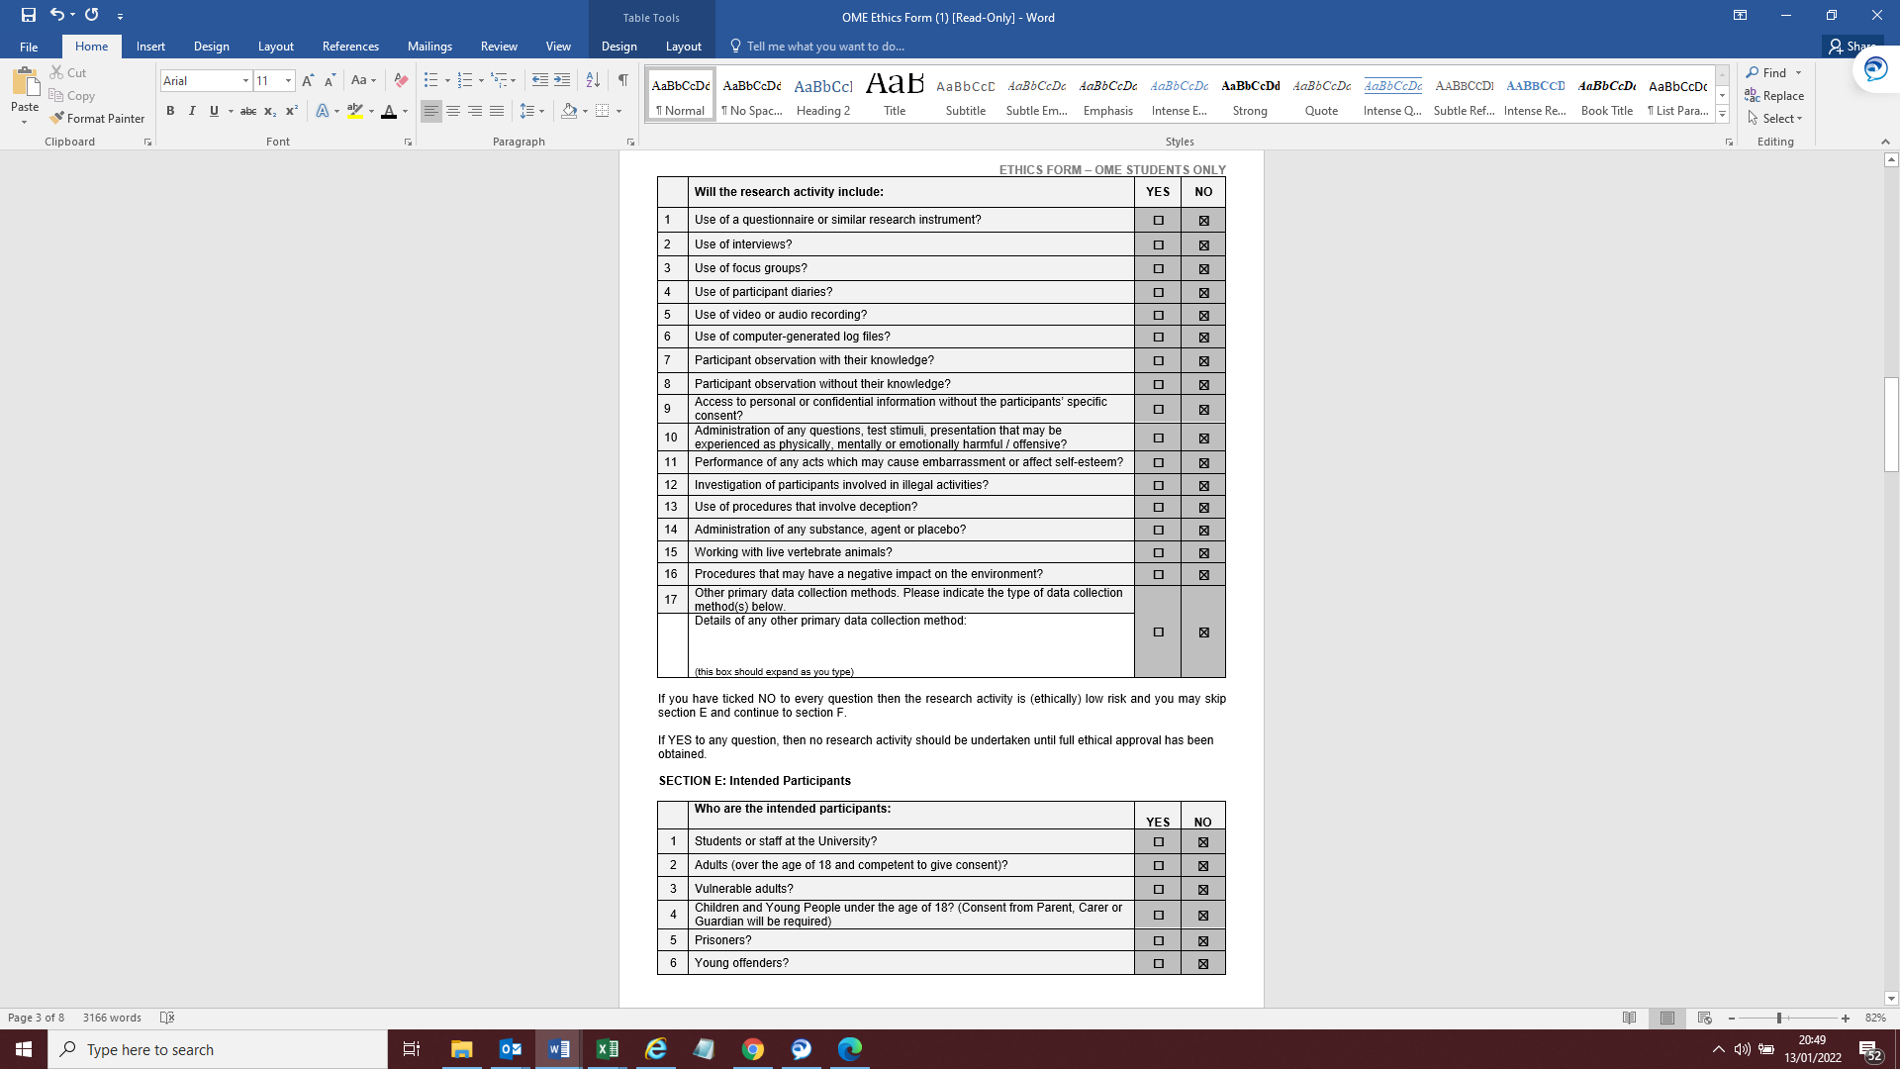
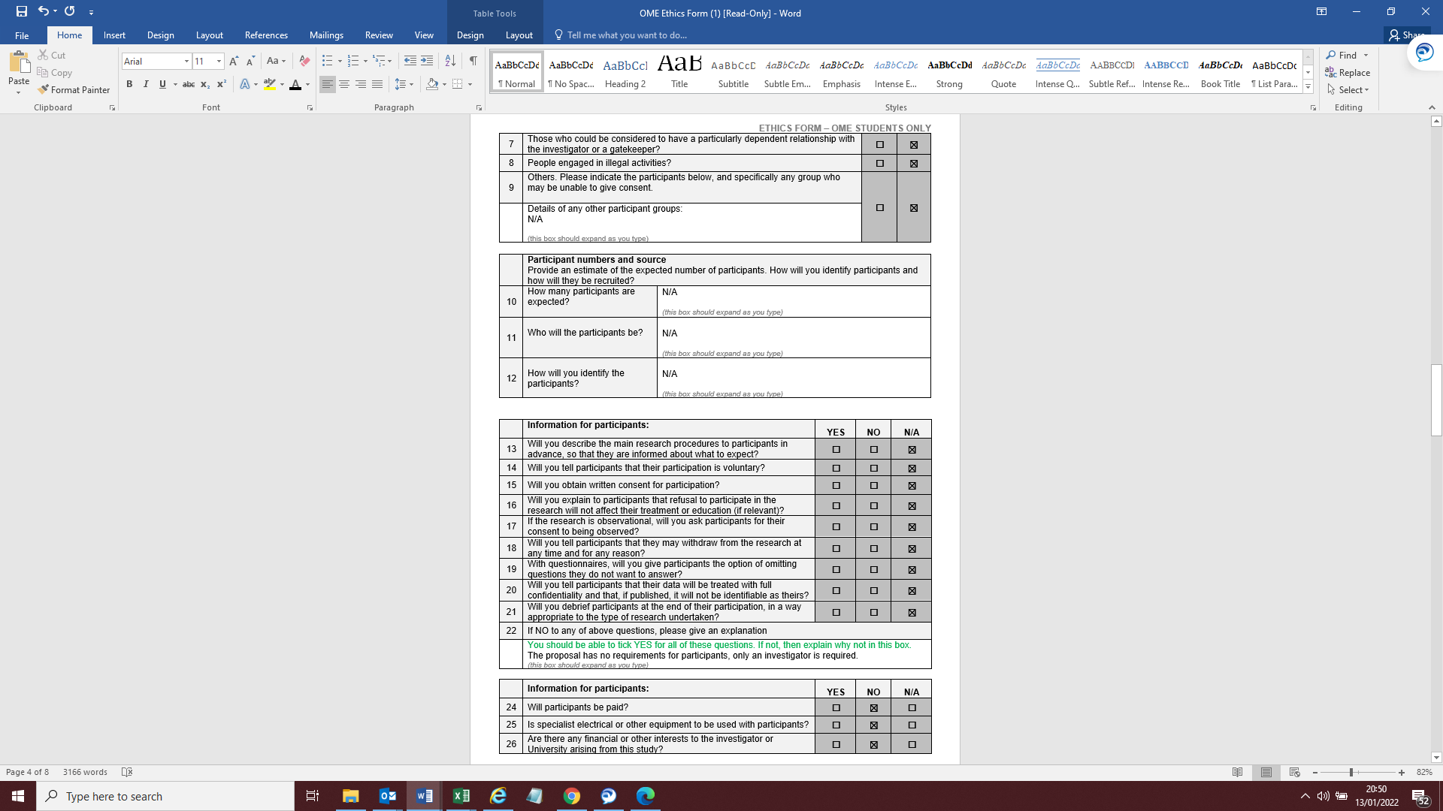
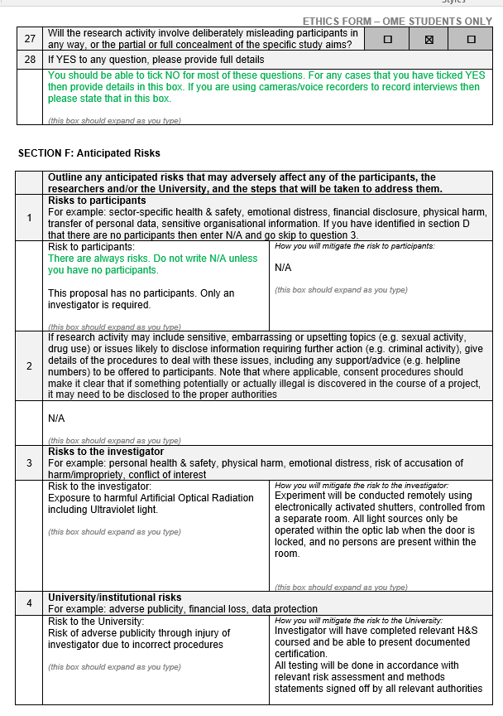
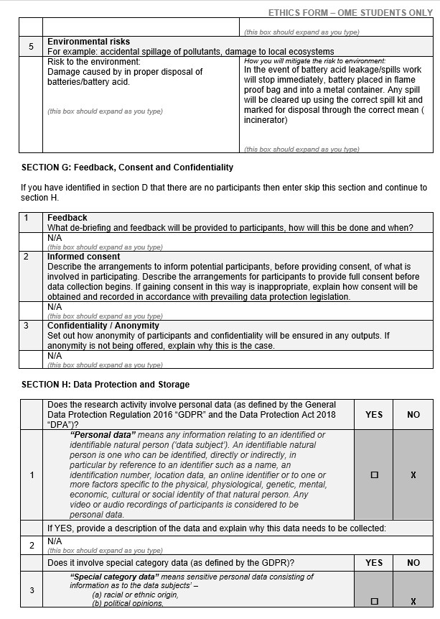
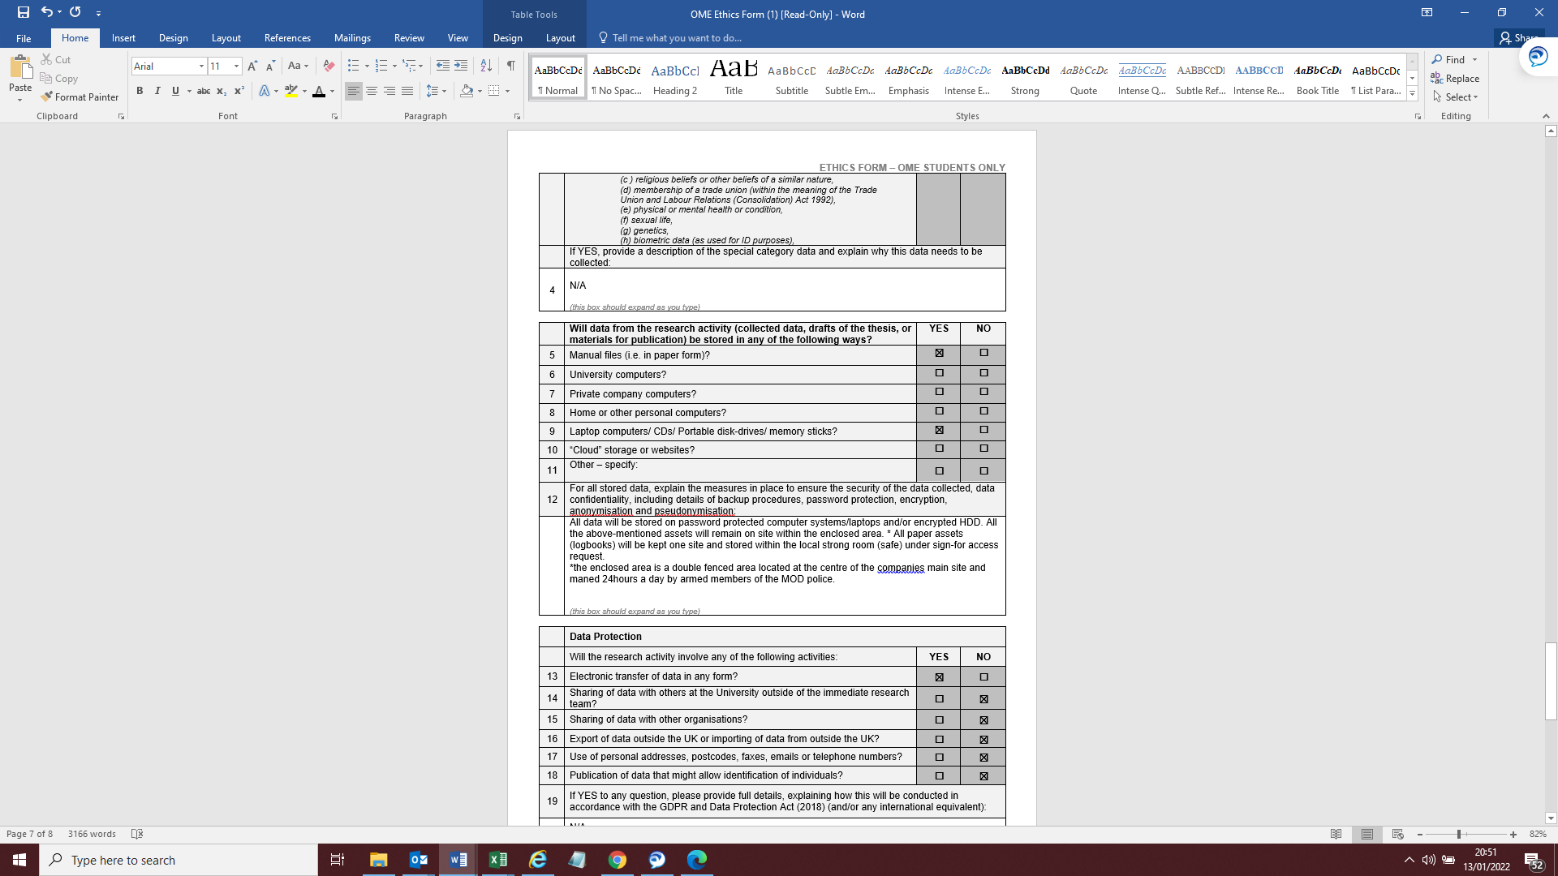
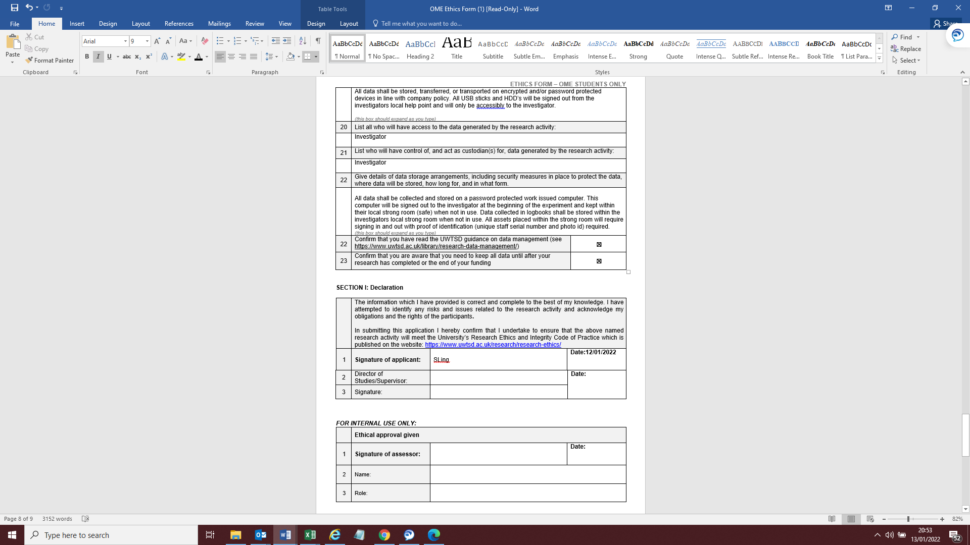

Table of Figures
Figure 1 Gantt chart timeline for project 3
Figure 2 Example of Table for data collection 4
Figure 3 Example of Acoustic Model 5
Figure 4 Example of a Met office forecast 6

Bibliography

[1] | P Gilbert, “CBR Range Operating Plan,” NA, NA, 2020.
[2] | R. O. N. J. M. Olsen, “A noise assessment and prediction system,” Semantic Scholar, NA NA NA. [Online]. Available: https://www.semanticscholar.org/paper/A-noise-assessment-and-prediction-system-Olsen-Noble/cfb2d63761427314527a97eb62b9212c9f28ea78#citing-papers. [Accessed 02 01 2022].
[3] | U. nations, “Noise prediction calculator,” United nations, NA NA NA. [Online]. Available: https://unsaferguard.org/un-saferguard/noise-prediction. [Accessed 01 01 2022].
[4] | B. &Kjaer, “How weather effects on noise measurements,” HBK company, NA NA NA. [Online]. Available: https://www.bksv.com/en/knowledge/blog/sound/noise-measurement-weather. [Accessed 04 01 2022].
[5] | Comnoise, “Noise sources and their measurement,” NA NA NA. [Online]. Available: https://www.who.int/docstore/peh/noise/Comnoise-2.pdf. [Accessed 05 01 2022].
[6] | MOD Shoeburyness, “Acoustic Forecasting & Noise Monitoring,” Qinetiq, NA NA NA. [Online]. Available: https://www.qinetiq.com/en/shoeburyness/noise-management/acoustic-forecasting-and-noise-monitoring. [Accessed 29 12 2022].
[7] | Met Office, “Met Office weather forecast,” Met Office, na na na. [Online]. Available: https://www.metoffice.gov.uk/weather/forecast/gcnfb360d#?nearestTo=Porton%20(Wiltshire)&date=2022-01-12. [Accessed 11 01 2022].
[8] | Met Office, “New radar noise level estimator,” NA NA NA. [Online]. Available: https://www.metoffice.gov.uk/research/news/2019/new-radar-noise-level-estimator. [Accessed 13 01 2022].

