
The research involved in vaccine development as a response to covid-19.
Introduction to Research and Evidence-Based Practice BMNS4006 Lecturer: Jaymie Phillips

2020/2021
By Kirsty webb ID 2004516

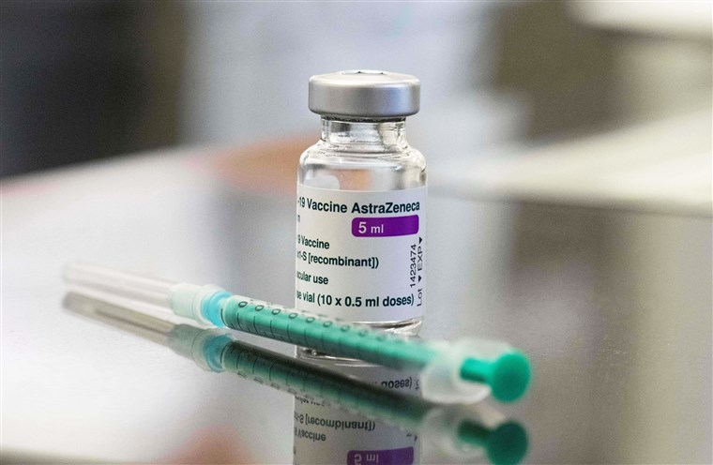
(S-nbcnews.com, 2021 AstraZeneca-vaccine)

Content Page

Introduction 3

Why did a new vaccine become necessary? 4 - 5

What was the analysis strategy, and how did 6 - 7
they know it was the best strategy.

What was the method of research? 8 - 10

Ethical issues. 11

Summery. 12

References. 13 - 16

Introduction

This paper would go into depth of AstraZeneca vaccine, identifying where the virus originated, including the differences among DNA and RNA, as well as the results of trials and how vaccines can prevent diseases and save lives, according to studies, if the benefits outweigh the risks. Fears about the new vaccine effectiveness, interaction with various populations. How the World Health Organisation (WHO) made an announcement of this virus and urgency for a solution. When testing procedure started, what was the right option for the study, the diverse types of people from other countries aiding in attempts to find solutions. Examining the trial's ethical tactics, side effects, and how this epidemic impacted communities' ethnic groups.

Why did a new vaccine become necessary?

There is medical emergency in developing an antidote to combat a disease nobody knew anything about, to help those have been affected by the disease. According to Cucinotta and Vanelli (2020) on March 11, 2020, the World Health Organization (WHO) declared the coronavirus (COVID-19) epidemic as global pandemic. COVID-19 is an airborne virus that is spread by coughing or sneezing, this disease affects the raspatory system. With that the WHO, (2020) described how the symptoms could range from a mild dose of flu or it could be come serious, for older people with other medical complications such as breathing problems, cancer diagnosis, excess weight, or diabetics, becoming extremely sick, resulting hospitalisation for medical support.

Liu, Kuo and Shih (2020) recalls how Covid 19 is part of the coronavirus family, this newly flu like coronavirus disease, is one of the fifth recorded public health emergency after the influenza outbreak. SARS-Covid, MERS and Influenzas were very contagious diseases. Centres of Disease Control and Prevention (2018) outline how Influenza viruses are continually evolving, and it is possible for non-human influenza viruses to adapt in such a way that they can easily infect people and spread from person to person. SARS-Covid-2, known as COVID-19, is contagious, it can spread quickly within communities and the population.
Boseley, Devlin and Belam (2020) recognise a disease can affect anyone, therefore can be passed from person-to-person. These viruses can cause a cold, which can become a serious illness like Swine flu, an acute respiratory syndrome (SARS), this newly discovered disease covid 19 has the same symptoms but with a higher infection rate. Zhou et al. (2020) found how COVID-19 was discovered in December 2019 in Wuhan, China. Most sufferers were suspected it to relate with a animal livestock market initially. furthermore, subsequent reports without any connection to the marketplace indicated individuals, spreading the virus to each other at a high rate. Cases have also been exported around the world, as officials were allowing people to travel, unsure of how severe the virus would become. The introduction of hygiene guidelines and keeping two meters apart was introduced in the beginning to aid slowing of the spread. According to Petersen et al. (2020) this SARS CoV-2, is more infectious, than in earlier disease outbreaks, caused serious death rates in the elderly. While with children there is an incredibly low infection rate and is just to be observed.

What was the analysis strategy, and how did they know it was the best strategy?
There is a high demand with research for a vaccine, to stop the spread of this disease and save lives. WHO (2021) had an emergency conference with other organisations to formulate action plans for the project, finding funds and locations for research, sharing knowledge they collect. Mahase (2021) reported that Sarah Gilbert, the professor leading the efforts in producing the oxford-AstraZeneca covid-19 vaccine, worked alongside Andrew Pollard with other health doctors, and non-profit organizations. Discussing how they were going to research and produce a new affective vaccine, Sarah Gilbert was working on another vaccine, collaborating with others to propose changing some DNA and RNA to help in the production of mRNA, and then launching vaccine trials. Supriya and Lakshmi (2021) demonstrates that the presence of spike proteins, which enable certain diseases to penetrate cell membranes and infect cells, is one of the key genetic features in combating Covid 19 and other diseases. The spike protein is also successfully moved from the MERS pathogen to the Covid19 protein.
DNA is genetic material in a cell that is deoxyribonucleic acid. Silveira, Moreira and Mendonça, (2020) describes how the DNA molecule is composed of two chains wrapped together, the chains are created by a double helix. Each chain consists of repeated subunits known as nucleotides which are placed in chemical bonds together. According to Seladi-Schulman (2019), DNA is unique to each individual, and genetic factor make up only one percent of the genetic information. The other ninety-nine percentage maintains factors such as if and how cells are used, also what amount to control cells in the body. different combination of amino acids such as Glycerine and tryptophan are the construction of the protein. Lurie et al. (2020) discovered this vaccination could be efficiently produced as it will not require growing or ferment. By focusing on synthesis processes, it can be mass produced for faster distribution, as in the middle of pandemic and need a vaccine as quick as possible, to slow down the spread of covid –19.

Genetics Generation (2015) demonstrates how RNA (mRNA) is a messenger copy of DNA. It is a singular chain. After synthesizing an RNA strand, it is essential for mRNA to be transferred into the proteins with special chemical change. Nonetheless, RNA's "bases" is different from DNA within this thymine (T). RNA is substituted with uracil (U), with which the RNA is coded, which produces mRNA, transferring the correct sequences of amnio acids to proceed. However, Ban et al. (2014) recognize that RNA-binding proteins are the primary regulators of cell proliferation, which is essential for RNA production. Fuller and Berglund (2020) also found after mRNA detects the virus, these molecules which are in the cell carry codes from the DNA in the nucleus to the sites of the protein. In experimental studies, enhancing RNA doses triggered greater immune responses to traditional Neutralizing antibodies.

What was the method of research?
The University of Oxford and Vaccitech worked together to invent AstraZeneca. The University of Oxford (2020) recognised how It used a sequence monkey virus which is developed on the reduced variant of a flu virus (adenovirus) which infects chimps as well as incorporates the DNA of the SARS-CoV-2 viral trigger molecule. The membrane trigger protein is developed following injection. However, Melbourne (2020) explains how the vaccine is manufactured using a type of cell – HEK-293 – which is developed via medically terminated human developing foetus. These cells are a newer decedent of cells that were originally obtained from an embryo in the 1970s. Kirby (2020) emphasises these cells are produced in a science room and are used in vaccines known as HEK-293. Human kidney cells are used in the ‘Oxford' vaccine, prepping its inflammatory response to SARS-CoV-2 infection if it further attacks the host. Kardani and Bolhassani, (2020) indicates that these findings show that ChAdOx1 vaccine releases spiked proteins, presenting further indications this new drug is stimulating the body's defences to combat COVID-19. AstraZeneca (ChAdOx1) was one of many vaccines that are being tested. Gulland, Gartner, and Roberts, (2021) explain the various varieties of vaccines developed to combat the disease; AstraZeneca and Pfizer were the first to have good results with testing, which then able to carry out vaccines quite quickly.
Almufleh and Joseph (2021) point out the research is a method of treatment that focuses on improving and evaluating clinical care. To make the right clinical choices, it is important to carefully integrate scientific findings with the individuals' beliefs. This approach is designed to aid doctors in making correct assessments, developing the best research schedule, choosing the best disease prevention approaches, and developing recommendations for a higher number of people with a similar disease. The ChAdOx1 nCoV-19 vaccines have already been studied in experiments involving some 23,000 patients in the United Kingdom, Brazil, and South Africa, according to the University of Oxford (2020). AstraZeneca is currently doing similar studies of 40,000 participants around the world in other countries abroad. The Department of Health (2021) reported that 90.3 percent of those who got the vaccination, averaged between the ages of 18 and 64, as well as 9.7 percent were aged 65. Most of the participants (75.5 percent) were Caucasian, while 10.1 percent were African, and 3.5 percent were Middle eastern; 55.8 percent were women and 44.2 percent were men.
However, Voysey et al. (2020) reported About 60% of the patients studied, regardless of background, already have underlaying medical issues, for example, diabetics, excess weight, or heart problems. Evidently adds an increased likelihood of causing serious infection if they caught the disease. Sze et al., (2020) conducted a survey which it revealed that people of black or Asian ethnic origin were admitted to hospitals at a higher rate than people of white ethnic origin. D'Souza and Wolfe (2021) accept that there was a greater percentage of ethnic minority, black and Asian patients needing intensive care; after the study, there was a limited number of ethnic minorities coming forward for the testing process, because they had doubt about this vaccine, because of the high volume of ethnic origin were getting sick and admitted to hospital, some were losing their lives because of the disease. According to Mahase, (2021) Professor Andrew Pollard and his team described how the vaccine was showing positive results at the third stage of the trial, showing strong protection and effectiveness against the disease. Even so, Čavojová, Šrol and Ballová Mikušková (2020) found with further consideration, through increasing vaccine analysis, this research may decrease the leading cause of covid-19 fatalities.
According to the University of Oxford (2020), these findings were based on 11,636 participants from the United Kingdom and Brazil who were divided into three groups. Two groups were given two full doses with a break in between, while the third group was in the United Kingdom and received a smaller dose first, followed by a full dose. Voysey et al. (2020) found that after the first dose, a month after the second dose of the AstraZeneca vaccination was given, there were fewer hospital admissions showing how this vaccine is working. The physical barriers as well as new therapies are needed to monitor COVID-19 before massive protection stops its transmission of SARS-CoV-2. Meanwhile, the University of Oxford (2020) recognise an effective cure may only have a minor impact on the epidemic in communities where there is an elevated risk of serious illness. However, within this fundamental stage, experts showed how AstraZeneca viral agent can be effective, along with containing the infection outbreak.
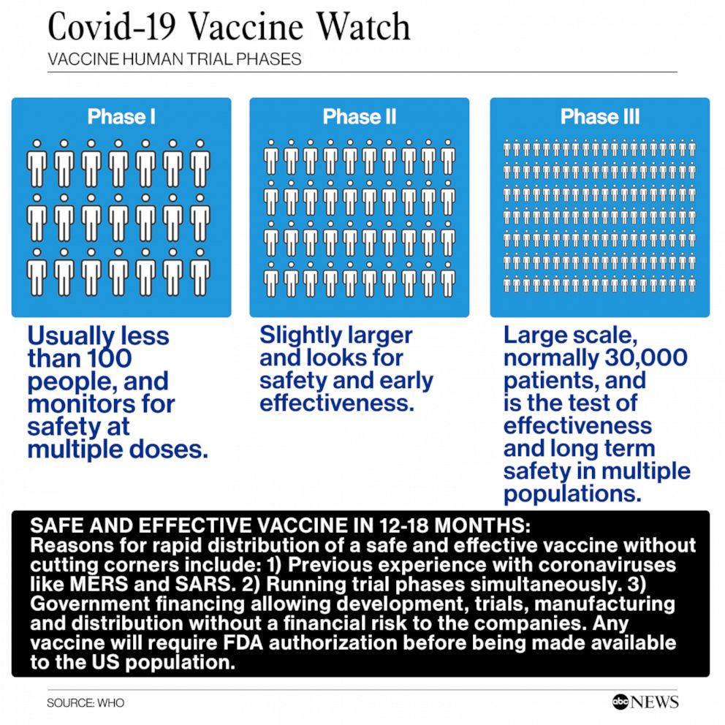
(ABC News 2021)

The University of Oxford (2021) records with evidence shown in the trials proved that this vaccine was working slowing down the disease. Symptoms which arise after having the vaccine are simillar with other inoculations. The indicators could be a fever, sore head, pain at the injection site and cold symptoms. Following this, the Human Medicines Regulations 2012 act, the Medicines & Healthcare products Regulatory Agency (MHRA 2021) recommended that the vaccine be approved for immediate use for COVID-19 disease outbreak.

Ethical issues

There are some ethical concerns with the trial of this vaccine as Calina et al. (2020) found, individuals taking part had the virus injected into their arm, not knowing anything about this disease. These risks can affect people differently, it may protect them or could be life changing leaving them with a long-term illness of respiratory problems or even lead to death. However, Jamrozik and Selgelid (2021) also report the ethical approach of some side effects are in reasonable boundaries with other viruses, there are many concerns with ethical acceptability of intentional infection as research activity, with no primary way in ruling out the lawful activities of intended contamination as research methods. History of vaccines.org (2018 )shows the importance of how to recognise the way vaccinations impact individuals. However, initiating drug development raises several ethical considerations, including the ability to ensure appropriate monitoring or care if infections are identified.

How to productively incorporate groups of people in the data collection phase; ensuring that the study including vaccination process is monitored by local ethics committee. Ensuring that everyone recognise the agreement, for instance, confusion recognizing certain principles such as removal from experiment, vaccines complications, and the variation of clinical study and therapy, implying that improved data techniques are implemented to improve patient safety. Čavojová, Šrol and Ballová Mikušková (2020) point out there can be ethical issues where the wider public are unsure of the scientific ideas, the impact of categorical imperatives questionable views on health-related actions is clearer, since confidence within effectiveness of unsuccessful therapies may contribute towards poor personal decisions, like rejecting vaccines and traditional approaches.

The WHO (2013) reports the authorities and governmental organisations have a moral responsibility to guarantee safety, having the correct policies and procedures place. Meagher et al. (2020) recognise that pessimism during the pandemic crises will intensify and generate new platforms for religious, ethnic, and political sectors; as there is threat of losing mutual understanding in the communities. Jamrozik and Selgelid (2020) acknowledge the ethical challenges posed with such experiments, including, wider consultation within the communities. clinical overview offers reviews of reliable ethical issues surrounding trials of SARS COVID-19, advantages to human health and individuals, dangers around these trials, uncertainties for volunteers, and having third-party concerns. The humanitarian nature of the current disease outbreak is significant, and moral codes must remain at the forefront of our agenda.

Conclusion
This paper described how the World Health Organization (2020) and other leading healthcare researchers collaborated to develop a new COVID-19 vaccine, AstraZeneca. Understanding where the virus originated, including an understanding of the variations between DNA and RNA, outcomes of trials. Research showed by having vaccine outweighs the dangers, vaccines can prevent diseases and save lives Ethical concerns about the vaccine's efficacy, contact with different populations, how belief in the vaccine is shaky... there needs to be a better structured baseline safety and effectiveness, screening is essential for ensuring continuous assessment of vaccine, (Tavares Da Silva et al., 2013), supporting ethnic minority in understanding of the treatments available to them (The British Phycological Society 2020), better approaches in researching information from government websites (GOV.UK 2021).

References

Almufleh, A. and Joseph, J. (2021) ‘The time is now: role of pragmatic clinical trials in guiding response to global pandemics’, Trials, pp 229–229.
Boseley, S., Devlin, H. and Belam, M. (2020) What is Covid-19? The Guardian. Available at: https://www.theguardian.com/world/2020/feb/27/what-is-covid-19 (Accessed 29th March 2021).
Ban, T., Zhu, J.-K., Melcher, K. and Xu, H.E. (2014) ‘Structural mechanisms of RNA recognition: sequence-specific and non-specific RNA-binding proteins and the Cas9-RNA-DNA complex’, Cellular and Molecular Life Sciences, 72(6), pp 1045–1058.
Calina, D., Hartung, T., Docea, A.O., Spandidos, D.A., Egorov, A.M., Shtilman, M.I., Carvalho, F. and Tsatsakis, A. (2020) ‘COVID-19 vaccines: ethical framework concerning human challenge studies’, DARU Journal of Pharmaceutical Sciences.
Čavojová, V., Šrol, J. and Ballová Mikušková, E. (2020) ‘How scientific reasoning correlates with health-related beliefs and behaviors during the COVID-19 pandemic?’, Journal of Health Psychology, p 135910532096226.
Cucinotta, D. and Vanelli, M. (2020) ‘WHO Declares COVID-19 a Pandemic’, Acta Bio-Medica: Atenei Parmensis, 91(1), pp 157–160.
Centers for Disease Control and Prevention (2018) Centers for Disease Control and Prevention. Available at: https://www.cdc.gov/ (Accessed 6th April 2021).
D’Souza, R.S. and Wolfe, I. (2021) ‘COVID-19 vaccines in high-risk ethnic groups’, The Lancet, 397(10282), p 1348.
The Department of health (2021) Information for Healthcare Professionals on COVID-19 Vaccine AstraZeneca. Available at: https://www.gov.uk/government/publications/regulatory-approval-of-covid-19-vaccine-astrazeneca/information-for-healthcare-professionals-on-covid-19-vaccine-astrazeneca (Accessed 6th April 2021).
Fuller, D.H. and Berglund, P. (2020) ‘Amplifying RNA Vaccine Development’, New England Journal of Medicine, 382(25), pp 2469–2471.
Gulland, A., Gartner, A. and Roberts, L. (2021) ‘How the Moderna, AstraZeneca, Pfizer and other Covid vaccines compare’, The Telegraph. 8 Apr. Available at: https://www.telegraph.co.uk/global-health/science-and-disease/covid-vaccine-astrazeneca-vs-moderna-pfizer-difference/ (Accessed 13 Apr. 2021).
Genetics Generation (2015) Genetics Generation. Available at: https://knowgenetics.org/dna-and-proteins/ (Accessed 1st April 2021).
Historyofvaccines.org. (2018) Ethical Issues and Vaccines | History of Vaccines.Available at: https://www.historyofvaccines.org/content/articles/ethical-issues-and-vaccines (Accessed 22nd April 2021).
Jamrozik, E. and Selgelid, M.J. (2020) ‘COVID-19 human challenge studies: ethical issues’, The Lancet Infectious Diseases.
Jamrozik, E. and Selgelid, M.J. (2021) Human Challenge Studies in Endemic Settings. SpringerBriefs in Ethics. Cham: Springer International Publishing.
Kardani, K. and Bolhassani, A. (2020) Vaccine development against SARS-CoV-2: from virology to vaccine clinical trials. Coronaviruses, 01.
Kirby, J. (2020) How does the AstraZeneca/Oxford vaccine work? Available at: https://www.msn.com/en-gb/health/medical/how-does-the-astrazeneca-oxford-vaccine-work/ar-BB1bgRZ3 (Accessed 6th April.2021).
Liu, Y.-C., Kuo, R.-L. and Shih, S.-R. (2020) ‘COVID-19: The first documented coronavirus pandemic in history’, Biomedical Journal, 43(4).
Lurie, N., Saville, M., Hatchett, R. and Halton, J. (2020) ‘Developing Covid-19 Vaccines at Pandemic Speed’, New England Journal of Medicine.
MacKenzie, R.J. (2018) DNA vs. RNA – 5 Key Differences and Comparison. Genomics Research from Technology Networks. Available at: https://www.technologynetworks.com/genomics/lists/what-are-the-key-differences-between-dna-and-rna-296719 (Accessed 1st April 2021).
Melbourne, P., Gyngell, C., and Taylor-Sands, M., University of Melbourne (2020) Gaining clarity on the ethical issues of a possible COVID-19 vaccine. Pursuit. Available at: https://pursuit.unimelb.edu.au/articles/gaining-clarity-on-the-ethical-issues-of-a-possible-covid-19-vaccine (Accessed 6th April 2021).
Mahase, E. (2021) ‘How the Oxford-AstraZeneca covid-19 vaccine was made’, BMJ, 372.
The Medicines & Healthcare products Regulatory Agency (MHRA 2021) Summary of the Public Assessment Report for AstraZeneca COVID-19 vaccine. Available at: https://www.gov.uk/government/publications/regulatory-approval-of-covid-19-vaccine-astrazeneca/summary-of-the-public-assessment-report-for-astrazeneca-covid-19-vaccine (Accessed 6th April 2021).
Meagher, K.M., Cummins, N.W., Bharucha, A.E., Badley, A.D., Chlan, L.L. and Wright, R.S. (2020) ‘COVID-19 Ethics and Research’, Mayo Clinic Proceedings, 95(6), pp 1119–1123.
Petersen, E., Koopmans, M., Go, U., Hamer, D.H., Petrosillo, N., Castelli, F., Storgaard, M., Al Khalili, S. and Simonsen, L. (2020) ‘Comparing SARS-CoV-2 with SARS-CoV and influenza pandemics’, The Lancet Infectious Diseases, 20(9).
Seladi-Schulman, J. (2019) DNA Explained and Explored. Healthline. Available at: https://www.healthline.com/health/what-is-dna (Accessed 4th April 2021).
Sze, S., Pan, D., Nevill, C.R., Gray, L.J., Martin, C.A., Nazareth, J., Minhas, J.S., Divall, P., Khunti, K., Abrams, K.R., Nellums, L.B. and Pareek, M. (2020) ‘Ethnicity and clinical outcomes in COVID-19: A systematic review and meta-analysis', EClinicalMedicine, p 100630.
Supriya, Lakshmi. (2021) Oxford-AstraZeneca COVID vaccine induces cell spikes like SARS-CoV-2's. News-Medical, Available at: https://www.news-medical.net/news/20210409/Oxford-AstraZeneca-COVID-vaccine-induces-cell-spikes-similar-to-SARS-CoV-2s.aspx (Accessed 13th April 2021)
Silveira, M.M., Moreira, G.M.S.G. and Mendonça, M. (2020) ‘DNA vaccines against COVID-19: Perspectives and challenges’, Life Sciences, p 118919.
Tavares Da Silva, F., De Keyser, F., Lambert, P H., Robinson, W H., Westhovens, R., and Sindic, C. (2013) ‘Optimal approaches to data collection and analysis of potential immune mediated disorders in clinical trials of new vaccines’, Vaccine, 31(14), pp 1870–1876.
The University of Oxford (2020) Oxford COVID-19 vaccine to begin phase II/III human trials | University of Oxford. Available at: www.ox.ac.uk website: https://www.ox.ac.uk/news/2020-05-22-oxford-covid-19-vaccine-begin-phase-iiiii-human-trials (Accessed 5th April 2021).
The University of Oxford (2020) First peer-reviewed results of phase 3 human trials of Oxford coronavirus vaccine demonstrate efficacy. Available at: https://www.research.ox.ac.uk/Article/2020-12-08-first-peer-reviewed-results-phase-3-coronavirus-vaccine (Accessed 5th April 2021).
The University of Oxford (2021) COVID-19 Vaccines. Available at: COVID-19 vaccines | Vaccine Knowledge (ox.ac.uk) (accessed 13th April 2021).
Voysey, M., Clemens, S.A.C., Madhi, S.A., Weckx, L.Y., Folegatti, P.M., Aley, P.K., Angus, B., Baillie, V.L., Barnabas, S.L., Bhorat, Q.E., Bibi, S., Briner, C., Cicconi, P., Collins, A.M., Colin-Jones, R., Cutland, C.L., Darton, T.C., Dheda, K., Duncan, C.J.A. and Emary, K.R.W. (2020) Safety and efficacy of the ChAdOx1 nCoV-19 vaccine (AZD1222) against SARS-CoV-2: an interim analysis of four randomised controlled trials in Brazil, South Africa, and the UK. The Lancet, 397(10269).
World Health Organization (2020) Coronavirus. World Health Organization. Available at: https://www.who.int/health-topics/coronavirus#tab=tab_1 (Accessed 29th March 2021).
World Health Organisation (2021) A Coordinated Global Research Roadmap. Available at: https://www.who.int/publications/m/item/a-coordinated-global-research-roadmap (Accessed 13th April 2021).
World Health Organisation (2013) WHO| Ethical considerations for vaccination programmes in acute humanitarian emergencies. Who.int. Available at: https://www.who.int/bulletin/volumes/91/4/12-113480/en/ (Accessed 13th April 2021).

Zhou, F., Yu, T., Du, R., Fan, G., Liu, Y., Liu, Z., Xiang, J., Wang, Y., Song, B., Gu, X., Guan, L., Wei, Y., Li, H., Wu, X., Xu, J., Tu, S., Zhang, Y., Chen, H. and Cao, B. (2020) ‘Clinical course and risk factors for mortality of adult inpatients with COVID-19 in Wuhan, China: a retrospective cohort study’, The Lancet, 395 (10229).

Images

News, A.B.C. (2021) Human trial for coronavirus vaccine launched by Moderna enters Phase 3. ABC News. Available at: https://abcnews.go.com/Business/moderna-launches-phase-human-trial-coronavirus-vaccine-us/story?id=72007945 (Accessed 15th April 2021).
S-nbcnews.com. (2021) Available at: https://media1.s-nbcnews.com/j/newscms/2021_07/3450231/210215-astrazeneca-vaccine-jm-1214_4d19b6660bbf4911e60060a852410a8b.fit-760w.jpg (Accessed 30th March 2021).

