Supplementary notes
High Street Decline – Pandemic

This presentation aims to discuss one of the main problems High Streets have had to face recently therefore the pandemic.
Nature
What is the root of the problem in this case?
Since the beginning of the Pandemic many shops in city centres were forced to close due to restrictions Government put in place. BBC news states than in 2020, more than 10 000 stores closed in UK. Several major high street chains have disappeared in recent years, including John Lewis and Debenhams chain. In addition, Topshop and Miss Selfridge have closed their doors because to the collapse of the Arcadia Group. The vacancy rate was up 14.5% in the second quarter (MarketLine, 2021) and because of Covid-19 acceleration, consumers are now shopping online almost everything they need such as groceries, clothes, appliances and more.
A different example is the city of London where since March 2021 has suffered 52% in sales due to shopping online and less tourists (Cook et al., 2022).
To aid finding the root cause of this problem, I designed a fishbone diagram following Ishikawa example where I identify diverse roots of the problem.
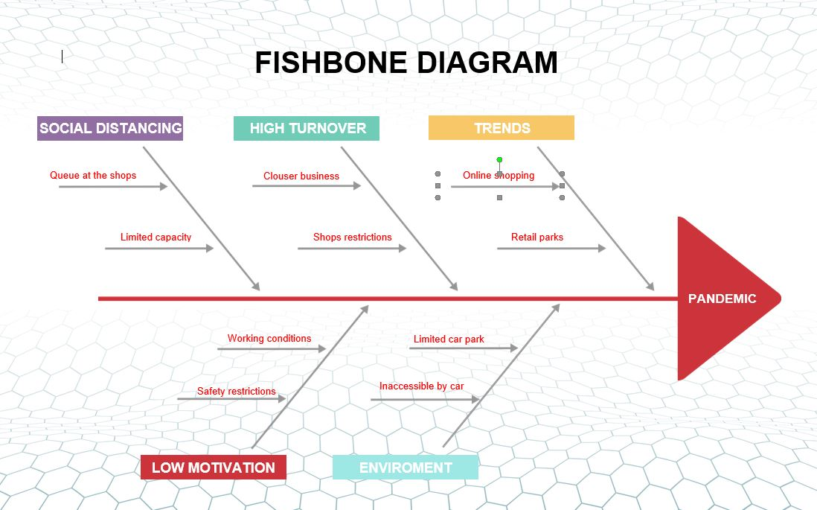

Scope
Who is affected by this problem?
Most affected by pandemic on High Streets has been shops and employees as they have been the first ones hit, but there are many other stakeholders suffering from it directly or indirectly such as restaurants owners, landlords, chain shops, investors, customers, and suppliers. They all seen a negative impact from the pandemic with repercussions on their activities. Also, the pandemic has had a negative impact on the country economy with devastating consequences on local economies in towns and cities.
Impact
How they been affected?
At the beginning of first lockdown, all nonessential shops have been told to close and not all of them been able to reopen when they’re allowed to with many of small businesses not surviving. The pandemic hit the economy hard but loosing jobs and reducing the workforce. The economy ware consuming more than producing and to balance that, individuals had to take the consequences. In spite of the fact that no economy is undamaged, smaller- and middle-salary countries typically suffer the most from economic shocks because their defences are weak and they tend to be dependent on a few sectors, such as commodity exports and tourism (University of Manchester). As for green energy, the COVI-19 has been delaying it as well, at least temporarily, by slowing down investments.
Also, the mental health of workers and business owners has been challenged during the pandemic with a significant number of individuals becoming anxious, being afraid to go to workplace and affecting their performance.
Parents had to take more responsibility at home because of schools’ closure and work remotely. Also, many landlords of Highs Streets were unable to rent their properties as commercial space and reorientated into estates as their renting price was unaffordable by businesses.

References list
- Cook, Chris, et al. “How the UK High Street Was Hit by the Pandemic: Look up Your Area.” Financial Times, 19 Jan. 2022, www.ft.com/content/9348c644-288f-42e7-9f4b-edea8b71be5b (Accessed on 27.01.2022)
- MarketLine. “The Pandemic Has Sped up the Demise of the UK High Street.” Www.retail-Insight-Network.com, 2 Aug. 2021, www.retail-insight-network.com/comment/pandemic-uk-high-street/ (Accessed on 27.01.2022)
- University of Manchester. “New Briefing Highlights Damaging Impact of Covid-19 on High Streets.” New Briefing Highlights Damaging Impact of Covid-19 on High Streets, 18 Oct. 2021, www.manchester.ac.uk/discover/news/damaging-impact-of-covid-19-on-high-streets/ (Accessed 31 Jan. 2022)

