
Slide 1

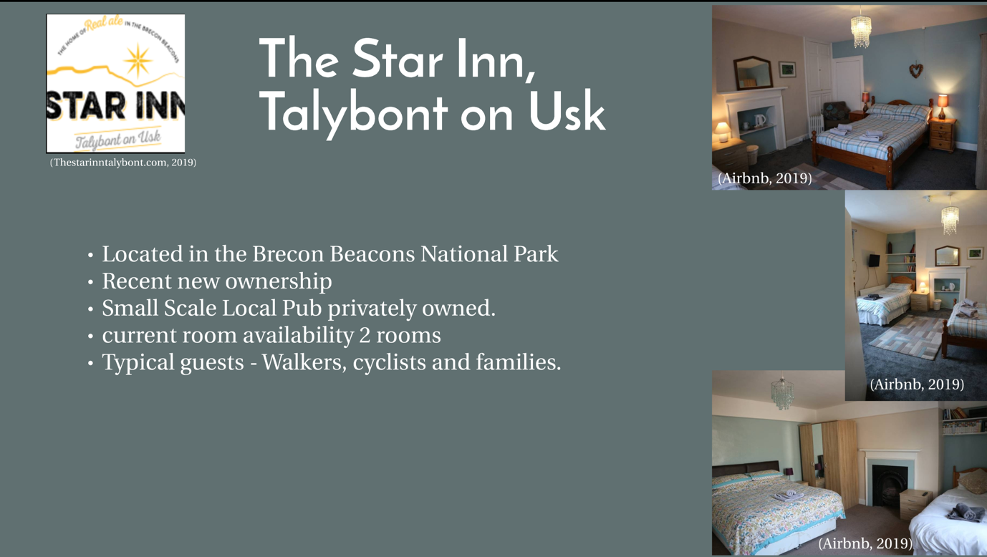Slide 2

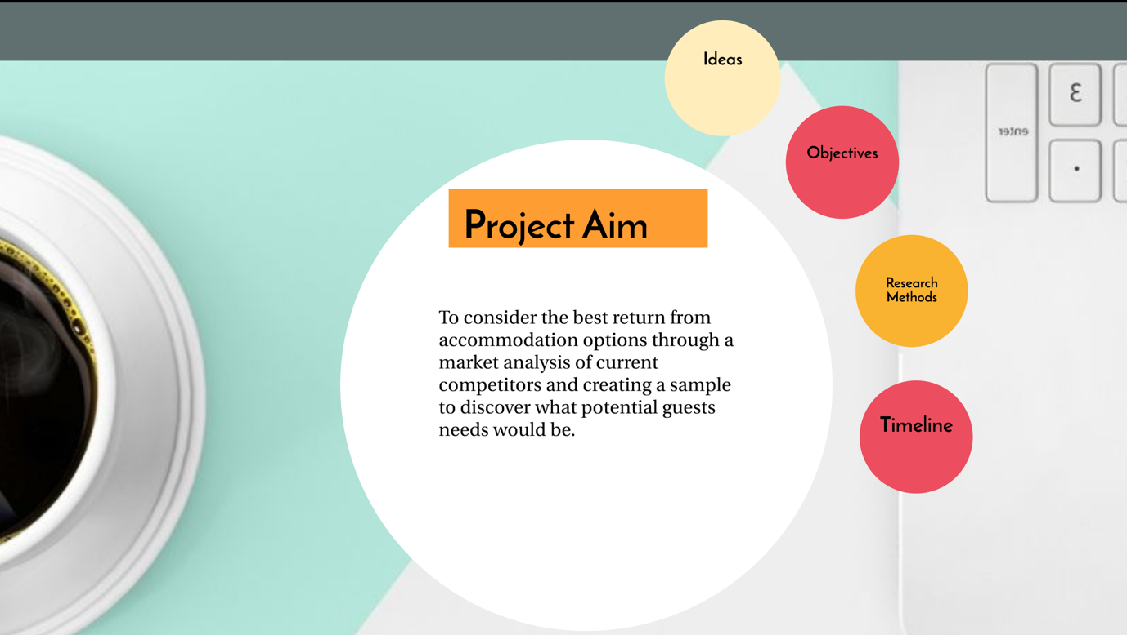
Slide 3

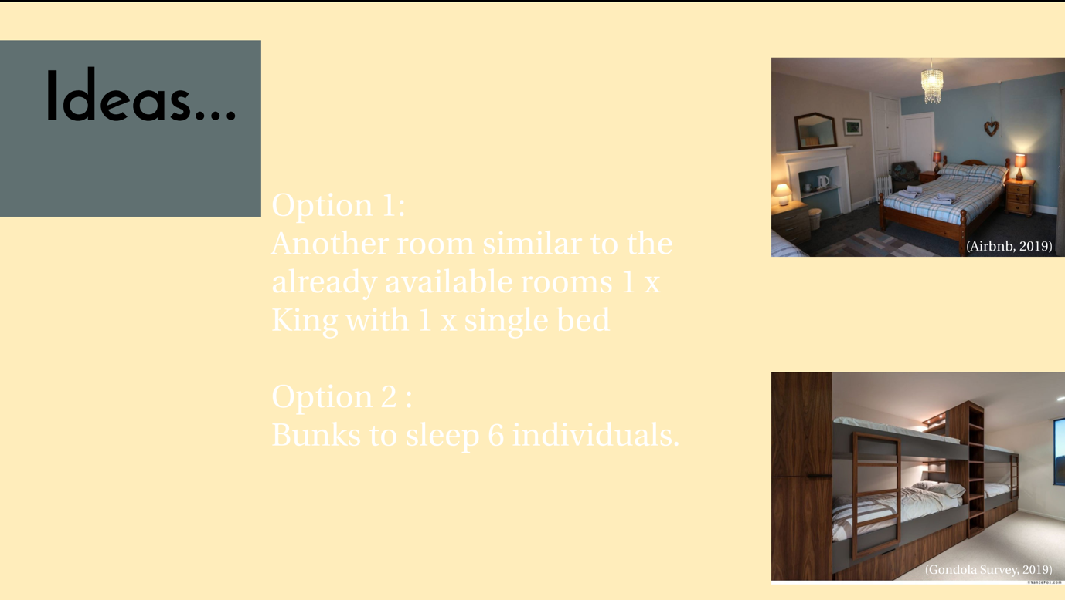
Slide 4

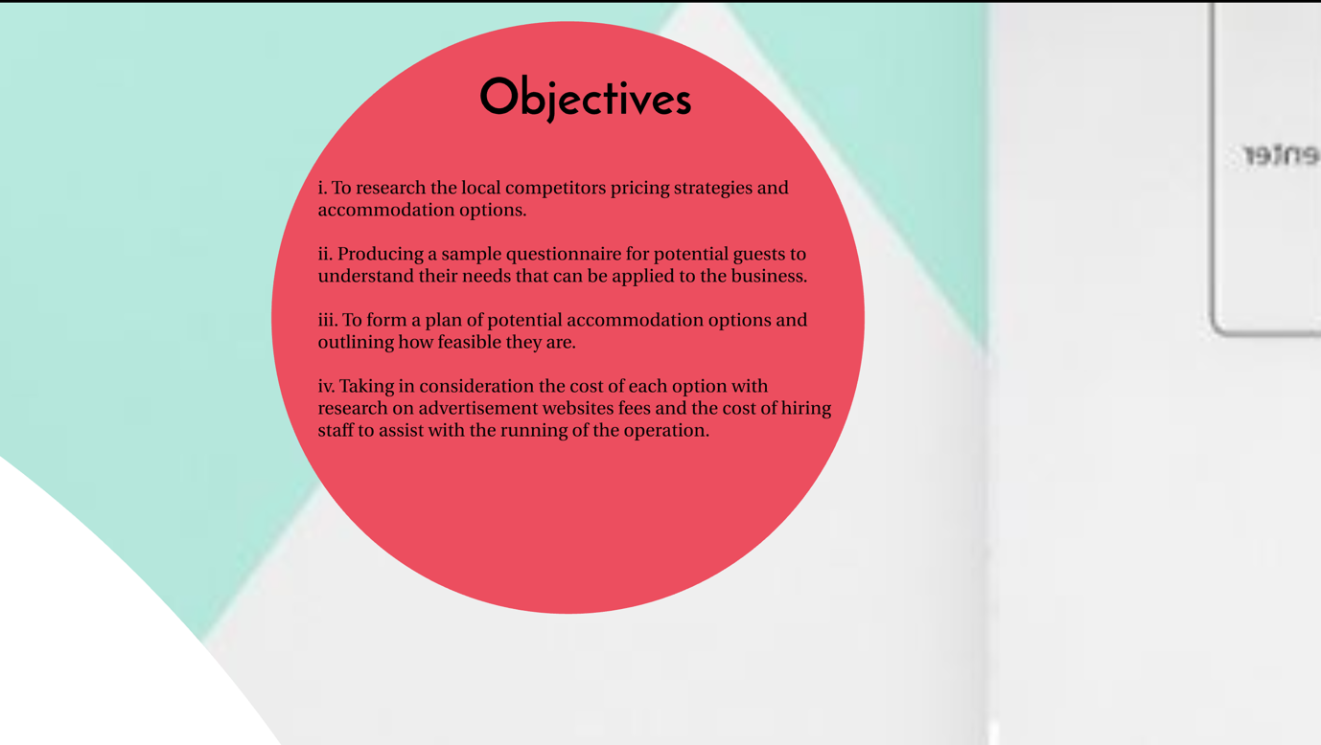Slide 5


Slide 6

Slide 7

Slide 8

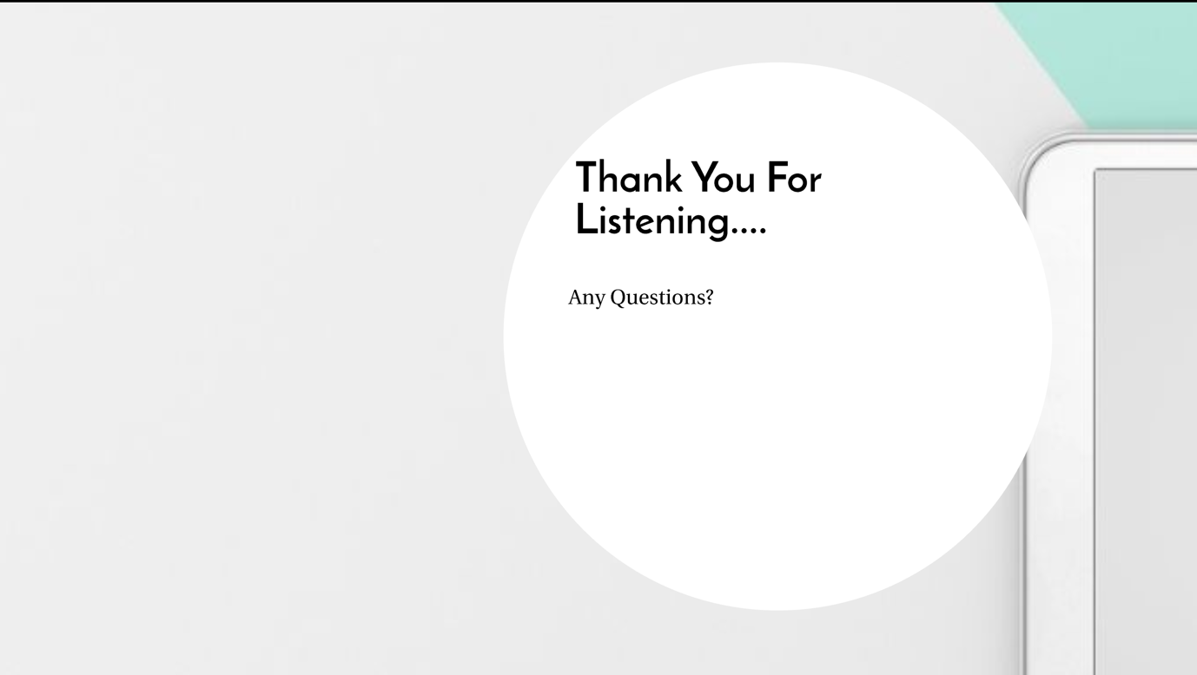
Slide 9

References
Airbnb. (2019). Stay @ The Star - Room 1 - Guest suites for Rent in Talybont-on-Usk, Wales, United Kingdom. [online] Available at: https://www.airbnb.co.uk/rooms/17939937?guests=1&adults=1 [Accessed 20 Feb. 2019].
Gondola Survey. (2019). Dark Wood Bunk Beds Phenomenal 12 Inspirational Examples Of Built In CONTEMPORIST Home Interior 19 - gondolasurvey. [online] Available at: http://gondolasurvey.com/dark-wood-bunk-beds/dark-wood-bunk-beds-phenomenal-12-inspirational-examples-of-built-in-contemporist-home-interior-19/ [Accessed 21 Feb. 2019].
Thestarinntalybont.com. (2019). The Star Inn Talybont. [online] Available at: http://www.thestarinntalybont.com [Accessed 20 Feb. 2019].

