

Strategic Management (LCMB7003)

Strategic Analysis of Marks & Spencer
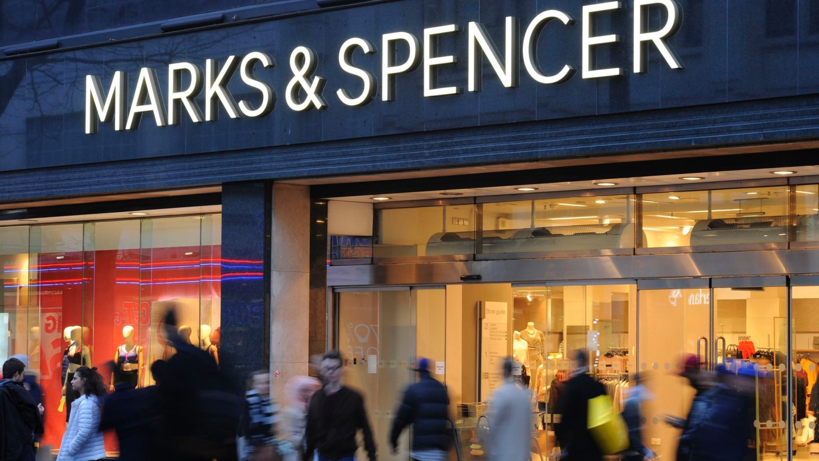

Student name: Ravinder Singh
Student Number: 2216782
Lecturer: Hossin Shokri
Word count: 6526
Submission Date: 8th may 2023
Table of Contents
Introduction 2
Marks & Spencer Background 2
Marks & Spencer’s Mission and Objectives 3
Macro-Environment Analysis 4
PESTEL Analysis 4
Micro-Environment Analysis 5
Industry Life Cycle 5
Porter’s Industry Five Forces Analysis 6
Internal Analysis 7
Strategic Resources and Capabilities 8
Marks & Spencer Strategic Resources and Capabilities 8
Value Chain Analysis 8
Primary Activities 9
Secondary Activities 10
VRIO Analysis of Distinctive Resources and Capabilities 10
SWOT Analysis 12
Strategies to Sustain Competitive Advantage 13
Growth Strategies 14
Green Strategy and CSR 15
Conclusion 15
Recommendation 16
References 17
Appendix 18
Appendix 1: PESTEL Analysis 18
Appendix 2:SWOT Analysis 19

Introduction
More than a century has passed since Marks & Spencer first opened its doors for business in the United Kingdom. The organization has been around for a very long time and has earned a stellar reputation for both the quality of its goods and the caliber of its customer care. Despite this, Marks & Spencer has had a difficult time competing successfully in the retail industry during the past few years. The firm has had to adapt to the shifting preferences of its customers, the intense rivalry in its industry, and the introduction of new disruptive technology. As a result, the company's sales and profits have fallen, and it has captured a smaller portion of the market (Mark and Spencer, 2023). Moreover,Marks and Spencer opened their first store in the United Kingdom in the year 1884, marking the beginning of the company's long history there. This retail establishment offers a broad selection of goods for purchase, which may include but are not limited to food, clothes, cosmetics, and home adornment items. Marks & Spencer not only has a presence in the United Kingdom, where it has more than a thousand stores, but also in around 450 other countries across the world, where it operates its own retail locations(marksandspencer.com, 2023). During the fiscal year that came to a close on April 2, 2022, around 10.9 billion GBP worth of sales income was generated by the United Kingdom and other nations combined. This is a loss of almost 900 million pounds as compared to the same time of the prior year (statista.com, 2023).
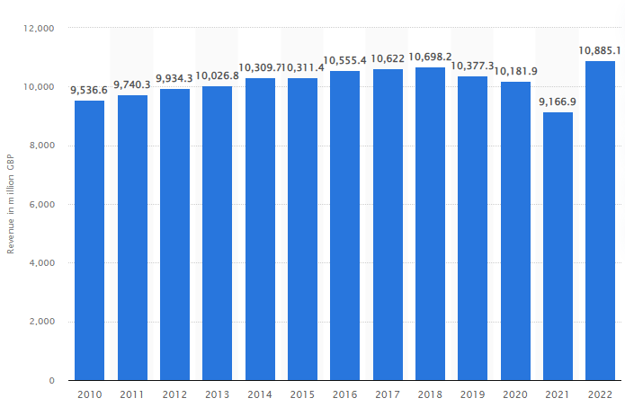
Revenue of the company
(Satatista, 2023)

A thorough examination of the industry's life cycle, Porter's five forces, value chain, strengths, weaknesses, opportunities, and threats, and available strategic resources and competencies will be subjected in this paper. The purpose of this case study is to examine the difficulties encountered by Marks & Spencer and the methods by which these difficulties may be surmounted. In order to help the company recover and restore its place in the market, the research provides a thorough review of its resources, competencies, and competitive environment.

Marks & Spencer Background
Marks & Spencer (often known as M&S) is a British multinational retail company that was established in 1884 by Michael Marks and Thomas Spencer. The headquarters of the corporation are located in London, which is located in the United Kingdom; nevertheless, the company has operations in more than 50 countries. The majority of clothing, home items, and upscale groceries are sold at M&S, as this is the company's primary focus (Mark and Spencer, 2023). Marks & Spencer's business strategy is unique in comparison to the other large retailers on the typical British high street. While many of the largest supermarkets do indeed house clothes departments within their larger establishments, no other business offers two such diverse lines of business as these supermarkets do.
By the year 2021, the company will have approximately 78,000 people working for it across all of the various businesses it operates in various parts of the world. In recent years, M&S has experienced a decline in both sales and profitability as a result of the increasing competition it faces from both online and low-cost retail establishments. In the year 2020, the business's total revenue was £9.9 billion, but it suffered a net loss of £87.6 million (Mark and spencer, 2023).
M&S's items are available in a variety of locations across the world, including the Middle East, Asia, Europe, and the United Kingdom. The firm keeps a substantial presence in that country thanks to the over one thousand retail locations that are connected by its distribution network there. The size of the company's online presence is growing, and the corporation already derives a sizeable portion of its revenue from the use of digital channels. In recent years, M&S has been working to turn around its poor financial performance by employing a number of strategies. These strategies include lowering costs, expanding their product lines, and increasing their presence on the internet. Yet, the retail market is marked by a high degree of competition, and the future performance of the company is uncertain as a direct result of the issues that it continues to face (Mark and spencer, 2023).

Marks & Spencer’s Mission and Objectives
Marks & Spencer has set for itself the lofty goal of becoming "the world's most sustainable retailer by the year 2025." To achieve this goal, the company is implementing a number of initiatives that aim to reduce the company's carbon footprint, increase ethical sourcing, and improve the quality of life for employees working throughout its supply chain. In addition, the objective of the organization includes providing outstanding products and services in response to the ever-evolving requirements and preferences of its customer base (Mark and spencer, 2023).
M&S has struggled in recent years to achieve its objectives because of a decline in both its sales and its revenues. The management has implemented a turnaround strategy with the goals of repositioning the brand, reducing expenses, and increasing operational efficiency in order to tackle these difficulties.
Objectives of M&S's
- To turn things around are to improve the quality and look of its clothing, home, and food products so that it can attract and keep customers.
- To lower its costs by optimizing its supply chain, making its operations more efficient, and cutting its overheads.
- To focus on improving its website and doing more digital marketing to grow its online business.
- To make things easier for itself by cutting down on the number of products it sells, streamlining its supply chain, and making things easier in its stores.

Macro-Environment Analysis
The macro environment analysis is an essential part of a company's strategic planning process, which enables the company to identify and evaluate opportunities and hazards that might impact the firm's business and determine where to focus its efforts. It is very important for management to be prepared with information before making any operational decisions so that they can make informed decisions when making them (Sammut-Bonnici, 2017).
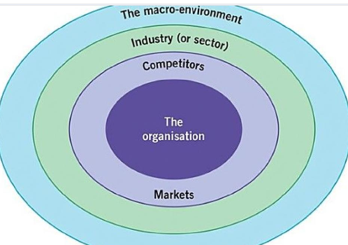
An analysis of the macro environmental factors affecting Marks & Spencer is conducted using a PESTEL analysis

PESTEL Analysis
There are several external factors that can impact an organisation, and a PESTLE analysis examines the most important ones (Political, Economic, Sociological, Technological, Legal, Environmental). People professionals and senior managers can use it in a number of different scenarios, and it can play an important part in the strategic decision making process.Moreover,As a result of a PESTLE analysis, organizations can obtain contextual information or insight into the operations of an organization, its brand positioning, its growth goals and its risks factors that impacts operations of the organization. Overall PESTEL Analysis can assist in determining the validity of existing products and services as well as the definition of new product development (Whittngton & Johnson, 2021, p. 5).
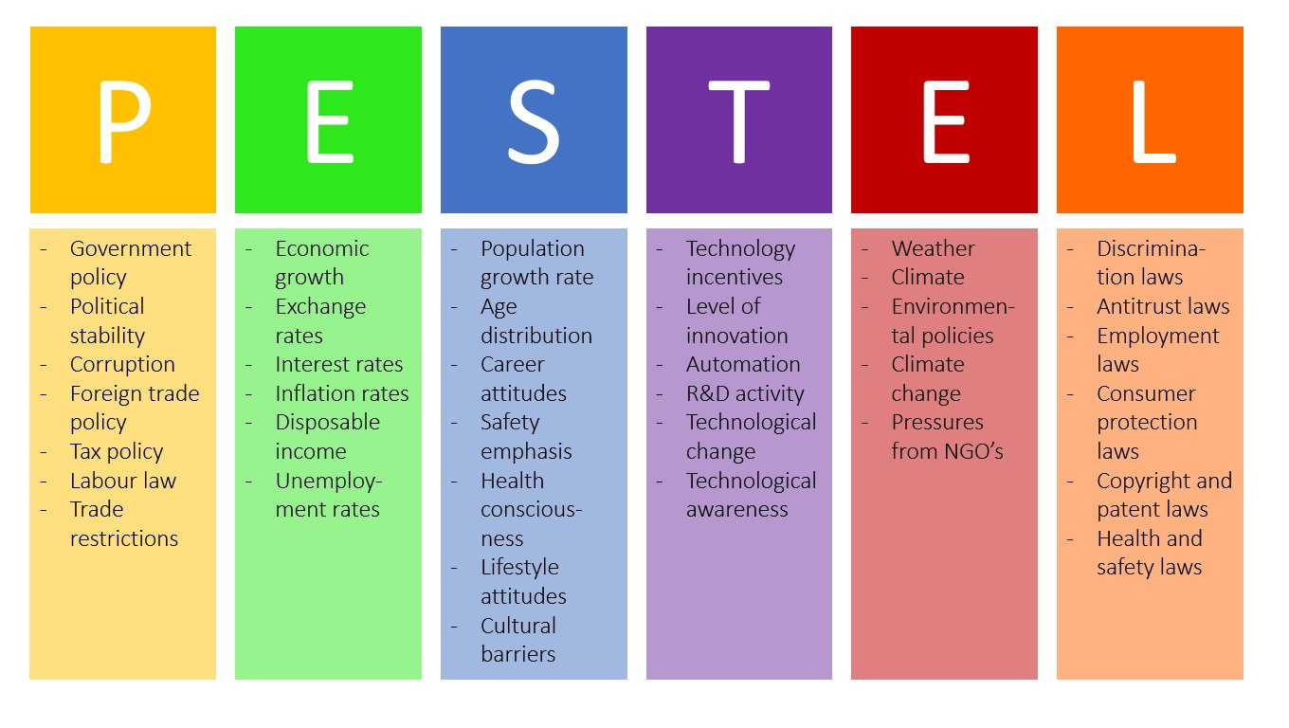
(Bruin, 2016)
- Political: Uncertainty in the UK and EU markets has a direct impact on M&S's bottom line. Costs have risen and supply chains have been disrupted because of changes in trade laws and regulations brought about by the UK's exit from the EU (Gysegom, 2019).
- Economic:M&S is being affected by a number of factors, including a slow economic development, a rise in prices or tax rate by the government, and increased competition from discount stores, among others.As an example, if the government increases taxes on the products of Marks & Spencer by a significant amount then that will result in an increase in the price of the products of Marks & Spencer, which would be detrimental to the sale of their products.
- Social: There are a number of sociocultural changes that are affecting M&S from a sociological perspective, such as changes in consumer behavior and preferences, in particular the increasing focus on sustainability and ethical sourcing. (Deloitte, 2019).
- Technological: The rise of internet shopping is evidence of the profound effect that technological progress has had on the retail sector (Wired, 2020). M&S's internet business and digital marketing initiatives have suffered because of the company's reluctance to accept new technologies.
- Environmental: Sustainability and climate change, for example, have risen in prominence as environmental concerns among modern consumers. Focusing on environmental efforts and ethical sourcing, M&S has been attempting to find solutions to these problems. Nonetheless, the business has been criticized for the way it handles sustainability issues.
- Legal: It is important to point out that M&S may face many challenges in the future due to government regulations pertaining to environmental protection, worker rights, and personal information security issues (Hanadhyas and Wulandari, 2022).

Micro-Environment Analysis
An analysis of the microenvironment is a process of evaluating the elements within the microenvironment. An organization's immediate environment consists of all the actors, factors, and elements that make up the immediate setting in which it operates, and they have a direct bearing on how the organization runs (Yaneva, 2020).

Industry Life Cycle
Over its existence, every industry passes through a series of growth and decline phases, which are modeled by the life cycle of the industry. The industry life cycle consists of four phases (Majid Bahramian, 2020).In recent years, the industry life cycle has become one of the most important business tools available to businesses. In this way, stakeholders are able to determine what the current state of the industry is in order to make informed decisions.

- Introduction: Marks & Spencer, a British department store chain, was established in 1884. The company pioneered innovative retail concepts, including the self-service model, and widened its product range to include apparel and food in its early years (Mark and Spencer, 2023).
- Growth: Marks & Spencer went through a period of rapid growth and expansion in the 1990s and early 2000s, when many new stores opened in the UK and around the world. Around this time, the company also expanded into providing monetary services, consumer items, and cosmetics to the public (Mark and Spencer, 2023).
- Maturity: Marks & Spencer has reached maturity as a retailer, and as a result, it now faces stiffer competition from budget and online stores. The corporation has had trouble responding to customers' preferences as they've evolved through time, such as the rise of online shopping, and has been criticized for poor quality products and high prices (Prefixbox, 2018).
- Decline: Marks & Spencer is struggling to preserve its market position and sales at now, having seen a fall in both. To combat these problems, the company is enacting a turnaround plan that prioritizes raising product standards while cutting expenses and increasing its internet visibility (Kenton, 2022).
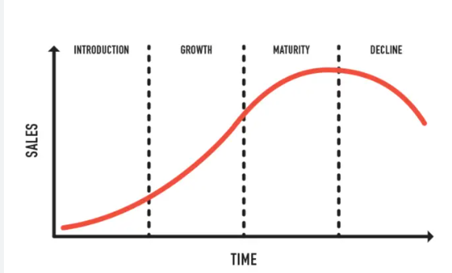
Fig 1: Industry Life Cycle
(Source: (Notes learning, 2020)

Porter’s Industry Five Forces Analysis
Porter's Five Forces Analysis is a helpful framework for analyzing the competitive dynamics of the retail business and the obstacles to Marks & Spencer's turnaround strategy, as presented in the case study.
Threat of new entrants:Threat of new entrants is moderate at best in the retail sector. The proliferation of e-commerce, however, has lowered the barrier to entry for new competitors. In order to counteract this risk, Marks & Spencer must expand its online offerings and strengthen its ability to conduct business online (Domain, 2020).
Barganing Power of suppliers:The second force, suppliers' bargaining power, is rather weak in the retail sector. But suppliers still have sway in areas like product development and quality assurance. Maintaining its high standards of quality and reliability requires close cooperation between M&S and its suppliers (Goyal, 2020).
Barganing Power of customers: Customersin the retail sector have a lot of negotiating power. Consumers can easily shop elsewhere and have a wide variety of things to choose from. In order to stand out from the crowd and win the allegiance of its customers, M&S must provide products and services that can't be found anywhere else (Faster Capital, 2023).
Threat of substitutes: The retail industry faces a significant level of the fourth factor, the threat of substitutes. Alternatives to M&S can be found at online merchants, bargain retailers, and other brick-and-mortar establishments (Whittngton & Johnson, 2021, pp. 6,7). The business must come up with strategies such as content marketing to set itself apart from rivals and provide goods and services that its rivals will have a hard time duplicating (Perry, 2023).
Competitive rivalry: Due to the abundance of retailers and the fierceness of the competition, competitive rivalry ranks high in the retail sector. M&S must set itself apart from competitors like bargain stores, online marketplaces, and even other traditional department stores by providing superior goods and services and fostering brand loyalty among its clientele. Marks & Spencer's supply chain has lagged other major department store businesses by many years (Whittngton & Johnson, 2021, pp. 6,7). Next, Inditex (the parent company of the Zara brand), and H&M are just a few of the competitors that have integrated with their suppliers and taken much more direct control over factories, allowing them to stock their stores more quickly and introduce new product lines more frequently (hmgroup, 2023).
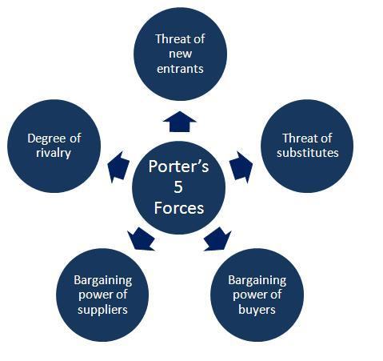
(studycorgi, 2022)

Internal Analysis
An internal analysis involves the evaluation of all the components that interact within an organization as a way of identifying failures and identifying possible areas for improvement. A strength and weakness analysis is the process of discovering the strengths and weaknesses of the organization .

Strategic Resources and Capabilities

Marks & Spencer Strategic Resources and Capabilities
The capacity of Marks & Spencer to carry out its strategy for turning the company around is significantly reliant on the strength of its strategic resources and skills. The following is a list of some of the most valuable assets and strengths that the company possesses:
Brand Reputation: Marks & Spencer has a great reputation in the marketplace for the quality and dependability of their products, most notably their food offerings. This presents an opportunity for the company to differentiate itself from other businesses and earn the commitment of its clientele (Mark and spencer, 2023).
Store Network: M&S has a significant competitive edge over purely online retailers as a result of the enormous store network it maintains across the country. If the company does not adapt to the changing preferences of its customers, this advantage may also become a negative for the company (Mark and spencer, 2023).
Product Development: M&S has a long history of being an industry leader in establishing new product categories, particularly in the field of food. This has been one of the company's primary focuses. This advantage can be leveraged to generate original new products and services that set the company apart from its competitors (Mark and spencer, 2023).

Value Chain Analysis
An analysis of the value chain of a business is a way of identifying where opportunities for improvement exist in each of the activities within the value chain within the organization. It is crucial to consider how each step adds value to or subtracts value from your final product or service when conducting a value chain analysis (Zamora, 2016). Similarly,the use of a value chain analysis can help improve one's comprehension of both the operational strengths and weaknesses of M&S.
- Inbound logistics: Because of the vertical integration of its supply chain, M&S has complete control over the product quality as well as the purchasing decisions that go into the creation of new inventory. To achieve the goals, it has set for itself regarding the reduction of costs and the expansion of production, the corporation might have to make some modifications to its logistical processes (Mark and Spencer, 2023).
- Operations: The day-to-day operations of M&S are complicated by the enormous retail network that the company maintains, which requires a significant investment. Because of shifting preferences among customers, the corporation might need to modify the configuration of the retail spaces it operates to maintain its position as a market leader (Mkansi and Nsakanda, 2021).
- Outbound Logistics: The M&S distribution network makes it possible to carry out timely and effective outbound logistics by ensuring that products are delivered to retailers and customers as quickly as feasible. Yet, for the company to remain competitive with retailers that are exclusively online, it will unquestionably have to improve its capabilities in the realm of electronic commerce (Mark and spencer, 2022).
- Marketing and Sales: In terms of marketing and sales, M&S is able to capitalise on its strong reputation as well as its dedicated customer base. Despite this, the company may need to increase the amount of money it spends on marketing and sales in order to bring in more clients and boost overall sales (Chernetsky, 2022).
- Service: M&S has developed its reputation as a retail giant on the strength of the quality of the service it gives to its customers. This reputation is based on the fact that M&S customers receive excellent service. Yet, in order for the organisation to continue providing such a high quality of service as it learns to cater to changing client demand, it may be necessary for the organisation to invest in training and development.

Primary Activities
- Supply Chain management and sourcing: M&S sources and manages its supply chain in collaboration with its suppliers. The firm has developed stringent ethical and sustainability requirements that its suppliers must meet, and it works aggressively to enhance the supply chain's sustainability and traceability (Esoimeme, 2020).
- Product Development: New items and lines for M&S stores are developed by the company's in-house staff of designers and product developers (annualreports.com, 2021).
- Brand management and Branding: M&S spends a lot of money on marketing to spread the word about the company and its wares. Advertisements, social media, and email blasts are just some of the ways that the company reaches out to its clientele (annualreports.com, 2021).
- CSR: M&S engages in numerous programmes to advance sustainability, ethical sourcing, and community involvement as part of its CSR (Corporate Social Responsibility) efforts. The M&S Foundation is the company's designated philanthropic arm, and it gives generously to many different charities (Mark and spencer, 2023)..

Secondary Activities
- Procurement: This refers to the processes that are required in order to source the labor and materials necessary for the core operations. Finding a dependable provider, negotiating a contract, and making a purchase are examples of the kinds of activities that fall under this category (Young, 2023).
- Technology Development: As the name suggests, research and development refers to any and all efforts made by a company in order to improve the quality of its products or the operations of the company. This term is abbreviated R&D. Examples of such activities include the creation of new items, the improvement of current ones, and the conception of completely original concepts.
- Human Resource Management: This term refers to the management of human resources in some capacity. This includes responsibilities such as recruiting, training, and assessing the performance of the staff (ADP, 2018).
- Infrastructure:It is in this category that activities related to finance, law and administration are classified(al Habibi, 2019).

VRIO Analysis of Distinctive Resources and Capabilities

Resource/Capability | Value | Rarity | Imitability | Organization
Brand Image | Yes | Yes | Partially | Yes
Supply Chain | Yes | Yes | Partially | Yes
Employee Skills and Expertise | Yes | Yes | Yes | Yes
E-commerce Platform | Yes | Yes | Potentially No | Yes
Table 1: VRIO Table
The case study on MarketLine about Marks & Spencer presents an excellent chance to apply the VRIO framework to the specific advantages and disadvantages possessed by the company.
Brand Image: Because of the strength of its brand image, Marks & Spencer has been able to build a strong reputation in the industry and draw in a dedicated customer base over the course of several decades. This has enabled the company to grow its customer base. Rarer is the fact that just a handful of other brands enjoy the same level of pervasive popularity and devoted customer base. However, it is possible that other companies could try to imitate your success with their own branding strategies, which means that it may not be completely inimitable. The company maintains a sustainable competitive advantage because of the consistency and power of its brand image throughout all of its marketing and communication endeavours (Federated media, 2017).
Supply Chain: Marks & Spencer is in a position to effectively manage its stock, reduce its costs, and maintain the quality of its products as a direct result of the well-established supply chain that the company utilizes. This asset's value is incalculable due to the fact that it enables the company to cut costs and differentiate itself from its rivals (Miethlich and Oldenburg, 2019). In addition, the supply chain used by Marks & Spencer is unique due to the fact that it is extremely thorough and well-integrated. The company has proven that it is able to efficiently manage this resource by implementing robust inventory management and quality control systems. These systems contribute to the capacity of the company to keep a competitive advantage over its competitors.
Employee Skills and Expertise: Knowledge and experience of staff members, in addition to the employee's skills and expertise Marks & Spencer has a large staff that is comprised of individuals that have a diverse set of skills and experience in a variety of areas, including product development, production, and customer support. If the company had access to this resource, it would be able to be more innovative, develop better products, and provide superior service to its customer base. In addition to this, it is extremely unusual because there are very few companies that can boast having such a multiethnic staff that is also highly trained. It takes a lot of time and effort to create a team with such skill, but once it is achieved, it may be impossible to replicate. In conclusion, the company has made investments in the training and development of its employees, which contributes to the maintenance of a continual edge in the market.
E-commerce Platform: Marks & Spencer provides customers with the ability to shop online through the use of an e-commerce platform. This asset not only assists the company in expanding into new markets, but it also makes it simpler for the company's current customers to make purchases from the organization (Optimizely, 2019). It is also uncommon because very few companies have devoted the time and money necessary to build out such an advanced online presence. This combination of features and ease of use may not be able to be replicated by anyone else, which would make it a truly one-of-a-kind product. The company has made investments in new technology and digital marketing strategies. This demonstrates that the resource is being managed effectively, which supports a sustained advantage over the competition.

SWOT Analysis
An SWOT analysis is the process of evaluating a company's strengths, weaknesses, opportunities, and threats (as well as evaluating its competitive position in the market) in order to develop a strategic plan. By analyzing both internal and external factors, as well as the potential for the company's future, a SWOT analysis will be conducted.Furthermore,the organizations can benefit from a SWOT analysis by getting a better understanding of their current situation, allowing them to analyze and measure their overall business performance in real time. An analysis of a company's strengths can help them better penetrate the market so that they will be able to achieve business goals through a better penetration of the market (Whittngton & Johnson, 2021).
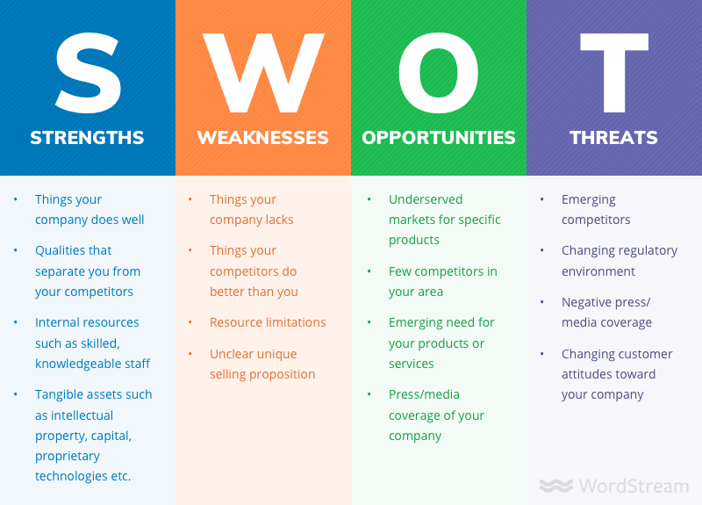
(Shewan, 2022)

Strengths | Weakness
- A well-known and reputable brand  - Knowledgeable workers  - A variety of goods, including food and clothing | - Declining market share and financial performance  - Slow e-commerce and digital technology adoption  - Limited global presence in comparison to competitors  - Reliance on the British market
Threats | Oppourtunities
- Fierce rivalry between traditional and online shops  - Uncertainty in the economy and probable downturns  - Adapting customer trends and desires  - Brexit's potential effects on operations and the supply chain | - Increasing sales in new overseas markets  - Market potential for growth in online retail  - Rising demand for items sourced ethically and sustainably  - Possibility of restructuring to decrease costs and streamline operations

Strategies to Sustain Competitive Advantage

If a company is able to maintain a competitive advantage over its competitors in the same industry or field, then it can consistently outperform them (Lynch, 2009) There is a high probability that companies with this type of advantage create a significant value for their customers in comparison to other businesses and this is true most of the time (Srivastava, et al., 2013, p. 15).In order to accelerate its competitive advantage, Marks & Spencer has adopted the following strategies:
- Cost Leadership: Marks & Spencer is regarded as a leader in the retail sector because of the importance it placed on ethical business practises and superior product quality. As a result of adopting this method, the company is now competitively priced within its field. Nonetheless, the company has difficulties due to the intense competition in the retail industry generally and in the UK market in particular. By simplifying operations, optimising supply chains, and cutting prices, Marks & Spencer may be able to address this issue and attract budget-conscious customers using cost leadership strategies (Srivastava, et al., 2013, p. 15).
- Differentiation: Marks & Spencer is distinguished from its rivals by the high quality of its goods and the efficiency of its business practises. In order to differentiate itself from competitors, the company may keep stressing the one-of-a-kind nature of its products, designs, and commitment to environmental responsibility. One way to do this is to roll out a marketing push that emphasises the company's dedication to its mission and the advantages it offers over rivals.
- Focus: The M&S separate itself apart from competitors by focusing on a specific clientele. To fulfil the growing demand for sustainably and ethically derived goods, the company may decide to target a population that is currently being ignored by the market. It's also possible that the organisation will cater to a niche market whose needs aren't being satisfied by the industry at large. This would entail catering not only the advertised products and services, but also all client interactions, to the preferences of the targeted demographic (Barney & B, 2019).

Growth Strategies
In order to realize its goals for expansion, an organization has to develop a growth strategy that can overcome the challenges it faces in the present and in the future. Marks & Spencer's growth strategy includes the following:
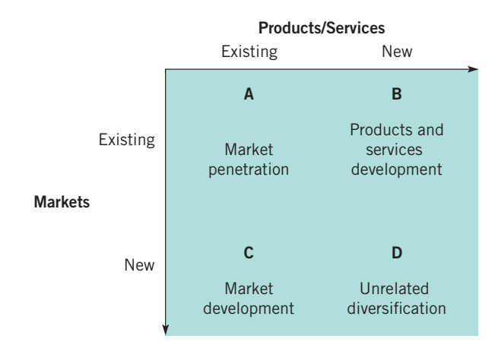
Ansoff Matrix
(Lecture Material Week 5)
- Market Penetration: In an effort to increase its overall market share, Marks & Spencer can choose to place more of its focus on the United Kingdom. A few examples of the types of promotional tactics that might work well in this context include holding sales, providing discounts, and establishing customer loyalty programmes. The company might do more to assure the pleasure of its customers by enhancing the quality of the services it provides at its brick-and-mortar sites, improving the quality of its customer service, and making the company's products and services more easily accessible via the internet (Arustamyan, 2021).
- Development of Markets: To better serve the needs of their growing customer base, Marks & Spencer may expand into new markets to better serve their customers. As a result, it would be a good idea for the company to increase its online presence or even to open physical stores in regions of the world where it is still underdeveloped. To acquire new clients, the company, for instance, might explore emerging economies in order to gain access to new markets. As this area has a growing demand for products that are eco-friendly and made using ethical methods, it makes sense that this would be the case.
- Product Development: Marks & Spencer is currently contemplating whether or not they should invest money in research and development in order to better satisfy the ever-changing requirements and preferences of their clients. A company might, for instance, expand its product line to include athleisure and sustainable apparel, or it might introduce additional healthy and organic food options in order to accommodate shifting consumer preferences. These are just two examples of how a business might adapt to changing customer preferences. Either of the two possible courses of action is reasonable for the corporation to take.
- Diversification: Diversification is an essential component of this strategy since it will make it easier for Marks & Spencer to enter new markets and product categories. This makes diversification one of the most important tenets of this approach. The corporation may, for example, enter foreign regions and introduce cutting-edge product lines that are specifically designed to appeal to the tastes and habits of the consumers in those regions. These product lines may be specifically designed to appeal to the tastes and habits of the consumers in those regions.

Green Strategy and CSR
Green Strategy: The company has adopted a green strategy that integrates concern for the environment into all facets of its day-to-day operations in order to continue to thrive. In order to reduce harmful pollutants, increase recycling rates, and use greener sources of raw materials as much as possible, the corporation has established stringent targets for reducing pollutants and reducing harmful pollutants. As part of their effort to execute Plan A 2025, Marks & Spencer intends to recycle all of the plastic packaging it uses by the year 2022, as well as to obtain all of its cotton from sustainable sources by 2025. Keeping true to its commitment to green business practices will help Marks & Spencer gain an edge in the market and gain the support of environmentally conscious consumers if it stays true to its commitment to green business practices.
CSR: A company like Marks & Spencer has long been dedicated to pursuing corporate social responsibility (CSR), something they are passionate about as well. Fair trade, ethical sourcing, and community involvement are just some of the areas in which the company has been recognized for its efforts. In order to demonstrate that Marks & Spencer is serious about adopting ethical and environmentally responsible business methods as a key part of its turnaround plan, the company might have to step up its corporate social responsibility initiatives. Increasing the openness of its supply chain and enforcing ethical standards on its vendors are two ways the company could better serve the public interest.
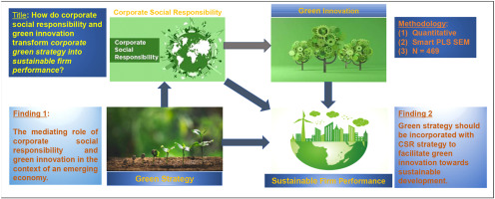
(Le, 2022)

Conclusion
It has been examined in the above study how Marks & Spencer has a variety of aspects to its business strategy, how technologies and other factors can impact its business model and how those factors can be used to maximize profitability, corporate social responsibility, and business sustainability.Marks and Spencer has been shown to have to develop their business strategies in a way that takes into account all of these factors in order to make sure that these strategies are optimal. The report also concluded that a PESTEL analysis of the organization showed that there were both opportunities and challenges for Marks & Spencer in the UK market.In the report it is stated that Marks & Spencer is capable of implementing its strategy for transforming the company around if it relies heavily on the strategic resources and skills it has available to it, such as brand popularity and product development if it is determined the most effective strategy for doing so.Upon analyzing the value chain of Marks & Spencer, it is clear that M&S controls both the product quality as well as the purchasing decisions that lead to the creation of new inventory, as well as the entire supply chain. In addition to the practices of green strategy and corporate social responsibility by the organization, the organization also gained a competitive edge in the market as a result of the practices of green strategy and corporate social responsibility.
The overall conclusion of the report was that due to the significant strength of the brand image that Marks & Spencer has developed over multiple decades as a result of the quality of its product range, the company has been able to build a strong reputation within the industry, as well as attract a loyal clientele.

Recommendation
The clothing and the food business of Marks and Spencer needs to be made more successful by making a plan or a tactic at the beginning, and then, based on that plan, taking action based on the tactic. To begin with, the organization needs to increase the valuation of their business more than they have in the past.On the other hand, the company also needs to broaden the range of clothes it offers so that it can cater to the needs of customers from different countries and different regions through their clothing collection. It is imperative that the institution determines who their ideal customers are by distinguishing them into four categories: audience, loyal consumers, and target audience. It is only through the loyal customers of their business that the company can be able to expand its operations, as well as providing them with motivation at work. As for Marks and Spencer, they will need to make sure that they are constantly checking their revenue streams in order to make their financial year more profitable in the future.Furthermore, Marks and Spencer should also maintain a good work environment for its employees, so that they get a sense of satisfaction working for the company, as that will then help them to be more productive as they will be able to fully focus on their work. As a consequence, we can conclude that when a business plan is put into place correctly, it can change the course of the company for the better.
Similarly, M&S is able to leverage its strong reputation in marketing and sales, as well as its loyal customer base, when it comes to making the most of its marketing and sales strategies.In spite of this, however, it may still be necessary for the company to increase the amount of money it spends on marketing and sales in order to increase the number of clients they bring in and increase their sales overall (Chernetsky, 2022).In addition, the organization needs to adopt the e-commerce and the adoption of digital technologies in order to be successful.Furthermore, it is recommended that Marks & Spencer is able to effectively tackle this issue by increasing productivity, improving supply chain operations, and cutting prices. By utilizing cost leadership strategies to address this issue, Marks & Spencer can successfully attract budget-conscious customers and address this issue.Among the other recommendations that we have for the organization, one is the need to explore emerging economies in order to acquire new clients for the company. It would be logical for the organizations to utilize this approach to meet the ever-growing demand for products which are environmentally friendly as well as ethical.

References
ADP, 2018. Human resource management (HRM). [Online]
Available at: https://www.adp.com/resources/articles-and-insights/articles/h/human-resource-management.aspx
[Accessed 19 April 2023].
Arustamyan, A., 2021. ROLE OF STRATEGIC MARKETING IN CREATING ORGANISATIONAL VALUE. Journal of education & humanities research, 10(11).
Barney & B, J., 2019. Strategic Management and competitive advantages: Concept aand cases. [Online]
Available at: https://ebookcentral.proquest.com/lib/trinity/detail.action?pq-origsite=primo&docID=5573680
Bruin, L. d., 2016. Scanning the Environment: PESTEL Analysis. [Online]
Available at: https://www.business-to-you.com/scanning-the-environment-pestel-analysis/
Chernetsky, V. V., 2022. A synthesis of research on the marketing-sales interface (1984–2020). Journal of industrial marketing management, Volume 105, pp. 159-181.
Deloitte, 2019. Shifting sands: How consumer behaviour is embracing sustainability. [Online]
Available at: https://www2.deloitte.com/ch/en/pages/consumer-business/articles/shifting-sands-sustainable-consumer.html
[Accessed 19 April 2023].
Domain, 2020. 10 Tactics to Beat Your Online Competition. [Online]
Available at: https://www.domain.com/blog/10-tactics-to-beat-your-online-competition/
[Accessed 19 April 2023].
Doyle, P. & Stern, P., 2006. Marketing Management and Strategy. 4 ed. Essex: Pearson Education Limited.
Faster Capital, 2023. What Makes A Successful Unique Product. [Online]
Available at: https://fastercapital.com/content/What-Makes-A-Successful-Unique-Product.html
[Accessed 19 April 2023].
Federated media, 2017. CONSISTENCY AS A COMPETITIVE ADVANTAGE. [Online]
Available at: https://blog.federatedmedia.com/consistency-as-a-competitive-advantage
[Accessed 19 April 2023].
Goyal, A., 2020. A Critical Analysis of Porter's 5 Forces Model of Competitive Advantage. Journal of Jetir, 7(7).
Gysegom, W., 2019. Brexit: The bigger picture—Rethinking supply chains in a time of uncertainty. [Online]
Available at: https://www.mckinsey.com/featured-insights/europe/brexit-the-bigger-picture-rethinking-supply-chains-in-a-time-of-uncertainty
[Accessed 19 April 2023].
hmgroup, 2023. Supply chain. [Online]
Available at: https://hmgroup.com/sustainability/leading-the-change/transparency/supply-chain/
[Accessed 19 April 2023].
Kenton, W., 2022. Price Controls Explained: Types, Examples, Pros & Cons. [Online]
Available at: https://www.investopedia.com/terms/p/price-controls.asp
[Accessed 19 April 2023].
Le, T. T., 2022. How do corporate social responsibility and green innovation transform corporate green strategy into sustainable firm performance?. Journal of Cleaner Production, pp. 1-12.
Lynch, R., 2009. Strategic Management. [Online]
Available at: https://ebookcentral.proquest.com/lib/trinity/detail.action?pq-origsite=primo&docID=5347868
Majid Bahramian, K. Y., 2020. Life cycle assessment of the building industry: An overview of two decades of research (1995–2018). Energy and buildings, Volume 219.
Mark and spencer, 2022. Shopping in store & online. [Online]
Available at: https://www.marksandspencer.com/c/help-and-support/shopping-instore-and-online
[Accessed 19 April 2023].
Mark and spencer, 2023. Corporate Governance at Marks and Spencer. [Online]
Available at: https://corporate.marksandspencer.com/about-us/corporate-governance
[Accessed 19 April 2023].
Mark and Spencer, 2023. Everything to celebrate. [Online]
Available at: https://www.marksandspencer.com
[Accessed 19 April 2023].
Mark and Spencer, 2023. Our Products. [Online]
Available at: https://corporate.marksandspencer.com/sustainability/our-products
[Accessed 19 April 2023].
Mark and spencer, 2023. Our year in review 2022. [Online]
Available at: https://corporate.marksandspencer.com/investors/our-performance-updates/2022-annual-report
[Accessed 19 April 2023].
Mark and spencer, 2023. Our year in review 2022. [Online]
Available at: https://corporate.marksandspencer.com/investors/our-performance-updates/2022-annual-report
[Accessed 19 April 2023].
Mind Tools , 2022. The Ansoff Matrix. [Online]
Available at: https://www.mindtools.com/a2gy5ya/the-ansoff-matrix
Notes learning, 2020. Industry Life Cycle in Mergers and Acquisitions. [Online]
Available at: https://noteslearning.com/industry-life-cycle-in-mergers-and-acquisitions/
[Accessed 19 April 2023].
Optimizely, 2019. What is an ecommerce platform?. [Online]
Available at: https://www.optimizely.com/optimization-glossary/ecommerce-platform/
[Accessed 19 April 2023].
Perry, P., 2023. Contest Marketing Strategy: A Guide to Boosting Your Brand with Social. [Online]
Available at: https://blog.submittable.com/contest-marketing/
[Accessed 19 April 2023].
Prefixbox, 2018. such as the rise of online shopping, and has been criticized for poor quality products and high prices. [Online]
Available at: https://www.prefixbox.com/blog/online-shopping-problems/
[Accessed 19 April 2023].
Sammut-Bonnici, T., 2017. Macroenvironment. Research gate, pp. 1-2.
Shewan, D., 2022. How to Do a SWOT Analysis (With Examples & Free Template!). [Online]
Available at: https://www.wordstream.com/blog/ws/2017/12/20/swot-analysis
Srivastava, M., Martinette, L. & Franklin, A., 2013. Building a Sustainable Competitive Advantage. Journal of Technology Management and Innovation, 8(2), pp. 47-60.
studycorgi, 2022. Japanese Animation Industry and Porter’s Five Forces. [Online]
Available at: https://studycorgi.com/japanese-animation-industry-and-porters-five-forces/
Whittngton, R. & Johnson, G., 2021. Exploring Strategy: Chapter 3. [Online]
Available at: https://ebookcentral.proquest.com/lib/trinity/detail.action?docID=5987036&pq-origsite=primo
Wired, 2020. The Evolution of the Internet and Its Impact on Retail Spaces. [Online]
Available at: https://www.wired.com/insights/2014/07/evolution-internet-impact-retail-spaces/
[Accessed 19 April 2023].
Wood, M. B., 2013. Essential Guide to Marketing Planning. 3 ed. Harlow: Pearson Education Limited.
Yaneva, D. E., 2020. IMPORTANCE OF THE MARKETING ENVIRONMENT ANALYSIS IN THE PROCESS OF STRATEGIC MARKETING DECISION MAKING. Economics & Law, 2(2), pp. 24-32.
Young, J., 2023. What is procurement?. [Online]
Available at: https://www.investopedia.com/terms/p/procurement.asp
[Accessed 19 April 2023].
Zamora, E., 2016. Value Chain Analysis: A Brief Review. Asian Journal of Innovation and Policy, 5(2), pp. 116-128.

Appendix

Appendix 1: PESTEL Analysis

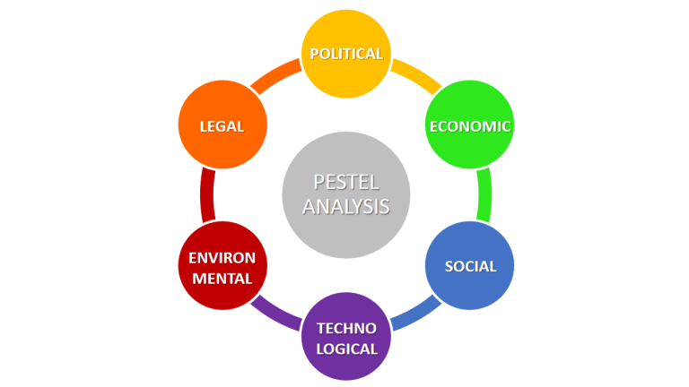

Appendix 2:SWOT Analysis


