MODULE CODE: SBUS 5121 Managing People

Student Name: Starliciuc Alexandru Madalin
Student Number: 1504818
Module Lecturer’s Name: Mushfiqur Rahman
Subject: Question 2

Introduction
This assignment is primarily created on existing information, readings and investigation from diverse assets completed by means of our unbiased records and expertise and documents from countrywide and global establishments. It targets to deliver precise deliberations of the issues connected with the threat of precariousness.
Concurring with the European Parliament's expressions of reference, it objectives to offer a meaning of tricky work and an explanatory idea, this covers the particular components and impacts of precariousness, their esteem and propensities.
Risky work is a concept that doesn't require a universally-accepted meaning in Europe.
More European Member States are confronted with one-of-a-kind labour market demanding situations, subject on a range of aspects, together with their scheme of industrial family members and financial arrangement and welfare systems.
The theoretical context counselled by way of Olsthoorn (2014) is a valuable start line whilst looking to conceptualise dangerous work. Primarily founded on an outline of the theoretical works on precariousness, he separates among 3 additives of precarious occupation.

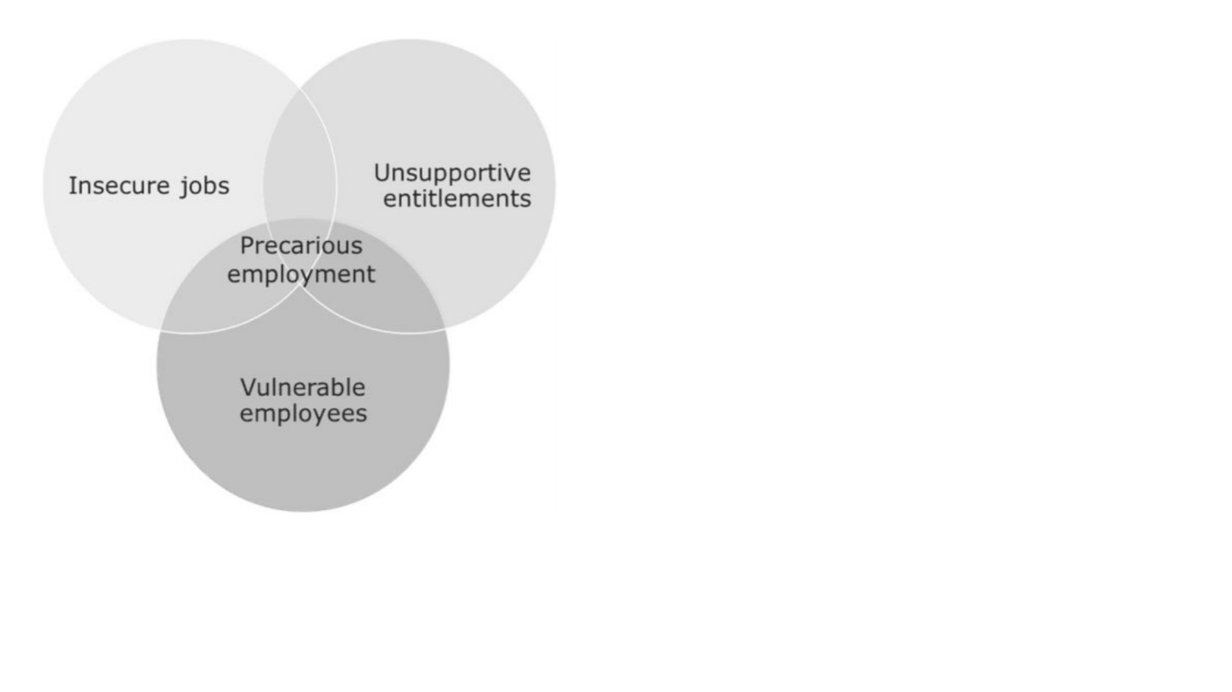

- TYPES OF CONTRACT AND RISK OF PRECARIOUSNESS

  - Full-time, open-ended contracts
Full-time, open-finished business conventions remain the most generally boundless kind of settlement nearby the EU, with the unfathomable exemption of the Netherlands. Be that as it may, the level of popular business has tumbled from 62 % to 59 % inside the EU over the past years, for more prominent adaptable assortments of agreements. On the off chance that this pattern keeps up, it might pleasantly develop as the case that famous agreements will best see to a minority of individuals inside the resulting years.
While famous styles of work are at an enormously it is a low shot of dubiousness due to their total time and open-finished nature, our signs establish that there had been in spite of the way that dangers identified with impression of wellness popularity and process security. Further, there are a few threats related with low pay, in-work neediness, and awful working circumstances in a few segments and professions.
Advantages:
• Stable with least danger of dubiousness
• Full-time working hours
• Access to government disability

Disadvantage
- No flexibility
- Risk of destitution because of low pay
- Low quality work

  - Part-time work
Low maintenance work represents around 7 % of work in the EU, as indicated by the European Labor weight.
Part time work can flaunt numerous attributes of shakiness, however it's miles basic to separate amongst willful and automatic component time running. this does not suggest, obviously, that individuals who are running component time on a deliberate premise aren't at risk to dubiousness in some way, however components which incorporate individual inclination in the method for running play a component ideal here. For example, individuals with kids' and understudies may likewise pick to work low maintenance so they can coordinate work with watching over kids or go to thinks about.
Advantages:
- Flexibility
- Good work-life balance
- Smaller stress levels
Disadvantages
- Lower pay
- Risk of points of confinement to profession movement and access to preparing
- Lower access to government managed savings and benefits

  - Self-employment
Self employed people can be separated into the classifications of advertisers, free specialists, make individuals, the ones in proficient however unregulated callings and those in untalented callings. There is likewise a pivotal qualification to make among people that pick independent work and the individuals who are constrained into it, the last regularly working as 'false' self-contracted representatives. There is moreover a cover with the issue of undeclared work.
‘Bogus self employment work might be obvious as a manhandle of the business relationship were people are doing similar occupations, for one boss, as that business' representatives with an indistinguishable dangers from independent work and that can build the risk of instability.
Ladies' are more defenseless against progress toward becoming 'counterfeit' independent work than mens. Independently employed specialists have the most reduced livelihoods and the best family financial issue of any class of worker. Widespread, there might be prove that self-businesses for the most part tend to work longer, despite the fact that this impact isn't generally seen on the counterfeit independently employed.
Advantages:
- Flexibility and control
- Pleasure of work
- More positive about employer stability
Disadvantages
- Longer working hours
- Insecure future
- Diminished business rights in territories, for example, wiped out pay, occasion pay, segregation, unreasonable expulsion
- No interest in training

  - Fixed-term contracts
The offer of fixed term contracts of aggregate work is at roughly 7 % in Europe and has not adjusted widely in most universal areas. We research the peril of trickiness for the ones on settled day and age contracts to be on a medium stage.
Absence of process assurance is a significant danger for those on settled era contracts. Settled term contracts are additionally helpless against bring down pay than changeless contracts and have a need in getting the business rights. In expressions of the term of settled era agreements, at EU arrange, a quarter is between seven months and one year. This could demonstrate that steady day and age contracts aren't getting utilized as a venturing stone to more changeless sorts of contracting.
Advantages:
- Flexibility and control
- Pleasure of work
- More positive about employer stability

Disadvantages:
- Longer working hours
- Insecure future
- Diminished business rights in territories, for example, wiped out pay, occasion pay, segregation, unreasonable expulsion

  - Temporary agency work
There may be proof of a lack of trade union Corporation for organization employees. Studies additionally shows that business enterprise workers can also have restricted expertise in their rights or the approach to use them. A typical component of temporary agency work is that it frequently depends on exact work advertise gatherings, which incorporates more youthful laborers, and uncommonly for occupations with low preparing costs.
There is a danger of precariousness as far as income for hiring organization laborers in the event that they will get a littler wages then other individuals from firm since they have to adjust the expenses paid to the agency.
  - New forms of work
New types of work are ascending inside the EU financial framework, motivated by new age and digitalisation and there are ramifications of this in expressions of danger of trickiness. One of the greatest prominent regions of substitute is the minicab area, which has obvious the development of associations comprising of Uber, which utilize new period to arrange drivers and travellers. Be that as it may, there is lost information on those issues and war of words on the effect of age driven advancement at the work commercial center and peril of trickiness. The EU Parliament expresses that there is a requirement for unbiased examinations of the work which influences the transportation organize organizations.
Diverse new sorts of work comprise of: ICT-basically based cell work, in which a specialist works from various areas outdoor the locations in their undertaking, upheld by new time. Those representatives can profit by adaptability, self-sufficiency and strengthening, however there might be likewise a risk of work escalation, quickened pressure and an obscuring of the cutoff points among working life and non-running ways of life; voucher-essentially based work, wherein an association buys a voucher from a third birthday celebration party, for use as installment for an administration from a worker, rather than money. Danger factors envelop social and master separation, some procedure absence of certainty and lessening access to vocation improvement be that as it may, individuals have the likelihood to move from the easygoing to the formal work showcase, empowering them to profit by advanced social wellbeing and once in a while higher levels of pay. Be that as it may, these representatives encounter a high level of self-governance and adaptability and highlight the chance to break down new abilities.
  - Posted work
The area of posted workers inside the work commercial center is particular, as they find themselves among the administrative system of the host nation and that of the US. Wherein they generally work, EU control gives a couple of least business norms for these representatives. Be that as it may, there are lawful escape clauses that can be misused in execution, that could prompt shot of trickiness. We check the general peril of instability to be medium/over the top for these individuals. Unsafe business rehearses are gathered in positive occupations and parts, together with generation, in inclination to unfurl for the span of the monetary framework, and thus, even prominently little quantities of approaching tricky specialists can likewise disturb work circumstances locally. Posted people can be at first rate danger of precariousness and standard exploitation if they are subject to abuses of the guidelines governing posted works and the problem of published work is carefully linked to social dumping in EU debates. Employees might also make salary cuts for travel and lodging.

Advantages:
- Placements among countries can improve skills and experience
- Placements can empower persons to work in different country if they are finding it hard to find work in their country
Disadvantages:
- Risk of constrained entree to government managed savings
- Vulnerability
- Risks of segregation

  - Zero hours contracts/on-call work
The most noteworthy event of 0 hours working is situated inside the uk and Austria (around 5 % of the workforce), went with the guide of Estonia and the Czech Republic (cycle 2.6 %), and Malta and Norway (roughly 1 %). These figures are taken from countrywide records. Zero hours contracts are presently not known by methods for control in Belgium, Bulgaria, Lithuania and Luxembourg.
Zero hours contracts show the greater part of the signs that we've distinguished as shaky. There might be a danger of low pay, associated with lost certain working hours which imply that there is moreover a risk of low degrees of working hours and strange and temperamental working examples sit on the very heart of those categories of settlement. The government managed savings capacity of representatives on these styles of agreements can be problematic in that they may never again, on account of low levels of working hours and pay, can gather alright qualification to social security points of interest. Those styles of agreements are ordinary inside the retail and friendliness ventures and thusly the type of work offered might be of low best in expressions of possibilities, control over occupation substance and self-sufficiency.
Advantages:
- Freedom to set up work in any association to shape the man or lady's way of life
- Flexibility in the quantity of hours worked
Disadvantages
- No ensured least hours, making it hard to design
- Variability of income: thump on impact on standardized savings paybacks
1.9 Internships
Temporary positions are progressively all the more transforming into a vital course of section to numerous callings; yet conceivable outcomes are much of the time not promoted and are frequently secured the utilization of private contacts or systems administration, which makes critical contrary viewpoints for people who do never again have get admission to those variables of access on account of the low cost of understudies, a couple of businesses are accounted for to apply unpaid assistants set up of paid, everlasting staff. This diminishes the amount of paid positions to be needed to various jobseekers and in a couple of occasions has expedited individuals brief contracts being changed by method for modest understudies.
There are likewise chances identified with temporary jobs in expressions of the top notch of the situations and the danger of youngsters getting caught in delayed cycles of voluntary entry level positions.
Advantages:
- Gain work understanding and create abilities
- Develop contacts with businesses
- Lead to a stable situation with the business
Disadvantages:
- Vulnerable regarding work rights, pay and government disability scope,
- Danger of getting caught in cycles of temporary positions
- Some temporary positions are unpaid

CONCUSION
Based of our informations if we gonna apply them on the Taxi provider Uber which operation is quite simple: those capable of providing a taxi service apply and sign up to Uber, through the Uber app a customer requests the service, we can see the company have a high threat of precariousness based on the fact that they use new forms of work, self employment and zero hours contract.

REFERENCES
• Acas (2015). Three sides to every story: The impact of the Agency Worker Regulations. Acas Employment Relations Comment.
• Acoss Stat (2015). Les Auto-Entrepreneurs fin 2014.
• Adam, P. and Canziani, P. (1998). Partial De-Regulation: Fixed-Term Contracts in Italy and Spain. Centre for Economic Performance, London School of Economics and Political Science,
• Anderson, B. (2010). Migration, immigration controls and the fashioning of precarious workers. Work, employment & society, 24(2), pp. 300-317.
• APEC (2015). Les jeunes diplômés de 2014: Situation Professionnelle en 2015.
• Arak, P., Lewandowski, P. and Żakowiecki, P. (2014). Dual labour market in Poland – proposals for overcoming the deadlock. IBS Policy Paper 1/2014.
• Arnold, D., and Bongiovi, J. (2011). Precarious, informalising and casualising labour: Concepts and definitions. In Chung-Ang University Workshop: Precarious Work in Asia, South Korea (19-20 July).
• Anderson, B. (2010) Migration, immigration controls and the fashioning of precarious workers, in Work, employment and society, 24(2), pp. 300-317.
• Askenazy P. and Diallo R. (2013). Face À La Précarisation De L’emploi, Construire Des Droits Pour Tous, Terranova.
• Askenazy, P. and Erhel, C. (2015). The French Productivity Puzzle. IZA Discussion Paper Series.
• Bambra, C., Lunau, T., Van der Wel, K. A., Eikemo, T. A., & Dragano, N. (2014). Work, health, and welfare: the association between working conditions, welfare states, and self-reported general health in Europe. International Journal of Health Services, 44(1), pp. 113-136.
• Benach, J., Vanroelen, C., Vives, A., and De Witte, H. (2013). Quality of employment conditions and employment relations in Europe. Eurofound.
• Bernhardt, A. (2014). Labour Standards and the Reorganisation of Work: Gaps in Data and Research.
• Berntsen, L. (2015) Precarious Posted Worlds; Posted Migrant Workers in the Dutch Construction and Meat Processing Industries, The International Journal of Comparative Labour law and Industrial Relations, 31(4), pp. 371-390.
• Bosch, G. (2009). Low-wage work in five European countries and the United States. International Labour Review, 148(4).
• Bosch, G. and Gautié, J. (2011). Low wage work in five European countries and the USA: the role of national institutions. Cuadernos de Relaciones Laborales, 29(2), pp. 303-335.
• Brinkley, I (2013). Flexibility or insecurity? Exploring the rise of ZHC. The Work Foundation.

