University of Wales Trinity Saint David
Wales Institute of Science & Art



Electronic Ignition & Fuel Injection Systems
Electrical Control Systems (ACHA4010)

Badrakh Nyamsuren
2011093
April 2022

Contents
1. Introduction 2
2. Literature review 3
2.1 Motronic System 3
2.1.1 Advantages and Disadvantages 3
2.2 Bosch LE3 Jetronic System 5
2.2.1 Advantages and Disadvantages 6
3. Methodology 7
3.1 ECU Testing 7
3.2 Further engine testing 8
3.3 Resistance test 9
4. Results & Analysis of waveforms 10
4.1 Analyzing the waveform 10
4.2 Injection Waveforms of Motronic 11
4.3 LE3 Jetronic Waveforms 16
4.4 Analysis of the Motronic data 22
4.5 Analysis of the LE3 Jetronic data 23
5. Comparison 24
6. Modification 25
7. Conclusion 26
8. References 27
9. Appendices 28
9.1Motronic Raw Data 28
9.2 LE3 Jetronic Data 30

1. Introduction

Over the last couple of decades, enormous amount of development has been made in motorsport and automotive engineering. The world has been starting to digitalized and increasing automation is revolutionizing many industries including automotive world. The electrical components are one of the most important part of the vehicle and day by day it is improved by engineers. In this report, the ignition and fuel systems of Vauxhall Motronic and LE3 engine will be tested at the university workshop to collect live data and it will be analyzed. In addition, any modification or improvements on the engine systems will be discussed and researched in order to increase the reliability, fuel efficiency and the life time of the engine. These engines and management systems are widely used on the cars that are on road in the UK and in future, the internal combustion engine might be banned in most European countries by 2035 (Pole, J. 2022). To prevent this ban, updating and maintaining these engines rather than buying new ones will save huge amount of money and environmentally, less car wastes will be thrown.
Due to my injured knee I could not attend the workshop testing with the group that I was assigned to do. The accident happened the day before the workshop testing and I could not walk which was very disappointing. Therefore, I contacted my fellow course mate for support and received a summary of the workshop testing. To understand this assignment, my previous experiences with the workshop engine testing and the documents of the engine management data on the Moodle helped me.

2. Literature review

2.1 Motronic System

(Bosch, 2007), (Bähr and Erkerl, 2015) explains the engine management system (Motronic) based on the previous L- Jetronic fuel injection system was designed to function as an electronic fuel injection and electronic ignition in a single control unit. Simply put, the Motronic system is an open and closed loop control for a gasoline engine.
(Bähr and Erkerl, 2015) by succeeding its launch from 1979 the new engine management system gradually added more functions to the system in response to legislative requirements such as by reducing exhaust gas emissions, meeting increased performance, comfort, and safety demand, and reducing fuel consumption. Gradually, several types of motronic systems were created such as the KE-Motronic, solely based on the KE-Jetronic continuous gasoline injection and Mono-Motronic also based on the Mono-Jetronic intermittent single point injection and so on (Dietsche and Reif, 2018).

2.1.1 Advantages and Disadvantages

The Motronic system combine two important features/functions, electronic fuel injection and ignition in a single electronic control unit (ECU) compared to a traditional two, this model in the process has allowed Bosch to increase performance and innovation thus decreased cost becoming a major earner at Bosch (Bähr and Erkerl, 2015).
Among the major advantages of the advances injection system Motronic, depending on the variable of the system such as on the M-Motronic, further development in the air-flow sensor was replaced by an air-mass meter enabling the engine to load more accurately thus the electronic ignition with a rotating ignition distributor was replaced by a fully electrical ignition with a static distributor system, where a separate ignition coil generates a high voltage for each of the cylinders (Dietsche and Reif, 2018).
One of the main advantages also include fuel saving by allowing the driver to feel at ease as the system itself adjusts the injection accordingly to its features and fuel consumption while also meeting the standards of the legislative requirements plus the system precisely measures its fuel during the phases such as warm-up, during performance and so on (Alexander Falchenko, 2020). Although the Motronic system is a highly standardized functions there maybe few shortcomings to the system such as the system uses a large number of sensors i.e., when a fault occurs there may be difficulty finding an error during a diagnosis due to this the cost regarding the complexity of the system highly effects the cost (Alexander Falchenko, 2020).
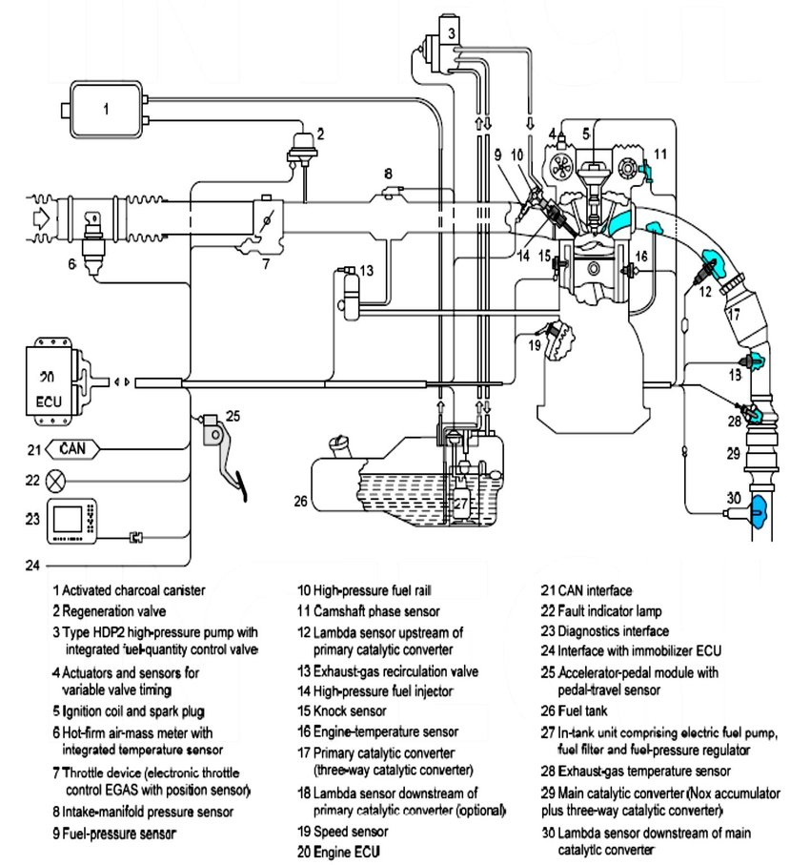

Figure 1. Components used for electronic control in MED-Motronic system of the Bosch (Bauer, 2004) (Siano, 2012)

2.2 Bosch LE3 Jetronic System

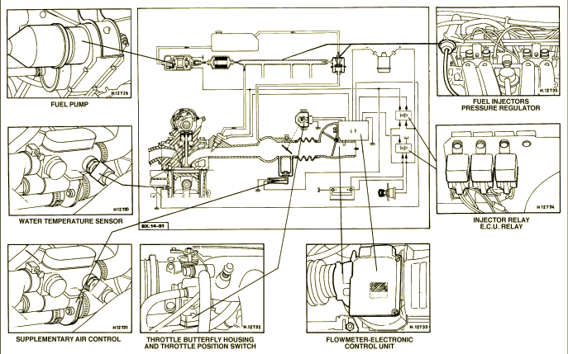
Figure 2. Bosch LE3 Jetronic fuel injection system component (Bosch, 1999)
Bosch (1999) explains the initial Jetronic name as an electronic injection and engine management system that has been in production from 1960 and number of varieties has been developed gradually with several differences and versions of unit advancement were made.
The system has number of improvements on the variety such as D and K where the D-Jetronic pulses the injectors regarding manifold the vacuum to achieve the air fuel ratio more accurately while K-Jetronic sprays fuel from each of the injector in a constant and gradually manifolds the vacuum to ref fuel pressure. However, the L-Jetronic electronically controls its fuel injection system where the need of driving to inject fuel is unnecessary (Bosch Technical Instruction, L-Jetronic, 1982).
Hence the engine's working circumstances are subject to change, a rapid adaption mechanism is essential, hence electronically controlled injection was adapted. Many sensors send inputs to the control unit, which subsequently determines the precise amount of fuel to be injected (Bosch Technical Instruction, L-Jetronic, 1982), Bosch (1999).

2.2.1 Advantages and Disadvantages

Unlike the Motronic series, the Jetronic system acted as a base line for the newer generation.
With a abase of three major functions pressurize fuel, monitor sensors and regulate fuel quantity, some advantages include high output where the elimination of carburettor enabled the induction paths by allowing higher torque to be achieved by filling in the cylinders, with the L-Jetronic it enables a car or the driver to know what amount of fuel needs to be filled in where allowing lesser fuel consumption (Bosch Technical Instruction, L-Jetronic, 1982), Bosch (1999).
The system also allows and provides the exhaust gas with low pollution where the initial connection to the air fuel ratio works precisely with L-Jetronic allowing the mixture formation necessary to observe the exact/present day exhaust (Bosch Technical Instruction, L-Jetronic, 1982), Bosch (1999).

3. Methodology

First, the students were divided into 9 groups, each group had a different time schedule for the engine testing. In order to start the engine testing, the workshop health and safety rules had to be followed, which included always wearing safety shoes, dust coats, and if needed eye protection glasses. Once the health and safety rules were followed, the engine dynamometer had to be connected with exhaust extractors while it is being tested. In addition, the workshop has a number of air ventilations and many smoke detectors as a backup and precaution. This is because the chemical smoke out of the exhaust can be harmful to people in the workshop. At final, both engines were ready to be started and tested. The group of students started with one engine rig then moved to the other engine rig when finished testing the previous one.

3.1 ECU Testing

In the first place, using the multi-meter, the pins of the ECU were needed to be examined individually with the ignition feed off. After that, the engine's ignition was turned on, and each ECU pin was examined once again in order to see if there’s an error.

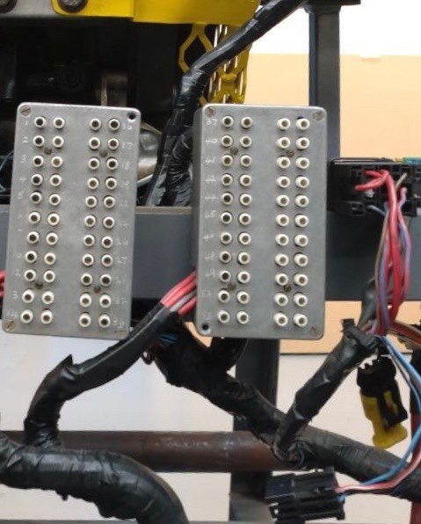
Figure 3.1.1 ECU pins

3.2 Further engine testing

Once the ECU pins were tested, the further engine components were tested. One of the highlight of the experiment is that using the Bosch oscilloscope and digital multi-meter to examine the engines temperature. First, placing the oscilloscope’s temperature gauge into the engine oil dipstick’s hole, the oscilloscope displayed temperature increment from twenty Celsius up to eighty Celsius on individual engine components and before start testing the next component, engine temperature needed to reach the right target. The following tests were performed after the temperature was reached. The resistance of NTC2, Injector, the voltage of NTC1 and NTC2, tank vent valve and lambda switching and rotary idle valve percentage on.

3.3 Resistance test

The final part of the engine component testing was testing the resistance and comparing them to their original specified resistive values from the factory and to see if there are changes. To test the it, the multi-meter used on the pins of the components, such as, ignition coil, airflow sensor, throttle potentiometer, injectors and HT leads.

4. Results & Analysis of waveforms

4.1 Analyzing the waveform

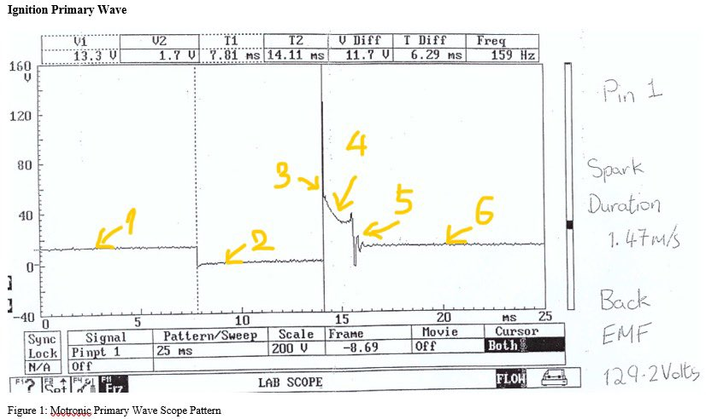
Figure 4.1.1 Motronic Ignition Primary Wave

On figure 4.1.1, the highlighted numbers are showing the fundamentals of the wave scope pattern and it will be clarified. The line number one on the wave form is the potential voltage of the injector. The line number two is displaying the dwell time just before the spark and 129.2 volts has produced by the back EMF in point three. Between point three to four, the spark duration was 1.47m/s. After the spark, the coil oscillates and the voltage dissipates at number five. Returning to the potential voltage at section six allows the cycle to restart. (Waveforms-Injector Pattern Tutorial 1995)

4.2 Injection Waveforms of Motronic

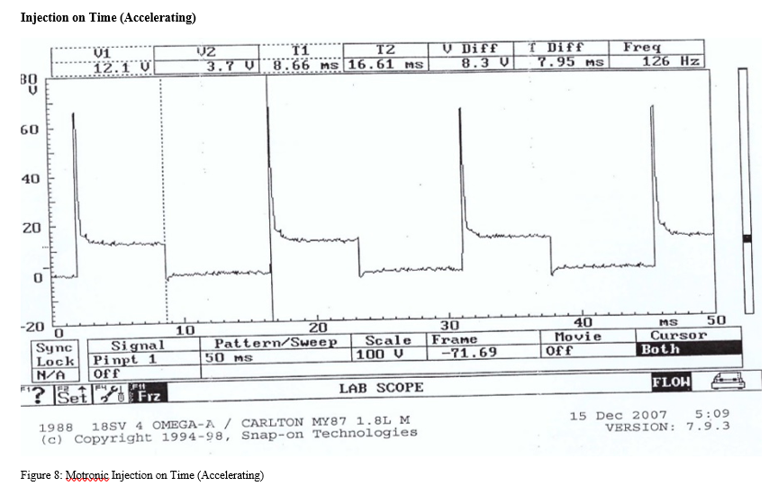
Figure 4.2.1 Injection on time (Accelerating)

Waveform above shows that injection on time when accelerating. It is because the injectors are pulsing more significantly more often and for than at idle. The reason is the engine needs more power when accelerating which means it needs more fuel to burn in order to make enough power. The ECU receive signals from sensors because the greater frequency of the injectors. Therefore, the ECU figures out the amount of fuel that is required.

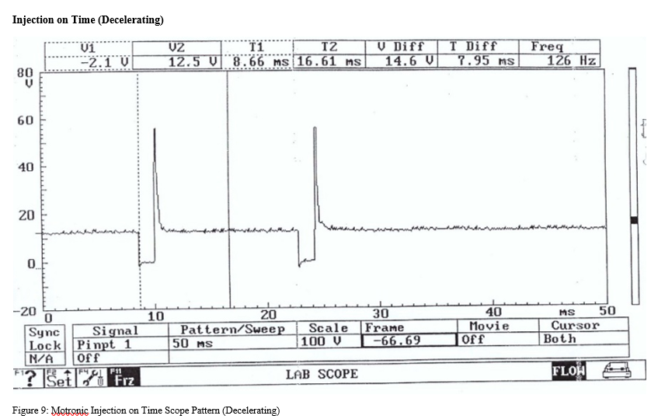
Figure 4.2.2 Injector on time (Decelerating)

In figure 4.2.2, it can be seen that the engine is decelerating and the injection on time reduces until it fully stops. This waveform is almost exact the opposite of the acceleration waveform. The sensors sense that the engine deceleration and makes the fuel leaner. Therefore, the engine will begin to back at idle rpm. If the sensors do not sense the deceleration and not providing low amount of fuel mixture, then the fuel consumption will increase dramatically.

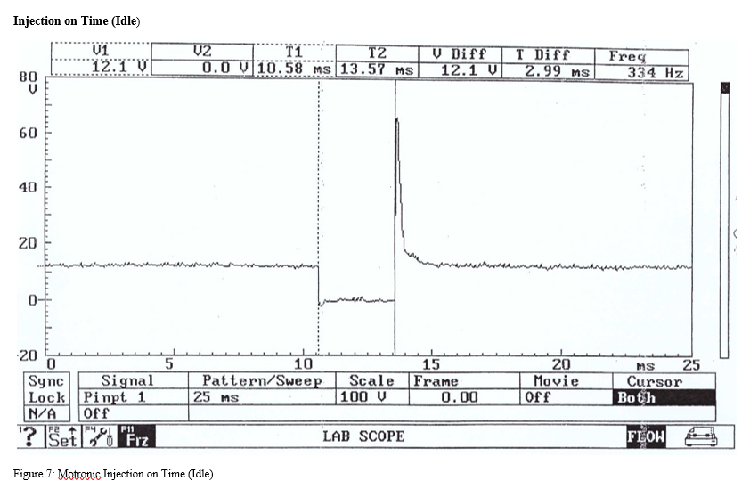
Figure 4.2.3 Injection on time (Idle)

The figure above displays that the engine is idling which means, the injectors constantly providing same amount of fuel mixture to the engine in order to keep the engine at idle. It can be called that the engine is on neutral. At low speed or at idle, the pulse of the engine does not need more time as the engine is not accelerating.

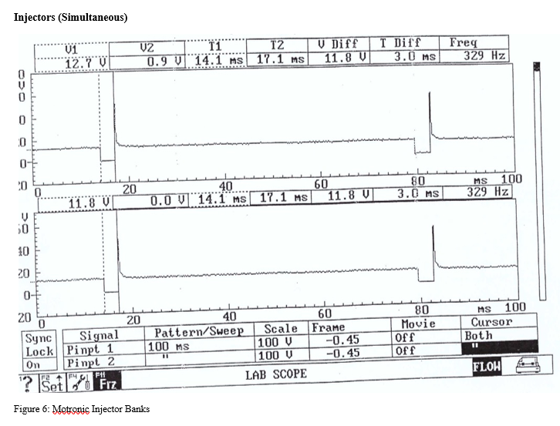
Figure 4.2.4 Injectors (Simultaneous)

Figure 4.2.4 is showing that identical waveform of pin number 16 and 17. The reason why they are identical is that the injections of the Motronic system is simultaneously injected.

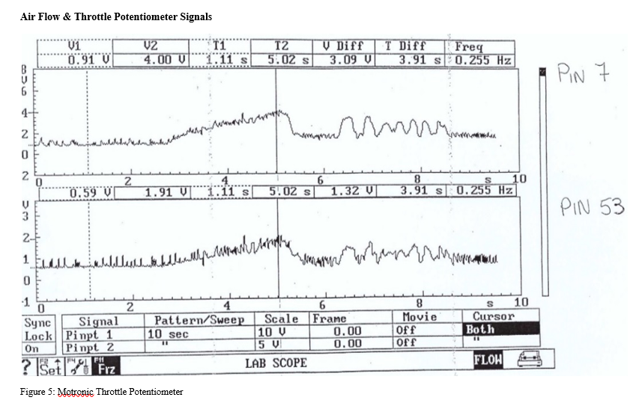Figure 4.2.6 Air flow & throttle potentiometer signals waveform

It can be seen that air flow (Pin 7) and potentiometer (Pin 53) are related to each other. The ECU receives the output of throttle potentiometer in order to figure out the amount of fuel is required. Air flow increases when throttle is opened and throttle potentiometer sends the data to the ECU.

4.3 LE3 Jetronic Waveforms

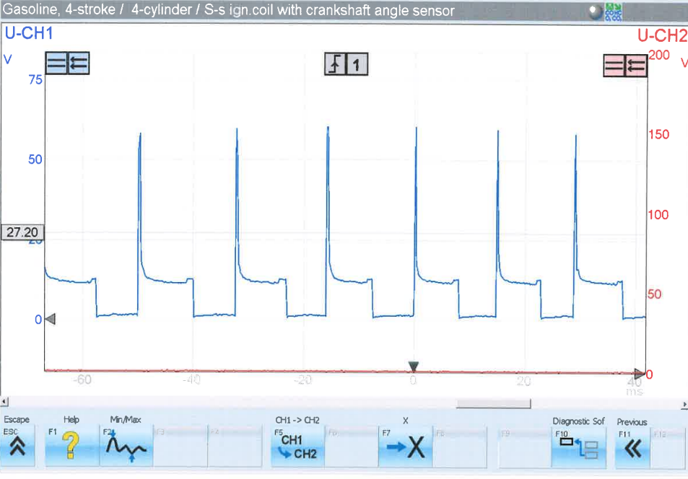
Figure 4.3.1 Injection on time (accelerating)

It can be seen that Jetronic’s injector has more pulse than the Motronic system when accelerating. This can be affected by the size of the engine. The Motronic has 2.0 liter comparing to LE3’s 1.6 liter which means, frequency of the Jetronic’s fuel injection is faster and higher than the Motronic. Except the frequency difference, both systems are almost same.

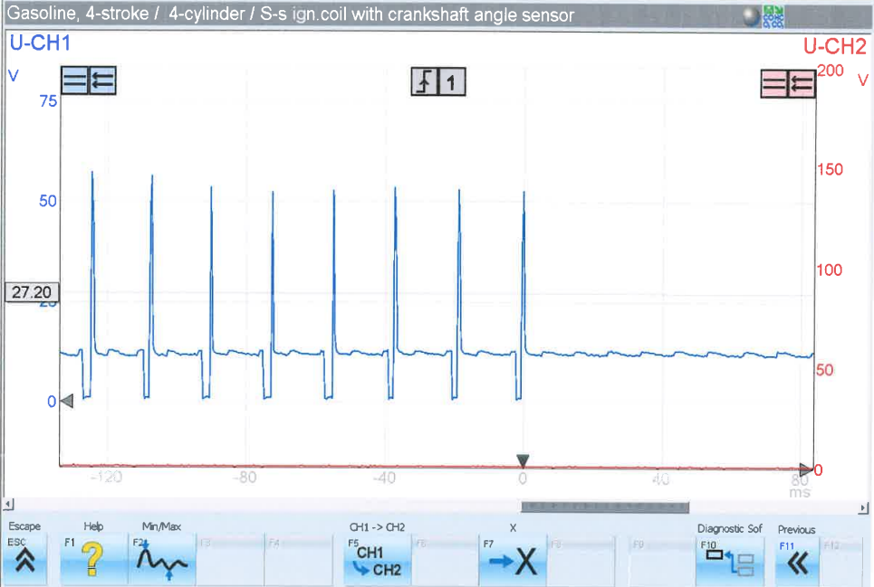
Figure 4.3.2 Injection on time (de-acceleration)

In figure 4.3.2, the waveform of Jetronic deceleration is displayed. It can be seen that it is quite similar to the Motronic except the different numbers of pulses during the deceleration. The Jetronic has more pulses than the Motronic. The Motronic system may be more modern and more fuel efficient than the Jetronic’s old system system.

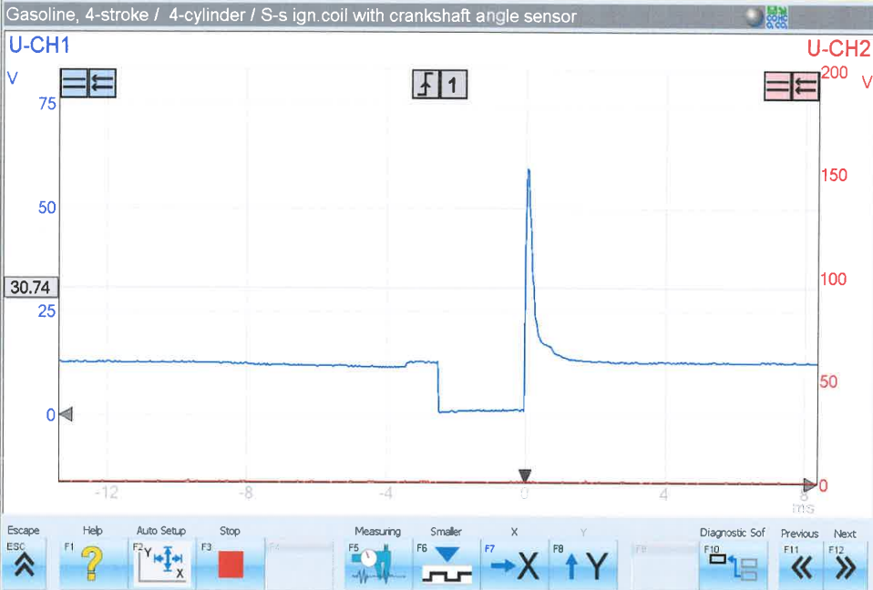
Figure 4.3.3 Injection on time (Idle)

The waveform above shows the Jetronic’s Idle pulse and it is very similar to the Motronic’s Idle pulse.

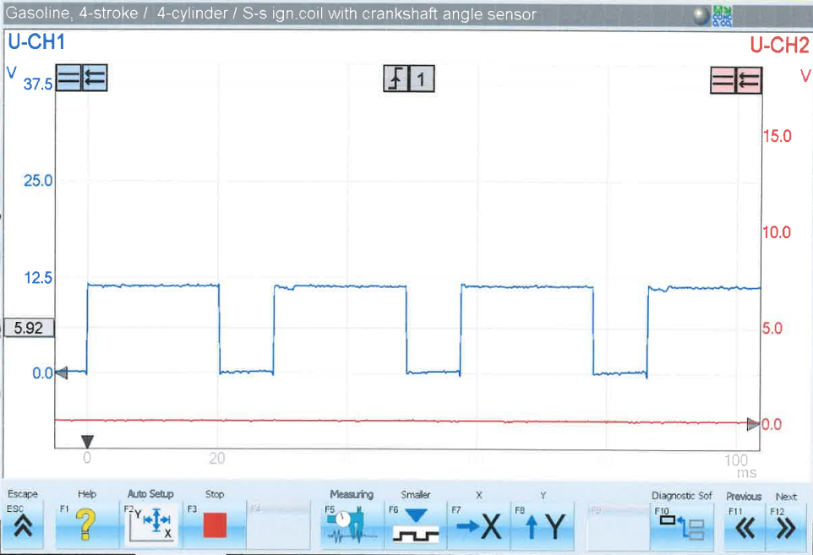
Figure 4.3.4 Crank signal (pin 5 speed reference)

After being digitized by an analogue to digital converter, the signal of the crank angle is shown in the waveform above. This signal may now be read by the ECU, which utilizes it as a crank speed reference. This is significant because the ECU now has a better understanding of the engine speed and can adjust the ignition timing and fuel supply accordingly.

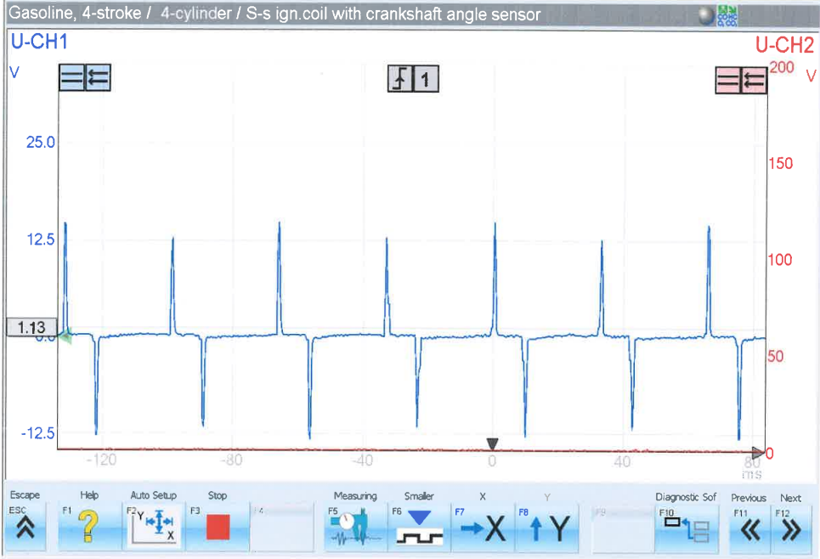
Figure 4.3.5 Crank signal (pin 12)

The Jetronic system's crank angle sensor is displayed in figure 4.3.5 above. It is clear from the waveform that this is an analogue system that produces an analogue waveform. Because the ECU is unable to interpret analogue signals therefore, they must be transformed to digital signals using an analogue to digital signal converter (Kaiser 2015).

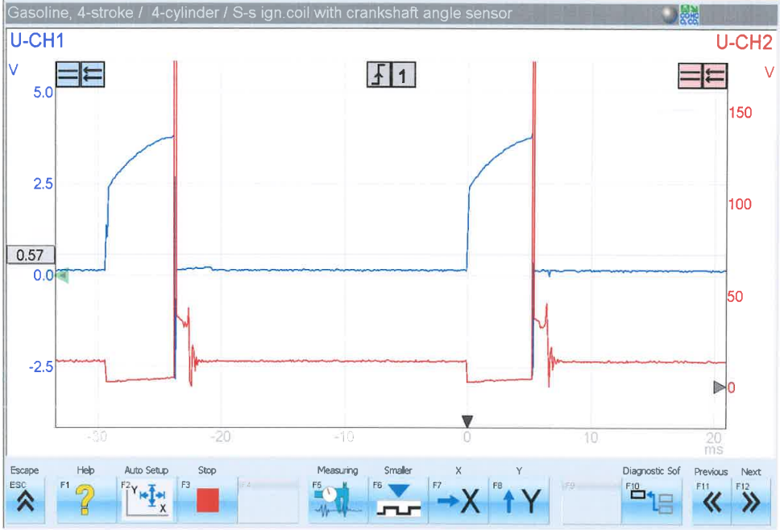
Figure 4.3.6 Spark advance signal & primary

The figure above shows the spark advance waveform to the primary spark waveform, displaying a direct connection between the two. The time of the primary spark's dwell is related to the peak of the spark advance waveform. The peak of the spark advance waveform is caused by a build-up of voltage prior to the spark, which is subsequently dissipated during the ignition, resulting in a voltage drop following the spark. The ignition system needs this because the spark advance mechanism keeps the spark timing precise at all engine speeds. According to Kawahara, the electronic spark advance system determines the ignition timing duration and generates an ignition signal based on the angle of the crank. The ECU calculates the best ignition timing based on driving conditions and delivers ignition signal to the spark plug.

4.4 Analysis of the Motronic data

The Raw table of the Motronic data shows all the data gathered during the testing of static voltage seen in table 9.1.1. from Appendix. From the data on 18 and 36 are the only pin that shows a signal whilst the ignitions are off. However, the pin 18 is permanent live and the 36 is a supply to the auxiliary along with the electronic control system.
Hence the Motronic electronic control system has to keep alive memory also known as KAM this requires electricity to save the data, the permanent live pin 18 gets the battery voltage. Thus, by allowing the battery to be not connected to a power it will store the data.
The auxiliary and the ecu pin 36 in this raw data explain that when the ignition is on, the supply of the auxiliary will no longer receive the power as to the all the other pins are active, whereas, when the ignition is turned off i.e., dash lights would need power.

The Table 9.1.2 shows the data of the resistance of the throttle potentiometer. As the throttle was open the resistance went up till 2560 and 2000 OHM when the throttle closed.
According to the auto data book (Auto data Fuel Injection, 1991) states when the throttle is wide open the resistance can be from 1900 to 2000 OHM whereas in our case the resistance exceeded the normal tolerance and has been much higher than the expected result. In this instance the cause maybe the system has been going on for a while and have had wear and tear or the acceleration may have caused the resistance to not work in normal standard thus increasing the resistance. Table 9.1.3 shows the Air Flow Resistance and table 9.1.4 Idle speed control and table 9.1.5 shows the live data collected during the engine was running at numerous temperatures.

4.5 Analysis of the LE3 Jetronic data

Appendix 9.2 shows the raw data of the LE3-Jetronic System.
The table 9.2.1. shows an electronic control unit static test where while the ignition was off there being no signals sent out.
The table 9.2.2 shows the spark advance electronic control unit have no signals while the engine was off as well.
Table 9.2.3 represents the throttle switch resistance however the same as the technical specifications in comparison to the Motronic throttle resistance.
Table 9.2.4 shows the injector resistance values also the same as the technical specifications.
Table 9.2.5 represents the auxiliary air valve resistor, however, was little higher than the technical specifications while the standard was 40 it went on little bit around 46.
Table 9.2.6 is alive data gathered while the engine was running at number of temperatures. Also, at the temperatures 60C it had to be stopped as to a fault in the age of the system and was unable to gather data at 80C.

5. Comparison

The both systems have tested in exact same way and it can be seen that most of the results were similar except the engine size affect. Both the systems also have many similar features such as, they don’t hold a knock sensor and their NTC2 values are very close at temperature ranges. The other factor of the difference is that the Jetronic system is older version of the Motronic. The Motronic system his much more advanced version of the Jetronic. One of the main difference is that Jetronic has two ECU’s, On the other hand, The Motronic has only one ECU to command the entire system which means, the Jetronic system will cost more and uses more space for the extra components to operate (Bosh Motronic handbook 1985). The Jetronic system does not have a tank vent valve unlike the Motronic system which mean, it will produce more pollution than the Motronic. Overall, the Motronic system is more reliable than the Jetronic system in many ways.

6. Modification

In previous section the difference between the Motronic and the Jetronic systems have compared and it can be seen that the Jetronic system is quite old and has outdated components compared to the Motronic system. It is mainly because the Motronic is the improved version of it. In this section, the possible improvement and modification to the Jetronic system will be covered. There are many outdated and unreliable component on the Jetronic system and one of them is the air flow meter system. This system can be replaced by much modern hot wire air mass meter as it will improve the right amount of air will be delivered to the engine at any condition without any pollutant because it can clean itself in high temperature.
The next ideal improvement would be having one ECU rather than two ECU to command the fuel and ignition systems in the Jetronic system. It can be inspired by the Motronic system, for example, fault codes can be saved in a live memory and will be more reliable due to not many components needed to run with.
Thirdly, the Jetronic system does not have tank vent and it can produce high emissions to the atmosphere. This can be simply done by adding the tank vent valve and tank vent. It can be reducing the emission significantly and prevents it in higher temperature as it vents the smoke before spreads in to air.
The last improvement that would be necessary for this system is a knock sensor. Unlike the Motronic, the Jetronic does not have a knock sensor. A knock sensor would sense faults before it is too late and it will be very helpful and saves a lot of money for the owner of the vehicle. According to Bosch, if knocking is detected by the sensor, it will be relayed to the ECU, which will display an engine warning light and save the fault code in the EOBD memory. This would extend the engine's lifespan once more by addressing problems before they became fatal.

7. Conclusion

In conclusion, the Jetronic and Motronic engine management systems were tested at workshop and gathered raw data. The testing has allowed the theory and academic learning to be understood into a wider knowledge thus increasing the ability of one’s idea of the different types of system in a live engine. The both systems are compared to each other and analyzed their waveforms. In contrast to the two systems, it has widely shown differences in regard to its technical specifications and has allowed experimentation more valid by taking in the idea of older version to an updated version. The Jetronic system uses outdated components and the Motronic system has more advanced technology. At the end of the report, the LE3 Jetronic system’s possible modifications are mentioned as it can become reliable and save large amount of money and car waste which will be great impact to the environment. In future, the internal combustion engine may be banned in most European countries which it would be great idea maintain and update the old engines and systems (Pole, J. 2022).

8. References

Dietsche, K.-H. and Reif, K. (2018) Automotive handbook. 10th edition revised and extended. Karlsruhe: Robert Bosch GmbH.

Bähr, J. and Erkerl, P. (2015) History of Global Enterprise. Munich: Beck C.H.

Bosch. (2007) Automotive electrics automotive electronics. 5th edition. Plochingen: Robert Bosch GmbH.

Ribbens, W.B. (2003) Understanding automotive electronics. 6th edition. Amsterdam: Elsevier Science.

Mohon, M. (2009) ‘Effect of fuel Injection Timing and Injection Pressure on Combustion and Odorous Emissions in DI Diesel Engines’, J Energy resources. 131(3). pp. 1-8.

Falchenko, A. (2020) ‘What is Motronic System?’, Avtotachki [blog]. 26 May. Available at: https://avtotachki.com/en/chto-takoe-sistema-motronic/#1042108010761099-1089108010891090107710841099-Motronic (Accessed: 17 May 2022).

Siano, D. (2012) Fuel Injection. Rijeka: InTech, pp. 13-14, illustration.
Keynes, M. (1978) L-Jetronic: a fuel-injection system from Bosch. 2nd ed. (1978). Arkansas: Delta Press.
Bosch, R. (1999) Gasoline Fuel Injection Sytem L-Jetronic: Bosch technical Instruction. Gerlingen: Robert Bosch GmbH.
Bosch. (1982) Technical instruction L-Jetronic. 1st edition. Germany: Robert Bosch GmbH.
Auto data (1991) Fuel Injection. Maidenhead: AutoData.
Pole, J. (2022) EU-wide ban on fossil fuel to kick in from 2035, as lawmakers back proposal. Available at: https://www.euronews.com/green/2022/05/12/eu-wide-ban-on-new-fossil-fuel-cars-to-kick-in-from-2035-as-lawmakers-back-proposal (Accessed 12 May 2022).
Waveforms - Injector Pattern Tutorial 1995.
Kaiser, M. 2015. Electronic control unit (ECU). Gasoline Engine Management, pp. 254–259. Available at: https://link.springer.com/chapter/10.1007/978-3-658-03964-6_16 (Accessed: April 2022).
Kawahara, N. 2007. Automotive Applications. Comprehensive Microsystems 3, pp. 369–390. doi: 10.1016/B978-044452190-3.00067-7.

9. Appendices

9.1Motronic Raw Data

Battery Voltage 12.46V
Table 9.1.1: ECU Static Voltage Testing (Motronic)
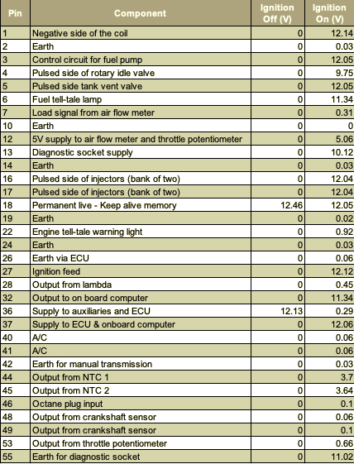

Table 9.1.2: Throttle Potentiometer resistance
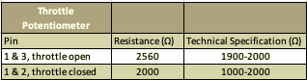

Table 9.1.3: Air Flow Resistance

Table 9.1.4: Idle Speed Control Resistance
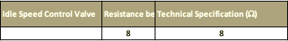

Table 9.1.5: Live Data Collected While Engine is Running at Various Temperatures
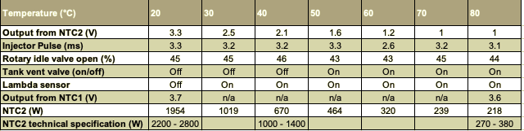

Table 9.1.6: Engine temperature and injection pulse (Cold Cranking)
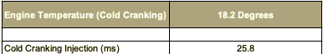

9.2 LE3 Jetronic Data

Battery Voltage 12.41V
Table 9.2.1: ECU Static testing fuel (LE3)
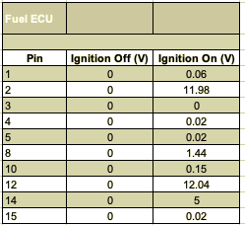

Table 9.2.2: ECU Static testing spark advance (LE3)
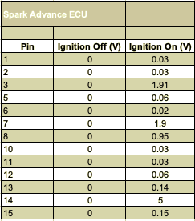

Table 9.2.3: Throttle switch Resistance
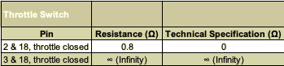

Table 9.2.4 Injector Valve Resistance

Table 9.2.5 auxiliary air valve Resistance
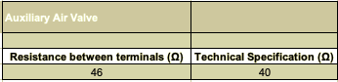

Table 9.2.6 Live Data Collected While Engine is Running at Various Temperatures


