

University of Wales Trinity Saint David
Prifysgol Cymru Y Drindod Dewi Sant
School of Engineering

Investigation into Resonant Circuits
Electrical & Electronic Principles (ACDB4002)

Aneurin (Nye) Evans
(1907963)
19/04/2021

Contents
1 Abstract 1
1.1 Aims 1
2 Introduction 2
3 Simulation Setup 3
4 Results 4
4.1 Initial calculations 5
4.2 Series RLC analysis 6
4.3 Parallel RLC analysis 8
4.4 Q Factor 8
5 Discussion 10
6 Conclusion 11
7 Acknowledgments 12
8 References 13

Abstract
This investigation was done by using the student number 1907963 to insert into a circuit in the software Proteus eventually find the resonant frequency in a series and parallel RLC circuit. The resonant frequency was calculated to be 61.3Hz with an average Q factor of 19.35.

Aims
The aims of this report are to successfully find the resonant frequency and Q factor of series and parallel RLC circuits using Proteus, Microsoft Excel and resources from the internet and other places online.

Introduction

The circuits used in the simulation are very simple series and parallel circuits, with a voltage probe, resistor, inductor and capacitor. Voltage and current probes were used in order record and plot these values along particular points along the circuit, on graphs.
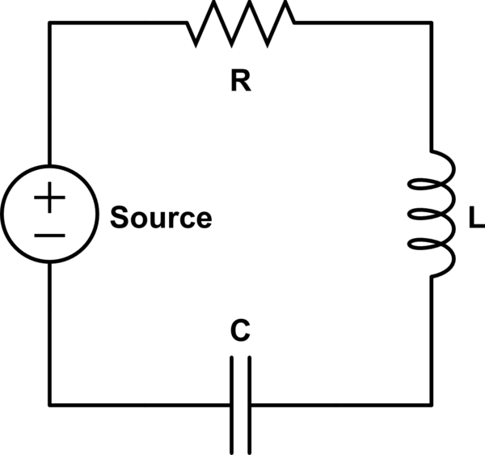
A basic summarisation of how a circuit works is this: to produce electricity, electrons are pushed through a wire by a power source i.e., a battery. The voltage is the measurement of the force that said electrons are being pushed through the circuit, while current is simply the flow of those electrons. These components depend on each other and change depending on the other. The resistance is exactly that, resistance to the flow of electrons. Any resistance also builds pressure i.e., voltage; and therefore, also has an effect on the circuit [1]. This theory is derived from Ohm’s Law, which states that V = IR.

Circuits are fundamental to essentially anything electric. They are seen in many different types and varieties across a vast number of components, in many different fields. Their set up and the components that make up a circuit will depend on the wider function of the component is in. You may find circuits anywhere from everyday appliances like electric kettles and televisions, to the laptop/computer this report is being written on and likely read off right now!
Figure 1 - Basic RLC circuit diagram
This report will aim to show how resonance works in circuits. The simulations and subsequent report will focus on series and parallel circuits individually. They should show that at the point of resonance within the circuit: voltage, current, resistance, frequency and phase of said circuit will all reach a specific point, whether two or more cross, reach their peak, reach their trough, or mirror each others pattern in the graphs. The uniformity and symmetry of some of the graphs will hopefully be a clear representation of resonance and be clear to all observing.

Simulation Setup

Two circuits will be simulated using Proteus simulation software. As mentioned previously, one series and one parallel circuit will be constructed and these will be RLC circuits, meaning there will be a Resistor, Inductor and Capacitor in each circuit.
Figure 2 - Proteus logo
The value of these components will be decided by student number, which in this instance is 1907963 and will correspond the Resistance, Capacitance and Inductance as follows:
R = 19Ω (Ohm’s) C = 7μF (07 Micro Farad’s) L = 963mH (Milli Henry’s)
It is important to note that in the following calculations that both values for C and L are converted to Farad’s and Henry’s respectively, for the purpose of the calculation, they were written like this:
C = 7 x10⁻⁶F L = 963 x10⁻³H
Using a derived equation and use of complex numbers (converting j to be 1), the resonant frequency of the circuit could be calculated. This is where the conversion to SI units is important. The equation and subsequent calculation are shown below:
$$f= \frac{1}{2π√LC}$$
By substituting the values of Inductance (L) and Capacitance (C) into the above equation, the resonant frequency for the values relating to the student number came out to be 61.29964622 Hertz (61.30Hz to 2 decimal places). This value was inputted into Proteus as the value of frequency and was taken into account when altering the starting frequency value. The range of frequencies instructed to measure from in the assignment brief was between 100Hz and 20kHz. This minimum value of 100Hz is clearly above the calculated resonant frequency of 61.3Hz. Therefore, for the purposes of this particular simulation, the minimum value was reduced to 1Hz.

Results
Below are the results obtained from the Proteus Simulation software. It will first show the circuit itself, then the subsequent graphs of each, starting with the series RLC circuit:
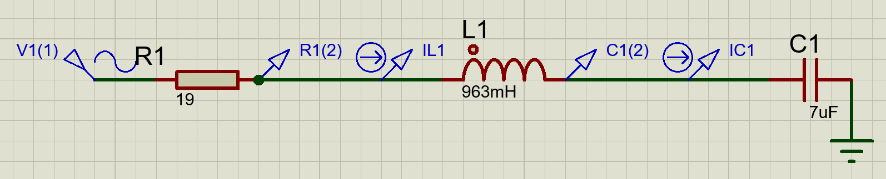
Figure 3 - Series RLC circuit diagram from Proteus
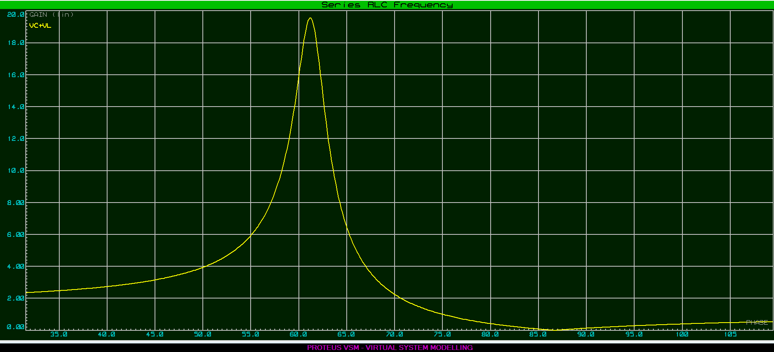
Figure 4 - Proteus graph of the Series RLC circuit

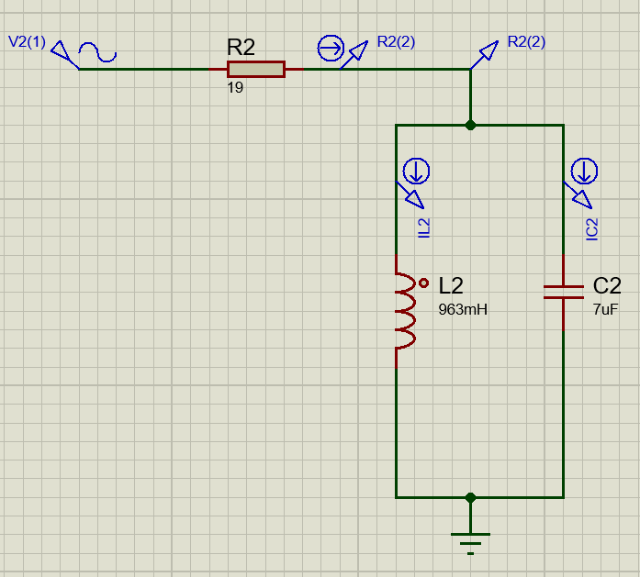
Figure 5 - Parallel RLC circuit diagram from Proteus
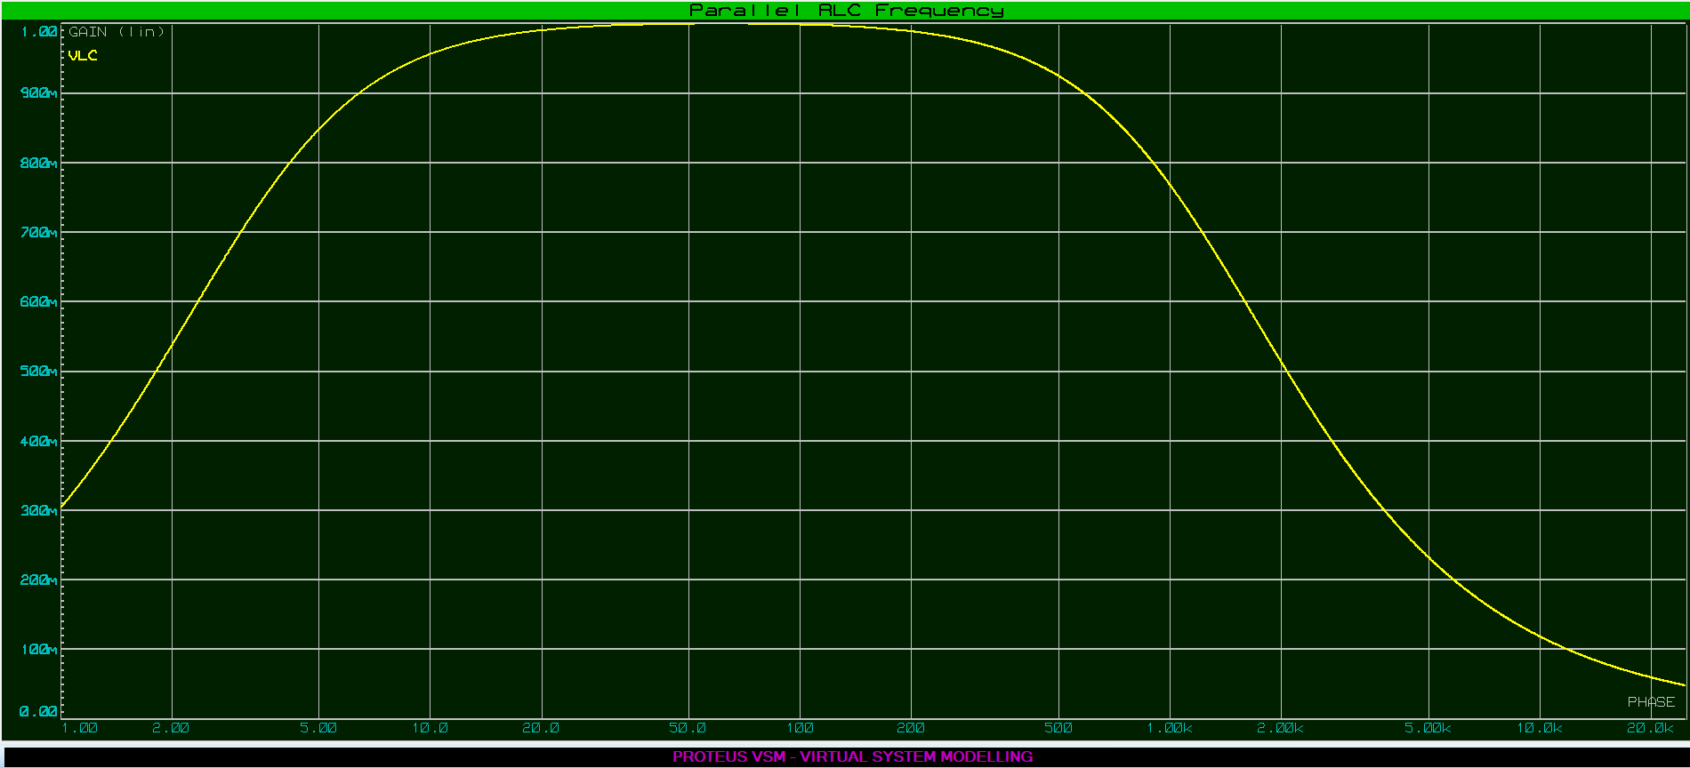
Figure 6 - Proteus graph of the Parallel RLC circuit

Initial calculations
The above graphs are trusted via the correct variables being inputted in the correct places, as well as the Proteus software itself running the circuits as expected. Calculations can be made to increase the validity of these Proteus results, allowing them to be compared to basic theory. The calculations in question are all shown below:
Impedance: $Z=R+j\left(XL-XC\right)$
Current: $VR=I ×R$ $VC=I ×XC$ $VL=I ×XL$
*Whereby:
- Z = Impedance (Ω)
- R = Resistance (Ω)
- ‘j’ is the known variable associated with complex numbers, sometimes written as ‘i’
- XL = Inductive Reactance (Ω)
- XC = Capacitive Reactance (Ω)
- V = Voltage (V)
- I = Current (A)
Using calculations shown already in the report, the value of XL was found to be 605.07Ω, XC was calculated as 227.36Ω. These values could then be put into the equation for impedance (shown above).

Series RLC analysis
Calculating these results on mass and organisning into nice graphs was done using Microsoft Excel and can be seen below:
Figure 7 - Table of calculated results (via Microsoft Excel)
It can be seen from this table of calculations that they are very similar to the results obtained via Proteus, therefore proving the validity of the Proteus simulation software and the Series RLC circuit. However, looking at a table like this, even when attempts have been made to make it more presentable, isn’t going to easily convey an awful lot. It is for this reason that a graph plotting the same variables as the Proteus graph, the voltage of the capacitor and inductor against frequency, has been produced. This is shown below in Figure 8:
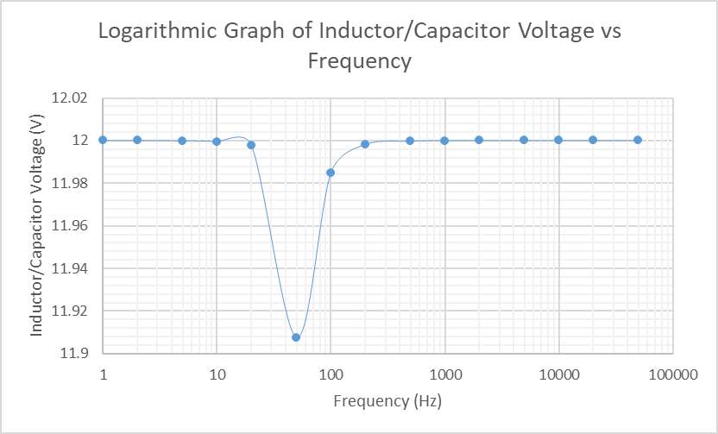
Figure 8 - Graph of Capacitor & Inductor Voltage against Frequency for the Series RLC circuit
By looking at both graphs for the Series RLC circuit (Figure 4 & Figure 8), from both Proteus and Excel, it is clear that resonance occurs at very similar/same frequencies. The resonant frequency was calculated to 61.30Hz and the graphs appear to be on that point exactly. In fact, by zzoming in and using a tool within Proteus, the frequency observed at resonance can be seen as being
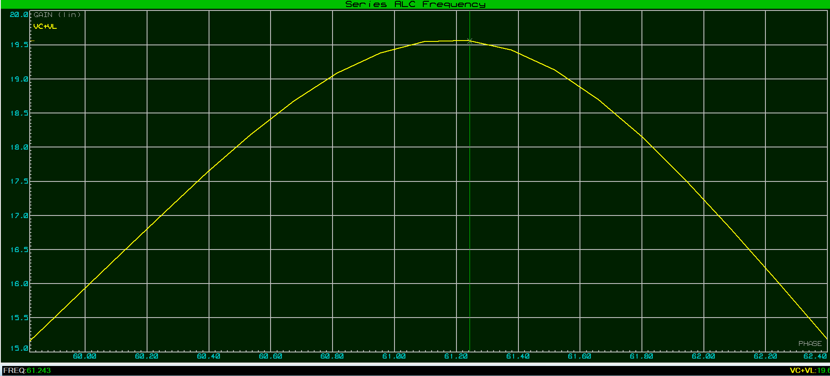
Figure 9 - A zoomed view of the Series RLC circuit graph in Proteus, with vertical light green line and frequency value in bottom left corner
The two red circles seen above show both where the pointer was placed at the peak to find the frequency (top) and the recorded resonant frequency itself (bottom left). Of course, this was done by eye and despite being relatively precise, it is not 100% precise. However, the figure shown (61.243Hz) is extremely close to the calculated value, it can be confidently deduced that this indeed would be the resonant frequency of this particular circuit.

Parallel RLC analysis
Now onto the parallel RLC circuit. The following images show the graphs, like the series ones, from Proteus and Excel. They will be further analysed in the discussion section.
Figure 10 - Full table of calculated results from Parallel RLC circuit
Once again, the inclusion of this table isn’t entirely necessary, but it is there prove that they were indeed done and for any reference that may need to be made.

Figure 11 - Excel graph for Parallel RLC circuit
As is clear by comparing the two graphs from the parallel RLC circuits, their shape is an almost identical match. Also the peak frequency appears to occur at similar point, therefore, the results can be trusted more confidently.

Q Factor
Next to determine was the Q factor, or Quality factor. This is a measure of the quallity of a resonant circuit and is a unitless value [2]. It can also be defined as the ratio between the power stored in the circuit reactance to the power dissiopated in the circuit resistance [3] [4]. There are a couple of ways of determining this, as before both will be done so that they can be compared and used to validate each other. The first method inolves using a graph to measure the bandwidth, which can then be used in a calculation to find Q. The second is just a calculation using the values of resistance, inductance and capacitance. These methods are suitable for both Series and Parallel RLC circuits, like the ones in this investigation.
Firstly, the method involving looking at the graph is as follows:
- Find the peak voltage (at resonance)
- Calculate 70.7% of said voltage
- The number calculated from step 2 will be used to cross reference to find the upper and lower frequencies that will determine the band width (voltage on y-axis, frequency on x-axis)
- The bandwidtch is calculated via the following equation: $Upper limit-Lower limit$
- Finally, to find Q, this equation is used: $Q=\frac{Resonant Frequency}{Bandwidth}$
By doing this method, it was found that the peak voltage at resonance was 19.6V and 70.7% of this figure was 13.8572V (13.9 to 1 d.p.). By looking at the Proteus graph, the upper and lower frequencies were found to be 62.7Hz and 59.5Hz respectively. Therefore, by taking the lower frequency from the upper frequency, the bandwidth was found to be 3.2Hz. Finally, to find Q, dividing the resonant frequency of 61.3Hz by the calculated bandwidth meant that the Q factor was 19.17 (No units). Comparing this to some other circuits or measures, this Q factor is relatively high, however it is known that a lower resistor value (in this case 19Ω) in the circuit, leads to a higher Q factor.
Like with other results, it is best to compare this finding with any others that are calculated via other means, if that is feasable of course. In this case, there is another calculation that can be done for both series and parallel circuits to find the Q factors (they will be the same for both). The equatoin is this:
$Q= \frac{1}{R}\sqrt{\frac{L}{C}}$
Substituting the relevant figures into this equation gives:
$Q= \frac{1}{19}\sqrt{\frac{963×10⁻³}{7×10⁻⁶}}$ = 19.52
It is clear that by comparing the two found Q factor values of 19.17 and 19.52 that they are certainly in the same ball park, so therefore can confidently say that they are valid.

Discussion
Looking at the results obtained via Proteus, firstly looking at the Series RLC circuit graph shown in Figure 2, it is clear that resonance occurs at somewhere just over 60Hz. To be precise, it was later calculated to be 61.30Hz. This value will be known and referred to as the ‘resonant frequency’. The curve initially starts at around 2.4V just after the 30Hz mark. It rises gradually until a sharp peak at resonance, which occurs at 19.6V. After this, it falls back down, past the 2.4V mark, to zero before slowly beginning to rise again at around 85Hz.
In both series and parallel RLC circuits, which as discussed contain one each of a resistor, inductor and capacitor, a condition called resonance occurs where the relative power of both the capacitor and the inductor are equal. This happens at a specific frequency (resonant frequency) and assumes that “XC = XL”, meaning that the reactance’s of the capacitor (C) and inductor (L) are the same[].
The parallel circuit works a little differently to its series counterpart and this is reflected in the difference between their respective graphs’ appearances. When the parallel RLC circuit is at resonance, the voltage, as we know, is at its peak, while the currents of both the inductor and capacitor that are in series with one another are equal. The overall curve for the parallel circuit was much smoother and gradual in comparison to the series circuit, although it did reach a peak voltage at resonance.

Conclusion
This experiment has determined that the voltage of the surrounding points of frequency at resonance follow a different pattern depending whether the circuit is series RLC or parallel RLC. The peak is much sharper at resonance in the series circuit, while being very gradual at the frequencies both before and after resonance.

Acknowledgments

This section is to acknowledge and thank those that helped in one way or another over the course of the experiment:
- Stephen Mosey: for teaching each topic to a degree that it was comfortable to apply knowledge to assignment, for setting clear instructions in lectures, demonstrating how to use Proteus and allowing access to lecture videos to top up/remind understanding of important applications for assignment. All of this as well as some very useful tips during assignment ‘clinics’ and lectures following the spring break.
- Antony Wingate: A fellow UWTSD student whom I exchanged a few messages with pretty much throughout the entire process to help with tips and applications of material.

References

[1] | S.Soclof, “"How Circuits Work",” HowStuffWorks.com, 2008.
[2] | A. Khaladkar, “What is the SI unit of quality factor(Q) in a LCR circuit?,” 2017.
[3] | Moore's Lobby, “Q Factor and Bandwidth of a Resonant Circuit,” in Resonance, Moore's Lobby, p. Chapter 6.
[4] | Electrical Technology, “Q Factor in Electronics and Electrical Engineering,” Electrical Technology, 2013.

Images:
Figure 1: https://i.stack.imgur.com/vrHLd.png
Figure 2: https://www.labcenter.com/images/logo.png

